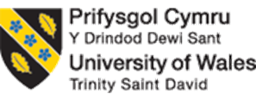
Programme : Master of Business Administration
Module : Human Capital Management
Module Code : LCMB7023
Assignment Title : Assessment Component 1 : Individual Report
Lecturer : Ejike Udeogu
Student Name : Pratikkumar Jagdisgbhai Kevadiya
Student Id Number : 2435897
Word Count : 2678
Submission Date : 17/10/2025

Table of Contents
1. Technological Advancements and Labour Market Transformation 3
2. Demographic and Geopolitical Forces Shaping Employment 5
2.1 Demographic Factors & Their HR Implications 5
2.2 Geopolitical / Global Forces & HR Challenges 6
3. Addressing Skills Gaps and Talent Shortages through Strategic HRM 8
3.1 Building Strategic Pipelines with Education and Training Partners…………..….8
3.2 Upskilling, Cross-Training, and Internal Mobility…………………………….……..8
3.3 How to Use Technology and Alternative Work Models…………………………….9
3.4 How to Enhance Recruitment Strategy and Candidate Experience……………..9
4. Reflective Report on Working in an International Context Capabilities 9
4.1 Introduction 9
4.2 Technology, Digital Competence 10
4.3 Communicating within Multicultural environments 11
4.4 Teamwork and Collaboration 11
4.5 Independent study and Lifelong Learning 12
4.6 Conclusion 12
Reference List 13

1. Technological Advancements and Labour Market Transformation
The advancing pace of technological change, often referred to as the Fourth Industrial Revolution, is profoundly reshaping the global labour market. The development of advanced artificial intelligence, automation, robotics, and other digital platforms is continually helping to build a better workplace. These transformations present challenges and opportunities simultaneously for human resource management strategies.
Impact on the labour market includes automation, which is one of the most significant factors influencing HRM or IHRM due to its consequences for the displacement of human labour. Zubair (2024) stated that a majority of US jobs were at risk of being replaced by automation, which reinforced a different outlook. However, studies like Furaijl et al., (2025) have also mentioned that technological change is likely to transform jobs rather than eliminate them, creating new roles and positions such as digital marketing, AI ethics, auditing, and data analysis. This argument between the displacement of jobs and the creation of new opportunities reflects the dual nature of these advancements, where a routine and low-skilled role declines, and the demand for high-skilled jobs increases.
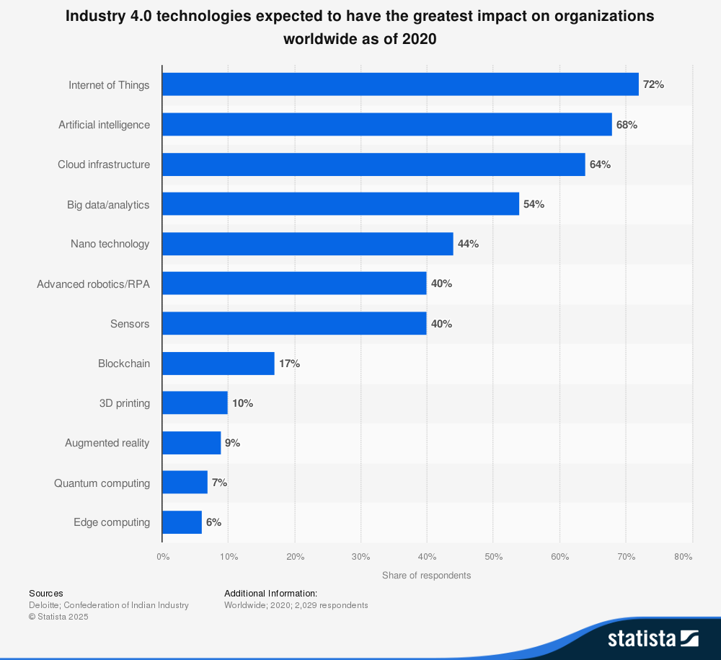
Figure 1: Impact of Industry 4.0 Technologies on Labour Market Organisations
(Source: Statista, Deloitte, Confederation of Indian Industry, 2025)
These developments prompt a rethinking of workforce planning from both an HRM and IHRM perspective. HR professionals will need to contend with the ongoing demands of reskilling and upskilling as the shelf-life of technical skills gets shorter (Barrett and Pack, 2023). The focus on learning and development has switched to skills such as digital literacy, adaptability, problem-solving and other attributes necessary for workforce agility (Shet, 2024). Finally, platform-based work has helped to develop for HR to consider alternative employment models. Job security, employee engagement, and fair pay, for instance, become overlaid in complexity as companies increasingly utilise the international freelance platforms and algorithmic management systems (Carr et al., 2025).
Considering an international level and a global landscape, another hurdle or challenge for IHRM is identifying and managing technological differences across borders (Appoh et al., 2025). For example, workers in developing economies may be at a higher risk of displacement in manufacturing jobs than those in developed economies where opportunities may emerge, in a new high-tech economy (Pulami and Nepal, 2024). So, HR leaders will therefore need to understand and be able to develop global strategies that weigh the costs effectively with a balanced social return, ethical investments, including the ethical use of AI tools in recruitment and performance management systems.
The progression of technology also opens possibilities for positive societal enhancements in an ethical or regulatory sense (Sætra and Danaher, 2022). For instance, the incorporation of technology as part of the recruitment process has implications for fairness and transparency seen through the lens of algorithms. Therefore, as labour markets evolve from the introduction of changing and new technology causing unemployment, HRM and IHRM will be put in the position to accommodate the introduction of these subject matters. Investment into human capital development, ethical development of technologies and workforce models that foster inclusion will enhance the possibility of reducing moral harms and further increase opportunity in a digital context.

2. Demographic and Geopolitical Forces Shaping Employment
Significant and thereby considerable changes are linked and related to demographics and geopolitical instability which leads to the creation of important changes in the current labor markets (Pulami and Nepal, 2024). These changes create opportunities and challenges for HRM and IHRM.

2.1 Demographic Factors & Their HR Implications
Labour supplies and demand are changing drastically due to forces in our demographics that require human resource responsiveness. In OECD counties, the ratio of aged population aged 65+, relative to the working-age population, is expected to rise from 21 to 33 per 100 over the period from 1994 and 2024, resulting in increased labour supply pressures and dependencies (OECD, 2024). Older workers are remaining in the labour market; for example, in 2024, the average employment rate for individuals aged 60-64 was 55.9% in OECD countries (OECD 2025). These trends place pressures on HR to retain older workers, modify tasks in the workplace to accommodate physical capacities, and provide learning opportunities throughout a lifetime for older workers.
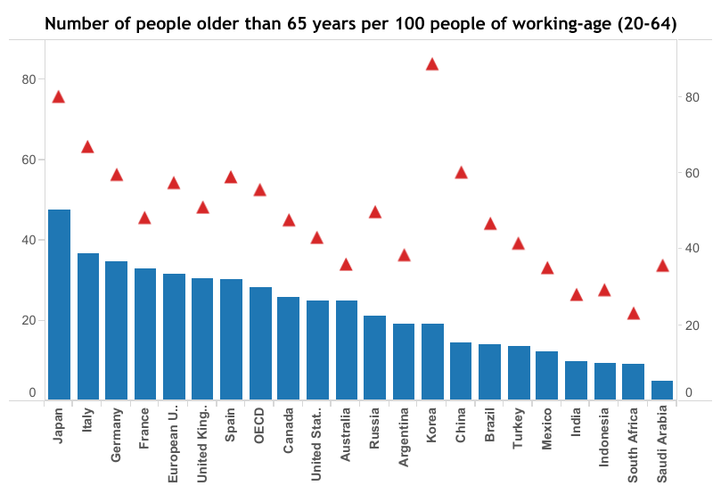
Figure 2: 65+ Working Age Individuals
(Source: OECD, 2024)
Alternatively, and in contrast, within the Global South, another demographic trend is much more pronounced, with youth bulges present and the pressures that regions of the world face with a large youth cohort require education systems and job creation to grow accordingly (Usman, 2023). Lastly, women's participation in the global labour force has increased significantly over the decades, but there are still huge regional gaps despite this. For example, even for prime-age women compared to men in the workplace, women's participation is lagging behind men's participation by over 40 percentage points in some markets (Brookings, 2024). In this regard, HRs will need to design policies to be more inclusive and enable benefits such as a bolt-on flexible work and childcare systems, and equitable and manageable cross-generational benefits.

2.2 Geopolitical / Global Forces & HR Challenges
In the world of geopolitics, there is now a need for organizations to rethink their supply chain and operational footprint due to current conditions defined by increasing tolerance of protectionism and competitive trade disputes. U.S. tariffs on imports from China averaged nearly 17 percent, causing significant trade diversion and reconfiguring supply chains (IMF, 2025). The overall number of global migrants is now estimated to be approximately 304 million of the population, indicating the complexity regarding cross-border mobility issues that organizations will have to contend with (Migrationdataportal.org, 2025).
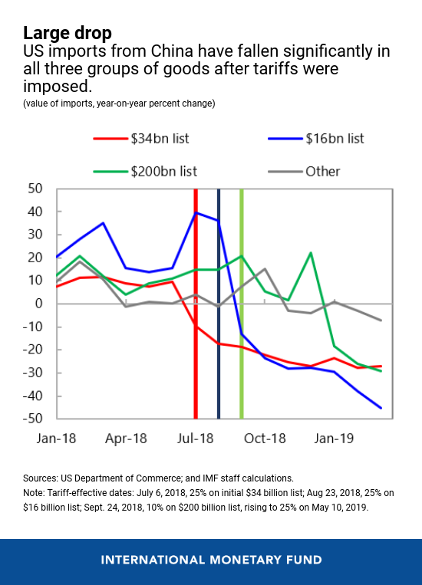
Figure 3: US-China Tariff Impacts
(Source: IMF, 2025)
Human Resource practitioners will have to be able to relocate or redeploy employees across jurisdictions, navigate through visa and immigration regulation, and mitigate risks to political instability or anti-foreign sentiments that focus on "locals first" hiring regulation (Appoh et al., 2025). Some of the challenges will be working through the inconsistent diversions in labour law and regulation across countries, wanting consistent arrangements but flexibility in strategy.
In addition, employees with multi-generational, different cultural and borderless workforces require more possibilities to create inclusive, adaptable approaches to policy based on heterogeneous expectations (Appoh et al., 2025). Thus, it can be mentioned that organisations must find the balance between the standardisation of HR globally, and the adaptation of to ensure competitiveness while being contextually relevant.

3. Addressing Skills Gaps and Talent Shortages through Strategic HRM
Researchers Orphanidou et al., (2023) have helped to highlight the ongoing issues regarding skill gaps and talent gaps in areas like technology, health care, and hospitality increasingly threatening organisational performance and service delivery. However, it is argued by Kim, Khoreva and Vaiman (2025) that despite organizations adopting strategic HRM in place of earlier HR functions to address some of these issues; strategic HRM is at times a reactive approach. Strategic HRM should exercise a more proactive, multi-pronged approach to address these issues.
3.1 Building Strategic Pipelines with Education and Training Partners
Organizations such as those in healthcare can create strong partnerships with educational institutions to assist in the design of curricula to better address workforce needs in the healthcare sector (Savandha and Fitriyani, 2025). For example, HR in healthcare would create internships and residencies, as well as collaborate on curricula with universities to ensure that healthcare graduates are job-ready (Lloyd, Vasandani and Salvacion, 2023). Pipelines will help narrow the gap between newly graduated professionals entering the labour market and organizational needs for those professionals.
3.2 Upskilling, Cross-Training, and Internal Mobility
Many organizations look for ongoing learning and development opportunities to assist with skill gaps. In hospitality, for instance, cross-training front-office staff on the various digital tools, alongside training chefs on the supply chain process, reduces the need for specialized roles. In the healthcare sector, upskilling current aspects such as administrative or support staff taking on a more specialized role, thereby stands as a more effective approach to healthcare labor shortages (Orphanidou et al., 2023). Strategic HRM must strive to create career ladders and promote internal mobility so the current workforce can remain in their current organization while filling necessary roles and eliminating the sole focus on external hiring.

3.3 How to Use Technology and Alternative Work Models
Strategic HRM means leveraging technology to aid in recruitment and HR operational functions. In the hotel or the hospitality industry, it can be stated that hotels implement self-service kiosks, mobile check-in, AI-powered communications with guests, and other automations to reduce reliance on manual workers (Bagadiya and Kathiriya, 2024). In technology and IT-related sectors, new tools for recruiting considering aspects such as the application of AI in the CV screening process as well as gamified assessments have made it easier to attract candidates and assess candidate fit (Manikran Pedige, 2025). Both flexible work models, remote hiring, and gig or shift-based work opportunities are ways to fill shifts dynamically in sectors like healthcare.
3.4 How to Enhance Recruitment Strategy and Candidate Experience
As organizations develop recruitment strategies, they are adding more channels to access less traditional or underrepresented talent pools. Targeted diversity recruitment, the use of social media, relationships with community groups, and recruiting international talent in a feasible as well as legal manner is possible for sectors such as the healthcare (HR Healthcare, 2024). Employers are also focusing on improving the candidate experience such as smoother selection process, virtual interviews, hiring based on skills and competence rather than solely credential-based to thereby mitigate candidate drop-off rates. As per the report by Shrm.org (2025) it has been stated that 69% of employers still find it difficult to fill full-time roles, and 51% say the low number of applicants is part of the difficulty associated with filling positions.

4. Reflective Report on Working in an International Context Capabilities

4.1 Introduction
In the modern globalised economy, the skill of working effectively in the international environment is the key to professional success. As labour markets become more intricate, employees are becoming expected to exhibit greater flexibility along the cultural, technological and organisational lines. Additionally, the quick development in the technological sphere has altered the essence of the work, as now people need not only to use digital tools but also to be innovative on a constant basis. The report is a critical reflection on my existing competencies in five areas that are considered as critical to international employability such as technology, communication, teamwork, leadership, and self-directed learning. The discussion is based on my current learning practice during this term as well as recent professional experiences, my strengths and weaknesses and development strategies can be proposed. With the help of academic research, I would like to evaluate my preparedness to succeed in globalised working conditions and define the steps toward development by using a reflective method.

4.2 Technology, Digital Competence
Technology has deeply permeated the global workplace, and human resource management (HRM) is becoming increasingly dependent on digital technologies, including HR analytics, AI recruitment tools, and global collaboration platforms (Gupta, 2024). I view technological flexibility as one of my capabilities. During the last term, I have successfully used online tools like Microsoft Teams, Zoom, and Google Workspace to work on group projects in different time zones. This is because these experiences have made me more competent in digital communication and project coordination with remote interpersonal communication, and these are competencies that strongly correlate with the requirements of a virtual team operating globally.
However, I can also identify one of my weaknesses in the fact that I have little experience with sophisticated HR technology, in particular, enterprise resource planning software, such as SAP SuccessFactors or Workday, which is hugely popular among multinational corporations. Moreover, I default myself to use a familiar tool instead of searching newer technologies and this could inhibit innovation.
I will take short professional courses availed via online platforms, like LinkedIn Learning and CIPD, that will offer hands-on experience with HR technologies to overcome these shortcomings. Besides that, the active exploration of AI-based HR analytics will enable the people to become more technologically literate (Venugopal et al., 2024). By using my strength in the ease of digital adaptation as I fill these gaps, I will be able to stay competitive in technologically advanced working environments in other countries.

4.3 Communicating within Multicultural environments
International employability involves effective communication across cultures since, through this process, one can navigate through the cultural differences to avoid misunderstanding. My advantages in this respect are good written communication skills developed by college writing and workplace reporting, and the ability to adjust in changing the communication style according to the audience. In recent seminar group projects, able to organise ideas in a logical way and present written work to a small group of people (Barrett and Pack, 2023). More than that, a cultural sensitivity has helped me to engage in inclusive discourse with other students with different backgrounds.
However, I also find the verbal communication in multicultural groups weak. I sometimes tend to be in hesitation to add to the conversation, especially where I must deal with other norms of communication. Such indecision will compromise my authority and reduce my impact when making decisions in the group. The studies point out that intercultural communication not only needs linguistic competence, but also cultural agility.
I will engage in cross cultural workshops and cross-cultural simulation-based exercises aimed at enhancing negotiation and verbal communication skills to become better. Requesting positive feedback among peers when engaging in international work will additionally enable a person to work on my style (Van Rompay-Bartels and Geessink, 2023). With my strength of written communication and cultural awareness, I can develop more confidence in oral communication in a multicultural setting.

4.4 Teamwork and Collaboration
Teamwork is very crucial in international workplaces, especially where teamwork is done virtually across time zones and national borders (Yousef, 2024). I am a team player who applies an inclusive and collaborative style as my key strength. I also actively promoted everyone to contribute in my recent group work through listening to and considering other team members and successfully integrating their different viewpoints into unified work. This skill is evidence that global teams that are successful need to be integrated and coordinated.
The negative aspect that has however come out in team-based activities is that I tend to overemphasise consensus. Inclusion has its benefits such as producing harmony but sometimes delays decision making in situations when the group needs a more aggressive guidance (Jerab, 2023). In a recent project, the process was slowed down due to the long debates on small points which affected the time limits and the need to create more decision-oriented contribution.

4.5 Independent study and Lifelong Learning
The ability to learn independently is a key component to long-term employability in labour markets that are volatile and global (Adamowicz, 2022). I believe that this is one of my strengths. I will always read academic literature and industry reports to keep abreast with HRM and IHRM developments. As an example, the involvement in the work with journal articles on the topic of digital HRM and global workforce diversity in the recent past has expanded my critical view of the existing problems. Another way I engage in reflective learning is through the evaluation of feedback on my assignments and the utilization of the feedback in future tasks. However, one weakness is that I tend to be more preoccupied with academic knowledge and do not necessarily apply knowledge to practice because of that. I sometimes had difficulty implementing theoretical frameworks in practice in simulation-based exercises in applying them to real-life scenarios. My self-directed learning would be too theoretical without closing this gap.

4.6 Conclusion
This reflection has critically analysed my abilities in five areas critical to international employability, which include technology, communication, teamwork, leadership and self-directed learning. I am digitally flexible, a written communicator, teamwork that is inclusive, transformational in nature, and reflective in learning. On the other hand, I have recognized such weaknesses as my low exposure to high-technology HR tools, reluctance in verbal contributions, excessive use of consensus within a team, a belief in multicultural leadership, and the inability to practice theory practically.

Reference List

Adamowicz, M., (2022). COVID-19 pandemic as a change factor in the labour market in Poland. Sustainability, 14(15), p.9197. https://www.mdpi.com/2071-1050/14/15/9197
Appoh, M., Gobile, S., Alabi, O.A. and Oboyi, N., (2025). Innovative HR Technologies: Transforming Expatriate Management and Immigration Services for the 21st Century. https://www.allmultidisciplinaryjournal.com/uploads/archives/20250521151530_MGE-2025-3-155.1.pdf
Bagadiya, D. and Kathiriya, K., 2024. The Future of Hotel (A Symbiosis of Automation and Human Interaction.). https://www.theseus.fi/bitstream/handle/10024/861876/Bagadiya_Kathiriya.pdf?sequence=2
Barrett, A. and Pack, A., (2023). Not quite eye to AI: Student and teacher perspectives on the use of generative artificial intelligence in the writing process. International Journal of Educational Technology in Higher Education, 20(1), p.59. https://link.springer.com/content/pdf/10.1186/s41239-023-00427-0.pdf
Brookings (2024). Prime-age Women Are Going above and beyond in the Labor Market Recovery. Available at: https://www.brookings.edu/articles/prime-age-women-labor-market-recovery/. (Accessed: 04 October 2025).
Carr, S., Hopner, V., Meyer, I., Di Fabio, A., Scott, J., Matuschek, I., Blake, D., Saxena, M., Saner, R., Saner-Yiu, L. and Massola, G., (2025). The Wheel of Work and the Sustainable Livelihoods Index (SL-I). Sustainability, 17(14), p.6295. https://www.mdpi.com/2071-1050/17/14/6295
Furaijl, H.B., Khader, O.M., Mohammed, R.J., Dawie, W.M., Salih, A.S. and Alwan, A.M., (2025). The digital economy and labor markets: how automation and AI are reshaping employment trends. Procedia of Environmental Science, Engineering and Management, 12, pp.251-260. https://procedia-esem.eu/pdf/issues/2025/no1/29_Furaijl_25.pdf
Gupta, R., (2024). Impact of artificial intelligence (AI) on human resource management (HRM). International Journal For Multidisciplinary Research, doi, 10. https://pdfs.semanticscholar.org/777c/20d96221f47f83130be9c5cf6a9986759917.pdf
HR Healthcare (2024). How HR in Healthcare Is Addressing the Talent Shortage. Available at: https://hrhealthcare.wbresearch.com/blog/how-hr-in-healthcare-is-addressing-the-talent-shortage. (Accessed: 04 October 2025).
IMF (2025). The Impact of US-China Trade Tensions. International Monetary Fund. Available at: https://www.imf.org/en/Blogs/Articles/2019/05/23/blog-the-impact-of-us-china-trade-tensions. (Accessed: 04 October 2025).
Jerab, D., (2023). How to Be an Effective Leader in Decision Making in an Unstable Environment. Available at SSRN 4525803. https://papers.ssrn.com/sol3/Delivery.cfm?abstractid=4525803
Kim, S., Khoreva, V. and Vaiman, V., (2025). Strategic human resource management in the era of algorithmic technologies: key insights and future research agenda. Human Resource Management, 64(2), pp.447-464. https://onlinelibrary.wiley.com/doi/pdf/10.1002/hrm.22268
Lloyd, S., Vasandani, M. and Salvacion, J.O.I., (2023). Graduate employment outcomes of health service management work integrated learning placements. Asia Pacific Journal of Health Management, 18(1), pp.98-108. https://journal.achsm.org.au/index.php/achsm/article/download/1639/1031
Manikran Pedige, D.U.B., 2025. Leveraging Large Language Models to Transform Recruitment in Human Resource Management: An Evaluation of AI-Driven Approaches. https://www.doria.fi/bitstream/handle/10024/192742/pedige_danushika_udani_bandara_manikran.pdf?sequence=2
Migrationdataportal.org (2025). Migration Data Portal: the Bigger Picture. Available at: https://www.migrationdataportal.org/themes/international-migrant-stocks-overview. (Accessed: 04 October 2025).
OECD (2024). Economic Resilience. Available at: https://www.oecd.org/en/topics/economic-resilience.html. (Accessed: 04 October 2025).
OECD (2025). OECD Employment Outlook 2025: Navigating the golden years: Making the Labour Market Work for Older Workers. Available at: https://www.oecd.org/en/publications/oecd-employment-outlook-2025_194a947b-en/full-report/navigating-the-golden-years-making-the-labour-market-work-for-older-workers_2bc681ed.html. (Accessed: 04 October 2025).
Orphanidou, Y., Efthymiou, L., Morphitou, R., Vlachos, D., Papadopoulos, M., Yakavenka, V. and Psilla, D., (2023, September). EXPLORING THE SKILLS GAP IN TOURISM AND HOSPITALITY: TOWARDS A NEW CLASSIFICATION OF SKILLS, COMPETENCIES, AND JOB POSITIONS. In 16th Annual Conference of the EuroMed Academy of Business. https://www.researchgate.net/profile/Michael_Neubert7/publication/374792524_euromed2023-book-of-proceedings-2023-09-24pdf/data/652fd3c75d51a8012b52c0b2/euromed2023-book-of-proceedings-2023-09-24.pdf#page=607
Pulami, M.J. and Nepal, S., (2024). The Potential Impact of Demographic Changes in Geopolitical Landscape. Asian Journal of Population Sciences, 3, pp.43-58. https://nepjol.info/index.php/ajps/article/download/61830/46530
Sætra, H.S. and Danaher, J., (2022). To each technology its own ethics: The problem of ethical proliferation. Philosophy & Technology, 35(4), p.93. https://link.springer.com/content/pdf/10.1007/s13347-022-00591-7.pdf
Savandha, S.D. and Fitriyani, D.R., (2025). Building a Sustainable Talent Pipeline: HR Development Strategies in Indonesia's Education System. Journal of Institutional Educational Management, 1(1), pp.30-41. https://jiemjournal.com/index.php/jiemjournal/article/download/4/2
Shet, S.V., (2024). A VUCA-ready workforce: exploring employee competencies and learning and development implications. Personnel Review, 53(3), pp.674-703. https://www.researchgate.net/profile/Sateesh-Shet/publication/377030528_A_VUCA-ready_workforce_exploring_employee_competencies_and_learning_and_development_implications/links/6592eb413c472d2e8ea66729/A-VUCA-ready-workforce-exploring-employee-competencies-and-learning-and-development-implications.pdf
Shrm.org (2025). Candidate ‘Ghosting’ and Employer Competition Are Fueling Talent Shortages, New SHRM Research Finds. Available at: https://www.shrm.org/in/about/press-room/candidate--ghosting--and-employer-competition-are-fueling-talent (Accessed: 04 October 2025).
Statista, Deloitte, Confederation of Indian Industry. (2025). Industry 4.0 technologies expected to have the greatest impact on organizations worldwide as of 2020. Available at: https://www.statista.com/statistics/1200006/industry-40-technology-greatest-impact-organizations-worldwide/ (Accessed: 04 October 2025).
Usman, M., (2023). Impact of Youth Bulge on Governance and Employability. Pakistan JL Analysis & Wisdom, 2, p.242. https://pjlaw.com.pk/index.php/Journal/article/download/67/58
Van Rompay-Bartels, I. and Geessink, J., (2023). Exploring peer feedback on behaviour in the international classroom: a case study on students’ experiences and perceptions. Journal of International Education in Business, 16(1), pp.1-17. https://www.emerald.com/insight/content/doi/10.1108/JIEB-07-2020-0063/full/pdf
Venugopal, M., Madhavan, V., Prasad, R. and Raman, R., (2024). Transformative AI in human resource management: enhancing workforce planning with topic modeling. Cogent Business & Management, 11(1), p.2432550. https://www.tandfonline.com/doi/pdf/10.1080/23311975.2024.2432550
Yousef, K., (2024). Exploring the impact of cultural diversity in global projects: A comparative analysis of virtual and face-to-face teamwork. International Journal of Cross Cultural Management, 24(2), pp.411-430. https://journals.sagepub.com/doi/pdf/10.1177/14705958241253754
Zubair, S., (2024). AI-Driven Automation: Transforming Workplaces and Labor Markets. Frontiers in Artificial Intelligence Research, 1(3), pp.373-411. https://sprcopen.org/FAIR/article/download/46/44

