

Course Title: MBA - International Business
Term 1

Module Name: Marketing Management
Module Code: LCMB7024

Student Name: Anuj Upendrakumar Raval
Student ID: 2432471

Lecturer’s Name: Dr. Laila Maazouz

A Study on Marketing Management:

Tesla Aero Move

Table of Contents
1. Introduction to Company and New Brand 5
2. STDP Analysis (Segmentation, Targeting, Differentiation, and positioning) 6
2.1 Segmentation 6
2.2 Targeting Strategy 7
2.3 Differentiation Strategy 7
2.4 Positioning Strategy 8
3. Market Mix of 7P’s 8
3.1 Product: 8
3.2 Price: 9
3.3 Place: 10
3.4 Promotion: 10
3.5 People: 11
3.6 Process: 11
3.7 Physical Evidence: 12
4. Marketing Strategy Pitch 13
5. Reflection of the Brand 14
6. Reference 16
Appendix 18

1. Introduction to Company and New Brand
Tesla is one of the most prominent automobile companies in the world and it is mostly recognized because of its reign in the automation car and performance innovation. During the last ten years, Tesla has been turned into a lifestyle and technology-oriented business and incorporated digital environments, smart gadgets, and custom-crafted. With changing urban lifestyles and increasing sustainability demands, Tesla can have the strategic capacity to grow out of its traditional automobile lines and venture into the new mobility services category (Mathiopoulou et al., 2023).
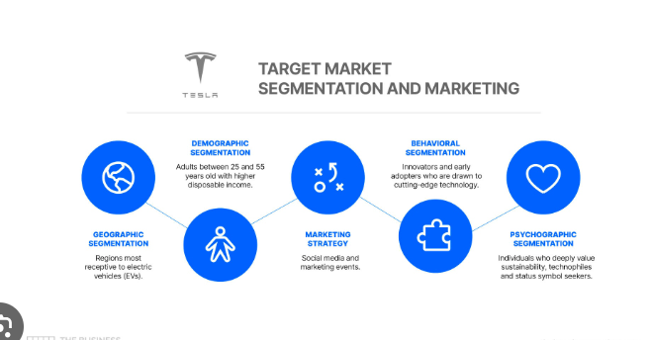
Figure1: Tesla Target Market Analysis
Source: (anthon, 2024)

The new brand, which is proposed, is called Tesla AeroMove, or the AI-powered electric scooter mobility service, which will help to lead an active, sustainable, and efficient urban lifestyle. Placed as a micro-mobility subscription platform that functions as a continuous flow, AeroMove combines smart electric scooters, a mobile application, a reward system with its connections to Tesla Learn Club and Tesla Training Club, and community-based mobility challenge. This new brand makes Tesla fit in the fast growing micro-mobility market that is occasioned by the global urbanisation, adoption of sustainable transport, and consumer preference of flexible mobility (Mathiopoulou et al., 2023).
AeroMove enhances the philosophy of Tesla which is to empower people to move to new levels and take this to an all-day mobility. It relates speed, health and urban commuting to a single ecosystem. With the migration of cities towards more sustainable modes of transport, Tesla has a brand equity, extensive digital presence, and creative designing capability that would pose a powerful opportunity to penetrate this new market category (Jabr, 2023).

2. STDP Analysis (Segmentation, Targeting, Differentiation, and positioning)

2.1 Segmentation
Tesla AeroMove is segmented through a multi-dimensional strategy where it has integrated demographic, psychographic, behavioural, and geographic to establish the potential consumers (Jabr, 2023).
Demographic Segmentation:
Age: 18-45
Revenue of Medium to high (business workers, students, gym lovers) and its Profession of a office employees, university students, freelance and gig employees. The education for a secondary, university, after-university education (Jabr, 2023).
Psychographic Segmentation:
Urban customers who lead a dynamic lifestyle. Conscience-based consumers focused on the environment. Innovation, digital connectivity, and brand identity are valued by the consumers. People who are interested in being convenient, quick, and have a free choice in their daily commuting (Solomon et al., 2021).
Behavioural Segmentation:
One may be a frequent urban commuter who needs short-haul transportation. The users interacted with fitness applications and performance tracking. Those who are loyal to the Tesla digital universe (TeslaApp, NRC, NTC). Those who want convenience through subscription and not through ownership (Solomon et al., 2021).
Geographic Segmentation:
Metropolitan cities of high population density. Areas that have good transportation mechanisms and high last-mile commuting requirements. Highly digital markets (USA, UK, Germany, UAE, Singapore, Japan) (Solomon et al., 2021).

2.2 Targeting Strategy
The targeting strategy Tesla AeroMove embraces is concentrated, which means that it targets the following segments:
Key targets market in the urban performance commuters:
These consumers are urban dwellers, they travel frequently and are interested in efficiency, sustainability and convenience. They attach importance to the rapid mobility solutions that fit their lifestyle and are attracted by the services that are technology-integrated. They are also the first to adopt smart mobility (Zhou, 2023).
Secondary Target Segment: Fitness and Lifestyle Lovers:
These people are already users of the existing digital platforms of Nike, including the TeslaRun Club and the TeslaTraining Club. To promote the lifestyle, AeroMove provides movement, activity, and a sense of community by providing a mobility service that strengthens these aspects. Mobility coupled with fitness rewarding will promote activity and retention (Zhou, 2023).

2.3 Differentiation Strategy
Tesla AeroMove stands out with brand experience, technology integration and lifestyle positioning:
AI-Enabled Smart Mobility:
The scooters have real time route optimisation, safety warnings, predictive maintenance and automated speed control depending on riding habits. Connection with the Tesla Digital Ecosystem. Move points are awarded to users on a per kilometre basis and these points can be redeemed on Tesla products or fitness challenges. Higher quality Design and Performance. Scooters have light aerodynamic design, long lasting batteries, anti-theft system, and ergonomic comfort (Zhou, 2023).
Sustainability Commitment:
Each scooter is made of recycled materials and solar-charging stations, which is part of the Move to Zero sustainability platform of Nike. Community-Building Mobility Problems. TeslaAeroMove has transferred the philosophy of Just Do It to the commuting city life where movement, competition and community events are associated with micro-mobility (Lei, 2025).

2.4 Positioning Strategy
Positioning Statement:
The positioning of Tesla AeroMove is to be the most dynamic, AI-driven mobility service in the world enabling an urban consumer to move smarter, faster and more sustainably and be part of the Tesla lifestyle ecosystem (Lei, 2025).
The positioning statement of the brand will be Not only scooter subscription but a premium mobility lifestyle service. An environmentally-friendly alternative to the conventional urban transport. A commuting solution that is technology based and an action-driven expansion of the Tesla brand. AeroMove is a logical continuation of the Tesla fundamental promise to make people move, perform and feel empowered (Lei, 2025).

3. Market Mix of 7P’s
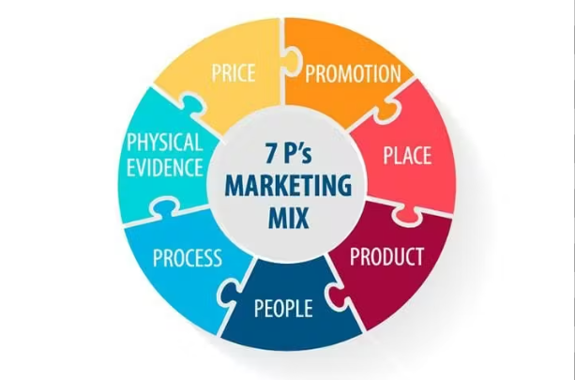
Figure2: Tesla 7P’s Marketing Mix
Source: (ware, 2021)

Tesla AeroMove is an all-inclusive mobility service, which combines the future of electric scooter technology with a digitally integrated subscription platform.

3.1 Product:
The Product aspect of the marketing mix is directed at providing a high-quality and seamless mobility experience, which is a product of Tesla design ethos and innovativeness. The smart electric scooter is the heart of the AeroMove, which is designed to be lightweight with a frame made of carbon-composite in order to provide stability and maneuverability in congested urban areas (Lapshyna, 2024). The scooter has GPS tracking, live performance monitoring, anti-theft locks, and an LED dashboard screen that reports the speed, battery status, and warnings. Its extreme range battery helps in commute of the day with minimal downtime among riders as it charges fast. The advanced shock-absorption systems would provide comfort and stability and allow traveling through different surfaces of the city (Lapshyna, 2024).
The physical product can be accompanied by the Tesla AeroMove mobile application that serves as the primary interface in managing the rides, taking the city paths and locating the performance of a user. The app can be linked to Tesla Run Club and Tesla Training Club so that movement can be translated into the Tesla Move Points that can be redeemed to get discounts on Tesla products or a subscription cut (Lapshyna, 2024). Tesla provides tiered subscriptions plans to meet various consumer demands: AeroBasic is the plan which is proposed to occasional riders, AeroPlus is the one which is offered to frequent riders and needs unlimited mobility, AeroElite is the plan of high value which is offered to high-value individuals with the additional insurance, roadside assistance, and the events of community mobility. Other supplementaries like reflective clothing, helmets, portable chargers, among others add value to the experience, making it more solid in the context of safety and convenience (Zeng et al., 2025).

3.2 Price:
The Price strategy of Tesla AeroMove conforms to the premium market positioning of Tesla and high value technology in the service. The brand applies a hybrid pricing strategy that takes into consideration the value-based pricing and tiered subscriptions. The prices are also an indication of the high performance and security aspect of the scooters and also the digital nature that makes AeroMove stand out in the other mobility services. AeroBasic provides an affordable pay-as-you-fly service costing PS3/ride or PS9/day which can attract the occasional fliers and tourists (Zeng et al., 2025).
AeroPlus with a price of PS59/month is aimed at every day commuters who enjoy the advantage of unlimited movement. With a fee of PS89 per month, AeroElite will offer insurance, priority maintenance, and entry to community events, which will make it a high-end offering. This framework is complemented by Tesla via its dynamic pricing methods such as student warranty, corporate mobility, and seasonal promotions. The bonus of Move Points is an additional perceived value motivator since it gives the user an opportunity to turn the number of kilometres travelled into a discount or a free subscriptions period, and this serves as a way to demonstrate loyalty to the customer (Zhen, 2025).

3.3 Place:
The Place strategy of Tesla AeroMove is based on the foundation of the omnichannel distribution model which is focused on the accessibility, visibility and convenience. Mostly, the service will be operated digitally in the form of the AeroMove mobile app and the Nike.com site where the users will be able to subscribe, find scooters, and manage their accounts. Physical visibility is also assisted by the strategic location of AeroMove service hubs in large metropolitan locations where scooters are stored, charged, and maintained. These centres will be situated close to universities, commercial areas, metro stations and fitness areas so that there is maximum uptake by the users (Zhen, 2025).
The flagship retail stores of Tesla in other cities, including London, New York, Seoul, and Los Angeles, also serve to expand the physical presence by providing customers with the possibility to test the scooters, as well as educate them about the service. Its implementation will be done in phases using a geographic approach where its launch will be targeted in urban areas that have shown high Micromobility adoption patterns, favourable infrastructure, and high concentration of students and working members of the population. This institutionalized methodology is what allows Teslato perfect its operations template to go further to other cities in the world like Paris, Berlin, Singapore, and Toronto (Zhen, 2025).

3.4 Promotion:
The Promotion component of the marketing mix of AeroMove is concerned with the creation of awareness, provoking the interest, and enhancing the brand awareness. Tesla will resort to integrated marketing communications, which involve the combination of digital, social and physical touchpoints in order to come up with a cohesive messaging strategy (Liu, 2024). Digital promotion will be on the forefront and the use of social media promotion (hashtag) like the move your city that stimulates user-created content (experience with the scooter). Fitness, lifestyle, and sustainability movers will be involved in challenges of mobility to increase reach and credibility. Tesla will also spend on out-of-home advertising, such as billboards, transit-station screens and branded charging hubs in busy urban areas (Liu, 2024).
The experiential marketing will form a significant part with events such as: urban mobility marathons, mobility days in the campus and sustainability festivals where local councils will co-organise them. These occasions support the Tesla Move to Zero sustainable mission and indicate the environmental advantages of micro-mobility. The CRM strategy will help in retaining customers and will be integrated as part of the AeroMove app, with users being sent personalised messages, information about their rides and share of rewards and exclusive deals (Viessmann and Polimeni, 2021).

3.5 People:
People component is critical in ensuring quality service delivery in AeroMove ecosystem. Tesla understands that satisfaction of the customers largely relies on individuals who promote and sustain the service. Payment questions relating to subscriptions, rider training, and support will be managed by the customer service teams and will guarantee proper instructions and timely help to all users. The operation of the scooters is managed by on-ground fleet and maintenance teams that are in charge of the operational safety of the scooters consisting of regular inspections, battery change, and mechanical maintenance. Such employees check that the scooters are safe, reliable, and fully functional to be used on a daily basis (Viessmann and Polimeni, 2021).
The teams of digital engagement deal with the online communication with the customers, communications through social media, and community-building efforts. Tesla has devoted much on training so that every service worker perceives the brand in terms of innovation, professionalism, and sustainability. Their joint effort has allowed AeroMove to provide positive, consistent and reliable user experience (Viessmann and Polimeni, 2021).

3.6 Process:
The Process aspect of the service delivery by AeroMove is structured in a manner that is most convenient to the users. The customer experience starts with the download of the AeroMove application, verification of identity, and choice of a subscription plan. The users will then be able to find the closest available scooter via a real-time map interface and unlock it by scanning a QR code. By the end of the journey, the users leave the scooter in specific hubs where it is automatically charged and serviced. Other characteristics include automated billing, trip history analytics, in-app customer support, among others, which improve the end to end experience. Mandatory tutorials to new users, controlled speed limits in busy places, and immediate emergency alerts are examples of safety mechanisms that keep the riders safe as they manoeuvre their way around the cities. These optimized processes make it stronger and more reliable, as well as more trusted by users, making AeroMove a better mobility service (Bohm et al., 2022).

3.7 Physical Evidence:
The final, Physical Evidence increases the believability and high-quality of the AeroMove brand. The scooters are an embodiment of the iconic design philosophy of Nike, as their frames are sleek, aerodynamic, and use quality materials, and the trademark Tesla swoosh can be found. Charging and service hubs are developed in accordance with the Tesla Move to Zero sustainability theme which reaffirms the environmental responsibility of the brand. The uniforms worn by the staff, merchandise and the scooter accessories are all branded in a uniform colour palette in AeroMove. Even the interface of AeroMove app, typography, layout, is compatible with the already existing digital ecosystem that Tesla has created, offering users a visually harmonious and mindfully designed experience. These visual impressions make Tesla sound out reliable, innovative, and aesthetically perfect, all of which contribute to the increased trust in the mobility service among customers (Bohm et al., 2022).

4. Marketing Strategy Pitch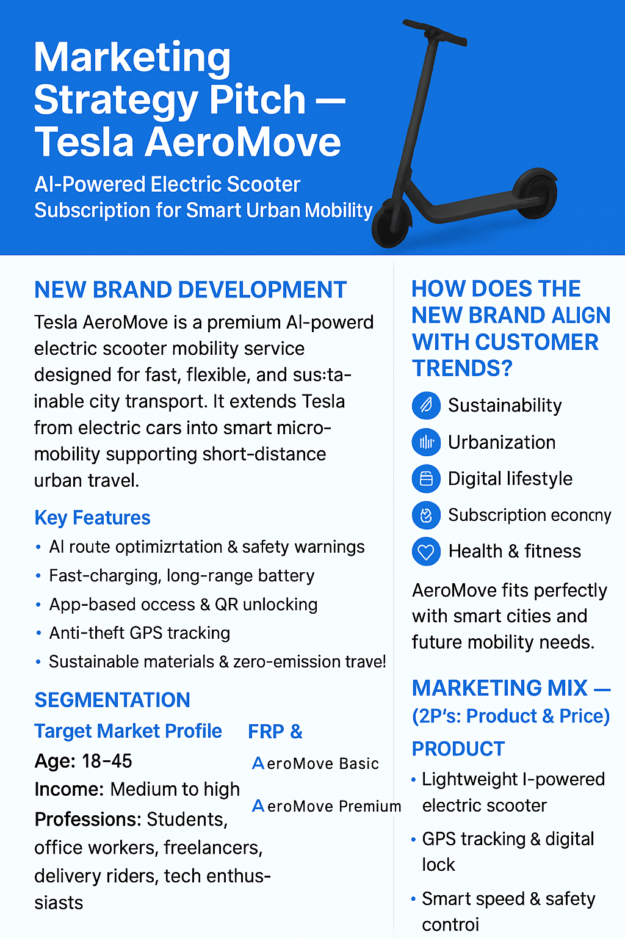

5. Reflection of the Brand
To create the Tesla AeroMove concept, there was a need to understand the concept of marketing strategy, marketing principles of brand extension and the trends of consumer behaviour. The assignment was a personal trial of critical thinking, as to how a company as well-established as Tesla can grow significantly into a new category and still maintain brand integrity. It was the process that I reinforced my skills in applying theory models including STDP and the 7ps to a real-life setting (Bohm et al., 2022).
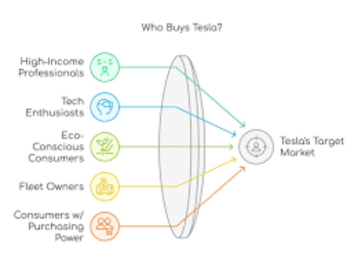
Figure3: Tesla Market Principal
Source: (Cezim, 2024)
The provided STDP analysis helped to understand the depth of segmentation in urban markets, i.e., how the variables of demographic, psychographic, behavioural, and geographic interact. I realised the need to choose a target audience that would be in line with the values and capabilities of the brand. The selection of the single segment, urban performance commuters, showed the potential of consumer needs, convenience, sustainability, and mobility, to integrate with the Tesla digital environment. This further confirmed my belief that in order to target effectively, it is necessary to target beyond just a segment- it is necessary to target a segment that the brand can serve better than any of the others (Nielsen and Shepherd, 2025).
The development of the marketing mix and 7Ps of the service-based brand allowed me to value the difference in service design in comparison to product marketing. Factors like People, Process and Physical Evidence played a primary role in determining the quality of the service, confidence of the users and brand loyalty. Creating every P in line with the brand image of Tesla made me understand how vital consistency is throughout the service experience (Nielsen and Shepherd, 2025).
Composing the pitch and poster allowed me to hone the persuasive communication skills. I was taught to be able to express strategic ideas in a succinct manner without losing clarity and interest. I translate a detailed marketing plan into an effective message, it was necessary to prioritise the essential value propositions and make them appeal to the investors and customers (Ryu, Miller and Godfrey, 2025).
All in all, the project enhanced my critical thinking, creativity and tactical communication skills. In order to further improve my solution, I would also use some consumer surveys or even mini qualitative feedbacks to confirm assumptions on mobility behaviour. Also, the financial modelling venture may be explored to bolster the business case. However, the experience has greatly enhanced my confidence to use marketing frameworks to solve new challenges of brand development (Ryu, Miller and Godfrey, 2025).

6. Reference
anthon, J. (2024). Tesla Target Market Analysis (2025). [online] Business Model Analyst. doi: https://businessmodelanalyst.com/tesla-target-market/?srsltid=AfmBOorag_S9Yn8RZQctQ60_A-Jj83K6PSY6EaFM0AqKTXLjebGvKY2t.
Bohm, S., Phi, H.B., Moriyama, A., Runge, E., Strehle, S., König, J., Cierpka, C. and Dittrich, L. (2022). Highly efficient passive Tesla valves for microfluidic applications. Microsystems & Nanoengineering, [online] 8(1), pp.1–12. doi: https://doi.org/10.1038/s41378-022-00437-4.
Cezim, B. (2024). An In-Depth Look at Tesla’s Marketing Strategy. [online] Digital Agency Network. doi: https://digitalagencynetwork.com/tesla-marketing-strategy/.
Jabr, F. (2023). John A. Long - Publications List. Publicationslist.org, 14(6).
Lapshyna, M.Y. (2024). The role of marketing in the development of international business. Sumdu.edu.ua. [online] doi: https://essuir.sumdu.edu.ua/handle/123456789/96789.
Lei, C. (2025). Analysis of Tesla International Strategies. Studies in big data, pp.237–246. doi: https://doi.org/10.1007/978-3-031-83911-5_21.
Liu, J. (2024). Marketing strategies of gasoline and electric vehicle enterprises: Toyota and Tesla. CRC Press eBooks, pp.654–661. doi: https://doi.org/10.1201/9781003564966-98.
Mathiopoulou, V., Rijks, N., Caan, M.W.A., Liebrand, L.C., Ferreira, F., de Bie, R.M.A., van den Munckhof, P., Schuurman, P.R. and Bot, M. (2023). Utilizing 7-Tesla Subthalamic Nucleus Connectivity in Deep Brain Stimulation for Parkinson Disease. Neuromodulation: Technology at the Neural Interface, [online] 26(2), pp.333–339. doi: https://doi.org/10.1016/j.neurom.2022.01.003.
Nielsen, S. and Shepherd, M. (2025). From Admiration to Ambivalence: Understanding Consumer Responses to Tesla’s Ethical Decline. [online] Lub.lu.se. doi : https://lup.lub.lu.se/student-papers/search/publication/9203716.
Ryu, K., Miller, E.G. and Godfrey, D.M. (2025). Brand Faith: How Spiritual Relationships Develop Between Consumers and Brands. Journal of Consumer Research. doi: https://doi.org/10.1093/jcr/ucaf055.
Solomon, O., Palnitkar, T., Patriat, R., Braun, H., Aman, J., Park, M.C., Vitek, J., Sapiro, G. and Harel, N. (2021). Deep‐learning based fully automatic segmentation of the globus pallidus interna and externa using ultra‐high 7 Tesla MRI. Human Brain Mapping, 42(9), pp.2862–2879. doi: https://doi.org/10.1002/hbm.25409.
Viessmann, O. and Polimeni, J.R. (2021). High-resolution fMRI at 7 Tesla: challenges, promises and recent developments for individual-focused fMRI studies. Current Opinion in Behavioral Sciences, 40, pp.96–104. doi: https://doi.org/10.1016/j.cobeha.2021.01.011.
ware, aw (2021). Marketing mix: definition, 4ps and 7ps, elements and examples. [online] awwaredigital. doi: https://awware.co/blog/marketing-mix/.
Zeng, Y., Yao, X., Yang, S. and Hsu, W. (2025). Strategic Marketing Analysis of NIO: A Case Study on Electric Vehicle Industry in China. SHS Web of Conferences, 215, p.01006. doi: https://doi.org/10.1051/shsconf/202521501006.
Zhen, Y. (2025). A Study of the Marketing Strategy of BYD Electric Vehicles in Chinese Market. [online] doi: https://e-research.siam.edu/wp-content/uploads/2025/08/MBA-2025-IS-Yue-Zhen-6617190054-A-Study-of-the-Marketing.pdf.
Zhou, Z. (2023). Tesla Marketing Analysis. Academic Journal of Business & Management, [online] 5(2), pp.171–177. doi: https://doi.org/10.25236/ajbm.2023.050225.

Appendix


