
Combustion analysis
M6X00417

Thesis
Mr William Peter Wilks
P151304

MAY 5, 2020 UNIVERSITY OF WALES TRINITY SAINT DAVID, SCHOOL OF ENGINEERING

Acknowledgements

I would like to take this opportunity to thank and show my appreciation to the following people. My two major project supervisors Malcolm McDonald and Owen Williams for sharing their wealth of knowledge, wisdom and support. My parents Eric and Elaine Wilks for their love and support, and for starting my obsession with motorcycles. Finally, to Owen Lord and Paul Gormlie for their comradeship throughout the past four years, but more so for the laughs.

‘This thesis is the result of the author’s original research. It has been composed by the author and has not been previously submitted for examination which has led to the award of a degree.’

Signed: WPWilks Date:4/5/2020

Abstract

The main emphasis of this study will be to conduct detailed engine analysis of engine pressure data of two vehicles typically seen on today’s road. One being a small engine capacity car using forced induction and the other a small capacity mid-weight motorcycle. In today’s world, manufacturers have come under much scrutiny due to motor vehicles being one of the main causes of climate change. Both vehicles produce similar peak pressures during combustion, so a comparison is fair. The aim is to be able to accurate calculate the temperatures found during combustion by means of a two-model, with special attention made to the thermodynamic processes. Combustion temperature has become one of the main parts of analysis for a manufacturer since they dictate the formation of emissions, but also defines the performance of the vehicle and how the vehicle is controlled through fuelling and ignition. The combustion model for the motorcycle will then be validated using combustion simulation software and therefore validate both models, since they will both be analysed using the same techniques.
Contents
Acknowledgements 1
Abstract 2
International System of Units 6
The Severn Defining Constants 6
Caesium hyperfine splitting frequency 6
Boltzmann constant 6
Planck constant 6
Avogadro constant 7
Speed of light in vacuum 7
Elementary charge 7
Luminous efficacy of monochromatic radiation of frequency 540 × 10¹² hertz 7
The Severn SI Base Units 8
Length - meter (m) 8
Time - second (s) 8
Amount of substance - mole (mole) 8
Mass - kilogram (kg) 8
Temperature - kelvin (K) 8
Luminous intensity - candela (cd) 9
Electric current - ampere (A) 9
Thermodynamics of Combustion 10
The Laws of Thermodynamics 10
Zeroth Law 10
First Law 10
Enthalpy of formation 11
Internal energy of an ideal gas 12
Specific heats 14
Second Law 16
Third Law 16
Engine data acquisition 17
Two-Zone combustion model 17
Abnormal combustion 18
Production of NOx 19
Data Acquisition 20
Validating Results 26
Results 28
Triumph NOx 28
Ford & Triumph Pressure, Volume & Temperature 29
Conclusion 30
Further Work 30
References 31

Figure 1- Showing the effect of temperature on the ratio of specific heats 15
Figure 2- Thermodynamic processes within the internal combustion engine 16
Figure 3- Energy mass balance of a two-zone model to the left and the division of the burned and unburned zones during combustion to the right 17
Figure 4- Auto ignition of the unburned zone 18
Figure 5- Nitrogen oxides production depending on equivalence ratio, Wilks & Heywood 19
Figure 6- Peak pressure graph taken from the Ford Fox 20
Figure 7- Ford log pressure versus log volume & examples of fitted trendline with the gradient identifying the value of the polytropic index 21
Figure 8- Ford mass fraction burnt 22
Figure 9- How the molecular weight changes with equivalence ratio. To the left worked carried out by Wilks and the middle Heywood. The right-hand diagram showing the unburned and burned specific gas constants. 24
Figure 10- Showing changing gamma values due to combustion 25
Figure 11- Triumph average, unburned and burned temperatures 25
Figure 12- Comparison of the Triumph's gamma value against crank angle 26
Figure 13- Comparison of the Triumphs specific gas constant against crank angle 26
Figure 14- Comparison of the Triumph’s unburned, burned and average cylinder temperatures. 27
Figure 15- Triumph NOx PPM 15.7AFR Figure 16- Triumph NOx PPM Stoichiometric 28
Figure 17- Triumph NOx PPM 12.7AFR Figure 18- Triumph NOx PPM 16.7AFR 28
Figure 19- Comparison of pressure versus volume. Ford on the left and Triumph on the right 29
Figure 20- Temperatures of unburned and burned zone along with average. Ford on the left, Triumph on the right 29

Equation 1- Energy balance for a closed system 10
Equation 2- Work-Done is equal to force multiplied by distance 10
Equation 3- Work-Done is equal to force multiplied by displacement (Piston) 10
Equation 4- Work-Done is equal to pressure multiplied by area (Bore) multiplied by displacement (Piston) 10
Equation 5- Work-Done is equal to pressure multiplied by the change in volume 10
Equation 6- Redefined energy balance for a closed system 10
Equation 7- Change in enthalpy energy balance 11
Equation 8- Enthalpy of formation 11
Equation 9- Stoichiometric combustion of gasoline 11
Equation 10- Lower heating value 11
Equation 11- Calorific value of gasoline 11
Equation 12- Change in momentum per impact. m=mass, v=velocity 12
Equation 13- Fist harmonic. v= speed of the wave, l= length of the wave 12
Equation 14- Change in momentum per second, per impact on the right-hand wall 12
Equation 15- Change in momentum per second 12
Equation 16- Force equals momentum per second 12
Equation 17- Pressure equals force by area 13
Equation 18- First part of the ideal gas law 13
Equation 19- Ideal gas with R being the universal gas constant 13
Equation 20- Change in internal energy 14
Equation 21- Specific heat at a constant volume 14
Equation 22 - Differential of the ideal gas law 14
Equation 23- Specific heat at constant pressure 14
Equation 24 - Molar specific heat 15
Equation 25- Ratio of specific heats 15
Equation 26- Specific heat of the unburned zone 15
Equation 27- Nitrogen oxides produced per cycle 19
Equation 28- Nitrogen oxides parts per million 19
Equation 29- Pressure at the end of a degree if combustion had stopped at P1 20
Equation 30 - Adiabatic compression & expansion 21
Equation 31- Polytropic index 21
Equation 32- Change in pressure due to combustion 22
Equation 33- Mass fraction burnt 22
Equation 34- Mass of air in cylinder 23
Equation 35- Mass of fuel in cylinder 23
Equation 36- Total mass in cylinder 23
Equation 37- Specific gas constant 24
Equation 38- Lean combustion chemical balance 24
Equation 39- Stoichiometric combustion chemical balance 24
Equation 40- Rich combustion chemical balance 24
Equation 41- Unburned molecular weight 24
Equation 42- Burned molecular mass 24
Equation 43- Average gas constant 24
Equation 44 - Increase in temperature of the unburned zone 25
Equation 45- Volume of the unburned zone 25
Equation 46 - Volume of the burned zone 25
Equation 47- Temperature of the burned zone 25

International System of Units

Before one can implement equations in their calculations or derive other formulae an understanding in the fundamentals within these equations should be known. The international system (SI) allows one to make calculations without any conversion due to the way in which they are derived and related to one another. The story of SI started in 1799 when France adopted the metric system, then in 1875 the treaty of the meter was signed by 17 nations, 1889 the international prototype of the Kilogram is built, 1960 the international system of units is established, 1967 the second is redefined in terms of the caesium atom, 1983 the meter is refined in terms of light, as of the November 2018 experts in the field of measurement voted for the revision of the SI, to a establish a system that is based entirely on physical constants of nature. The vote was unanimous and came into effect on the 20th of May 2019 (National Institute of Standards and Technology, 2019).

The Seven Defining Constants

Caesium hyperfine splitting frequency

Caesium is metal atom with caesium-133 being it most common isotope. Hyperfine splitting frequency describes the frequency of microwave radiation that is needed to cause caesium-133 outer most electron to jump between two closely spaced low energy or hyperfine states, without any external influence such as the earth’s magnetic field. The frequency Δν_{Cs} is precisely, 9192631770 Hz.

Boltzmann constant

Though this constant carries Ludwig Boltzmann name due to his work on entropy, Boltzmann himself never used the constant. It was in fact Max Planck in work at the start of the 20th century. The Boltzmann constant relates the average kinetic energy of any molecule with its temperature. The most accurate measurement of this constant was obtained using acoustic gas thermometry in 2017. The experimented compiled of a triaxial ellipsoid chamber, using microwave and acoustic resonance to determine the speed of sound of a monatomic gas within said chamber. With an agreed value of $k_{B}$ 1.380 649 × 10⁻²³ $J/K$

Planck constant

In quantum mechanics, the quanta of an electromagnetic action inform us of the energy that is exchanged and absorbed in specific amounts. The size of those quanta is defined by the Planck’s constant. It can also be described as the relation of a photon’s energy to its frequency. Planck’s constant multiplied by a photon’s frequency gives us its energy. Planck constant h is equal to exactly 6.626 070 15 × 10⁻³⁴ Joule seconds.

Avogadro constant

Avogadro constant denoted N_{A} is used to describe the number of elementary entities within a mole of a substance. Since atoms are incomparably small, he calculated how many hydrogen atoms one must accumulate to have a gram of them. This number was calculated to be 6.02214076×10²³ . This quantity of atoms is equal to one mol and the mol is used to describe the atomic mass of all the elements within the periodic table, which describes the mass of one mol of that element with hydrogen weighing 1.00784 ${Kg}/{Kmol}$.

Speed of light in vacuum

The speed of light denoted c is thought to be the fastest any conversional matter can travel due to special relativity. To accurately measure the speed of light it would take the use of laser interferometer and the reclassification of the second to concur with Caesium hyperfine splitting frequency and therefore the metre was defined as the length in which a light travels in a vacuum intervals of 1/299792458 of a second. Meaning light within a vacuum will travel at 299792458 $m/s$.

Elementary charge

Elementary charge denoted e is connected to electromagnetism. Electromagnetism is one of the four forces of nature, the others being gravitational force, strong nuclear force and weak nuclear force. It is used to describe the charge transported by a current of one ampere in one second. This acquaints to 1.602176634 × 10⁻¹⁹ coulombs.

Luminous efficacy of monochromatic radiation of frequency 540 × 10¹² hertz

Luminous efficacy of monochromatic radiation of frequency 540 × 10¹² hertz denoted K_{cd ,} gives the relationship between the amount of visible light produced at a certain power and the green light it produces that be picked up by the human eye in a well lit room at a frequency of 540 × 10¹² hertz . This is equal to 683 lumens per watt.

The Seven SI Base Units

By use of the previously stated seven defining constants, the following seven base SI units can be derived. These are the internationally verified definitions as listed on the NIST website (National Institute of Standards and Technology, 2019) . No alterations have been made due to these been official definition and in place as a cross-reference when deriving formulae and their units.

Length - meter (m)

‘’The meter (m) is defined by taking the fixed numerical value of the speed of light in vacuum c to be 299,792,458 when expressed in the unit m s⁻¹, where the second is defined in terms of ∆ν_{Cs}.’’

Time - second (s)

‘’The second (s) is defined by taking the fixed numerical value of the caesium frequency ∆ν_{Cs}, the unperturbed ground-state hyperfine transition frequency of the cesium-133 atom, to be 9,192,631,770 when expressed in the unit Hz, which is equal to s⁻¹.’’

Amount of substance - mole (mole)

‘’One mole (mol) contains exactly 6.02214076 × 10²³ elementary entities. This number is the fixed numerical value of the Avogadro constant, N_{A}, when expressed in the unit mol⁻¹ and is called the Avogadro number. The amount of substance, symbol n, of a system is a measure of the number of specified elementary entities. An elementary entity may be an atom, a molecule, an ion, an electron, any other particle or specified group of particles.’’

Mass - kilogram (kg)

‘’The kilogram (kg) is defined by taking the fixed numerical value of the Planck constant h to be 6.62607015 ×10⁻³⁴ when expressed in the unit J s, which is equal to kg m² s⁻¹, where the meter and the second are defined in terms of c and ∆ν_{Cs}.’’

Temperature - kelvin (K)

‘’The kelvin (K) is defined by taking the fixed numerical value of the Boltzmann constant k to be 1.380 649 ×10⁻²³ when expressed in the unit J K⁻¹, which is equal to kg m² s⁻² K⁻¹, where the kilogram, meter and second are defined in terms of h, c and ∆ν_{Cs}. The temperature 0 K is commonly referred to as "absolute zero."’’

Luminous intensity - candela (cd)

‘’The candela (cd) is defined by taking the fixed numerical value of the luminous efficacy of monochromatic radiation of frequency 540 × 10¹² Hz, K_{cd}, to be 683 when expressed in the unit lm W⁻¹, which is equal to cd sr W⁻¹, or cd sr kg⁻¹ m⁻² s³, where the kilogram, metre and second are defined in terms of h, c and ∆ν_{Cs}.
Radiation at frequencies other than 540 x 10¹² Hz is also measured in candelas in accordance with the standard luminous efficiency, V (λ), curve that peaks at 540 x 10¹² Hz (yellow green).’’

Electric current - ampere (A)

‘’The ampere is defined by taking the fixed numerical value of the elementary charge e to be 1.602176634 × 10⁻¹⁹ when expressed in the unit C, which is equal to A s, where the second is defined in terms of ∆ν_{Cs}.’’

Thermodynamics of Combustion

Thermodynamics is a branch of physics that is used to describe the relationship of heat and temperature in addition to other forms of energy, for instance mechanical and chemical energy (Gao, 2016).

The Laws of Thermodynamics

Zeroth Law
The zeroth law states that for two systems to be in thermal equilibrium with a third system, then the two systems themselves must also be in thermal equilibrium. Therefore, if the said two systems shall not exhibit any heat flow when in contact with each other.

First Law
The first law of thermodynamics also known as the conservations of energy or energy balance, states that energy can not be created or destroyed, therefore energy can only be transformed into other forms of energy. This statement can therefore be used to describe the change of internal energy ( $∆U$ ) is equal to the heat energy ($Q)$ transferred to or from the system, minus the work-done $\left(W\right)$ on or by the system.
$$∆U=Q-W J$$
Equation 1- Energy balance for a closed system
For use when describing the internal combustion engine, the above equation can be redefined in the following ways:
As a result of the chemical energy released from combustion. This increases the heat energy within the system, and therefore the kinetic energy of the molecules. Moreover, the kinetic energy of gas molecules is directly proportional the absolute temperature. Pressure increases within the cylinder while obeying the ideal gas law. This increase in pressure exerts a force on the piston. From this understanding the following can be derived:
$$W=F∙d J$$
Equation 2- Work-Done is equal to force multiplied by distance
$$∴W=F∙ ∆x$$
Equation 3- Work-Done is equal to force multiplied by displacement (Piston)
$$∴W=P ∙A ∙ ∆x$$
Equation 4- Work-Done is equal to pressure multiplied by area (Bore) multiplied by displacement (Piston)
$$∴W=P ∙ ∆V$$
Equation 5- Work-Done is equal to pressure multiplied by the change in volume
$$∴ ∆Q= ∆U ∙P∆V J$$
Equation 6- Redefined energy balance for a closed system

Enthalpy of formation

As stated previously, combustion release chemical energy. Hess’s law can be used to describe how much energy is released or gained from this process. Germain Hess stated that the enthalpy of a reaction will be the same no matter how many steps are taken. Consequently, the change in enthalpy is equal to the change in heat energy when pressure is constant.
$$∆H=∆U+P∆V=∆Q$$
Equation 7- Change in enthalpy energy balance
$∆H_{f }^{°}$ Standard enthalpy of formation. The enthalpy associated with 1mol of a compound from its respective elements in the standard and most stable states or allotrope. Measured at sea level (1 atmosphere) and room temperature (298k). Pure elements in their standard states have an enthalpy of formation of zero ($∆h_{f }^{°}{(O}_{2})$= 0${KJ}/{mol}$.
$$∆H_{reaction}^{°}= Σ_{np}∆H_{f products}^{°}-Σ_{nr}∆H_{f reactents}^{°}$$
Equation 8- Enthalpy of formation
By means of balancing the equation for stoichiometric combustion of $C_{8}H_{18}$ (gasoline) in the industry standard for air which only account for oxygen and nitrogen content we get:
$C_{8}H_{18}$ + 12.5($O_{2}$+ $\frac{79}{21}$ $N_{2}$) $→$ 8C$O_{2}$ + 9$H_{2}$O + 47.02 $N_{2}$
Equation 9- Stoichiometric combustion of gasoline
From the above balanced chemical reaction and Hess’s enthalpy of formation equation it is possible to calculate the energy released from this reaction. Many experiments have been undertaken by various labourites on the enthalpies associated with different compounds are readerly available. This was shown to be 5065 MJ when burning 1 Kmol of fuel at constant pressure and the$H_{2}$O product is a gas.
Table 1- Showing calculated enthalpy, molecular weights, unburned & burned masses and stoichiometric balance
It is then also possible to calculate the energy released per unit of fuel, by dividing the enthalpy of formation by the unburned mass of the fuel. This is known as the lower heating value (LHV) when the $H_{2}$O product is a gas and the HHV when $H_{2}$O product is a liquid.
LHV = $\frac{5065}{114.232}$ = 44.34 ${MJ}/{Kg}$
Equation 10- Lower heating value
$∴$ Calorific value = 44.34 x${10}^{6}$ $J/{Kg∙K}$
Equation 11- Calorific value of gasoline

Internal energy of an ideal gas

Internal energy is the sum of the kinetic and potential energy of the molecules with said system. To better understand this, it is appropriate to look at the most basic system in the form of an ideal gas. An ideal gas is a theoretical gas, where the molecules in said gas occupy negligible space and do not interact an have no protentional energy. This said the internal energy of a system is the sum of the transitional, rotational and vibrational kinetic energy of the molecules. As stated in kinetic molecular theory the average kinetic energy of a gas is proportion to its temperature, therefore the internal energy of an ideal gas is also. The law of equipartition of energy states the energy in a system is shared equally by all the degree of freedom, with the average kinetic energy of any molecule in a gas being $\frac{1}{2} K_{B}T$. From this it is possible to derive the ideal gas equation (Williams, 2019).
With the assumption made that the gas is contained within a hard-walled container, so that there is no energy loss and on impacting the wall the molecules bounce back at the same rate and before impact the momentum to the right equals positive $mv_{x}$ and to the left negative $mv_{x}$.
$mv_{x}-(-mv_{x}$ $)=2mv_{x}$
Equation 12- Change in momentum per impact. m=mass, v=velocity
With the equation for a stationary wave used to describe the number of impacts a molecule has with the right wall per second:
$$\frac{v_{x}}{{2l}_{x}}= 1^{st}Harmonic$$
Equation 13- Fist harmonic. v= speed of the wave, l= length of the wave
Combining the two equations gives us:
$$2mv_{x} ∙ \frac{v_{x}}{{2l}_{x}}=\frac{mv_{x}^{2}}{l_{x}}$$
Equation 14- Change in momentum per second, per impact on the right-hand wall

If the number of molecules in the container is $η$:
$$∴ η∙ \frac{mv_{x}^{2}}{l_{x}}$$
Equation 15- Change in momentum per second

Since Newton’s second law is equal to momentum per second:
$η∙ \frac{mv_{x}^{2}}{l_{x}}=m ∙ \frac{∆v}{∆t}=F$orce N
Equation 16- Force equals momentum per second

Now introducing pressure:
$P= \frac{F}{A}$ = $\frac{F}{l_{y} ∙ l_{z}}$
Equation 17- Pressure equals force by area
Substituting force for momentum per second:
$$P= \frac{η∙mv_{x}^{2}}{{l_{x} ∙ l}_{y} ∙ l_{z}}=\frac{η∙mv_{x}^{2}}{v}$$
$$∴PV= η∙mv_{x}^{2}$$
Equation 18- First part of the ideal gas law
As stated above the average kinetic energy of any molecule in a gas being $\frac{1}{2} K_{B}T$. Boltzmann stated that all molecules have the same kinetic energy therefore:
$$\frac{1}{2} mv_{x}^{2}=\frac{1}{2} K_{B}T$$
$$∴mv_{x}^{2}= K_{B}T$$
$$∴PV= η∙{ K}_{B}T$$
By revisiting what Avogadro stated there are ${6.02214}^{26}$ molecules in a Kmol therefore:
$n ∙ {6.02214}^{26}= η Kmols$
$∴$PV = $n ∙ {6.02214}^{26}∙ { K}_{B}T$
$∴$PV = $n ∙ {6.02214∙10}^{26}∙ {1.3806∙10}^{-23}T$
$∴$PV = $n ∙8314.608276 ∙T$
$∴$PV = $n ∙ R_{u}∙T$
$∴$PV = $n ∙ RT$
Equation 19- Ideal gas with R being the universal gas constant
Finally showing how the ideal gas equation is derived. With special attention to the universal gas constant and how it is governed by two of the seven natural constants. Moreover, all gases obey this law.

Specific heats

In thermodynamics specific heat is used to describe the heat energy that is required to increase 1Kmol of a substance by 1K. There are two variations on this, the heat required at constant volume (C_{v} ) and the heat required at constant pressure (C_{p} ) .
Using the first law of thermodynamics if you put heat into a gas the change in internal energy is equal to:
$∆U=m ∙ C_{v} ∙ ∆T$ J
Equation 20- Change in internal energy
By using equation 7 for a constant volume and therefore the change in volume is to zero.
$$∴ ∆Q=∆U$$
$$∴ ∆Q=m ∙ C_{v} ∙ ∆T J$$
So, the specific heat required to increase 1Kmol of a substance by 1K at a constant volume is governed by the change of enthalpy in the system.
$$∆H=∆U+P∆V=∆Q= C_{v}$$
Equation 21- Specific heat at a constant volume

By the differentiating the ideal gas law (equation 19) .
$$∆PV+ P∆V=m ∙R ∙ ∆T$$
Equation 22 - Differential of the ideal gas law

Since at a constant pressure the change in pressure is equal to zero.
$$∴ P∆V= m ∙R ∙ ∆T$$

By applying this to equation 7 the change in heat is equal to.
$$∆Q= m ∙ C_{v} ∙ ∆T+ m ∙R ∙ ∆T$$
$$∴ ∆Q=m \left(C_{v}+R\right)∙ ∆T$$

So, the specific heat required to increase 1Kmol of a substance by 1K at a constant pressure is.
$$C_{p}= C_{V}+R$$
Equation 23- Specific heat at constant pressure
Or in terms of the molar specific heat.
$\tilde{C_{p}}=\tilde{C_{v}}+\tilde{R } J/{K_{g} K}$
Equation 24 - Molar specific heat

Ratio of specific heats

The ratio of specific heats $(γ)$ is the ratio between specific heat at constant volume to the specific heat at constant pressure and is used an exponent when calculating the change in temperature of an adiabatic process, more over the change in temperature of the unburned zone within a two zone combustion model . This ratio is also useful when compared to the polytropic index as it allows one to see if the system is behaving adiabatically or if there is some heat loss or gained, especially when analysing compression and expansion process.
$$γ=1+ \frac{\tilde{R}}{\tilde{C_{v}}} = \frac{\tilde{C_{p}}}{\left(\tilde{C_{p}}-\tilde{R}\right)}$$
Equation 25- Ratio of specific heats
There has been much research and experiments done over the years on the specific heat capacity at constant pressure . So, literature is readily available on how this value changes regarding temperature with different elements. Since we are considering combustion, work carried out by Heywood was referred to as he uses a polynomial equation to describe the specific heat capacity of gasoline. He also uses a polynomial equation to describe this for the oxygen and nitrogen components of stoichiometric combustion. By plotting Heywood’s equation alongside the experiment data any discrepancy could be identified, this was not found to be the case. The following equation could then be implemented to calculate the specific heat capacity of the unburned zone and then gamma.
$\tilde{C_{p}} Unburned= \frac{\tilde{C_{pC_{8}H_{18}} }+ 12.5 (( \tilde{C_{p O_{2}}} +3.76 \left(\tilde{C_{p N_{2}}}\right))}{(\left( 1+\left(12.5 x 4.76\right)\right)} J/{K_{g} K}$
Equation 26- Specific heat of the unburned zone
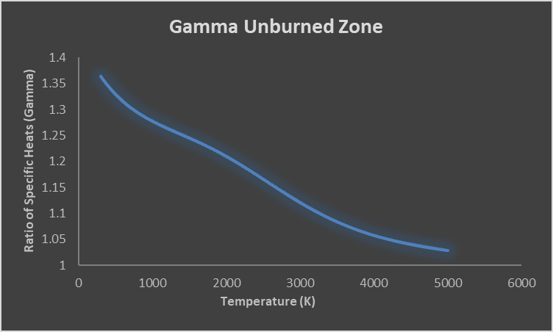
Figure 1- Showing the effect of temperature on the ratio of specific heats

Second Law

The second law state that the entropy of a system can never decreases over time and shall only remain constant if a thermodynamic process is reversable, as in an adiabatic process. This means all matter will tend towards a less ordered state. It is for this reason one day all the stars will stop fusing hydrogen atoms together and the sky will be black. Some people may argue that turning water into ice is reversing this process, it is true the molecules are in a more ordered state but due to the burning of fossil fuels and therefore entropy is increased. Entropy in thermodynamic is like the genie in the bottle once he’s out there no way of getting him back in.

Third Law

The third law states that the entropy of a system will become constant when it reaches zero degrees kelvin. In simple terms atoms will stop vibrating as they reach absolute zero.

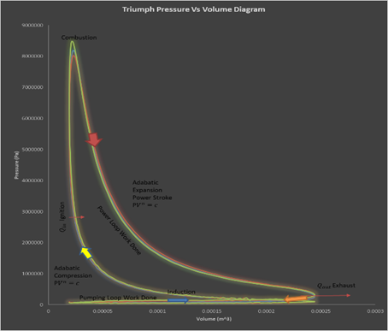
Figure 2- Thermodynamic processes within the internal combustion engine

Engine data acquisition

The purpose of this section it to identify the appropriate techniques one should implement when processing cylinder pressure data. For the purpose of comparison and validation two pressure data sets were acquisitioned. To highlight the effects different engine configurations have on the thermodynamic process within an engine, it was thought to be appropriate to choose data from the automotive and motorcycle industry. These typically reflect the way these industries have headed in the last few year with a small capacity turbocharged car the Ford Fox and a mid-weight sports motorcycle the Triumph 675R.
The aim being to process the data and use a two-zone combustion model to find the temperatures of the burned and unburned zones during combustion. Being able to calculate these temperature is one of the most important things to industry, since the temperatures of these zones allow the manufacturer to know the rate chemical reactions occur when considering the amount of harmful emissions produced from the combustion process, and if detonation can happen within the unburned zone.

Two-Zone combustion model
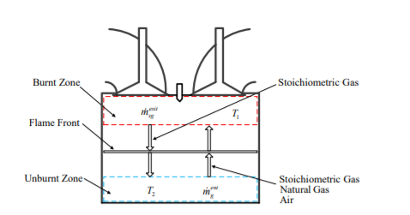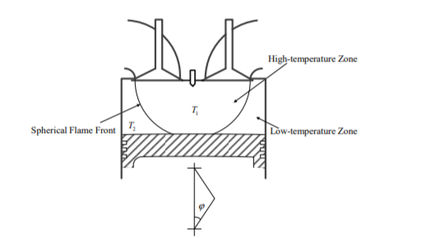
Figure 3- Energy mass balance of a two-zone model to the left and the division of the burned and unburned zones during combustion to the right
For the purpose of this analysis the combustion chamber was dived into two separate systems with the flame front being the point of division. Both systems are considered closed from the point of the inlet valve closing to the exhaust valve opening. Zone one being the unburned charge mixture and zone two the burned mixture. Though the flame front can be considered a separate system for all intents and purposes this is considered negligible. The pressure is considered uniform throughout the combustion chamber. The temperatures are divided into two separate zones (unburned and burned) with no heat transfer between them. The cylinder volume is equal to the combination of both zones. Finally both zones are considered to behave as an ideal gas though they have separate properties (La Xiang, 2018) (Gunter P. Merker, 2006) (Mcdonald, 2020).

Abnormal combustion

When talking about spark ignition engines, during the end of the compression stroke or in some cases after, reasons for this are as follows, heat is added to the system in the form of spark. During normal combustion the spark (15000 - 30000 volts) stimulates the homogeneous mixture for around 0.3-1_{m}s before the start of combustion, this period is known as ignition delay. The flame front then propagates from the spark plug throughout the combustion chamber at around m/s, until ideally all the fuel mixture is burned (Taylor, 1985) (Gunter P. Merker, 2006).
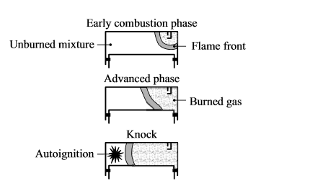
Figure 4- Auto ignition of the unburned zone
The term abnormal combustion or knock is used to describe the combustion of the unburned zone before the flame front has reached it. In accordance with Merker and Heywood there are two main reasons for this, auto ignition and surface ignition. Auto ignition is caused by the compression of the unburned zone by the pressure wave of the flame front, see above figure. While surface ignition is caused by hot spots on the cylinder wall, cause by “hot flakes’’ around 1200K left over from the previous combustion, this problem is seen a lot with older 2-stroke machines, where hot carbon deposits cause the engine to runaway (rapidly increased revolutions per minute) (Gunter P. Merker, 2006) (Heywood, 2018) (Taylor, 1985).
The main advantage of using gasoline when considering this problem is that gasoline is highly resistant to ignition. Meaning auto ignition will only happen between 1000K-1200K which is higher than temperatures due to compression. This said, in certain engine configuration and circumstances it is possible to reach these temperatures. Forced induction being one of these reasons. Since forced inductions increase the amount of charged mixture for a given volume compared to the same engine geometry but naturally aspiring, you increase the peak pressure respectively. As said previously this can cause autoignition if the burned zone compresses the unburned zone too much. Companies get around this by retarding the ignition, so the start of combustion happens after top dead centre, meaning the charge mixture is burnt in a larger volume. Another factor that can cause auto ignition is if the exhaust gases recycled by the use of EGR (exhaust gas recirculation) are not complete mixed with the charge mixture, leading to areas of residual hot gases. One finally point that could cause this is inlet preheating. If the charge mixture entering the engine is around 420K meaning once it has mixed with the residual gases a temperature around 560K at bottom dead centre could cause pre ignition (Gunter P. Merker, 2006) (Taylor, 1985) (Heywood, 2018).

Production of NOx

From previous work carried out by the author, the temperature within the combustion chamber was the dictating factor when considering the production / formation of $NO_{X}$. The term $NO_{X}$ is the collective term for nitric oxide and nitrogen dioxide. In accordance with Heywood, Merker and Williams the formation of $NO_{X}$ is due to the high temperatures during combustion causing the oxygen and nitrogen to dissociate into less stable radicles ($O_{2}→O+O$) ($N_{2}→N+N$) typically between 2100-2500K. The spark during ignition adds energy in the form of heat to the system, increasing the kinetic energy of the particles, once enough energy has been added to allow the particles to collide, known as activation energy a reaction can commence in the form of combustion. The flame then spreads leaving in its wake the burned gas zone where pressure increases, temperature and the dissociation rate. It is in this zone where $NO_{X}$ are formed, known as thermal $NO_{X}$ according to the Zeldovich mechanism. The Zeldovich mechanism is an equation used to describe the production of $NO_{X}$during lean burn conditions. It relies on the relationship of kinetic collision rate, activation energy and the concentration of nitrogen and oxygen. $NO_{X}$ can also be formed within the flame front known as prompt $NO_{X}$ and from nitrogen found within the fuel itself know as fuel $NO_{X}$ (Williams, 2019) (Heywood, 2018) (La Xiang, 2018) (Wilks, 2020) (Gunter P. Merker, 2006).
$$\sum_{xsoc}^{xeoc}{\left(\frac{4.17×{10}^{13}\left[N_{2}\right][O_{2}]^{1/2}EXP(\frac{-67837}{T})}{RPM ×6}∙ V_{combustion chamber}\right)}$$
Equation 27- Nitrogen oxides produced per cycle
$$PPM=\frac{{NO}_{x}\frac{Kmols}{cycle}}{α\left(n_{1}+n_{2}+n_{3}+n_{4}\right)} ∙ {10}^{6}$$
Equation 28- Nitrogen oxides parts per million

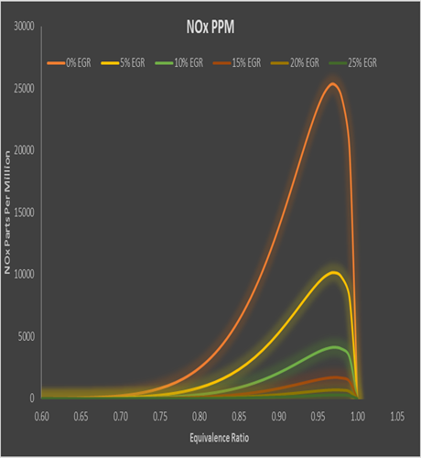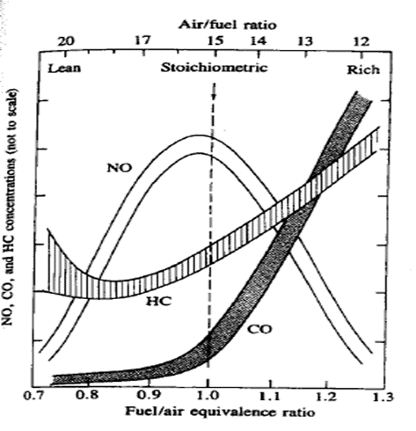
Figure 5- Nitrogen oxides production depending on equivalence ratio, Wilks & Heywood

Data Acquisition

When presented with cylinder pressure data the first task one should undertake is finding the start (SOC) and end (EOC) of combustion. The first logical step is look at the ignition timing, if we know this, and we are looking at data with no pre ignition, the SOC will happen a few degrees after since we will always encounter some ignition delay. The next stage is to plot a pressure crank angle diagram as below:
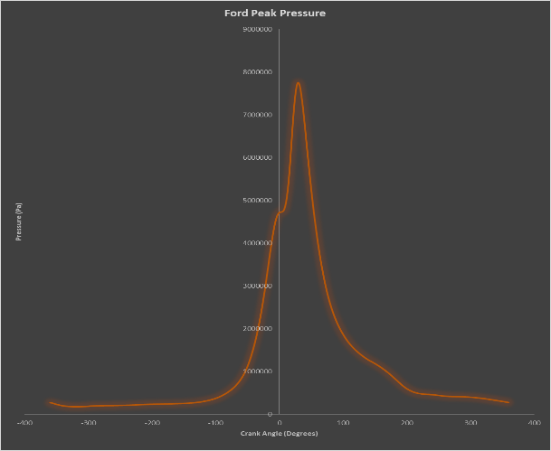
Figure 6- Peak pressure graph taken from the Ford Fox

As it can be seen aft TDC there is a decrease in the gradient just before the pressure rapidly peaks with a steeper gradient, this is due to combustion. When comparing this point with the ignition timing we know this is what we are seeing, but it doesn’t identify exactly where the start is nor the end. To do this we need another method. By calculating the pressure with no combustion, we are then able to subtract this from the real pressure henceforth highlight the pressure increase due to combustion.

$$P_{2n}= P_{1} (\frac{V_{1}}{V_{2}})^{n} Pa$$
Equation 29- Pressure at the end of a degree if combustion had stopped at P1

P1 being the actual pressure, V1 and V2 the volumes and n being the polytropic index. The polytropic index is used to describe the compression and expansion process with heat transfer. Therefore, the polytropic index has different values for this respectively. It also comes in useful when one is wanting to understand what kind of thermodynamic process is happening. This is done by comparing it to the value for gamma. When gamma is smaller than the polytropic index the heat and work are in the same direction, with some heat loss, when gamma is larger, heat and work flow are in the opposite direction with some heat loss, like the cooling of vapour when compressed and when gamma equals the polytropic index there is no heat transfer hence an adiabatic process. If the value for the polytropic index equals one it is said to be isothermal (constant temperature), if it equals zero the isobaric (constant pressure) and a value of less than zero indicating that heat flows in or out of the system simultaneously.
There are two methods of identifying the value of the polytropic index. One by means of plotting log pressure versus log volume diagrams, where the two slopes identify the compression and expansion process. Trendlines can then be used to find the average polytropic index for these processes. The other by means of taking the logarithm of the equation for an adiabatic process both can be seen below.
$$PV^{n}=c$$
Equation 30 - Adiabatic compression & expansion
$$∴ P_{1}V_{1}=C$$
$$∴ P_{2}V_{2}=C$$
$$∴ P_{1}V_{1}= P_{2}V_{2}$$
$$∴ln P_{1}V_{1}= lnP_{2}V_{2}$$
$$∴ln P_{1}{+ nlnV}_{1}= lnP_{2}+nlnV_{2}$$
$$∴n = \frac{lnP_{2}{- lnP}_{1}}{lnV_{1}{- lnV}_{2}}$$
Equation 31- Polytropic index

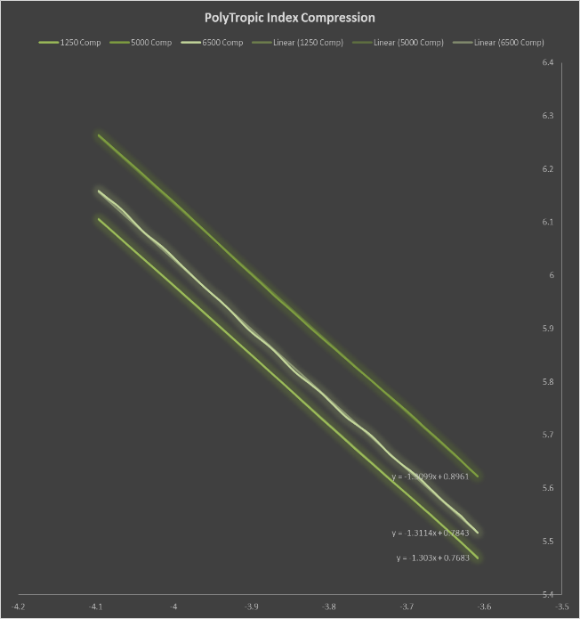
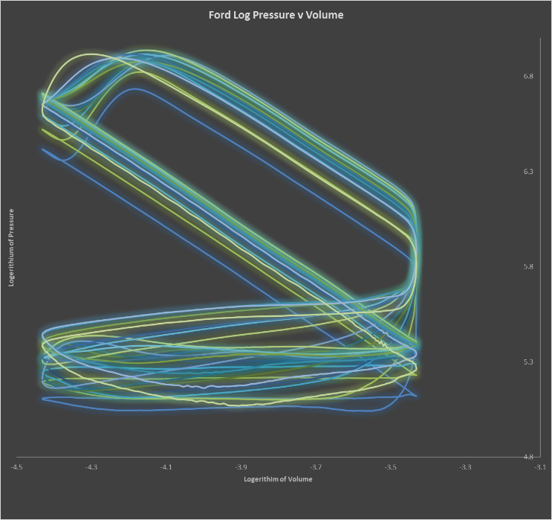

Figure 7- Ford log pressure versus log volume & examples of fitted trendline with the gradient identifying the value of the polytropic index

The change in pressure can then be calculated per degree of crank angle.

$∆P= P_{2}- P_{1 }(\frac{V_{1}}{V_{2}})^{n} Pa$
Equation 32- Change in pressure due to combustion

It helps to covert the change in pressure into bar at this stage for ease of identification of the SOC and EOC. The SOC can be seen after the ignition point where the value of delta P becomes positive, it then increases during combustion before tending back to zero EOC. Then ignition delay can also be known, this increasing with rpm.
The next step is to calculate the mass fraction burnt (MFB) per degree. MFB is used to describe the chemical energy released due to combustion on a scale of 0 to 1, or it can be said the percentage of fuel burned per degree of crank rotation.

$$MFB= \frac{\sum_{SOC →θ}{∆P}}{\sum_{SOC →EOC}{∆P}}$$
Equation 33- Mass fraction burnt

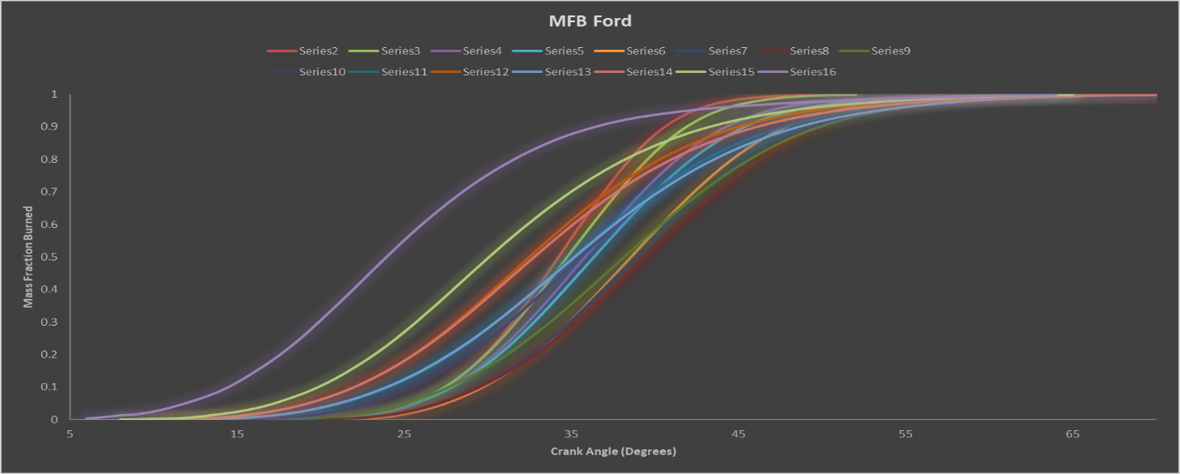
Figure 8- Ford mass fraction burnt

The average cylinder temperature between inlet valve closing and exhaust valve opening must be calculated, by means of the ideal gas law. Before this can be done the total mass in the cylinder must be known and the specific gas constants of the unburned and burned zones.
To find the mass within the cylinder two methods were used. The fox data listed fuel mass per hour, air to fuel ratio and lambda so the use of formula was used since any loss due to valve overlap could be accounted for. Whereas the Triumph data only had air to fuel ratio data, so the decision was made to use Ricardo Wave to find the mass.

${{Mass}_{Air}}/{Cylinder}= \frac{{{Mass}_{Fuel}}/{Hour}}{60 ∙RPM ∙\left(0.5 ∙Number of cylinders\right)} ∙AFR K_{g}$
Equation 34- Mass of air in cylinder
$$∴ {{Mass}_{Fuel}}/{Cylinder}= {Avg}_{AFR} ∙ {{Mass}_{Air}}/{Cylinder} K_{g}$$
Equation 35- Mass of fuel in cylinder
$$∴ {{Mass}_{Total}}/{Cylinder}={{Mass}_{Fuel}}/{Cylinder}+ {{Mass}_{Air}}/{Cylinder} K_{g}$$
Equation 36- Total mass in cylinder

Table 2- Total mass in cylinder per rpm with varying air to fuel ratios

The specific gas constant is defined by the universal gas constant relationship to its mass. It also relates to the two specific heats know as Mayer’s relation.
$$\tilde{R}= \frac{R}{molecular weight} J/{K_{g} K}$$
Equation 37- Specific gas constant
To find the varying molecular weights of the unburned and burned zone, three different chemical balances were used for rich, lean and stoichiometric conditions. With varying concentrations of the molecules calculated depending on equivalence ratio.
0.9$C_{8}H_{18}$ + 12.5($O_{2}$+ $\frac{79}{21}$ $N_{2}$) $→$ 7.2C$O_{2}$ + 8.1$H_{2}$O +${1.25 O}_{2}$ 47.02 $N_{2}$
Equation 38- Lean combustion chemical balance
$C_{8}H_{18}$ + 12.5($O_{2}$+ $\frac{79}{21}$ $N_{2}$) $→$ 8C$O_{2}$ + 9$H_{2}$O + 47.02 $N_{2}$
Equation 39- Stoichiometric combustion chemical balance
1.1$C_{8}H_{18}$ + 12.5($O_{2}$+ $\frac{79}{21}$ $N_{2}$) $→$ 6.3C$O_{2}$ + 9.9$H_{2}$O + 2.5CO + 47.02 $N_{2}$
Equation 40- Rich combustion chemical balance
$${Unburned}_{molecular weight}= \frac{Unburned Molecular Mass}{(( 1+12.5 \left(1+ \frac{79}{21} \right))} {K_{g}}/{K_{mol}}$$
Equation 41- Unburned molecular weight
$${Burned}_{molecular weight}= \frac{Burned Molecular Mass}{Concentraions of each molecule} {K_{g}}/{K_{mol}}$$
Equation 42- Burned molecular mass
${\tilde{R}}_{avg}=MFB ∙ {\tilde{R}}_{B}+\left(1-MFB\right){\check{R}}_{UN} J/{K_{g} K}$
Equation 43- Average gas constant

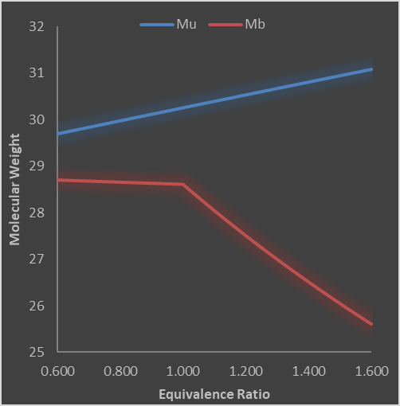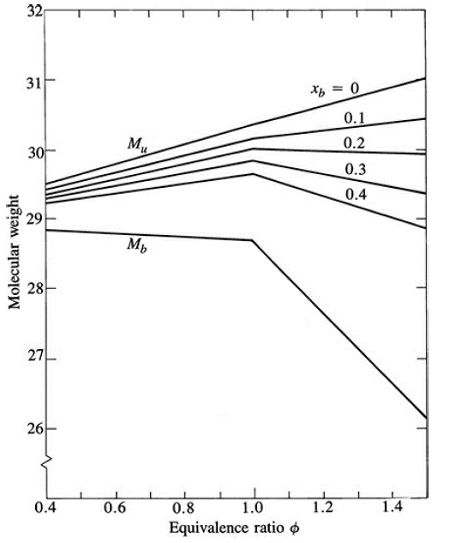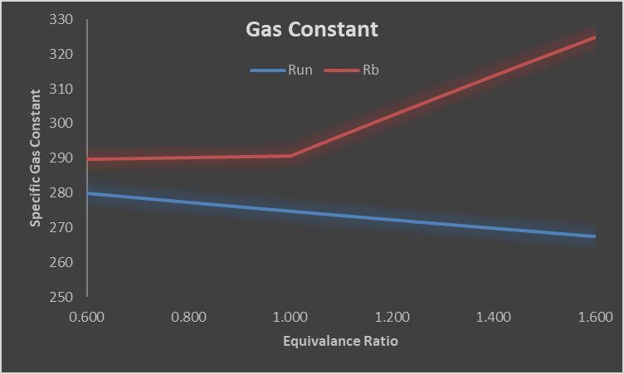
Figure 9- How the molecular weight changes with equivalence ratio. To the left worked carried out by Wilks and the middle Heywood. The right-hand diagram showing the unburned and burned specific gas constants.

It is then possible to calculate the average cylinder temperature per degree. By rearranging the ideal gas law and solving for temperature. With $\tilde{R_{Un}}$ used up to the SOC, $\tilde{R_{Avg}}$ SOC to EOC and $\tilde{R_{B}}$ . By use of gathering a polynomial equation from the graph of gamma values it is possible to find out the average value for gamma per degree.
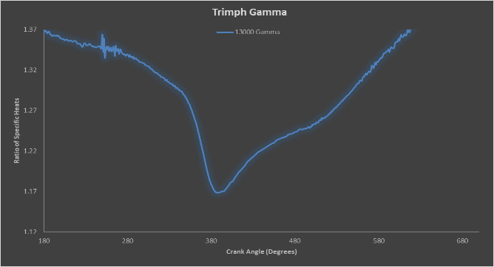
Figure 10- Showing changing gamma values due to combustion
Finally, the temperatures and volumes of the unburned and burned zone can be calculated. At the start of combustion, the first unburned temperature should equal the average, from then on, the following formula should be used from SOC to EOC.
$$T_{Un2}= T_{Un1} (\frac{P_{2}}{P_{1}})^{\frac{γ_{Un}-1}{γ_{Un}}} °K$$
Equation 44 - Increase in temperature of the unburned zone
$$V_{Un}= \frac{\left(1-MFB\right){Mass}_{Total} ∙ R_{Un} ∙ T_{un}}{P} m^{3}$$
Equation 45- Volume of the unburned zone
$$V_{B}= V_{Cylinder}- V_{Un} m^{3}$$
Equation 46 - Volume of the burned zone
$$T_{B}= \frac{P ∙ V_{B}}{MFB ∙{Mass}_{Total} ∙ R_{B}} °K$$
Equation 47- Temperature of the burned zone
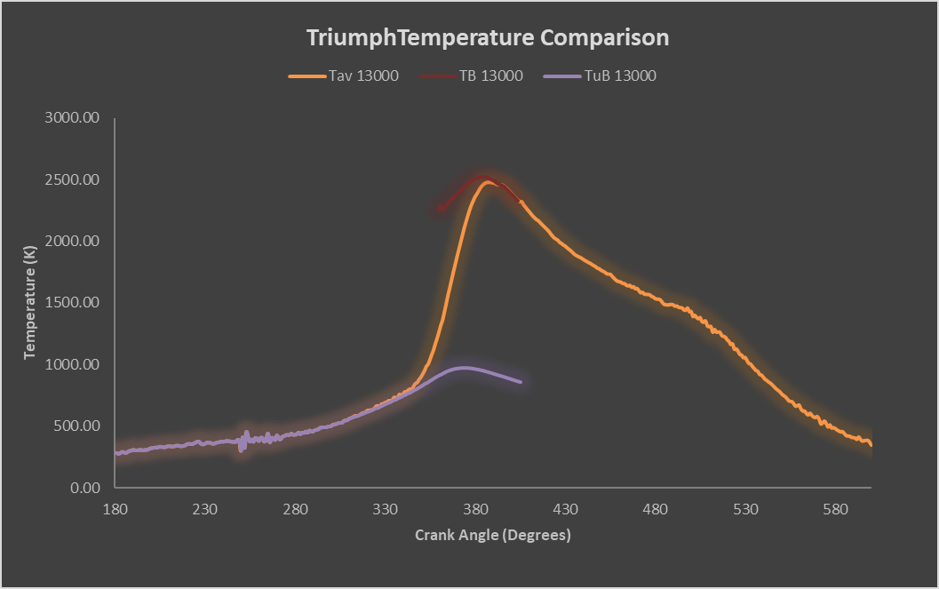
Figure 11- Triumph average, unburned and burned temperatures

Validating Results

For purposes of validation a 2-zone model of the Triumph 675R was created in Ricardo Wave. The idea being that if the results from Wave model correlated well with the hand calculations for the Triumph the results from the analysis on the Ford Fox would also be correct and therefore a fair comparison of results can be achieved.
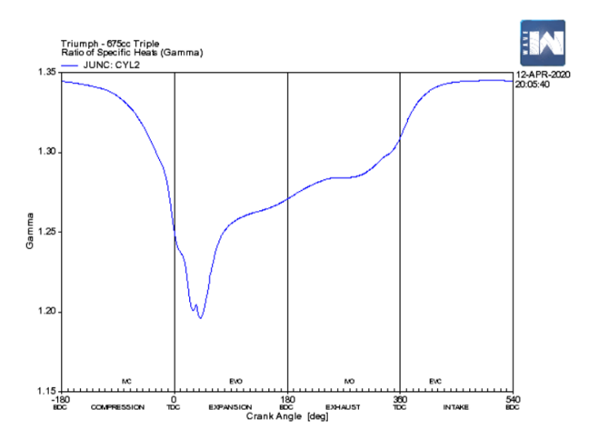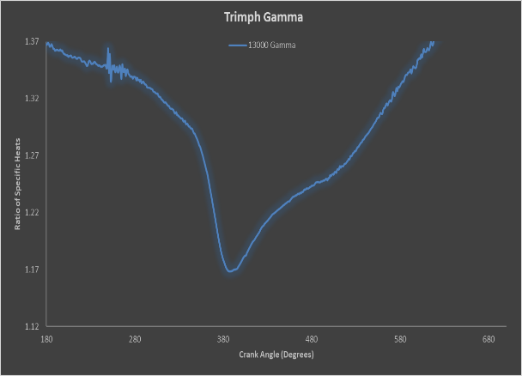
Figure 12- Comparison of the Triumph's gamma value against crank angle

When looking at these for sets of results both the Excel and Wave results corollate well as they trend in the same manor. In both graphs produced by Wave the same spike in the data can be seen and since both the specific gas constant and gamma are functions of temperature, Wave is accounting for something else within its calculations. The author believes this to be some excessive heat. The Wave model also predicts a slightly lower value in gamma at the start of the compression stroke meaning it must be predicting I slightly higher cylinder temperature as the inlet closes. But with good trends and results within a couple percent of each other, the hand calculations and the creation of the Wave model can be seen to be very accurate.
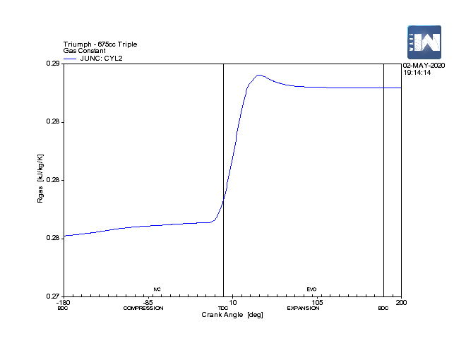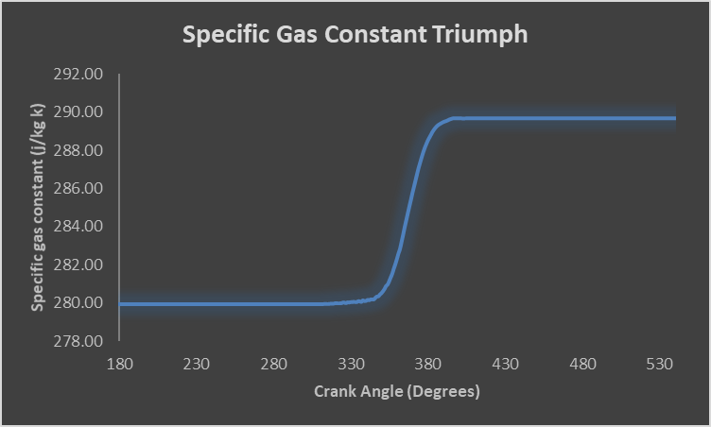
Figure 13- Comparison of the Triumphs specific gas constant against crank angle

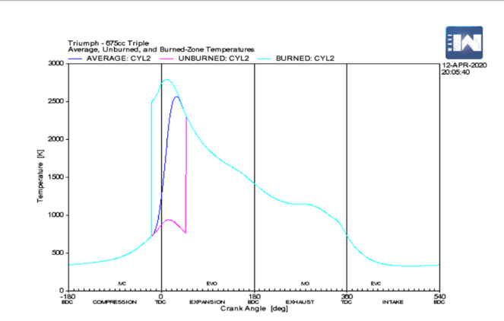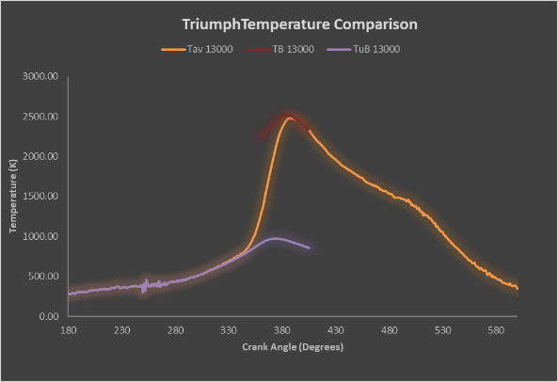
Figure 14- Comparison of the Triumph’s unburned, burned and average cylinder temperatures.

As with the previous results both graphs correlate well. With near identical trends baring the temperature of the burnt zone. It is this that it is causing the spikes within the other graphs. It is believed that Wave is predicting a higher pressure from the energy released within the burned zone. It can now be seen that the previous statements are correct about the high temperature at the start of compression, which will also have some effect on the burned zone temperature. This said the average and unburned temperature are all within 10-15 percent of each other and with some further refinement to the Wave model these are predicted to be within 5-10 percent.

As these results have shown, the hand calculations are within a few percent of what the Ricardo model predicted. Therefore, confidence can be had in that the appropriate calculations were undertaken with no inappropriate conversions or other mistakes made. As a finally note there will always be discrepancies in results when the data has come from a second-hand source and a model created in Wave. To overcome this one should collect the data so important information like atmospheric conditions and the thickness of the cylinder walls can all be correctly entered with the Wave model.

Results

Triumph NOx
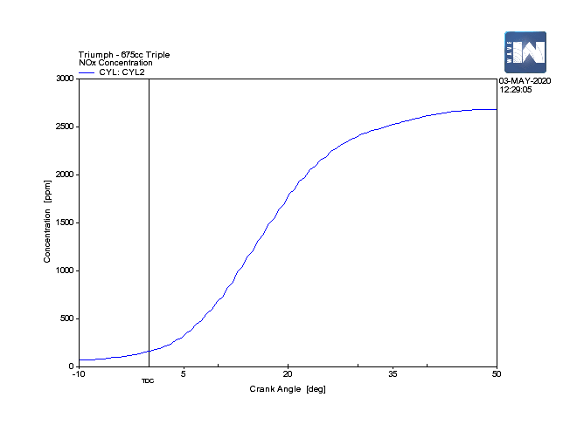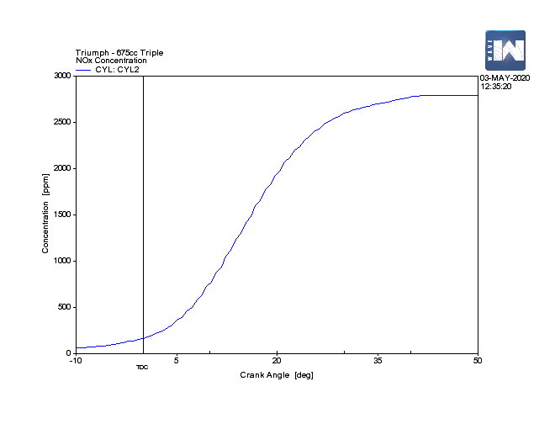
Figure 15- Triumph NOx PPM 15.7AFR Figure 16- Triumph NOx PPM Stoichiometric
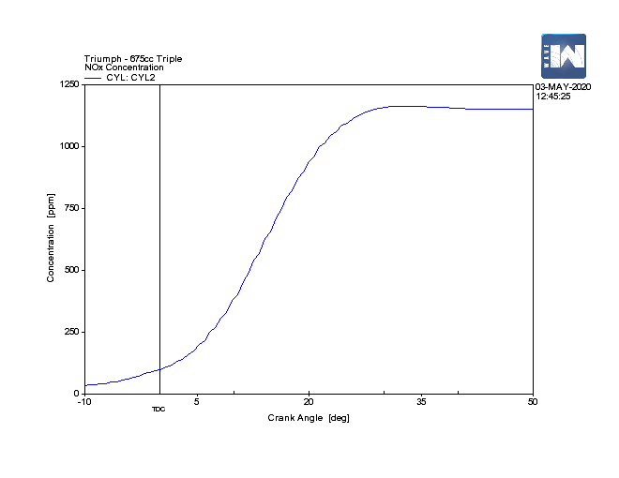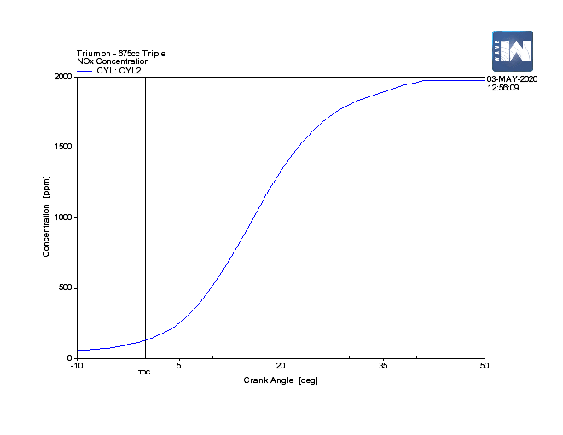
Figure 17- Triumph NOx PPM 12.7AFR Figure 18- Triumph NOx PPM 16.7AFR

The first thing that can be taken from the above graph is that $NO_{X}$ are produced as a function of the MFB. This can be seen as the plots behave as a Wiebe curve. From this is can be stated the level of $NO_{X}$ produced is solely dependent on the temperature within the cylinder and the concentration of oxygen and nitrogen. With the highest parts per million been produced in slightly lean condition but falling with increasing lean conditions. As stated by Heywood $NO{}_{X}$ are also produced in stoichiometric and rich conditions, this can also be seen in the graphs. Though the chemical balance forbids this since there is no spare oxygen’s, but in the real word oxygen can be bonded with other elements in the atmosphere and can also from ethanol within the fuel itself. So the results compare well to predictions made by the author, Heywood and Williams (Heywood, 2018) (Williams, 2019) (Wilks, 2020).

Ford & Triumph Pressure, Volume & Temperature

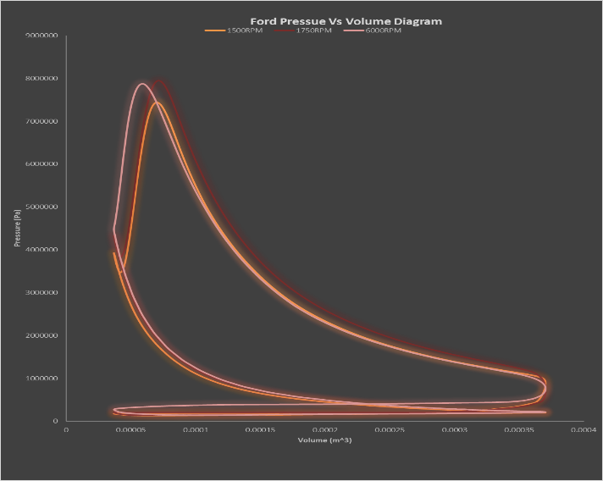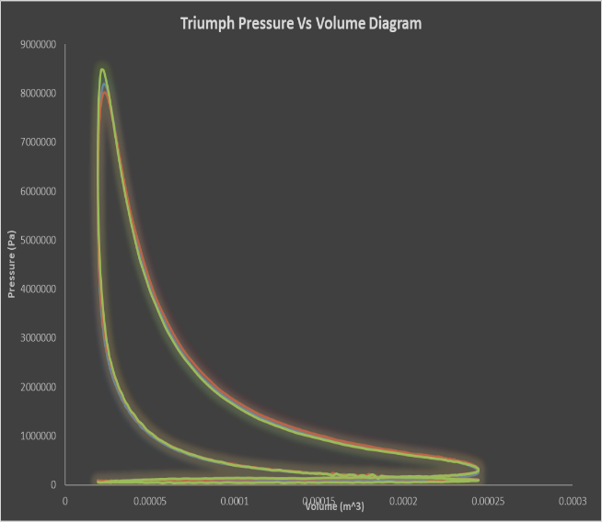
Figure 19- Comparison of pressure versus volume. Ford on the left and Triumph on the right

Both engines can be seen to make similar peak pressure around 75-85 Bar. Though due to being turbocharged the Ford’s peak pressure must develop after top dead centre as a precaution in case of knock, especially at 6000 RPM. Both engines have unburned temperatures lower than 1000K but with cyclic variation a higher cylinder pressure could occur leading to a higher unburned temperature and possible knock. This said looking at the Ford temperatures at 1500 and 1750 RPM the temperatures are quite low meaning if one was wanting to modify this engine, advancing the ignition could be a possibility, creating more positive work done on the piston. Though the formation of $NO_{X}$ and other forms of emissions would increase, due to the increasing the burned zone temperature.

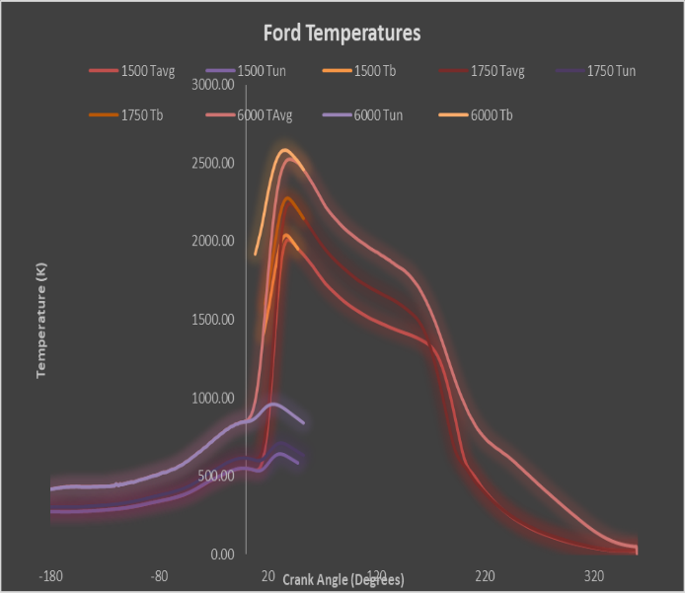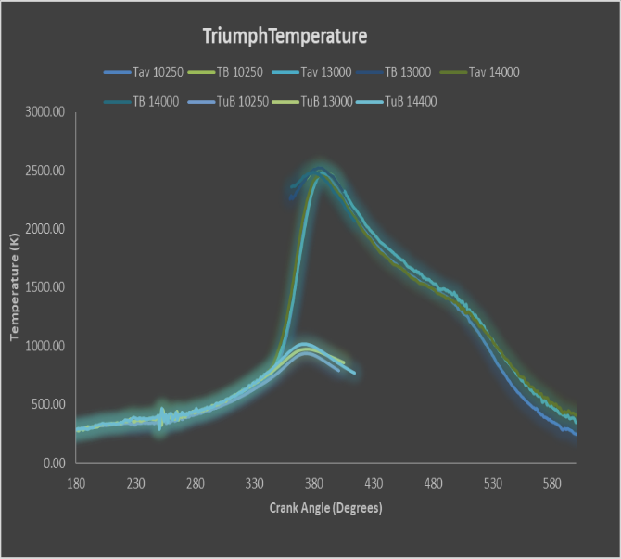
Figure 20- Temperatures of unburned and burned zone along with average. Ford on the left, Triumph on the right

Conclusion

A very detailed analysis has been undertaken with results showing a great deal of accuracy. Mainly due to the accurately modelled thermodynamic process. The formation of emissions due to temperature has identified while also investigating the reason why turbo charged engines must retard the ignition. There has been a great deal of knowledge gained from this experience along with confidence in one’s results.
In the below section is what the author was originally hoping to do but since an assault involving the police, mental health and a world pandemic this was unachievable for 7-8 weeks of university time was lost. As a result, the corrected way to simulate the back and forth reactions could not have been taught. This said the author takes great pride in what has been achieved.

Further Work

If one was to carry this analysis on further, a model would be created to accurate predict the temperatures of different vehicles based on their engine geometry and type of induction. From this a detailed emission model would be created. This could then be used by a manufacturer to specify the specification of their new line of vehicles to coincide with legislation.

References
Gao, P. D., 2016. https://www.mcgoodwin.net. [Online]
Available at: https://www.mcgoodwin.net/pages/thermodynamics.pdf
[Accessed 2020 4 1].
Gunter P. Merker, C. S. G. S. F. O., 2006. Simulating Combustion. Berlin: Springer.
Heywood, J., 2018. Internal Combustion Engine Fundamentals. 2 ed. New York: McGraw-Hill Education.
La Xiang, E. S. a. Y. D., 2018. A Two-Zone Combustion Model for Knocking. 19 January , p. 23.
Mcdonald, M., 2020. Combustion Analysis [Interview] (15 03 2020).
National Institute of Standards and Technology, N., 2019. https://www.nist.gov/pml/weights-and-measures/metric-si/si-units. [Online]
Available at: https://www.nist.gov/pml/weights-and-measures/metric-si/si-units
[Accessed 1 3 2020].
Sara McAllister, J.-Y. C. A. F.-P., 2011. Fundimentals of Combustion Processes. Berlin: Springer.
Taylor, C. F., 1985. The Internal-Combustion Engine in Theory and Practice. 1 ed. Massachusetts : The Massachusetts Institute of Technology .
Wilks, W., 2020. Thesis [Interview] (5 03 2020).
Williams, D. O., 2019. Powertrain & Sustainability [Interview] (12 October 2019).

Appendix

Figure 21- European emission limits over the years
Figure 22- Heywood's polynomial equation for the specific heat at constant pressure of various elements
Figure 23- Heywood's polynomial equation for the specific heat at constant pressure of gasoline
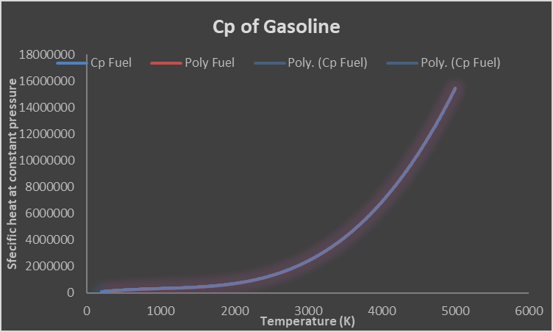
Figure 24- Change in the specific heat at constant pressure of gasoline

Figure 25- The change in specific gas constant with equivalence ratio

Figure 26- Engine fuel and combustion data
Figure 27- Stoichiometric and energy release calculator

