Kwame Assa-Agyei
london campus
ASSESSMENT

Module Name: Software Solutions for Business
Module Code: ACCA4026_LON

Student Name: Jamile Barbosa Kashif
Student ID: 2514981
Group No: 1

Lecturer’s Name: Farhad Ahmed
Submission Deadline: 15st December 2025
Table of Contents
Introduction 1
Task 1. e-Commerce Website builders or software solutions 1
1.1 Shopfy 1
1.2 Wix 1
Task 2. Mind-map of contemporary software applications 2
a. Mind mapping and explain the benefits of using mind mapping in business operations 2
b. Create a mind map of contemporary software applications 3
Task 3. Office Applications 3
a. Four office software solutions for business operations 3
MS Word 3
MS PowerPoint 3
M Excel 3
MS Access 4
b. Practical demonstration of Two Office Features 4
Graphics with data 5
If Statement 6
Task 4. Communication and Collaboration applications 6
a. One contemporary Communication and one Online Collaboration applications/tools 6
MS Outlook 6
MS Teams 6
b. One feature of a freely available Communication (1) and one feature of a Collaboration (1) application 7
MS Outlook 7
Ms Teams 7
Conclusion 8
References 8

Introduction
In today’s business world, software applications play a very important role in helping organisations work more efficiently. Companies use different types of tools for building websites, managing office tasks, organising ideas, and improving communication. These applications make everyday operations faster and easier, while also supporting teamwork and collaboration. In this assignment, I will look at some examples of modern software solutions, including e‑commerce platforms like Shopify and Wix, office applications such as Word and Excel, and communication tools like Outlook and Teams. The aim is to understand their key features and how they are used in business operations.

Task 1. e-Commerce Website builders or software solutions

1.1 Shopfy
Shopify is one of the most popular e‑commerce website builders used worldwide. It was launched in 2006 and has since become a leading platform for businesses of all sizes. The main reason this platform is so widely adopted is because it provides an all‑in‑one solution for online selling. Users can design their store, manage inventory, process payments, and even run marketing campaigns without needing advanced technical skills. It offers a wide range of customizable templates and themes, which makes it easy for businesses to create a professional‑looking storefront that reflects their brand identity [1].
Another important feature of this website is its multichannel selling capability. Merchants are not restricted to their website alone; they can also sell products through social media platforms, marketplaces like Amazon, and even in physical shops using Shopify’s point‑of‑sale system. This flexibility is particularly useful for businesses that want to reach customers across different channels. It also supports multiple payment gateways and currencies, which makes it suitable for international trade [2].
The platform has tiered pricing plans, meaning small businesses can start with affordable options while larger companies can access advanced features such as analytics and shipping discounts. Overall, Shopify is recognized for its scalability, ease of use, and comprehensive ecosystem. It allows entrepreneurs to start small and grow their business confidently, making it one of the most effective contemporary e‑commerce website builders.

1.2 Wix
Wix is a popular website builder that has expanded into e‑commerce through its Wix eCommerce suite. Originally designed for general website creation, Wix now provides tools that allow users to build fully functional online stores. Its main strength lies in its design flexibility. Wix uses a drag‑and‑drop editor, which makes it very beginner‑friendly, while also offering advanced customization options for experienced users. The platform includes over 500 templates, and it even integrates AI‑driven design assistance to help users quickly generate personalized websites [3].
From an e‑commerce perspective, Wix offers a wide range of features to support online selling. Merchants can manage product listings, create categories, configure tax and shipping options, and accept payments through multiple providers. Wix also ensures that websites are mobile‑optimized, which is essential for modern online shopping. In addition, the platform includes marketing and SEO tools, such as email campaigns, social media integrations, and analytics dashboards, which help businesses attract and retain customers [4].
Another advantage of Wix is its affordability. Users can start building their store for free and only pay when they are ready to sell. This makes Wix particularly appealing to startups, small businesses, and individuals who want to experiment with online commerce before committing to higher costs. While Wix may not scale as effectively as Shopify for very large enterprises, it is an excellent option for those who value creative freedom and ease of use.

Task 2. Mind-map of contemporary software applications

Mind mapping and explain the benefits of using mind mapping in business operations
Mind mapping is a technique used to visually organize ideas. It usually starts with one main topic in the middle of a page, and then branches out into related ideas. This makes it easier to see connections between different points. In business, mind mapping is becoming more popular because it helps with planning, problem‑solving, and teamwork [5].
One of the biggest benefits of mind mapping is that it helps with creativity. When people brainstorm using a mind map, they don’t have to think in a straight line. Instead, they can add ideas wherever they fit, which often leads to new connections and solutions. For example, a marketing team might use a mind map to plan a campaign, and by seeing all the ideas laid out visually, they can spot opportunities that might have been missed in a normal list.
Mind mapping also improves organization and productivity. Businesses often deal with complex projects that have many parts. A mind map can break down a big project into smaller tasks, making it easier to manage. This helps teams keep track of deadlines and responsibilities. It also reduces the chance of forgetting important details, since everything is shown in one diagram [6].
Another benefit is better communication. In meetings, mind maps can be used to show strategies or workflows in a way that everyone can understand quickly. Instead of reading long documents, employees can look at the map and see how different ideas connect. This makes discussions more engaging and ensures that people are on the same page.
Mind mapping can also support decision‑making. Managers often need to compare different options before making a choice. By laying out the pros and cons in a mind map, they can see the situation more clearly. This structured approach helps them make better decisions.
Finally, mind mapping helps with learning and memory. Because the technique mirrors how the brain works, people often find it easier to remember information presented in a mind map. This is useful in training sessions, where complex topics can be simplified into diagrams that employees can recall later.
In conclusion, mind mapping is a simple but powerful tool for business operations. It encourages creativity, improves productivity, supports communication, helps with decision‑making, and makes learning easier. For these reasons, many companies are starting to use mind maps as part of their everyday work.

Create a mind map of contemporary software applications
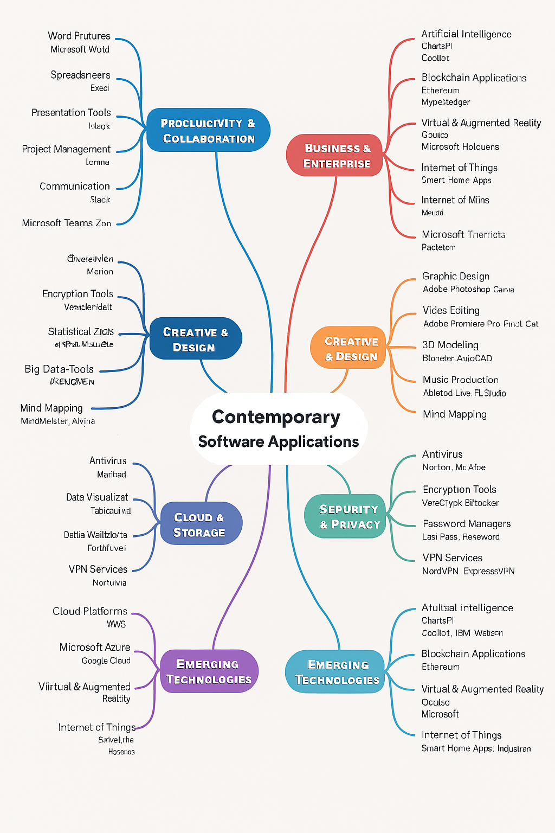

Task 3. Office Applications

Four office software solutions for business operations

MS Word
Microsoft Word is one of the most widely used word processing applications. It is part of the Microsoft Office suite and is designed to help users create, edit, and format documents. As a student, I find Word essential because it allows me to write essays, reports, and even professional documents with ease.
Word provides a wide range of formatting tools such as font styles, paragraph alignment, tables, and templates. It also includes advanced features like spell check, grammar suggestions, and thesaurus integration, which help improve the quality of writing [7]. Another important feature is its compatibility with multiple file formats, including DOCX, PDF, and RTF, making it versatile for different uses [8].
The biggest benefit of Word is its user-friendly interface. Even beginners can quickly learn how to use it. It also integrates seamlessly with other Microsoft applications like Excel and PowerPoint, which makes collaboration easier. Word is available across platforms (Windows, macOS, iOS, Android, and web), so users can access their documents anywhere.
Despite its strengths, Word has some limitations. For example, it can be expensive since it requires a Microsoft 365 subscription [7]. Also, while Word is powerful, it can sometimes feel overwhelming because of the sheer number of features [8].

MS PowerPoint
Microsoft PowerPoint is a presentation software that allows users to create slideshows combining text, images, audio, and video. It is widely used in education, business, and professional settings.
PowerPoint offers a variety of templates and themes that make presentations visually appealing. It supports animations, transitions, and multimedia embedding, which help in engaging audiences [9]. Collaboration features allow multiple users to edit slides simultaneously, and integration with OneDrive makes sharing easy [10].
The main benefit of PowerPoint is its ability to simplify complex information into visual slides. This makes it easier for audiences to understand [9]. It is also very flexible, allowing customization through add-ins and design tools.
One limitation is that PowerPoint presentations can become monotonous if not designed creatively. Overuse of animations or text-heavy slides can reduce effectiveness [10].

M Excel
Microsoft Excel is a spreadsheet application used for organizing, analysing, and visualizing data. It is one of the most important tools in computing and business.
Excel provides formulas, functions, and pivot tables for data analysis. It also supports charts and graphs, which help in visualizing data trends [11]. Conditional formatting allows users to highlight important information. Excel integrates with other Office apps and supports macros for automation [12].
This application biggest benefit is its powerful data management capabilities. It can handle large datasets and perform complex calculations [11]. For students, Excel is useful for managing budgets, analysing data in projects, and learning basic programming concepts through formulas.
The platform does have limitations. It is not ideal for very large-scale databases, as performance can slow down [12]. Errors in formulas can lead to incorrect results, which is risky in professional settings.

MS Access
Microsoft Access is a database management system (DBMS) that combines a relational database engine with a graphical interface. It is designed for small to medium-sized businesses and individuals who need to manage structured data.
Access allows users to create databases with tables, queries, forms, and reports. It supports SQL queries and integrates with other Office applications [13]. Its graphical interface makes database design easier for beginners.
The main benefit of Access is its ease of use compared to other DBMS tools. It allows rapid development of applications without requiring advanced programming skills [14]. For students, Access is a good introduction to databases because it combines theory with practical tools.
Access has limitations in scalability. It is not suitable for very large databases or complex queries [13]. Security is also weaker compared to enterprise DBMS [14].

Practical demonstration of Two Office Features

Graphics with data
< 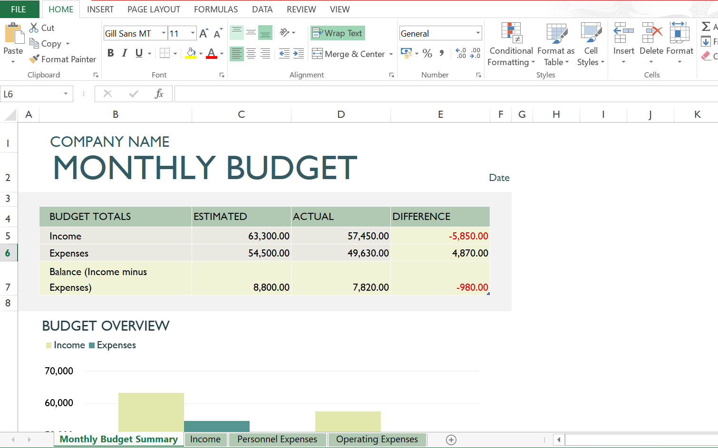
Creating a spreadsheet with the data you have will make possible for the software to create different graphics to visualize the information in a easier way. This can be very useful for presentations in the work enviroment or even for family meetings when you need to explain certan points of your ideas in a clear manner.
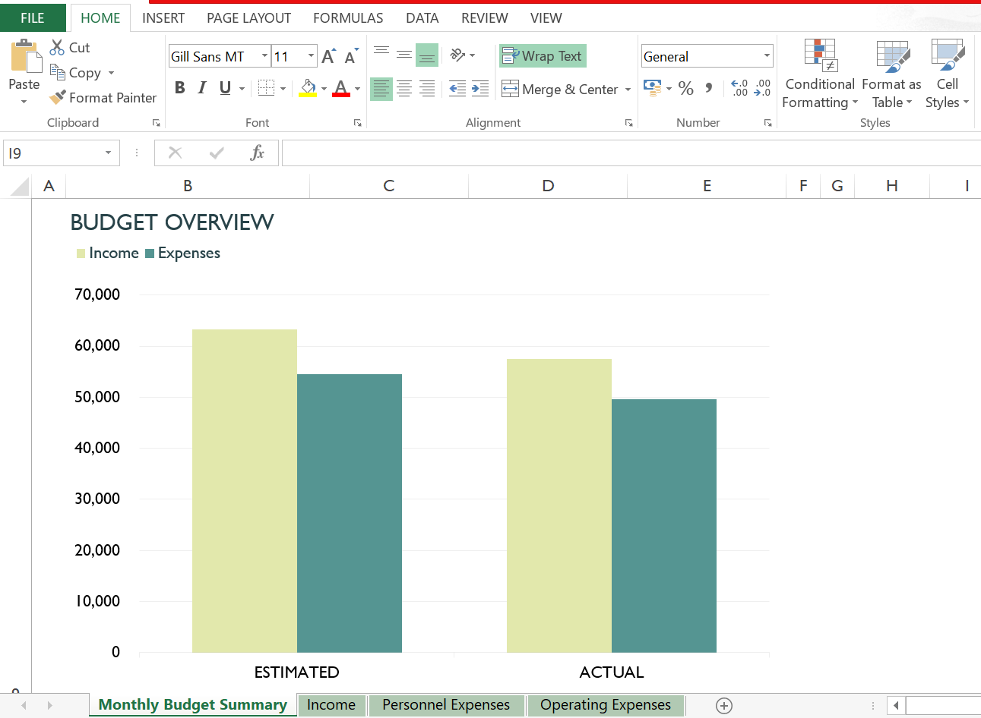

If Statement
<Insert screenshots with captions>

Task 4. Communication and Collaboration applications

One contemporary Communication and one Online Collaboration applications/tools

MS Outlook
Microsoft Outlook is one of the most widely used communication applications in the modern business world. It is part of the Microsoft 365 suite and is mainly known as an email client, but it also includes other features like calendars, contacts, and task management. Businesses rely on Outlook because it combines communication and organisation in one platform, which makes it easier to manage daily work [15].
One of the key features of Outlook is email management. Users can send, receive, and organise emails efficiently. Outlook provides folders, rules, and filters to help manage large volumes of emails. The Focused Inbox is another useful feature, which separates important emails from less urgent ones, helping professionals stay on top of their priorities [16].
Another important feature is the calendar integration. Outlook allows users to schedule meetings, book conference rooms, and send invitations. The calendar is linked directly with email, so when someone sends a meeting invite, it appears in the recipient’s calendar automatically. This makes it easier for teams to coordinate schedules and avoid conflicts [15].
Outlook also includes a contacts hub, where users can store and manage information about colleagues, clients, and partners. This is integrated with LinkedIn profiles, which helps professionals connect and view more details about the people they are working with [17].
Security is another strong point of Outlook. It provides enterprise‑grade security and encryption, which is important for protecting sensitive business information. Many organisations trust Outlook because it ensures that confidential data is safe [16].
Outlook is also highly integrated with other Microsoft 365 apps. For example, users can share files directly from OneDrive, collaborate on documents in Word or Excel, and access Teams meetings from their Outlook calendar. This integration makes Outlook more than just an email tool—it becomes a central hub for communication and productivity [15].
In summary, Microsoft Outlook is a powerful communication tool because it combines email, calendar, contacts, and tasks in one application. It is secure, easy to use, and integrates well with other Microsoft services. Businesses use Outlook not only to send emails but also to organise meetings, manage tasks, and collaborate with colleagues.

MS Teams
Microsoft Teams is a modern collaboration platform that has become essential in business environments. It is also part of the Microsoft 365 suite and is designed to bring together chat, video meetings, file sharing, and app integration in one place. Teams is especially popular in organisations that work remotely or in hybrid setups [18].
One of the main features of Teams is chat and channels. Teams allows users to create channels for different projects or departments, where members can communicate and share files. This helps keep conversations organised and makes it easier to find information later [19].
Another important feature is video meetings and calls. Teams supports one‑to‑one calls, group meetings, and large webinars. Users can share screens, record meetings, and use features like live captions. This makes Teams a strong alternative to other video conferencing tools [18].
Teams also supports file sharing and co‑authoring. Documents can be uploaded to channels, and multiple users can edit them at the same time. Changes are saved automatically, and everyone can see updates in real time. This makes collaboration faster and reduces the need to send files back and forth via email [20].
Integration is another strength of Teams. It connects with other Microsoft apps like Word, Excel, PowerPoint, and OneNote. It also supports third‑party apps, so businesses can customise Teams to fit their workflows. For example, project management tools or customer service apps can be added directly into Teams [19].
Teams also includes features like the Whiteboard app, where users can brainstorm ideas visually, and task management tools that help track progress. These features make Teams more than just a chat app—it becomes a complete collaboration platform [21].
Security is also a priority in Teams. It uses Microsoft’s enterprise‑grade security to protect conversations, files, and meetings. This is important for businesses that handle sensitive information [18].
In summary, Microsoft Teams is a powerful collaboration tool that combines chat, video meetings, file sharing, and app integration. It helps teams work together more effectively, whether they are in the office or working remotely.

Conclusion
Overall, this assignment shows how different software applications are essential for modern businesses. E‑commerce platforms allow companies to sell products online, office applications help with creating documents and managing data, and mind‑mapping tools support planning and organisation. Communication and collaboration tools like Outlook and Teams are especially important because they make it easier for people to connect and work together, whether in the office or remotely. By learning about these applications, we can see how technology supports business operations and improves productivity.

References
[1] Shopify, “Website Builder | Create a Free Website With AI in Minutes,” Shopify.com. [Online]. Available: https://www.shopify.com/website/builder. . [Accessed: Dec. 14, 2025].
[2] E. Ryan and O. Simpson, “Shopify Review 2025: The Best Builder for Selling,” Website Builder Expert, Jul. 1, 2025. [Online]. Available: https://www.websitebuilderexpert.com/ecommerce-website-builders/shopify-review/. . [Accessed: Dec. 14, 2025].
[3] Wix, “eCommerce Website Builder: Build An eCommerce Site,” Wix.com. [Online]. Available: https://www.wix.com/ecommerce/website. . [Accessed: Dec. 14, 2025].
[4] Wix, “Online Store Builder - Create an Online Store For Free,” Wix.com. [Online]. Available: https://www.wix.com/ecommerce/online-store. . [Accessed: Dec. 14, 2025].
[5] ABC Money, “The Power of Mind Mapping for Business Success,” ABC Money, Dec. 23, 2024. [Online]. Available: https://www.abcmoney.co.uk/2024/12/the-power-of-mind-mapping-for-business-success/. . [Accessed: Dec. 14, 2025].
[6] Business.com, “How Mind Mapping Helps Entrepreneurs Succeed,” Business.com, Oct. 4, 2024. [Online]. Available: https://www.business.com/articles/benefits-of-mind-mapping-for-professionals/. . [Accessed: Dec. 14, 2025].
[7] J. Roberts, “20 Pros And Cons Of Microsoft Word,” ProsPlusCons, Nov. 3, 2024. [Online]. Available: https://prospluscons.com/pros-and-cons-of-microsoft-word/
[8] J. Scott, “18 Advantages And Disadvantages Of Microsoft Word,” PresentationSkills.me, Jun. 12, 2024. [Online]. Available: https://www.presentationskills.me/advantages-and-disadvantages-of-microsoft-word/

[9] J. Scott, “17 Advantages And Disadvantages Of PowerPoint,” PresentationSkills.me, Sep. 19, 2023. [Online]. Available: https://www.presentationskills.me/advantages-and-disadvantages-of-powerpoint/
[10] “The Advantages and Disadvantages of PowerPoint,” The Knowledge Academy, Nov. 21, 2025. [Online]. Available: https://www.theknowledgeacademy.com/blog/advantages-and-disadvantages-of-powerpoint/
[11] “Advantages and Disadvantages of MS Excel,” AlmaBetter, Dec. 14, 2023. [Online]. Available: https://www.almabetter.com/bytes/articles/advantages-and-disadvantages-of-ms-excel
[12] “Top 10 Cons & Disadvantages of Using Microsoft Excel,” ProjectManagers.net. [Online]. Available: https://projectmanagers.net/top-10-cons-disadvantages-of-using-microsoft-excel/
[13] “Advantages and Disadvantages of Microsoft Access,” The Knowledge Academy, Nov. 17, 2025. [Online]. Available: https://www.theknowledgeacademy.com/blog/advantages-and-disadvantages-of-microsoft-access/
[14] T. Singh, “Advantages & Disadvantages of MS Access,” ScaleupAlly, Jul. 1, 2024. [Online]. Available: https://scaleupally.io/blog/advantages-disadvantages-of-ms-access/
[15] E. Nolasco, “Microsoft Outlook: Key Features & Benefits,” Office Tutorial, Feb. 11, 2025. [Online]. Available: https://officetutorial.net/outlook/features-benefits/1224/
[16] Microsoft, “Outlook for Business,” Microsoft 365, 2025. [Online]. Available: https://www.microsoft.com/en-gb/microsoft-365/outlook/outlook-for-business
[17] E. Diez, “Mastering Microsoft Outlook: Why It’s a Vital Tool in IT and Business Communication,” Tech GN, 2025. [Online]. Available: https://techgn.com/mastering-microsoft-outlook-why-its-a-vital-tool-in-it-and-business-communication/
[18] Microsoft, “Collaborate, Communicate & Work Together in Microsoft Teams,” Microsoft, 2025. [Online]. Available: https://www.microsoft.com/en-gb/microsoft-teams/collaboration
[19] Cloudfuze, “Microsoft Teams Features for Effective Collaboration in 2025,” Cloudfuze, 2025. [Online]. Available: https://www.cloudfuze.com/microsoft-teams-features/
[20] The Knowledge Academy, “What is Microsoft Teams? Everything You Need to Know,” The Knowledge Academy, Sept. 9, 2025. [Online]. Available: https://www.theknowledgeacademy.com/blog/microsoft-teams-guide/
[21] Wavenet, “Top Microsoft Teams Features & Benefits in 2025 - What’s New,” Wavenet, Sept. 2, 2025. [Online]. Available: https://www.wavenet.co.uk/blog/microsoft-teams-features

