  - Powertrain Technology (M4X02196)

Engine Performance Characteristics
Subith Joseph (1902458)
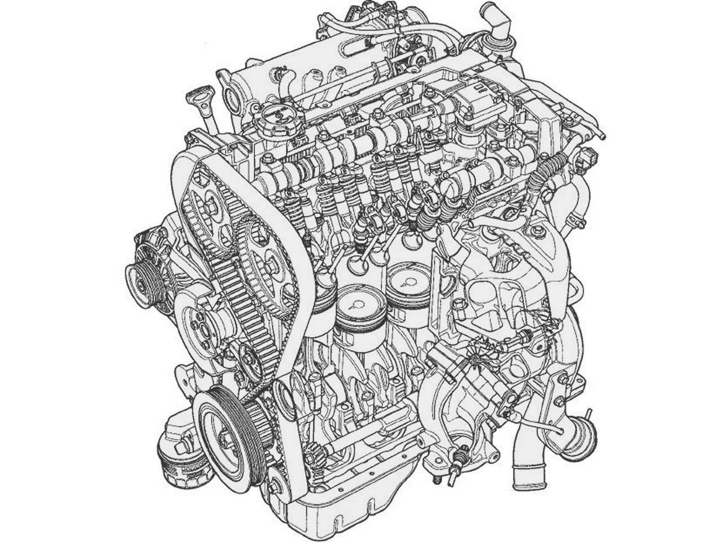
(N/A, 2007)

Table of Contents
Introduction 3
Experiment & Procedures 4
Safety 4
Set up 4
Dynamometer 5
Analysis 9
Units used 9
Formulas/Calculations Used 10
Graphical Data 11
11
12
Data Analysis 12
Load 12
Fuel rate 12
Lambda 12
Torque 13
Brake Power 13
Conclusion 14
Evaluation 15
Bibliography 16

Introduction

The purpose of this report is to performing a testing and analysis one a Honda engine (B16A). To analyse how the Honda Engine (B16A) is engineered to run by using an4 engine dynameter; using all the data from the engine dynameter then calculate the total Load, Power, Torque output, Fuel consumption and also the efficiency.
The Engine chosen is from a Honda Civic 1.6L DOHC VTEC B16A. This engine was designed for high fuel economy when on normal driving conditions but also high power in high RPM for spirited driving conditions. This is achieved by a system called VTEC (Variable Valve Timing & Lift Electronic Control). VTEC also known as Variable Valve Timing & Lift Electronic Control is a system which increases the volumetric efficiency of a combustion chamber, this is accomplished by switching an electronically controlled solenoid which locks the larger cam profile which is also attached to the camshaft. This larger cam lobe results the intake valve to stay open for longer and also the valve to go further in the combustion chamber allowing the engine to take in more air which then resulting in a higher power output.
The Dynameter chosen for this report is the SCHENCK W230. This is an engine dynameter, this uses a sensitive strain gauge to calculate the load and also uses electro magnets to create resistance to the engine which is mounted. The engine is connected to the dynameter via the drive shaft straight from the flywheel.

Experiment & Procedures

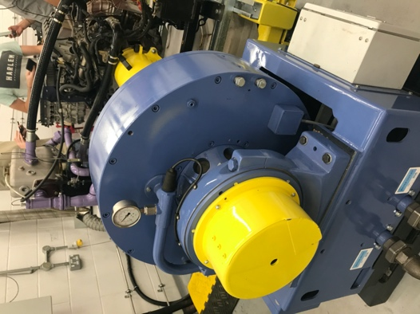
Safety

When starting the procedure wearing the correct PPE (Personal Protection Equipment) is needed for protection, this includes; Steel cap Boots, Fireproof Lab Jacket, safety goggles, gloves.
(n/a, dynamometer, 2019)

Set up
When setting up the Dynamometer, Calibrating the Dynamometer is needed. This is done by placing two 1 metre long plates on the calibrating bolts on both sides of the of the dynamometer. Then placing 20kg on post ends of the calibrating plates. This then would cause a load value to the strain gauge on the dynamometer; this is measured in ‘nm’ also called Newton Metres. Then calculate the values and then compare it to the system value then add or decrease value to equalize the two values.
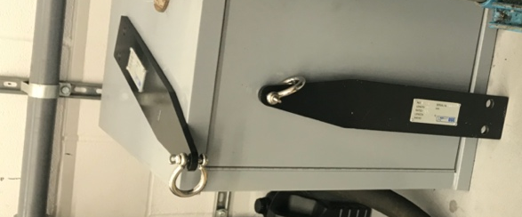
Calculating the Total load $=$D$×$L $=$ (Distance$×$length)
(n/a, calibration arms, 2019) (n/a, Fuel System, 2019)
$Kg$ $N$ = Kg $× 0.981=N$
$$nm=n*m$$
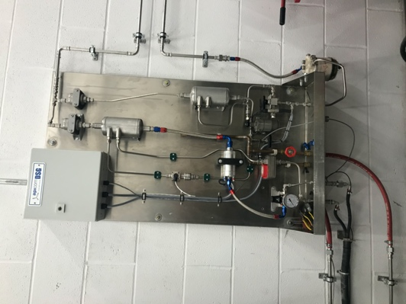
After Calibrating the Dynamometer then checking the fuel system is needed; this is by switching on the engine and checking if there is fuel pressure on the engine fuel injectors and also fuel priming the fuel system, also extraction fan if they are working, this can be tested by testing if the fan turn on by switching it on.
All of these safety procedures are needed to perform a dynamometer test in a safe manner and reduces the risk for any accidents.
(n/a, Fuel System, 2019)

Before starting any test on the dynameter, it is important that the engine which is going to be tested it warmed up to operating temperature, this is so that the engine is running on the default programmed mapping. This is important that when the engine is cold the vehicle is programmed to a rich air to fuel ratio, this is also called open loop. During Open loop the ECU (Engine Control Unit) only takes reading from the Coolant temperature sensor (thermostat) to read the engine temperature and disables the 02 (oxygen/Lambda sensor), this is so that the engine would not know fuel it is burning while trying to warm up.

Dynamometer
Setting up the dynamometer software can varies depending on what application it is used for. For this Report the run graph is set up to x axis = engine speed (RPM), Left y axis = Dyno Torque (Nm) and Right y axis= Engine power (BHP).
For this report doing a sweep test is needed, when setting up the sweep test; Ramp time to start (sec) set to 3 (the time in-between for the engine to raise its engine speed; Hold time (sec) 1 (the time of the engine to hold the specific engine speed, Starting at 1000 rpm; Finishing at 5500 rpm.
Then selecting start test for the test to proceed; The Dynamometer will automatedly go through the specific rpm and wait for the engine to settle then raise again until 5500 rpm, doing this will produce a more accurate reading of the fuel consumption and also give time for the sensors of the engine and the dynamometer to get more accurate readings
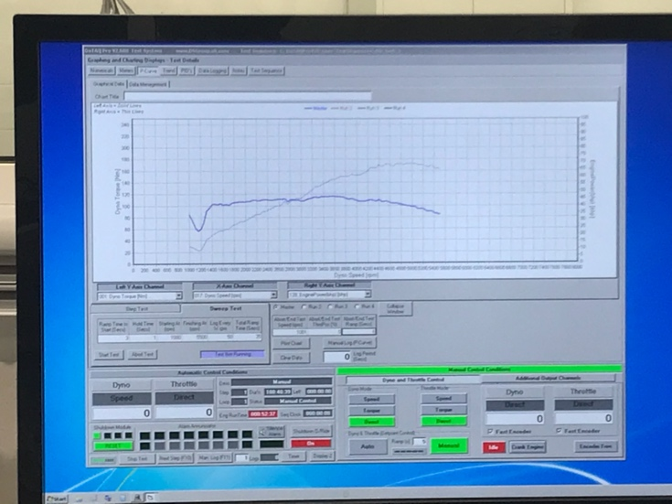

Results
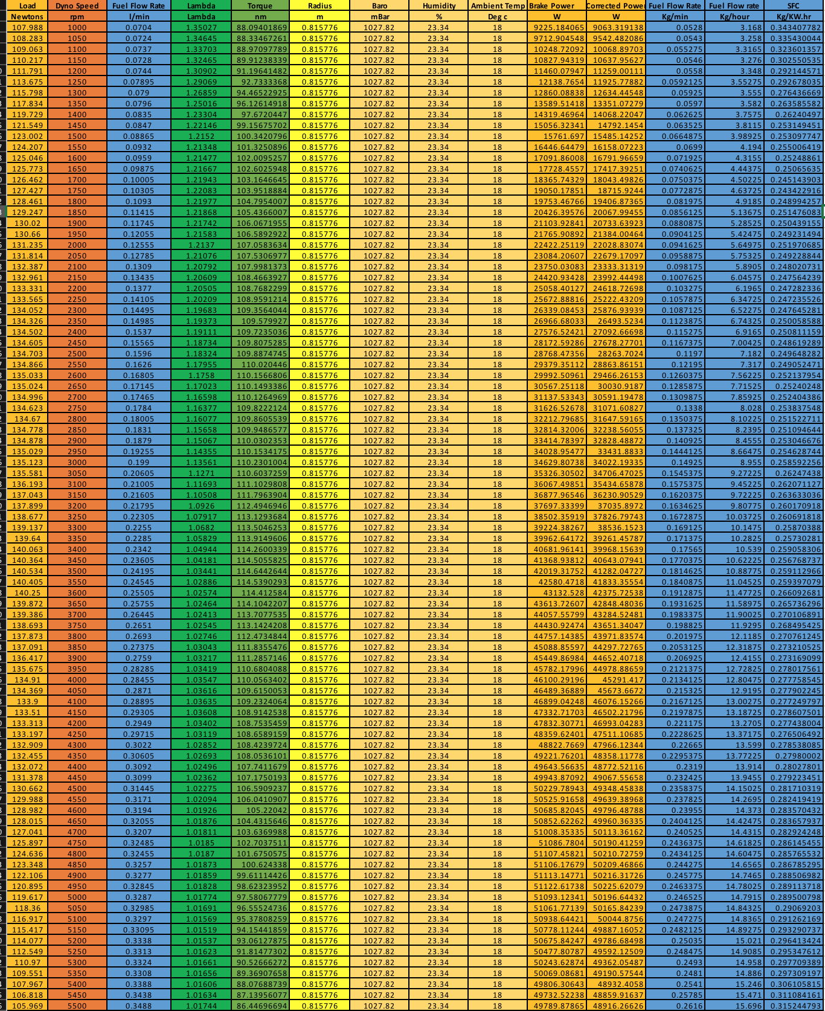
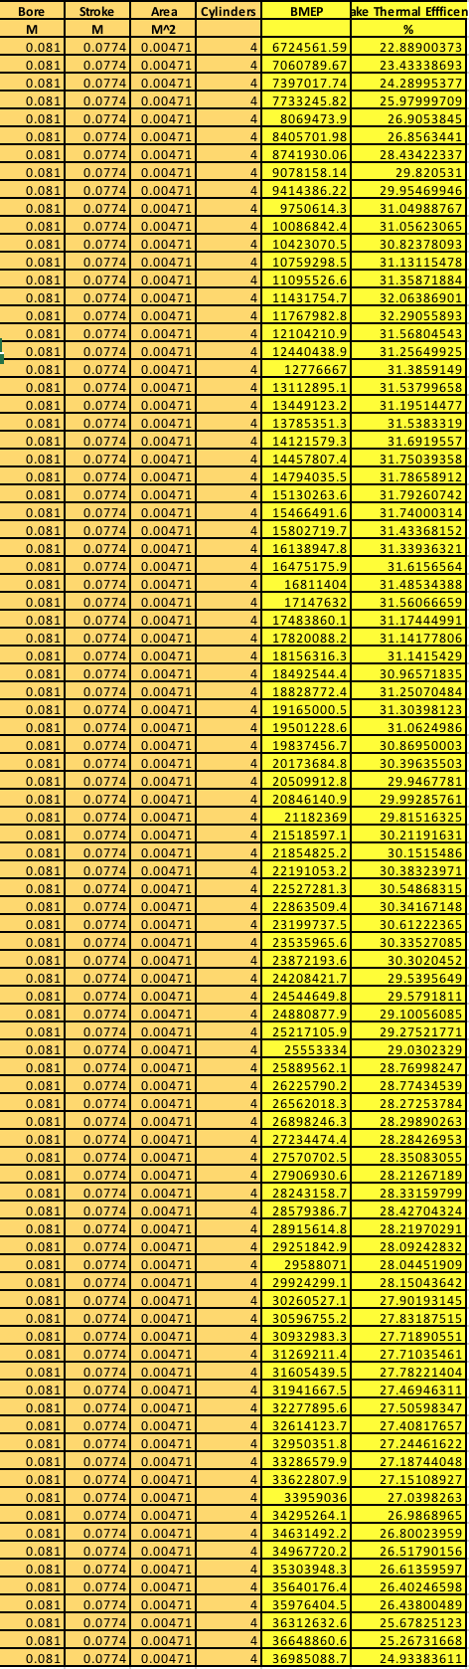

Analysis

Units used

N – Newton – Load
RPM (Revolution Per Minute) – Engine speed
L/min - Litres Per Minute – Fuel Flow Rate
Lambda – Oxygen content
Nm – Newton metre – Torque
M – metres – Radius – Bore – Stroke
mBar – milli-bar – Baro – Pressure
% - Humidity – Brake Thermal Efficiency
$℃$ - Temperature – Ambient Temp
W – watts – Brake Power – Corrected Power
Kg/min – Kilogram per min – Fuel Flow Rate
Kg/hour – Kilogram per hour – Fuel Flow Rate
Kg/KW.hr – Kilogram per Kilowatts hour – SFC – Specific Fuel Consumption

Formulas/Calculations Used
Load, Dyno speed, Fuel Flow Rate (L/min), Lambda, Baro, Humidity and Ambient temperature were made from the dynamometer automatically from the test
The Radius, Bore Stroke and number of Cylinder was found by researching the engine manufacture specification
Torque – $Load * Radius$
Brake power – $\frac{\left(2*π\right)*Dyno speed*Torque)}{60}$
$$Corrected Power=(\left(\frac{1.01325}{\frac{Baro}{1000}}\right)*\left(\sqrt{\frac{Ambient temp+273}{293}}\right)*\left(Brake Power\right))$$
$$Fuel Flow rate \left(\frac{Kg}{\min{}}\right)=Fuel Flow Rate \left(\frac{L}{\min{}}\right)*0.75$$
$$Fuel Flow Rate \left(\frac{Kg}{Hour}\right)=Fuel Flow Rate \left(\frac{kg}{\min{}}\right)*60$$
$$SFC=Fuel Flow Rate\frac{\frac{Kg}{hour}}{\frac{BrakePower}{1000}}$$
$BMEP=(Brakepower$ *120)/ (Area*Load*Number of Cylinder*Bore)
$$Brake Thermal Efficency =((\frac{Brakepower}{1000})/(\left(\frac{Fuel Flow Rate\left(\frac{Kg}{\min{}}\right)}{60}\right)*45800*100)$$

Graphical Data
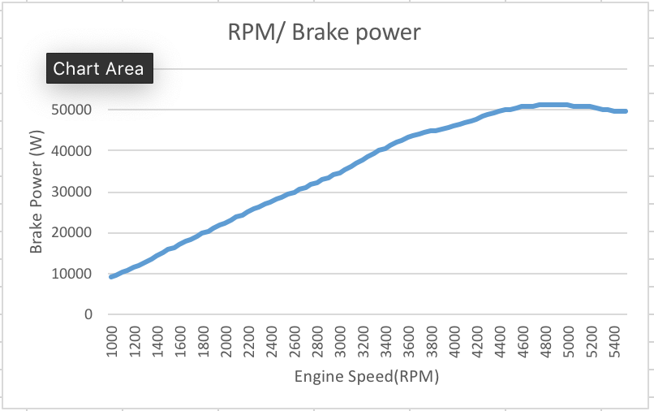
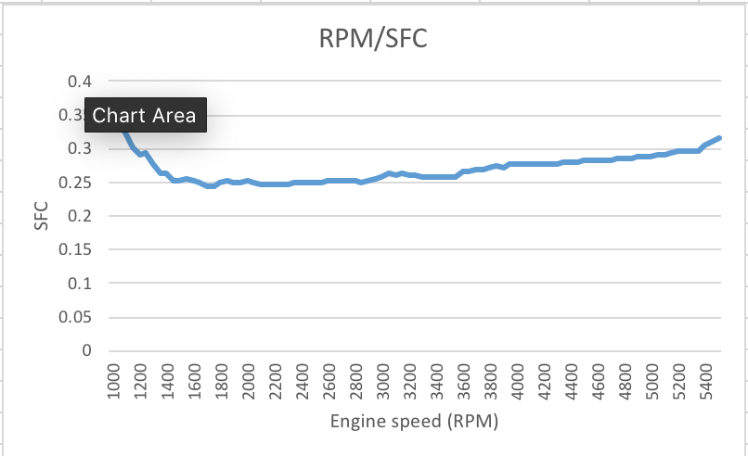
The data on this Table shows the brake Power Curve as it raises through the engine speed

The data on this table shows the SFC (Specific Fuel Consumption) as it goes through the engine speed
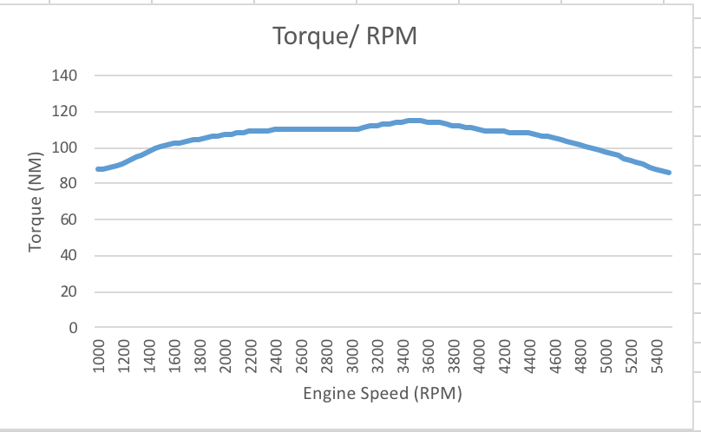
The data on this table shows the Torque curve of the engine as is goes through higher engine speed

Data Analysis

Load
Load on the engine raises to the point of 3500 rpm, this is where the engine is at its maximum load and then past this point the engine cannot produce more load

Fuel rate
Fuel rate is the amount of fuel the engine takes for it to run. Fuel rate increases through as the engine speed increases, this is because the engine is running faster so it will need to inject more fuel so for each revolution the engine will produce power.

Lambda
Lambda is the value of the oxygen content in the exhaust, this is how the vehicle calculates if the engine needs more fuel to get the perfect mixture of 14.7:1 Air to Fuel mix ratio, the values of the lambda reduces this shows that the higher the engine speed is the leaner the fuel to air mixture it becomes, this is most like due to its mapping it is programmed to run at.

Torque
Torque is the twisting force of the engine, the higher the torque the higher the power output and also the higher load capacity. Torque is at its maximum at 3500 rpm, this is because as the engine speed raises it is not as efficient creating a strong combustion, to increase torque more fuel would be needed, this would mean needing to run a rich mixture but then this can also lead to damaging the engine if too rich due to carbon deposits, to prevent this increasing the volumetric efficiency could be achieved by adding a turbo or a supercharger.

Brake Power
Brake power is the acceleration force of the engine, the higher the Brake power the higher the vehicle can accelerate and also increase its top speed. The Brake Power figures for this engine shows that at its peak at 4900rpm. This shows that this engine has a high-top end power, having this can lead to less power at lower rpm but then for spirited driving a high revving engine would be a more exciting drive for the driver,

Conclusion

Doing this Task was a great experience not just as an engineer to know what happens throughout the engine while it goes through its ranges of rpm but as a programmer who programs mapping for engine. This can be used if you would like to increase power and torque or increase fuel efficiency. Using the dynamometer and learning how the software work was a great transferable skill. Also, after analysing how the engine performs it taught me why engine power and torque dips after a point of certain rpm and also showed how a standard engine mapping looks like.

Evaluation

As the task was restricted due to time and money, if there wasn’t any limit to either then I would test varies type of 4-cylinder engines and then go into detail with its manufacture mapping and then talk about why each engine are engineered for different needs and applications.

Bibliography
N/A. (2007, March 28). Car cutaway. Retrieved from Modern Racer: http://www.modernracer.com/memfeatures/carcutaways/mitsubishilancerevowrc04insides3.jpg
n/a. (2019). calibration arms.
n/a. (2019). dynamometer. Swansea.
n/a. (2019). Fuel System.

