DESIGN

FOR

ADDITIVE MANUFACTURING (DfAM)

USING

THE ROCKER ARM OF A CAR

AS CASE STUDY

By

ASOWATA EFEHI DAVIDSON
STUDENT ID : 2304469

COURSE CODE: ACEA 7008

TABLE OF CONTENT
Title ------------------------------------------------------------------------------------------------------I
Table of Content -------------------------------------------------------------------------------------II

1.0 Introduction -------------------------------------------------------------------------------------- 1
1.1 Background -------------------------------------------------------------------------------------- 1
2.0 Literature Review ------------------------------------------------------------------------------- 2
2.1 Design Methodology and Topology Optimisation ---------------------------------------2
2.2 Part Consideration ------------------------------------------------------------------------------2
2.3 Material Selection and Additive Manufacturing Techniques ------------------------ 2
2.4 Performance Evaluation and Structural Analysis ----------------------------------------3
2.5 Design for Additive Manufacturing Principles ------------------------------------------- 3
2.6 Comparisons Between Topology Optimisation and Generative Design Tools---- 3
3.0 Critical Evaluation of DfAM for the selected Component ----------------------------- 5
3.1 Complex Geometries Optimisation --------------------------------------------------------- 5
3.2 Rapid Prototyping and Iteration ------------------------------------------------------------- 5
3.3 Material Waste Reduction -------------------------------------------------------------------- 5
3.4 Supply Chain Considerations ----------------------------------------------------------------- 5
3.5 Tooling Consideration ------------------------------------------------------------------------- 6
3.6 Material Selection and Post-Processing ---------------------------------------------------- 6
3.7 Process-specific Constraints -------------------------------------------------------------------6
3.8 Cost and Sustainability ------------------------------------------------------------------------- 6
4.0 Selection of Component ----------------------------------------------------------------------- 7
4.1 Diagram of the Rocker Arm ------------------------------------------------------------------- 7
4.2 Evaluation of Existing Rocker Arm Desing ------------------------------------------------- 7
4.3 Identified Limitations in Current Design --------------------------------------------------- 8
4.4 Opportunities for Optimisation via Additive Manufacturing --------------------------8
5.0 Process of Redesign of the Suspension Rocker Arm -------------------------------------10
5.1 Step-by-step Redesign of the Suspension Rocker Arm --------------------------------- 10
5.2 Diagrams of the Various Stages of the Redesigned Suspension Rocker Arm ------10
Conclusion ----------------------------------------------------------------------------------------------12
References ----------------------------------------------------------------------------------------------13
Appendices -------------------------------------------------------------------------------------------- 15

INTRODUCTION
1.1 Background of the work
Design for Additive Manufacturing (DfAM) has emerged as a pivotal methodology in the automotive industry, enabling the creation of components with complex geometries that were previously unattainable through traditional manufacturing processes. This approach leverages the capabilities of additive manufacturing (AM) to produce lightweight, optimised parts that contribute to overall vehicle performance and efficiency. A pertinent example of DfAM application is the redesign of the rocker arm in automotive suspension systems, utilising generative design tools to achieve significant mass reduction while maintaining structural integrity.
The rocker arm, a critical component in the suspension system, traditionally manufactured using conventional methods, has been the subject of various studies aiming to enhance its design through DfAM. For instance, a case study by the University of Calabria's Unical Racing Team involved the application of topology optimisation and generative design tools to redesign a rocker arm for a Formula SAE race car. This redesign aimed to achieve a lighter and stiffer component, improving the overall performance of the vehicle (Barbieri and Muzzupappa, 2022).
Similarly, Desktop Metal's application of 3D printing to manufacture a rocker arm demonstrates the practical benefits of DfAM. By reverse-engineering the standard part and utilising generative design techniques, they produced a lightweight rocker arm in 17-4 PH stainless steel, showcasing the potential for AM to create complex geometries that are both functional and efficient (Desktop Metal, n.d.).
The integration of generative design tools within DfAM allows for the exploration of numerous design alternatives, optimising material usage and structural performance. These tools consider various factors such as load conditions, material properties, and manufacturing constraints to propose designs that traditional methods might overlook. The result is a component that not only meets the functional requirements but also contributes to the overall efficiency and sustainability of the vehicle.
This report presents a comprehensive analysis of an existing suspension rocker arm design with the objective of identifying potential improvements through additive manufacturing (AM) and generative design techniques. The rocker arm plays a critical role in high-performance and motorsport suspension systems, acting as a load transfer component between the control arm (or pushrod) and the spring-damper assembly. Traditional manufacturing methods impose limitations on design complexity and material efficiency, making this component a strong candidate for optimisation through AM-enabled approaches.

LITERATURE REVIEW
The literature review on "Design for Additive Manufacturing (DfAM), using Suspension Rocker Arm as a Case Study" explores the integration of advanced manufacturing techniques into automotive suspension components, focusing on rocker arms. This analysis synthesizes recent studies, highlighting the evolution of design methodologies, material considerations, and performance evaluations.
2.1 Design Methodologies and Topology Optimization
A significant advancement in DfAM is the application of topology optimisation to suspension components. This computational technique enables the creation of lightweight structures by removing unnecessary material, leading to enhanced performance. For instance, a study by Cecchel et al. (2024) demonstrated the use of topology optimization in designing a rocker arm, resulting in a component that met fatigue and stress criteria while reducing weight.
2.2 Part Consolidation
AM allows for the merging of multiple components into a single part, reducing assembly time and potential failure points. This approach not only simplifies manufacturing but also improves the overall reliability of the component (Leary et al., 2014, p. 15).
2.1.3 Material Complexity and Multi-Material Printing
AM facilitates the use of multiple materials within a single part, enabling the creation of components with varying properties tailored to specific functions. This capability is advantageous in producing parts that require different material characteristics in different regions (Zhang et al., 2015, p. 12).
2.1.4 Support Structure Minimisation
Reducing the need for support structures in AM not only decreases material usage but also enhances the surface finish and reduces post-processing time. This is achieved through careful design considerations, such as optimising build orientation and incorporating self-supporting angles (Stanković et al., 2015, p. 8).
2.3 Material Selection and Additive Manufacturing Techniques
The choice of materials is critical in DfAM, influencing the mechanical properties and manufacturability of suspension components. Cecchel et al. (2024) employed 17-4 PH stainless steel in their rocker arm prototypes, fabricated using Laser Powder Bed Fusion (LPBF) technology. This material selection offered a balance between strength and weight, suitable for high-performance applications.
In another approach, Randle Engineering (n.d.) developed a high-volume suspension arm using pressed steel, enhancing durability and reducing costs. This case highlights the practical considerations in material selection and manufacturing processes for mass production.
2.4 Performance Evaluation and Structural Analysis
Evaluating the performance of rocker arms designed for additive manufacturing involves comprehensive structural analysis. Finite Element Analysis (FEA) is commonly used to simulate stress distribution and deformation under load. For example, Niu et al. (2015) conducted FEA on their suspension system, assessing stress distribution and total deformation to ensure structural integrity.
Furthermore, Cecchel et al. (2024) tested their rocker arm prototypes on a functional engine test bench, validating the FEA simulations and confirming the component's performance under real engine conditions.
2.5 Design for Additive Manufacturing Principles
DfAM emphasises design strategies that leverage the capabilities of additive manufacturing technologies. These include the creation of complex geometries, reduction of part count, and optimisation of material usage. Leutenecker-Twelsiek et al. (2016) highlighted the importance of early decisions on part orientation to minimise support structures and improve surface quality.
Additionally, Barbieri and Muzzupappa (2022) compared generative design and topology optimisation tools, providing insights into performance-driven engineering design approach.
2.6 Comparison Between Topology Optimization and Generative Design tools
Feature | Topology Optimisation | Generative Design
Objective and Role in Additive Design. | Minimises material usage while maintaining structural integrity. Ideal for lightweighting in AM.  Improve performance and reduce weight of a component that fits within a pre-defined space. | Explores multiple optimised design options, tailored for manufacturing constraints (including AM).  Generate novel, manufacturable geometries that take full advantage of AM’s design freedom.
Design Flexibility and Output Quality | Constrained to initial design space; generally optimises a known shape.  Raw material distribution (mesh or density map); often requires CAD reconstruction.  High, but needs clean-up for support reduction and surface quality. | Allows open-ended exploration, generating multiple shapes not preconceived by the designer.  Directly creates CAD-ready solid models suitable for direct AM fabrication.  Very high, as outputs are generated with specific AM constraints in mind (e.g., support minimisation, orientation).
Manufacturing Consideration | Not inherently aware of AM constraints (e.g., overhangs, print orientation). These must be manually considered.  Requires post-optimisation smoothing and CAD conversion for 3D printing. | Explicitly incorporates AM constraints (e.g., print orientation, support structure reduction, minimum wall thickness).  Often requires little to no redesign; outputs are ready for AM.
Tools and Algorithms | Altair OptiStruct, ANSYS Mechanical, Abaqus, SolidWorks Simulation. | Autodesk Fusion 360 (Generative Design), Siemens NX (Generative Engineering), nTopology.
Limitation | May produce unprintable or inefficient geometries without manual adjustment. Often not optimised for print orientation or support material. | Computationally intensive. May generate too many solutions, requiring design filtering. Often cloud-dependent.

CRITICAL EVALUATION OF DfAM FOR THE SELECTED COMPONENT ( SUSPENSION ROCKER ARM)
The adoption of Design for Additive Manufacturing (DfAM) in the redesign of the rocker arm presents a paradigm shift from traditional subtractive processes to a more agile and innovative engineering approach. This evaluation critically considers the principal challenges and opportunities offered by DfAM in relation to complex geometries, rapid prototyping, waste reduction, supply chain, tooling, material selection, process constraints, cost, and sustainability.
3.1 Complex Geometries and Optimisation
DfAM enables the integration of complex geometries that are otherwise unachievable using traditional manufacturing methods. The rocker arm, a component subject to high mechanical stress, benefits significantly from topology optimisation. Lattice structures and generative design can reduce mass while maintaining strength and stiffness (Rosen, 2007, p. 2). This geometrical freedom allows for more organic forms, stress distribution improvements, and performance enhancements. However, these complex geometries can complicate build orientation, support structure removal, and increase the demand for advanced simulation tools (Gibson et al., 2021, p. 221).
3.2 Rapid Prototyping and Iteration
Additive manufacturing significantly reduces the lead time for prototyping. For the rocker arm, multiple iterations can be produced in a matter of days rather than weeks, facilitating performance testing and rapid design modifications (Berman, 2012, p. 156). This agility accelerates the product development cycle, particularly beneficial in motorsport and aerospace sectors. Nonetheless, the repeatability and mechanical reliability of printed prototypes compared to final production versions remain a concern, especially with variations introduced by machine calibration and powder quality (Thompson et al., 2016, p. 217).
3.3 Material Waste Reduction
DfAM dramatically reduces material waste, especially in contrast to subtractive methods such as CNC machining, which often results in up to 90% material loss. Additive techniques build the rocker arm layer by layer, using only the material necessary (Gibson et al., 2021, p. 172). However, powder-based processes like Selective Laser Melting (SLM) still require support structures, and some material may become unusable due to oxidation or contamination (Herzog et al., 2016, p. 12).
3.4 Supply Chain Considerations
By decentralising manufacturing, DfAM offers the opportunity to bring production closer to the point of use. This is particularly advantageous for components like rocker arms used in niche or low-volume markets. Spare parts can be printed on demand, reducing inventory and logistics costs (Holmström et al., 2010, p. 107). However, this model demands a digital infrastructure capable of securely managing CAD files, material standards, and intellectual property, which may introduce cyber risk and require regulatory updates (Ford and Despeisse, 2016, p. 25).
3.5 Tooling Considerations
One of the most significant advantages of DfAM is the elimination of tooling. Traditional rocker arm manufacturing requires expensive dies and fixtures, particularly for forging or casting processes. Additive methods bypass this need, reducing initial capital expenditure (Gao et al., 2015, p. 662). However, for high-volume production, the lack of tooling advantages may diminish, as unit costs for additive parts remain relatively high compared to amortised tooling in mass production (Thompson et al., 2016, p. 219).
3.6 Material Selection and Post-Processing
While DfAM supports a growing range of materials, limitations still exist. The redesigned rocker arm demands high-performance alloys like Ti6Al4V or Inconel 718 due to their strength-to-weight ratios and fatigue resistance. These materials are compatible with SLM, but require careful thermal control to avoid residual stresses and anisotropy (Herzog et al., 2016, p. 6). Post-processing such as heat treatment, surface-finishing, and support removal remains essential, adding cost and complexity (Gibson et al., 2021, p. 198).
3.7 Process-Specific Constraints
Additive processes like SLM and Electron Beam Melting (EBM) impose constraints on minimum feature sizes, over-hang angles, and surface roughness. The rocker arm must be designed within these limits to ensure manufacturability. Overhangs beyond 45 degrees often require support structures, impacting surface finish and increasing post-processing needs (Thompson et al., 2016, p. 215). Furthermore, the layer-by-layer nature of AM may introduce anisotropy in mechanical properties, necessitating orientation optimisation and process control.
3.8 Cost and Sustainability
In low-to-medium volume applications, DfAM offers cost advantages through reduced tooling, prototyping and supply chain streamlining. For the rocker arm, cost efficiency is improved through weight reduction and potentially enhanced fuel efficiency downstream (Ford and Despeisse., 2016, p. 24). Nevertheless, machine costs, powder recycling challenge, and energy consumption during laser sintering remain concerns. Long-term sustainability gains are achievable, but dependent on recycling protocols, energy source and part lifecycle analysis (Kellens et al., 2017, p. 1022).

COMPONENT SELECTED
4.1 Diagram of the Suspension Rocker Arm
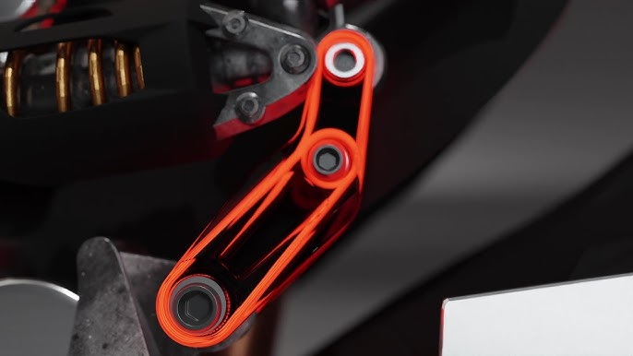
Fig 1: Suspension Rocker-Arm component

4.2 Evaluation of Existing Rocker Arm Design

4.2.1 Functional Role

Transmits suspension forces from the wheel (via a pushrod or pullrod) to the damper and spring assembly.

Rotates around a fixed axis and must maintain structural integrity under variable high loads.

Ensures stiffness and precision to maintain suspension geometry and dynamic performance.

4.2.2 Design Characteristics
- Solid cross-sections with symmetric arm structures.
- Machined holes and bearing seats for pivot, damper, and control arm attachments.
- Designed with generous safety factors due to high cyclic loads and impact conditions.
4.3 Identified Limitations in Current Design
4.3.1 Over-Engineering and Mass Excess
- Subtractive manufacturing methods necessitate conservative geometries.
- Significant material exists in low-stress zones, contributing to unnecessary weight.
- Excess mass increases unsprung weight, negatively affecting vehicle handling and suspension response.
4.3.2 Limited Load Path Efficiency
- Traditional design features straight or rectangular arms, which do not follow the true stress paths generated during operation.
- Stress concentrations are present around mounting interfaces due to abrupt geometry transitions.
4.3.3 Manufacturing Constraints
- Complex internal geometries or optimised truss-like structures are infeasible with CNC machining.
- Integration of secondary functions (e.g., sensor mounts, lubrication routing) is limited by tooling access.
4.4 Opportunities for Optimization via Additive Manufacturing
4.4.1 Mass Reduction through Generative Design
- By using Autodesk Fusion 360's Generative Design environment, the rocker arm can be reimagined to:
- Minimize material use by aligning geometry with natural stress paths.
- Automatically generate high-performance structures tailored to specific load cases.
4.4.2 Structural Efficiency
- Generative design enables organic geometries that reduce stress concentrations and evenly distribute loads.
- The resulting geometries often resemble bone or lattice structures, combining stiffness with low weight.
4.4.3 The resulting geometries often resemble bone or lattice structures, combining stiffness with low weight.
- Additive manufacturing allows incorporation of sensor mounts, wiring channels, and hollow oil ducts directly into the component.
- This reduces part count and simplifies assembly, increasing reliability and maintainability.
4.4.4 Performance Enhancements
- Reduced unsprung mass improves suspension reactivity and road holding.
- Improved stiffness-to-weight ratio enhances responsiveness and durability under racing conditions.

PROCESS OF REDESIGN OF THE SUSPENSION ROCKER ARM
With the use of Autodesk Fusion 360, the process of the redesign of the suspension rocker arm is presented below.
5.1 Step-by-step Redesign of the Suspension Rocker Arm
5.1.1 Objective: Redesign a suspension rocker arm to reduce weight, while maintaining strength.
5.1.2 Material Used: Aluminium Alloy (AlSi10Mg).
5.1.3 Create the Initial Geometry - import preserved geometry: Mounting holes (pivot points), Connection areas (rod ends, shock absorber).
5.1.4 Generative Design Workspace: Switch from Design to Generative Design workspace in Fusion 360.
5.1.5 Generative Design Set-up.
- Preserved geometry (Green): regions that must remain untouched (pivot and mounting holes).
- obstacle geometry (Red): areas where material cannot exist (clearance zones, suspension travel paths).
- Starting Shape (Yellow)
5.1.6. Apply Constraints and Loads: Apply fixed constraints (where the part is bolted).
- Apply loads: From damper and wheel contact (via pushrod).
5.1.7 Select Aluminum Material: Input material - AlSi10Mg
5.1.8 Manufacturing Method: Select Additive Manufacturing
5.1.9 Set Objectives: Select Minimize mass and set Maintain factor of safety to 3.0
5.1.10 Generate Outcomes: Run the simulation in the cloud (Fusion estimates how long it takes). Wait for design outcomes to be generated (dozens of variations based on different load paths and geometries).
5.2 Diagrams of the various stages of the redesigned suspension rocker arm
5.2.1 Imported preserved geometry
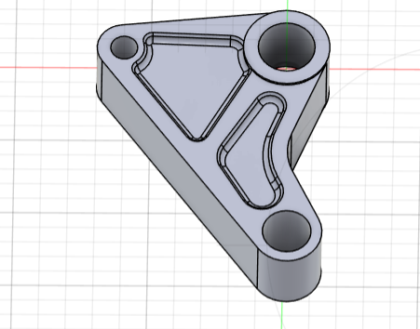
Fig 2
5.2.2 Defined geometry
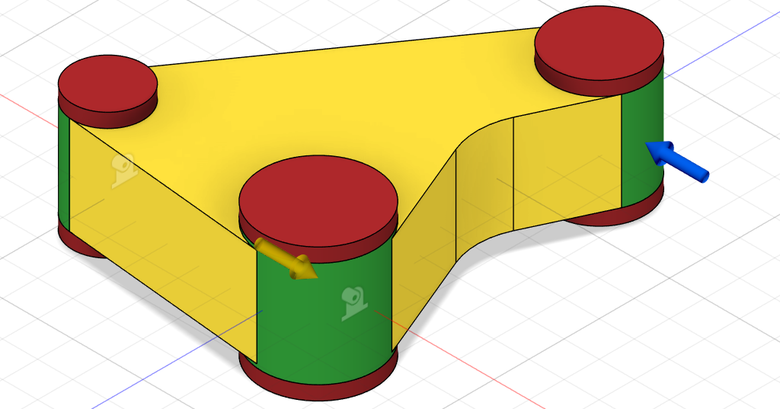
Fig 3
5.2.3 Redesigned geometry Outcome
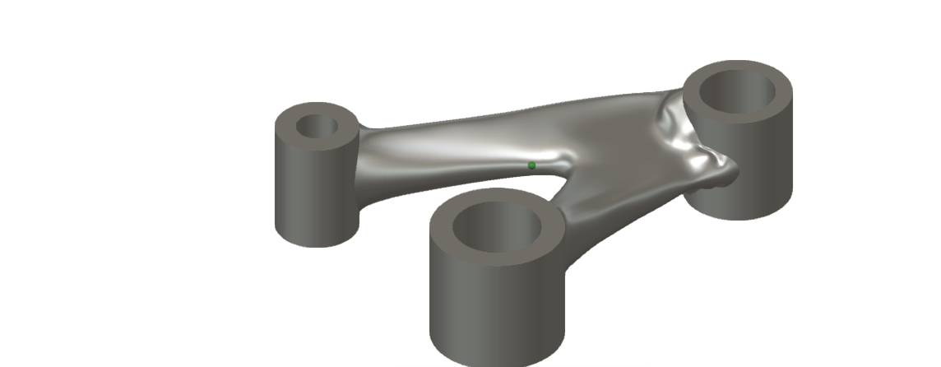
Fig 4

CONCLUSION
In conclusion, the case study of the rocker arm illustrates the transformative potential of DfAM in automotive engineering. Through the application of generative design tools, engineers can create components that are not only lighter and stronger but also more aligned with the principles of sustainable and efficient manufacturing.

REFERENCES
Barbieri, L. & Muzzupappa, M. (2022). Performance-Driven Engineering Design Approaches Based on Generative Design and Topology Optimization Tools: A Comparative Study. Applied Sciences. Available at: https://www.researchgate.net/publication/358699229_Performance-Driven_Engineering_Design_Approaches_Based_on_Generative_Design_and_Topology_Optimization_Tools_A_Comparative_Study
Desktop Metal. (n.d.). Design for Additive Manufacturing: Generative Design. Available at: https://www.desktopmetal.com/resources/design-for-additive-manufacturing-generative-design
Gibson, I., Rosen, D.W. and Stucker, B., 2021. Additive Manufacturing Technologies: 3D Printing, Rapid Prototyping, and Direct Digital Manufacturing. 3rd ed. Springer, pp. 308–317.
Herzog, D., Seyda, V., Wycisk, E. and Emmelmann, C., 2016. Additive manufacturing of metals. Acta Materialia, 117, pp.371–392.
Cecchel, S., et al. (2024). 'Evolution of prototyping in automotive engineering: a Comprehensive Study on the reliability of Additive Manufacturing for advanced powertrain components'. Frattura ed Integrità Strutturale, 68, 109-126. Available at: https://www.researchgate.net/publication/378259422_Evolution_of_prototyping_in_automotive_engineering_a_Comprehensive_Study_on_the_reliability_of_Additive_Manufacturing_for_advanced_powertrain_components
Niu, J., et al. (2015). 'Design and analysis of new suspension system for ultra-light weight green vehicle'. ICALEO 2015: 34th International Congress on Laser Materials Processing, Laser Microprocessing and Nanomanufacturing. Available at: https://pubs.aip.org/lia/icaleo/proceedings-abstract/ICALEO2015/2015/99/390046
Leutenecker-Twelsiek, M., et al. (2016). 'Optimizing the build direction for additive manufacturing'. Rapid Prototyping Journal, 22(3), 524-533. Available at: https://www.emerald.com/insight/content/doi/10.1108/RPJ-10-2015-0154/full/html
Cecchel, S., et al. (2024). 'Evolution of prototyping in automotive engineering: a Comprehensive Study on the reliability of Additive Manufacturing for advanced powertrain components'.
Leary, M., Merli, L., Torti, F., Mazur, M. & Brandt, M., 2014. Optimal topology for additive manufacture: A method for enabling additive manufacture of support-free optimal structures. Materials & Design, 64, pp. 1-15.
Stanković, T., Mueller, J., Egan, P. & Shea, K., 2015. Optimization of Additively Manufactured Multi-Material Lattice Structures Using Generalized Optimality Criteria. Computers & Structures, 158, pp. 1-11.
Zhang, F., Zhou, C. & Das, S., 2015. Multimaterial Structural Topology Optimization with a Generalized Cahn–Hilliard Model of Multiphase Transition. Structural and Multidisciplinary Optimization, 51(2), pp. 1-12

Berman, B. (2012). 3-D printing: The new industrial revolution. Business Horizons, 55(2), pp.155–162.

Ford,S. and Despeisse, M. (2016). Additive manufacturing and sustainability: an exploratory study of the advantages and challenges. Journal of Cleaner Production, 137, pp.24-25.
Gao, W. et al. (2015). The status, challenges, and future of additive manufacturing in engineering. Computer-Aided Design, 69, p. 662
Gibson, I., Rosen, D.W. and Stucker, B. (2021). Additive Manufacturing Technologies: 3D Printing, Rapid Prototyping, and Direct Digital Manufacturing. 3rd ed. Springer. PP. 172-221
Herzog, D. et al. (2016). Additive manufacturing of metals. Acta Materialia, 117, pp.6–12.
Holmström, J. et al. (2010). The direct digital manufacturing (r)evolution: Definition of a research agenda. Operations Management Research, 3(1), p. 107
Kellens, K. et al. (2017). Environmental impact of additive manufacturing processes: does AM contribute to a more sustainable way of part manufacturing? Procedia CIRP, 61, p. 1022
Rosen, D. (2007). Design for Additive Manufacturing: A Method to Explore Unexplored Regions of the Design Space. Solid Freeform Fabrication Symposium, pp.1–14.
Thompson, M.K. et al. (2016). Design for Additive Manufacturing: Trends, opportunities, considerations, and constraints. CIRP Annals, 65(2), pp.215–219.

APPENDICES
Structural Outcome
Properties:
- Status-Converege
- Generative Model-Generative model 1
- Material: Aluminium AlSi10Mg
- Orientation - Z⁺
- Manufacturing Method - Additive
- Visual Similarity - Ungrouped
- Volume (mm³) - 55,724.073
- Mass, Kg - 0.149
- Max Von Mises Stress (MPa) - 79.624
- Safety Factor Limit - 3
- Min Safety Factor -3.014
- Max Displacement Global (mm) - 0.26
Additional References
DebRoy, T., Wei, H.L., Zuback, J.S., Mukherjee, T., Elmer, J.W., Milewski, J.O., Beese, A.M., Wilson-Heid, A., De, A. and Zhang, W., 2018. Additive manufacturing of metallic components – Process, structure and properties. Progress in Materials Science, 92, pp.112–224.
Murr, L.E., Gaytan, S.M., Ramirez, D.A., Martinez, E., Hernandez, J., Amato, K.N., Shindo, P.W., Medina, F. and Wicker, R.B., 2012. Metal Fabrication by Additive Manufacturing Using Laser and Electron Beam Melting Technologies. Journal of Materials Science & Technology, 28(1), pp.1–14.
Frazier, W.E., 2014. Metal Additive Manufacturing: A Review. Journal of Materials Engineering and Performance, 23(6), pp.1917–1928.
Randle Engineering. (n.d.). 'High volume suspension arm'. Available at: https://www.randle.co.uk/case-studies/high-volume-suspension-arm/
Medellin-Castillo, H.I. & Zaragoza-Siqueiros, J., 2019. Design and Manufacturing Strategies for Fused Deposition Modelling in Additive Manufacturing: A Review. Chinese Journal of Mechanical Engineering, 32(1), pp. 1-11.

