

Task 1 – Reading Task Template
Upload your photo of your A3 in-class notes here:
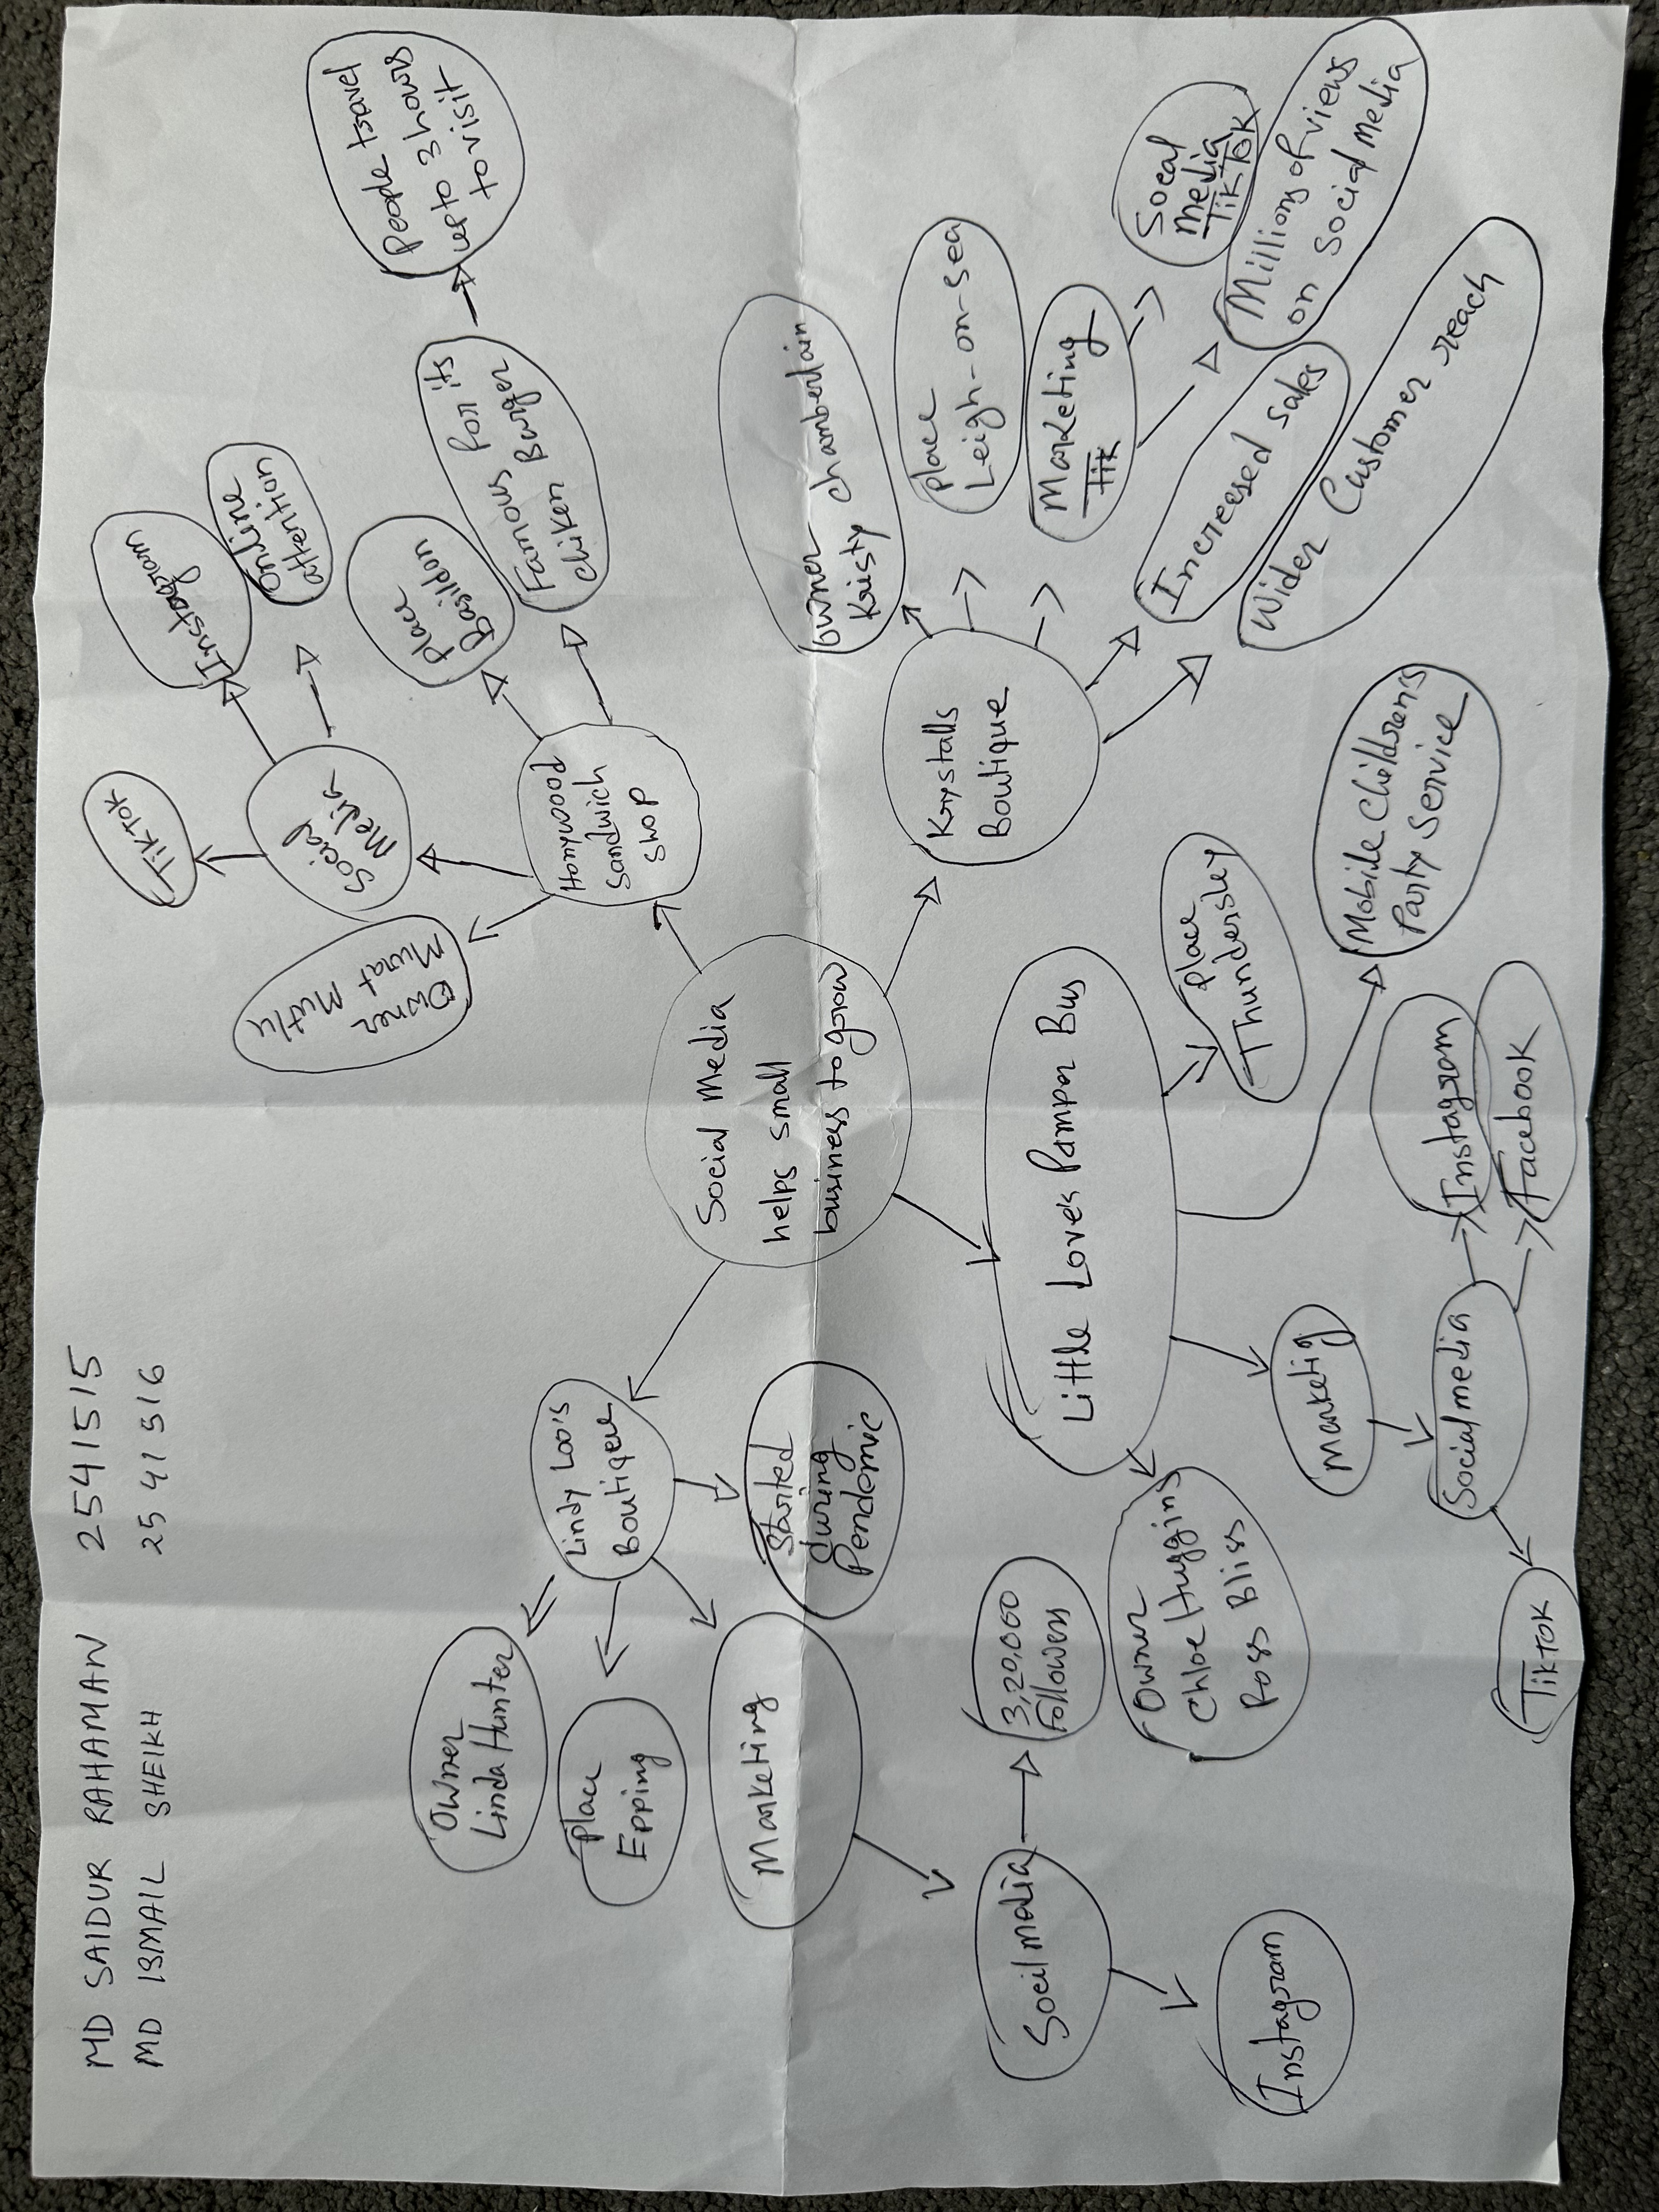

1. Answer these questions using the sentence starters below
a. What is the main idea of the text?
The main idea is that social media platforms such as Facebook, TikTok and Instagram can help small businesses become popular and attract customers from far away.
b. What are two key points?
One key point is that the Honeywood sandwich shop became famous online and people travel from distance.
Another key point is that several other small businesses increased their sales and customer numbers after their videos went viral on social media.
c. What part of the text did you find most important? Why?
The most important part is how social media helped small businesses reach thousands of new customers because it shows the powerful impact that online marketing can have on business growth.
d. Was anything unclear or difficult to understand?
I was not sure about how businesses can consistently create viral content because there is no guarantee that every post become popular.
e. How did your group help you understand the text better?
My group helped me by discussion the examples from the article and sharing different ideas about how social media influences businesses.
3. One sentence reflection
Question: What did you find challenging about this task?
The hardest part was identifying the most important information from different business examples and summarise it clearly.

