DISSERTATION TO INVESTIGATE THE INFLUENCE OF VARIOUS MODES OF ADVERTISING ON BUYING BEHAVIOURS OF CUSTOMERS IN THE UK

By
Muhammad Ansaar Khalid (2130064)

Dissertation submitted to the
University of Wales Trinity Saint David
For partial completion of an MBA General Management
Supervisor: Konstantina Mari

TABLE OF CONTENT
Topics
Chapter 1: Introduction
Chapter 2: Review of Literature
Chapter 3: Methodology
3.1 Research Philosophy, Approach and Strategy
3.2 Collection of Data (Primary and Secondary)
3.3 Formation of questionnaire
3.4 Examination of the data
Chapter 4: Empirical Analysis
4.1 Demographic Information
4.2 Influence of advertising on buying behaviours of customers
4.3 Influence of various modes of advertising
4.4 Open Ended Questions
Chapter 5: Conclusion and Discussion
Recommendations
References
Appendices

CHAPTER 1
INTRODUCTION
Advertising has been considered as an instrument of marketing to raise the number of customers through bringing newly made products into the notice of general public (Britannica, 2023). This domain is also known as brand marketing. Various global companies as well as business corporations utilise various types of advertisements to fascinate people and surge their annual sales (Weiss, 2023). Similarly, media hubs earn sound income through broadcasting these advertisements (Britannica, 2023). The most widely used mode of advertisement in developed part of the world is digital means of advertisement via different platforms like Facebook or twitter on social media, searching engine, audio and video ads etc. (Amazon Ads, 2023); however additional outdated types of advertising in most developing as well as underdeveloped countries are through print media, on fliers and commercials, and on radio and TV etc. Digital ads are more common as compared to traditional ads because individuals find it stress-free to see advertisements with a single click away.
Other non-traditional methods include “product placements, brochures and space advertisements” (Sernoff, 2022). Product placement mainly targets larger audience through featuring branded products in a joint production hub (Kenton, 2022). These are also known as embedded advertisement and are mainly telecasted in TV shows or movies. Moreover, brochure is a form of ad where information about the product is printed on the sheet (EdrawMax, 2023). This mode of advertisement is more common among tourists for map locating. Additionally, space advertisements include release of rockets in space with promotion statements of branded products (Brockwell, 2019). These statements may be visible for many days to many weeks in space as a unique, expensive and rare method of advertising (Sent into Space, 2023).
According to Indeed Survey: “On one hand, these advertisements provide instant information to the customers about the products; on the other hand, this is the fastest way to influence the customer’s behaviours to buy these products. Therefore, companies and business giants intentionally make advertisements to influence their target audience and increase their sales. Similarly, customers also tend to have various buying behaviours. Some are habitual or spendthrift buyers, some are frugal or complex buyers, some are variation-seekers, some are impulsive buyers, and some are tough decision makers or analytical buyers. All of these buyers react differently to the product advertisements” (Indeed, 2023). For instance, habitual buyers have a habit of buying things for no reason. They do not even bother for what purpose they are purchasing things. Spendthrift buyers are not too different from habitual buyers as they spend hefty amounts of money on purchase of things. Similarly, frugal customers take a lot of time in choosing options as they have no intention to spend money easily. Moreover, variation-seekers tend to look for various options available in the market and thoroughly compare them for their pros and cons. For these behaviours, the corporations choose their embattled consumers and later on project the advertisements appropriately.
The United Kingdom is augmented with different customers due to high number of migrants in the country (Vargas-Silva and Rienzo, 2022). There have been five different types of buyers reported so far in the UK (Wren, 2022) These are new, impulse, angry, insistent and loyal buyers (Wren, 2022). New buyers are those who have various queries for their choices and purchases. Impulse buyers are really quick in decision-making for their purchase. Angry customers are those who are not friendly in nature. Inconsistent buyers are those who always tend to have some proof to satisfy their choices of purchase. Loyal customers are those who do not change their brands with preferable choices at any cost (Wren, 2022). Overall, all these types of buyers are kept under consideration when a certain ad is made by advertising agencies for buyers in the UK.
According to the world bank (2023) survey, the typical buying behaviour of people living in the UK has been changed after Brexit. Very few people feel optimistic about the change while most of them are worried. The panic was clearly visible in their quest for searching options for online purchase from other countries via Amazon within last month that reached up to eighty-six percent. World bank report (2023) also revealed that brand loyalty has been the most sensitive matter while cost effectivity comes afterwards. Similarly, sixty-eight percent of Brits consider ethical behaviour of brands before any purchasing activity. Moreover, about twenty-eight percent Brits still prefer to go to stores for buy the products physically. Digital advertising has also taken over the minds of people as it has been targeting audience specifically in certain regions in the UK. For instance, urbanised regions are more prone to get hit by digital advertisements while rural areas are ignored most of the times (World Bank, 2023).
Culturally, the England, the Scotland, Wales, and Northern Ireland are quite different and diverse. Advertising agencies target specific audience that instigate sense of prominence among those chosen ones. For instance, ad slogans like ‘Nothing Beats a Londoner’ or ‘We are not an island’ show preference of targeted audience from London and cities with coastline, respectively (World Bank, 2023). Moreover, generics, like The Best Meal in Town, Best Vegan Meal, Best Skincare, Best paint company, are also used to attract customers (L’Estrange and Allen, 2021). The study revealed that about twenty-eight percent of people prefers to go for physical shopping as they don’t rely on online shopping at all. Similarly, the individuals who prefer online shopping belong to age group 35 and above (L’Estrange and Allen, 2021). Interestingly, they also reported that out of four persons in UK, one has bought clothing from a new shop in last year only.
Therefore, the current research work is an endeavour to investigate the impact of different modes of advertising on customers as the previously existing studies were conducted mainly before Brexit and Covid 19 scenario.
Aims and Objectives
The present study is aimed at investigating the influence of various modes of advertising on buying behaviours of customers in the UK. Keeping in view the aims, the objectives of the present research are to:
- understand the use of various modes of advertisements in the UK
- analyse the influence of various modes of advertisements on customer’s buying behaviours in the UK
- find the reasons of the most popular modes of advertisements among public in the UK
- observe the least liked modes of advertisements among public in the UK

CHAPTER 2
REVIEW OF LITERATURE
All the activities required to communicate a sponsored message and encourage the purchase of goods are included in advertising (Stanton, 1984). Customers start their buying journeys with advertisements. It is supported by Ehrenberg’s Awareness-Trail-Reinforcement (ATR) paradigm from 1974. The primary purpose of advertisements is to increase the number of potential clients for product sales (Britannica, 2023). Different global corporations, industry behemoths, and advertising firms employ various forms of advertising to draw in customers and boost revenue (Weiss, 2023). The most popular method of advertising nowadays is digital, which is done through a variety of social media sites including Google, Bing, Facebook, Instagram, Twitter, LinkedIn, Pinterest, and Amazon (Gibbons, 2020). It also covers display ads, audio and video streaming adverts, and search engine marketing (Amazon Ads, 2023). Print advertisements in periodicals, newspapers, and billboards, as well as audio and visual advertisements aired on radio and television, are some conventional forms of advertising. On the screens of mobile devices like smartphones, tablets, and laptops, people find it simpler to access adverts with just one click. Product placements, pamphlets, and space advertisements are some other uncommon methods (Sernoff, 2022). In comparison to traditional modes of advertising, digital modes are more affordable, non-intrusive, non-interruptive, provide real-time results and fast publicity, boost brand image, incorporate worldwide participation, and are simpler to study (Saini, 2017).
In their investigation into how commercials affect consumers’ various purchasing behaviours, Siddiqui et al. (2021) concluded that advertising had a significant impact on consumers’ decisions to favour certain products over others. Additionally, they said that one of the major elements affecting a customer’s access to different adverts and purchasing decisions is their economic situation. Dhore and Godbole (2018) examined the effects of online advertisements on Indian consumers’ purchasing patterns. The study found that consumers are frequently altering their purchase decisions based on advertisements as a result of the fast-evolving internet infrastructure. According to Shetty et al. (2019), marketing strategies with high-quality advertisements encourage clients to make the most purchases. Their research showed that those between the ages of 18 and 28 were among the most regular consumers, and that one of the most important characteristics when being swayed by specific advertisements was a person’s economic independence.
Customers are influenced to start making purchases by adverts’ layout. Niazi et al. (2012) looked at the strategies for effective advertising and also examined how they affected consumers’ purchasing decisions. The notion that customers who have access to online and social media forums are more likely to be convinced by these adverts was also validated by Dhore and Godbole (2018). The effects of radio, newspaper, television, and online advertisements on Tanzanian consumers were also highlighted by Mbura and Kagoya (2021). According to the survey, consumers were only affected by the media that they could access; for instance, radio and television received favourable ratings, while internet media did not. Due to the information they had, Tanzanian companies focussed more on providing highly regarded advertising platforms. The largest international advertising platforms are Google, Bing, Facebook, Instagram, Twitter, LinkedIn, Pinterest, and Amazon; less popular ones include Bidvertiser, AdRoll, etc. (Gibbons, 2020). According to Haider and Shakib (2018) and Ha et al. (2011), advertisements play a role in customers switching their loyalty from one long-standing company to another. As a result, one might assert that advertising reform customers’ lives. It immediately impacts human psychology and compels people to alter their priorities more quickly. This viewpoint that it is the gimmick integrated while designing ads that directly strike the customer’s psychology and persuade him to buy the goods is also supported by O’Shaugnessy’s 2003 book Persuasion in advertising.
Sama (2019) carried out a study on the effect of these advertisements run on radio, TV, newspaper, mags, journals and other print media on behaviour of customers for their regular purchases. The study revealed that the most people in that target region of respondents get influenced by newspaper while TV and internet has lower impact than newspaper. The probable reasons the paper provided were accessibility of newspaper in that region was smooth than that of TV and internet. Similarly, the purchasing activity has been severely affected by TV in some areas under study. They also provided some factors affecting purchasing activity as awareness, interest, emotions and convictions. They also investigated not only effect on purchasing but also studied post purchasing behaviours opted by buyers.
To analyse the impact of advertisement on buying behaviours with special focus on cosmetic products, a research study was carried out by Ampofo (2014). The study confirmed that the respondents’ buying attitude was provoked by advertisements and they also started recommending the products to others due to these very advertisements. Similarly, Kabarwala (2019), Tamizhjyothi (2013), Rai (2013), Rix (2007), as well as Goldsmith and Lafferty (2002) investigated the impact of advertising as a non-verbal communication on customers. The results of each of these researches revealed that the quality of product, prices, cost-effectivity, branding, celebrity endorsement highly impacts and motivates the customers. Moreover, digital advertisements are the most widely used and advanced way of accessing product information.
Various researches focused on impulsive buying as a reaction of digital advertising (Rodrigues et al., 2021). A research mentioned that due to ease of accessibility of digital ads through mobile and internet, the market competition has increased significantly (Varadarajan, 2020). As a result, thhe MNCs and business giants are forced to develop competitive ads with huge investments to beat the other stakeholders and increase their market value (Ding et al., 2020). Another research asserted that decisions and post purchase behaviours are highly influenced by these very advertisements (Stankevich, 2017). Additionally, it was referred that people with young age group are more influenced than the older ones after seeing the advertisements (Meena, 2018). Therefore, most ads tend to focus and target on youth. Moreover, the role of sales induced promotions has been another sensitive factor that affect the purchasing activities (Khan et al., 2019).

CHAPTER 3
METHODOLOGY
This research work includes quantitative research strategy through questionnaire method followed by data analysis.
3.1 Research Philosophy
Positivist research philosophy is the most adequate and apt for quantitative assessment of information. According to this philosophy, all existing theories are used and interpreted during the investigation. The positivist school of thought prefers to conduct quantitative research of data such as questionnaire based survey that has been opted for present research (Muhaise et al., 2020). It assists in creating a relation between educational perspectives as well as societal class differences and preferences (Maarouf, 2019). This philosophy prefers to answer clearly, descriptively and openly that depicts feelings and emotions freely without any hesitation. It is vividly said that positivist theory and qualitative methods concur in synchronisation (Su, 2019).
As far as the significance of positivist research philosophy is concerned, it focuses on social norms and factors and brings about social change in the society (Maarouf, 2019). The quantitative methods of research permit the researchers to gather data into large sets and correlate them to find cause of an event and its consequence of human life. Social surveys stand atop in this category. For current research work, it is evident that the positivist research philosophy is enough and apt to understand the customers’ behaviour among the Brits.
3.2 Research Approach
Deductive research approach has been opted for the quantification of the information provided for generalised conclusion (Maarouf, 2019). It initially begins with formulating a theory based on perception, then deducing a hypothesis from it, and later on gathering and analysing the raw data through certain analysis. Basically, it is a type of method that generalise the hypothetical interpretations and then verify it through data collection that we have been doing in the form of questionnaire. This method is also known as top-down method that initiates with general supposition to reach at a specific conclusion.
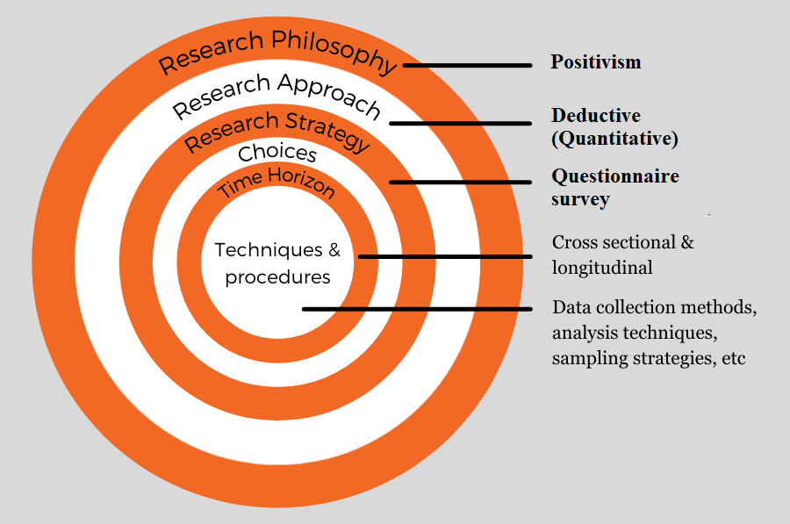
Figure 1: Research Onion (Source: “Saunders et al., 2007”)
There are several benefits of deductive approach. First, it provides a possibility to reach at a conclusion from general suppositions. Second, it explains the causes and consequences of certain phenomenon. Third, it allows the researchers to apply their results on broader approaches (Su, 2019). For this research our suppositions can be various, such as, my opinions and choices change with nature/ quality of advertisements, do you pay attention to online advertising? Do you buy unnecessary things while seeing these advertisement? Your preferred mode of advertisement is: Radio, Print (Newspaper, magazine, brochures etc.), TV, Mobile, Internet or all of these. Similarly, do you think you have changed your brand loyalty due to advertisement? Have you ever noticed advertisements on print media? During TV shows, do you keenly observe advertisements during breaks? Do pop-up advertisements on the internet bother you? Do you use your mobile to see advertisements to get an idea about a product?
3.3 Research Strategy
The research strategy will be comprised of formation of a questionnaire. The data will be collected via Goggle Forms and later on analyse through Excel. A questionnaire is a great tool of research that gathers answers of questions based on public opinion. These questions are arranged in order for meaningful data collection to fulfil aims and objectives of the research.
3.3.1 Collection of Data (Primary and Secondary)
The general people will be polled for the primary data via a questionnaire. 100 people will remain the sample size. The secondary data will be acquired from readily available sources such academic journals, books, blogs on the internet, and reliable websites.
    - Formation of Questionnaire
A number of inquiries will be performed to comprehend public opinion on the basis of primary and secondary research questions obtained from the study's objectives. The most common question type will be a dichotomous one, asking respondents to respond with a yes or no on whether they agree or disagree. There will be between 20 and 25 of these. To get the most accurate picture of what the general population thinks about how they purchase after seeing advertisements on various platforms, certain open-ended questions will also be added. The order of the questions will place the most critical (primary) questions first and the less critical (secondary) questions second. In addition, 5 to 6 demographic questions about age, gender, income, and education will be asked. The responses of the participants will be kept anonymous to protect people's privacy. The survey is located in Appendix A.
    - Examination of the data
Microsoft Excel software will be used to analyse the primary data that was gathered through the questionnaire. There will be a calculation of the proportion of all agreed or disputed replies. For easier understanding, a report will be created and provided in the Google Forms as charts.

CHAPTER 4
EMPIRICAL ANALYSIS
The empirical analysis mainly comprises of four sections: demographic information, influence of advertising on buying behaviours of customers, influence of various modes of advertising, and open ended questions.
4.1 Demographic Information
Initially, the respondents were asked about their personal and demographic information.
4.1.1 Age Group
In this section, the first question asked was about their age group. The provided age groups were below 18, 18-34, 35-54, 55-74 and above 74. The result revealed that 90.7 % of the respondents belonged to the age group 18 to 34 (Fig. 1). While other ager groups were below 10 % in total. These statistics also suggest that the most frequent users of internet are from the same age group who get influenced quickly by various mode of advertising. The least number of respondents were from age group under 18. However, age groups 35-54 and 55-74 were between 2 to 6 % in total.
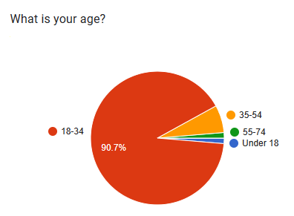
Fig 1. Age groups of respondents
4.1.2 Gender
Afterwards, the respondents were asked about their gender. The provided choices were male, female and prefer not to say. The result revealed that 57.3 % of the respondents were male while 40 % of the respondents were females, whereas 2.7 % preferred not to mention their gender (Fig. 2).
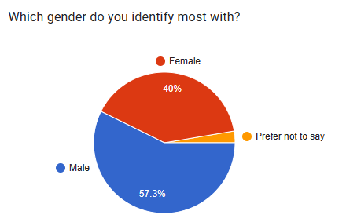
Fig 2. Gender of respondents

4.1.3 Monthly Income Group
The next question from the respondents was about monthly income group. The provided categories were less than £2000, £2000-£4000, 4000-£6000 and above £6000. The result revealed that 65.3 % of respondents were having less than £2000 monthly salary that also indicates age group between 18 to 34. Similarly, 17.3 % of respondents were having monthly salary £2000-£4000, 12 % of respondents were having monthly salary above £6000 while less than 10 % respondents were having monthly salary between £4000-£6000 (Fig. 3). Overall, the majority of the respondents were having monthly salary less than £2000.
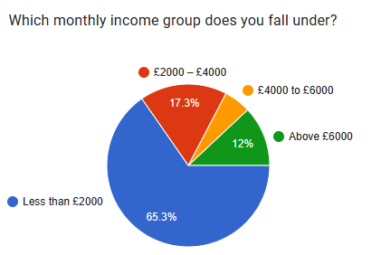
Fig 3. Monthly income of respondents

4.1.4 Current Employment Status
The subsequent question from the respondents was about their current employment status. The provided categories were full-time employment, part-time employment, unemployed, self-employed, home-maker, student or retired. The end result stated that 69.3 % of respondents were students (who have less than £2000 monthly salary and their age group is between 18 to 34). Likewise, 10.7 % of respondents were full-time employed and 9.3 % of respondents were part-time employed, while very few respondents were unemployed, home-maker or self-employed (Fig. 4). While there were no respondents who were retired.
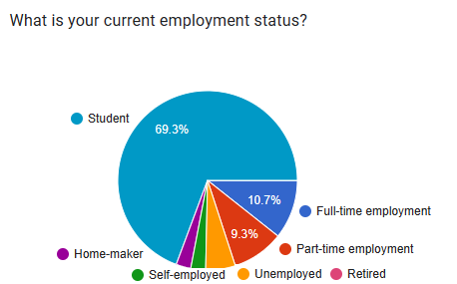
Fig 4. Current employment status of respondents

4.1.5 Highest Qualification
The next question from the respondents was about their highest qualification. The provided categories were no degree, less than a high school diploma, high school diploma or equivalent, bachelor’s degree, master’s degree or doctorate. The result showed that 44 % of respondents were having high school diploma or equivalent, 28 % of respondents were having bachelor’s degree, 12 % of respondents were having master’s degree and 12 % were also having no degree at all, while very few respondents were having less than a high school diploma (Fig. 5). Only one respondent was doctorate in qualification.
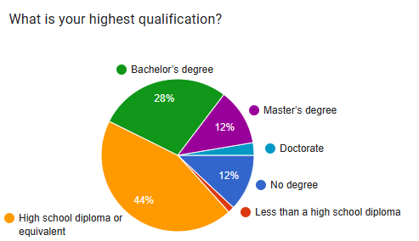
Fig 5. Highest qualification of respondents

4.2 Influence of advertising on buying behaviours of customers
After demographic information, the respondents were asked about the influence of advertising on buying behaviours of customers.
4.2.1 Interest of customers in seeing advertisements of new products
In this section, the first question asked was about the interest of customers in seeing advertisements of new products. The result revealed that 73.3 % of the respondents keenly see advertisement of new products (Fig. 6). One thing to mention is that the majority of the respondents belong to age group 18-34 that ensures the active participation from youth. However, 26.7 % of the respondents showed no interest in seeing advertisements of new products. This percentage also shows that majority of the respondents have an inclination towards seeing advertisements to have information about new products.
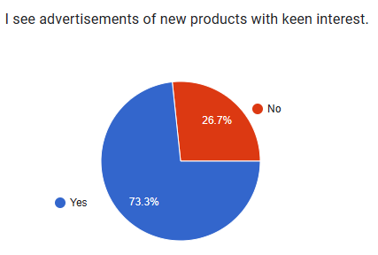
Fig 6. Percentage of customers to see advertisements of new products keenly

4.2.2 Looking for advertisements when intend to buy new products
The subsequent question asked was planning about looking for advertisements when intend to buy new products. The result showed that 68 % of the respondents look for advertisements before plan to buy new products. However, 32 % of the respondents showed no interest in looking for advertisements before buying new products (Fig. 7). This higher %age shows that most of the respondents have an inclination towards seeing advertisements to have information about new products prior to its purchase.
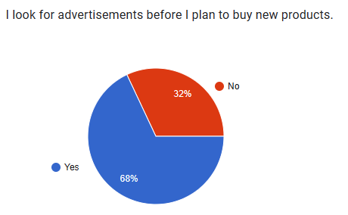
Fig 7. Percentage of customers to see advertisements of new products as a must before purchase

4.2.3 Consideration of advertisements as an authentic way of getting information about new products
The next question inquired was about consideration of advertisements as an authentic way of getting information about new products. The result indicated that 50.7 % of the respondents consider advertisements as an authentic way of getting information about new products. Contrarily, 49.3 % of the respondents opposed this consideration (Fig. 8).
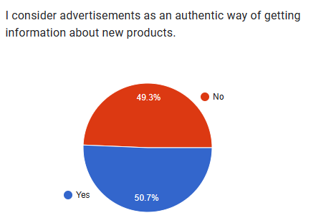
Fig 8. Percentage of customers considering advertisements as an authentic way of getting information about new products

4.2.4 Consideration of advertisements as an authentic way of getting information about new products and brands
The following question was about the consideration that advertisements keep customers updated about new products and brands. The result revealed that 92 % of the respondents believed firmly that advertisements do keep customers updated about new products and brands. Whereas, merely 8 % of the respondents believed that advertisements do not keep customers updated about new products and brands (Fig. 9). This higher %age shows that majority of the respondents see advertisements to remain updated about new products and brands.
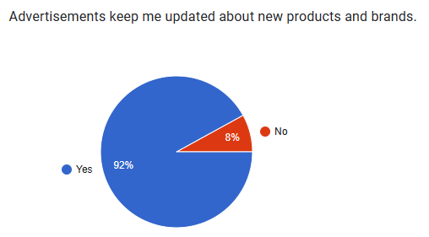
Fig 9. Percentage of customers that consider advertisements as a way to remain updated about new products and brands

4.2.5 Influence of advertisements on decision-making ability while purchasing any product
The subsequent question was about influence of advertisements on decision-making ability while purchasing any product. The result showed that 64 % of the respondents believed that their decision of purchasing any product gets influenced by advertisements. Similarly, 6 % of the respondents thinks contrarily and feel independent from influence of advertisements while purchasing any product (Fig. 10). This high %age shows that most of the respondents get their decision influenced from advertisements while purchasing any product.
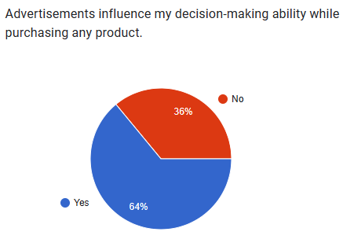
Fig 10. Percentage of customers to see advertisements of new products keenly

4.2.6 Getting convinced as customers by the claims made by brands about products in advertisements
Next question was about getting convinced as customers by the claims made by brands about products in advertisements. 38.7 % of customers agreed to the question posed that they get easily convinced by the claims made by brands about products in advertisements. However, 61.3 % of the respondents that reflects majority of the respondents believe that they do not get easily convinced by the claims made by brands (Fig. 11). This also pose a question on credibility of multinational corporations (MNCs) over the quality and price etc. of products.
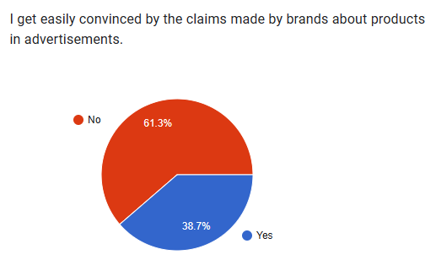
Fig 11. Percentage of customers that get easily convinced by the claims made by brands about products in advertisements

4.2.7 Choosing a brand repeatedly due to advertisements
The subsequent question was about choosing a brand repeatedly due to advertisements. The result showed that 44 % of the respondents believed that they repeatedly choose a brand due to their advertising. However, 56 % of the respondents considers independence from the very influence of advertising for choosing a brand to purchase certain product (Fig. 12). This higher %age shows that not most of the respondents choose a brand repeatedly due to advertisements.
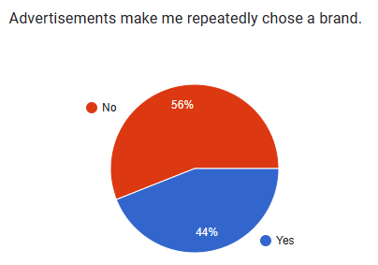
Fig 12. Percentage of customers that choose a brand repeatedly due to advertisements

4.2.8 The promotional offers made in an advertisement that make the customers feel attracted to purchase that product
The following question was about the promotional offers made in an advertisement that make the customers feel attracted to purchase that product. The result revealed that 77.3 % of the respondents strongly believed that promotional offers made in advertisements do keep customers attracted while purchasing new products. However, 22.7 % of the respondents considered these promotional offers in advertisements do not make customers feel attracted to purchase that product (Fig. 13). This higher %age indicates that majority of the respondents find these promotional offers attractive while purchasing products.
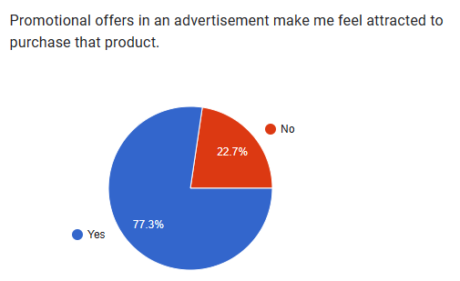
Fig 13. Percentage of customers that find promotional offers in an advertisement attractive while purchasing a product

4.2.9 Satisfaction of customers while seeing advertisement of that brand from where they prefer to purchase
The next question inquired was about satisfaction of customers while seeing advertisement of that brand from where they prefer to purchase. The result revealed that 78.7 % of the respondents feels satisfied while seeing advertisement of that brand from where they prefer to purchase. Contrarily, 21.3 % of the respondents opposed this feeling of satisfaction and they said that they are independent of the influence of advertisements or selection of a specific brand (Fig. 14). The higher %age indicates satisfaction of customers while seeing advertisement of that brand from where they prefer to purchase.
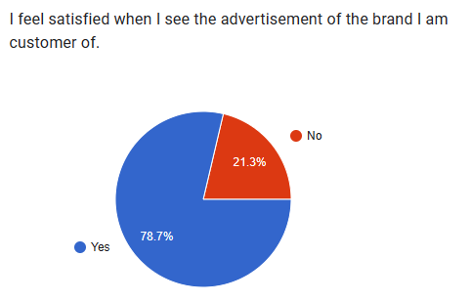
Fig 14. Percentage of customers that feel satisfied when see advertisements of the brands from where they regularly purchase

4.2.10 Purchasing a product when dislike their advertisement
The next question from the respondents was about purchasing a product when dislike their advertisement. The result showed that 88 % of respondents do not buy a product if they dislike the advertisements of any product. Whereas, only 12 % of the respondents buy certain product whose advertisement is least liked to them (Fig. 15). The higher %age indicates no purchase of a product when customers dislike their advertisement.
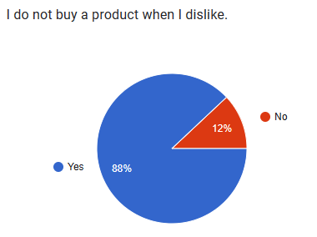
Fig 15. Percentage of customers who do not buy a product when dislike their advertisement

4.3 Influence of various modes of advertising
In the next section, the respondents were asked about the influence of various modes of advertising.
4.3.1 The opinions and choices of the customer that may or may not change with nature or quality of advertisements
In this segment, the first question asked was about the opinions and choices of the customer that may or may not change with nature or quality of advertisements. The result revealed that 61.3 % of the respondents’ opinions and choices change with nature or quality of advertisements (Fig. 16). However, 38.7 % of the respondents said that their opinions and choices do not change with nature or quality of advertisements. This %age value signifies that the opinions and choices of the customer may change with nature or quality of advertisements.
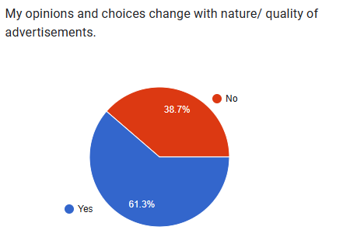
Fig 16. Percentage of customers who do not buy a product when dislike their advertisement

4.3.2 Paying attention to online advertising
The next question from the respondents was about paying attention to online advertising. The result showed that 52 % of respondents prefers online advertising. Whereas, 48 % of the respondents do not prefer online buying (Fig. 17).
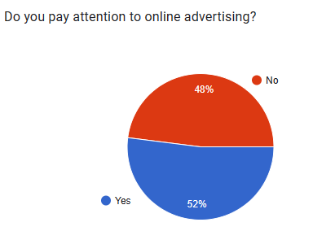
Fig 17. Percentage of customers who do not buy a product when dislike their advertisement

4.3.2 Buying unnecessary things while seeing their advertisement
The next question inquired was buying unnecessary things while seeing their advertisement. The result revealed that only 36 % of the respondents buy unnecessary things due to advertisements. Contrarily, 64 % of the respondents opposed this kind of purchase and never buy unnecessary things because of advertisements (Fig. 18). This higher %age indicates skepticism of customers over advertising of brands.
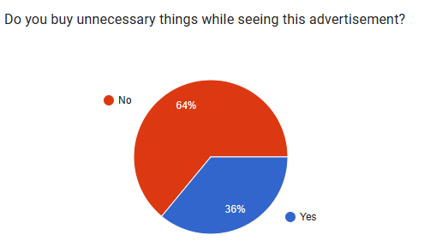
Fig 18. Percentage of customers who do not buy a product when dislike their advertisement

4.3.3 The preferred mode of advertisement
The following question was about the preferred mode of advertisement. The options provided were radio, print (newspaper, magazine, brochures, TV, mobile, internet or all of these). The result revealed that 44 % of the respondents opted Internet, 21.3 % of the respondents chose all of these and 21.3 % of the respondents chose mobile as preferred mode of advertisement. However, 9.3 % of the respondents opted for TV as a mode of viewing advertisement (Fig. 19). This higher %age of Internet and mobile phone indicates that majority of the respondents find it easier to use mobile phone and internet for purchasing products via advertisements. Whereas, none chose radio as the preferred mode of advertisement.
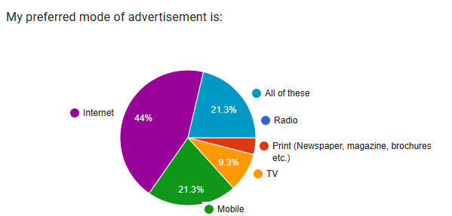
Fig 19. Percentage of preferred mode of advertisement

4.3.4 Factors that influence the purchase
The subsequent question was about the factors that influence the purchase. The options provided were advertising, brand, price, recommendation from others, quality, packaging and other. The result revealed that 38.7 % of the respondents opted for quality, 24 % of the respondents chose brand, 16 % of the respondents chose price as high factor affecting purchase and 14.7 % of the respondents chose recommendation from others (Fig. 20). This overall higher %age was of quality and then brand label that indicates customers’ choice.
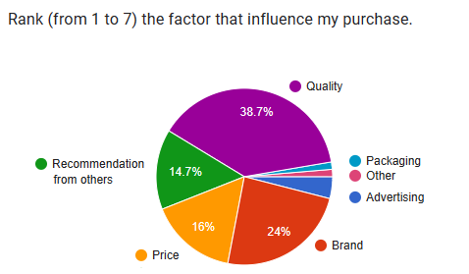
Fig 20. Percentage of factors that influence the purchase

4.3.5 Brand loyalty due to advertisement
The next question was about the brand loyalty due to advertisement. The result showed that 56 % of the respondents certainly affirmed that they have changed their brand loyalty due to advertisement. However, 44 % of the respondents denied that they have changed their brand loyalty due to advertisement (Fig. 21). This %age of showed a mixed response from the respondents regarding the brand loyalty due to advertisement.
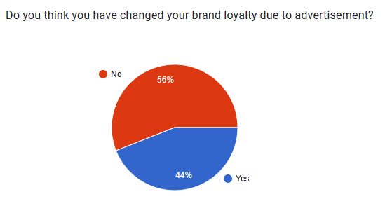
Fig 21. Percentage of customers that changed brand loyalty due to advertisement

4.3.6 Use of print media for advertisement
The following question was about the use of print media for advertisement. The result revealed that 72 % of the respondents have noticed advertisements on print media. However, 28 % of the respondents have never noticed advertisements on print media (Fig. 22). This high %age of inclination towards advertisements reveal that people tend to see print media for various purposes.
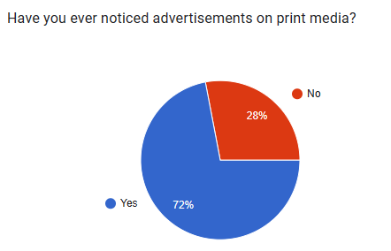
Fig 22. Percentage of customers who have ever noticed advertisements on print media

4.3.7 Keen observation of advertisements during TV show breaks
The subsequent question was about the keen observation of advertisements during TV show breaks. The result showed that 61.3 % of the respondents denied that they never keenly observe advertisements during TV show breaks. In fact, they get exhausted from it. Moreover, 38.7 % of the respondents agreed that they keenly observe advertisements during TV show breaks (Fig. 23). This higher %age of denial indicates that majority of the respondents find it boring to see advertisements during TV show breaks.
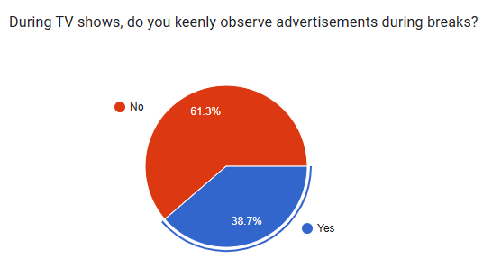
Fig 23. Percentage of customers who keenly observe advertisements TV show breaks

4.3.8 Pop-up advertisements on the internet whether they bother the customers or not
The following question was about the pop-up advertisements on the internet whether they bother the customers or not. The result revealed that 70.7 % of the respondents opted for yes. However, 29.3 % of the respondents disagreed to the question posed (Fig. 24). This higher %age of clearly indicates that majority of the respondents find it troublesome to use internet with pop-up advertisements.
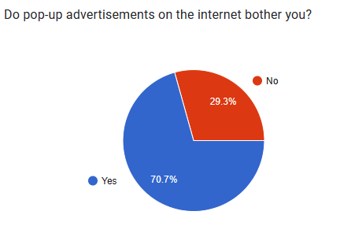
Fig 24. Percentage of customers who get bothered by pop-up advertisements on the internet

4.3.9 Seeing the advertisements through mobile phone to get an idea about a product
The next question was about seeing the advertisements through mobile phone to get an idea about a product. The result revealed that 69.3 % of the respondents use mobile phone to see advertisement to get an idea about a product. However, 30.7 % of the respondents do not use mobile phone to see advertisement to get an idea about a product (Fig. 25). This higher %age of advertisement indicates that people use mobile phone to see advertisement to get an idea about a product.
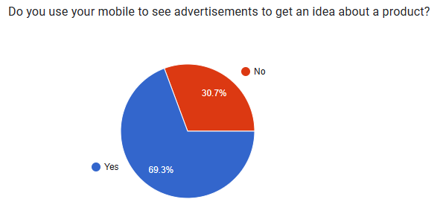
Fig 25. Percentage of customers who use mobile to see advertisements to get an idea about a product

4.4 Open Ended Questions
The final section of the questionnaire dealt with open ended questions. Respondents were provided with the choice to answer anything they feel appropriate about the questions asked. The first question was what do you look out for in an advertisement? The most frequent answers were quality, colour, style, quality of product, product info and features, sales, price, quality of brands, product nature, honesty of brand, creativity, short time duration, informative, entertaining, humorous, packaging, discount offer, affordability, creativity, and cosmetics and clothes (See Appendix B1).
The next question was why one of the following is your preferable mode of advertisement? (Radio, Print, TV, Mobile, Internet, All of these). The most common answers were in following order: Internet was the most preferable mode of watching advertisement for most of the customers. TV was the second preferable mode of watching advertisement for most of the customers. Mobile was the third preferable mode of watching advertisement for most of the customers and then print media was the least preferable mode of watching advertisement for most of the customers (See Appendix B2).
Subsequent question was what would be the world like without advertisements? The frequent answers were boring, dull, difficult, colourless, world of unawareness, less attractive, outdated, better place, peaceful, calm, happier, less commercialized, uninformed, same, irritating, less updated, less consumerism in the world, natural peace, stone age era, finish, and the product couldn’t get high reach in customer (See Appendix B3). The subsequent question was if you have ever gotten angry at some advertisement? The most common answer was yes, while few chose no and two people chose perhaps as an answer (See Appendix B4).
The following question was to name some advertisements that you like? Also state the reasons? The most common answers were people prefer advertisements that are funny, are less than 5 seconds in duration, give new scientific information, online advertising, of apparels for better knowledge of what is in fashion, drinks (Coca cola and pepsi etc.), chocolates, detergent, skin care, clothes, mobile phone advertisements, ads featuring cricketers, food related ads, the Apple “Think Different” campaign, Nike “Just Do It” campaign, Fanta ad because of the vibrant colours, advertisement of cars, Ramadan and Eid ads, washing powder ads, acne treatment products and books related ads (See Appendix B5).
Next question was to name some advertisements that you dislike? Also state the reasons? The answers received were people dislike fake ads, all debt ads, longer adds, skin whitening, super market, romantic ads, ads with hatred in any case, washing powders and pop-ups ads, home accessories, biscuit ads, advertisements that are sexist, racist, or promote harmful stereotypes. As these types of ads perpetuate negative attitudes and behaviours towards certain groups of people and can be very damaging, advertisement based on paid you tubers’ reviews, an ad that might claim that if you don’t buy a certain brand of toothpaste than you will get cavities, gum disease etc. (See Appendix B6).
The subsequent question was to infer the opinion that what makes an advertisement effective. Most common answers were its location, short duration, price, quality, audio/video quality, graphics, packages offered, story of advertisement, moral lesson oriented ads, music, content, celebrities, clearly stating quality and price of products, innovative, strategy driven, brand oriented, updated technology, humorous, affordable price, free delivery, creativity, public interest, offering discount, quality based satisfaction, feedback or customer reviews, correct information (no exaggeration), sarcasm as well patriotic (See Appendix B7).

CHAPTER 5
CONCLUSION AND DISCUSSION
In the present research, the personal and demographic information was obtained. Out of the provided age groups (below 18, 18-34, 35-54, 55-74 and above 74), 90.7 % of the respondents belonged to the age group 18 to 34, while age groups 35-54 and 55-74 were between 2 to 6 % in total. The least number of respondents were from age group under 18. For the question related to gender, the provided choices were male, female and prefer not to say. The result revealed that 57.3 % of the respondents were male while 40 % of the respondents were females, whereas 2.7 % preferred not to mention their gender. For the question related to monthly income group, the provided categories were less than £2000, £2000-£4000, 4000-£6000 and above £6000. The result revealed that 65.3 % of respondents were having less than £2000 monthly salary that also indicates age group between 18 to 34. Similarly, 17.3 % of respondents were having monthly salary £2000-£4000, 12 % of respondents were having monthly salary above £6000 while less than 10 % respondents were having monthly salary between £4000-£6000. Overall, the majority of the respondents were having monthly salary less than £2000.
About the current employment status, the end result stated that 69.3 % of respondents were students (who have less than £2000 monthly salary and their age group is between 18 to 34). Likewise, 10.7 % of respondents were full-time employed and 9.3 % of respondents were part-time employed, while very few respondents were unemployed, home-maker or self-employed. Whereas, there were no respondents who were retired. For the question related to the highest qualification, the result showed that 44 % of respondents were having high school diploma or equivalent, 28 % of respondents were having bachelor’s degree, 12 % of respondents were having master’s degree and 12 % were also having no degree at all, while very few respondents were having less than a high school diploma. Only one respondent was doctorate in qualification (Meena, 2018).
After demographic information, the respondents were asked about the influence of advertising on buying behaviours of customers. In this section, the first question asked was about the interest of customers in seeing advertisements of new products. The result revealed that 73.3 % of the respondents keenly see advertisement of new products while 26.7 % of the respondents showed no interest in seeing advertisements of new products. The subsequent question asked was planning about looking for advertisements when intend to buy new products. The result showed that 68 % of the respondents look for advertisements before plan to buy new products and 32 % of the respondents showed no interest in looking for advertisements before buying new products. The next question inquired was about consideration of advertisements as an authentic way of getting information about new products. The result indicated that 50.7 % of the respondents consider advertisements as an authentic way of getting information about new products and 49.3 % of the respondents opposed this consideration. The following question was about the consideration that advertisements keep customers updated about new products and brands. The result revealed that 92 % of the respondents believed firmly that advertisements do keep customers updated about new products and brands and 8 % of the respondents believed that advertisements do not keep customers updated about new products and brands. The subsequent question was about influence of advertisements on decision-making ability while purchasing any product. The result showed that 64 % of the respondents believed that their decision of purchasing any product gets influenced by advertisements and 6 % of the respondents thinks contrarily and feel independent from influence of advertisements while purchasing any product. Next question was about getting convinced as customers by the claims made by brands about products in advertisements. 38.7 % of customers agreed to the question posed that they get easily convinced by the claims made by brands about products in advertisements and 61.3 % of the respondents that reflects majority of the respondents believe that they do not get easily convinced by the claims made by brands. The subsequent question was about choosing a brand repeatedly due to advertisements. The result showed that 44 % of the respondents believed that they repeatedly choose a brand due to their advertising and 56 % of the respondents considers independence from the very influence of advertising for choosing a brand to purchase certain product. The following question was about the promotional offers made in an advertisement that make the customers feel attracted to purchase that product. The result revealed that 77.3 % of the respondents strongly believed that promotional offers made in advertisements do keep customers attracted while purchasing new products and 22.7 % of the respondents considered these promotional offers in advertisements do not make customers feel attracted to purchase that product. The next question inquired was about satisfaction of customers while seeing advertisement of that brand from where they prefer to purchase. The result revealed that 78.7 % of the respondents feels satisfied while seeing advertisement of that brand from where they prefer to purchase and 21.3 % of the respondents opposed this feeling of satisfaction and they said that they are independent of the influence of advertisements or selection of a specific brand. The next question from the respondents was about purchasing a product when dislike their advertisement. The result showed that 88 % of respondents do not buy a product if they dislike the advertisements of any product while only 12 % of the respondents buy certain product whose advertisement is least liked to them.
In the next section, the respondents were asked about the influence of various modes of advertising. In this segment, the first question asked was about the opinions and choices of the customer that may or may not change with nature or quality of advertisements. The result revealed that 61.3 % of the respondents’ opinions and choices change with nature or quality of advertisements while 38.7 % of the respondents said that their opinions and choices do not change with nature or quality of advertisements. The next question from the respondents was about paying attention to online advertising. The result showed that 52 % of respondents prefers online advertising whereas 48 % of the respondents do not prefer online buying. The next question inquired was buying unnecessary things while seeing their advertisement. The result revealed that only 36 % of the respondents buy unnecessary things due to advertisements and 64 % of the respondents opposed this kind of purchase and never buy unnecessary things because of advertisements. The following question was about the preferred mode of advertisement. The options provided were radio, print (newspaper, magazine, brochures, TV, mobile, internet or all of these). The result revealed that 44 % of the respondents opted Internet, 21.3 % of the respondents chose all of these and 21.3 % of the respondents chose mobile as preferred mode of advertisement. However, 9.3 % of the respondents opted for TV as a mode of viewing advertisement. The subsequent question was about the factors that influence the purchase. The options provided were advertising, brand, price, recommendation from others, quality, packaging and other. The result revealed that 38.7 % of the respondents opted for quality, 24 % of the respondents chose brand, 16 % of the respondents chose price as high factor affecting purchase and 14.7 % of the respondents chose recommendation from others. The next question was about the brand loyalty due to advertisement. The result showed that 56 % of the respondents certainly affirmed that they have changed their brand loyalty due to advertisement and 44 % of the respondents denied that they have changed their brand loyalty due to advertisement. The following question was about the use of print media for advertisement. The result revealed that 72 % of the respondents have noticed advertisements on print media. However, 28 % of the respondents have never noticed advertisements on print media. The subsequent question was about the keen observation of advertisements during TV show breaks. The result showed that 61.3 % of the respondents denied that they never keenly observe advertisements during TV show breaks and 38.7 % of the respondents agreed that they keenly observe advertisements during TV show breaks. The following question was about the pop-up advertisements on the internet whether they bother the customers or not. The result revealed that 70.7 % of the respondents opted for yes and 29.3 % of the respondents disagreed to the question posed. The next question was about seeing the advertisements through mobile phone to get an idea about a product. The result revealed that 69.3 % of the respondents use mobile phone to see advertisement to get an idea about a product and 30.7 % of the respondents do not use mobile phone to see advertisement to get an idea about a product.
The final section of the questionnaire dealt with open ended questions. Respondents were provided with the choice to answer anything they feel appropriate about the questions asked. The first question was what do you look out for in an advertisement? The most frequent answers were quality of product, product info and features, sales, price, name of brands, honesty of brand, creativity, short time duration, informative, entertaining, humorous, packaging, discount offer, affordability and creativity. The next question was why one of the following is their preferable mode of advertisement? (Radio, Print, TV, Mobile, Internet, All of these). The most common answers were in following order: Internet was the most preferable mode of watching advertisement for most of the customers. TV was the second preferable mode of watching advertisement for most of the customers. Mobile was the third preferable mode of watching advertisement for most of the customers and then print media was the least preferable mode of watching advertisement for most of the customers. Subsequent question was what would be the world like without advertisements? The frequent answers were boring, dull, difficult, colourless, world of unawareness, less attractive, outdated, less commercialized, uninformed, same, irritating, less updated, less consumerism in the world, natural peace, stone age era, finish, and the product couldn’t get high reach in customer. Some opposite answers were better place, peaceful, calm, happier. The subsequent question was if you have ever gotten angry at some advertisement? The most common answer was yes, while few chose no and two people chose perhaps as an answer. The following question was to name some advertisements that you like? Also state the reasons? The most common answers were people prefer advertisements that are funny, are less than 5 seconds in duration, give new scientific information, online advertising, of apparels for better knowledge of what is in fashion, drinks (Coca cola and pepsi etc.), chocolates, detergent, skin care, clothes, mobile phone advertisements, ads featuring cricketers, food related ads, the Apple “Think Different” campaign, Nike “Just Do It” campaign, Fanta ad because of the vibrant colours, advertisement of cars, Ramadan and Eid ads, washing powder ads, acne treatment products and books related ads. Next question was to name some advertisements that you dislike? Also state the reasons? The answers received were people dislike fake ads, all debt ads, longer adds, skin whitening, super market, romantic ads, ads with hatred in any case, washing powders and pop-ups ads, home accessories, biscuit ads, advertisements that are sexist, racist, or promote harmful stereotypes. As these types of ads perpetuate negative attitudes and behaviours towards certain groups of people and can be very damaging, advertisement based on paid you tubers’ reviews, an ad that might claim that if you don’t buy a certain brand of toothpaste than you will get cavities, gum disease etc. The subsequent question was to infer the opinion that what makes an advertisement effective. Most common answers were its location, short duration, price, quality, audio/video quality, graphics, packages offered, story of advertisement, moral lesson oriented ads, music, content, celebrities, clearly stating quality and price of products, innovative, strategy driven, brand oriented, updated technology, humorous, affordable price, free delivery, creativity, public interest, offering discount, quality based satisfaction, feedback or customer reviews, correct information (no exaggeration), sarcasm as well patriotic.
In conclusion, advertising is crucial in helping customers decide what to buy. MNCs and corporate behemoths approach clients directly using a variety of innovative forms of advertising, such as Meta (Facebook) or other digital forums, to boost sales. It is also important to note that these clients might change their preferred brands and businesses as a result of being drawn to specific advertisements. As a result, these commercials cause clients' allegiance to shift. These alterations in consumer behaviour are related to MNC and corporate giant marketing, which demand significant financial outlays on their parts. The data show that advertising has a significant impact on customer markets in the UK. The MNCs and corporate behemoths are advised by this research effort to rethink their current policies and solve the problems that are the least important to them. The current work may also offer a road map to UK investors, corporate titans, and policymakers for increased sales and better client relationships.

RECOMMENDATIONS
Based on the results, following suggestions have been recommended to the corporate behemoths in the UK as a roadmap for improved sales and better business relations with customers:
- Most of the people who see advertisements do not have monthly income more than £2000 so they should target cost-effectivity as a main tool to convince.
- Students are the keenest viewers of advertisers so investors and business corporations who are manufacturing student-centered items should invest more in advertising.
- Since people are more interested in watching ads to get information about new products, so all newly launched items must be advertised.
- As majority of the people consider promotional offers made in an advertisement really attractive and get influenced to change brand loyalty, advertising companies and business corporations should mainly focus more on promotional offers.
- Internet and mobile are highly influencing and most widely used modes of seeing advertisements, so they should focus mainly on these sources. Print media comes later but should be available.
- Quality, brand, price and recommendation from others are four factors that influence the public choice the most in descending order. So, companies should focus on these factors while making the ads.
- The pop-up advertisements on the internet should be discouraged as people find it bothering. Alternatively, TV ads should be used as main mode.
- As far as advertisements are concerned, the ad making agencies should focus on following factors: creativity, short time duration, informative, entertaining, humorous.

REFERENCES
Ahmed, S., Ashfaq, A. 2013. Impact of Advertising on Consumers’ buying behavior through Persuasiveness, Brand Image, and Celebrity endorsement. Global Media Journal 6(2), pp. 149.
Amazon ads. 2023. What is digital advertising? A beginner’s guide. Available online from: <https://advertising.amazon.com/library/guides/what-is-digital-advertising#:~:text=What%20are%20the%20different%20types%20of%20digital%20advertising%3F,Audio%20advertising%20...%206%20Social%20media%20advertising%20> accessed on 10 March 2023.
Ampofo, A. 2014. Effects of Advertising on Consumer Buying Behaviour: With Reference to Demand for Cosmetic Products in Bangalore, India. New Media and Mass Communication 27: 48-67.
Britannica, The Editors of Encyclopaedia. 2023. “advertising”. Encyclopedia Britannica, available online from: <https://www.britannica.com/topic/advertising> accessed on 12 March 2023.
Brockwell, H. 2019. The great ad-space race: the history of space advertising. Techradar, available online from: <https://www.techradar.com/news/the-great-ad-space-race-the-history-of-space-advertising> accessed on 10 March 2023.
Dhore, A., Godbole, S. 2018. A descriptive study of the effectiveness of Internet advertising on consumer buying behavior in Nagpur city. International Journal of Latest Engineering and Management Research 3(5), pp. 1-3.
Ding, Y., DeSarbo, W., Hanssens, D., Jedidi, K., Lynch, J., Lehmann, D. 2020. The past, present, and future of measurements and methods in marketing analysis. Market. Lett. 31, 175–186.
EdrawMax. 2023. What is a brochure – Types and Examples, available online from: <https://www.edrawmax.com/brochure/> accessed on 03 May 2023.
Ehrenberg, A.S.C. 1974. Repetitive Advertising and the Consumer. Journal of Advertising Research 14(2), pp. 25-33.
Goldsmith, Lafferty. 2002. Consumer response to websites and their influence on advertising effectiveness. Journal of electronic networking application and policy 12(4).
Gibbons, M. 2020. 18 best paid advertising platforms, Web FX. Available online from: <https://www.webfx.com/blog/marketing/paid-advertising-platforms/#:~:text=Online%20advertising%20platforms%20list%201%201.%20Google%20Ads,Pinterest%20Ads%20...%208%208.%20Amazon%20Ads%20> accessed on 10 March 2023.
Ha, H. Y., John, J., Janda, S., Muthaly, S. 2011. The effects of advertising spending on brand loyalty in services. European journal of marketing 45(4), pp 673-691.
Haider, T., Shakib, S. 2018. A study on the influences of advertisement on consumer buying behavior. Business Studies Journal 9(1), pp. 1-13.
Hamze, M.M. 2020. An analysis of advertisement, customer’s purchasing performance and behaviors: a case study on Kurdistan region. Humanities Journal of University of Zakhlo 8(2), pp. 30.
Indeed Editorial Team. 2023. 11 types of customer Buying Behaviours, available online from: <https://www.indeed.com/career-advice/career-development/types-of-buying?utm_campaign=earnedsocial%3Acareerguide%3Asharedirectshare%3AUS&utm_content=11%20Types%20of%20Customer%20Buying%20Behaviors&utm_medium=social&utm_source=directshare> accessed on 10 March 2023.
Kabarwala, N.R. 2019. Impact of advertising on consumer buying behaviour. International Journal of Advanced Research in Management and Social Sciences (IJARMS) 8(4): 209-223.
Kenton, W. 2022. Product Placement: Definition, How It Works, Examples. Investopedia, available online from: <https://www.investopedia.com/terms/p/product-placement.asp> accessed on 02 May 2023.
Khan, M., Tanveer, A., Zubair, S. 2019. Impact of sales promotion on consumer buying behavior: a case of modern trade, Pakistan. Govern. Manag. Rev. 4: 38–53.
L’Estrange, J., Allen, E. 2021. The shift in shopping: The data that reveals the permanent changes to U.K. consumer behaviour. Consumer Insights. Available online from: <https://www.thinkwithgoogle.com/intl/en-gb/consumer-insights/consumer-trends/pandemic-consumer-behaviour-changes/> accessed on 05 May 2023.
Maarouf, H., 2019. Pragmatism as a supportive paradigm for the mixed research approach: Conceptualizing the ontological, epistemological, and axiological stances of pragmatism. International Business Research 12(9), pp.1-12.
Mbura, O.K., Kagoya, S.M. Effect of Advertisement on Consumers’ Buying Behaviour of Real Estates in Tanzania: Insight from the National Housing Corporation. Tanzanian Economic Review 11(1), pp. 137-155.
Meena, S. 2018. Consumer psychology and marketing. Int. J. Res. Analyt. Rev. 5: 218–222.
Muhaise, H., Ejiri, A.H., Muwanga-Zake, J.W.F., Kareyo, M., 2020. The research philosophy dilemma for postgraduate student researchers. International Journal of Research and Scientific Innovation 7, pp.202-204.
Niazi, G.S.K., Siddiqui, J., Shah, B.A., Hunjra, A.I. 2012. Effective advertising and its influence on consumerbuying behavior. Information Management and Business Review 4(3), pp. 114-119.
Shetty, S., Sowmya, Maiya, U. 2019. Impact of advertisement of consumer buying behavior. International Journal of Advance and Innovative Research 6(2), pp. 32-36.
O’Shaugnessy, J. O’Shaughnessy, N. 2003. Persuasion in Advertising. Routledge Press.
Rai, N. 2013. Impact of advertising on consumer behaviour and attitude with reference to consumer durables. International Journal for Management Research and Business Strategy 2(2): 74-79.
Rix. 2007. Marketing a practical approach. 6th edn. AU: McGraw Hill Australia Pvt. limited.
Rodrigues, R.I., Lopes, P., Varela, M. 2021. Factors affecting impulse buying behaviour of consumers. Opinion 12: 1-3.
Saini, S. 2017. 11 Benefits of digital marketing over traditional marketing. Available online from: <https://technians.com/blog/benefits-digital-marketing-over-traditional-marketing/#author-readmore> accessed on 18 March 2023.
Sama, R. 2019. Impact of Media Advertisements on Consumer Behaviour. Journal of Creative Communications 14 (1): 54-68.
Saunders, M., Lewis, P., Thornhill, A. 2007. Research Methods for Business Students, (6th ed.) London: Pearson.
Sent into Space. 2023. Space Advertisements, available online from: <https://www.sentintospace.com/space-advertising-marketing> accessed on 05 May, 2023.
Sernoff, L. 2022. 10 Types of advertising and how to use them effectively. WiX Blog, available online from: <https://www.wix.com/blog/2021/05/types-of-advertising#:~:text=10%20Types%20of%20advertising%201%2001.%20Online%20search,...%208%2008.%20Product%20placement%20...%20More%20items> accessed on 16 March 2023.
Siddiqui, M.S., Johri, A., Shoeb, A., Saxena, A.K., Siddiqui, J.H., Usmani, K. 2021. A study on the influence and impact of advertising to consumer purchasebehaviour in rural areas of India. Academy of Strategic Management Journal 20(5), pp. 1-22.
Stankevich, A. 2017. Explaining the consumer decisionmaking process: critical literature review. J. Int. Bus. Res. Market 2: 7–14.
Su, N. 2019. The Sage handbook of qualitative business and management research methods: History and Traditions, In: Positivist Qualitative Methods.
Tamizhjyothi. 2013. Consumer attitude towards cosmetic products. IJEMR 3.
Varadarajan, R. 2020. Customer information resources advantage, marketing strategy and business performance: a market resources based view. Indus. Market. Manag. 89: 89–97.
Vargas-Silva, C., Rienzo, C. The Migration Observatory. 2022. Migrants in the UK: An overview. Available online from: <https://migrationobservatory.ox.ac.uk/resources/briefings/migrants-in-the-uk-an-overview/> accessed on 8 March 2023.
World Bank. 2023. ‘UK Consumer Behavior: What do the British want?’. Market Insights. Available online from: <https://www.wordbank.com/us/blog/market-insights/uk-consumer-behavior/> accessed on 26 May 2023.
Weiss, A. 2023. Does advertising lead to higher sales? MarketingProfs. Available online from: <https://www.marketingprofs.com/Tutorials/Advertising_Sales.asp> accessed on 18 March 2023.

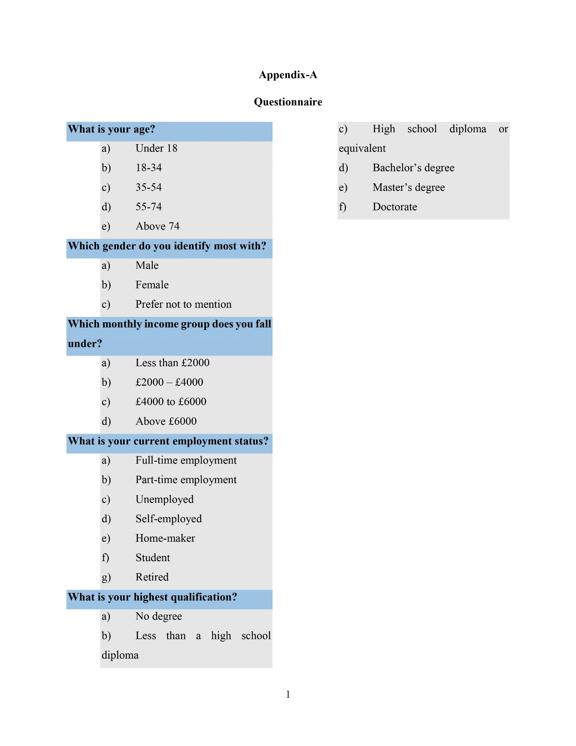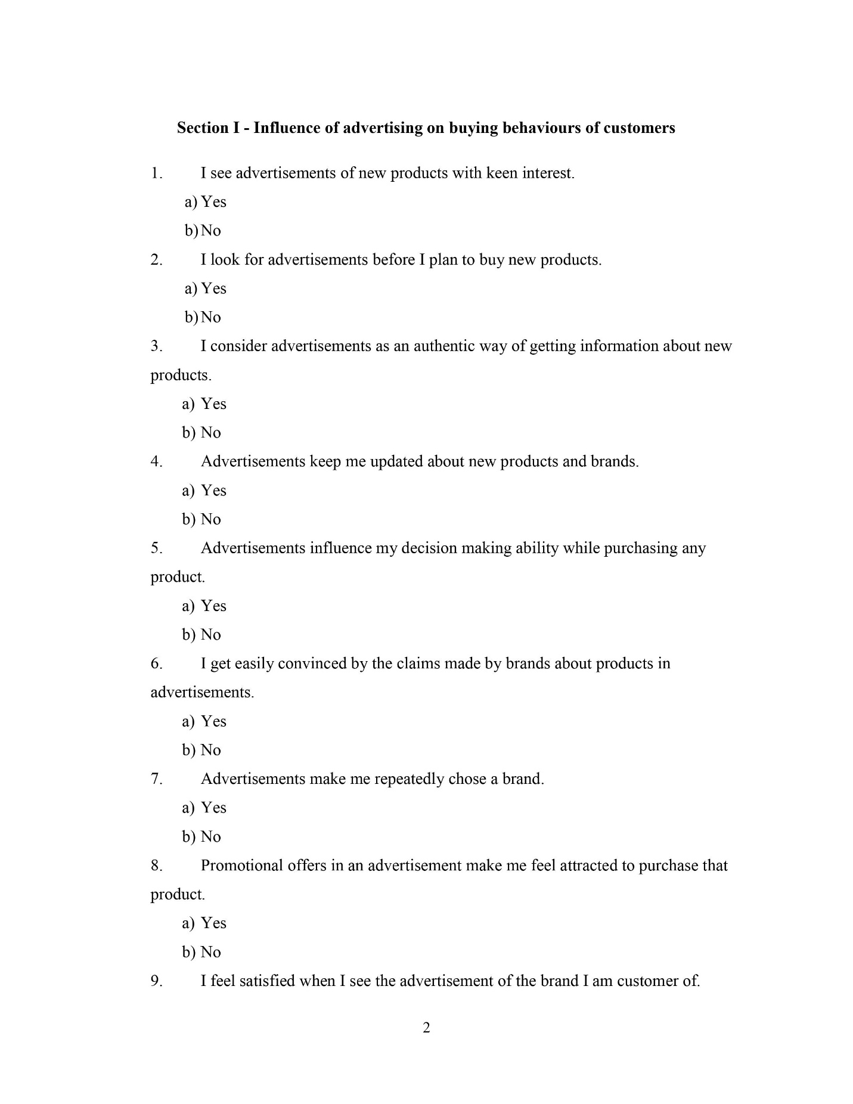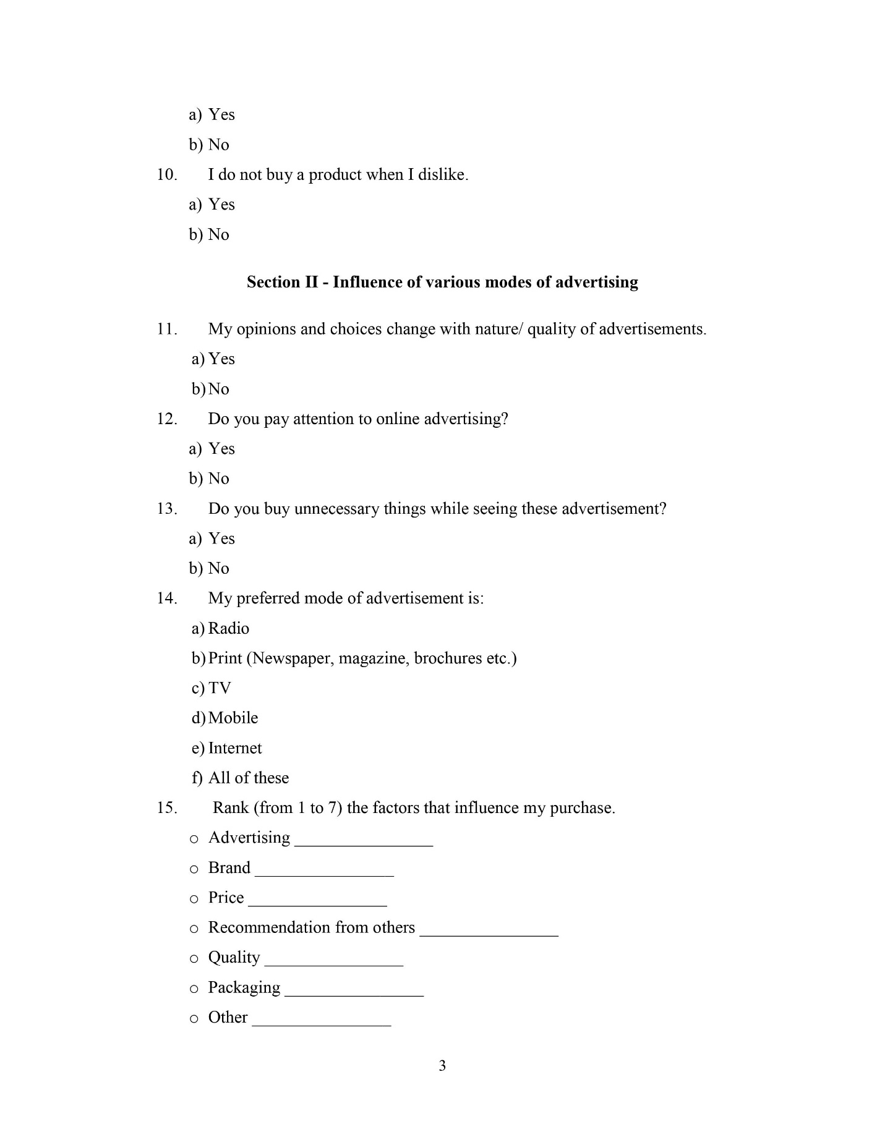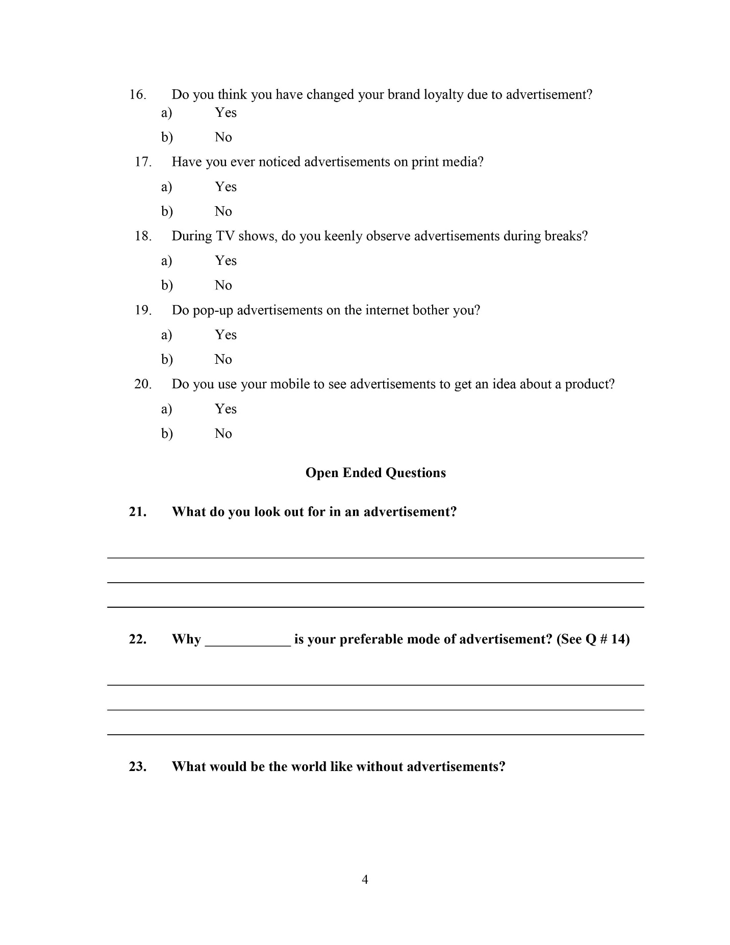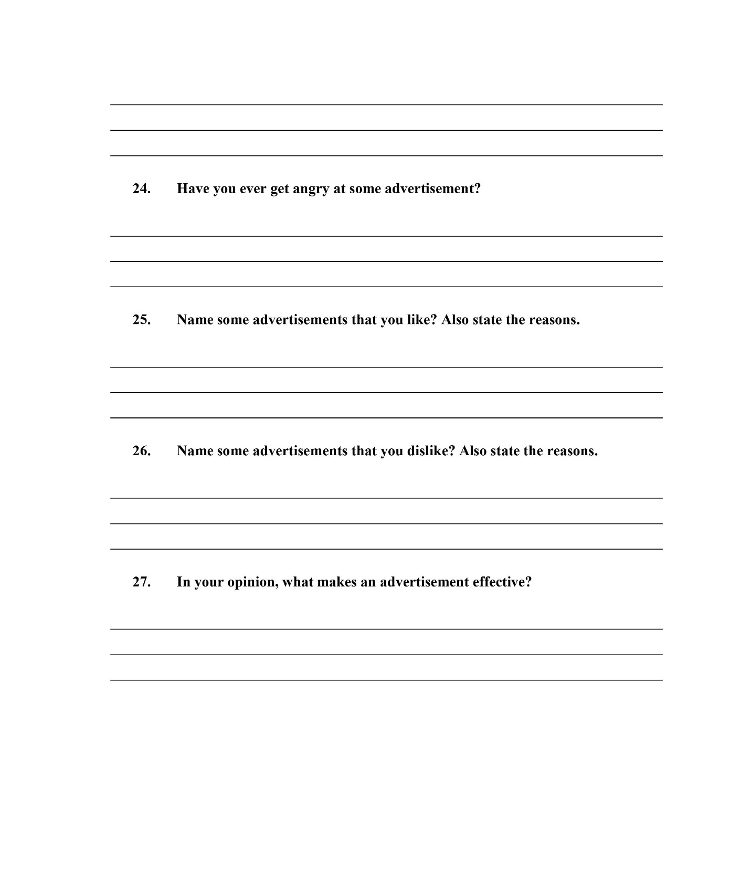

Appendix-B1
Answers of Open Ended Questions

What do you look out for in an advertisement?
Answers collected:
- Nothing
- Yes, everything
- Quality
- Colour
- Style and colour
- Product info, sales
- New things
- Price
- Brands
- Yes
- Offer
- Truth
- Most often I don’t look out for an advertisement
- Quality of brand
- Way to use that product
- I just skip.
- The quality of product and its reviews and design plus features
- Price and Quality
- I skip the ad all time
- Product nature, quality
- Product features
- Honesty of brand
- I look for ads that are creative, informative, and memorable.
- Anything catchy, like some hook lines or a song
- The quality of a brand
- Nothing
- It’s time duration
- Nothing
- Quality of brand
- The quality of it
- Quality of product
- I look only brands
- I only see reviews
- Quality and price
- Quality of the product
- Quality and Price
- Informative
- The product specs and features
- Clearly articulate the brand value to their audience
- Quality of product
- Nothing but must be sensible
- Pretty much everything like price quality of product delivery
- Entertaining + humorous
- Packing
- Product
- Information about product and its effectiveness
- Facts about the product. Correct information
- Products
- Any offer or any discount
- Affordable
- Creativity
- The quality of thing
- Entertainment just like late ufone ads of early 2010s
- Mostly the quality and price
- Cosmetics and clothes
- product price and quality
- Discount and quality satisfaction
- Specifications
- Information regarding the product
- Discounts and which person is advertising
- How better they attract me
- Quality
- Humour
- It should not be very long
- It should be to the point and show all aspects related to the product including price

Appendix-B2
Answers of Open Ended Questions
Why ____________ is your preferable mode of advertisement? (Radio, Print, TV, Mobile, Internet, All of these)?
Answers collected:
- Internet
- TV
- Internet
- Mobile
- Clear and precise
- I use mobile more than any other mode
- Because I watch TV
- TV, because we cannot skip it and good advertisement can be enjoyable
- TV
- Internet, because I use it mostly
- Print is my preferable mode of advertisement because it doesn’t disturb your work
- The internet is my preferred mode of advertisement because it allows for a wider reach and more precise targeting
- I prefer reading over watching so Print is my preferred mode
- Because it is more convenient
- It is easy to ignore
- Internet. Because you see feedback of other people’s
- Because I use it more often
- Easily accessible
- Because I use it most
- Internet because it gave us complete knowledge of product its uses its reviews its ratings etc.
- Easy in hand
- Internet because the Advertisement is short
- Internet is easier to see advertisement.
- Less bothering
- Phone because I use it the most
- It provides more and authentic information
- TV because it’s not feels disturbing to watch an ad on TV as it does on mobile
- Mobile because easy to avoid
- Because it is the best source of information
- Because I use it more
- Internet is my preferable mode to observe advertisements because any kind of information is easily available on internet and their reviews
- Attractive and reachable to a large audience
- To gather information
- Internet because mostly new products and brands are working through social media
- we spend a lot of our daily time on these things so I think they can be useful
- Mobile using Instagram I see advertisements and keenly observe them
- I always prefer TV specially cartoon channels because kids love attractive ads.
- Mobile, internet
- Because Easily access
- Internet because it is easy to access
- Internet, because I use it daily.
- Mobile messages disturb less because you can see it in free time
- I feel enjoyed to watch out through internet scrolling
- Internet because we are always scrolling and sitting on Internet.
- All

Appendix-B3
Answers of Open Ended Questions
What would be the world like without advertisements?
Answers collected:
- No
- Boring
- Dull
- Difficult
- No idea
- Colourless
- Less attractive
- Online
- less choices
- Outdated
- A better place
- I think that advertisements are important so that world can get know how of product
- A world without brand
- peaceful
- Calm
- Happier and clam
- Nothing but World may be information less
- May be amazing
- Yes
- No choices, opinions
- You won’t be aware of new products and their features unless you go to market
- Just like empty
- World of unawareness to products and brands.
- Waste of time, for search for product
- Without advertisements, the world would be less commercialized, but also less informed about new products and services.
- No awareness of products, definitely would affect the market
- Nothing, because when u haven’t money to buy anything then no question arises that how much u like advertisement
- No entertainment
- Just as the same. Could be even better.
- They are just irritating.
- Without advertisements a world has nothing to do
- People won’t know about new products and products will be sold solely on other recommendations
- People may remain unknown about products
- people remain unknown about the products
- It was like empty
- Less updated
- Not so interesting
- Economy will fall down due to less sale of products and unawareness of products.
- Much better
- Boring
- Boredom
- A Little boring
- Make no sense
- Will be difficult to find new things and businesses will be adversely affected
- People remains uninformative about new products, and promotions on that.
- Nothing
- Less consumerism in the world
- For living in this world of social media advertisement is important, world without advertisements I can’t imagine.
- We would be unaware of new products which we might like
- A World lack of information about new products
- I think nothing would change for me
- Well it feels like a natural peace
- Better
- No interest to buy a product only be bought when in need
- Peaceful and simple because ads of new unnecessary products cause a lot of wasteful spending of money
- A world without advertisement would be like a stone age era, without advertisement people would be un aware of a lot of products and different brands
- no information about thing
- Un updated about new brands and substitute goods
- Nothing will change
- There would be lack of information about new products.
- Like No knowledge of what’s going on in market
- No
- Very good
- Best
- It would be much boring. We won’t easily be known of new products.
- Too much boring
- Without advertisement the product couldn’t get high reach in customer
- Finish
- Empty

Appendix-B4
Answers of Open Ended Questions
Have you ever gotten angry at some advertisement?
Answers collected:
- Yes
- No
- Mostly. During videos i am watching
- Yes, many times
- Perhaps
- Yup
- Nope
- A lot of times
- Yes
- Yes, sometimes
- Yes, I have gotten angry at some advertisements that I felt were misleading or offensive.
- Yes. The ones that pop up on YouTube
- Yes, Every Advertisement.
- yes
- Yes, at some illogical dance advertisings selling a biscuit
- Yep often
- Yes, some interested or repeated advertisements make me angry
- Yes, they can be very annoying sometimes
- No, as far as it is not hurting any my sentiments.
- In childhood nope but now yes!
- Yes, while watching any drama or football videos I have mostly come through lots of advertisements. These are the things that I dislike the most as they interrupt.
- Yes, many times
- Yes, if trusted people goes for cheap and shit product to advertise and you purchase it and then finds it a shit
- Most of the time
- Yes, advertisements creating any religious conflict.
- Yes, a lot of advertisements are anti cultural or very sunny
- No

Appendix-B5
Answers of Open Ended Questions
Name some advertisements that you like? Also state the reasons?
Answers collected:
- Funny
- All
- Drinks
- Kit kat
- All the adds which are less than 5 sec
- Detergent, skin care…give new scientific information
- Clothes-because I like to see new trends
- I like online advertising because it’s saved environment
- All type
- Everyone
- advertisements of apparels for better knowledge of what is in fashion
- Mobile Phone Advertisements
- Recent pepsi’s ad was a good one, because of Babar Azam and Naseem Shah
- Clothing advertisements
- Skin care products because I love my skin care
- Not Any
- Don’t like any
- Coca cola because of its music
- Ufone because it’s ads are sometimes so funny. Pepsi because it’s ads are on spot.
- Short stories about respect
- Internet because save environment
- Not something particular
- Doesn’t remember any
- Food
- Funny Advertisments
- Foods
- I really like the Apple “Think Different” campaign because it was inspirational and helped redefine the company’s brand. I also like the Nike “Just Do It” campaign because it was motivational and encouraged people to push themselves to their limits.
- I like the Fanta ad because of the vibrant colours they used and Uphone ads because of their comic relief
- Study advertisement
- Nothing
- Drinks adds specially coca cola
- I like none
- Digital advertisement i likely most
- Coke and pepsi advertisements are best because of the quality
- Pepsi advertisments
- Pepsi
- I like foody advertisement
- Ufone its funny
- Nurpur
- Effective and attractive advertisements
- Advertisement of cars because I love cars
- Old Ufone Ads
- Video commercial or ads because they are usually more interesting than those that are static
- Nil
- Ramadan and Eid ads
- U phone’s 50-year celebration ad
- Lux because it features my fav heroine.
- Vivo V21 e because its sale man behaviour is very good and fulfil all the things that he said
- I don’t like any advertisement in particular
- Advertisements of shoes, dresses etc. and some necessary think I like much.
- I like ads that do not interrupt my work or not waste time
- Advertisement related to awareness about calcium because its great reminder
- I like shoes and glasses advertisement and reason is that I love these things
- Skin care brands
- pepsi, tapal
- Surf excel. it’s really interesting
- Washing powder, vim. Their content and the person advertising
- In my childhood, I used to watch Ufone ads with great interest because their approach was very unique, and Cocomo and Orange Candy ads were also very attractive.
- I like advertisements related to sports, such as Messi making Pepsi’s advertisement because he is my favourite player.
- Advertisements about food products or daily life products because these help to find new products or ideas about anything.
- Cosmetic product
- Acne treatment products and books.
- Because I’m facing the issue of acne and I like reading book in free time.
- Don’t like any advertisement
- Ariel (on sharing house work load with women)
- Walls (mother’s day message)
- Shan (good themes)
- I like Indian adds they have humour in adds also conveys a message in humour as well you never gotta bored
- In soft form because I want environment green
- New Brand
- In which ads use my favourite actors
- I don’t like any
- Tapal, Lipton because I love tea
- The advertisement of Josh a company of contraceptives which produce advertisements full of humour
- Mobile
- Can’t recall now

Appendix-B6
Answers of Open Ended Questions
Name some advertisements that you dislike? Also state the reasons?
Answers collected:
- Nothing
- No
- Fake
- All debt ads
- N/a
- Longer adds
- I can’t like
- Skin whitening -it’s not going to effect
- Super market- because I always buy out of my convenience
- Prints
- Whom try to copy
- Romantic ads because I am single
- ads with hatred in any case
- New apps
- Washing powders and pop-ups
- Home accessories
- Not any
- Haven’t noticed any
- Biscuit ads
- Girls undergarments because i am a boy.
- Sting
- Prints waste of paper
- Not something
- Products that relate to one gender or adults and they are shown even on cartoon channels or channel for children
- Cocomo advertisements
- I dislike advertisements that are sexist, racist, or promote harmful stereotypes. These types of ads perpetuate negative attitudes and behaviours towards certain groups of people and can be very damaging.
- Can’t think of any
- Some brand advertisement like fair lovely
- Pepsi, coke etc.
- Soap adds sometime it’s disgusting
- Same as above
- Advertisement based on paid you tubers’ reviews are not authentic. That why I dislike them
- nothing
- Property maker, cream, makeup
- Chewing gums etc. petty things, very annoying
- Jameen Shireen
- Irrelevant advertisements
- Unnecessary products
- Not remember
- An ad might claim that if you don’t buy a certain brand of toothpaste than you will get cavities, gum disease etc.
- Many (less reality)
- Senseless ads
- Don’t remember
- Pepsi, because whenever there is a cricket match, it appears on screen even before the over ends.
- I don’t dislike them either.
- Promotion of unusual think like promotion ads of apps, etc.
- YouTube ads or ads in mobile games that waste a lot of time and are annoying and completely irrelevant and uninteresting
- Advertisement about personal hygiene
- Advertisements that contain false offers or offered that are old
- Nothing in particular
- boom boom bubble gum, AC advertisements
- Faiza beauty cream
- Prolonged advertisements. Rooh afza
- During the Corona epidemic, Snapchat ads on YouTube made it difficult to live I hated those ads.
- While watching any movie or match I dislike advertisement, cannot mention any specific one.
- About girl’s personal things due to privacy reasons.
- Long advertisement
- Cold drinks and irrelevant products
- Not such advertisement
- I hate advertisements who goes 180 degree of product you can’t grab what message is being given when finally, you see a product you feel aaaah what…!!!
- Print waste of paper
- New brand but not good quality
- In which ads can’t use my favourite actors
- Every
- Make-up. I don’t apply that much
- Foods
- I remember many of ufone advertisement were quite bothering
- No one

Appendix-B7
Answers of Open Ended Questions
In your opinion, what makes an advertisement effective?
Answers collected:
- Yes
- To make some good ideas
- It’s location
- Short
- Price
- Quality
- Yeah
- Yes
- audio/video quality and idea behind it
- Graphics and nature of product
- Make it short and simple
- Packages offered
- Story of advertisement
- Truth
- Lesson
- Its music and visual
- Content, Quality and Celebrities
- Peaceful
- If made by trust-worthy honest person that gives true opinion generally people are more likely to trust product quality
- When it clearly state quality and price of products
- Choice of lyrics in advertisements
- An effective advertisement is one that captures the viewer’s attention, communicates a clear message, and inspires action. It should be memorable, creative, and relevant to the target audience
- Innovation, being different, and familiar famous faces
- Strategy
- If is positive, then it will be effective
- How it’s launched and how it makes by maker
- That they are easy to skip and ignore
- Your choices
- The quality of the advertisement
- Telling truth in advertisement
- Telling truth about the product
- Advertisement should be short and authentic and it give us interesting knowledge that wo never knew before
- Quality. values. price. location. brand
- Delivering your underlying idea in a short period effectively
- Update technology
- I don’t know
- Product centric and humour
- Breakthrough, branding and benefit
- Its reality
- Sense and creativity
- Storytelling and easy to understand
- More humorous the advertisement, more effective it is.
- Communication and packing of product
- Discount offers
- I think authentic information about product and colour scheme of poster make it effective
- If it has chosen the appropriate audience and provides true information. It should also develop an interest in the customer
- Facts about the product rather false information
- True data
- Affordable price
- Free delivery
- Price and effectiveness
- Creativity
- Public interest
- The content behind and should not be prolonged to get annoyed
- Advertisements should have a point, there should be a lesson, the music should be good, the audience should wait for the ads during the serial breaks and not just turn off the TV
- Advertisement must depict the original quality of the product and it must not deceive the customers.
- An authentic data about famous or trending things.
- yes
- Discount
- Quality satisfaction
- Feedback or customer reviews
- Only advertisement can be interesting if the relative company will give information about the specifications of the product but almost all the advertisement now a day just tell us that the product is good but doesn’t exactly explain how it is good
- Correct information (no exaggeration). Attractive graphics. A good message for audience
- Short clip with some humour and targeted one should focus the content which totally goes related to product
- Life simple
- Nothing
- The quality of the product and its price
- Humour, sarcasm and patriotic
- It should be according to audience



