KATHERINE MIDDLETON
An Exploration into the socio-cultural impacts of a local community event – A case study of the Nos Galan Road Race.

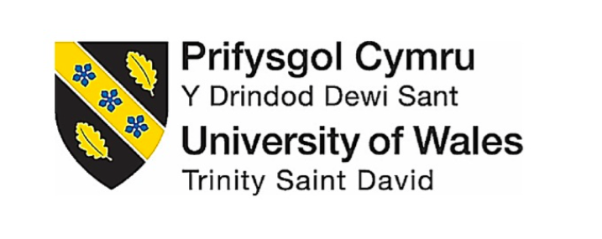

Award BA (Hons) Degree

Dissertation - Events Management
UWTSD Swansea
(2019)

Module: BMTH6000
Tutor: Caroline Jawad

DECLARATION 1
This work has not been previously submitted for any other degree.
Signed................................................... Date......................................................
DECLARATION 2
The researcher has made every effort to keep the dissertation free from subjective validation and bias.
Signed................................................... Date......................................................
STATEMENT 1
This dissertation is being submitted as required by University for the degree of BA Events Management.
Signed.................................................... Date......................................................
STATEMENT 2
This dissertation is the result of my own independent work, expect where acknowledgments of referencing are stated. A bibliography is attached to the dissertation.
Signed................................................... Date......................................................
STATEMENT 3
I hereby give consent for my dissertation, to be available to the UWTSD if accepted to be made available on the University’s Library internet and be available to photocopy for University purposes.
Signed...................................................... Date.........................................................

Acknowledgments

Firstly, I would like to thank my family and friends for supporting myself throughout my university degree. Giving me inspiration in times when I felt that I would not achieve my end goal. Secondly, I would like to give a special mention to all my fellow students, and friends that I have made at university. We have pushed each other along and picked each other up when we were at our lowest inspiring one another to do well. I also need to thank the lectures who have supported and mentored me throughout my university degree. A special thank you to John Howell who encouraged me to finish my third year in university, thank you for believing in me. I also need to thank Suzanne Wells and Caroline Jawad for helping me through this difficult journey the dissertation. Inspiring me to do well and to acquire my degree.

Table Contents
Abstract 6
1.0 Chapter 1 Introduction 7
1.1.1 Rationale 7
1.1.2 Nos Galan Road Race 9
1.1.3 Aims and Objectives 9
1.1.4 Conclusion 10
2.0 Chapter 2 - Literature Review 11
2.1 Social Impacts of Events 12
2.1.1 Cultural/ Historical impacts for small festivals 13
2.1.2 Why Small Festivals / benefit 14
2.1.3 Perceived Tourism 15
2.1.4 Volunteering 16
2.1.5 Social Capital 17
2.1.6 Creating Social Networks 18
2.1.7 Community well-being 19
2.1.8 Sustainable Communities 20
2.1.9 Conclusion 21
3.0 Chapter 3 Methodology 22
2. To conduct primary research into the socio – cultural impacts that can be generated by an event. 22
3.1 Research Onion 22
3.1.1 Philosophy 23
3.1.2 Choice 23
3.1.3 Collection and Analysis 24
3.1.4 Strategy 24
3.1.5 Questionnaire design 24
3.1.6 Pilot study 25
3.1.7 Sampling 25
3.1.8 Collection and Analysis 26
3.1.9 Strategy 26
3.2.0 Interview design 27
3.2.1 Sampling 27
3.2.2 Time horizon 27
3.2.3 Reliability 28
3.2.4 Validity 28
3.2.5 Limitations 28
3.2.6 Ethical considerations 29
3.2.7 Conclusion 29
Chapter 4 – Introduction 30
4.1 Main Findings 31
4.1.1 Interview Analysis 31
4.1.2 Social Impacts on a Community 32
4.1.3 Well-being of a Community 33
4.1.4 Building skills and Networks 33
4.1.5 Sustainability 34
4.1.6 Questionnaire Analysis 35
4.1.7 Social Impacts on a Community 35
Figure 1 - Pie Chart showing what positive socio-cultural benefits were obtained at the Nos 35
4.1.8 Negative Impacts 37
Figure 2 - Pie Chart showing what negative consequences the community felt were obtained by the event. 37
4.1.9 Well -Being of a Community 38
Figure 3 - Pie Chart showing how the Nos Galan can contribute to the well-being of a community. 38
4.2.0 Building skills and Networks 39
Figure 4 - Pie Chart showing how connections were made at the Nos Galan. 39
4.2.1 Sustainability 40
Figure 5 - Bar Chart showing how a community can make an event sustainable. 40
4.2.3 Conclusion 41
5.0 Chapter 5 Conclusion 42
5.1.1 Reflect on Analysis 45
5.1.2 Recommendations 46
5.1.3 Recommendation 1 46
5.1.4 Recommendation 2 46
6.0 Appendices 47
Appendix 1 Questionnaire Design 47
Nos Galan Road Race - General Event Feedback 47
Appendix 2 Questionnaire results 50
Appendix 3 Transcribed Data 55
Appendix 4 Ethics Form 66
Appendix 5 Consent Form for interviews / Questions 70
Appendix 6 Gantt Chart 76
Bibliography 77

Abstract

Nos Galan Road Race is a community-based event which is organised by Rhondda Cynon Taff (RCT) and the Mountain Ash Committee. It is part of the New Year’s Eve Celebrations that is held within the town of Mountain Ash. The event celebrates the life of the Welsh runner Guto Nyth Bran. There are over 1,800 participants who take part in the race and over 11,000 spectators. This is a huge impact on a town that’s population is relatively small with just over 7,344 people residing within Mountain Ash area.
There have been many authors such as Ritchie (1984) Dwyer (2000) Small (2008) Grosbois (2009) Getz (2007) Timothy (2011) and Black (2016) that have researched the socio – cultural impacts of events. As a result of such research they have formulated frameworks to evaluate the social impacts that an event can generate. Positive impacts included economic development, community growth, social cohesion, entertainment, tourism, volunteering and the well-being of a community. Negative consequences related to social costs, such as crime, traffic congestion, noise and disruption to residents’ lifestyles.
For the purpose of this study and to build on the secondary research that has already been conducted within this area, the researcher has specifically focus on the Nos Galan Road Race. Primary researcher has been conducted at the event to analyse what social – cultural impacts can be obtained from a community – based event. Evaluating a community’s perceptions towards the Nos Galan Road Race and examined how a community event can be made sustainable. The methodology has been designed from the pre-existing literature in order to answer the aim and objectives of the dissertation. A mixed – methods approach has been conducted which gives the research study and inductive and deductive approach. This method of research is set out to best answer the research question.

1.0 Chapter 1 Introduction

One of the most profound trends in any event is the way in which people embrace an event, using the concept of ‘experiences ‘, which in turn create socio – cultural impacts (Getz, 2007). These impacts occur because of the observed rise and demand for such ‘experiences’ that emotionally connect with people (Getz, 2007). The growth of such events has produced a change in consumption patterns, that demand more entertainment, new technology and a need for people to attach themselves to an event (Getz, 2007). Participation and involvement in an event applies to the temporary state in which people are drawn together, removed from everyday life, so they have something specific in common (Getz, 2007). The cultural event -goer wants to learn and acknowledge something new, which in turn engages them emotionally and cognitively to an area, this includes tangible things such as historic sites, cultural experiences, meeting and connecting with others, which in turn can connect them to cultural performances (Getz, 2007). The theming of an event suggests what is to be celebrated, although in many community events it is the community itself that is the object of celebrations (Getz, 2007). Planned events generate social experiences, which in turn are associated to leisure (Getz, 2007). In effect events help build reality in our minds to explain experiences that create socio-cultural impacts (Getz, 2007).

Rationale

Community – based events are an important part of a community they encourage people in the community to be more socially active. (Gov, 2017) The events are normally small in scale and attendance and represent the point “where community and its outward manifestations of image and identity collide” (Derrett, 2000). Small community events in response have a need or desire to celebrate their unique identity (Douglas, et al., 2001). They are themed public occasions that occur for a short period of time and celebrate a community`s way of life and traditions (Douglas et al., 2001). All events have direct social and cultural impact on their participants and sometimes on their wider host community as outlined by Hall (1989) and Getz (1997) (Bowdin et al.,2006). Among event organisers there is a growing recognition of the need to measure social impacts of the event as host community dissatisfaction threatens their long- term success.

It has been suggested by Small (2005) that as result of the unique interaction between visitors, and a destination area and its population that socio-cultural impacts occur (Small, et al., 2005). The level of contact with visitors is another factor that influences residents’ perceptions of tourism to an area and can have positive and negative perceptions (Small 2005).
Cultural experiences are defined as seeking knowledge to learn and understand something new, that foster belonging and sharing among social groups and families within a community (Getz 2007). Local community events who share this cultural expression often produce a range of benefits enhancing pride within a community, creating a sense of identity and strengthening a feeling of belonging (Bowdin et al., 2011). The extent in which the community are involved with the event has influence on these effects and how they are perceived (Getz 2007). A variety of unproved claims have been made about the socially transforming power of events, so more research must be justified within this area (Getz 2007).
Social sustainability refers to the connective qualities within a community, which in turn relate to the personal advantages of well-being that connectively entails the community (Black 2016). Sustainable development is an important part of a community, in which the community and its members are satisfied (Black 2016). These connections are made or reinforce through local community events, between people, their culture and their cultural heritage (Black 2016). Identifying theses connections may in turn contribute to satisfy human needs (Black 2016). However, despite recognition into the pre -existing literature many authors, such as Reid (2008) highlight a paucity of research into the social impacts of events (Reid, 2008)

1.1.2 Nos Galan Road Race

For the purpose of meeting the objectives to this field of study the socio – cultural impacts have been evaluated at the Nos Galan Road Race. The research has critically explored the social benefits a community event can generate. The Nos Galan has been incorporated into the primary research of the study. The Nos Galan Race is a sports event that is held every year it is a 5km race around the town of Mountain Ash. It is held within the small town as part of the community`s Christmas celebrations.

1.1.3 Aims and Objectives

The aim of the dissertation is to critically analyse and evaluate whether the Nos Galan Road Race has socio – cultural benefits for its participants and spectators. In order to achieve the aim, set out in the dissertation. Extensive research has been conducted surrounding the subject, this research has look to meet the following objectives:

- To examine whether the event can contribute to the well-being of a community.
- To analyse the capacity of the event for building skills and community networks.
- To examine how a community can, make an event sustainable.
The first objective examined whether social participation at an event can contribute to the well-being of a community. The community -based event study examined whether different members of a community from different backgrounds engage with the event and found meaning that positively benefits the community, enhancing a local community’s spirit.
The second objective investigated whether different sub-groups at the event can connectively engage with each other and build on developing a local community. Analysing if the event can build new social skills and has the ability to create new hubs within and outside of a local community.
The third objective looked to determine if an event can develop relationships with all stakeholders and work towards deeply embedding sustainability into the heart of the event to leave a legacy for future events.
The aim and objectives that have been set out in this field of study will answer the title of the dissertation.

The aims and objectives will be explored in chapter (2) and will be met through conducting an extensive literature review of all secondary data that surrounds the topic of socio-cultural impacts. From the pre – existing literature chapter (3) the methodology will be formulated conducting extensive research and subsequent data analysis. Whereby in-depth interviews have been conducted, further data analysis has been formulated from the survey questionnaire. The methodology research strategy has utilised a mixed – methods approach, which will give the research a triangulation design. All data analysis was then explored and evaluated in chapter (4) of the dissertation. Chapter (5) explored the themes and theories that have become evident in both chapters (2) and (4). This will feed directly into the two recommendations if new research was to be undertaken.

1.1.4 Conclusion

This research of study has looked deeply into the socio-impacts that occur at a small community event. Measuring and monitoring the perceptions and expectations of both the community, participants and the spectators who engaged with the event. Examining whether the event contributes to the well-being of a community. The primary goal of this research was to meet its aims and objectives, which are tied to this field of study.

2.0 Chapter 2 - Literature Review

This chapter is designed to examine the socio-cultural benefits that can be obtained from a community event, and what secondary research has already been collected within this area.
People are the most socially evolved species, as such we develop social interactions which can trigger events (Bladen et al., 2012). According to Maslow (1943), these social needs relate to other human needs, such as Self-actualisation, Esteem, Love, Belonging, Safety and Physiological (Maslow, 1943). Maslow states that these latter needs are partially fulfilled through family and social relationships. Bladen defines them as motivational factors that are triggered by events (Bladen et al, 2012). These emotions are drivers of individual behaviours, such as, personal growth, a sense of achievement and a need or desire.
Due to the increasing popularity of community-based events, coupled with their positive and negative impacts on host communities, has led to a growing body of research on the impacts of events. There is a growing demand for the measurement of the socio-cultural impacts of these events (Small, 2005). Despite the well documented literature needed to address the diverse impacts of events, the research undertaken has focused mostly on the evaluation of their economic impacts alone (Grosbois, 2009). As events have significate potential to positively contribute to the communities that host them (Grosbois, 2009).
Such events can make a significant contribution to the visitor’s economy, helping in the regeneration of buildings and spaces within the host community which in turn improves the destinations image (Derrett, 2004). The growing recognition of the importance of socio-cultural impacts and the paltry previous research into this area have led to several studies proposing frameworks and scales for their assessment (Grosbois, 2009). Many researchers such as Ritchie 1984; Dwyer et al., 2000; Getz 2007; have all proposed scales for measuring the social impacts of events (Grosbois, 2009). Analysing if different events can create different socio-cultural experiences.

2.1 Social Impacts of Events

Socio – cultural impacts of events refer to the positive as well as the negative consequences on a community. In an article on event evaluation Ritchie (1984) proposed a conceptual framework evaluating the impacts of events (Ritchie, 1984). ‘Ritchie distinguished among economic, tourism / commercial; physical; socio-cultural; psychological; and political impacts that were either positive or negative’ (Ritchie, 1984). ‘Ritchie maintains that positive socio-cultural impacts included strengthening of regional traditions and values, improving the quality of personal relationships derived from the extensive volunteer efforts, increasing the level of local interest and participation in the type of activity associated with the event’ (Ritchie, 1984). Negative psychological impacts included in this study were tendency towards defensive attitudes concerning host regions, leading to a varying degree of host/visitor hostility (Grosbois, 2009). Modification of the event / activity to accommodate tourism at the event generated negative perceptions within the community (Grosbois, 2009).
Since early 2000`s there has been an increase number of studies focusing on the social impacts of events. ‘Dwyer (2000) developed a comprehensive list of social and economic benefits and cost of events’ (Dwyer et al., 2000). Social benefits of Dwyer (2000) study included community development, such as civic pride, participation and education, with positive attitude to the locality (Dwyer et al., 2000). It is argued and summitted by Dwyer (2000) that social costs included disruption to residents’ lifestyles, noise, crowding, traffic congestion, crime and damage to property (Dywer et al., 2000). Research has shown that by applying different frameworks to different events, and listing the potential impacts each time may very likely decrease the comparability of the evaluations and lead to continued research within this area.

2.1.1 Cultural/ Historical impacts for small festivals

Cultural heritage festivals emulate cultural traditions or mark historical occasion associated with the community staging the festival (Arcodia & Robb, 2000). These festivals can attract a wide range of culturally inspired tourists who can become immersed and learn about the historical context of a destination (Azara et al., 2018). Small- community festivals, often lack knowledge, expertise and financial resources as outlined by Getz (2012). These small communities are pressured to be self-sufficient in event planning and organization (Reid, 2011). As Abram and Waldren (1997) pointed out that communities do not simply possess culture or identity. It is through the engagement with culture practices that they get to know themselves “as communities” (Abram & Waldren ,1997).
According to Timothy (2011) “what communities fear most are the negative social and cultural impacts [tourism] brings with it, such as conflicting use of social space; cultural change; cultural commodification or disharmonious resident-tourist or destination-tourism relations”. However, Getz (2008, 2012) highlighted how little empirical research exists on the strains the “touristification” of small heritage- based festivals and events pose on the communities that own them. There is little agreement on tourism being bad for cultural events, or on how and why negative impacts occur (Noronha, 1977).
However, Barrio et al (2012) pointed out “from the analytical point, interest now lies in highlighting that all these new cultural expressions have become part of citizens demand and particularly as a means whereby they engage in tourism” (Barrio et al, 2012). Like any other form of tourism, heritage -based tourism needs careful management to minimize the likelihood of causing negative socio- cultural impacts to the host communities (Kaiser & Nishikawa, 2010).
Tourists are drawn to communities by their local customs and beliefs. Different concepts have been investigated surrounding festivals and events within the tourism and anthropology literature (Woosman & Aleshinloye, 2018). Research has focused on the perceived attitudes of the resident towards tourism development. Findings indicated that residents had positive attitude to economic development, but were also aware that these positive benefits could have a negative effect on the environment, which in turn could reduce their satisfaction for tourist development (Pavlic eta al., 2015). As the Nos Galan Race is held within the small town of Mountain Ash, primary research will analyse residents’ perceptions towards tourism.

2.1.2 Why Small Festivals / benefit

Planned events always have a purpose and goal. Certain outcomes are both desired and predicted, but there are always negative and positive impacts that are generated from an event (Getz, 2007). Fredline et al (2003), formulated the Generic Scale measuring the social impacts of the small festival. Fredline`s study uncovered six factors (i.e., social and economic development benefits: concerns about justice and inconvenience, impact on public facilities, impacts on behaviour and environment; long term impact on a community; and impact on some goods and services). The generic scale used within this study measures the quality of life within a community. By using such scale research could provide answers to improve the social networks and bonds that can link a community and help to regenerate local businesses.
However, most recently Small (2007) established the Social Impact Perception Scale, yielding six factors as well: Inconvenience, community identity and cohesion, personal frustration, entertainment, socialization opportunities, community growth and development (Woosnam & Aleshinloye, 2018). Using this scale will help assess the reliability and validity into social perceptions. The FSIAS scale remains the most utilized ‘Bagiran and Kurgun (2013) current study was able to demonstrate sound psychometric properties of the scale, however only found two unique factors social benefits and social costs’ (Woosnam & Aleshinlove, 2018). This scale measures attitude and has been utilized to identify different dimensions of socio-cultural impacts. Comparing these two scales positive attitudes were found to enhance community development. Creating new opportunities for a community to connect with one another. Negative impacts of the scales highlighted personal frustrations and social costs that can impact a community, such as disruption to residents’ lives, traffic congestion and crime.
These social and cultural impacts mainly result from visitors. According to De Bres and Davis (2001) if not managed appropriately there can be implications for numerous aspects of the community fabric (e.g., place identity, community pride and regional identity). However, Getz (2010) research focused on the economic development. Getz (2010) states that the most research topic in the festival literature-has primarily focused on economics. Felsenstein & Fleischer (2003) agree that many communities view festivals as a viable means of economic development, in small communities’ large number of visitors are welcomed. An injection of economic growth into a local community can help to maintain a good quality of life for a community and help make an event sustainable (Woosnam & Aleshinlove, 2018).

2.1.3 Perceived Tourism

It has been suggested that it is as a result of the unique interaction between tourists that socio- cultural impacts occur (Small, 2005). As festivals and events put their destination on display, and its community, it has the real potential to create socio-cultural impacts (Small, 2005). Delmere, Wankel and Hinch (2001) built upon existing tourism impacts, the study aimed to develop a scale of social impacts specifically related to festivals (Delmere et al, 2001). Using a Nominal Group Technique procedure allowed for the initial generation of potential social impacts of community festivals (Small, 2005). Negative impacts of the study uncovered disruption to residents’ lives which in turn resulted from over-crowded tourism. Communities may very likely lose their sense of identity if tourism is not managed effectively.
‘Griffiths & Sharpley (2012) study implicated research focus on festival impacts is the idea that residents and tourists are separate from one another – as members of the “in” and “out” group’ (Griffiths & Sharpley, 2012). Identifying that separation exists between those within the community and those outside. An understanding of residents’ attitudes towards tourism development and its social impacts on their quality of life is essential in achieving a local community’s support for further development (Pavlic et al., 2015). The results provided indicated the residents were aware of the positive economic impacts tourism has on a community but were also aware of the negative impact on the environment which in turn could reduce their satisfaction with future tourism development (Pavlic et al., 2015). Stylidis (2014) studied the role of the residents’ place image and perceived tourism impacts in shaping their support for tourism development (Stylidis et al, 2014). The results suggested that more favourable perception of economic, socio- cultural and enviromental impacts of tourism uncovered that residents had greater support for future tourism development. It is assumed that perceived positive and negative impacts, personal benefits, community involvement and quality of life influence local resident support for further tourism development. New research within this area will look to identify if a community and tourists can connect with one another, creating new social groups within the event.

2.1.4 Volunteering

Volunteers play a big part in an event and volunteering is a compelling social impact as identified by eventimpacts.com. As outlined by Bladen (2012) many events only succeed because of the efforts of the volunteer (Bladen et al., 2012). Clary and Snyder (1999) maintains that volunteering is important in motivating a person`s decision to contribute their time and effort without expecting financial rewards (Clary & Snyder, 1999). However, Tyson and York (2000) define motivation as “an inner force that impels individuals to behave in a variety of ways” (Tyson & York, 2000).
Cary and Snyder (1999) study focused on what encouraged individuals to volunteer at an event. The main motivational functions that the study focused on were listed as values, understanding enhancement, career, social and protective. (Cary & Snyder, 1999). Cary & Snyder found that different individuals volunteered for different reasons at an event, such as people felt it is important to help others or participate within a community, feeling that the work would enhance them as a person, helping them feel better about themselves, assisting in helping them gain a career that they desired, the want to network with people who share common goals (Cary & Snyder, 1999). While Getz (2007) maintains “that those who have a good experience at an event are more likely to become motivated to volunteer than others”. This demonstrates that events have the power to encourage more people to volunteer.
Further research conducted by Wilson (2000) has grouped these motivations into two main areas, symbolic and psychological reasons. Wilson (2000) suggests that a sociological motivation may inspire people with strong values giving their time and resources for free. Whereby a psychological motivation relates to an individual’s psychological needs met by volunteering (Wilson, 2000). While authors such as, ‘Thoits & Hewitt (2001) state that volunteering at an event has positive socio-cultural benefits, such as it contributes to the well-being and happiness of an individual including psychological health and better self- esteem. (Thoits & Hewitt, 2001). These values are important in helping individuals maintain a healthier lifestyle. Various authors have discussed different approaches to understanding the volunteer motivation at an event. However, the studies have mainly focused on human resource motivation theories. In the absence of supported research these assumptions cannot provide practical explanations for event volunteer’s motivation (Bladen et al., 2012). Research within this field of study has tended to mainly focus on small and repeated events.

2.1.5 Social Capital

Particular attention has been devoted to social benefits of events that are captured under the ‘social capital’, ‘community self-worth’, ‘civic pride’, ‘social belonging’, ‘quality of life’, ‘place identity’ constructs (Fredline & Faulkner, 2000). Definitions of these benefits are overlapping and is not clear which one of these refers to social benefits (Grosbois, 2009). Socio – cultural capital has been defined as ‘the norms and social relations embedded in the social structures of societies that enable people to achieve desired goals (Narayan, 1999).
Kelly and Kelly (2000) research aimed to capture the development of social capital through events analysing the following social impacts: Social cohesion, community identity, the development of local businesses, regeneration of local amenities and the delivery of knowledge about the history and heritage of an area (Kelly & Kelly, 2000). Mackeller (2007) investigation analysed the links that are formed from one-off events and how they help build further links for regional communities and how they gave people an opportunity to work together in solving common interests of concern (Mackeller, 2007). Measuring the concepts of socialization through the event experience will analyse the relationships among people in a particular society, this enables the researcher to investigate whether a society can function effectively. Social and commercial networks link different sub-groups helping to maintain a community’s infrastructure.
However, Wood (2006) framework focused between social capital and civic pride. Wood (2006) used a slightly different approach he measured residents’ attitudes to the local area before and after the event. Wood (2006) research explained that ‘social capital measures focus more on behavioural intent in terms of trust, networks and participation whereas civic pride is more of an effective measure, in that it relates to feeling and attitude and does not act as a precursor to behavioural change’ (Wood, 2006). Behavioural change relates to the behaviours that an individual will engage in at an event. These relate to how an individual participates and engages with a community. Whereas civic pride brings a community together and makes a community feel good about where they live.
Schulenkorf (2009) study focused on the social capital within and among groups. ‘Schulenkorf research established that sporting events can lead to the reduction of intergroup conflict, creation of common social identity, establishing social capital which in turn could lead to the improvement to the quality of life of the host communities’ (Schulenkorf, 2009). Evaluating the social impacts using different frameworks and events has led to continued fragmented research within this area.

2.1.6 Creating Social Networks

Festivals have been described as both facilitating and depending on networks of connection (Derrett, 2003). Derrett (2003) data was rich with evidence in reference to social connectivity describing the events as reference points for socialising, as hubs for connections, at individual, group and intergroup level (Black, 2016). Various number of participants were interviewed over several festivals. Respondents saw the events as social occasions which potentially established old connections to reform and new connections to be created, although the majority believed that the renewal of existing connections predominated (Black, 2016). These impacts may very likely reunite a community and form new connections to people who may live outside of the community.
Bowdin (2013) describes festivals as sites of display, whether those be of “unique, importance high-end art work [or] being of and for the community (Bowdin, 2013). Festivals can provide close, bonded networks, characterised by relations between existing family of friends often without a bounded place (Black, 2016). They can simultaneously provide social links to a wider, bridge of networks making connections beyond geographical or socially familiar boundaries (Black, 2016). Macnab et al (2010) study emphasised that a sustainable community requires a balance internal and external connections to avoid becoming to exclusive or inward looking (Macnab et al, 2010). Multi levels of network were referred to by respondents at the event regarding more formal networks instigated through the involvement of community groups or organisations and informal personal networks through individual involvement (Black, 2016). The respondents perceived low levels of local content and opportunities, as the festival was less able to connect and contribute to a network of belonging (Black, 2016). Heritage content was considered to primarily enable connections with place and community for [tourists] over and above any connections for locals or insiders (Black, 2016). Heritage content had less impact on local connectivity and may even exclude sectors of the local community through perceptions of inauthenticity or localness. If positive findings can be found from local connectivity new social networks may be formed within a community, which in turn could create new bonds between residents and tourists.

2.1.7 Community well-being

Well- being has been one of the main focal points of many policy discussions and developments. Improving individual`s well-being to a meaningful level has been the fundamental goal for all modern societies as it is an indicator of how residents perceive their lives to be going (Chen. Lehto, & Cai, 2013). While there are several factors that can influence residents’ well-being, many studies have shown that activities that provide opportunities for enhancing social interactions and relationships are positively correlated with subjective well-being (Chang. Wray, & Lin, 2014).
Diener & Suh (1997) define subjective well-being as “a person’s cognitive and affective evaluations of his or her life (Diener & Suh, 1997). They distinguished that cognitive evaluations referred to an individuals’ assessment of how much an event can influence the individuals’ life satisfaction (Diener & Suh, 1997). While affective evaluations assessed the emotions, moods and feelings an event can generate, defining that as a product of individuals’ emotional reactions to an event can bring fulfilment to their lives.
Ryan & Frederick (1997) argues that competence, independence and relatedness are basic human needs that must be satisfied for an individual to experience an ongoing well-being (Ryan & Frederick, 1999). They further argue that without satisfying these three basic needs, individuals cannot thrive (Ryan & Deci, 2000). Events can provide opportunities to attain some of the intrinsic aspirations and goals, such as socialization, togetherness, personal growth, self-actualization and community attachment (Yolal et al., 2016). All of which can have positive impact and directly satisfy some of the basic psychological needs (Yolal et al., 2016).
Arcodia & Whitford (2006) maintain that hosting community festivals also create socio-cultural benefits for host communities creating a sense of community among residents. They can also provide opportunities for cultural exchange between visitors and hosts and provide entertainment and recreational opportunities for locals (Arcodia & Whitford, 2006). Leenders, Go, & Bhansing (2015) argue that festivals may also negatively influence social and cultural mosaics of host communities, and therefore, pose challenges to traditional morals and values, leading to loss identity in the community (Leenders et al, 2015). Even though studies have shown to have negative consequences, research states that the benefits are likely to outweigh the negative consequences.

2.1.8 Sustainable Communities

Community festivals consist of many displays and performances, some of which carry heritage value, “the living expressions and traditions inherited by communities and transmitted to their descendants “(UNESCO, 2003). As outlined by Black (2016) social sustainability festivals act as a platform for cultural survival through providing a consistent opportunity for cultural display, participation and engagement (Black, 2016). However, as Highmore (2016) states the term culture has been employed in both “an economic and social sense” and, of particular relevance within the context of social sustainability, may be instrumental in bringing social cohesion to a fragmented and disenfranchised social scene” (Highmore, 2016).
Putnam (2000) maintains that a socially sustainable community needs both bonds and bridges and the exchange of knowledge through both these avenues is an important contributor to this end (Putnam, 2000). However, many researchers for example: Coalter (2007) are critical that Putnam`s version is over- simplified, underplaying negative aspects, and overemphasising positive outcomes (Stevenson, 2016). Derrett (2005) developed a specific model to identify festival contribution to community social sustainability. Derrett (2005) referred to the ability of festivals to more readily transfer and share power amongst stakeholders through a broad range of culture and display (Black, 2016). Building on these examples, and within the theoretical frameworks for social sustainability (Black, 2016). The data supported these theoretical findings that a combination of consistent opportunities to connect must be in balance with innovative and culturally adaptable ways of making connections (Black, 2016).
Approaches vary depending upon the political context of different places, which governs how much power is devolved in the decision making (Stevenson, 2016). Achieving sustainable destination development is challenging due to unequal power relations within host communities (Yang, Ryan & Zhang, 2014). There are also disparities within a community: unemployment, poverty that exist within host communities mean that some are more able to participate than others. Achieving a fair balance is difficult and the notion of what is fair is contested (Scheyvens, 2011). New research will analysis how the Nos Galan can be made sustainable to leave a legacy behind for future generations.

2.1.9 Conclusion

Substantial research on socio-cultural impacts at an event is evident. There has been a multitude of academic theory that has been conducted within this area on the socio-cultural benefits that can be obtained through such events. This chapter will inform the researcher in instructing the development of the study, in particular the methodology that will be used. In comparison to the extensive amount of literature surrounding individual theorists that relate to socio-cultural benefits. However, applying different frameworks to various events and listing potential impacts each time may very likely decrease the comparability of the evaluation and lead to continued research within this area. This provides a platform for new research to be undertaken.

3.0 Chapter 3 Methodology

Chapter 3 will describe the data collection and data analysis techniques that have been used within this study of research.

2. To conduct primary research into the socio – cultural impacts that can be generated by an event.

3.1 Research Onion

Research methods are associated with different kinds of research design. The research philosophy adopted by the researcher contains important assumptions about the way in which the researcher views the world (Saunders et al., 2007). These assumptions have aided the research strategy and the methods that are chosen as part of that strategy (Saunders et al., 2007). Understanding the research methods is a vital part of the research design. The research onion which has been developed by Saunders (2007) illustrates the different pathways research can be conducted.
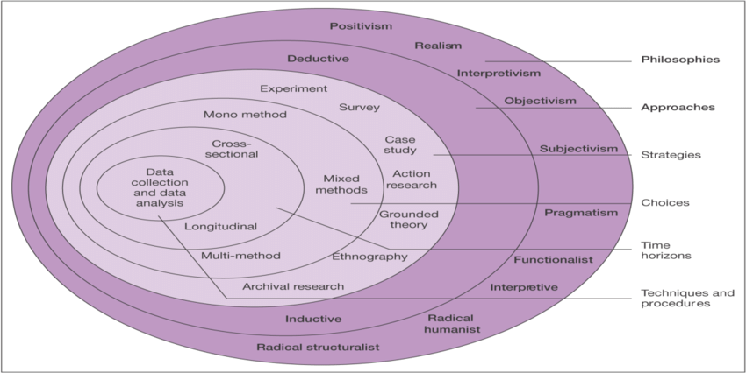
(Sanders et al., 2007)
Following the above diagram quantitative and qualitative research will be conducted for the purpose of this dissertation. This method of research is known as the mix-methods approach (Saunders, 2007). Positivism paradigm was used for gathering questionnaire data this gives research a deductive approach. An inductive approach which is linked to phenomenology was used for gathering interview data.

3.1.1 Philosophy

A questionnaire was used by the researcher to gather samples of quantitative data which could potentially establish reliability. According to Bryman & Bell (2003), quantitative research is outlined as a distinctive research strategy. It is described as entailing the collection of numerical data and as exhibiting a view of relationships between theory and research as deductive which is linked to positivism, and as an objectivist conception of social reality (Bryman & Bell, 2003). The paradigm is the most appropriate to the researchers chosen topic and methods used for the study.
The researcher has also collected qualitative data for the purpose of this study, this will give the study an inductive approach which is linked to phenomenology. As Bryman and Burgess (1999) observe, qualitative research is by no means straightforward. The analysis of qualitative data involves a demanding process. For the purpose of this study, the researcher has audio-record the interviews and subsequently transcribe and reproduced a written account using the actual words (Saunders et al, 2007).
For this study, the researcher has chosen to identify patterns of socio-cultural benefits within a community event. There by a deductive and inductive approach is appropriate for the aims and objectives of the research.

3.1.2 Choice

The researcher chose to collect primary data using two methods, this general term is known as (mixed- methods) technique, analysing procedures sequentially. These procedures the researcher felt was the best way in answering the research questions. As both quantitative and qualitative data collection techniques have their own strengths and weaknesses (Smith, 1975). Different techniques and procedures will have different effects, the researcher has used different methods to cancel out the `method effect`. One of the advantages of using such an approach is that it enables triangulation to take place (Saunders et al., 2007). This has given the researcher greater confidence being placed in the conclusion.

3.1.3 Collection and Analysis

The researcher has conducted a survey that was carried out on respondents that attend the Nos Galan Road Race for the purpose of this study. An important component of the positivist approach to this study is that the research is undertaken, as far as possible in a value- free way (Saunders et al, 2007). The resources of this study will be external to the process of data collection. In affect there is very little that can be done to alter the substance of data collection. Remenyi (1998) defines research as “The assumption is that the research is independent of and neither affects nor is affected by the subject of the research” (Remenyi et al., 1998).

3.1.4 Strategy

The purpose of using a survey strategy was to collect primary data that was relevant to the research topic. Survey`s as outlined by Bryman & Bell (2003) have fewer questions, with an easier approach taken to the design. Which in turn were shorter to reduce the risk of `respondents’ fatigue` (Bryman & Bell, 2003). An advantage in using structured questionnaires is that the collection of data will be more cost effective, and so this was chosen by the researcher. The researcher asked questions that were clear and unambiguous, ensuring that the questionnaire was easy to complete.

3.1.5 Questionnaire design

The questionnaire consisted of ten questions, the research questions asked were concerning the socio-cultural benefits that can be obtained from a community event. These included motivational factors, community development, well-being, building community networks, tourism to an area and sustainability. The questions were closed ended multiple choice, as closed questions enhance the comparability of an answer, this will make it easier to show the relationships between respondents (Bryman & Bell, 2003). This choice of questionnaire designs the researcher felt would be less time constraining when being completed by respondents. The researcher chose not to include gender of age in the questionnaire, as the researcher felt this was not appropriate when asking questions that were based on emotions rather than demographic.

Using this process may very likely clarify the meaning of a question for respondents, as this availability of answers may help clarify the situation for them (Bryman & Bell, 2003). However, closed questions contain certain disadvantages, the loss of spontaneity in respondents’ answers. Respondents’ might come up with interesting replies that may not be covered by the fixed answers that are provided (Bryman & Belle, 2003). One of solutions that the researcher has use to overcome this was to ensure that multiple choice questions were included (Bryman & Belle, 2003) (Look at Appendix 1 Questionnaire design). (Appendix 2 Questionnaire Results).

3.1.6 Pilot study

Prior to using the questionnaire, a small pilot study was conducted. The purpose in using a pilot study is to refine the questions so that respondents will have no problem when answering the questions and there will be no problem in recording data (Saunders et al., 2007). This primary analysis will ensure that all data collected will enable the researcher’s investigative questions to be answered. A pilot study is important for the researcher, as it will enable the researcher to obtain some assessment of the questions’ validity and the reliability of the data that will be collected (Saunders et al., 2007). The pilot study was conducted to ensure that the questions achieved the objectives of the study and generated the required response.

3.1.7 Sampling

The questionnaire was sent to an Events Manager and to four different running clubs in the Rhondda Cynon Taff (RCT) Borough, who attended or participated in the Nos Galan Road Race. The researcher felt that non -probability sampling was the most appropriate form of sampling to use, as all samples were chosen statistically at random. Each running club has over 30 participants. One hundred participants responded to the survey that was generated for the Nos Galan Race. According to Collis & Hussey (2003) definition if the sample that has been chosen is large enough the questionnaire should turn out to be completely unbiased (Collis & Hussey, 2003). A sample that is unbiased will give the opinions of each section of the population in a balanced way. The researcher has survey different members from each section of the population for the sample to be unbiased.

3.1.8 Collection and Analysis

The researcher has also collected qualitative data for the purpose of the study. The main steps in qualitative research describes the order of stages in which research is undertaken. This type of research is more controversial than quantitative research, as it exhibits somewhat less codification of the research process (Bryman & Bell, 2003). The relationship between theory and research is examined, with the nature of concepts differing between qualitative and quantitative research. Qualitative research tends to be concerned with words rather than numbers (Bryman & Bell, 2003). The use of words has helped the researcher to gather valid and reliable data that was relevant for the research questions and objectives (Saunders et al., 2007). (Look at Appendix 3 Transcribed data collection).

3.1.9 Strategy

The researcher has used the interview strategy for the purpose of this study, all primary data has been collected from “singular interviews” rich data has been collected by using smaller samples. The nature of the qualitative data collected has implications for its analysis (Saunders et al., 2007). If data is not grouped into categories the results generated may be an impressionistic view of what the participants mean. To overcome this issue the researcher has analysed qualitative by writing an actual written account of what the participants said all data has been converted for the purpose of the dissertation.

3.2.0 Interview design

The researcher has conducted five interviews for the purpose of this study, ten minutes has been given for each interview to be audio-taped. The researchers aim was to build theory that would add to the body of knowledge, which in turn will gain an understanding of attachment that is obtained from a community. The researchers disadvantage when collecting data is that all interviews that are transcribed may be time consuming and expensive. An advantage of using this method will encourage respondents to express themselves with authenticity. This method used for the collection of data may give the study a greater understanding on what socio-cultural benefits can be obtained from a community event. The research chose to use highly formalised and structured interviews, using standardised questions for each respondent. The aim of this approach is to ensure all interviewees were presented with the same questions in the same order. The researcher felt this was the best approach in the collection of reliable data.

3.2.1 Sampling

Purposive sampling has enabled the researcher to select cases that were more appropriate in helping the researcher answer the research question and meet the objectives. This form of sampling is the most commonly used in the collection of small samples. This has helped the researcher collect informative data for the purpose of the study. The sample consisted of a small proportion of organisers and participants that are involved with the Nos Galan Road Race (Saunders et al., 2007)

3.2.2 Time horizon

The Time horizon refers to how much time is taken when conducting research. The cross-sectional time horizon refers to the study of a particular phenomenon at a particular time (Saunders et al., 2007). While longitudinal refers to a study that takes place over an extensive time period. For the purpose of this study, and the time constraints, the researcher chose to conduct cross-sectional research as this method had the highest capability in achieving the aims of this research. Cross-sectional research can be applied to both quantitative and qualitative methods of research.

3.2.3 Reliability

Reliability could affect the questionnaire if carried out on different days, the researcher selected a more neutral timing to avoid subject or participant error (Saunders et al., 2007). Similarly, participant bias may also affect the researchers results, interviewees may say what they think that their employer wants them to say. The researcher has taken elaborate steps to ensure all respondents remain anonymous. Observational error may very likely occur if there are more than one interviewer. The researcher has ensured all interviews were carried out solely by the researcher (Saunders et al., 2007).

3.2.4 Validity

Validity this criterion applies primarily to quantitative research and to the search for the measurement of social scientific concepts (Bryman & Bell, 3003). Validity is concerned with the integrity of the conclusions that is generated from a piece of research (Bryman & Belle, 2003). Measurement of validity is to do with whether the devised concept really does reflect the right concept that it is supposed to be denoting (Bryman & Bell, 2003). It is in this context that the issue of how many people are selected to participate in the research becomes crucial to the researcher (Bryman & Bell, 2003). The collection of quantitative data allowed the researcher to generally determine validity by asking a series of questions to answer the research objectives.

3.2.5 Limitations

A limited time-frame will exist for the purpose of this study for the collection of primary data. The sample may not likely extend to wide population but would be the most appropriate for the study. The researcher has produced a Gantt chart to efficiently manage time within this process. Extensive time keeping has allowed for both quantitative and qualitative data to be analysed. This allows the study to be viewed from a numerical and written angle. (Look at Appendix 6 Gannt Chart).

3.2.6 Ethical considerations

The researchers chosen topic will be governed by ethical considerations. The researcher has considered the extent in which the data is to be collected. This has important implications for the negotiation of access to people, and so ethical considerations must be applied to the field of study. For this research all participants who have take part will remain anonymous, and all answers will remain confidential. All data collected will be within the guidelines of the Data Protection Act to protect the anonymity of all respondents. The data will remain on the researcher’s data base for the purpose of this study and will not be viewed or shared with any other persons other than the researcher and the faculty supporting the research (University of Wales Trinity St David). All respondents over the age of eighteen will take part in the study, and no vulnerable individuals will be surveyed or interviewed. A statement will be attached to all interviews so that consent will be given before proceeding to audio- tape. A consent box was provided on all questionnaires for the consent of the respondents. A covering letter and consent form wi provided to all interviewees with a copy being obtained by the researcher and the respondent. For a copy of the ethical form approval granted by the university prior to the dissertation (Look at Appendix 4). For the consent form provided to the interviewees and Questionnaire (Look at Appendix 5).

3.2.7 Conclusion

All research undertaken has been carried out and completed for the purpose of this study in a systematic way. Research has undertaken a mixed-methods approach, which the researcher felt was the best way in answering the aim and objectives of the study. Quantitative data which has already been completed within this field of study will be updated by the new data that will be provided from the study. The collection of qualitative data could provide new information updating analysis content. If new information is to be found by the researcher, this could provide new ideas to enhance the well-being of a community.

Chapter 4 – Introduction

This chapter is constructed in two parts and includes present findings discussed in relation to chapter (2). All personal information of all participants involved has been removed from the data base keeping all participants anonymous in line with the aspect of the ethics forms shown in (Appendix 4 and 5).
This chapter intends to gain a resolution to the aims and objectives of this dissertation study stated below:
The aim of this study was to identify whether the Nos Galan Road Race has socio-cultural benefits for its participants and spectators.
There were three objectives to this field of study:
- To examine whether the event could contribute to the well- being of the community.
- To analyse the capacity of the event for building skills and community networks.
- To examine how a community can, make an event sustainable
The main themes from the literature review are shown below:
- Providing an overview to understand community perceptions of what socio – cultural impacts may arise from the staging of a community event. As outlined by theorist’s small community events are usually defined as celebrating the traditions that are passed down from generations, show casing their heritage (Derrett, 2010).

- Traditional events are organised by communities for a number of reasons including, but not limited to, show casing their cultural heritage, attracting tourism, building community networks, promoting their town, promote social cohesion and providing additional cultural entertainment offerings to local residents, thereby they can be seen as providing opportunities to improve the local communities quality of life (Cudny, Korec & Rouba, 2012). Enhancing social relationships to improve individual’s well-being.

- Adaptations of the social dimensions of sustainable community development emphasises the needs and the priorities of the host communities (Ooi et al., 2014), this in turn increases “people`s control over their lives (Timur & Getz, 2008). Local authorities play an important part because they have the authority to redistribute power and can empower communities to make decisions in their local area (Dale & Newton, 2010). However, critical analysis shows interpretations of sustainability approaches may vary over time and are influenced by politics and trends in policy-making (Stevenson, 2013).

A critical analysis of the data has been based on mixed – method, triangulation approach, which commenced with five interviews. Participants that were interviewed worked for Rhondda Cynon Taff in conjunction with the Nos Galan Road Race. This was followed by a questionnaire completed by 100 community members that either participate or spectate at the event. This added a quantitative perspective to the analysis and looked to further enhance the themes that became apparent from the analysis of the interviews. This use of a mixed – methods approach to the research design has given the study a greater detailed analysis.

4.1 Main Findings

4.1.1 Interview Analysis

The five interviews took place at two different locations Mountain Ash, and Abercynon which involved a highly formal structured interview. All participants were asked the same open-ended questions for the purpose of the dissertation. The interviews lasted for approximately ten minutes. This gave the researcher the benefit of adopting a free-flowing interaction between the participants and researcher. Ten questions have given a detailed account of what participants said. Four questions have been used within chapter (4). The researcher feels that this was the best way in answering the aims and objectives. All other written accounts transcribed in full (Look at Appendix 2).

4.1.2 Social Impacts on a Community

The participants provided clear perceptions about the Nos Galan Road Race. Respondents felt it had positive impacts in involving a community and bringing people together. As Small (2008) defines in chapter (2) these social impacts can help a community grow and develop into a community, giving the community a sense of identity. While negative consequences related to the social costs an event can obtain, this related to disruption to the community’s lifestyles. Dwyer (2000) states in chapter (2) that social costs related to noise, crowding, crime and damage to the area. Research agrees these negative aspects can affect a community. Whilst from the interviews that were carried out by the researcher deprivation in an area can detach a community and isolate certain groups. When conducting interviews, the participants perceptions of the Nos Galan Race are shown below.
“Thoughts would be its great as it’s an ongoing thing and happens every year. Getting community involved in the event” (Participant 1).
“Some people would really enjoy the event coming to the area, as it brings a lot of people. A lot of people wouldn’t take to the idea, as it disrupts their everyday routine with road closures’” (Participant 2).
“Money, I think a lot of families reply on food banks. I think any kind of event got to focus on that and bare that in mind. Trying to subsidise as much of the event as you can for people to attend” (Participant 3).
“I think it’s a great way of socializing” (Participant 4).
“Some people who live in the town like the race. Others think it attracts the wrong type of people and it’s about money to some members of the community” (Participant 5)

4.1.3 Well-being of a Community

The themes that were apparent related to making people feel good about their lives giving a community a sense of belonging. Group cohesiveness was evident helping to building social relationships within a community. Arguably in chapter (2) Black (2016) defines events with heritage content had less impact in making connections within a local community. Whilst new research has shown that local communities at an event can connect and bond together as discussed within the interview research.
“One it brings people together; it is about how people feel. It is all about people’s well-being as well. It’s about their mental well-being” (Participant 1).
“It brings people together it brings a lot of people closer together” (Participant 2)
“Certain events can bring communities together. With regards to community spirt you see that coming out in these kind of event” (Participant 3)
“I think it makes them happier about themselves’ (Participant 4).
Make people happy about their lives” (Participant 5).

4.1.4 Building skills and Networks

For it is evident community events bring people together. Which in turn built new bonds and networks with diverse sub-groups at the event. This in turn would enhance new skills and development to be found within the community. As Derrett (2003) outlines in chapter (2) events are socialising hubs for connections. New data has shown socializing hubs can be formed from a community event. As shown below all participants perceived the event had brought people closer together creating new bonds between residents in the local community.
“One is work in partnership with local organisations. People working within community centres, local businesses, shops, schools, and sports clubs. So, they all get involved” (Participant 1).

“Obviously, it brings people together, and obviously working together to know a community” (Participant 2).
“What is does communities diverse with different people. You`ve got doctors, labourers and all sorts, but when they come together as a community. They can bring all their skills into a hub. So, you get a nucleus of people and develop whatever they want to do” (Participant 3)
“They can join people together at an event” (Participant 4).
“It helps bring people together” (Participant 5).

4.1.5 Sustainability

One theme that became evident through the interviews was that the event had to innovate each year. Marketing their brand in different ways to attract tourism to the area. Involving and communicating with stakeholders, building on relationships to make the event sustainable. As in the literature review many theorists define that connections within a community help make an event sustainable. Whilst new research has shown that marketing and branding an event can also help make an event sustainable. It was made apparent in the interview comments below that the event had to attract people from outside of the community to aid the event in becoming sustainable.
“One is changing the event from year to year. So, it makes it more challenging and more inviting. Maybe involving the community, a little bit more. Involving family bringing families together, bringing friends together” also attract people from outside the community. (Participant 1).
“Obviously, the event has been going for a few years, and obviously it gets bigger and bigger each year. You`ve just got to advertise, and word of mouth as every year there are more people coming” (Participant 2).
“Right sustainability comes down to learning. Do an event once and remember the good things and bad. Try and improve on the bad things and keep the good things going, because if you get people wanting to come, they will keep on coming” (Participant 3).
“Advertising through social media” (Participant 4).
“Having new attractions in the event each year. It is good they have a mystery runner, as people come to see who it will be, and local papers come to report on the event so it’s good” (Participant 5).

4.1.6 Questionnaire Analysis

Following on from the data that was collected through interviews, additional data was obtained from a survey questionnaire that was distributed to a sample of 100 respondents that either participated or spectated at the Nos Galan Road Race. These insights were further evaluated within the survey questionnaire.
The data that was collected from the questionnaire was beneficial to the study as it added a quantitative component to the analysis, specifically when looking to further evaluate the social impacts that can be obtained from a community event. This quantitative data was compared with the results that were made apparent in the literature review and in addition the resulting that were obtained from the interviews. The researcher felt that five questions from the survey would best answer the aims and objectives related to the field of study. A template of all the questionnaire can be found in (Appendix 1). With all results shown in (Appendix 2).

4.1.7 Social Impacts on a Community
The data collection from the interviews gave a clear insight into how they feel a community perceives the Nos Galan Road Race, and what positive and negative consequences can be obtained from an event. The researcher has selected questions from the questionnaire that would best answer the aims & objectives of the dissertation.
Question four of the questionnaire asked respondents to indicate what social benefits can be created from a community event. Analysis of the content is depicted in figure 1

Figure 1 - Pie Chart showing what positive socio-cultural benefits were obtained at the Nos
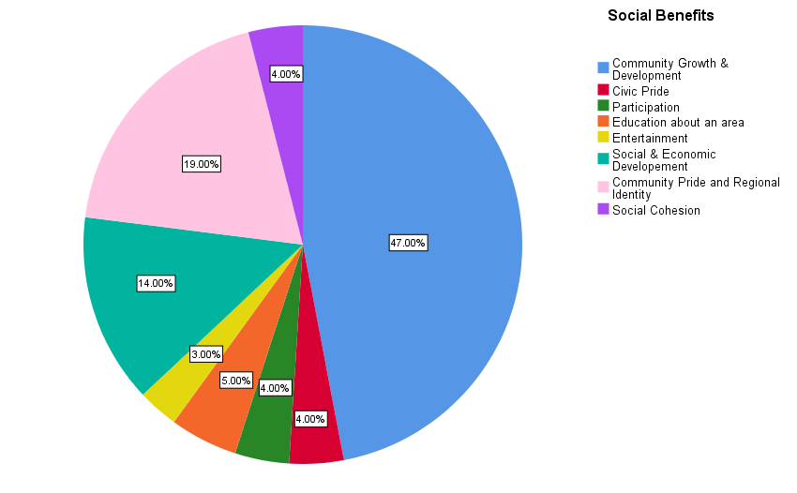

The results provided by the respondents provided clear evidence that the Nos Galan Road Race had positive socio – cultural benefits. There were two distinctive benefits obtained by the event. (47%) of the community felt that the event had changed relationships within the community, which in turn had helped the community to grow and develop. Psychological benefits were also found within the study. (19%) of respondents felt a need or desire to belong to a community, which in turn creating a sense of belonging within the community, helped the community connect to local identity. In addition (14%) of the community felt the event could attract tourism to an area that would further enhance economic development to the area. Whilst a smaller margin of (5%) had perceived the event had educated visitors about the area. Civic pride, participation and entertainment were marginally small in relation to the event. The extent of community involvement in the event is evident this in turn influences the event and how the event is perceived. The community bonded together giving them a feeling of ownership and control. This enhanced community pride giving them a sense of belonging, creating sub-groups between one another so that the community could develop and grow, creating long lasting benefits for the community.

4.1.8 Negative Impacts

Question three of the survey questionnaire wanted to analysis whether a community perceived the event to have negative consequences. Analysis of the content is depicted in figure 2.

Figure 2 - Pie Chart showing what negative consequences the community felt were obtained by the event.
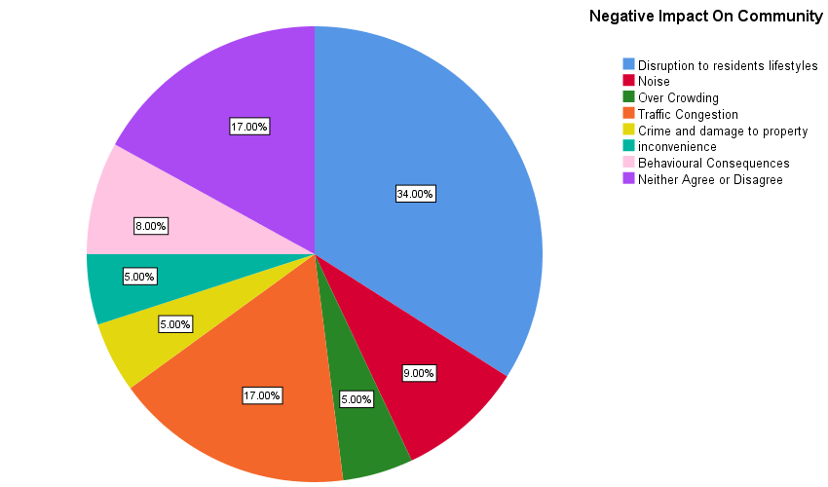

As research has shown in this field of study, social costs can have a negative impact on an event. (34%) of respondents who attended the Nos Galan Road Race related to the negative consequences that were obtained from the event. Residents wanted tourism within the area but were aware of the disruption to residents’ lifestyles. (17%) of the community perceived it was to do with road closures at the event, which in turn created traffic congestion. Whilst (17%) of respondents neither agreed nor disagreed that the event created negative impacts. Smaller groups of respondents believed these negative consequences can be generated from behaviour, noise, crime, overcrowding creating inconvenience for residents. Studies included in chapter (2) argue that positive benefits outweigh the negative benefits. As shown in figure 1. One of the negative impacts researched by Dwyer (2000) in chapter (2) focused on the social costs that can be generated by an event, which in turn can disrupt residents’ lifestyles. Many theorists as outlined in the literature review have focused on the positive and negative impacts of events. As defined in chapter (2) Getz (2007) states an event will always generate positive and negative impacts.

4.1.9 Well -Being of a Community

Question eight of the survey questionnaire asked respondents to indicate if the Nos Galan could contribute to the well-being of a community. Analysis of the content is depicted in figure 3.

Figure 3 - Pie Chart showing how the Nos Galan can contribute to the well-being of a community.
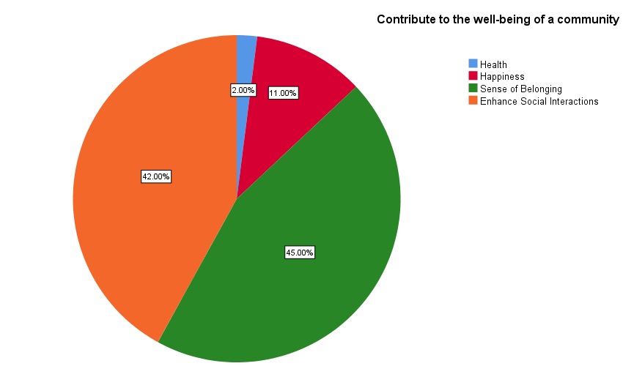

It was evident from the survey that the Nos Galan could contribute to the well-being of a community. As Bladen (2012) defines in chapter (2) events have the power to trigger motivational factors. Whist Maslow (1943) states in chapter (2) one of the basic human needs is a sense of belonging. (45%) of the respondents at the event felt it was important to belong to a community. This in turn enables a community to develop strong social relationships between locals and visitors. This was evident in the data collected, (42%) of respondents felt that the event enhanced social interactions between individuals attending the event. Which in turn reconnected old connections and created new connections with visitors and a community. (11%) of respondents felt the event created a sense of happiness within the community. Whilst other respondents believed that the Nos Galan Race only contributed (2%) to health. Belonging and connections were the main themes in the analysis.

4.2.0 Building skills and Networks

Question nine of the survey questionnaire asked respondents what social networks they perceived could be obtained from the event. Analysis of the content is depicted in figure 4.

Figure 4 - Pie Chart showing how connections were made at the Nos Galan.

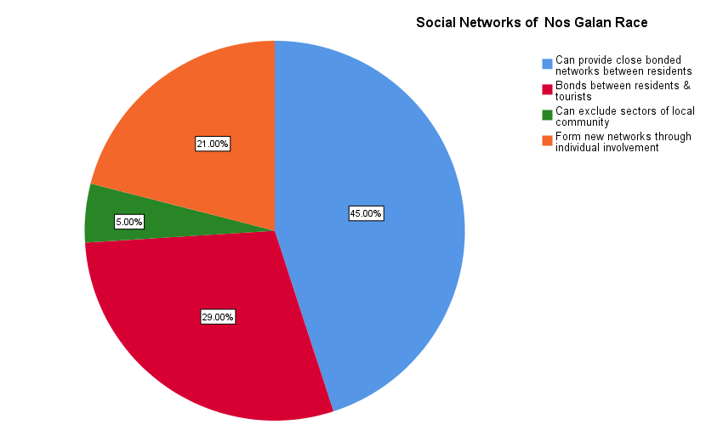

As depicted in figure 4 the community perceived that social connectivity was evident within the study. (45%) perceived that the event enhanced bonds within the community, which in turn brought a community together. Whilst (29%) perceived that a local community could connect with tourists, which in turn formed new bonds to be made outside of the community. In addition (21%) of respondents saw that participation at the event enhanced new connections to be made. Only (5%) of respondents felt that sectors of the community could be excluded, which in turn related to deprivation within the area, as analysed in question one of the interviews. As black (2016) study defines in chapter (2) old connections and new connections can be formed, but old connections were more predominate than new connections. Relationships were built within the event connecting a community together, which in turn reformed old community networks between residents and linking new groups outside of the community to the event. Connecting old and new social hubs, which in turn enhanced community development. The new data will update the old data for the purpose of the dissertation.

4.2.1 Sustainability

Question nine of the survey questionnaire asked respondents how a community can make an event sustainable. Analysis of the content is depicted in figure 5.

Figure 5 - Bar Chart showing how a community can make an event sustainable.

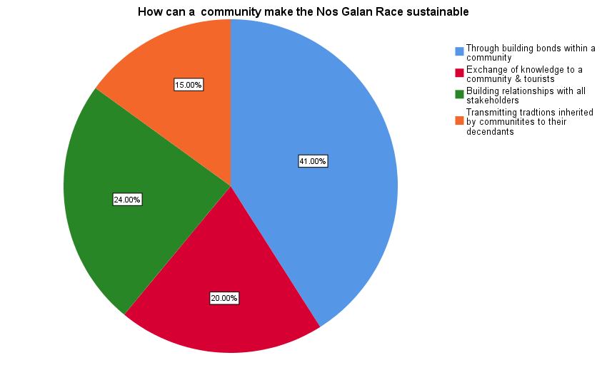

It is evident from the research undertaken at the Nos Galan that an event is made sustainable through connectivity and social hubs, which were evident at the event. (41%) of respondents felt that the event acted as a social platform providing new opportunities for residents to bond with each other. Creating opportunities to engage in cultural display and participate at the event. (24%) felt the event could be made sustainable by involving the community and building relationships between organisers and the community. Whilst (20%) felt it was through the engagement with locals and visitors that knowledge could be exchange providing a platform for new social sub-groups to be formed. A further (15%) of respondents believed that it is through cultural heritage associated with the community that cultural traditions arise, which in turn exchanges cultural knowledge to their descendants to leaving a legacy behind for Nos Galan. As Highmore (2016) states in chapter (2) the term culture is particularly relevant within the context of social sustainability, which may bring social cohesion to a disenfranchised social scene fragmenting the community. New research within this study disagrees with Highmore research. As research has shown connectivity at the event reconnected locals to the event, but also connected visitors to the area forming new bonds and links, which in turn has made the Nos Galan Road Race sustainable.

4.2.3 Conclusion

It `is apparent from the interviews and survey questionnaire that socio-cultural impacts can be obtained from a community event. With the gathering of people at the Nos Galan, old and new sub-groups have been formed bonding locals and visitors together through cultural exchange which was generated by the event. In addition, through this cultural exchange the Nos Galan, may very likely leave a legacy behind for future events. Chapter 5 will discuss and evaluate the analysis.

5.0 Chapter 5 Conclusion

Chapter 5 will discuss and evaluate the extent in which the aim and objectives of the dissertation study have been achieved and ultimately give the resolution to the title of the research study. This will be followed by a review of all the areas of the dissertation that may be considered as needing additional research and will propose further areas of analysis that would be conducted if the study were to be repeated by the researcher.
The aim of the study was to identify whether the Nos Galan Race had socio -cultural benefits for all its participants and spectators.
There were three objectives to this field of study:
- To examine whether the event could contribute to the well -being of a community.
- To analyse the capacity of the event for building skills and community networks.
- To examine how a community can, make an event sustainable.

The aim of the research was to conduct a study that looked at people’s perceptions as to whether the Nos Galan Road Race could generate socio-cultural impacts. This aim was met through conducting an extensive literature review of the pre-existing research that surrounds the topic of socio – cultural impacts. Initially the review of the pre-existing literature focused on the evaluation of the socio – cultural impacts that were obtained from an event, proposing different frameworks for different events. As the literature review highlighted different frameworks at different events may very likely decrease the similarity of the evaluations and lead to continued research within this area. By using different frameworks each time at different events, creates different socio- cultural impacts each time making it difficult to pin point a certain socio – cultural impact.
Researchers such as Ritchie (1984) and Small (2008) provided key literature on socio – cultural impacts obtained by an event. The literature review then provided a detail discussion by Dwyer (2000) into the social costs that can be generated from such events. These different frameworks provided the researcher with a greater understanding on how the methodology and data research would be conducted. The critical review of the literature

however, uncovered positive and negative impacts. Chapter (4) provided clear evidence that positive and negative socio-cultural impacts can occur at an event. However, the positive consequences at the event outweighed the negative impacts as discussed by Getz (2007) in chapter (2) and can be seen in chapter (4) of the dissertation. The themes were made apparent in chapter (4) that positive socio – cultural benefits can enhance community development, which in turn brings a community closer together, which enables a community to connect with each other, creating a sense of identity within the community.
The first objective of the dissertation study was to conduct research into an event to analyse if an event could contribute to the well-being of a community. This objective was met by extensively researching literature that was put forward in chapter (2). Chen Lehto & Cai (2003) Diener & Suh (1997) and Arcodia & Whitford (2006) maintain that events provide opportunities to enhancing social skills within a community, which in turn could bring fulfilment to individuals lives. The critical evaluation of the literature however, uncovered criticism associated with the well-being of a community and argues that such events can lead to a loss of identity within the community. The themes that were made apparent in chapter (4) was that connections can be made at an event giving the community a sense of belonging, which in turn contributed to the well-being of a community. Enhancing social interactions between residents, making them feel good about their lives, which give them a sense of belonging, which in turn gives the community an identity.
The second objective of the dissertation focused on if an event could build skills and community networks. As stated in the literature view by Derrett (2003) events are points of socialising, which in turn can enhance hubs for connections. Arguably Black (2016) research in chapter (2) states that heritage events have low levels of local connectivity. It was evident in chapter (4) from the interviews and questionnaire that an event can bring a community together creating bonds between a community and predominantly build new connections outside of a community, which in turn created new social hubs to be formed which enhanced a community’s skills and development. The community built new skills and social networks at the event, which in turn bonded the community and enhanced bonds between visitors from outside of the community.

The third objective of the dissertation study analysed whether the Nos Galan could be made sustainable for future events. The literature review highlighted that events are made sustainable through cultural display, participation and engagement at an event. Whilst researchers such as Derrett (2005) maintain it is through sharing power between stakeholders that makes an event sustainable. For it is evident in chapter (4) of the dissertation that building bonds and relationships between stakeholders can help make an event sustainable. One of the themes that was made apparent in the interviews was that the event had to innovate each year to attract locals and visitors to an area. Marketing and advertising an event were made apparent in the interviews, which in turn would attract more locals and visitors to help make the event sustainable.
The interviews provided rich qualitative data that gave key insights in to the socio – cultural impacts that can be generated by an event. The following analysis of the interview data provided the researcher with an extensive knowledge into how an event can bring a community closer together, which in turn gives a community a sense of belonging. The positive impacts the event created provided the community to make connections between locals and visitors. Enabling a community to make old and new connections between sub-groups at the event, which in turn formed new hubs for cultural exchange, which may very likely help make the event sustainable.
The survey questionnaire added a quantitative element to the research which gave the research a more in-depth analysis on how spectators and participants perceived the event. The overriding results of which, confirmed the themes obtained in the interviews was that a community event can contribute to the well-being of a community, which created a sense of belonging with in a community, which in turn enhanced social interactions creating bonds and links within a community. New connections were made between locals and visitors providing evidence that a community could connect tourists to an area, exchanging knowledge between old and new groups, which built new skills and community networks.
Through this mixed – method approach that was detailed in chapter (3) of the research methodology the researcher was able to examine and critically analyse the socio – cultural impacts that can be generated by an community event , and as such was able to answer the aims and objectives set out in the dissertation.

5.1.1 Reflect on Analysis

As discussed in chapter (3) of the methodology, perhaps the greatest limitation associated with the dissertation can be attributed to the lack of time the researcher had to complete the study. The researcher felt that a mixed – method approach would be the best way in answering the research question. The analysis of interviews and questionnaire were relevant for this dissertation that are set out in chapter (4). Five interviews were conducted using purpose sampling this form of sampling the researcher felt was the most appropriate in the collection of small samples. Whilst non- probability sampling was used for the collection of the questionnaire. Non – probability sampling used for the purpose of this dissertation was the most appropriate as the sample was big enough for the purpose of the dissertation, set within the given time scale in chapter (3).
Study limitations exist due to the constraints on the methodology in the collection of primary data. As the sample did not extend to a wider population but was the most appropriate for the study within the given time-frame. Data collection for the questionnaire was carried out at a more natural timing to avoid subject or participant error. A series of questions were formulated by the researcher to generally determine validity to answer the research objectives. In addition, the interviews were carried out solely by the researcher to avoid observational error.
The analysis derived from one singular event the Nos Galan Road Race, which focused on the socio – cultural impacts that can be generated by an event. The literature review has provided information enabling the researcher to formulate questions for both the interviews and questionnaire. One of the advantages of using a mix-methods approach is that it enables triangulation to take place. As shown in chapter (4) all new research that has been completed within this area by the researcher will update existing data that has already been completed.
The researcher may look to additionally conduct primary research to analyse if there are certain groups within the community who are isolated and detached from an event by deprivation, with additional analysis into marketing and branding of an event. This primary research may very likely help future events to become more sustainable. Gantt Chart in (Appendix 6) is how the research was undertaken throughout the dissertation.

5.1.2 Recommendations

As the results show in chapter (4) there are two recommendations to this field of study. In relation to primary research being carried out within this area.

5.1.3 Recommendation 1

Primary research to be conducted into a community event to investigate whether deprivation does exclude members of a community.

5.1.4 Recommendation 2

Primary research into a community event to analysis if the marketing and branding of an event can make a community event sustainable.

6.0 Appendices

Appendix 1 Questionnaire Design

Nos Galan Road Race - General Event Feedback

1. Consent box please tick
◯ yes

2. Can social costs have negative impacts on a community. Please tick relevant box below
◯ Disruption to residents’ lifestyles
◯ Noise
◯ Crowding
◯ Traffic congestion
◯ Crime and damage to property
◯ Inconvenience
◯ Behavioral consequences
◯ Neither agree nor disagree

3. Can community events educate individuals about an area and increase participation.
◯ Yes
◯ No

4. What social benefits do you feel can be created from a community event
◯ Community growth and development
◯ Civic Pride
◯ Participation
◯ Education about the area
◯ Entertainment
◯ Social and Economic development
◯ Community pride and regional identity
◯ Social cohesion

5. What are your thoughts on tourism do you feel that community involvement and the quality of life influence residents support for tourism development
◯ Yes
◯ No
◯ Most of the time
◯ Occasionally

6. Do you feel that tourists can learn about a community’s culture through community events
◯ Yes
◯ No

7. What motivates individuals to volunteer?
◯ Want to be part of a community
◯ Volunteering contributes to the well-being and happiness of an individual
◯ Career purposes
◯ Helping others
◯ None of the above

8. What are your thoughts on community events? How do they contribute to well-being of a community?
◯ Health
◯ Happiness
◯ Sense of belonging
◯ Enhance social interactions
◯ Loss of identity

9. What social networks can be built from community events
◯ Can provide close bonded networks between residents
◯ Can provide bonds between residents and tourists
◯ Can exclude sectors of local community
◯ Form new networks through individual involvement

10. How do communities make an event sustainable
◯ | Through building bridges and bonds within a community

◯ | Exchange of knowledge to a community and tourists

◯ | Building relationships with all stakeholders involved with the event

◯ | Transmitting traditions inherited by communities to their descendants

Appendix 2 Questionnaire results

- Consent box please tick

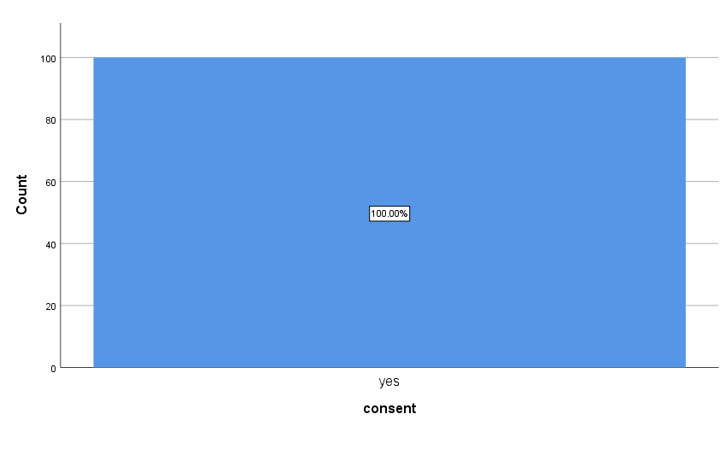

2. Can social costs have negative impacts on a community. Please tick relevant box below 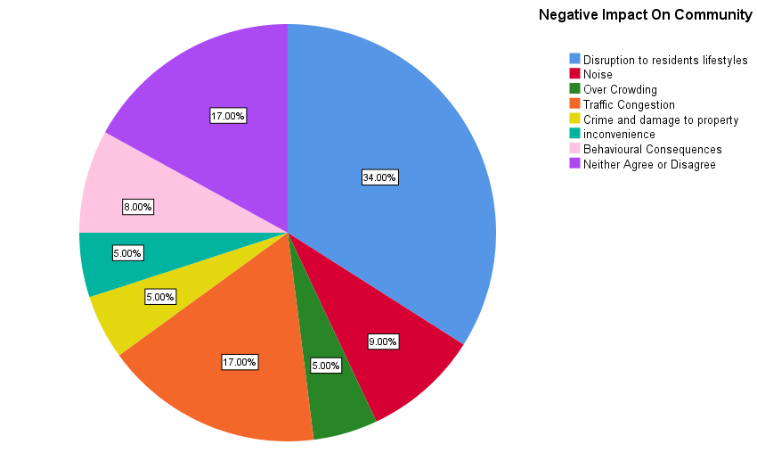

3. Can community events educate individuals about an area and increase participation.
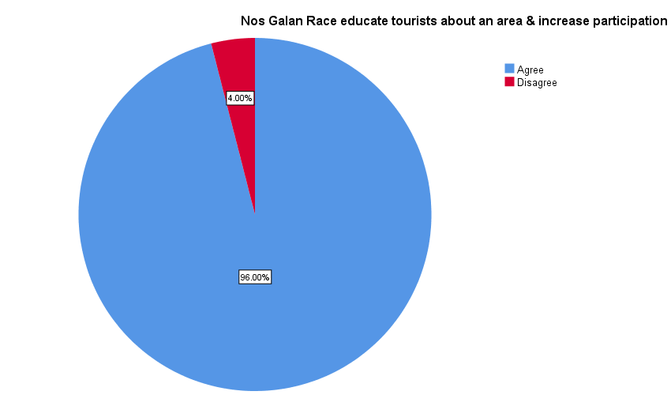

4. What social benefits do you feel can be created from a community event

5. What are your thoughts on tourism do you feel that community involvement and the quality of life influence residents support for tourism development

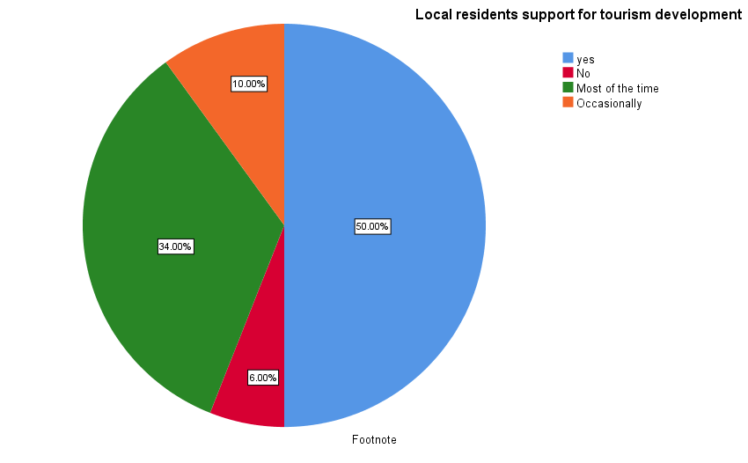

6. Do you feel that tourists can learn about a community’s culture through community events

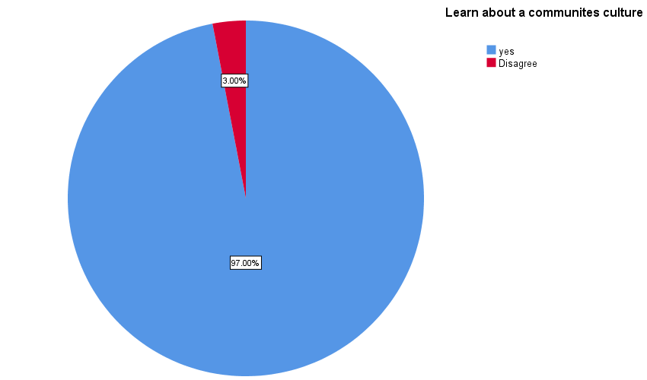

7. What motivates individuals to volunteer?

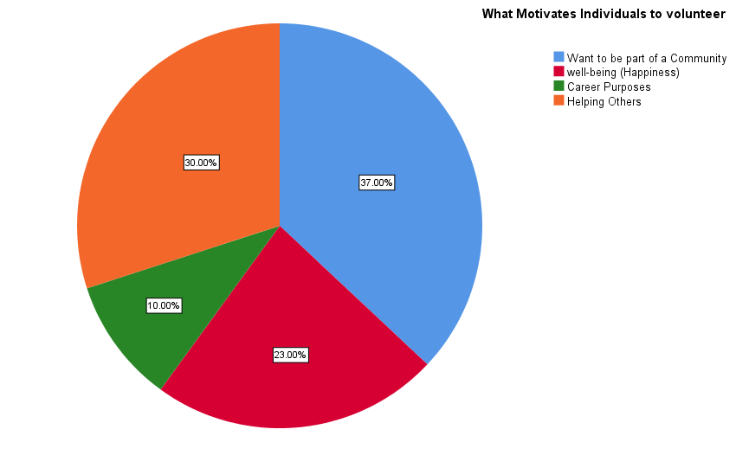

8. What are your thoughts on community events? How do they contribute to well-being of a community?

9. What social networks can be built from community events

10. How do communities make an event sustainable
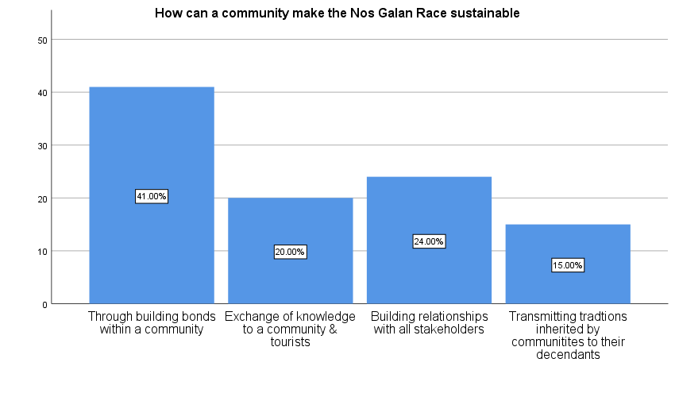

Appendix 3 Transcribed Data

Participate 1
Interviewer: Hello thank you for letting me interview you today for my research.
Participant 1: That’s ok your more than welcome.
Interviewer: What do you think motivates participants to take part in the race?
Participant 1: so, one would be motivation, could be a goal they want to achieve or raise funds for a local charity. Which is quite a high-level thing if they want to raise money for Cancer of heart disease or a children’s charity whatever their goal would be what they want to achieve from that.
Interviewer: So, they raise money for all different Charites?
Participant 1: Whatever they choose it doesn’t have to be for Heart foundation just a good cause. That’s why a lot of people tend to enter for that as they know the money going to a good cause. Some of the people may not have even walked or run before so it’s a new challenge for them and it’s that sense of achievement as well that they’ve done it and think I can do that next time “It’s great”. Its benefits children as well any kind of age. I’ve even had people with their pets their dogs, even had mothers with their prams. It’s all about bringing the community together you know.
Interviewer: What do you think motivates spectators?
Participant 1: Like I say it brings people together. There may be a loved one yea running the race and they want to cheer them on. Or it might be that they want to have a day out. People come to the race for all sorts of reasons. Yea they want to come and enjoy the race and the day yea. As its Christmas more people want to get out and do something that they wouldn’t normally do Yea. Its good.
Interviewer: What are your thoughts why individuals volunteer?
Participant 1: Umm one is motivation is to maybe engage with other people or so involvement with the community so it’s very important to everyone where ever you live. Even if it’s in the valleys or Cardiff even London yea. So, we got to try and bring people together as it’s all about improving health and well-being.

Interviewer: How do you think an event of this nature contributes to the well-being of a community?
Participant 1: One it brings people together. Two it’s a activity which is organised you could go to a community where they don’t get any kinda participation umm an organised event, but it’s about how people feel, helping people to have fun and enjoy. Even though I promote physical activity and health it’s all about peoples well- being as well it`s about their mental well-being. I think that’s more important than their physical well-being.
Interviewer: What are your thoughts on community events?
Participant 1: So, yea I think these types of events yea bring a community together they give something back to the community. As some areas of the community come from deprived back grounds and gives them something to look forward to. Yea it makes them part of something otherwise a community becomes stale and no one wants that. Yea I work with different community’s all over and its good yea for everyone living in the Rhondda and Cynon area to get involved.
Interviewer: How can community events build skills and community networks?
Participant 1: One is work in partnership with local organisations. So, I work through Rhondda Cynon Taff. So, I know a lot of people in like sports development, People working within the leisure centres. Umm local community centres, local businesses, shops, whatever school’s yea. Um even like a local rugby club or football club. Yea so a sport club umm so they all get involved. Running clubs there quite a lot of running clubs around the valleys now. Yea theirs a lot of cycling clubs around the valleys now. So, there’s a lot more activities going on in our areas now. Like what it used to be years ago. Yea I think when I was a kid, we had to make our own fun you know, but there`s so much choice today and it’s nice to get people involved in doing something for a local cause. Rather than saying well I don’t really want to have a go at that. So, it trying to get more people involved. We want people doing more activities yea which is great. Definitely great for children

Interviewer: Do you feel these types of events enhances community development?
Participant 1: Yea we get involved with the Rhondda Runners they do a beginner’s class and they also do an intermedia one. As well so we get involved with those. We get involved with walking groups. So, we try and get involved with them as well. You don’t have to run it you can walk it if you want to as well. It’s not all about saying I’ve got to run around the park I take a walk around the

park. As long as we get people doing some sort of activity Yea. We get the leisure Centre involved we get the local schools involved. Yea as many people we can get to come together to do an activity and to improve their health the more the merrier.
Interviewer: What are your thoughts on how a community views the event itself?
Participant 1: Thoughts would be it great as it’s an ongoing thing and happens every year yea. Its um maybe trying to bring in new ideas and the programme and we going to have like Rhondda Radio there. So, and a bit of community radio Umm we tend to have mascots um like activities for the kids. Face painting, we have Umm even got a Grinch for our Christmas one. He just run around the track and have photographs taken yea. Even getting the local Mayor involved Yea. Supports a lot of Charites his term in office and um so he will come and open the event. So, he like cut the ribbon yea we have a photographer there, so we have a bit of press release, put it into the local paper. Um advertise on social media yea so it’s not just about the event itself. It`s about promoting across the community.
Interviewer: Do you feel this event can attract new tourism to an area?
Participant 1: Yea. It engages the community a lot more but also encourages people living outside areas and thinking whoo they do that they got an event in the valley or up in the Rhondda. Thinking well I wouldn’t mind having a go at that. Yea we get loads of people like from Cardiff up to the Rhondda or Rhondda will go down to Cardiff. Yea so it`s an interaction between two areas. That could be like 20 or 30 miles away. Yea and its grown and it making sure we have different ideas every year, because you’re thinking keeping the event you put on may be quite stagnant. Im getting a bit fed- up of that now. Yea its changing making it more exciting putting something new in. Yea and I think that important for us, important for me anyway yea to put those kinda things on. I live in Mountain Ash at the moment, but im originally from Pontypridd. So, I cover the whole of the valley, because my job im over the Rhondda im over in Cynon im over in Aberdare Yea im in Hawthorn im everywhere. So im all over (RCT). Yea but it’s nice to get involved with other people in other areas as well. Try and bring people together yea. Rather saying well that’s your area that’s your area. No come on come over to our area. Or we go over to their area so working in partnership, and I think that’s more important. They might have an idea and thinking well we might want to get involved in your idea. Or come and have a look at our idea yea, and maybe want to work together.

Interviewer: How do you make an event of this nature sustainable?
Participant 1: One is changing it from year to year so make it more challenging more inviting more umm maybe involving the community a little bit more. Trying on new event ideas as well our event this year is, we going to be doing a Santa Splash it`s going to be a trail at the moment. Yea Um let’s try something different. The Santa Splash is in the pool that going to involve people using the facilitates, but also within the surrounding area as well. As we got a special school nest to the Rhondda. Yea there`s a lot people living and around the sports centre as well. You got a lot of transport you got the Network Rail. Yea so there all different areas that can locate to the event. We have like a kid’s party bouncy castle take some photographs sweets, face painting, mascots there something different every year. To make people want to come to the Nos Galan Race. It’s like I don’t fancy doing that run anymore let’s do something different. So, we bring in new events something changing all the time. Like the event that we been putting on like the 5k run we get the kids doing like a 1k run around the park, but surprising on how many kids what to get more involved. In being more active. Well like can I do the 5k run instead when like course you can. Or my dad’s doing it and I do it with my dad. You find the kids are encouraging thing is do you want to do the 1k no I want to do the 5k. Yea so they motivated themselves to do even more. Yea like interacting with more of the kids at the end of the day they are our future. Is to encourage them more. Yea to say what the benefits have been for physical activity. Is involving family yea bringing families together, bringing friends together. Yea

Participant 2
Interviewer: Thank you for letting me interview you today. There is no wrong or right answer. This interview today is for research purposes for my dissertation.
Participant 2: No problem
Interviewer: what do you think motivates participants to take part in the race?
Participant 2: Well um it could be a few things. It could be personal goals, um another one would be for doing it for a charity and um maybe you’ve lost somebody through an illness, and you want to raise money for that Cancer Research or whatever.
Interviewer: So, what do you think motivates spectators to attend such events?
Participant 2: Obviously if you got a family member or a friend running in the race obviously you want to go and support her, and obviously if you work for a charity, you’re going to be there to support that person running for that charity.
Interviewer: Yes, what are your thoughts on why individuals volunteer?
Participant 2: Obviously again personal reasons, obviously you want to achieve something it’s a real big achievement, and again it could be doing for personal reasons like a bereavement something like that.
Interviewer: Do you feel an event of this nature contributes to the well-being of a community?
Participant 2: It brings people together and otherwise you wouldn’t get involved in these things. Yes, it brings people a lot closer together.
Interviewer: What are your thoughts about community events?
Participant 2: Community events obviously again its um brings people together. Um a chance to know your neighbour in your community. Otherwise people just go along their own personal lives, bring children back and forth to school so just brings your community together, and to know who your living by really.
Interviewer: How can community events build skills and community networks?
Participant 2: Um obviously it brings people together and obviously working together to know the community.

Interviewer: Do you feel these types of events can enhance community development?
Participant 2: Aw definitely it can. Yes, um can I have that question again please.
Interviewer: Yes of course.
Interviewer: Do you feel these types of events can enhance community development?
Participant 2: Yes, definitely it brings people together and brings people into your community as well. So obviously yes it can yea.
Interviewer: What are your thoughts on how a community views the event?
Participant 2: Some people would really enjoy the um event coming to the area as it brings a lot of people, but obviously then a lot of people then wouldn’t take to the idea, as it disrupts their everyday routine. With closure of roads and um obviously then they got to make different arrangements, but other people would think its ok.
Interviewer: yes
Interviewer: Do you feel this event can attract tourism to the area?
Participant 2: Oh, definitely as it brings a hell of a lot of people from different parts of the country, because it’s a very big event, and obviously people will come here and like different parts. Um of the area and would bring tourism yes defiantly.
Interviewer: How do you make an event of this nature sustainable?
Participant 2: Obviously um the event has been going on for a good few years, and obviously it gets bigger and bigger each year. Um and obviously you just got to advertise, and word of mouth as every year there are more people coming. It gets wider and wider so yea defiantly.
Interviewer: Thank you for your time
Participant 2: No problem.

Participant 3
Interviewer: Thank you for letting me interview you for my dissertation. There are no wrong or right answers and all information is confidential.
Participant 3: Yes, that’s fine.
Interviewer: So, what do you think motivates participants to take part in the race?
Participant 3: Um self-gain in way they set themselves a challenge maybe. They want to try and push themselves on. Um be involved in groups um. I personally voted to do a few triathlons last year. There’s like a bit of competitiveness in me. So, it’s sometimes pushing boundaries. I think that any event you sign up to you got to have the heart and the want as well.
Interviewer: Yes, I think so
Participant 3: You have to prepare yourself as not everybody goes and runs at an event every day.
Interviewer: So, what do you think motivates spectators to attend such an event?
Participant 3: Um I think spectators going. They to go to certain events I should imagine they have some sort of interest in it. Interest in people who are doing the event. Family member just to give them a bit of support and some encouragement and maybe just to be part of the event itself.
Interviewer: Yes, that right.
Interviewer: What are your thoughts on why individuals volunteer?
Participant 3: I actually think volunteering work is great. In any capacity not necessary you’re going to be part of something all the time. Um personally I volunteered myself just marshalling. Your there is the capacity of helping, but your also there to see how individuals are doing. Your there to try and push and support them in that way as well. As also the event itself with the financial implications they can’t always pay for people to be doing this. They rely on individuals to do it.

Interviewer: How do you feel an event of this nature contributes to the well-being of a community?
Participant 3: Certain events can bring communities together. You know going back years ago I remember the Rhondda fun run. There would be people on every side of the streets, whatever it was looked forward to. Going back to the old rugby club run. So, this event is the same. With regards to community spirt you see that coming out in these kinds of events, and people obviously enjoy that. It’s not something they would do all the time I should imagine, but as this is an annual event, I

think it makes people want to do it. Also, it puts a community onto the map. As you advertise outside of an area it could encourage people coming from other areas. Then the businesses in the community might benefit, because they going to different shops in the area to get this and that.
Interviewer: So, what are your thoughts about community events?
Participant 3: Love it. Putting on the event it’s just seeing their faces. Blew me out of the water to be fair. Um just to see the enjoyment, what is actually brought to them as individuals fascinating. I think without people trying to put on the event it wouldn’t happen. I think it needs to be them people in the community that want it to go on. Then hope it gets a good rally of support behind it to push it on.
Interviewer: How can community events build skills and community networks?
Participant 3: What it does communities diverse with different people. You got doctors, labourers you got all sorts. But when they come together as a community. They can bring all their skills into a hub. So, you get a little nucleus of people and develop whatever they want to do. With loads of input.
Interviewer: Do you feel these types of events can enhance community development?
Participant 3: Hundred percent. I don’t know if you feel the same way as me. You think of a community when we were younger. Everybody knew everybody. You know you could go next door and they would make you a cup of tea. I think that’s gone massive from communities. So many different faces, but I think cos of the way the event has grown, because we are a town. Don’t mean to say the community is as strong as it was years ago, but that doesn’t mean you can’t get it back. Talking as a local councillor, we see how much its growing and we got little bits money which we have got, but we are trying to develop it into the community side of it.

Interviewer: What are your thoughts on how a community views the event?
Participant 3: Money. I think a lot, how can I put it. If you just look, there’s a lot of families in the community rely on food banks. Rely on family to help, because you know cost living has gone up, but your actual pays haven’t really. I think any kind of community event got to focus on that and bare that in mind. Trying to subsidise as much of the event as you can for people to attend.
Interviewer: Do you feel this event can attract tourism to an area?
Participant 3: With regards to the area for tourism. I think its very important people do come. You see shops closing every day, and pubs, clubs, cafes they all are struggling, and if you were putting something on in the area that would help out the community. With people who are trying to get business going as I don’t think they make a lot of money.
Interviewer: How do you make an event of this nature sustainable?
Participant 3: Right sustainability comes down to learning. Do an event once, remember the good things the bad things. Try and improve on the bad things. and try and keep the good things going. I think any event it needs to be something that people want to come to., because if you get something people want to come to, they going to keep coming.
Participant 4
Interviewer: Hello and thank you for talking to me today.
Participant 4: Your welcome I’m glad to help.
Interviewer: Ok so my first question is. What do you think motivates participants to take part in the race?
Participant 4: I think it’s the thrill and wanting to lead a healthier lifestyle.
Interviewer: Thank you that leads me to me second question. What do you think motivates spectators to attend such an event?
Participant 4: I think it’s the enjoyment of watching the race, and people come to support family members, and have a good day out.
Interviewer: What are your thoughts on why individuals volunteer?
Participant 4: I think it makes them fitter

Interviewer: How do you feel an event of this nature contributes to the well-being of a community?
Participant 4: I think it makes them happier about themselves.
Interviewer: What are your thoughts about community events?
Participant 4: They’re a good way to socialize.
Interviewer: How can community events build skills and community networks?
Participant 4: They can join the people together at the event.
Interviewer: Do you feel these types of events can enhance community development?
Participant 4: Yes, I think it can enhance the regeneration of buildings in the community.
Interviewer: What are your thoughts on how the community views the event?
Participant 4: Depends on what the event is basically. Well this is road racing some people may enjoy it, some people may not.
Interviewer: Ok, do you feel this event can attract tourism to the area?
Participant 4: Yes, in an advertisement way.
Interviewer: How do you make an event of this nature sustainable?
Participant 4: Advertising through social media.
Interviewer: Ok and thank you very much.
Participant 5
Interviewer: Hello and thank you for letting me interview you today for my dissertation.
Participant 5: Its fine glad to be of service.
Interviewer: So, the first question I am going to ask you is, what do you think motivates participant to take part in the race?
Participant 5: To part to participate and to reach certain goals.
Interviewer: Ok, what do you think motivates spectators to attend such an event?
Participant 5: They go to the event to see their friends and socialize.

Interviewer: What are your thoughts on why individuals volunteer?
Participant 5: To reach certain goals in life.
Interviewer: How do you feel an event of this nature contributes to the well-being of a community?
Participant: Make people happy about their lives.
Interviewer: What are your thoughts about community events?
Participant 5: I think it’s a good thing.
Interviewer: A good thing?
Participate 5: Yes, it’s good to have the road race in the town, and its Christmas so people enjoy it.
Interviewer: Ok, how can community events build skills and social networks?
Participant 5: It helps bring people together.
Interviewer: Do you feel these types of events can enhance community development?
Participant 5: Yes, it can help the community, and bring new things to town.
Interviewer: What are your thoughts on how a community views the event?
Participant 5: Some people who live in the town like the race. Others think it attracts the wrong type of people.
Interviewer: Do you feel this event can attract tourism to an area?
Participant 5: Yes, it can through advertising through social media.
Interviewer: How do you make an event of this nature sustainable?
Participant 5: Having new attractions in the event every year. Its good they have the mystery runner, as people come to see who it will be, and local papers come to report on the event so it’s good.
Interviewer: Thank you for your time.

Appendix 4 Ethics Form

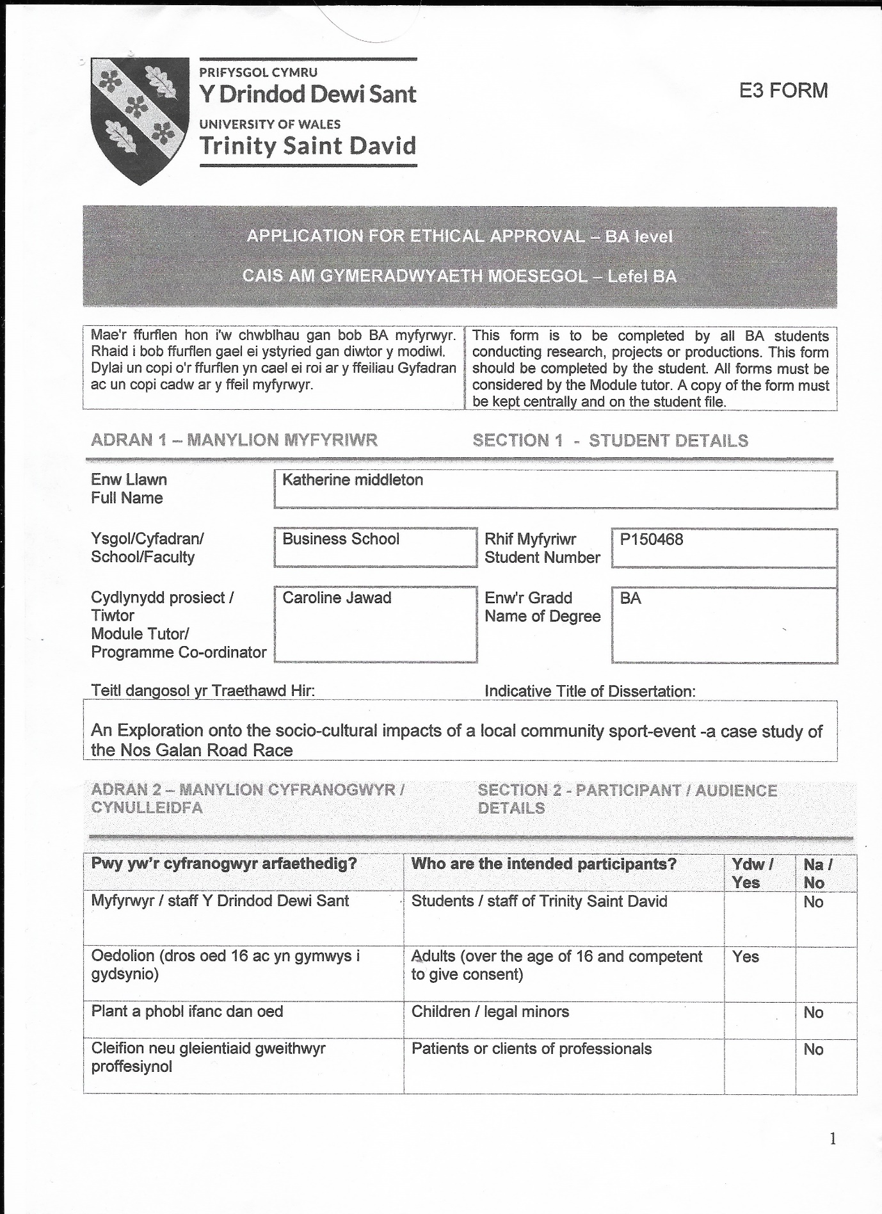

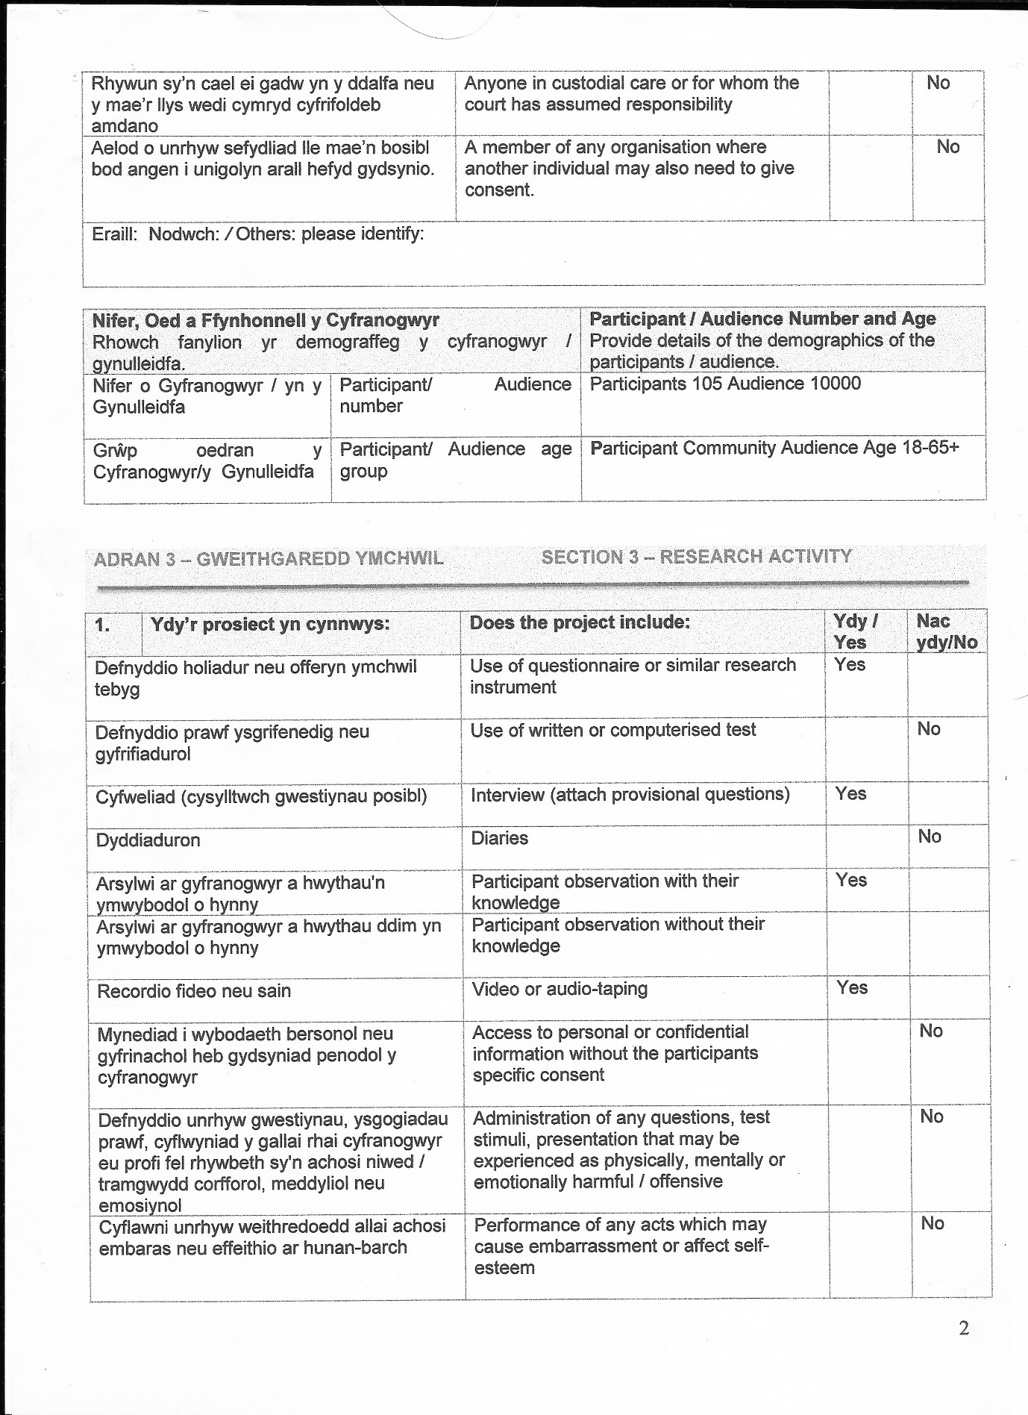

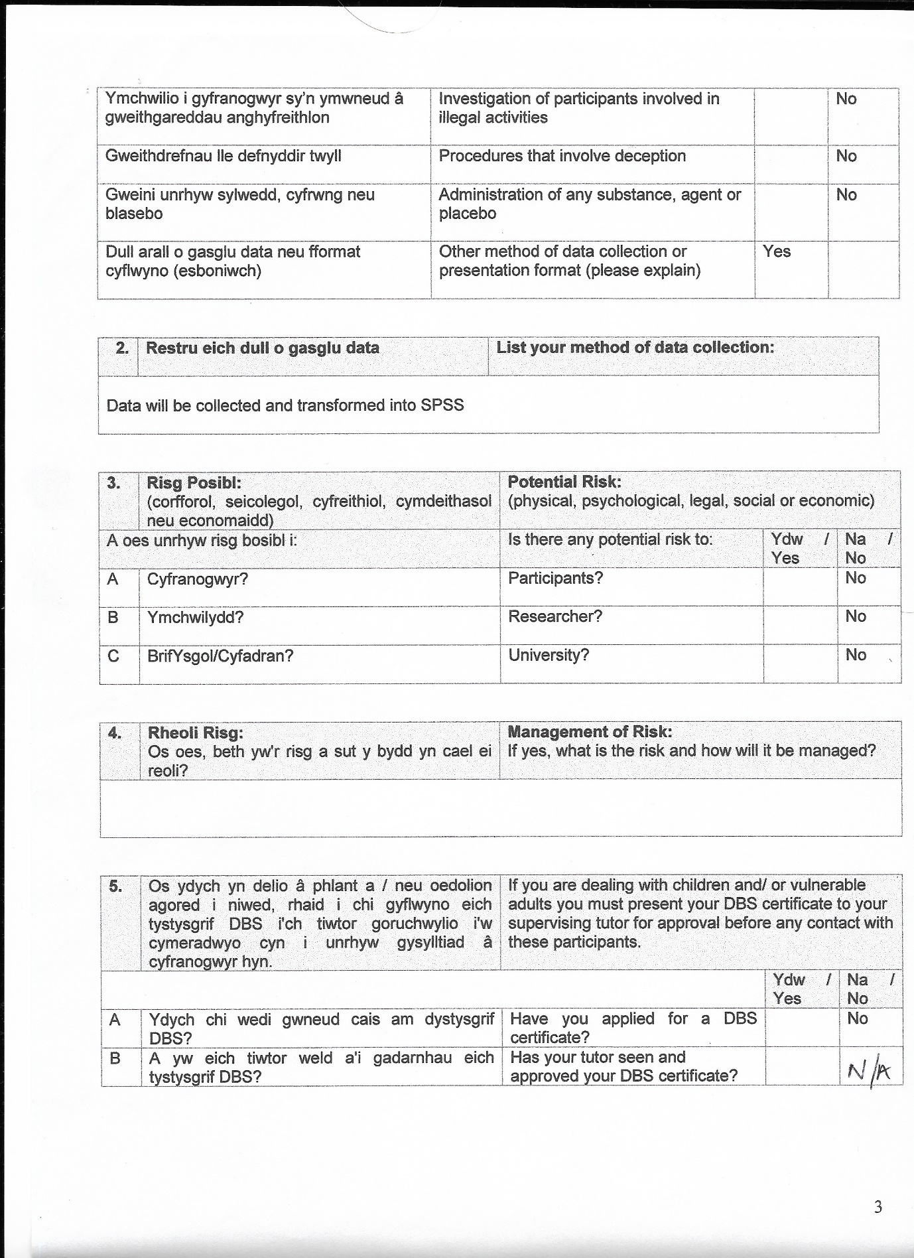

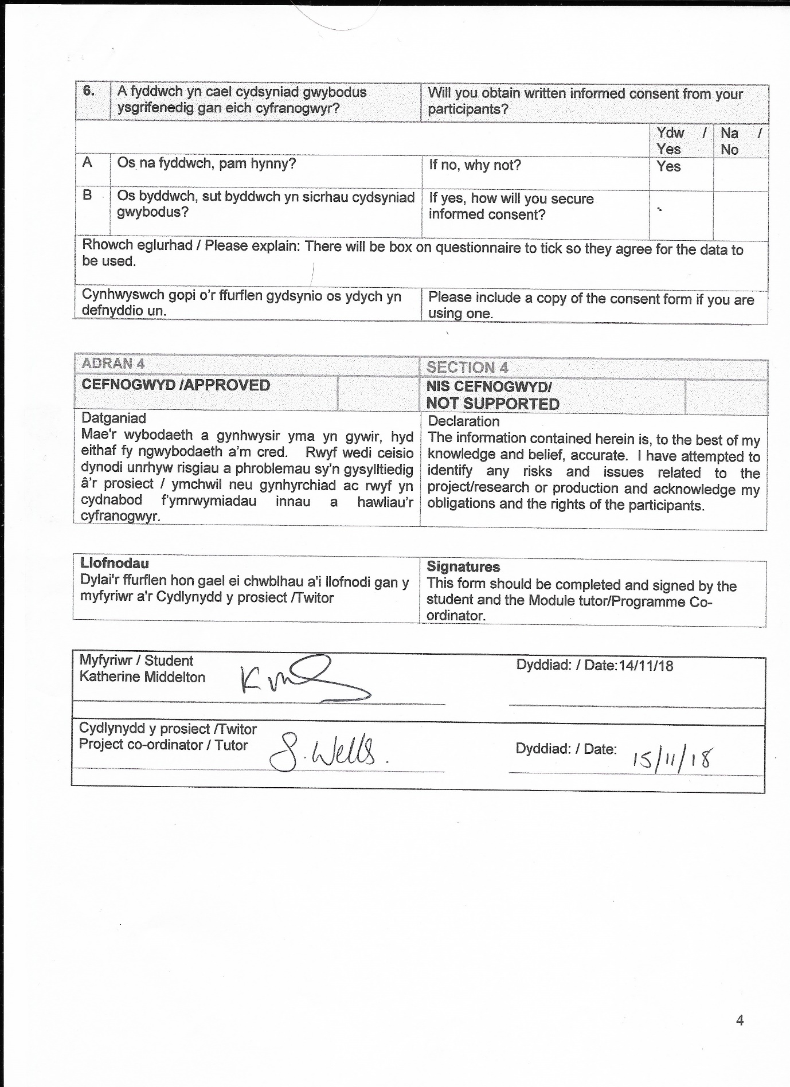

Appendix 5 Consent Form for interviews / Questions

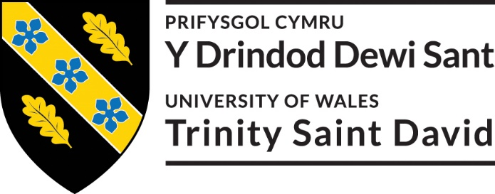

Cyfranogwr Rhif Adnabod:
Participant Identification Number:1-5
CWESTIYNAU CYFWELIAD SAMPL | SAMPLE INTERVIEW QUESTIONS
TEITL Y PROSIECT: / PROJECT TITLE: Nos Galan Road Race

1 | What do you think motivates participants to take part in the race?
2 | What do you think motivates spectators to attend such an event?
3 | What are your thoughts on why individuals volunteer?
4 | How do you feel an event of this nature contributes to the well-being of a community?
5 | What are your thoughts about community events
6 | How can community events build skills and community networks?
7 | Do you feel these types of events can enhance community development?
8 | What are your thoughts on how a community views the event?
9 | Do you feel this event can attract new tourism to the area?
10 | How do you make an event of this nature sustainable?

ENW A CHYFEIRIAD YR YMCHWILYDD
NAME & ADDRESS OF RESEARCHER
Katherine Middleton
Katherine Middleton 11 Elwyn Street Coed Ely Tonyrefail CF398PW

Cyfranogwr Rhif Adnabod:
Participant Identification Number: Participants 1-5
FFURFLEN GANIATÂD CYFRANOGIAD | PARTICIPATION CONSENT FORM
TEITL Y PROSIECT: / PROJECT TITLE: Nos Galan Road Race
Name of Researcher: Katherine Middleton
Please initial box

1. I confirm that I have read and understand the information sheet dated 15/02/19 for the above study. I have had the opportunity to consider the information, ask questions and have had these answered satisfactorily.

2. I understand that my participation is voluntary and that I am free to withdraw at any time, without giving any reason.

3. I understand that any information given by me may be used in future reports, articles or presentations by the research team.

4. I understand that my name will not appear in any reports, articles or presentations.

5. I agree to take part in the above study.

________________________ ________________ _____________________________
Name of Participant Date Signature

_________________________ ________________ _____________________________
Researcher Date Signature

You may decline to participate in this study. You may end your participation in this study at any time. If you decide to remain anonymous, maintaining your anonymity will be a priority and every practical precaution will be taken to disguise your identity. If you prefer anonymity, there will not be any identifying information on audiotapes or transcripts of this or any interview. No-one will hear any audiotapes or see any transcripts without your prior consent. All materials generated from this or any interview will remain confidential.

When completed, please return in the envelope provided (if applicable). One copy will be given to the participant and the original to be kept in the file of the research team at: PLACE:

ENW A CHYFEIRIAD YR YMCHWILYDD | NAME & ADDRESS OF RESEARCHER  Katherine Middleton  11 Elwyn Street, Coed Ely, Tonyrefail, CF398BL

Cyfranogwr Rhif Adnabod:
Participant Identification Number: 1-5
FFURFLEN GANIATÂD CYFRANOGIAD | SAMPLE PARTICIPANT INFORMATION SHEET
TEITL Y PROSIECT: / PROJECT TITLE: Nos Galan Road Race.

*THIS FORM IS TO BE AMENDED AND ADAPTED AS NECESSARY

Dear Participant:

My name is Katherine Middleton and I am studying in the School of University of Wales Trinity David Swansea Business Campus.

I would like to invite you to participate in my research project. This project will provide information and aims to identify whether the Nos Galan can provide socio-cultural benefits to a community.

*Attached to this letter is a short questionnaire developed by Katherine Middleton which will assess the dissertation. I believe your opinions will be extremely helpful to me.

Through your participation in the questionnaire and/or interviews, I hope to ascertain new research findings within this area.

All questionnaires will be kept strictly confidential to the researchers involved and at NO time will individual questionnaires be released to the general public. This gives you a chance to express your views on your programme a confidential and anonymous forum and still be able to make a difference. Your participation in this study is completely voluntary so you can withdraw from the questionnaire at any stage.

Our questionnaire should take about 10 minutes to complete, but there is no time constraint. There are also no right or wrong answers. Attached to this letter along with the questionnaire is consent form. (e.g. an instruction sheet / a consent form /a feedback sheet). As this is a new project, your feedback is also important to us and we would be much obliged if you could also complete the feedback sheet along with the questionnaire. We understand that your time is at a premium, but your opinions are very valuable to us.

After careful and precise analysis of the data obtained from this questionnaire, I will be happy to provide you with a copy of the findings at your request. The results of this questionnaire will hopefully enhance my understanding of Socio – Cultural Impacts and will be stored on Katherine Middleton data base. The results of the research will be fed back to Participants in the Interviews.

We thank you in advance for your time and participation. If any questions do arise, feel free to contact me at your convenience.

ENW A CHYFEIRIAD YR YMCHWILYDD | NAME & ADDRESS OF RESEARCHER  Katherine Middleton  11 Elwyn Street, Coed Ely, Tonyrefail, CF398BL

Appendix 6 Gantt Chart

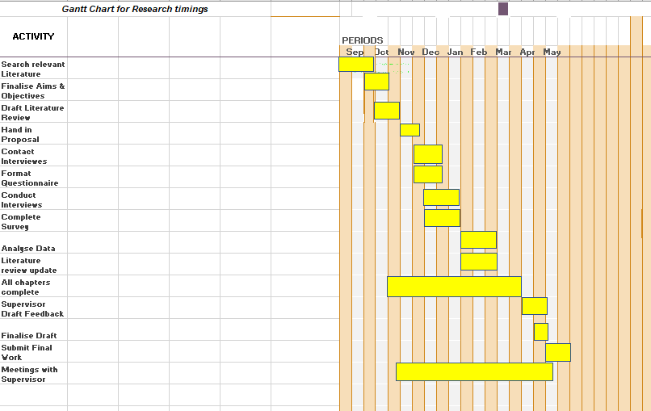

Bibliography

Abram, S. &. W. J., (1997). . Introduction: Tourists and tourism - identifying with people and places. . In: 1. (Ed)., ed. Tourists and tourism: Identifying with people and places. . Oxford. : Berg. , pp. 1-11. .
Anderson, J. &. M. L., (1978). . The motivation to volunteer. Nonprofit and Voluntary Sector Quarterly.. Journal Of Voluntary Action Research. , 7. ((3/4). ), pp. 12-129. .
Andersson, T. &. G. D., (2008). . "Stakeholder management stratergies of festivals".. Journal of Covention & Event Tourism. , 9. ((3). ), pp. 199-220. .
Arcodia, C. &. R. A., (2000). . A future for event management : A taxonomy of event management.. Journal Events beyond. , 6. ((4). ), p. 154. .
Arcodia, C. &. W. M., (2006). . Festival attendance and the development of social capital.. Journal of Convention and Event Tourism. , 8. ((2). ), pp. 1-18. .
Bagiran, D. &. K. H., (2013). . A research on social impacts the Foca Rock Festival: The validity of the Festival Social Impact Attitude Scale.. Journal Tourism. , 19. ((9). ), pp. 930-948. .
Barrio, M. D. M. &. H. L., (2012). . Evaluating intangible cultural heritage: The case of cultural festivals.. Journal City, Culture and Society. , 3. ((4). ), pp. 235-244. .
Barrow, C. J., (2000). . Social Impact assesment: an introduction.. 1st (Ed). ed. London: : Arnold Publishers. .
Belisle, F. &. H. D., (1980). . The percived impact of tourism by residents.. Journal Annals of Tourism. , 11. ((1). ), pp. 83-101. .
Black, N., (2016). . Festival connections: How consistent and innovative connections enable small-scale rural festivals to contribute to socially sustainable communities.. International Journal of Event and Festival Management. , 7. ((3). ), pp. 172-187. .
Blade, C. K. J. A. E. &. W. N., (2012). . Managing the event human resource. . In: 1. (Ed)., ed. Events Management; An Introduction. . Abington. : Routledge. , pp. 128-129. .
Bowdin, G. A. J. O. W. H. R. &. M. I., (2006). . Events Manangement.. 3rd (Ed). ed. Great Britian. : John Wiley & Sons. .
Bowen, M., (2013). . "A Festival Frenzy" ArtsProffessional.. [Online]
Available at: https://www.artsprofessional.co.uk/magazine/268/article/festival-frenzy?utm_source.
[Accessed Friday 8th. Febuary (2019). ].
Bowitz, E. &. I. K., (2009). . Economic impacts of cultural heritage-Research and perspectives.. Journal of Cultural Heritage. , 10. ((1). ), pp. 1-8. .
Broughham, J. &. B. R. W., (1981). . A segmentaion analysis of resident attitudes to social impcat tourism.. Journal Annals of Tourism. , 8. ((4). ), pp. 569-590. .
Bryman, A. &. B. E., (2003). . Business Research Methods.. 1st (Ed). ed. New York. : Oxford University Press. .
Bryman, A. &. B. R., (1999). . Qualitative Research-Fundamental Issues in Qualitative Research.. (Vol 1). ed. s.l.:s.n.
Casimir, G. N. K. Y. Y. W. K. &. O. G., (2014). . The relationships amongst leader-member exchange, percived organizational support, affective commitment. and in-role performance: A social- exchenge perspective.. Journal Leadership & Organization Development. , 35. ((5). ), pp. 366-385. .
Chang, P. J. W. L. &. L. Y., (2014). . Social relationships, leisure activity and health in older adults.. Journal Health Psychology. , 33. ((6). ), pp. 516-523. .
Chen, Y. L. X. Y. &. C. L., (2013). . Vacation and well-being: A study of Chinese tourists.. Journal Annals of Tourism Research. , Volume 42. , pp. 284-310. .
Clary, E. &. S. M., (1999). . The motivations to volunteer theoretical and practical considerations.. Journal Current directions in psychological science. , 8. ((5). ), pp. 156-159. .
Coalter, F., (2007). . Sports clubs, social capital adn social regeneration:. Journal Sports in Society. , 10. ((4). ), pp. 537-599. .
Collis, J. &. H. R., (2003). . Business Research: A pracitical guide for undergraduate and postgraduate students.. 2nd (Ed). ed. Basingstoke. : Palgrave Macmillian. .
Cudny, W. K. P. &. R. R., (2012). . Residents' perception of festivals-a case study of Lodz.. Journal Sociologia. , 44. ((6). ), pp. 704-728. .
De Bres, K. &. D. J., (2001). . Celebrating group and place identity: A case study of a new regional festival.. Journal Tourism Geographies. , 3. ((3). ), pp. 326-337. .
De Bres, K. &. D. J., Journal Tourism Geographies. . Celebrating group and place identity: A case study of a new regional festival.. 3.((3). ), pp. 326-337. .
Deiner, E., (2009). . Assessing Well-Being : The Collected Works of Ed Diener.. 1st (Ed). ed. London. : Springer. .
Delamere, T. A., (2001).. Development of a scale to measure resident attitudes towardthe social impacts of community festivals, Part ll: Verification of the scale.. Journal Event Management. , 7. ((1). ), pp. 25-38. .
Delamere, T. A. W. L. &. H. T., (2001). . Development of a scale to measure resident attitudes toward the social impacts of community festivals, Part 1: Item generation and purification of the measure.. Journal Event Management. , 7. ((1). ), pp. 11-24. .
Delmare, T. A. W. L. &. H. T. D., (2001). . Developement of scale to measure resident attitudes toward the social impacts of community festival, part 1: item generation and purification of the measure.. Event Management. , 7 ((1)), pp. 11-24.
Derett, R., (2003). . Festivals & regional destinations: How festivals demonstrate a sense of community & place.. Journal Rural Society. , 13. ((1). ), pp. 35-53. .
Derret, R., (2004). . Festivals, events and the destination.. 1st (Ed). ed. Oxford. : Butterworth. .
Derrett, R., (2005). . "Why do regional community cultural festivals survive?" The impact of Events: Triple Bottom Line Evaluation and Event Legacies.. Sydney. , Third International Event Management Conference. .
Diener, E. &. E. S. M., (1997). . Subjective well-being and age: An international analysis.. Journal Annual review of gerontology and geriatrics. , Volume 17, pp. 304-324. .
Diener, E. &. S. E., (1997). . Measuring quality of life: Economic, social and subjective indicators.. Journal Social Indicators Research. , 40. ((1/2). ), pp. 1-31. .
Diener, E., (2009). . The science of well-being: Collected works of Ed Diener.. Vol (37). ed. London . : Springer. .
Douglas, N. &. D. R., (2001). . Special interest toruism: context and cases.. In: J. W. a. Sons., ed. Special Interest tourism. . Australia. : Milton. , p. 67.
DWYER, L. M. R. M. N. &. M. T., (2000). . A framework for assessing 'tangible' and 'intangible' impacts of events and coventions.. Events Management. , 6.((3). ), pp. 175-189..
Felenstein, D. &. F. A., (2003). . Local Festivals and tourism promotion: The role of public assistance and visitor expenditure.. Journal of Travel Research. , 41((4). ), pp. 385-392. .
FREDLINE, E. &. F. B., (2000). . Host community reactions: A cluster analysis.. Annals of Tourism Research. , 27. ((3). ), pp. 763-784. .
Fredline, E. &. F. B. B., (2002b). . Variations in residents` reacyions to major motorsports events: why residents percieve the impacts of events differently.. Event Management. , 7((2). ), pp. 115-126. .
Fredline, L. J. L. &. D. M., (2003). . The development of a generic scale to measure the social impacts of events.. Journal Event Management. , 8((1). ), pp. 23-37. .
Getz, D., (2007). . Event Studies : Theory, research and policy for planned events.. 1st (Ed). ed. Oxford. : Elsevier. .
Getz, D., (2008). . Event Tourism: Definintion, evaluation and research.. Journal Tourism Management. , 29. ((3). ), pp. 403-428. .
GETZ, D., (2010). . Event tourism: Definition, evolution, and research.. Journal Tourism Management. , 29. ((3). ), pp. 403-428. .
Getz, D., (2010). . The nature and scope of festival studies.. International Journal of Event Management. , 5.((1). ), pp. 1- 47. .
Getz, D., (2012).. Event Studies; discourses and future directions.. Journal Event Management., 16.((2).), pp. 171-187..
Getz, D., (2013). . Event tourism: concepts, international case studies and research. 1st (Ed). ed. USA : Elmsford. .
Griffiths, I. &. S. R., (2012). . Influences of nationalism on tourist-host relation-ships.. Journal Annals of Tourism Research. , 39 ((4). ), pp. 2051-2072. .
Grosbois, D. D., (2009). . Assessing The Socio-Cultural Impact of Special Events: Frameworks, Methods, And Challenges.. Journal of Tourism Challenges and Trends, , 11((2). ), pp. 39-52..
Highmore, B., (2016).. Social Science > Popular Culture. . In: 5. (Ed)., ed. Culture. . Oxford.: Routledge., pp. 1-165. .
Kee, Y. H. L. C., (2018). . Motivations for Volunteering and its Assocations with Time Perspectives and Life Satisfaction: A latent Profile Approach.. Journal Pschological Reports. , 121((5). ), pp. 932-951. .
KELLY, A. &. K. K., (2000). . Impacts and values,assessing the arts and creative industries in the South West. Bristol:. Bristol Cultural Development Consirtium. .
Kim, K. U. M. &. S. M., (2013). . "How does Tourism in Community Impact the Quality of Life of Community Residents".. Journal Tourism Management. , 36. ((5). ), pp. 527-540. .
Kotler.P.G.A, T., 2012. Principles of Marketing. London: Pearson Education Limited.
Kotler, P. a. A. G., 2012. Principles of Marketing. 14 ed. London: Pearson.
Kristiansen, E. S. B. P. M. &. W. I., (2015). . 'We can do it': Community, resistance, social solidarity, and long term volunteering at a sport event.. Journal Sport Management Review. , Volume 18. , pp. 256-267. .
Kristiansen, E. S. E. &. H. D., (2014). . From Community Based Identities to Individual Benefits for Volunteers : A Compariosn of Three Sporting Events.. Journal Scandinavian Sport Studies. , Volume 5. , pp. 47-68. .
Larson, M., (2009). . "Festival innovation: complex and dynamic network intereaction".. Scandinavian Journal of Hospitality and Tourism. , 9. ((1/3). ), pp. 288-307. .
Leenders, M. A. G. &. B. P., (2015). . The importance of the location in hosting a festival: A mapping approach.. Journal of Hospitality Marketing & Management. , 24. ((7). ), pp. 754-769. .
MACKELLAR, J., (2006). . Coventions festivals, and tourism: Exploring the networks that binds.. Journal of Convention & Event Tourism. , 8. ((2). ), pp. 45-56. .
Mackellar, J., (2007). . Conventions, festivals and tourism: Exploring the network that binds.. Journal of Convention & Events Tourism. , 8. ((2). ), pp. 45-56. .
Macnab, N. T. G. &. G. I., (2010).. "The changing nature of connectivity within and between communities". [Online]
Available at: https://www.ahrc.ac.uk/fundingopportunities/documents.
[Accessed Monday 4th. March. (2019). ].
Maki, A. D. P. &. S. M., (2016). . Time perspective and volunteerism: The importance of focusing on the future.. The Journal of Social Psychology. , 156. ((3). ), pp. 334-349. .
Mari, J. &. W. M., (2013). . An exploration of events research: Events topics, themes and emerging trends.. International Journal of Event and Festival Management. , 4. ((1). ), pp. 6-30. .
Maslow, A. H., (1943).. A Theory of Human Motivation, Psychological Review.. Journal Psychological Review., 50. ((4). ), pp. 370-396. .
Max-Neef, M., (1991). . Human Scale Development: Conception, Application and Further Reflections.. 1st (Ed). ed. New York. : The Apex Press. .
NARAYAN, D., (2008). . Bonds and bridges: Social capital and poverty, Poverty Group, PREM. The World Bank.. [Online]
Available at: http://www.worldbank.org/htmll/dec/Publications/Workpapers/home.html.
[Accessed Monday 21st. January. (2019). ].
Noronha, R., (1977).. Paradise reviewed: tourism in Bali.. In: Paradise Reviewed. . Oxford.: Oxford University Press., pp. 177-204.
Pavlic, I. P. &. P. B., (2015). . The Social Impacts of Tourism on Local Community`s Quality of Life.. Journal Tourism in Southern and Easten Europe. , Volume 3, pp. 259-272. .
Pranic, L. &. C. L., (2012). . Host population perceptions of the social impacts of sport tourism events in transition countries: Evidence from Croatia.. International Journal of Event and Festival Management. , 3.((3). ), pp. 236-256. .
Putman, R., (1995). . Bowling alone:America`s declining social captial.. Journal of Democracy. , 6. ((1). ), pp. 65-78. .
Putman, R., (2000). . Bowling alone: The collapse and revival of the American Community.. New York. : Simon adn Schuster. .
Reid, S., (2008). . "Identifying social consequencesof rural events".. Journal Event Management. , 11. ((1/2). ), pp. 89-98. .
Reid, S., (2011). . Event stakeholder management : developing sustainable rural event practices.. International Journal of Event and Festival Management. , 2. ((1). ), pp. 20-36. .
Remenyi, M. &. S. S. M., (1998). . Business bemefits from information systems through an active bemefits realisation programme.. International Journal of Project Management. , 16((2). ), pp. 81-98. .
RITCHIE, J., (1984). . Assessing the impact of hallmark events: Conceptual and research issues.. Journal of Travel Research. , 22. ((1). ), pp. 2-11. .
Riuba, W., n.d. Residents perceptions of festivals - a case study of Lodz Sociologia. 44. ((6). ), pp. 704-728..
Roche, M., (1994). . "Mega - events and urban policy".. Journal Annals of Tourism Research. , 21. ((1). ), pp. 1-19. .
Ryan, R. &. D. E., (2000). . Self-determination theory and the facilication of intrinsic motivation, social development, and well-being.. Journal American Psychologist. , 55. ((1). ), pp. 68-78. .
Ryan, R. &. F. C., (1997). . On energy, personality, and health: Subjective vitality as a dynamic reflection of well-being.. Journal of Personality. , 65((3). ), pp. 529-565. .
Sachs, I., (1999). . "Social sustanability and the whole development:exploring the dimensions of sustainable development", in Becker, E and Jahn, T. . In: 1. (Ed)., ed. Suatainabilty and the Social Science: A cross Disciplinary Approach to Integrating Environmental Considerations. . London. : Zed Books. , pp. 25-36. .
Saunders, M. L. P. &. T. A., (2007). . Preparing Your Dat For Analysis. . In: 4. (Ed)., ed. Research Methods for Business Students. . Essex. : Pearson Education Limited. , pp. 474-475. .
Saunders, M. L. P. &. T. A., (2007). . Research Methods for Business Students.. 4th (Ed). ed. Essex. : Persaon Education Limited. .
Saunders, M. L. P. &. T. A., (2007). . Understanding Your research philosophy. . In: 4. (Ed)., ed. Research Methods for Buisness Students. . Essex. : Pearson Education Limited. , pp. 101- 157. .
Saunders, M. L. P. &. T. A., (2007). . Understanding Your Research. . In: 4. (Ed)., ed. Research Methods of Business Students. . Harlow. : Person Education Limited. , p. 105. .
Scheyvens, R., (2011). . The challenge of sustainable tourism development in the Maldives : Undersatnding the social and political dimensions of sustainability.. Asia Pacific Viewpoint. , 22. ((1). ), pp. 28-51. .
SCHULENKORF, N., (2009). . An ex ante framework for the strategic study of social utility of sports events.. Journal Tourism and Hospitailty Research. , 9. ((2). ), pp. 12-131. .
SMALL, K., (2008). . Social dimensions of community festivals: an application of factor analysis in the development of the Social Impact Perception (SIP) scale.. Journal Event Management. , 11((1-2). ), pp. 45-55. .
Small, K. E. D. &. S. L., (2005), . A Flexible Framework For evaluating The Socio-Cultural Imapcts Of A (Small) Festival.. Intertnational Journal of Event Management Research. , 1(1), pp. 66-77.
Small, K. E. E. &. S. L., (2005). . A Flexible Framework for Evaluating the Socio- Cultural impacts of a (small) Festival.. International Journal of Event Management Research. , 1. ((1). ), pp. 66-74. .
Stevenson, N., (2016). . Local festivals, social capital and sustainable destination development: experiences in East London.. Journal of Sustainable Tourism. , 24. ((7). ), pp. 990-1006. .
Stylidis, D., (2014). . "Residents" Support for Tourism Development: The Role of Residents` Place Image and Perceived Tourism Impacts.. Journal Tourism Management. , Volume 45. , pp. 260-274. .
Thoits, P. &. H. L., (2001). . Volunteer work and well-being.. Journal of health and social behaviour. , 42. ((2). ), pp. 115-131. .
Timothy, D., (1994). . Enviromental impacts of heritage tourism.. Journal Physical and socio-cultural perspectives. , 11((4). ), pp. 37-49. .
Timothy, D., (1997). . Tourism and the personal heritage experience.. Journal Annals of Tourism Research. , 24. ((3). ), pp. 751-754. .
Timothy, D., (2011). . Cultural heritage and tourism: An introduction.. (Vol 4). ed. Bristol. : Channel View. .
Timur, S. &. G. D., (2008). . A network perspective on managing stakeholders for sustainable urban tourism.. International Journal of Contemporary Hospitality Management. , 20.((4). ), pp. 445-461. .
Tyson, S. &. Y. A., (2000). . Essentials of HRM.. 4th (Ed). ed. Oxford. : Butterworth-Heinemann. .
UNESCO., (2003). . "Text of the convention for the safeguarding of intangible cultural heritage".. [Online]
Available at: https://www.unesco.org/culture/ich/index.
[Accessed Monday 6th. March. (2019). ].
Veal, A., (2006). . Questionaire Surveys. . In: Research Methods for Leisure and Tourism: A Practical Guide. . Harlow. : Pearson Education Limited. , pp. 231-232. .
Veal, A., (2017). . Research methods for leisure and tourism.. 5th (Ed). ed. UK.: Pearson. .
Vecco, M., (2010). . A definition of cultural heritage: from the tangible to the intangible.. Journal of Cultural Heritage., 11.((3). ), pp. 321-324. .

Volai, M. R. R. C. S. &. G. D., (2015). . A pilot study on spectators` motivations and their socio-economic perceptions of a film festival.. Journal of Convention & Event Tourism. , 16. ((3). ), pp. 253-271. .
Waldren, J., (1996). . Insiders and outsiders: Paradise and reality in Mallorca.. 1sy (Ed). ed. Oxford. : Berghan Books. .
Wilson, J., (2000). . Volunteering.. Journal Annual Review of Sociology. , 26. ((1). ), pp. 215- 240. .
WOOD, E., (2006). . Measuring the social impacts of local authority events: a pilot study for a civic pride scale.. International Journal of Nonprofit Voluntary Sector Marketing. , 11. ((3). ), pp. 165-179. .
Woolcock, M., (2001). . The place of social captial in understanding social and economic outcomes. Isuma:. Canadian Journal of Policy Research. , 2. ((1). ), pp. 11-17. .
Woosnam, K. &. A. K., (2018). . Residents' Emotional Solidarity With Tourists: Explaining Percived Impacts Of A Cultural Heritage Festival.. Journal of Hospitality & Tourism Research. , 42. ((4).), pp. 587-605. .
Woosnam, K., (2012). . "Using Emotional Solidarity to Explain Residnets` Attitudes about Tourism Development.. Journal of Travel Research. , 51. ((3). ), pp. 315-327. .
Woosnam, K. M. A. K. V. W. C. &. Q. W., (2014). . Applying and expanding the theoretical framwork of emotional solidarity in festival context.. Journal Event Management. , 18. ((2). ), pp. 141-151. .
Woosnam, K. V. W. C. &. A. S., (2013). . Confirming the festival social impact attitude scale in the context of a rural Texas cultural festival.. Journal Event Management. , 17. ((3). ), pp. 78-91. .
Yang, J. R. C. &. Z. L., (2014). . Sustaining culture and seeking a just destination: Governments , power and tension-a life-cycle approach to analysing tourism development in an ethnic-inhabited scenic area in Xinjiang, China.. Journal of Susatainable Tourism. , 22. ((8). ), pp. 1151-1174. .
Yeoman, I., (2013). . A futurist`s thoughts on consumer trends shaping future festivals and events.. International Journal of Event and Festival Management. , 4. ((3). ), pp. 249-260. .
Yolal, M. G. D. U. M. K. H. &. K. S., (2016). . Impacts of festivals and events on residents' well-being.. Journal Annals of Tourism Research. , Volume 61., pp. 1-18. .
Zhou, Y. &. A. J., (2009). . Residents' perceptions towards the impacts of the Beijing 2008 Olympic Games.. Journal of Travel Research. , 48. ((1). ), pp. 78-91. .

