HEALTHCARE ON HAND

Purpose
The purpose of this guidance paper is to provide an understanding of the importance of employee well-being and how legal and societal factors influence in shaping provisions of health and safety-both mental and physical of employees. It is to guide HR professionals on how good employment practices can help create a sustainable business and have positive impact on employees’ working lives.
Amidst cost-of-living crisis and labour market shortages, organisational efforts in supporting employees vary in their ability and resources. Research says employee’s inability to tackle financial burden and maintain a work life balance has sparked the Great resignation with nearly 19% of the UK workforce to look for higher salary jobs (UNUM, 2022).
Any organisation has a duty of care to protect the health, safety, and well-being of their employees. These risks to an employee’s health and well-being may be stressed due to a result of long working hours or struggling to maintain work-life balance. This guidance outlines the different provisions of work life balance support by employers and how it can have a positive impact on organisational goals.
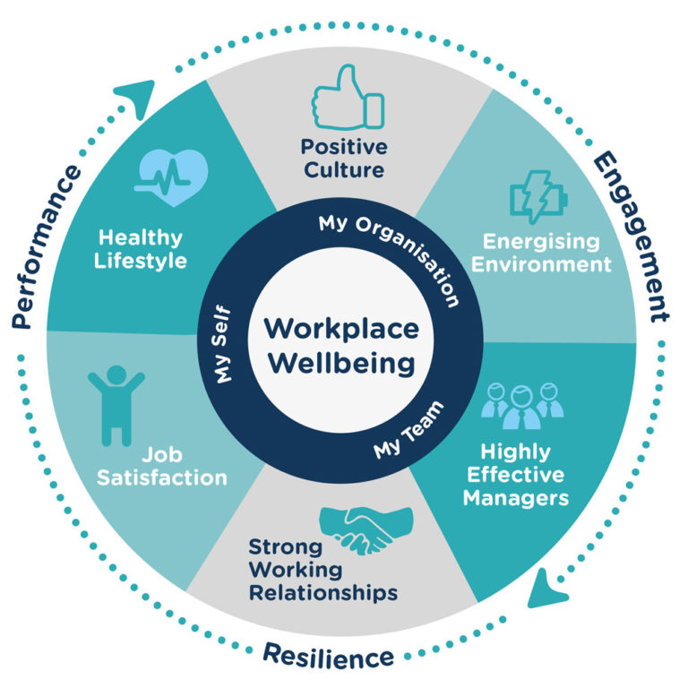(Image- Emcompass Benefits, 2021)

HEALTHCARE ON HAND

AC 3.1 Explain the importance of work-life balance within the employment relationship and how it can be influenced by legislation.
Work-life balance refers to striking a balance between work which is remunerated and personal/social responsibilities which an individual wants to fulfil (Managementstudyguide, 2015). An important antecedent of work-life balance initiative such as flexi time is job satisfaction. Job satisfaction, which is a positive reaction towards an individual’s job is a driving force for employee engagement and turnover intention (Brough et al., 2014).
The Working Time Regulations 1998; a statutory instrument in the UK to protect the health and safety of workers by introducing minimum rules for employees on working hours, rest/breaks, length of working week and on night work (GOV.UK, 1998).
Under Employment relations bill, flexible working request is a statutory right for any employees to request flexible working from day one of their employment to suit their schedule (GOV.UK, 2022). Employers are obligated to deal with the request in “reasonable manner”. The flexibility and independence generated from flexi work can reduce work-family conflict by letting employees find equilibrium between their priorities at work versus at home (Greenhaus, Ziegert and Allen, 2012).
The importance of work life balance within the employment relationship comes down to key indicatives such as organisational productivity, well-being, job performance, and employee engagement. These indicatives are highly impacted by the provision of work-life balance support/policies by employers within an organisation such as flexible working shifts (part-time, hybrid or remote working, compressed hours), annualised leaves, parental leaves, exceptional leaves, etc (Acas,2015a). Creating an adaptable work environment gives employees the ability to control when and how they work, which consequently improves morale and productivity at work. Research also has proven that work stress, overworking and burnout are correlated to productivity and job satisfaction (Shagvaliyeva and Yazdanifard, 2014).

AC 3.2 An explanation of what is meant by, and the importance of, wellbeing in the workplace.
Workplace wellbeing encompasses all the aspects of working life, from physical and psychological safety to how workers perceive their work and work environment (ILO, 2009). Organisations that implement well-being strategies are likely to succeed with organisational effectiveness (Zakaria, Abdulatiff and Ali, 2014). Researchers have generally recognised that workers experiencing poor health and well-being at work can have detrimental impact on productivity, absenteeism, job satisfaction and overall organisational performance (Rajgopal, 2010).

HEALTHCARE ON HAND

According to Deloitte Insights factors that impact employee’s well-being (Bhatt, Bordeaux, and Fisher, 2023) but are not limited to are.
- Job design- Improvements in well-being has long been debated with the quality of job design specially the autonomy a job can provide. Professional self-efficacy has a positive outcome of job performance and motivation (Musilek, 2019).
- Leadership- supportive leadership style is central to employees’ well-being. A leadership role that doesn’t provide support and clarity can induce stress, uncertainty and limits intellectual stimulant which further leads to job dissatisfaction and burnout (Griffin, 2018).
- Financial insecurity- A lack of focus on financial well-being of employees can cause employees to have a negative perception on fairness and justice within the organisation. A fair pay, rewards/bonus and compensation, or financial support to struggling employees improves engagement and reduces stress due to the rise in cost of living (Voznyak et al., 2022)

Employee well-being is linked to organisational performance and employee engagement (CIPD, 2022c) as it prevents withdrawal behaviours like stress leave, unauthorised absence or turnover (RTWknowledge, n.d.). Nurturing well-being which is critical to creating a resilience workforce creates a motivated and stable workforce and a positive outlook on work (Addison, 2022).

AC 3.3 Summarise the main points of discrimination legislation.

Discrimination in workplace can take place in the form of putting someone at a disadvantage or unjust treatment of people especially on the grounds of-
- Age
- Disability
- Gender reassignment
- Marriage and civil partnership
- Race
- Pregnancy and maternity
- Religion or belief
- Sex
- Sexual orientation (Legislation.gov, 2010)
Under the Equality Act 2010 these are protected characteristics and is important to know who are protected under discrimination law and they are employees, contractors, job applicants and former employees (Acas, 2020). It ensures fair and equal opportunity, although positive action can be taken lawfully for groups who are underrepresented within an organisation to improve equality and reduce disadvantage (GOV.UK, 2023). The main point of discrimination law in the workplace is to eliminate or reduce pervasive and substantial group disadvantage (Khaitan, 2016).

HEALTHCARE ON HAND

Discrimination can manifest as (Equality and Human Rights commission, 2020)-
- Direct- treating someone unfairly due to a protected characteristic. For example- Employer refuses to recruit an applicant due to her being homosexual (sexual orientation) although she is a qualified candidate. It does not matter what motivated the action and is considered direct discrimination.
- Indirect-when a company has provision, policy and practice that hinders individuals with protected characteristic and puts them at a disadvantage if the policies apply same for everyone (Equality and Human Rights Commission, 2019).
- Harassment-unwanted conduct or behaviour and must have a purpose of a person’s dignity or creating a hostile work environment because you have one of the protected characteristics (Falconer, 2020a).
- Victimisation-when an individual is subjected to a detriment or disadvantage after raising concern about discrimination or supports an allegation of discrimination (Falconer, 2020b). Any sort of ill treatment against the person can be classed as victimisation.

AC 3.4 Explain what diversity and inclusion mean and why they are important.
Diversity in workplace is the practice of having a workforce with various racial, ethnic, cultural, and socio-economic backgrounds who have different experiences, lifestyles and interest and sexual orientation (Wentling and Palma-Rivas, 1997).
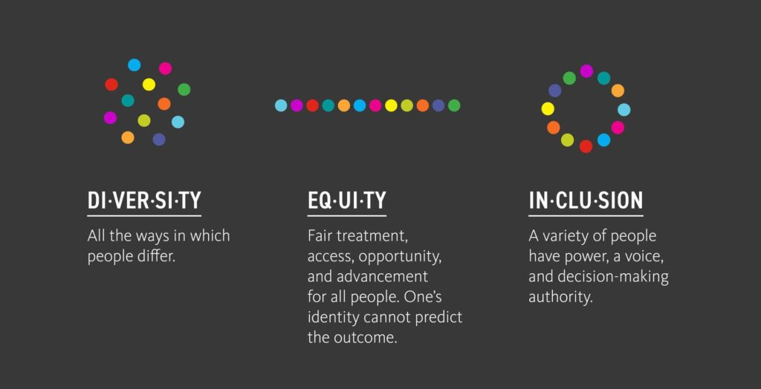
(Image- Jones, 2022).

HEALTHCARE ON HAND

Inclusion is the practice of allowing diversity to have equal access to opportunities and resources (Verlinden, 2019), where employees are treated respectfully and fairly without having to conform (CIPD, 2019a). Without equality, diversity and inclusion becomes an unfulfilled potential.

The social justice case perceives diversity and inclusion as a bridge to close the gap of inequality, and people should be treated fairly based solely on their merits (CIPD, 2022a). The business case however suggests that diversity and inclusion does support and boosts organisational performance (CIPD, 2018). For example-Women in leadership roles to commit gender equality has shown to improve financial performance of the organisation (Fechter, 2023).
According to Harvard business review (Lorenzo and Reeves, 2018), organisations with above average diversity had 19% higher innovation revenues which means that creativity and innovation can be cultivated with a heterogeneity workforce. Diversity initiatives in recruitment also helps organisations attract high calibre talent with diverse skills and perspectives (Caccavale, 2021).
Inclusion is important as it allows inclusive practices to build a better and safer working environment for specially those who are marginalized in wider society such as minority groups, employee with disabilities, or gender (Daley, 2019). Inclusion is also important to create psychological safety in the workplace (Edmondson, 2020) which is crucial in fostering employee engagement and well-being (Nuotto and Santalo, 2022). Inclusive practices give diversity the real impact (CIPD, 2019b) by supporting and addressing different ways in which we work and behave.
AC 3.5 Explain the differences between fair and unfair dismissal.
Fair dismissal is when an employee is dismissed from their contractual agreement with a justifiable reason (TUC.org, 2022). Under the Employee Rights Act 1996(Legislation.gov, 2011), there are 5 fair reasons.
- Poor conduct-a single act of gross misconduct (for example- theft, bullying, violence) or multiple acts of misconduct (lateness, insubordination, policy infraction) (Martin Searle Solicitors, 2016)
- Capability-performance issues and can relate to their skill, aptitude, and health (Sanderson, 2022).
- Redundancy- business closure or reduced need for that specific role the employee holds.
- Statutory restriction- prevents continuation of employment of an employee if it breaches the law or regulation (Colley, 2018).
- Other substantial reason- all the other categories that can be fair reasons to be dismissed (employees’ refusal to accept changes to contractual terms or employee brings disrepute to organisation outside of work) (Indeed, 2023).

HEALTHCARE ON HAND

Unfair dismissal is also a statutory right (IBB Law, 2022) which occurs when an employee was dismissed unfairly, and their employer has failed to follow correct procedure without providing a principal reason or more set out in the category above (Knowles, 2017).For example, if an employee was made redundant and shortly after a new person was hired for the same position (PHR Solicitors, 2023).
If a dismissal was deemed unfair, employees with 2 years of service can bring their claim to Employment tribunal within 3 months of their dismissal date which can result to a risk of financial loss to employers. Failure in not following correct procedures such as investigations or warnings to improve before a dismissal, even if there was a justified reason to dismiss, it is still considered an unfair dismissal (Landau Law Solicitors, 2023).

Conclusions and recommendations
As people professionals, it is important to promote work-life balance within the organisation by recognising its importance. To help your employees achieve a balanced life, we need to tailor work-life balance approach individually which can be done by holding a one-to-one meeting and discussing what is suitable for them (Beneden Health, 2017). Training line/senior managers on work-life balance programs and asking them to lead by example so they themselves can lead a balanced life (Fuhl, 2020). In modern day society, individuals have competing responsibilities outside of work such as care commitments for children or elderly, education commitments, religious observances, and other interests/ duties outside of work (Acas, 2015b). Work-life balance in not just about limiting the number of work hours in the workplace but it is also about the culture and positive environment within the organisation. It should not only be taken as a legal compliance but also an imperative to build best human resource practices.
Employee well-being goes beyond physical safety. HR professionals need to support with a proactive approach rather than a reactive when it comes to well-being. High performance is only sustainable if it’s healthy and can only be done with a team of resilient workforce (Taylor, 2018). HR professionals need address resilience both at individual and organisational level (CIPD, 2022b) which means planning resilience interventions. For instance, at an organisational level creating job design that are effective and focused on the person’s role may contribute to reducing stress and higher engagement in the workplace (CIPD, n.d.).
Anti-discriminatory practices and culture is fundamental to the ethical basis for care and protection provisions in the workplace. Understanding acts that support equality and diversity is essential to creating a healthy and inclusive working environment. There are several theories and models that organisations used to promote equality, diversity, and inclusion in the workplace such as diversity management, anti-discriminatory and anti-bias training (Gray, 2023). These approaches can help HR professionals develop policies, goals, and strategies to create a diverse and inclusive environment or to address the root causes/ symptoms of discrimination in the workplace.

HEALTHCARE ON HAND

Best practices in promoting equality, diversity and inclusion can be done by-
- Developing a clear and comprehensive diversity and inclusion policy that not only sets the organisation’s commitment but also outlines their goals, strategies, and procedures to creating one.
- Educating and training programs to spread awareness at all levels such as workshops, seminars, etc.
- Non-discriminatory hiring and recruitment practices such as blind recruitment which removes certain information (age, gender, or ethnic background) from applicant’s resume and only shows the details to evaluate candidate that are needed (Feldmann, 2018).
It is important to understand and prevent a dismissal turning out to be unfair and the negative impact it can have on existing employees as well. Not only it affects the employee who was unfairly dismissed but the consequence of it can lead other employee’s emotional well-being to decline (HRnews, 2021). In some cases, a dismissal can be automatically unfair and fundamentally violates an employees’ basic employment rights (IAS, n.d.). Following the correct procedure before taking any formal disciplinary action against employees is important as it not only avoids future claims but also ensures ethical and sustainable employment practices.

Main body word count- 1368
Total word count- 2174

References
Acas (2015a). “Flexible working and work-life balance”. Available at: https://www.acas.org.uk/sites/default/files/2021-03/flexible-working-and-work-life-balance-guide.pdf. (Accessed 29/5/2023).
Acas (2015b). “Flexible working and work-life balance”. Available at: https://www.acas.org.uk/sites/default/files/2021-03/flexible-working-and-work-life-balance-guide.pdf. (Accessed 29/5/2023).
‌Acas (2020). “Discrimination and the law” .Available at: https://www.acas.org.uk/discrimination-and-the-law. (Accessed 31/5/2023).
Benenden Health (2017). “Why employee work-life balance matters”. Available at: https://www.benenden.co.uk/be-healthy/work/why-employee-work-life-balance-matters-and-how-you-can-improve-it/. (Accessed 12/6/2023).
‌Bhatt, Dr.J., Bordeaux , C. and Fisher, J. (2023). “The workforce well-being imperative”. Available at: https://www2.deloitte.com/uk/en/insights/topics/talent/employee-wellbeing.html (Accessed 31/5/2023).
Brough, P., Timms, C., O’Driscoll, M.P., Kalliath, T., Siu, O.-L., Sit, C. and Lo, D. (2014). ‘Work–life balance: a longitudinal evaluation of a new measure across Australia and New Zealand workers’, The International Journal of Human Resource Management, 25(19), pp.2724–2744. Available at: https://doi.org/10.1080/09585192.2014.899262. (Accessed 16/6/2023).
‌Caccavale, J. (2021). “The Business Case for Diversity”. Available at: https://www.beapplied.com/post/benefits-of-equality-and-diversity-the-business-case-for-diversity. (Accessed 7/6/2023).
‌CIPD (2018). “Facing up to the business case”. Available at: https://www.cipd.org/contentassets/b9e3a8bf1e8448ae959050526efb1e7a/diversity-and-inclusion-at-work_2018-facing-up-to-the-business-case-1_tcm18-44146.pdf. (Accessed 7/6/2023).
CIPD (2019a). “Building inclusive workplaces”. Available at: https://www.cipd.org/en/knowledge/reports/building-inclusive-workplaces/. (Accessed 16/6/2023).
CIPD (2019b). “Building inclusive workplaces”. Available at: https://www.cipd.org/en/knowledge/reports/building-inclusive-workplaces/. (Accessed 7/6/2023).
‌CIPD (2022a). “Equality, diversity and inclusion in the Workplace”. Available at: https://www.cipd.org/en/knowledge/factsheets/diversity-factsheet/. (Accessed 7/6/2023).
CIPD (2022b). “Supporting employee resilience: guide for HR professionals”. Available at: https://www.cipd.org/en/knowledge/guides/resilience-guide/#planning-resilience-interventions. (Accessed 13/6/2023).
CIPD (2022c). “Well-being at Work”. Available at: https://www.cipd.org/en/knowledge/factsheets/well-being-factsheet/#:~:text=Fostering%20employee%20wellbeing%20is%20good. (Accessed 14/6/ 2023).
‌CIPD (n.d.). “Developing resilience An evidence-based guide for practitioners”. Available at: https://www.cipd.org/globalassets/media/misc/developing-resilience_2011-evidence-based_tcm21-10079.pdf. (Accessed 13/6/2023).
Colley, A. (2018). “Dismissal: Potentially Fair Reasons for Dismissal | Real Employment Law Advice”. Available at: https://realemploymentlawadvice.co.uk/2018/10/08/dismissal-as-a-result-of-a-statutory-restriction/ (Accessed 8/6/2023).
‌Daley, S. (2019). “What is Diversity &Inclusion in the workplace?”. Available at: https://builtin.com/diversity-inclusion. (Accessed 7/6/2023).
Edmondson, A.C. (2020). “The Role of Psychological Safety in Diversity and Inclusion”. Available at: https://www.psychologytoday.com/gb/blog/the-fearless-organization/202006/the-role-of-psychological-safety-in-diversity-and-inclusion. (Accessed 7/6/2023).
ENCOMPASS Benefits (2021). “Employee Wellbeing”. Available at: https://encompassbenefits.com/encompass-blog/health-safety/employee-wellbeing/. (Accessed 14/6/2023)
‌Equality and Human Rights Commission (2019). “What Is Direct and Indirect Discrimination?”. Available at: https://www.equalityhumanrights.com/en/advice-and-guidance/what-direct-and-indirect-discrimination. (Accessed 1/6/2023).
‌Equality And Human Rights commission (2020). “Your Rights under the Equality Act 2010”. Available at: https://www.equalityhumanrights.com/en/advice-and-guidance/your-rights-under-equality-act-2010. (Accessed 31/5/ 2023).
Falconer, K. (2020a). “The 4 types of discrimination: what every employer needs to know”. Available at: https://www.hrsolutions-uk.com/4-types-of-discrimination/ (Accessed 1/6/2023)
‌Falconer, K. (2020b). “The 4 types of discrimination: what every employer needs to know”. Available at: https://www.hrsolutions-uk.com/4-types-of-discrimination/. (Accessed 1/6/ 2023).
Fechter, J. (2023). “What is the Business Case for Diversity?”. Available at: https://hr.university/dei/business-case-for-diversity/. (Accessed 7/6/2023).
Feldmann, J. (2018). “Council Post: The Benefits And Shortcomings Of Blind Hiring In The Recruitment Process”. Available at: https://www.forbes.com/sites/forbeshumanresourcescouncil/2018/04/03/the-benefits-and-shortcomings-of-blind-hiring-in-the-recruitment-process/?sh=320f336938a3. (Accessed 13/6/2023).
Fuhl, J. (2020). “12 ways to support a better work-life balance for your employees”. Available at: https://www.sage.com/en-gb/blog/hr-support-better-work-life-balance-workplace/. (Accessed 12/6/2023).
‌GOV.UK (1998). “The Working Time Regulations 1998”. Available at: https://www.legislation.gov.uk/uksi/1998/1833/contents/made. (Accessed 29/5/2023).
‌GOV.UK (2022). “Millions of Britons to be able to request flexible working on day one of employment”. Available at: https://www.gov.uk/government/news/millions-of-britons-to-be-able-to-request-flexible-working-on-day-one-of-employment. (Accessed 29/5/2023).
GOV.UK (2023). “Positive action in the workplace”. Available at: https://www.gov.uk/government/publications/positive-action-in-the-workplace-guidance-for-employers/positive-action-in-the-workplace#:~:text=Positive%20action%20allows%20additional%20help. (Accessed 31/5/ 2023).
Gray, P. (2023). “Equality, Diversity and Inclusion: The Definitive Guide for HR Managers”. Available at: https://www.hrreview.co.uk/guides/equality-diversity-and-inclusion-the-definitive-guide-for-hr-managers/150812. (Accessed 13/6/2023).
Greenhaus, J.H., Ziegert, J.C. and Allen, T.D. (2012). ‘When Family-supportive Supervision Matters: Relations Between Multiple Sources of Support and Work–Family Balance’, Journal of Vocational Behavior, 80(2), pp.266–275. Available at https://doi.org/10.1016/j.jvb.2011.10.008 (Accessed 16/6/2023)
Griffin, H. (2018). “Leadership and its Effects on Employee Wellness and Morale”. Available at: https://ohiostate.pressbooks.pub/pubhhmp6615/chapter/from-personal-to-societal/. (Accessed 30/5/2023).
‌ HRnews (2021). “How an Unfair Dismissal Can Affect Your Remaining Employees”. Available at: https://hrnews.co.uk/how-an-unfair-dismissal-can-affect-your-remaining-employees/. (Accessed 13/6/2023).
IAS (n.d.). “Unfair Dismissal: Guide for Employees in the UK”. Available at: https://iasservices.org.uk/employment/employees/unfair-dismissal/. (Accessed 13/6/ 2023).
‌IBB Law (2022). “Wrongful Dismissal”. Available at: https://www.ibblaw.co.uk/service/employment-law-services-individuals/wrongful-dismissal-claims#:~:text=wrongful%20dismissal%20gives%20rise%20to. (Accessed 11/6/2023).
Indeed (2023) “5 Fair reasons for dismissal”. Available at: https://uk.indeed.com/career-advice/starting-new-job/reasons-for-dismissal (Accessed 11/6/2023).
‌International Labour Organization (2009). “Workplace well-being”. Available at: https://www.ilo.org/safework/areasofwork/workplace-health-promotion-and-well-being/WCMS_118396/lang--en/index.htm#:~:text=Workplace%20Wellbeing%20relates%20to%20all. (Accessed 30/5/2023).
Jones, D. (2022). “The business case for diversity equity and inclusion”. Available at: https://www.dhjlegal.com/2022/09/05/the-business-case-for-diversity-equity-and-inclusion/. (Accessed 13/6/2023).
‌Knowles, C. (2017). “What’s the difference between unfair and wrongful dismissal?”. Available at: https://www.peoplemanagement.co.uk/article/1745504/unfair-dismissal-wrongful-dismissal-differences#:~:text=These%20terms%20are%20often%20used%20interchangeably%2C%20but%20there%20are%20key. (Accessed 11/6/2023).
Landau Law Solicitors (2023). “Unfair dismissal”. Available at: https://landaulaw.co.uk/unfair-dismissal/. (Accessed 11/6/2023).
‌Legislation.gov (2010). “Equality Act 2010”. Available at: https://www.legislation.gov.uk/ukpga/2010/15/contents. (Accessed 31/5/2023).
Legislation.gov (2011). “Employment Rights Act 1996”. Available at: https://www.legislation.gov.uk/ukpga/1996/18/section/98. (Accessed 8/6/ 2023).
‌Lorenzo, R. and Reeves, M. (2018). “How and Where Diversity Drives Financial Performance”. Available at: https://hbr.org/2018/01/how-and-where-diversity-drives-financial-performance. (Accessed 7/6/2023).
‌Managementstudyguide (2015). “Introducing Work Life Balance: Concern and Opportunities of Work Life Balance”. Available at: https://www.managementstudyguide.com/introducing-work-life-balance.htm (Accessed 29 May 2023).
Martin Searle Solicitors (2016). “What Is A Fair Dismissal For Employers?”. Available at: https://www.ms-solicitors.co.uk/employer/unfair-dismissal-claims/factsheet-what-is-a-fair-dismissal/# (Accessed 8/6/2023).
‌Musilek, J. (2019). “The Top 7 Workplace Factors that Impact Employee Health”. Available at: https://www.greatplacetowork.com/resources/blog/the-top-7-workplace-factors-that-impact-employee-health (Accessed 30/6/2023).
Nuotto, K. and Santalo, J. (2022). “Psychological safety improves retention and wellbeing”. Available at: https://www.unleash.ai/strategy-and-leadership/psychological-safety-improves-retention-and-wellbeing/. (Accessed 7/6/2023).
PHR Solicitors (2023). “Employers: Avoid unfair dismissal cases”. Available at: https://www.phrsolicitors.co.uk/legal-services-for-businesses/for-employers/resources/avoid-unfair-dismissal. (Accessed 11/6/2023).
‌Rajgopal, T. (2010). ‘Mental well-being at the workplace’, Indian Journal of Occupational and Environmental Medicine, 14(3), p.63. Available at: https://www.ncbi.nlm.nih.gov/pmc/articles/PMC3062016/. (Accessed 16/6/2023).
RTWknowledge (n.d.). “Occupational wellbeing and its effect on performance”. Available at: https://www.rtwknowledge.org/article_print.php?article_id=193#:~:text=Improved%20employee%20wellbeing%20improves%20the. (Accessed 14/6/2023).
‌Sanderson, F. (2022). “What are the 5 fair reasons for dismissal?”. Available at: https://www.myhrtoolkit.com/blog/5-fair-reasons-for-dismissal#:~:text=In%20this%20case%2C%20an%20employee. (Accessed 8/6/ 2023).
Tarunabh Khaitan (2015). The Point of Discrimination Law, pp.117–140. Available at: https://doi.org/10.1093/acprof:oso/9780199656967.003.0005 (Accessed 16/6/2023).

Taylor, S. (2018). “3 steps to building a resilient, high performance organisation”. Available at: https://www.insidehr.com.au/3-steps-resilient-high-performance-organisation/. (Accessed 13/6/2023).
‌TUC.org (2022). “What is meant by the term ‘a fair dismissal’?”. Available at: https://www.tuc.org.uk/guidance/what-meant-term-fair-dismissal#:~:text=The%20legal%20phrase%20is%20%22substantial. (Accessed 8/6/2023).
‌ UNUM (2022). Cost-of-living crisis expected to spark the ‘Great Resignation’ of 2023. Available at: https://www.unum.co.uk/about-us/media/cost-of-living-crisis. (Accessed 13/6/2023).
Verlinden, N. (2019). “Diversity vs Inclusion: What’s the difference?”. Available at: https://www.aihr.com/blog/diversity-vs-inclusion/ (Accessed 1/6/2023).
‌Voznyak , H., Bil , M., Mulska, O. and Radelytskyy , Y. (2022). ‘Financial wellbeing of households in instability’, Investment Management and Financial Innovations, 19(1), 135-144.. Available at: http://dx.doi.org/10.21511/imfi.19(1).2022.10 (Accessed 30/5/2023).
Wentling, R. and Palma-Rivas, N. (1997). “Diversity In The Workforce: A Literature Review”. Available at: https://www.sreb.org/sites/main/files/file-attachments/diversity_in_the_workforce_lit_review.pdf?1632075949. (Accessed 1/6/ 2023).
‌Zakaria, M., Abdulatiff, N.K. and Ali, N. (2014). ‘The Role of Wellbeing on Performance in Services Sector’, Procedia - Social and Behavioral Sciences,164, pp.358–365. Available at: https://doi.org/10.1016/j.sbspro.2014.11.088. (Accessed 16/6/2023).
‌
‌

