Line Rosenskiold (P151225)

Digital Marketing
Line Elvira Rosenskiold (P151225)

Executive Summary

This report gives a brief introduction to what Social Media marketing is and why it is so important within marketing in general and especially to the University of Wales Trinity Saint David. The report also investigates the RACE Planning Framework which is a marketing tool used to communicate and reach the target audience. The researcher found that UWTSD is using multiple social media channels, and is in fact communicating with both existing customers as well as potential customers. It is, however, recommended that UWTSD use Instagram more, as it is stated by Statista (2018) the age group being most active is in fact between 18-24 and 25-34 which is can be argued to be the age group that the university would want to reach.

Table of Contents
Executive Summary 1
1.0 Introduction 3
1.1 University of Wales Trinity Saint David 3
2.0 Social Media Marketing 3
2.1 RACE Planning Framework 4
2.1.1 Reach 4
2.1.2 Act 4
2.1.3 Convert 7
2.1.4 Engage 7
2.2 Summary of RACE 9
3.0 Critical Evaluation of Social Media Activities Procedures 9
3.1 Advantages and Disadvantages of Monitoring Social Media Activities 9
4.0 Conclusion 10
5.0 Recommendations 10
6.0 Bibliography 11

Introduction
This report aims to explain why social media is important for University of Wales Trinity Saint David with a focus on the RACE Planning Framework. The Framework will be used to assess the current social media activities by the university and to critically evaluate which social media is the most important at each stage of the consumer life cycle whilst discussing the advantages and disadvantages of social media activity.

University of Wales Trinity Saint David
The University of Wales Trinity Saint David (UWTSD) was formed through a merge of the University of Wales Lampeter, Lampeter and Trinity University College and Swansea Metropolitan University in November 2010. The university holds 17 campuses mainly located in South West Wales. UWTSD has a strong focus on learner experience and aims to be a sustainable organisation. Their mission is to develop skilled and employable graduates. (UWTSD, 2018)
As stated above, UWTSD has a large focus on student experience, and regularly distributes surveys to their students in order to make it a university with significant focus on student experience and to develop their campuses and courses based on student feedback.
The university was ranked as one of the top seven universities in the United Kingdom for Academic Learning in 2018. (UWTSD, 2018)
The University of Wales Trinity Saint David currently holds different social media such as Facebook, Instagram, Twitter and YouTube in addition to their own website.

Social Media Marketing
Social Media marketing can be seen as a way of marketing through internet, and by using social media platforms in order to achieve marketing and branding goals. This includes activities such as sharing and posting image and text updates, as well as videos and other content that can help drive audience engagement (WordStream, 2018). Marketing through social media can be seen as an essential part of online marketing as it involves how to interact and communicate with the consumer using different social media platforms.
Chaffey (2002) defines social media marketing in Sokolska (2017) as “Monitoring and facilitating customers interaction, participation and sharing through digital media to encourage positive engagement with a company and its brands leading to commercial value. Interactions may occur on a company site, social networks and other party websites.”

RACE Planning Framework

Reach
Reach involves building awareness of a product, service or a brand in general. This is often done through media such as websites or other social media platforms in order to build traffic and to drive visits to different web presences. (Chaffey, 2017). In the reach stage it can be argued that Instagram is the most important platform for prospective students as Statista (2018) have reported that the age groups of 18-24 and 25-34 is the most active on Instagram, and this is arguably the age group the university would want to reach as they are coming out of college and going in to higher education. This can also be seen in Table 1.1 where HESA (2018) stated that there was a total of 950,090 enrolled students that were 20 years old or younger and 637,320 students that were between 21-24 years old. It can also be debated that UWTSD is reaching a larger audience and building more traffic to their website by having all their social media accounts linked and by cross-promoting events such as open days.
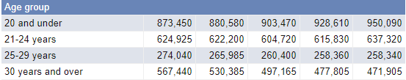
Table 1.1 – HESA (2018) table on HE Student Enrolments by Personal Characteristics

Act
Act, also known as interact, is a separate stage with the aim to generate leads and to pursue visitors to act when they reach your website or any other social network presence. Act can also be seen as a way of encouraging participation. This can involve sharing content through customer reviews or social media (Chaffey, 2016) As already mentioned, the University of Wales Trinity Saint David use various social media platforms posting photos, videos and other appropriate content showcasing events and student experiences to connect with prospective students on a more realistic level. However, the university also have a strong focus on promoting its own students by sharing and re-posting great achievements of both university achievements and outside of university achievements. This can be seen in Figure 1 and 2 below. It needs to be noted that students within specific faculties and schools use their voice through organising events to promote their course and the university in order to attract prospective students. One of these are for example MTour The World Is Our Lecture Theatre which attracted 7 colleges across South Wales to get an insight in the tourism industry, however, it was also a great opportunity for the college students to interact with university lecturers and current students. The university also emphasises on building connections through culture by promoting cultural events such as Chinese New Year and the Norwegian Constitution on their social media platforms. It can be argued that by promoting such events, students are more encouraged to participate as it shows appreciation of cultural diversity and respect to the individual culture. This can be seen in Figure 3 where the University have promoted Chinese New Year on their Facebook account. It can be argued that University of Wales Trinity Saint David’s Facebook page is the best marketing platform in the Act stage of RACE as they continuously post information that may be seen as important factors for prospective students, such as cultural events, award ceremonies, personal student achievements outside university and promoting sustainability.
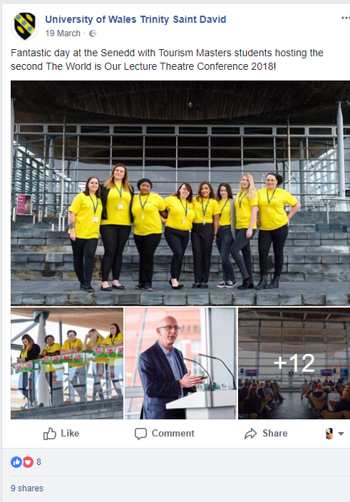
Figure 1 – MTour The World Is Our Lecture Theatre Conference ((Photo: University of Wales Trinity Saint David, Facebook)
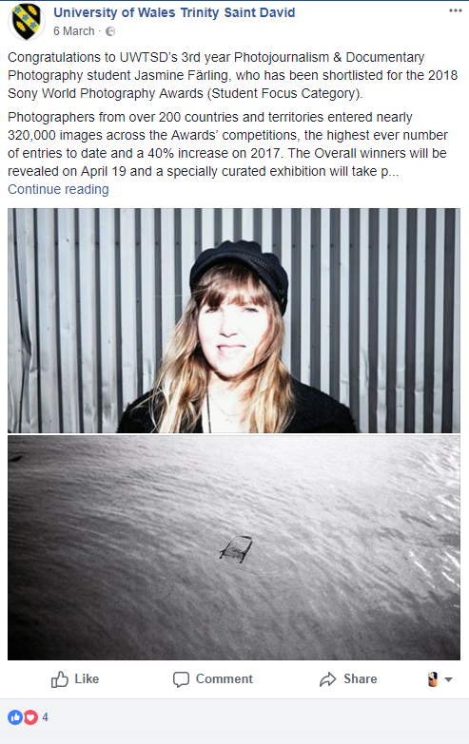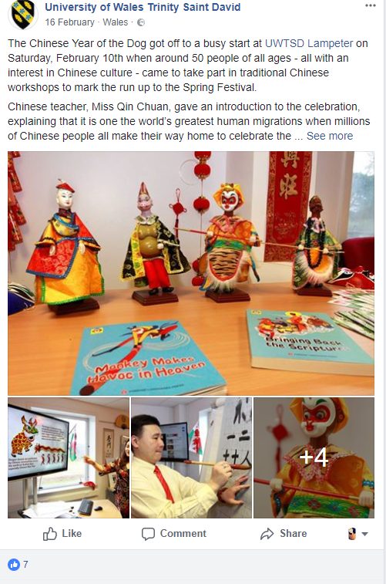
Figure 2 – UWTSD Promoting Student Achievements outside University (Photo: University of Wales Trinity Saint David, Facebook)
Figure 3 – University of Wales Trinity Saint David promoting Chinese New Year in Lampeter Campus ((Photo: University of Wales Trinity Saint David, Facebook)

Convert
According to Chaffey (2017) the convert phase of RACE planning framework involves getting the audience to become paying customers. The university of Wales Trinity Saint David has a large focus on student experience and providing good academic progress. This is highly represented on their website and through their use of social media. It can be debated that the use of recorded student experiences as a way of connection with potential future students can generate a higher number of applicants.
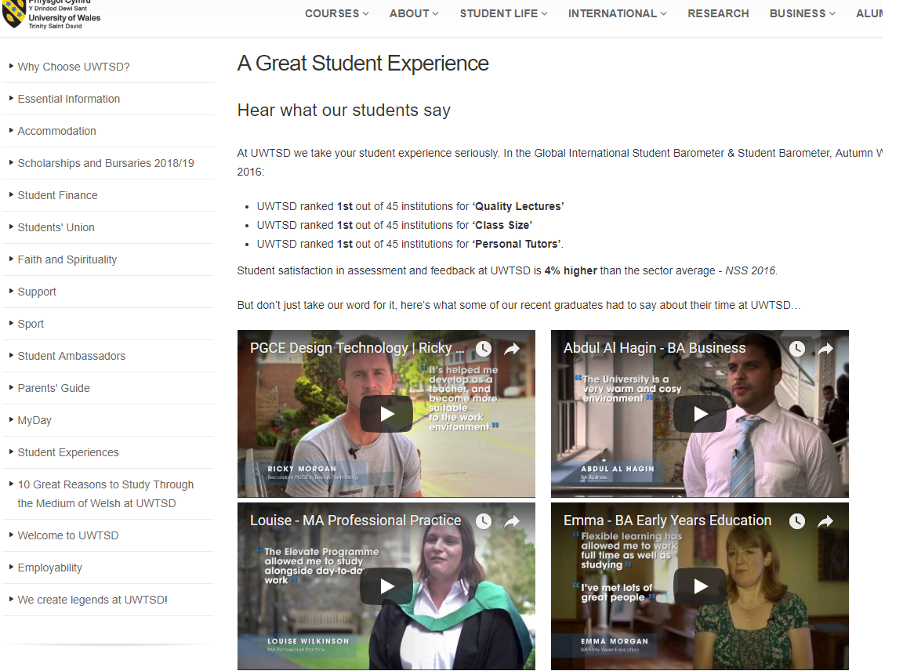
Figure 4 – University of Wales Trinity Saint David promoting Student Experience
(Photo: University of Wales Trinity Saint David, Website)

Engage
This stage of the RACE Planning Framework includes developing a long-term relationship of first time byers. This is done in order to build customer loyalty which can be argued to be a reason for repeat purchases (Chaffey, 2016) The photos the university post on different social media platforms as well as their written content shown on their website may result in previous students returning to accomplish a higher degree or enrolling to do an integrated master’s programme. The university emphasises on the possibility of being an exchange student and the opportunity to study abroad during the students second year as an undergraduate, whilst on certain courses there is an opportunity to undertake a placement either local or abroad. This placement can be extended to a sandwich year where the student can do a full year in their placement. It can be argued that students value the opportunity to go abroad if they have the chance to do so, and therefore by promoting this, the university may be more inclined to have their students come back and do either their integrated masters or an MBA degree. It also needs to be noted that faculties within the Business Campus, and other campuses, use field trips to encourage students to continue their studies. This can be related back to 1st year BA Business Management where students were able to partake in a field trip to France, and 4th year MTour students were able to go to Malaysia. By promoting exchange years, placement opportunities and field trips, this is possibly helping the university in building customer loyalty whereas students come back to continue their degrees.
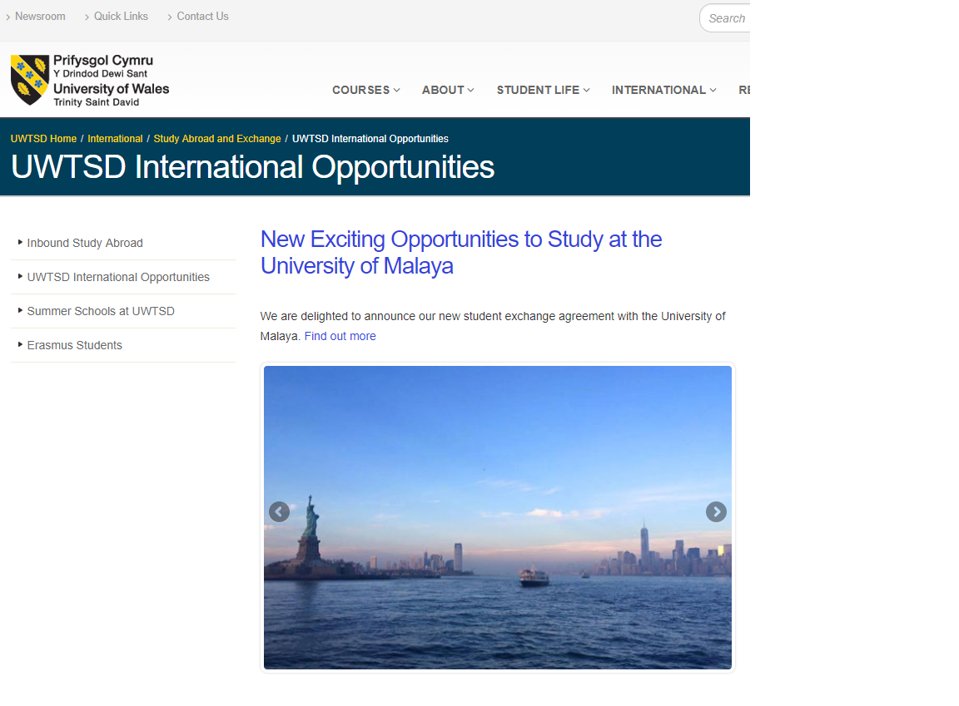
Figure 5 – University of Wales Trinity Saint David promoting exchange year in Malaya
(Photo: University of Wales Trinity Saint David, Website)

Summary of RACE
As noted, University of Wales Trinity Saint David use different social media platforms. However, the university only post pictures and other content that are appropriate to their brand. The university does this by being visible through their website, and other social media platforms such as Instagram, Twitter and Facebook. It is clear that the university is targeting a wide variety of age groups, however, the emphasis being on college students. The university is more successful in reaching the younger audience, such as college students, due to use of relevant social media platforms.

Critical Evaluation of Social Media Activities Procedures

Advantages and Disadvantages of Monitoring Social Media Activities
The popularity of digital marketing is constantly on the rise and according to Watson et al. (2002) several businesses are investigating how social network marketing can be used to promote their products and services. It can be argued that platforms such at Twitter and Facebook has contributed to a shift in how businesses market their products and services in today’s society. There are a number of benefits of using social media as a marketing tool. The organisation is able to provide unlimited information to customers without any physical interaction. In addition to this, using social media platforms in order to promote products and services is likely to involve a lower cost than with traditional marketing methods as well as helping increase brand recognition which can result in reaching a broader audience.
However, despite numerus advantages with using social media to market products or services, there are some disadvantages to be considered. Unhappy customers are able to post offensive comments, photos or videos which can have a damaging effect on the brand. The social networks that is used must therefore be managed efficiently in order to respond immediately. Another potential disadvantage with social media marketing is that it is more likely to attract already existing customers and not potential customers.

Conclusion
In conclusion, social media marketing can be described as a way of market a product or service using digital platforms in order to drive engagement. The RACE Planning Framework is a tool that can be used in order to encourage positive engagement with a brand. University of Wales Trinity Saint David use a variety of social media platforms in order to communicate with the audience. These platforms varies from Facebook, Twitter, Instagram, YouTube and their own website. It can be argued that the university is benefiting from using such marketing tools as they are able to reach their target audience. However, using social media can also arguably be seen as a disadvantage as it may result in negative feedback

Recommendations
It has been noticed by the researcher, after analysing University of Wales Trinity Saint David’s use of social media, that the following recommendations should be implemented in order to reach a larger audience whilst still communicate with existing students;
- Instagram should be utilised as one of their main social media channels
- Continue being active on other social media platforms
- Create groups on social media where prospective students can interact with existing students and lecturers in order to get an honest opinion on the university and the course they are interested in
- Student take-over on social media where they show prospective students different campuses, lecture rooms and facilities available

Bibliography
Abrons, R., 2018. The Disadvantages of Using Social Networks as Marketing Tools. [Online]
Available at: http://smallbusiness.chron.com/disadvantages-using-social-networks-marketing-tools-20861.html
[Accessed 24 04 2018].
Adams-Mott, A., 2018. Advantages and Disadvantages of Social Media Marketing. [Online]
Available at: http://smallbusiness.chron.com/advantages-disadvantages-social-media-marketing-21890.html
[Accessed 22 04 2018].
Blue Fountain Media, 2018. 10 Advantages of Social Media Marketing for Your Business. [Online]
Available at: https://www.bluefountainmedia.com/blog/advantages-of-social-media-marketing/
[Accessed 24 04 2018].
Chaffey, D., 2002. E-business and e-commerce management. 6th ed. Harlow: Pearson Education Limited.
Chaffey, D., 2016. Digital Marketing: Strategy, Implementation and Practice. 6th ed. Harlow: Pearson Education Limited.
Chaffey, D., 2017. Introducing RACE: A practical framework to improve marketing. [Online]
Available at: https://www.smartinsights.com/digital-marketing-strategy/race-a-practical-framework-to-improve-your-digital-marketing/
[Accessed 14 04 2018].
HESA, 2018. Who's studying in HE?. [Online]
Available at: https://www.hesa.ac.uk/data-and-analysis/students/whos-in-he
[Accessed 22 04 2018].
Nadaraja, R. & Yazdanifard, R., 2013. Social Media Marketing: Advantages and Disadvantages, Kuala Lumpur: Center of Southern New Hampshire University .
Sokolska, K., 2017. Chaffey's Theory - Social Media Marketing. [Online]
Available at: http://blogs.brighton.ac.uk/klaud/2017/11/30/chaffeys-theory-social-media-marketing/
[Accessed 11 04 2018].
Statista, 2018. Distribution of Instagram users worldwide as of April 2018, by age and gender. [Online]
Available at: https://www.statista.com/statistics/248769/age-distribution-of-worldwide-instagram-users/
[Accessed 24 04 2018].
Upadhyay, G., 2016. How To Apply RACE Digital Marketing Framework To Your Hospitality Marketing. [Online]
Available at: https://www.linkedin.com/pulse/how-apply-race-digital-marketing-framework-your-gulit-upadhyay
[Accessed 24 04 2018].
UWTSD, 2018. The University. [Online]
Available at: https://www.uwtsd.ac.uk/about/
[Accessed 22 04 2018].
UWTSD, 2018. UWTSD International Opportunities. [Online]
Available at: http://www.uwtsd.ac.uk/international/study-abroad-and-exchange/international-opportunities/
[Accessed 22 04 2018].
UWTSD, 2018. UWTSD ranked 7th in UK for ‘Academic Experience’ in the 2018 Times Higher Education Student Experience Survey. [Online]
Available at: https://www.uwtsd.ac.uk/news/press-releases/press-2018/uwtsd-ranked-7th-in-uk-for-academic-experience-in-the-2018-times-higher-education-student-experience-survey-.html
[Accessed 22 04 2018].
Watson, R., Pitt, L., Berthon, P. & Zinkhan, G., 2002. U-commerce: expanding the universe of marketing. Journal of the Academy of Marketing Science, 30(4), pp. 333-347.
WordStream, 2018. Social Media Marketing for Businesses. [Online]
Available at: https://www.wordstream.com/social-media-marketing
[Accessed 16 04 2018].

