

Learning in the digital era/ Workshop skills
(L4 Assignment 2)

Module: ACCA4025

Title: Lab Notebook

Student Number: 2220588

Name: Luis Lloyd

Lab Notebook
Logbook recording the build of a single supply, non-inverting amplifier with a gain of 3. All test result values and data will be recorded. Simulated/ Breadboard & PCB.

Schematic of the amplifier
Drawn and simulated using proteus.
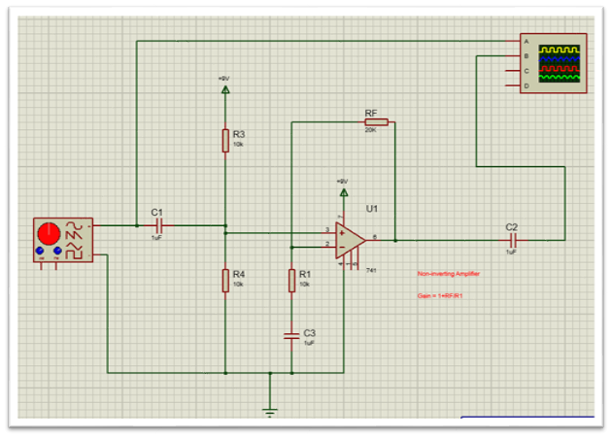
Component | Values
R1 | 10kΩ
RF(2) | 20kΩ
R3 | 10kΩ
R4 | 10kΩ
C1 | 1uF
C2 | 1uF
C3 | 1uF
Amp | 741

Proteus Simulation Table
Tables of voltage measurements and gain calculations taken from Proteus simulations at various frequencies.

[741 Amplifier]
Frequency | Output |  | Frequency | Output |  | Frequency | Output
100 | 270 |  | 200 | 280 |  | 500 | 298.8
1k | 297.5 |  | 2k | 298.8 |  | 5k | 298.8
10k | 298.8 |  | 20k | 297.5 |  | 50k | 295
100k | 287 |  | 200k | 255 |  | 500k | 157.5
1M | 86.25 |  | 2M | 45 |  | 5M | 20
.-3db point |  | 211.2516

RMS
From the values above the highest reading 298.8 multiplied by 0.707 to give us the RMS/-3db point:
RMS Value 211.25.
Between a frequency range of 200K & 500K. We can now start to take closer measurements to determine the bandwidth.

Table continued showing results at closer spaced frequency measurements in increments of 50k
Frequency | Output |  | Frequency | Output |  | Frequency | Output
250 | 237.5 |  | 300 | 218.75 |  | 350 | 201.25
400 | 185 |  | 450 | 171.25

As per table above the range is between 300k & 350k. We now repeated the process to get an accurate reading of bandwidth.
Table continued showing results at closer spaced frequency measurements in increments of 10k
Frequency | Output |  | Frequency | Output |  | Frequency | Output
310 | 215 |  | 320 | 212.5 |  | 330 | 208.75
340 | 205
 |  |  | GBP |  | 3* 320 |  | 960

Bandwidth = 320kHz Gain = 3 GBP = bandwidth x gain
GBP = 960k

We can check this by looking at a data sheet for a 741 amplifier.
[extract from the Texas instruments data sheet]
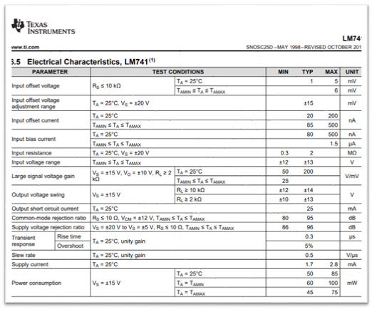

Graph of tabulated values for simulated circuit against frequency
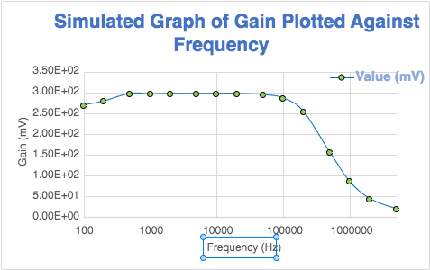

Breadboard
The amplifier circuit was built on a breadboard using the same components as in the schematic. Using Pebble, we could lay out the circuit onto a simulated breadboard to then use as a wiring diagram guide to the physical breadboard.
Image of breadboard circuit built on pebble
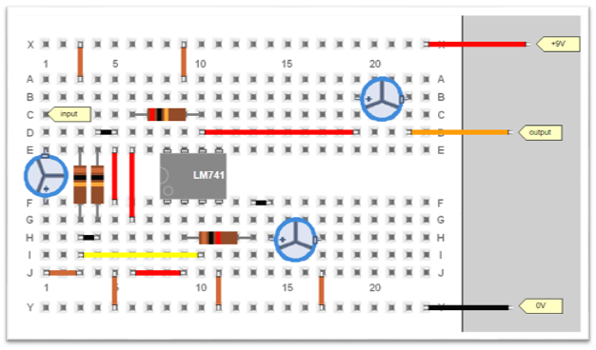
Equipment list in order to build and test the breadboard circuit.
- Breadboard
- Cable
- Cable Cutters/ strippers
- Oscilloscope
- Signal generator
- Power supply
- Components as previously stated (resistors/capacitors/Op-amp)
Breadboard Build Procedure
- All components are connected in their correct locations according to the diagram as shown above
- Once the components are in place cut and strip the jumper cables to length, connecting to correct terminals as per diagram.
- Add cable to connect the power supply to the circuit (+9V supply)
- The Output of the signal generator will then connect to the Input of the breadboard
- Oscilloscope will connect onto the input to show the correct frequency and to measure any change in input voltage values.
- The negative leg will connect onto the circuit at the negative leg of the capacitor on the output of the 741.

Testing the circuit on bread board procedure.
- To test the circuit on the breadboard, an oscilloscope was connected to the output of the amplifier.
- A signal generator was connected to the input of the amplifier. The signal generator provided the input signal to the circuit.
- The input and output waveforms were observed on the oscilloscope to measure the gain of the circuit.
- The circuit was tested at different frequency ranges to check for any variations in the gain. This was done by adjusting the frequency of the input signal on the signal generator.
- The circuit was tested, and output voltage was recorded.
The testing process for the breadboarded circuit involved using an oscilloscope and a signal generator as the main equipment. Oscilloscope allows for the measurement of the voltage and time of the output signal. This was used to measure the voltage gain of the circuit and observe the output.
The signal generator connected to the input of the amplifier circuit. The signal generator provided a controlled input signal.
The circuit was tested at different frequency ranges to check for any variations in the gain, which was done by adjusting the frequency of the input signal on the signal generator.
The oscilloscope and signal generator together allow for the measurement of the voltage gain and observation of the output waveform, which is a key aspect of the circuit's performance.
Image of actual Breadboard as built below:
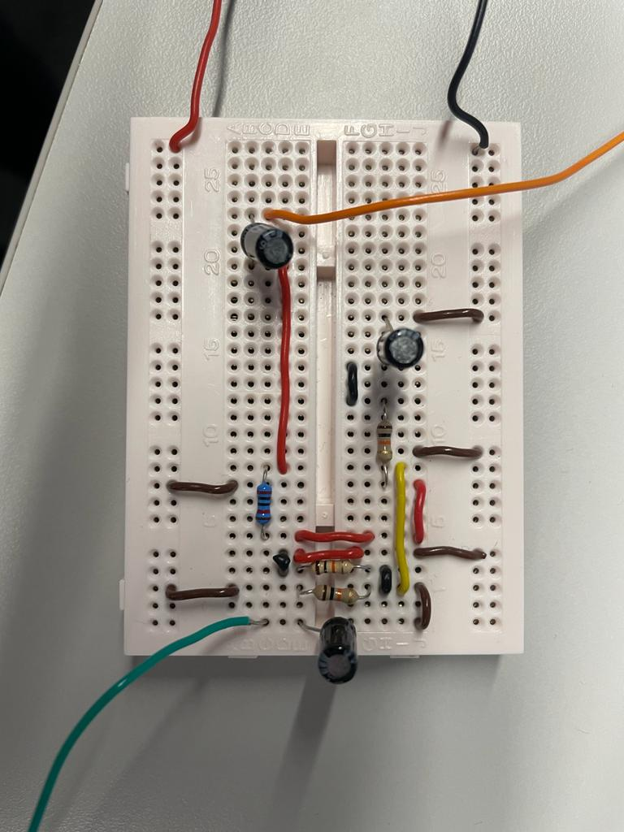

Table of voltage measurements and gain calculations at various frequencies for the breadboarded circuit

[Breadboard] Input voltage 202mV
Frequency | Output |  | Frequency | Output |  | Frequency | Output
100 | 540 |  | 200 | 560 |  | 500 | 572
1k | 568 |  | 2k | 568 |  | 5k | 568
10k | 568 |  | 20k | 564 |  | 50k | 560
100k | 552 |  | 200k | 440 |  | 500k | 176
1M | 60 |  | 2M | 12 |  | 5M | 4

RMS Value 404.4. Between a frequency range of 200K & 500K.
Closer values can now be taken to find the Bandwidth.

Table continued showing results at closer spaced frequency measurements
Frequency | Output |  | Frequency | Output |  | Frequency | Output
210k | 432 |  | 220k | 426 |  | 230k | 400
225k | 408 |  | 227.5k | 400 |  | 226k | 404

Bandwidth = 226kHz Gain = 2.831 GBP = bandwidth x gain
GBP = 639960.4

Graph of tabulated values for breadboard:
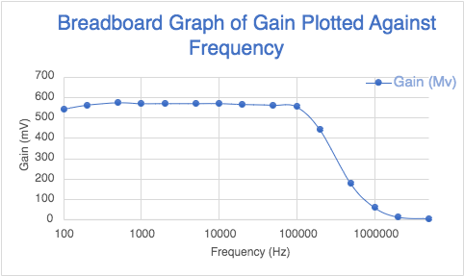

Schematic of the amplifier drawn in Easy-PC
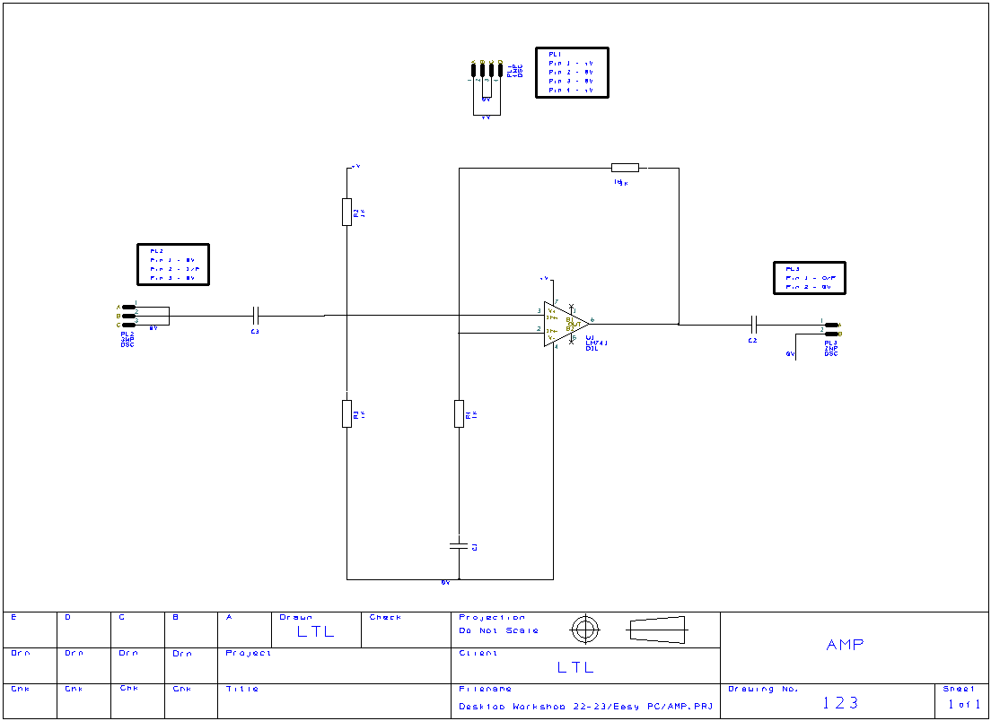

PCB from EasyPC
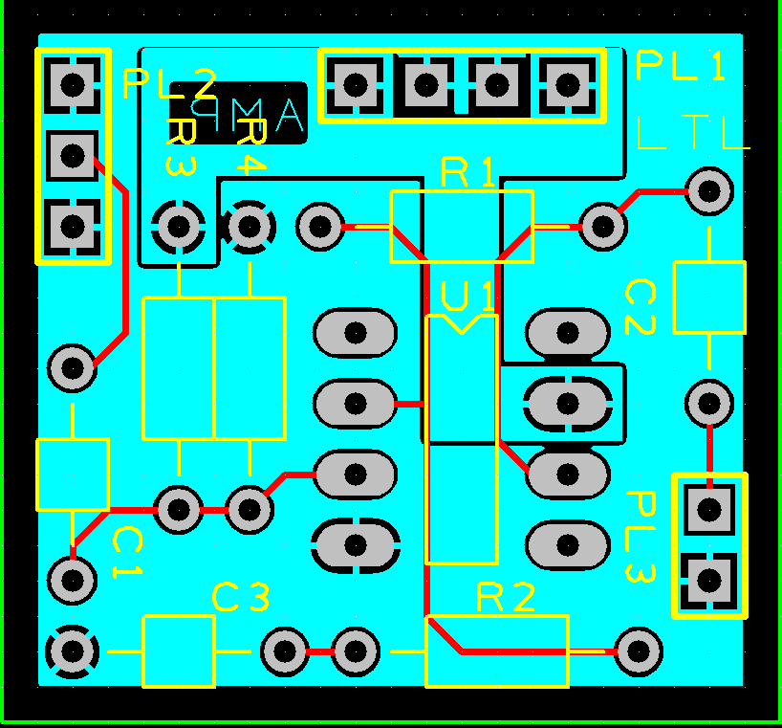
Details of the build and test of PCB
- The PCB for the amplifier circuit was designed using Easy-PC. The schematic from the breadboard build was used as the basis for the PCB design.
- The layout of the components and connections were optimized for the PCB.
- The PCB was then sent to be manufactured.
- The components were then soldered onto the PCB according to the layout and connections as designed. Extra caution taken whilst soldering to avoid any damage to the PCB.
- The circuit was tested by connecting an oscilloscope to the output of the amplifier and an input signal was applied to the circuit through a signal generator.
- The input and output waveforms were observed on the oscilloscope to measure the gain of the circuit.
- The circuit was also tested by measuring the voltage gain.
- The circuit was tested at different frequency ranges to check for any variations in the gain.
- All values then recorded.

Image of actual PCB layout and solder of components.
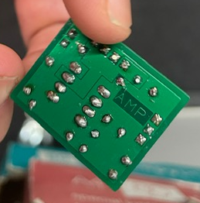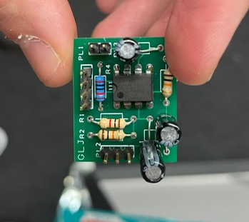

PCB
Table of voltage measurements and gain calculations at various frequencies for the PCB circuit
[PCB] #Input voltage 192mV
Frequency | Output |  | Frequency | Output |  | Frequency | Output
100 | 260 |  | 200 | 350 |  | 500 | 408
1k | 424 |  | 2k | 432 |  | 5k | 432
10k | 432 |  | 20k | 432 |  | 50k | 432
100k | 424 |  | 200k | 352 |  | 500k | 128
1M | 40 |  | 2M | 24 |  | 5M | 16

RMS Value 305.424. Between a frequency range of 200K & 500K.
Closer values can now be taken to find the Bandwidth.

Table showing results at closer spaced frequency measurements
Frequency | Output |  | Frequency | Output |  | Frequency | Output
210k | 344 |  | 220k | 336 |  | 230k | 328
240 | 320 |  | 250 | 305 |  | 260k | 296

Bandwidth = 250kHz Gain = 2.25 GBP = bandwidth x gain
GBP = 687204
Graph of tabulated values for PCB:


