Zakir Hussain-0251055
Tesco report

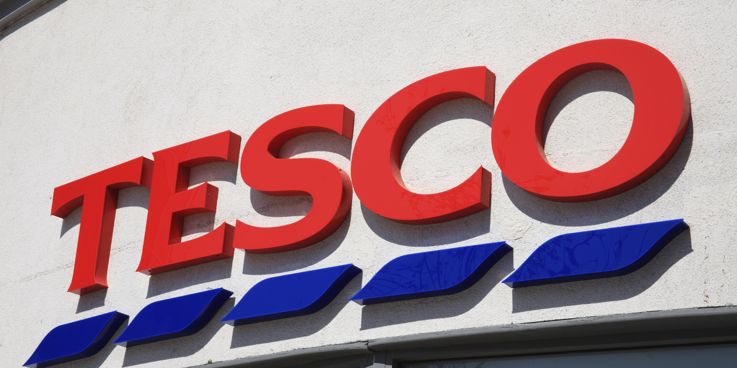
Image from (Bing.com, 2019)

Executive summary

The researcher will in this report give a brief overview of current product and services of Tesco. The researcher will discuss how Tesco previously have planned, communicated and reviewed their last attempt at resolving its problem. The researcher will describe the nature, the scope and the impact of the problems facing Tesco. The researcher will undertake a ‘swot’ and ‘pestle’ analysis of Tesco to highlight the cause of Tesco’s problems. The researcher will list Tesco’s stakeholders and provide a stakeholder analysis, and provide a conclusion highlighting the main issues. This report will also include potential business options in the recommendations section.

Contents page

Content Page no.
Executive summary 2
- -Terms of reference 4
- – Procedure 4
- – Findings 5-12
- -Conclusion 13
- –Recommendations (Options) 14

1.0
Terms of Reference

This is a report requested by Maria Heffernan the director of ‘UK Business Consultants Ltd’ on 07/02/19 from Zakir Hussain (junior business consultant ‘UK Business Consultant Ltd’). The purpose of this report is to describe the scope of Tesco’s problems and resolve such problems by using models such as ‘swot’, ‘pestle’ and ‘stakeholder analysis’ to make recommendations to resolve the problems. This report has a submission deadline of 29/3/19.

2.1
Procedure
Research from books, journals and websites were acquired to help prepare this report.

3.0
FINDING
BACKGROUND TO ORGANISATION

Jack Cohen in 1919 started the Tesco journey, when Cohen set up a stall in East End of London selling groceries, Mr Cohen made a sale of £4 from which £1 was profit. The first official Tesco store opened in 1929 in London with the idea of ‘bringing affordable food to the people of Great Britain’. In the 1930 and 1940 Tesco expanded across London and its suburbs. Tesco in 1947 went public on the London stock exchange, in 1950, Tesco opened its first supermarket and started its national expansion. Tesco in 1990 started its global expansion to; India, Thailand, Malaysia, Poland, Ireland, Czech Republic and Slovakia. Tesco in 2019 has a product range of; fresh food, a clothing line, electrical product ranges, Tesco banking services, Tesco insurance service, club card service, online purchasing service that delivers, in store cafes and eateries. Tesco currently is the largest UK retailer with over 3400 stores, employing over 440,000 people. The brand has been successful in its operations in Europe and Asian with international profits of £640 million (Tesco plc, 2019).’When you get to be as big and as successful as Tesco has become, people put a sort of sheen on the journey-as if the place we got to was inevitable. But it really wasn’t. I think it’s important Tesco’s story is told honestly because there were moments when we could just as easily have gone the other way’ (Ryle, 2013).

3.2
Previous strategy to resolve its problems

The researcher has found that in Tesco’s illustrious and impeccable market growth record from the time it was founded in 1919, its biggest and most costly mismanagement, and miscommunication was its American expansion in 2003- 2007. Tesco had sent out 40 researchers to America to research the American market before Tesco located there. The researchers had failed to identify the American shopping habits, which could have been done by analysing one of their UK competitors Asda. Asda is owned by its parent company Walmart and have an American style of selling more items for a discount e.g. buy 3 items get 1 free and offer bigger value pack of items. This clearly indicates selling strategies for consumers who prefer bulk shopping (Asda rebrands forces Walmart connection into identity, 2019).The Tesco store locations were ineffective, they were instead on outbound, on the way home route, they were inbound, on the way into work route. The researchers failed to identify the Americans’ road layouts, they are not similar to the UK or European road layouts (Why Tesco Failed in the United State, 2019). Tesco’s UK model of ‘fresh affordable food bought regularly in a week’ moto was not the American way. Tesco made their first loss in their history, a loss of 1.6 billion pounds. Tesco Board, Executive Committee and operational units met regularly to review performance risks, all Tesco departments have targets based on a new balanced scorecard of performance against KPIs and financial targets. All Tesco store plans are monitored and reviewed regularly by the Executive Committee and the Board. Tesco worldwide operations’ ongoing communication process informs Tesco executives about the long-term strategy and ensures that they understand their part in it. Tesco have clear guidelines and policies set out to ensure that there is an appropriate focus on balance between short term and longer-term delivery. Tesco communicated poor growth performance with senior executives and after reviewing their options decided to leave the American market (Tescoplc.com, 2019). Tesco resolved the problem by selling 208 store leases trading under the name of ‘Fresh & Easy’ to billionaire Ron Burkle's Yucaipa Cos. The researcher has found Tesco gave Mr Ron Burkle’s company a loan of £120 million as a part of the transaction of the sale (Cbsnews.com, 2019).

Tesco are trying to reclaim and to maintain its leadership position in the U.K retail market in 2019 because it had lost significant market value to U.K competitors Aldi and Lidl. The researcher has found during Tesco’s American expansion their supply lines where stretched, their expansions to Europe, the Far East, Asia, and America resulted in UK customers complaining of empty shelves of certain items (Trustpilot, 2019). Tesco had taken their attention off their original and main base of customers, the UK market, while Lidl and Aldi were slowly increasing their market value while attracting more Tesco past loyal customers. The researcher has found Tesco have reviewed and have planned to resolve the supply chain problem by acquiring a known successful retail supplier ‘bookers’ (License Global, 2019). The researcher has found Tesco after reviewing and monitoring Aldi and Lidl increase of market value and their decline in market value have targeted Aldi and Lidl. Tesco plan to compete with Aldi and Lidl to re-gain market value by launching its own discount stores, they plan to open budget supermarket stores in UK from September 2019 (Aldi and Barrie, 2019).

3.3
Nature, scope and impact of current problems facing Tesco

The researcher has found one of Tesco’s problems are; consumers spending less money at their stores due to austerity, which has affected the country since the start of 2008 recession. Consumers key interests are affordability, shopping habits are changing, shopping at discounters such as Aldi and Lidl are no longer an embarrassing habit (Mail Online, 2019). The researcher has found Tesco’s achievements of reaching its peak potential for many years as UK number 1 retailer and in the top 5 in the world regularly. Tesco have a very wide variety of products and services (Tesco plc, 2019). Tesco must develop a strategy to reduce cost of product and services to re-appeal to consumers who have been affected by austerity. With Brexit limping into effect this will be harder and on certain products to contain the cost after adding tax levees charged at ports. The researcher has found Tesco would have reduced staff on certain section in store, reduce the availability of certain products due to keeping a leaner stock level and by keeping supply chain cost low as possible hence the acquirement of the retail supplier ‘Bookers’. Tesco are planning to streamline the management staff; profits would be in decline in order to reduce cost in Brexit time era (Blasting News, 2019).

The researcher has found a future potential problem for Tesco in the planned merger of Asda and Sainsbury. Tesco market value has decreased, Aldi and Lidl have advanced in growth in the market with 9.9% market value. The researcher foresees the merger of Asda and Sainsbury consolidating the market value to a potential combined 23.3% market value, which would make them a powerhouse in UK retail and leaving Tesco at second position with 22.1% market value. The combined buying power would increase the clientele base and longevity in Brexit time era because of the combined resources and expertise, which the merged companies will use to offer customers cheaper quality products than their rivals (Which? News, 2019).

The researcher has found customer trust in the brand to be decreasing due to the horsemeat scandal of 2013. Tesco consumers were mislead, there were certain meat products that contained 60% horsemeat (BBC News, 2019). The researcher has found staff moral to be decreasing due to stores closing, lowering of staff working hours and uncertainty of job losses. Tesco plan to axe 1500 jobs combined from certain under-performing departments, which would increase shareholder morale but decreasing employee moral and portray the brand to the public negatively (Osborne, 2019).

3.4

Swot analysis

The researcher has found Tesco’s strength to be; currently number 1 UK retailer in terms of sales revenue and profit. Tesco dominate the top four UK grocery category with 4% of market share and have been recently the most popular in Ireland. Tesco have geographic diversity with 6800 stores in 14 countries with a big market share in Asia. Tesco stores are continuing their trends of increasing store numbers from 3751 in 2008 to 6966 currently worldwide. Tesco have diverse product range: Tesco mobile, clothing range, home-ware items, music downloads, DVD rentals, school uniforms, financial services and cotton fair trading across the globe and has recorded success with this strategy. Tesco is Europe’s largest employer with 734k jobs. Tesco has been awarded 25 awards for excellence and performance in the market. Tesco technology is of superior quality in the bar code re-ordering systems and mobile phone devices. Tesco has a proven record for efficient supply chain performance with efficient waste management and cost efficiency policy (Business Strategy Hub, 2019). The supermarket chain recently celebrated its best Christmas sales since 2009, with a 2.2 per cent rise in UK like-for-like sales in the six weeks up to 5 January (Osborne, 2019).
.

The researcher has found Tesco’s weakness to be; their failed operations in Japan, which they exited after 9 years and America, which they exited after 5 years. Meanwhile other UK competitors gained ground and took advantage of their attentions being spread thin. Tesco have had their reputations tainted through the 2017 accounting scandals with over inflated profits declarations. Tesco’s low-cost strategies are reducing their profit margins, although Tesco are market leaders. Tesco had poor performance in certain worldwide markets due to poor research before relocating which indicates Tesco research methods are ineffective (Business Strategy Hub, 2019).
.

The researcher has found Tesco’s opportunities to be; the answer to the growing threat of discount retailers, Aldi and Lidl by opening a version in ‘Jacks’. Tesco are making strategic alliances with other brands and reputable companies to expand their product range to attract more customers. Tesco are looking for joint venture partnership in regions where they are underperforming. Tesco can upgrade their online shopping experience to continue to be leaders in the market place. Tesco can look to emerging developing countries to relocate there, which can be profitable for the company such as; South- Korea, Turkey, and Indonesia (Business Strategy Hub, 2019).Tesco could improve Christmas advertisements to encourage good seasonal performance(Osborne, 2019). Tesco plan to reduce supply chain cost in the future by acquiring ‘bookers’ supply Chain Company. (Blasting News, 2019).

.

The researcher has found Tesco’s threats to be; the Christmas advertisement in 2017, saw social media backlash claiming Tesco disrespected the Christian faith. Tesco faced media backlash from using fake farm names on certain items, to which it faced severe legal issues in 2017. Tesco’s big potential threat of a merger of Asda and Sainsbury, it would potentially take away their number 1 in UK retail market status. Tesco’s biggest threat is Brexit, with cost of future transportation, new taxes and levees on ports and supply chain unknown; it makes it difficult for future cost forecast and policy planning. Economic crisis and credit crunch will affect all of Tesco’s stakeholders and influence their regional stores (Business Strategy Hub, 2019).

3.4.3
Pestle analysis

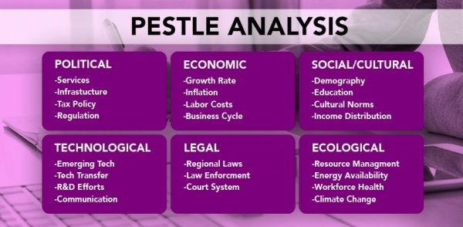
Image from (CMS Voc, 2019)

Economic
The researcher has found Tesco customers have less disposable income and are looking at cheaper shopping options due to austerity and high unemployment. This has helped the increase of customers opting to shop at discounters Aldi and Lidl. The pound sterling has fallen and has become difficult for Tesco to maintain low cost product for the UK customers. The UK living cost has gone up, employees are unhappy with pay due to this fact, pay increase is required; which would decrease Tesco profits. Suppliers cost of transportation will go up to a level unknown after Brexit. The UK interest rates are high due to Brexit uncertainty (kasi, 2019) .The researcher has found, Tesco’s new venture of ‘jacks’ a possible rival to discounters Aldi and Lidl (Aldi and Barrie, 2019).
Technological
The researcher has found Tesco to have market leading innovations in the grocery industry. Tesco introduced the ‘club card’ service, the self-service checkouts to reduce ques, which had an impact on staff numbers, as it required less checkout employees (Tesco plc, 2019).Tesco are planning on introducing vending machines in-store on certain department to increase profits, by reducing staff numbers, which would increase shareholders trust in the brand but decrease employee morale and trust (Osborne, 2019).

Legal

Tesco have to resolve the gender un-equality pay gap to avoid fines, which is currently on going and would need resolving to gain consumer, staff, and media loyalty and trust. Tesco would need to resolve this bad publicity quickly and communicate this to media to rectify this incident (Scott, 2019).Post Brexit import cost could increase transportation cost of products (Business Strategy Hub, 2019).
.

Stakeholder analysis

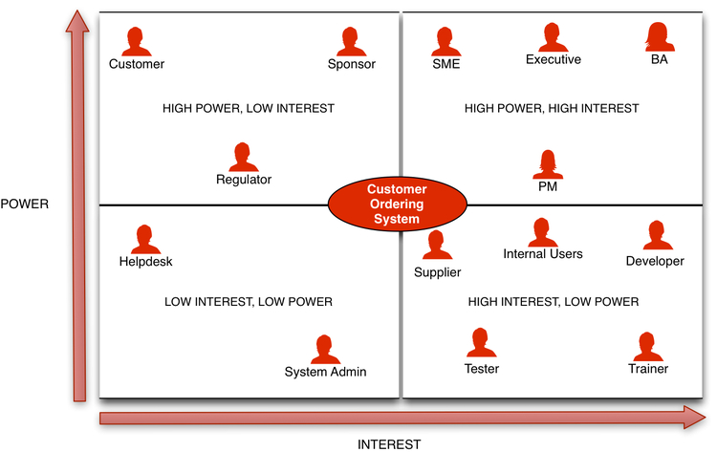
Image from (Famuyide and Famuyide, 2019)

High interest, low power-keep Informed
Tesco employees are unhappy with current job losses and any future job losses; the media is portraying the brand in a negative light. social media such as face book, local newspapers .Environmental group have high interest, can report any possible environmental accidents to local ,central government and also publicise to other stakeholder via social media. Customers would shop where it is convenient, favourable, where it is most rewarding (Rupen Sharma, 2019).

Low interest, low power-minimal effort
Certain part-time employees, builders, repair work personal, and local residents, but this could turn into higher interests if possibility of job losses. Local small business have low interest but it could change if Tesco were to sell similar products for cheaper price (Rupen Sharma, 2019).
High power, low Interest-keep satisfied
The government have not indicated the outcome of brexit, when and even if extra charges would be applied on ports, which would affect costing of supply chain. Tesco would need to pass onto customers or absorbs from the profit margin. Suppliers have high power; Tesco would rely on them for prompt delivery to maintain customer product availability. Locol police force, have low interest, which would change if crime rate around store is high (Rupen Sharma, 2019).
High power, high interest-key players
Tesco shareholders, who have been unhappy with Tesco stocks being 50% down due to under-performance in the market. Company C.E.O. David Lewis is under scrutiny over tax inflation scandals, possible change in C.E.O. if company performance do not improve. David Lewis has the power, for job cuts, marketing new policy, and redirecting the company to a better or a worse future. Board of directors, who have the power to vote in a new C.E.O and vote in new policymaking decisions, when to relocate and close a store, which will effect employees and customers. Local government agencies, such as council, environmental groups. Competitors have to be constantly monitored to remain competitive (Rupen Sharma, 2019).

4.0 Conclusion
The researcher has found Tesco 2019 have a strong product portfolio and are still a UK market leader in terms of sales revenue and profit margin with a big cash reserve. Based on the analysis included in this report Tesco customers now have less disposable income and are seeking cheaper shopping options, hence the rise of customers choosing to shop at Aldi and Lidl. The pound sterling has fallen leading to difficulties maintaining low cost products for the UK customers. The UK living cost has increased, employees are not satisfied with salary due to this fact. The UK interest rates are high due to Brexit uncertainty. Tesco’s reputation has been damaged by the Christmas advertisement in 2017 which people perceived Tesco disrespected the Christian faith. Furthermore, the 2017 accounting scandals with over inflated profits declarations. Tesco’s major potential threat is linked to the merger of Asda and Sainsbury, this could potentially take away their number 1 spot in UK retail market. An even bigger threat is Brexit, with the cost of managing Tesco after Brexit being unknown it makes it difficult for Tesco to forecast future cost and policy planning. Economic crisis and credit crunch will affect all of Tesco’s stakeholders and influence their regional stores. Tesco’s low-cost tactics are dropping their profit margins. Tesco had poor performance in some worldwide markets due to inadequate research before relocating revealing Tesco’s ineffective research methods.

5.0
Recommendations(Options)

The chairman and the board may wish to consider the following recommendations
After performing in-depth market research and market analysis, which would avoid future failure and losses, like it suffered in America; which was a result of poor market research. Explore the emerging markets and expand its stores in Asian and African countries, it is advised to use 50% outsourced local researcher’s native to the country of location interest. Tesco could by having natives feedback on certain decision-making process get a native’s opinion, would make understanding consumer shopping culture faster and maybe avoid any potential future mistakes. Resolve any future controversial crisis by addressing the issues quickly, such as product authenticity issues or brand issues. Resolve any past legal and financial matters including high debts, tax payments, and outsource independent accounts auditing team, to avoid a miss-calculation on profits.

Upgrade its online business and e-commerce sites to provide a pleasant shopping experience for customers. Tesco could advance club card technology and offer increased savings on money saved to use exclusively in ‘jacks’ which would increase awareness of Tesco’s sister company. Develop an app to record customer data, and offer savings on items on most popular bought products, Tesco could bulk buy such products to increase profits. Customers could use in the discount sister company ‘Jacks’. Take customer feedback regarding the launches of new advertisements to avoid bad publicity. Boost its marketing and advertising activities to grab more customers for ‘jacks’ store nationally, and locally by researching which areas have high unemployment and low disposable incomes.

6.0
Appendices

7.0
Acknowledgements

The researcher appreciates the assistance of the library staff of University of Wales Trinity Saint David. The researcher appreciates the assistance of Mr John A. Quelch (Dean, University of Miami Business School) and Miss Sabrina Begum in writing of this report.

8.0
Reference list

Aldi, T. and Barrie, J. (2019). Tesco set to open discount chain store to compete with budget supermarkets Lidl and Aldi. [online] inews.co.uk. Available at: https://inews.co.uk/news/business/tesco-discount-supermarkets/ [Accessed 25 Mar. 2019].

Asda rebrands forces Walmart connection into identity. (2019). [Blog] Truely deeply. Available at: http://www.trulydeeply.com.au/2015/03/asda-rebrand-forces-walmart-connection-into-identity/ [Accessed 25 Mar. 2019].

BBC News. (2019). Tesco value bolognese 60% horsemeat. [online] Available at: https://www.bbc.co.uk/news/uk-21418342 [Accessed 28 Mar. 2019].

Blasting News. (2019). Brexit Britain: how supermarkets like Tesco are suffering and what it means. [online] Available at: https://uk.blastingnews.com/business/2017/03/brexit-britain-how-supermarkets-like-tesco-are-suffering-and-what-it-means-001552775.html [Accessed 26 Mar. 2019].

Bing.com. (2019). tesco - Bing. [online] Available at: https://www.bing.com/images/search?view=detailV2&id=4212ED944D104E69AB33719AF6424A4A3F7A577B&thid=OIP.aa-bj5hDtnetkx87AtzJQwHaDt&mediaurl=http%3A%2F%2Fthirdforcenews.org.uk%2Fimages%2Fuploads%2Farticles%2F93695%2Fweb_tesco_logo.jpg&exph=1001&expw=1999&q=tesco&selectedindex=109&ajaxhist=0&vt=0&ccid=aa%2Bbj5hD&simid=608041817359191412 [Accessed 28 Mar. 2019].

Business Strategy Hub. (2019). TESCO SWOT Analysis 2019 | SWOT analysis of TESCO | Business Strategy Hub. [online] Available at: https://bstrategyhub.com/tesco-swot-analysis-2019swot-analysis-of-tesco/ [Accessed 26 Mar. 2019].

Cbsnews.com. (2019). Why did Tesco fail in the U.S.?. [online] Available at: https://www.cbsnews.com/news/why-did-tesco-fail-in-the-us/ [Accessed 25 Mar. 2019].
CMS Voc. (2019). [online] Available at: http://cmsvoc.co.uk/blog/pestle-analysis/ [Accessed 27 Mar. 2019].
Famuyide, S. and Famuyide, S. (2019). Stakeholder Matrix: A Practical Guide. [online] Business Analyst Learnings. Available at: https://businessanalystlearnings.com/ba-techniques/2013/1/23/how-to-draw-a-stakeholder-matrix [Accessed 28 Mar. 2019].
kasi, A. (2019). PESTEL-PESTLE Analysis of Tesco. [online] Free PESTEL Analysis. Available at: http://freepestelanalysis.com/pestel-pestle-analysis-of-tesco [Accessed 28 Mar. 2019].

License Global. (2019). Tesco to Acquire Booker Group. [online] Available at: https://www.licenseglobal.com/retailer-news/tesco-acquire-booker-group [Accessed 25 Mar. 2019].

Mail Online. (2019). Recession hits Tesco: Grocery giant's sales fall to lowest figure in 16 years as shoppers turn to budget supermarkets. [online] Available at: https://www.dailymail.co.uk/news/article-1091079/Recession-hits-Tesco-Grocery-giants-sales-fall-lowest-figure-16-years-shoppers-turn-budget-supermarkets.html [Accessed 26 Mar. 2019].
Osborne, S. (2019). Tesco 'to axe up to 15,000 jobs and close meat, fish and deli counters'. [online] The Independent. Available at: https://www.independent.co.uk/news/business/news/tesco-job-losses-meat-fish-deli-counters-a8748586.html [Accessed 29 Mar. 2019].

Rupen Sharma, P. (2019). Power/Interest Grid (Matrix) for Stakeholder Prioritization. [online] Bright Hub PM. Available at: https://www.brighthubpm.com/resource-management/80523-what-is-the-powerinterest-grid/ [Accessed 29 Mar. 2019].

Ryle, S. (2013). The making of Tesco. BANTAM PRESS, pp.1-45.

Scott, K. (2019). Tesco reports a 12% mean gender pay gap for fixed hourly pay. [online] Employee Benefits. Available at: https://www.employeebenefits.co.uk/issues/february-2018/tesco-gender-pay-gap/ [Accessed 29 Mar. 2019].

Successstory.com. (2019). Tesco Story - Profile, History, Founder, Founded, CEO | Retail Stores | SuccessStory. [online] Available at: https://successstory.com/companies/tesco-plc [Accessed 24 Mar. 2019].

Tesco plc. (2019). Financial performance. [online] Available at: https://www.tescoplc.com/investors/reports-results-and-presentations/financial-performance/ [Accessed 26 Mar. 2019].

Tesco plc. (2019). History. [online] Available at: https://www.tescoplc.com/about-us/history/ [Accessed 24 Mar. 2019]

This is Money. (2019). Jack's fails to do Tesco any favours as it loses ground to Aldi & Lidl. [online] Available at: https://www.thisismoney.co.uk/money/markets/article-6281169/Jacks-fails-Tesco-favours-UKs-biggest-supermarket-loses-ground-Aldi-Lidl.html [Accessed 25 Mar. 2019].

The Guardian. (2019). Tesco on the retreat as overseas expansion turns in rotten returns. [online] Available at: https://www.theguardian.com/business/2013/aug/11/tesco-retreat-overseas-rotten-returns [Accessed 25 Mar. 2019].
Trustpilot. (2019). Tesco is rated "Bad" with 2.9 / 10 on Trustpilot. [online] Available at: https://uk.trustpilot.com/review/www.tesco.com?page=3 [Accessed 25 Mar. 2019].

Which? News. (2019). Potential Sainsbury’s and Asda merger comes with possible price cuts for shoppers – Which? News. [online] Available at: https://www.which.co.uk/news/2018/04/potential-sainsburys-and-asda-merger-comes-with-possible-price-cuts-for-shoppers/ [Accessed 26 Mar. 2019].

Why Tesco Failed in the United State. (2019). [Blog] youtube NBC. Available at: https://www.bing.com/videos/search?q=youtube+tesco+nbc+america+failure&view=detail&mid=E0B25DD7081B0692BC8FE0B25DD7081B0692BC8F&FORM=VIRE [Accessed 25 Mar. 2019].

9.0
Bibliography
Maund, A. (n.d.). Certificate in higher education
Exploring careers. (2003). Indianapolis, IN: JIST Works

