
Sports Independent Project
Applied Portfolio

Student Name:  Adelaida Terente | Project Title:  Active Future Swansea
Project Aim:
The aim of this Independent Project is to create an accessible, youth-centred website that centralises Swansea Council’s physical activity and sports opportunities for children aged 8-16, enabling parents, young people, schools, clubs and community organisations to easily navigate and access all programmes, events and initiatives offered across Swansea. The website will act as a digital hub designed to promote participation, inclusion and awareness by providing clear, updated and comprehensive pathway information aligned with Swansea Council’s Sport & Health priorities.
Objectives:
.1 Ethics & Proposal
- Develop a clear rationale and project plan.
- Complete the ethics form addressing all ethical considerations (scope, risks, consent, data protection).
- Present the project’s background, aim, and timeline.

2. Research & Literature Review
- Review literature on youth physical activity, digital engagement, and community interventions.
- Analyse policy and best practice to inform project design.
- Synthesize findings to shape the website’s structure and content.

3. Creation & Implementation
- Design and develop an interactive website featuring Swansea Council’s youth sport offers.
- Integrate accessibility, filtering, and feedback tools.
- Evaluate and refine based on user engagement and feedback

INDEPENDENT PROJECT

Contents: Page:
1.0 Element 1: Individual Presentation (5 min online; Ethic Form) …………………….3-13
1.1 Individual Presentation (5 min online) ……………………………………………...3
1.2 Ethic form……………………………………………………………………………3-13
Section A…………………………………………………………………………………3
Section B…………………………………………………………………………………4-6
Section C…………………………………………………………………………………6
Section D…………………………………………………………………………………7-8
Section E………………………………………………………………………………….9-10
Section F………………………………………………………………………………….10
Section G………………………………………………………………………………….10-12
Section H………………………………………………………………………………….13

2.0 Element 2: Literature Review………………………………………………………….14-21

2.1 Introduction …………………………………………………………………………….14
2.2 Aim of the Project……………………………………………………………………...14-15
2.3 Youth Physical Activity in the UK………………………………………………….…15
2.3.1 National participation trends and challenges………………………………………...15
2.3.2 Factors influencing engagement among 8-16-year-olds…….…………………….…15
2.4 The Welsh Context……………………………………………………………………..15-16
2.4.1 Current landscape of youth physical activity in Wales……………………………....15-16
2.4.2 Policy drivers and national initiatives supporting youth engagement………………..16
2.5 Swansea Local Context…………………………………………………………………16-17
2.5.1 Swansea Council’s physical activity pathway for young people………….………….16
2.5.2 Existing programmes, community events and participation barriers…………………16-17
2.6 Pathway Development in Youth Sport…………………………………………………..17-18
2.6.1 Theoretical models (LTAD, physical literacy)……………………………………...…17-18
2.6.2 Importance of clear progression routes for children and teens………………………...18
2.7 Inclusion and Accessibility in Youth Sport…………………………………………..….18
2.7.1 Barriers for diverse groups……………………………………………………………..18
2.7.2 Strategies for promoting inclusive participation………………………………………..18
2.8 Stakeholder Engagement………………………………………………………………….18-19
2.8.1 Role of Swansea Council, schools, clubs and families………………………………….18
2.8.2 Communication challenges and the need for centralised information………….……….18
2.9 Digital Engagement and Website Design………………………………………………….19-20
2.9.1 Evidence for digital solutions in supporting youth physical activity……………..……...19
2.9.2 Best practice for youth-centred website design…………………………………………..19-20
2.9.3 Relevance to Swansea’s activity pathway………………………………………..………20
2.10 Conclusion and Recommendations…………………………………………………….......21

3.0 Element 3: Website design…………………………………………………………….…...21-28

3.1 Reflection / Conclusion / Recommendations (key learning points) ………………….…….28-29
3.2 Reference List……...……………………………….………………….…………………...30-34

3.3 Bibliography…………………………………………………………………………….......35
3.4 Appendices….……….……………………………………………………………………...36-39

1.0 Element 1 - Individual Presentation
1.1 Individual Presentation: https://www.youtube.com/watch?v=DlY9QctuJrM
Ethics Form
SECTION A: About You (Principal Researcher)
1 | Full Name: |  | Adelaida Terente
2 | Tick all boxes that apply: |  | Member of staff: | ☐ | Honorary research fellow: | ☐
 | Undergraduate Student | ☒ | Taught Postgraduate Student | ☐ | Postgraduate Research Student | ☐

3 | Institute/Academic Discipline/Centre: | Institute of Management and Health
4 | Campus: | Swansea Waterfront, SA1
5 | E-mail address: | 2224223@student.uwtsd.ac.uk
6 | Contact Telephone Number: | 07950718657
 | For students:
7 | Student Number: | 2224223
8 | Programme of Study: | Sports Management
9 | Director of Studies/Supervisor: | Andrew Thomas

Where research activity is carried out in collaboration with an external organisation
10 | Does this organisation have its own ethics approval system? | YES | ☐ | NO | ☒
 | If Yes, please attach a copy of any final approval (or interim approval) from the organisation (this may be a copy of an email if appropriate).

SECTION B: Details of Research Activity
1 | Indicative title: | Active Future Swansea: Centralising Youth Physical Activity Opportunities Online
2 | Proposed start date: | 28/10/2025 | Proposed end date: | 29/03/2026
Introduction to the Research (maximum 300 words per section)
Ensure that you write for a Non-Specialist Audience when outlining your response to the points below:
- Purpose of Research Activity(Rationale)
- Aims of Research Activity(1)
- Objectives of Research Activity(3)
Demonstrate, briefly, how Existing Research has informed the proposed activity and explain
- What the research activity will add to the body of knowledge

- How it addresses an area of importance.
3 | Purpose of Research Activity  Promoting participation in local physical activity programmes and events for children and teens, supporting healthy habits and wellbeing.​
4 | Research Question
5 | Aim of Research Activity  The aim of this Independent Project is to create an accessible, youth-centred website that centralises Swansea Council’s physical activity and sports opportunities for children aged 8-16, enabling parents, young people, schools, clubs and community organisations to easily navigate and access all programmes, events and initiatives offered across Swansea. The website will act as a digital hub designed to promote participation, inclusion and awareness by providing clear, updated and comprehensive pathway information aligned with Swansea Council’s Sport & Health priorities.
6 | Objectives of Research Activity  - Ethics & Proposal  - Develop a clear rationale and project plan.  - Complete the ethics form addressing all ethical considerations (scope, risks, consent, data protection).  - Present the project's background, aim, and timeline.  2. Research & Literature Review  - Review literature on youth physical activity, digital engagement, and community interventions.  - Analyse policy and best practice to inform project design.  - Synthesise findings to shape the website's structure and content.  3. Creation & Implementation  - Design and develop an interactive website featuring Swansea Council's youth sport offers.  - Integrate accessibility, filtering, and feedback tools.  - Evaluate and refine based on user engagement and feedback.

 | Does your research relate to one or more of the seven aims of the Well-being of Future Generations (Wales) Act 2015? | YES | NO
12 | A prosperous Wales | ☒ | ☐
13 | A resilient Wales | ☐ | ☒
14 | A healthier Wales | ☒ | ☐
15 | A more equal Wales | ☒ | ☐
16 | A Wales of cohesive communities | ☒ | ☐
17 | A Wales of vibrant culture and thriving Welsh language | ☐ | ☒
18 | A globally responsible Wales | ☐ | ☒
19 | If YES to any of the above, please give details:
The project seeks to improve young people’s skills, confidence, and lifelong participation in physical and community activities, thereby contributing to economic and personal growth (A Prosperous Wales). It promotes mental and physical well-being by increasing access to health-enhancing activities (A Healthy Wales). The project ensures equal opportunities by making inclusive activities accessible to all children and teens regardless of background (A More Equal Wales). Lastly, it fosters stronger community bonds and social connection by linking families, schools, and local groups through shared participation in sports and events

(A Wales of Cohesive Communities).

SECTION C: Scope of Research Activity
 | Will the research activity include: | YES | NO
1 | Use of a questionnaire or similar research instrument? | ☐ | ☒
2 | Use of interviews? | ☐ | ☒
3 | Use of focus groups? | ☐ | ☒
4 | Use of participant diaries? | ☐ | ☒
5 | Use of video or audio recording? | ☒ | ☐
6 | Use of computer-generated log files? | ☐ | ☒
7 | Participant observation with their knowledge? | ☐ | ☒
8 | Participant observation without their knowledge? | ☐ | ☒
9 | Access to personal or confidential information without the participants’ specific consent? | ☐ | ☒
10 | Administration of any questions, test stimuli, presentation that may be experienced as physically, mentally or emotionally harmful / offensive? | ☐ | ☒
11 | Performance of any acts which may cause embarrassment or affect self-esteem? | ☐ | ☒
12 | Investigation of participants involved in illegal activities? | ☐ | ☒
13 | Use of procedures that involve deception? | ☐ | ☒
14 | Administration of any substance, agent or placebo? | ☐ | ☒
15 | Working with live vertebrate animals? | ☐ | ☒
16 | Procedures that may have a negative impact on the environment? | ☐ | ☒
17 | Other primary data collection methods. Please indicate the type of data collection method(s) below. | ☐ | ☒
 | Details of any other primary data collection method: | ☐ | ☒
If NO to every question, then the research activity is (ethically) low risk and may be exempt from some of the following sections (please refer to Guidance Notes).

If YES to any question, then no research activity should be undertaken until full ethical
approval has been obtained.

SECTION D: Intended Participants
If there are no participants then do not complete this section, but go directly to section H.

 | Who are the intended participants: | YES | NO
1 | Students or staff at the University? | ☐ | ☒
2 | Adults (over the age of 18 and competent to give consent)? | ☒ | ☐
3 | Vulnerable adults? | ☐ | ☒
4 | Children and Young People under the age of 18? (Consent from Parent, Carer or Guardian will be required) | ☒ | ☐
5 | Prisoners? | ☐ | ☒
6 | Young offenders? | ☐ | ☒
7 | Those who could be considered to have a particularly dependent relationship with the investigator or a gatekeeper? | ☐ | ☒
8 | People engaged in illegal activities? | ☐ | ☒
9 | Others. Please indicate the participants below, and specifically any group who may be unable to give consent. | ☐ | ☐
 | Details of any other participant groups:  Families, schools, community groups | ☐ | ☐

Participant numbers and source
Provide an estimate of the expected number of participants. How will you identify participants and how will they be recruited?
10 | How many participants are expected? | Estimated up to 100 for feedback; website is open to all eligible youth in Swansea.
11 | Who will the participants be? | Children and young people aged 8–16 who live in Swansea, including pupils from local schools and attendees of Swansea Council’s sport and physical activity programmes (e.g., Us Girls, Young Ambassadors, community events like 10k run). Parental or guardian consent will be obtained for all participants under 18.
12 | How will you identify the participants? | Participants will be identified through Swansea Council’s networks and local schools, youth clubs, and community sports programmes. Recruitment will be voluntary, using:  - Emails and newsletters sent to parents via schools and clubs  - Posters or flyers at leisure centres and community hubs  - Links and announcements on Swansea Council websites and social media pages  This ensures participants are part of the target audience (children 8–16) while keeping the process safe, transparent, and low-risk.

 | Information for participants: | YES | NO | N/A
13 | Will you describe the main research procedures to participants in advance, so that they are informed about what to expect? | ☐ | ☐ | ☒
14 | Will you tell participants that their participation is voluntary? | ☐ | ☐ | ☒
15 | Will you obtain written consent for participation? | ☐ | ☐ | ☒
16 | Will you explain to participants that refusal to participate in the research will not affect their treatment or education (if relevant)? | ☐ | ☐ | ☒
17 | If the research is observational, will you ask participants for their consent to being observed? | ☐ | ☐ | ☒
18 | Will you tell participants that they may withdraw from the research at any time and for any reason? | ☐ | ☐ | ☒
19 | With questionnaires, will you give participants the option of omitting questions they do not want to answer? | ☒ | ☐ | ☐
20 | Will you tell participants that their data will be treated with full confidentiality and that, if published, it will not be identifiable as theirs? | ☒ | ☐ | ☐
21 | Will you debrief participants at the end of their participation, in a way appropriate to the type of research undertaken? | ☒ | ☐ | ☐
22 | If NO to any of above questions, please give an explanation

 | Information for participants: | YES | NO | N/A
24 | Will participants be paid? | ☐ | ☐ | ☒
25 | Is specialist electrical or other equipment to be used with participants? | ☐ | ☐ | ☒
26 | Are there any financial or other interests to the investigator or University arising from this study? | ☐ | ☒ | ☐
27 | Will the research activity involve deliberately misleading participants in any way, or the partial or full concealment of the specific study aims? | ☐ | ☒ | ☐
28 | If YES to any question, please provide full details

SECTION E: Anticipated Risks

Outline any anticipated risks that may adversely affect any of the participants, the researchers and/or the University, and the steps that will be taken to address them.

If you have completed a full risk assessment (for example as required by a laboratory, or external research collaborator) you may append that to this form.
1 | Full risk assessment completed and appended? |  | Yes | ☒
1 |  |  | No | ☐
2 | Risks to participants  For example: sector-specific health & safety, emotional distress, financial disclosure, physical harm, transfer of personal data, sensitive organisational information
 | Risk to participants:  Minimal; no personal or sensitive data collected; promoting safe, verified community events. | How you will mitigate the risk to participants:  Anonymised data collection, moderation of content, adherence to safeguarding policies.
3 | If research activity may include sensitive, embarrassing or upsetting topics (e.g. sexual activity, drug use) or issues likely to disclose information requiring further action (e.g. criminal activity), give details of the procedures to deal with these issues, including any support/advice (e.g. helpline numbers) to be offered to participants. Note that where applicable, consent procedures should make it clear that if something potentially or actually illegal is discovered in the course of a project, it may need to be disclosed to the proper authorities
 | If sensitive or upsetting topics arise, participants will be informed in advance, consent will clarify that illegal disclosures must be reported to authorities, and support resources like helpline numbers will be provided for participants’ wellbeing.
4 | Risks to the investigator  For example: personal health & safety, physical harm, emotional distress, risk of accusation of harm/impropriety, conflict of interest
 | Risk to the investigator:  Minimal (remote, digital project). | How you will mitigate the risk to the investigator:  Work remotely, take breaks, use secure tools.
5 | University/institutional risks  For example: adverse publicity, financial loss, data protection
 | Risk to the University: Minimal; aligned with public health objectives. | How you will mitigate the risk to the University:  Follow data protection laws, ensure cybersecurity, use verified content.
6 | Environmental risks  For example: accidental spillage of pollutants, damage to local ecosystems
 | Risk to the environment:  None | How you will mitigate the risk to environment:

 | Disclosure and Barring Service
 | If the research activity involves children or vulnerable adults, a Disclosure and Barring Service (DBS) certificate must be obtained before any contact with such participants. | YES | NO | N/A
7 | Does your research require you to hold a current DBS Certificate? | ☐ | ☐ | ☒
8 | If YES, please give the certificate number. If the certificate number is not available please write “Pending”; in this case any ethical approval will be subject to providing the appropriate certificate number.

SECTION F: Feedback, Consent and Confidentiality

1 | Feedback  What de-briefing and feedback will be provided to participants, how will this be done and when?
 | Participants will receive clear information about the study, be informed that participation is voluntary, and know they can withdraw anytime. Feedback and study findings will be shared appropriately, ensuring participant confidentiality and data protection throughout.
2 | Informed consent  Describe the arrangements to inform potential participants, before providing consent, of what is involved in participating. Describe the arrangements for participants to provide full consent before data collection begins. If gaining consent in this way is inappropriate, explain how consent will be obtained and recorded in accordance with prevailing data protection legislation.
 | Informed consent will be obtained by clearly informing participants about the study’s purpose, procedures, and their rights, including voluntary participation and withdrawal at any time. Written consent will be collected, ensuring they fully understand the research before agreeing to participate. For children, parental or guardian consent will be required alongside the child’s assent.
3 | Confidentiality / Anonymity  Set out how anonymity of participants and confidentiality will be ensured in any outputs. If anonymity is not being offered, explain why this is the case.
 | Confidentiality and anonymity will be ensured by collecting only necessary data, storing it securely with restricted access, and anonymizing or pseudonymizing participant information to prevent identification. No personal identifiers will be published, and participants will be informed about data protection measures.

SECTION G: Data Protection and Storage

 | Does the research activity involve personal data (as defined by the General Data Protection Regulation 2016 “GDPR” and the Data Protection Act 2018 “DPA”)? | YES | NO
1 | “Personal data” means any information relating to an identified or identifiable natural person (‘data subject’). An identifiable natural person is one who can be identified, directly or indirectly, in particular by reference to an identifier such as a name, an identification number, location data, an online identifier or to one or more factors specific to the physical, physiological, genetic, mental, economic, cultural or social identity of that natural person. Any video or audio recordings of participants is considered to be personal data. | x | ☐
 | If YES, provide a description of the data and explain why this data needs to be collected:
2 | The research will collect personal data (e.g., names, ages, contact details) necessary to manage participation, verify eligibility, and communicate with participants. This data is essential to obtain informed consent, ensure ethical compliance, and provide feedback securely and appropriately.
 | Does it involve special category data (as defined by the GDPR)? | YES | NO
3 | “Special category data” means sensitive personal data consisting of information as to the data subjects’ –  (a) racial or ethnic origin,  (b) political opinions,  (c ) religious beliefs or other beliefs of a similar nature,  (d) membership of a trade union (within the meaning of the Trade Union and Labour Relations (Consolidation) Act 1992),  (e) physical or mental health or condition,  (f) sexual life,  (g) genetics,  (h) biometric data (as used for ID purposes), | ☐ | X
 | If YES, provide a description of the special category data and explain why this data needs to be collected:
4

 | Will data from the research activity (collected data, drafts of the thesis, or materials for publication) be stored in any of the following ways? | YES | NO
5 | Manual files (i.e. in paper form)? | ☐ | ☒
6 | University computers? | ☒ | ☐
7 | Private company computers? | ☒ | ☐
8 | Home or other personal computers? | ☐ | ☒
9 | Laptop computers/ CDs/ Portable disk-drives/ memory sticks? | ☐ | ☒
10 | “Cloud” storage or websites? | ☒ | ☐
11 | Other – specify: University-approved central storage. | ☐ | ☐
12 | For all stored data, explain the measures in place to ensure the security of the data collected, data confidentiality, including details of backup procedures, password protection, encryption, anonymisation and pseudonymisation:
 | Data security measures include password protection, encryption of data at rest and in transit, and controlled access limited to authorized personnel. Data is regularly backed up to secure servers, and anonymisation or pseudonymisation is applied to reduce identifiability. These steps ensure confidentiality, integrity, and compliance.

 | Data Protection
 | Will the research activity involve any of the following activities: | YES | NO
13 | Electronic transfer of data in any form? | ☒ | ☐
14 | Sharing of data with others at the University outside of the immediate research team? | ☐ | ☒
15 | Sharing of data with other organisations? | ☐ | ☒
16 | Export of data outside the UK or importing of data from outside the UK? | ☐ | ☒
17 | Use of personal addresses, postcodes, faxes, emails or telephone numbers? | ☒ | ☐
18 | Publication of data that might allow identification of individuals? | ☐ | ☒
19 | Use of data management system? | ☒ | ☐
20 | Data archiving? | ☒ | ☐
21 | If YES to any question, please provide full details, explaining how this will be conducted in accordance with the GDPR and Data Protection Act (2018) (and any international equivalents, where appropriate):
 | Data archiving complies with GDPR by securely storing personal data only as long as necessary, or indefinitely if used solely for public interest archiving, scientific, or statistical research. Safeguards like pseudonymisation protect privacy, and retention policies are documented and regularly reviewed to ensure legal compliance and data minimization.
22 | List all who will have access to the data generated by the research activity:
 | Only the immediate research team will have access to the data. Access is restricted through secure, GDPR-compliant controls to ensure confidentiality and data protection. No unauthorised individuals or organisations will have access unless explicitly agreed and properly safeguarded.
23 | List who will have control of, and act as custodian(s) for, data generated by the research activity:
 | Control of and custodianship for data generated by the research will be held by the principal investigator and the immediate research team. They act as data controllers responsible for GDPR compliance, including data processing, security, and managing data subject rights. The institution's data protection officer oversees overall adherence to relevant laws and policies, ensuring accountability and proper governance.
24 | Give details of data storage arrangements, including security measures in place to protect the data, where data will be stored, how long for, and in what form. Will data be archived – if so how and if not why not.
 | Data will be securely stored on university-approved servers with encryption and access controls. Regular backups and password protections ensure data safety. Data will be kept in digital form for the required retention period, with archiving done securely following GDPR. Secure deletion will be applied when data is no longer needed.
25 | Please indicate if your data will be stored in the UWTSD Research Data Repository (see https://researchdata.uwtsd.ac.uk/ ). If so please explain. (Most relevant to academic staff)
 | The use of the UWTSD Research Data Repository is encouraged for academic staff to store, manage, and share research data securely. It supports compliance with data protection rules, enables long-term preservation, and facilitates controlled access. Researchers are expected to deposit relevant data unless ethical or confidentiality reasons prevent this.
26 | Confirm that you have read the UWTSD guidance on data management (see https://www.uwtsd.ac.uk/library/research-data-management/) | YES | ☒
27 | Confirm that you are aware that you need to keep all data until after your research has completed or the end of your funding | YES | ☒

SECTION H: Declaration
The information which I have provided is correct and complete to the best of my knowledge. I have attempted to identify any risks and issues related to the research activity and acknowledge my obligations and the rights of the participants.

In submitting this application I hereby confirm that I undertake to ensure that the above named research activity will meet the University’s Research Ethics and Integrity Code of Practice which is published on the website: https://www.uwtsd.ac.uk/research/research-ethics/
1 | Signature of applicant: | Adelaida Terente | Date:  28/10/2026

Checklist: Please complete the checklist below to ensure that you have completed the form according to the guidelines and attached any required documentation:
☒ | I have read the guidance notes supplied before completing the form.
☒ | I have completed ALL RELEVANT sections of the form in full.
☒ | I confirm that the research activity has received approval in principle
☐ | I have attached a copy of final/interim approval from external organisation (where appropriate)
☐ | I have attached a full risk assessment (where appropriate) ONLY TICK IF YOU HAVE ATTACHED A FULL RISK ASSESSMENT
☒ | I understand that it is my responsibility to ensure that the above named research activity will meet the University’s Research Ethics and Integrity Code of Practice.
☒ | I understand that before commencing data collection all documents aimed at respondents (including information sheets, consent forms, questionnaires, interview schedules etc.) must be confirmed by the DoS/Supervisor, module tutor or Academic Director.

RESEARCH STUDENTS ONLY
Once complete, submit this form via the MyTSD Doctoral College Portal at (https://mytsd.uwtsd.ac.uk).

STUDENTS ON UNDERGRADUATE OR TAUGHT MASTERS PROGRAMMES should submit this form (and receive the outcome) via systems explained to you by the supervisor/module leader.

2.0 Element 2 - Literature Review

Active Future Swansea/Pathway Development
2.1 Introduction

Physical activity plays a critical role in supporting the physical, mental and social development of children and young people. However, participation levels across the UK have declined over the past decade, particularly during the transition from childhood to adolescence, when young people begin to form personal preferences and make more independent decisions about how they spend their time. (Department of Health and Social Care, 2019). National surveys show that this age group is at heightened risk of disengaging from organised sport and physical activity, highlighting the importance of accessible, enjoyable and well-structured opportunities to support sustained participation. (Sport England, 2025)

In Swansea, a wide range of physical activity and sport programmes are delivered for children and young people, including initiatives focused on girls’ participation, leadership development, physical literacy, inclusive community sport, and youth-targeted events. This provision is guided locally by the Creating an Active and Healthy Swansea strategy, which aligns with national wellbeing and sport development priorities set out in the Foundations Framework for Wales. (Foundations Framework Wales, 2024). While the breadth of provision demonstrates a strong local commitment to youth sport development, opportunities remain dispersed across multiple websites, social media platforms and organisational channels. This fragmentation creates barriers for families and young people attempting to identify suitable activities, reducing awareness, limiting access and weakening progression through participation pathways.

This literature review examines research and policy related to youth physical activity, pathway development, inclusion, stakeholder collaboration and digital communication. Drawing on academic literature, national and Welsh policy documents, participation surveys and local authority evidence, the review explores key barriers to engagement, the importance of clear and inclusive participation pathways, and the potential role of centralised digital platforms in supporting youth sport development. The findings provide an evidence base for the development of a youth-centred website aimed at improving access to physical activity opportunities for 8–16-year-olds in Swansea and strengthening community engagement in active lifestyles.

2.2 Aim of the Project

The aim of this Independent Project is to create an accessible, youth-centred website that centralises Swansea Council’s physical activity and sports opportunities for children aged 8-16, enabling parents, young people, schools, clubs and community organisations to easily navigate and access all programmes, events and initiatives offered across Swansea. The website will act as a digital hub designed to promote participation, inclusion and awareness by providing clear, updated and comprehensive pathway information aligned with Swansea Council’s Sport & Health priorities.

The development of a website has been selected to improve awareness of local provision, as increased visibility supports participation, physical wellbeing and positive lifestyle habits during childhood and adolescence. The project aligns with professional responsibilities within Swansea Council’s event planning environment, where coordination and promotion of activities are essential. Primary

beneficiaries include children and families, educational settings and local sports clubs. Potential risks to successful completion include limited website engagement or low interest in available programmes, which will be addressed through user-focused design and clear pathway presentation.

2.3 Youth Physical Activity in the UK
2.3.1 National participation trends and challenges

Across the UK, children’s physical activity levels have been a cause for concern for more than a decade. Large-scale studies, such as the School Sport Survey and Active Healthy Kids evaluations, consistently show that fewer than half of children meet the recommended 60 minutes of moderate-to-vigorous physical activity per day. Sedentary behaviours, academic pressures, digital distractions, and reduced opportunities for informal play all contribute to declining participation, a trend worsened by COVID-19 disruptions. (Early Years Wales, n.d)

National analyses highlight that inactivity is associated with lower wellbeing, reduced confidence and weaker social development, particularly among adolescents. (Sport Wales, 2024; Welsh Government, 2025). Research by James et al. (2025) shows a strong link between children’s self-reported physical activity and improvements in mental health and wellbeing, reinforcing the argument that sustained participation is vital not only for fitness but for emotional resilience. Similar findings are echoed by Biddle and Asare (2011), Telama (2009), and Sallis et al. (2012), who identify long-term health benefits of early physical activity engagement.

However, studies also acknowledge limitations: much UK data relies on self-report, which can lead to overestimation, and participation varies significantly by gender, ethnicity, disability and socio-economic context. (Collins and Kay, 2014; Long et al., 2014).
2.3.2 Factors influencing engagement among 8–16-year-olds

The transition from childhood to adolescence is a critical period for sport engagement. Research shows that disengagement begins around age eight, when children gain autonomy and start prioritising activities based on enjoyment, competence and social belonging. (Deci and Ryan, 2000; Weiss and Wiese-Bjornstal, 2009). By early adolescence, competing interests such as social media, gaming, socialising, music and fashion increasingly dominate free time, making sport less appealing unless it aligns with identity and peer culture. (Woods et al., 2020; Fraser-Thomas et al., 2008).

Motivational factors are central. Self-Determination Theory suggests that participation is sustained when activities support autonomy, competence and relatedness. (Deci and Ryan, 2000). Therefore, environments that are overly competitive, restrictive, or exclusionary tend to discourage
long-term involvement. These trends directly shape the rationale for Active Future Swansea: a digital platform that presents diverse, inclusive, youth-friendly opportunities designed to meet the motivational needs of children and teenagers.

2.4 The Welsh Context
2.4.1 Current landscape of youth physical activity in Wales

Wales faces particularly significant challenges regarding youth activity levels. The Active Healthy Kids Report Card described inactivity as the “fourth pandemic,” emphasising widespread declines in fitness, play and structured sport participation. (Richards et al., 2022; AHKGA, 2022). Earlier reports show that these issues are longstanding, with no substantial improvement over time. (Tyler et al., 2016; HBSC Wales Survey, 2018). The Wellbeing of Wales report reinforces concerns about rising sedentary behaviour, mental health struggles, and widening inequalities among young people. (Welsh Government, 2025).

Sport Wales surveys provide detailed insight into participation behaviour, showing that girls remain less active than boys in almost every age group (Sport Wales, 2022; 2024). The data also highlight a sharp decline in physical activity during the secondary school years, indicating a critical period for disengagement. In addition, young people from lower-income families are significantly less likely to participate in structured sport reinforcing the impact of socioeconomic inequality on access and opportunity. (Sport England, 2026). Across all groups, enjoyment and confidence consistently emerge as the strongest predictors of long-term engagement in physical activity and sport. These findings illustrate the need for supportive local environments, improved pathway communication, and accessible opportunities all of which are central to the design of the Active Future Swansea website.

2.4.2 Policy drivers and national initiatives supporting youth engagement

Welsh Government strategies emphasise physical activity as a public health priority. Policies such as Healthy Weight: Healthy Wales, Play Sufficiency duties, and the national curriculum’s emphasis on wellbeing all promote increased movement, confidence and physical literacy. Sport Wales programmes aim to broaden participation, support school-community links and reduce inequalities through inclusive programming, targeted interventions and accessible resources.

These policy frameworks reinforce the value of creating a digital tool that supports communication, promotes awareness and helps children navigate available opportunities. By aligning with national priorities, the Active Future Swansea website will not only address local needs but also support broader Welsh Government ambitions. (Welsh Government, 2019; Play Wales, n.d)

2.5 Swansea Local Context
2.5.1 Swansea Council’s physical activity pathway for young people

Swansea Council provides an extensive and diverse range of opportunities for children and teenagers to be active. These include structured sports sessions, inclusive programmes, school-based leadership schemes, community events, leisure centre activities and nature-based outdoor experiences. Element 1 of this project presented these visually, showing the number and diversity of entry points into local physical activity pathways.

Key programmes include Us Girls Swansea, which offers confidence-building sessions for girls aged 8-14, alongside the Young Ambassadors scheme, a leadership initiative that trains pupils to promote sport and physical activity within their schools and local communities. Provision also includes physical literacy support aimed at helping children develop fundamental movement skills from an early age. In addition, community-based opportunities such as the Swansea Bay 1K and 3K races, junior holiday camps and family-focused activities encourage wider participation outside of school settings. These initiatives are supported by the Council’s network of leisure and sports centres, as well as its parks and outdoor activity spaces, which provide accessible environments for regular physical activity.

These opportunities form a broad participation pathway, from introductory activities to progression into clubs, volunteering and leadership roles. However, Swansea Council information is dispersed across multiple web pages, social media posts and external platforms, making it difficult for families to navigate. A centralised, youth-friendly digital solution is therefore needed.

2.5.2 Existing programmes, community events and participation barriers

Swansea hosts several major events that attract high levels of youth participation, including the Admiral Swansea Bay 10K junior races, multi-sport camps, sport festivals and outdoor adventure programmes.

Organisations such as Swansea City AFC Foundation deliver additional initiatives within schools, enhancing skill development and participation.
Despite strong provision, barriers remain. Reports, council communication posts and community feedback indicate a lack of clear, centralised communication about available activities, alongside limited awareness of free or low-cost opportunities (Wales247, 2020). Socio-economic inequalities continue to affect access to transport and equipment, further restricting participation for some families.

In addition, confidence issues persist among girls and young people from minority communities, which can discourage initial and sustained engagement in sport and physical activity. These challenges have been compounded by post-pandemic declines in routine sport participation, with disruptions to early years provision and community programmes having a lasting impact (Swansea Council Early Years, 2020).

These challenges echo national findings and underpin the need for a digital platform that improves signposting and accessibility.

2.6 Pathway Development in Youth Sport
2.6.1 Theoretical models (LTAD, physical literacy)

Pathway development theory provides useful frameworks for understanding how children engage with sport over time. The Long-Term Athlete Development (LTAD) model outlines stages from fundamentals to lifelong participation or performance. (Balyi & Hamilton, 2004; Balyi, Way
& Higgs, 2013). It emphasises age-appropriate training, playful early experiences and support through transitions.

Physical literacy complements LTAD by stressing the importance of confidence, motivation and competence in movement. (Whitehead, 2010; Liu et al., 2021; Grauduszus et al., 2023). These models highlight that youth pathways are not linear; they require flexible opportunities, inclusive settings and accessible entry points. Swansea’s current provision supports this through school programmes, community-based events and inclusive sessions. However, navigating these pathways requires clear communication so that families understand progression routes.

2.6.2 Importance of clear progression routes for children and teenagers

Clear and visible progression routes are essential for sustaining young people’s engagement in sport, particularly during transitional ages when motivation becomes more fragile. Research on athlete development pathways shows that children are more likely to remain active when they understand how to progress from introductory stages of participation into more advanced or specialised opportunities. (Ford et al., 2011; Green, 2005).

When pathways lack clarity, young people often report feelings of uncertainty, exclusion, or misalignment between their skills and the expectations of organised sport structures. For Swansea, this means that opportunities such as Us Girls, school-club links, junior races, leisure-centre programmes and volunteering initiatives must be presented in a way that clearly communicates how a young person can move from beginner activities into regular weekly sessions, club membership, leadership or competitive sport. (Swansea Council, 2024)

Wylleman & Lavallee’s developmental model emphasises that social, psychological and organisational transitions must be supported holistically. (Wylleman & Lavallee, 2004). Therefore, a progression model that includes recreational, competitive and leadership routes is essential. A

centralised website can make these pathways explicit through visual mapping, filtering tools and step-by-step guidance, reducing confusion and supporting long-term participation for 8-16-year-olds.

2.7 Inclusion and Accessibility in Youth Sport
2.7.1 Barriers for diverse groups

In Wales, as in the UK, inclusion challenges disproportionately affect girls, low-income families, disabled children and minority groups. Key barriers include cost, confidence, cultural expectations, limited transport, and inaccessible facilities. (Sport England, 2020; Long et al., 2014; Collins & Kay, 2014).

For girls, studies highlight body confidence, fear of judgement and lack of social support as major barriers. (Women in Sport, 2022). Locally, Swansea Council acknowledges the need to support disadvantaged communities, young carers, neurodiverse children and disabled young people through inclusive settings. Programmes such as Us Girls, SEND- friendly activities and community initiatives aim to reduce inequalities, but improved communication is required to reach all families effectively.

2.7.2 Strategies for promoting inclusive participation

Promoting inclusive participation requires addressing structural, cultural and social barriers that prevent young people from accessing opportunities. In the Welsh context, Sport Wales emphasises the importance of providing low-cost sessions, expanding provision in areas of deprivation and ensuring programmes are culturally relevant and gender sensitive. (Sport Wales, 2022; 2024).

Evidence suggests that girls’ participation improves when activities are framed around enjoyment, friendship, confidence and empowerment rather than performance outcomes. (Women in Sport, 2022). This aligns with Swansea’s Us Girls programme, which emphasises social support, relatable role models and accessible environments.

Physical literacy research highlights the need for early positive movement experiences that build competence and confidence for all children, including those with additional learning needs. (Liu et al., 2021; Grauduszus et al., 2023). Inclusive strategies also include SEND-friendly activity formats, adapted equipment, accessible facilities and multi-sensory learning approaches.

Swansea’s community spaces, outdoor parks and leisure centres present strong foundations for inclusive provision, but awareness remains inconsistent. Therefore, enhanced digital communication is essential to ensure that families with limited resources or digital literacy can easily identify suitable activities.

2.8 Stakeholder Engagement
2.8.1 Role of Swansea Council, schools, clubs and families

Stakeholder theory highlights the interdependence between organisations, participants, families, schools and communities. (Freeman, 1984; Ferkins, Shilbury & McDonald, 2005). In youth sport, collaboration is crucial.

Schools play a major role through curriculum delivery and leadership programmes; clubs provide progression routes; the Council offers infrastructure, funding and community sessions; families influence motivation and access.

Effective pathways depend on stakeholders sharing information, coordinating efforts and presenting opportunities clearly. This is currently a weakness in Swansea not because provision is limited, but because communication is fragmented across platforms. (Swansea Council,2025)

2.8.2 Communication challenges and the need for centralised information

Fragmentation of information is one of the most persistent barriers identified in sport development literature. Swansea families currently encounter activity lists across Swansea Council webpages, Facebook pages, TicketSource listings, school bulletins, club websites and tourism platforms.

Fragmented communication disproportionately disadvantages parents with limited time, digital confidence or familiarity with sport systems, reinforcing participation inequalities. (Bloyce & Smith, 2010). Stakeholder theory stresses that collaborative systems require shared communication frameworks to prevent duplication of efforts and ensure coherent messaging. (Freeman, 1984; Ferkins et al., 2005).

Without a single source of trusted information, families rely heavily on social media algorithms, which often hide posts, update irregularly or provide minimal detail. For youth pathways in Swansea, this means that opportunities appear disjointed, making it difficult for young people to understand how different programmes connect. A centralised website directly addresses this issue by offering a coordinated communication channel that supports stakeholders across schools, clubs and communities.

2.9 Digital Engagement and Website Design
2.9.1 Evidence for digital solutions in supporting youth physical activity

Digital platforms have become critical tools for promoting active lifestyles, particularly among young people who increasingly consume information online. Research indicates that online systems can improve awareness, behaviour change and self-management of activity levels. (RSPH, 2019).
Digital health promotion is most effective when information is easy to navigate, visually appealing and personalised for the target population. (McMillan & Morrison, 2006).

In Wales, where many sport programmes rely on social media, inconsistent posting patterns and limited detail often mean families miss early registration opportunities or remain unaware of free sessions in their area.

A structured website can offer permanent, searchable, professionally organised content that social media alone cannot provide. Centralised digital tools also support monitoring and evaluation, enabling Swansea Council to analyse engagement patterns, geographical reach and trends across age groups a key aspect of long-term pathway development.
2.9.2 Best practice for youth-centred website design

Youth-centred website design requires a user experience tailored to the needs, preferences and behaviours of young people aged 8-16. Best-practice frameworks emphasise intuitive navigation, minimal text density, strong visual structure and mobile-first optimisation, as young people primarily access information via smartphones. (Nielsen, 1999; Norman, 2013).

Information architecture principles highlight the importance of findability: content must be searchable, logically arranged and visually signposted. (Morville & Rosenfeld, 2006). Accessibility is equally important. This includes alt-text for images, adjustable font sizes, dyslexia-friendly colour palettes and compatibility with screen readers.

Youth research also highlights the effectiveness of interactive features such as quizzes, filters by age or interest, and location-based searches. Feedback tools allow young people to shape future provision,

supporting participatory design principles. These considerations will shape the development of Active Future Swansea in Element 3.

2.9.3 Relevance to Swansea’s activity pathway

Swansea’s physical activity ecosystem includes schools, leisure centres, clubs, parks, community groups, local charities and national governing bodies. While provision is strong, it lacks an organising structure that presents opportunities in a coherent pathway.

A centralised website can make visible the progression from introductory sessions to club membership, leadership opportunities or competitive sport. For example, children may begin with a free half-term sports camp, progress into weekly sessions at a leisure centre, join a community club and later undertake the Young Ambassadors programme. Without explicit mapping, families may not recognise these possibilities.

A digital platform also helps align Swansea’s youth sport infrastructure with Welsh Government priorities by integrating physical literacy, wellbeing and inclusion goals. It supports schools by providing quick access to community sessions and enhances clubs’ ability to recruit new members. Most importantly, it empowers young people to explore activities independently.

2.10 Conclusion and Recommendations

This literature review highlights that youth physical activity participation in the UK, Wales and Swansea is influenced by a complex range of factors, including declining motivation during adolescence, socio-economic inequalities, gender-related barriers and fragmented systems of communication (Sport Wales, 2022; Richards et al., 2022). Although Swansea offers a wide range of physical activity and sport opportunities for children and young people, evidence suggests that structural and systemic issues continue to limit effective engagement and sustained participation.

Fragmented communication across multiple digital platforms reduces the visibility of opportunities, particularly for disadvantaged families and young people who may rely on mobile-only internet access (Sport Wales, 2023). The absence of a clearly defined and accessible participation pathway further restricts progression, leading to missed opportunities for skill development and long-term engagement. Socio-economic disparities remain evident, as free or low-cost provision is inconsistently promoted, limiting access for those most in need (Sport Wales, 2022). In addition, post-pandemic behavioural changes have contributed to reduced routine participation among adolescents, reinforcing the need for targeted re-engagement interventions (Sport Wales, 2023).

Theoretical and empirical literature strongly supports the need for a coordinated and inclusive response. Long-Term Athlete Development theory and physical literacy frameworks emphasise that young people are more likely to sustain participation when progression routes are visible, inclusive and developmentally appropriate (Balyi et al., 2013; Whitehead, 2010). Furthermore, stakeholder theory highlights the importance of collaboration and unified communication between local authorities, schools, clubs and families to maximise engagement and reduce duplication (RSPH, 2019).

National and Welsh participation surveys continue to demonstrate declining activity levels during adolescence and persistent inequalities in access to structured sport, particularly among young people from lower-income backgrounds (Sport Wales, 2022; Richards et al., 2022).

In response to these findings, Active Future Swansea, developed in Element 3, provides an evidence-based solution that directly addresses the identified gaps in provision. By offering a centralised, youth-friendly digital platform, the website improves accessibility, strengthens participation pathways

and enhances awareness of inclusive and affordable opportunities. In addition, digital centralisation supports improved data collection and evaluation, enabling Swansea Council to better understand reach, participation trends and unmet need (Sport Wales, 2023).

Grounded in academic research, national and Welsh policy, and local evidence, Active Future Swansea aligns with Welsh Government priorities and represents a sustainable intervention to strengthen community engagement in active lifestyles.

3.0 Element 3 - Website design
https://activefuture-swansea.co.uk/
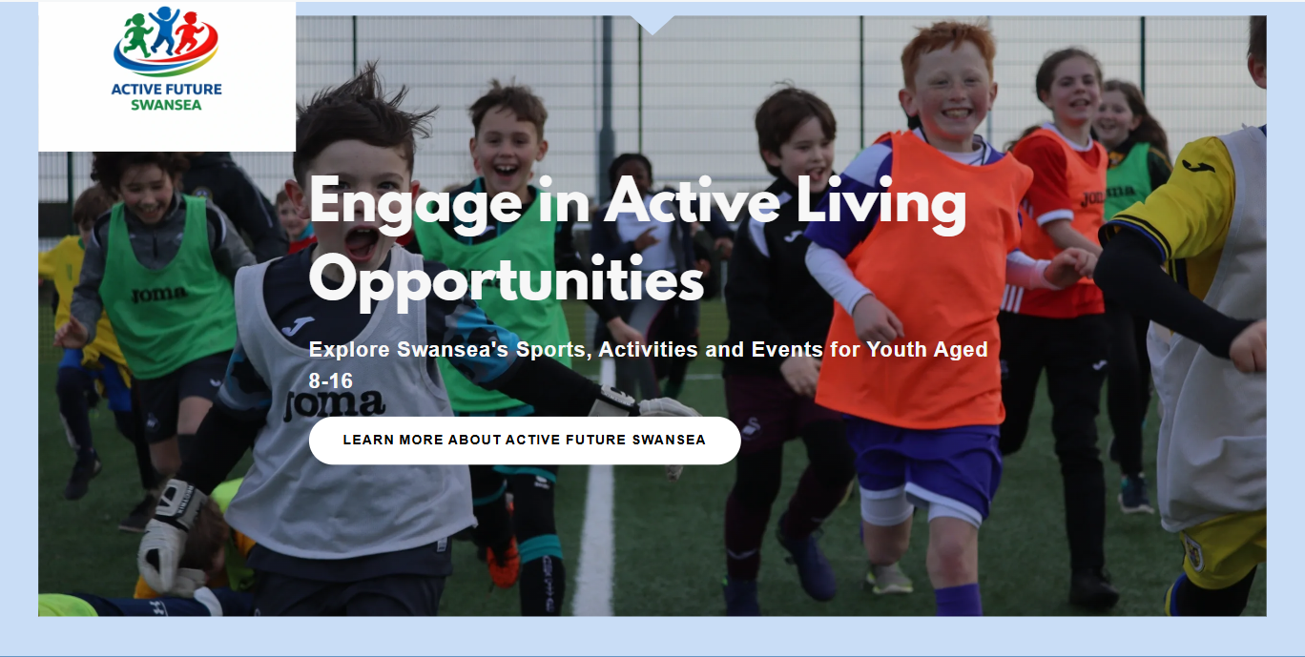
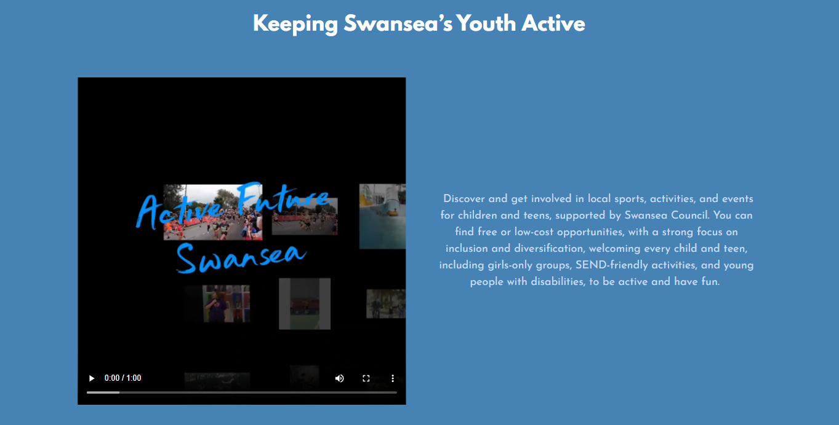

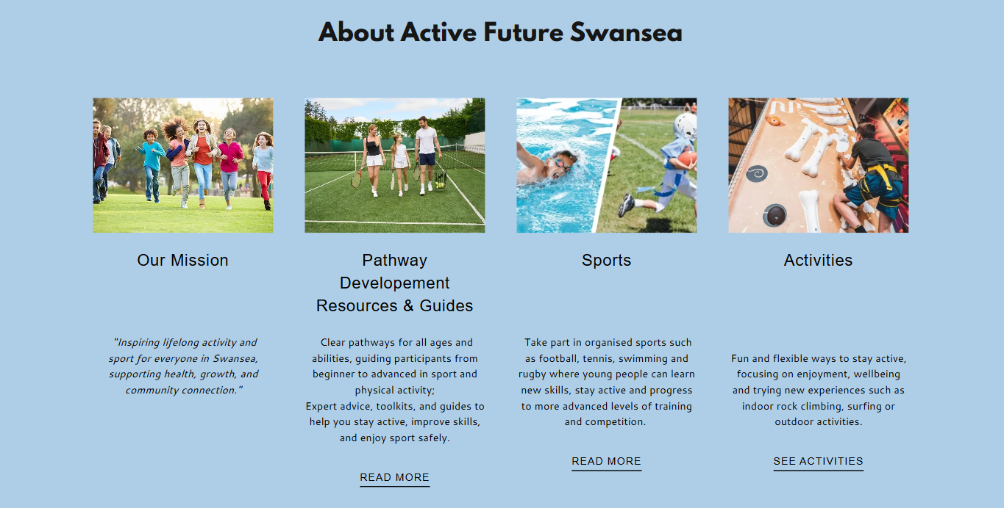

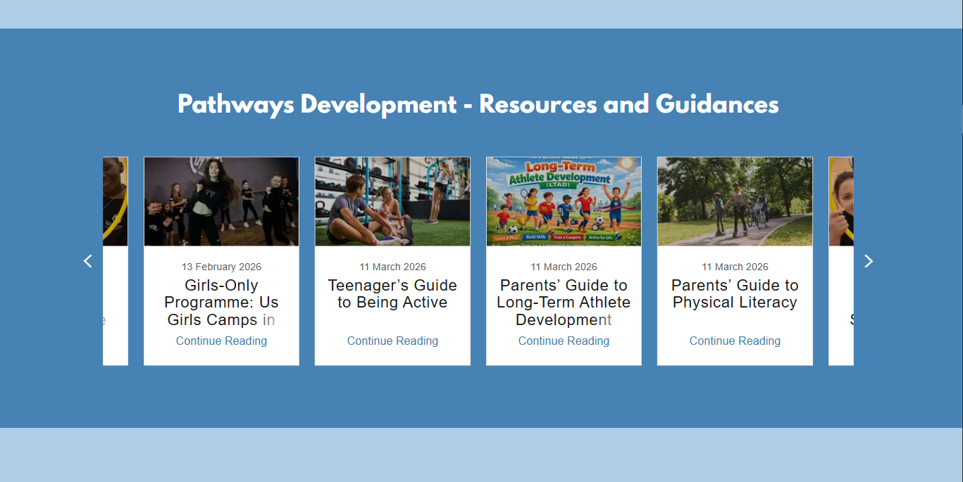
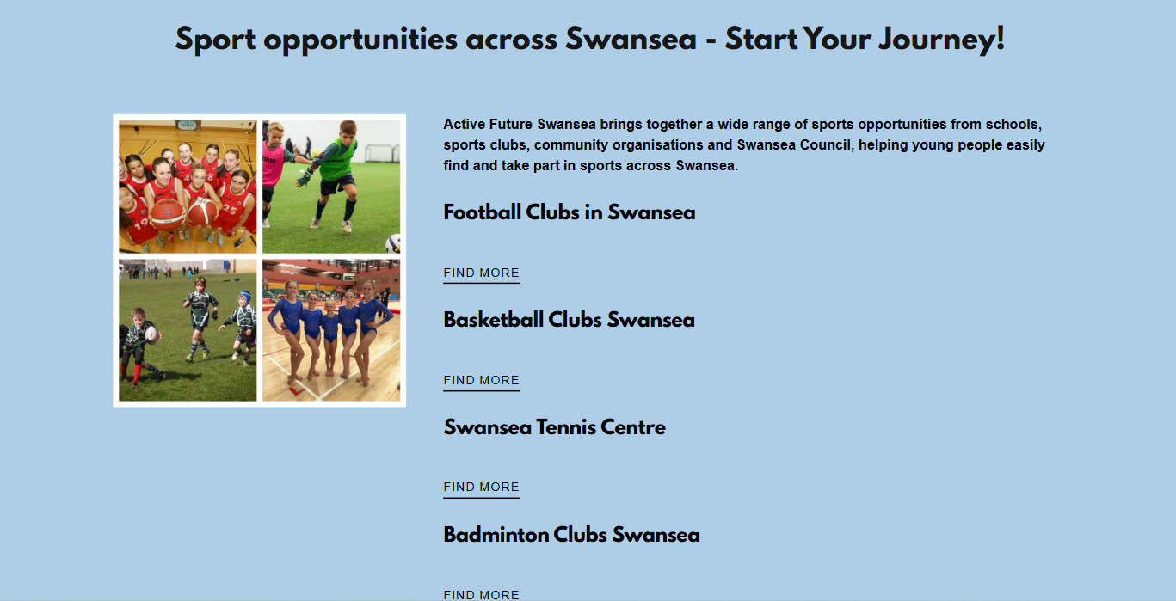

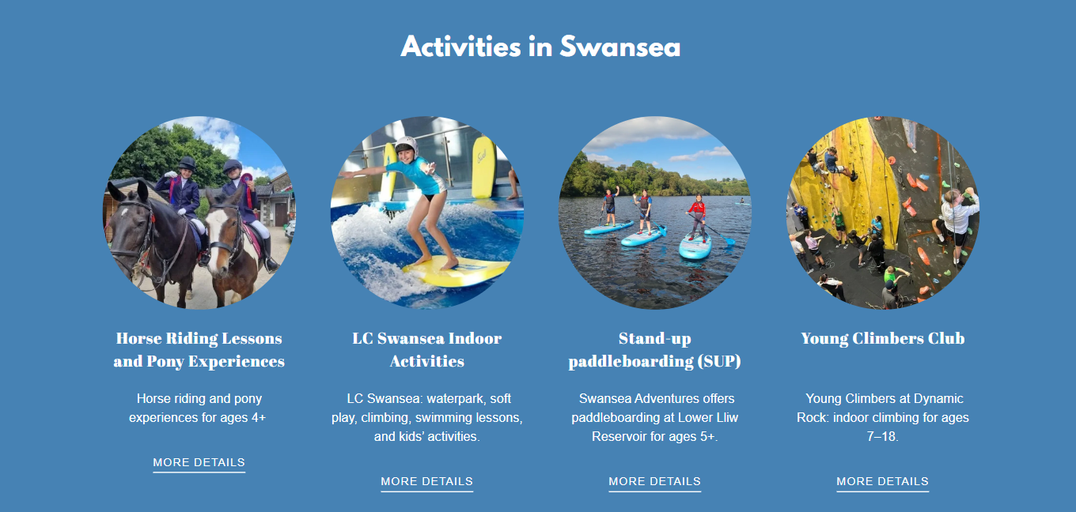
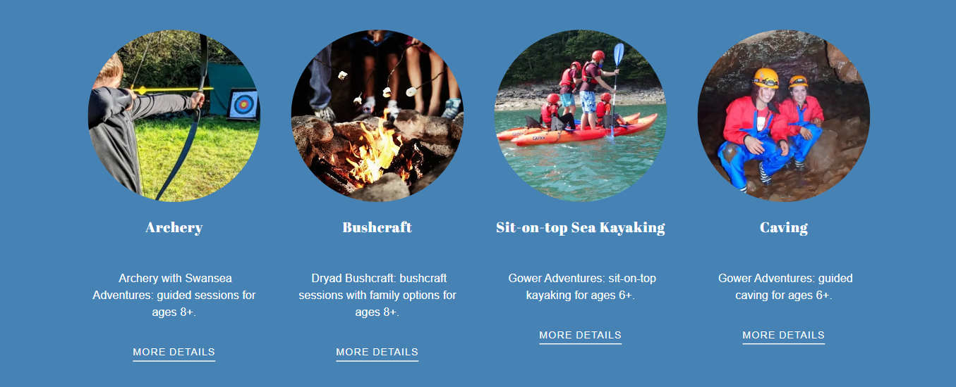
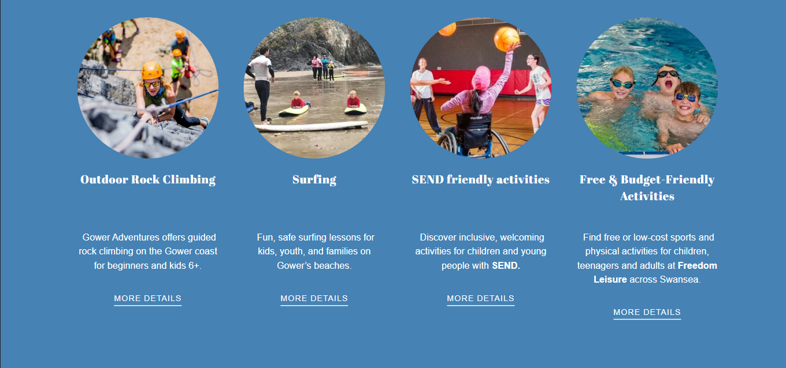

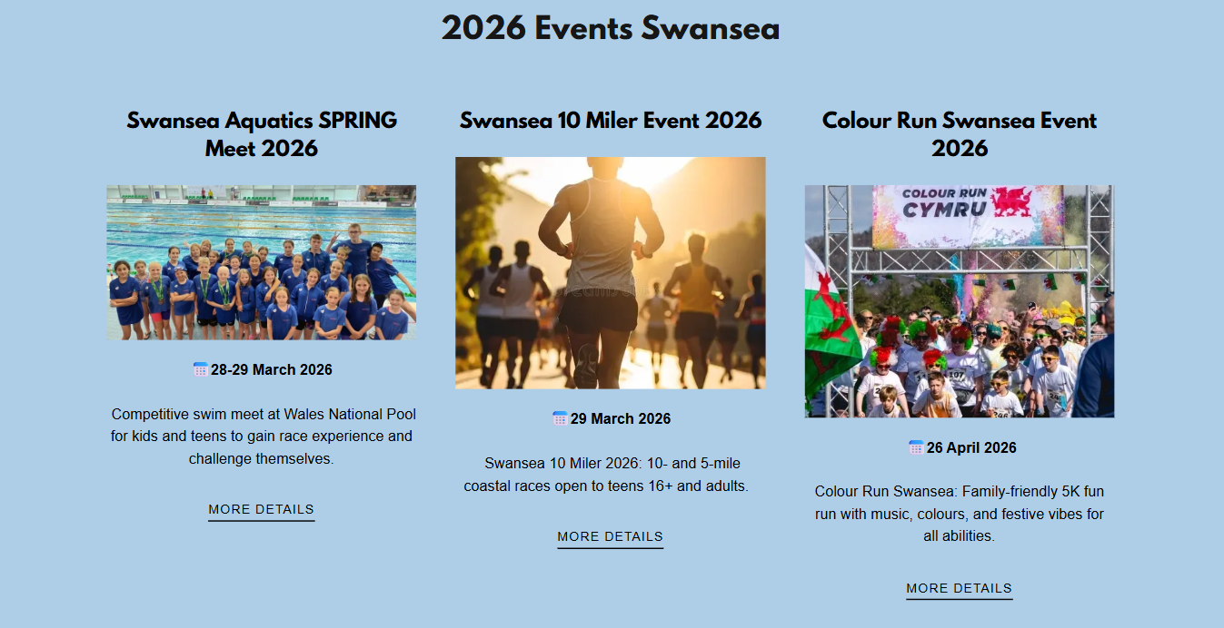
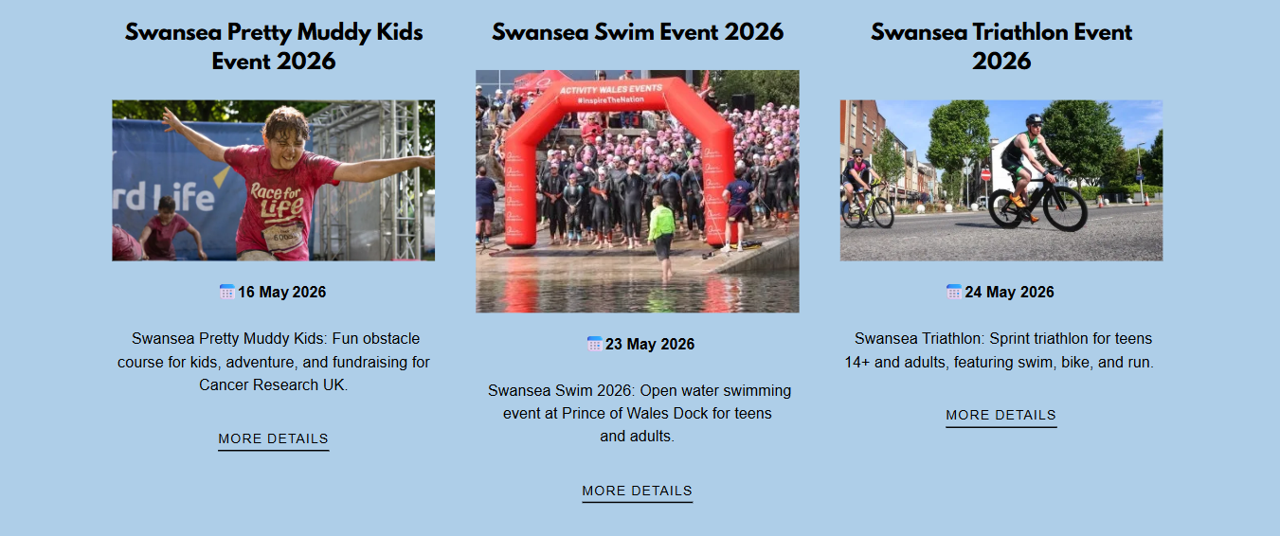
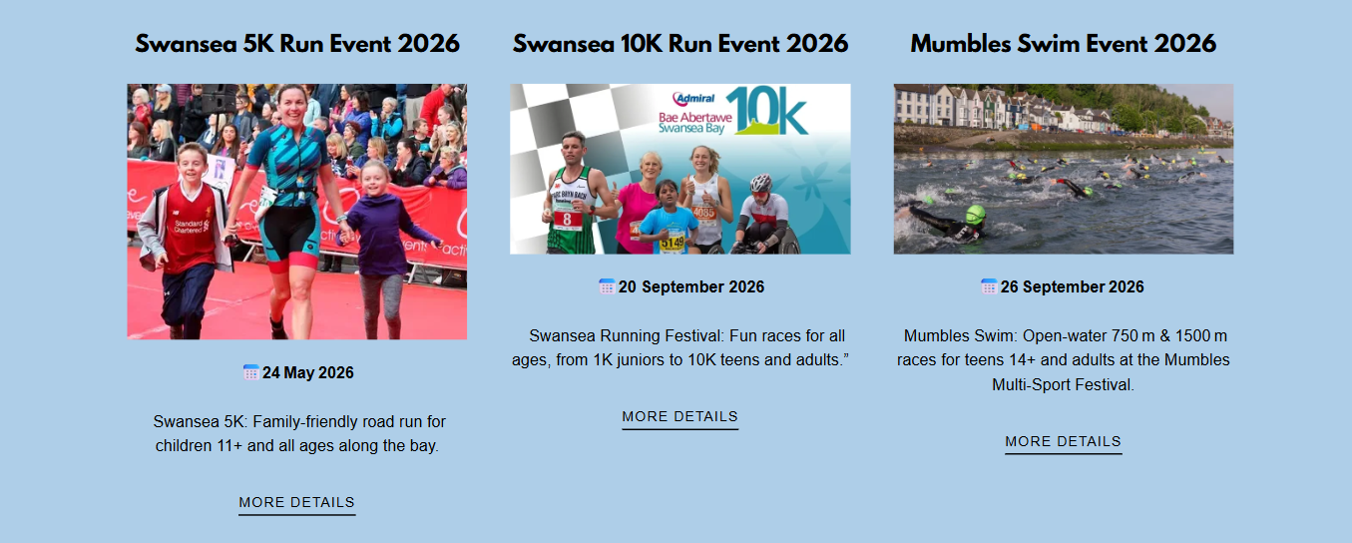
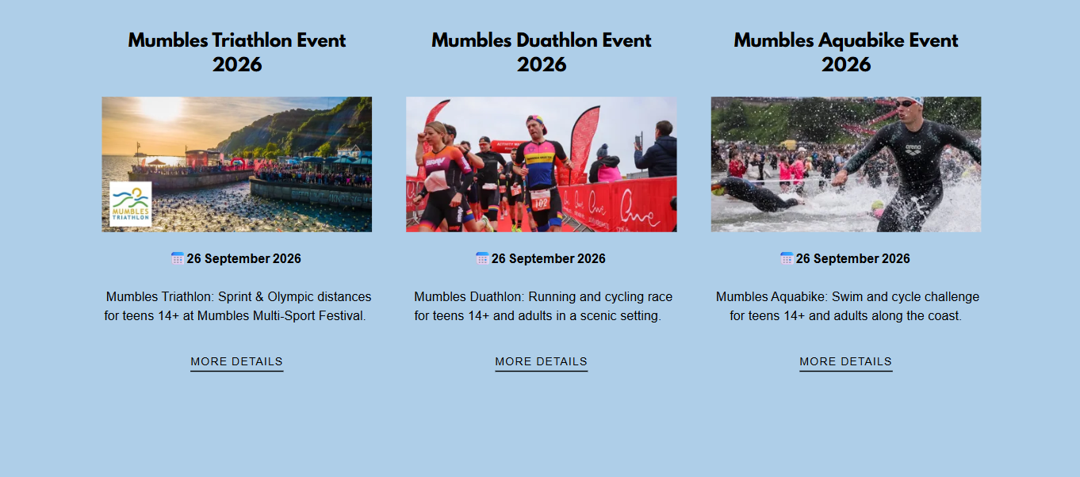
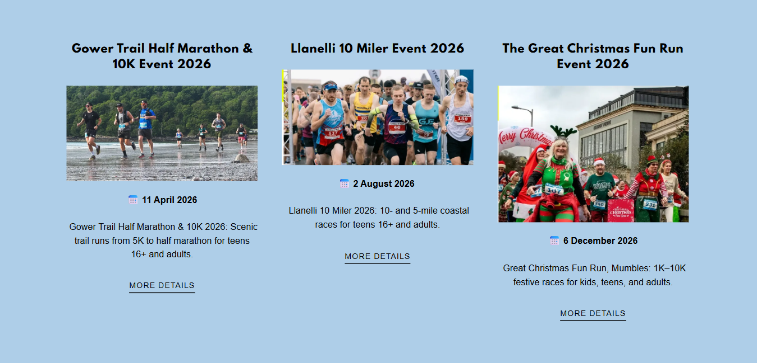
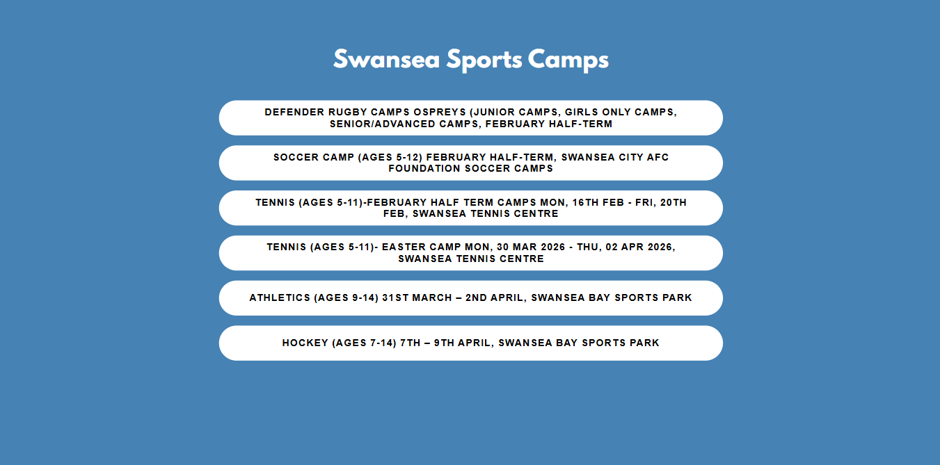
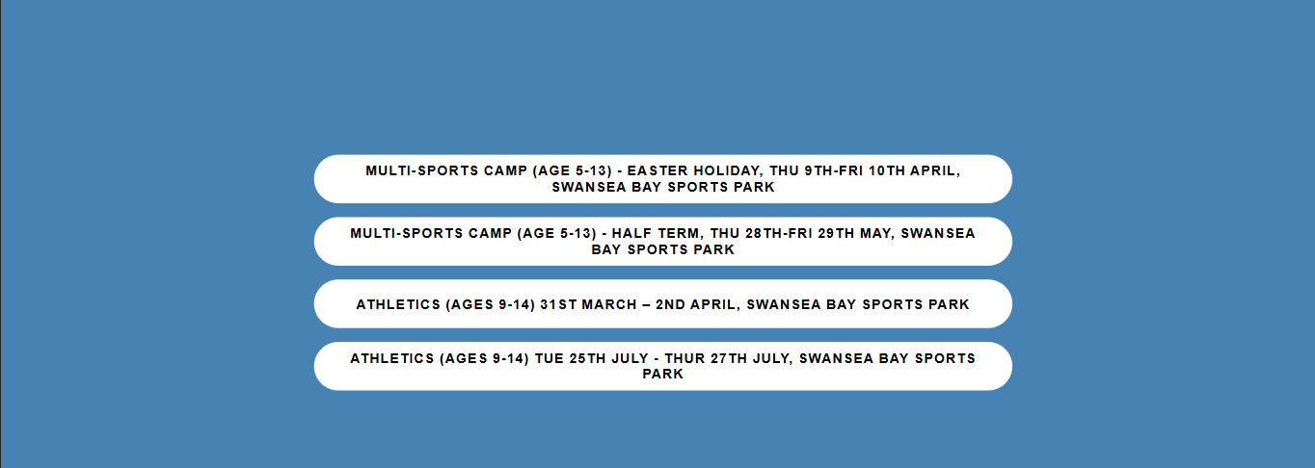
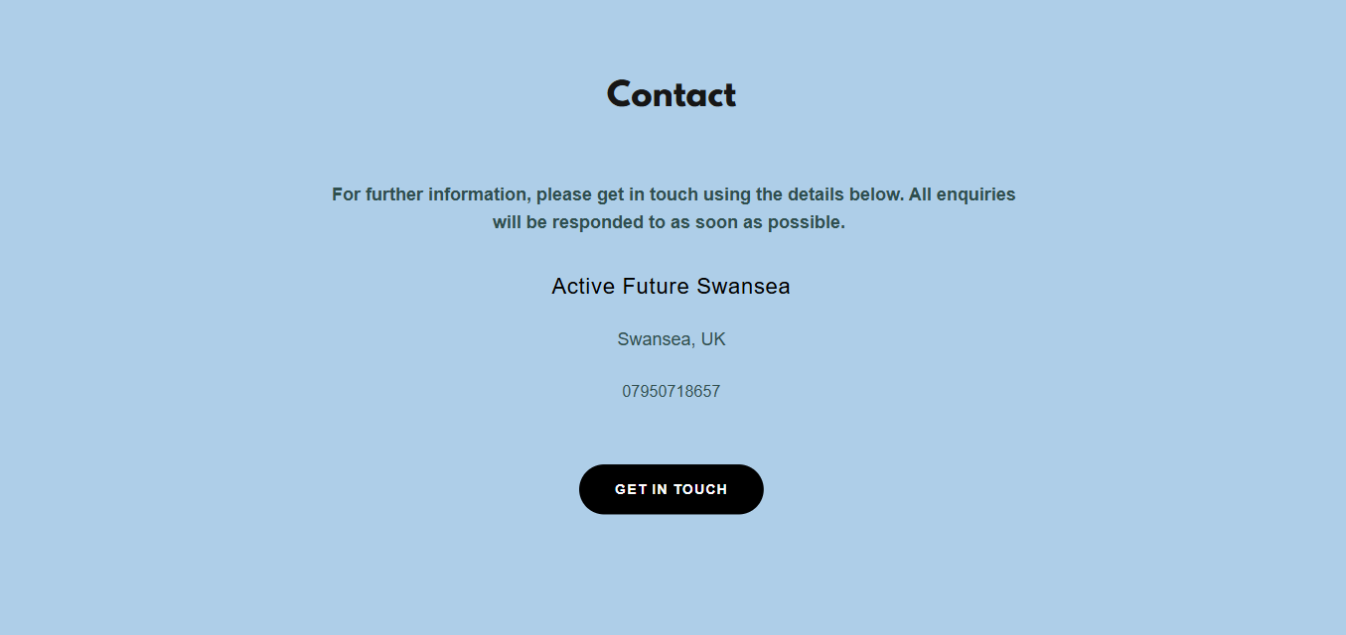
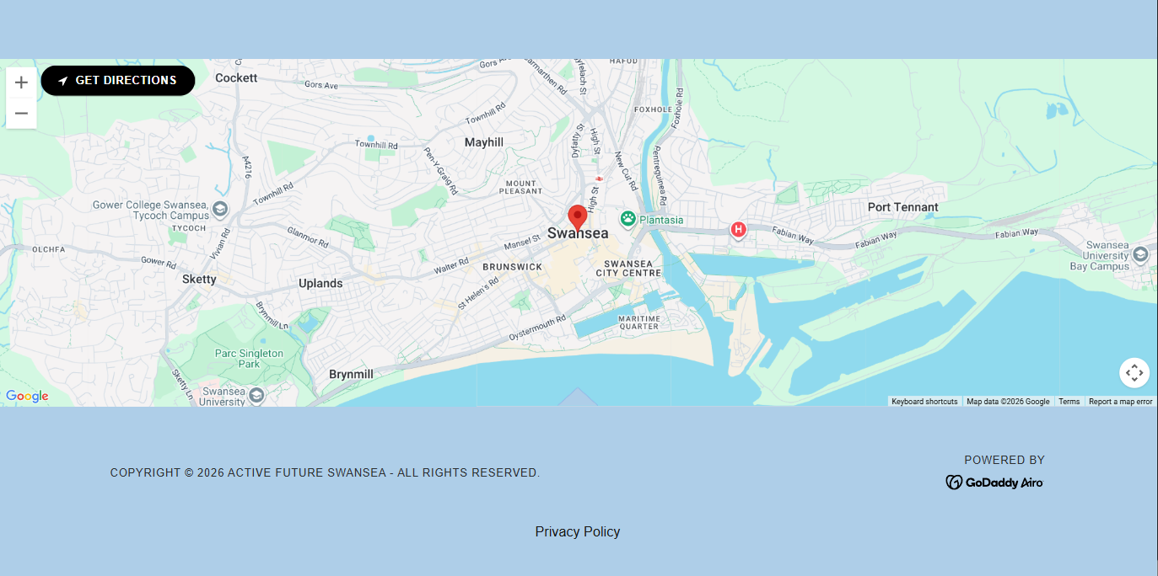

3.1 Reflection / Conclusion / Recommendations (key learning points)
Reflection:
In this project, I developed a deeper understanding of how digital platforms can be used to promote sport and physical activity among children and young people. Creating the Active Future Swansea website helped me recognise the importance of accessibility, clear structure, and engaging content when targeting families, schools, and young participants.
I also learned how important it is to link practical ideas with theory, particularly concepts such as physical literacy and Long-Term Athlete Development (LTAD). These frameworks helped shape the activities and pathways presented on the website, ensuring they are age-appropriate and support long-term participation in sport.
Additionally, I improved my skills in planning and organising information, especially when structuring sections such as activities, resources, and events. This has enhanced my ability to communicate ideas clearly to a specific target audience.
Conclusion:
Overall, the project was successful in creating a user-friendly and informative platform that promotes sport opportunities in Swansea. The website provides a clear pathway for children, teenagers, and families to explore different activities and stay engaged in physical activity.

The project highlights the importance of community-based sport initiatives and demonstrates how digital tools can support participation and awareness. It also reflects current priorities within the UK and Wales, such as increasing youth physical activity levels and improving health and well-being.
Recommendations (key learning points):
To improve the project, several recommendations can be made. Incorporating user feedback from children, parents, and coaches would help improve the quality and relevance of the content. Adding interactive features, such as booking options, would enhance the overall user experience. In addition, using social media platforms would help reach a wider audience and increase engagement with the website.
This project demonstrated the importance of user experience in digital platforms, particularly the value of interactive features in increasing engagement. It also highlighted the role of partnerships with schools and sports clubs in improving participation and building credibility within the community.
In addition, the project showed the need for regularly updated content to maintain user interest and ensure information remains relevant. The importance of accessibility and inclusion was also a key learning point, reinforcing that sport opportunities should be designed to suit a wide range of abilities and backgrounds.
Overall, the project strengthened my understanding of how to effectively promote physical activity and sport participation through a well-structured and inclusive digital platform.

3.2 Reference List
Active Healthy Kids Global Alliance (2018) Wales Poster 2018 – Active Healthy Kids Report Card. AHKGA.
Active Healthy Kids Wales (n.d.) Wales. Available at: https://www.activehealthykids.org/wales/ (Accessed: 2 January 2026).
Active Sussex (n.d.) Physical literacy - Active Sussex. Available at: https://www.activesussex.org/physical-literacy/
Activity Alliance (2023) Benefits of physical activity in schools shown in new research. Available at: https://www.activityalliance.org.uk/news/8617-benefits-of-physical-activity-in-schools-shown-in-new-research
Allcott-Watson, H., Chater, A., Troop, N. and Howlett, N. (2023) ‘A systematic review of interventions targeting physical activity and/or healthy eating behaviours in adolescents’, Health Psychology Review, pp. 1–24.
Balyi, I. and Hamilton, A. (2004) Long-Term Athlete Development: Trainability in Childhood and Adolescence. Victoria: National Coaching Institute.
Balyi, I., Way, R. and Higgs, C. (2013) Long-Term Athlete Development. Human Kinetics.
Bingham, D.D. et al. (2025) ‘Children’s perceptions of physical literacy: Exploring meaning, value, and capabilities for lifelong physical activity’. Pre-print.
Bloyce, D. and Smith, A. (2010) Sport Policy and Development: An Introduction. London: Routledge.
Carl, J. et al. (2022) ‘The effectiveness of physical literacy interventions: A systematic review with meta-analysis’, Sports Medicine, 52(12).
Coalter, F. (2013) Sport for Development: What Game Are We Playing? London: Routledge.
Collins, M. and Kay, T. (2014) Sport and Social Exclusion. 2nd edn. London: Routledge.
Côté, J., Fraser-Thomas, J. and Deakin, J. (2008) ‘Understanding dropout and prolonged engagement in adolescent competitive sport’, Psychology of Sport and Exercise, 9(5), pp. 645–662.
Deci, E. and Ryan, R. (2000) ‘Self-Determination Theory and the facilitation of intrinsic motivation’, American Psychologist, 55(1), pp. 68–78.
Early Years Wales (2021) Our work during the pandemic: Play, Learn, Thrive – insights report. Cardiff: Early Years Wales.
Early Years Wales (n.d.) Home. Available at: https://earlyyears.wales/ (Accessed: 29 December 2025).
Ekelund, U. et al. (2016) ‘Does physical activity attenuate or eliminate the detrimental association of sitting time with mortality?’, The Lancet, 388(10051), pp. 1302–1310.

Ford, P.R. et al. (2009) ‘The role of deliberate practice and play in career progression in sport’, High Ability Studies, 20(1), pp. 65–75.
Foundations Framework Wales (2024) Good Practice in Physical Activity and Sporting Environments for Children aged 3–11 years. Available at: https://www.sport.wales/files/dda266496f90d4d4aded0f1db9cacf02.pdf
Fraser-Thomas, J.L., Côté, J. and Deakin, J. (2005) ‘Youth sport programs: an avenue to foster positive youth development’, Physical Education & Sport Pedagogy, 10(1), pp. 19–40.
Freeman, R.E. (1984) Strategic Management: A Stakeholder Approach. Boston: Pitman.
Grauduszus, M. et al. (2023) ‘Definitions and assessments of physical literacy among children and adolescents: A scoping review’, BMC Public Health, 23, 1450.
Grauduszus, M. et al. (2024) ‘School-based promotion of physical literacy: A scoping review’, Frontiers in Public Health, 12.
Green, M. (2005) ‘Integrating pathways: Elite sport development and mass participation agendas’, Managing Leisure, 10(3), pp. 153–179.
Guthold, R. et al. (2020) ‘Global trends of insufficient physical activity among children and adolescents’, The Lancet Child & Adolescent Health, 4(1), pp. 23–35.
Hylton, K. (ed.) (2013) Sport Development: Policy, Process and Practice. 3rd edn. London: Routledge.
International Physical Literacy Association (n.d.) Physical literacy. Available at: https://www.physical-literacy.org.uk/
James, M. et al. (2018) ‘Teenage recommendations to improve physical activity for their age group’, BMC Public Health, 18(1).
James, M. et al. (2025) ‘To what extent does self-reported physical activity impact children’s wellbeing and mental health?’, PLOS ONE, 20(5).
Liu, Y. et al. (2021) ‘Physical literacy in children and adolescents’, European Physical Education Review, 27(1), pp. 96–112.
Local Government Association (2024) Us Girls: targeted approach for low income communities by Street Games.
Long, B. et al. (2025) ‘The predictive relationship between parents’ perceptions of physical activity and children’s physical literacy’, Scientific Reports, 15(1).
Long, J. and Spracklen, K. (2014) Sport, Leisure and Social Justice. London: Routledge.
McMillan, S. and Morrison, M. (2006) ‘Online communication and health promotion effectiveness’, Health Education Journal, 65(1), pp. 34–49.

Morville, P. and Rosenfeld, L. (2006) Information Architecture for the World Wide Web. Sebastopol, CA: O’Reilly.
Mytime Active (2018) It’s a wrap for Us Girls.
NHS (2024) Physical activity guidelines for children and young people.
Nielsen, J. (1999) Designing Web Usability. Indianapolis: New Riders.
Norman, D. (2013) The Design of Everyday Things. Revised edn. Cambridge, MA: MIT Press.
Play Wales (n.d.) Current play policy in Wales. Available at: https://play.wales/play-policy-legislation/current-policies/
Richards, A.B. et al. (2022) ‘WALES 2021 Active Healthy Kids (AHK) Report Card’, International Journal of Environmental Research and Public Health, 19(13).
Routledge (n.d.) Home. Available at: https://www.routledge.com
Sallis, J. et al. (2012) ‘Environmental and policy interventions to promote physical activity’, American Journal of Preventive Medicine, 43(5), pp. 551–567.
Sport England (2023) Physical Literacy Consensus Statement for England published.
Sport England (2025) Active Lives Children and Young People Survey Academic Year 2024–25.
Sport England (n.d.) Research. Available at: https://www.sportengland.org/research
Sport Wales (2022) School Sport Survey 2022: State of the Nation report. Cardiff: Sport Wales.
Sport Wales (2023) Statistics.
Sport Wales (2024a) Annual report and accounts 2023–2024. Cardiff: Sport Wales.
Sport Wales (2024b) Wales Activity Tracker Survey 11 – January 2024: Gender.
Sport Wales (n.d.) Home.
StreetGames (2025) Us Girls.
Swansea Bay 10K (2025a) Junior 1K Race Information.
Swansea Bay 10K (2025b) Junior 3K Race Information.
Swansea City AFC (n.d.) Foundation.
Swansea Council (2021) Physical Literacy.
Swansea Council (2023) ‘Big day at LC for city’s latest young sports ambassadors’.
Swansea Council (2024a) Heaps of cool ideas and things to do this summer.
Swansea Council (2024b) Young Ambassadors.

Swansea Council (2025a) Children and Young People.
Swansea Council (2025b) Sport and Health.
Swansea Council Early Years, Play and Inclusion Team (2020) Covid-19: Supporting children in the early years during the pandemic.
Swansea Virtual School (2025) 2025 Swansea Bay 10K – Junior Races.
Taylor, P. et al. (2021) Managing People in Sport Organisations. London: Routledge.
TicketSource (n.d.) Swansea Sport and Health.
Tyler, R. et al. (2016) ‘Results from Wales’ 2016 Report Card’, Journal of Physical Activity and Health, 13(S2), pp. S330–S336.
UK Government (2019) Physical Activity Guidelines: Children and Young People (5 to 18 years).
UK Government (2020) What works in schools and colleges to increase physical activity.
University College London (2024) The importance of physical activity for young people’s mental health and wellbeing.
University of Wales Trinity Saint David (n.d.) About Physical Literacy.
Visit Swansea Bay (n.d.) Home.
Wainwright, N. (2025) ‘Supporting Swansea’s early years through play’, University of Wales Trinity Saint David News.
Wales247 (n.d.) Home.
Weir, N. et al. (2024) ‘Physical literacy and physical activity in early years education’.
Welsh Government (2018) Health Behaviour in School-aged Children (HBSC) Wales Survey 2017/18.
Welsh Government (2019) Healthy weight: healthy Wales.
Welsh Government (2023) Health behaviour in school-aged children.
Welsh Government (2025) Quality information for the Wellbeing of Wales report: 2025.
Whitehead, M. (2010) Physical Literacy. Routledge.
Women in Sport (n.d.) Home.
World Health Organization (2020) Digital Health Promotion Guidelines.
World Health Organization (2020) WHO guidelines on physical activity and sedentary behaviour.
Youth Sport Trust (n.d.) Physical literacy toolkit.

Youth Sport Trust (2026) Young Ambassadors Wales.

3.3 Bibliography
Activity Alliance (2020). Activity Alliance | Disability inclusion sport | My Active Future: Including every child. [online] Available at: https://www.activityalliance.org.uk/how-we-help/research/5658-my-active-future-including-every-child-march-2020.
GOV.UK (2012). Children with Special Educational Needs and Disabilities (SEND). [online] Available at: https://www.gov.uk/children-with-special-educational-needs.
KIT (2023). 4 Ways to Build Inclusive Sports and Recreation Programs for Children with Disabilities. [online] Kids Included Together. Available at: https://www.kit.org/build-inclusive-sports/.
Local Government Association (2025). Rapid Evidence Review: Improving opportunities for physical activity for care-experienced children and young people (September 2025). [online] Available at: https://www.local.gov.uk/rapid-evidence-review-improving-opportunities-physical-activity-care-experienced-children-and-young.
Sport Wales (2022). How parents engage toddlers in physical activity - Report. [online] Available at: https://www.sport.wales/research-and-insight/parents-engaging-pre-school-children-physical-activity-review/
Wainwright, N., Goodway, J., Whitehead, M., Williams, A. and Kirk, D. (2018). Laying the foundations for physical literacy in Wales: the contribution of the Foundation Phase to the development of physical literacy. Physical Education and Sport Pedagogy, 23(4), pp. 431–444.
Welsh Government (2020). Health and Well-being: Introduction - Hwb. [online] Available at: https://hwb.gov.wales/curriculum-for-wales/health-and-well-being/.
World Health Organization (2020). WHO guidelines on physical activity and sedentary behaviour. [online] Available at: https://www.who.int/publications/i/item/9789240015128.

3.4 Appendices
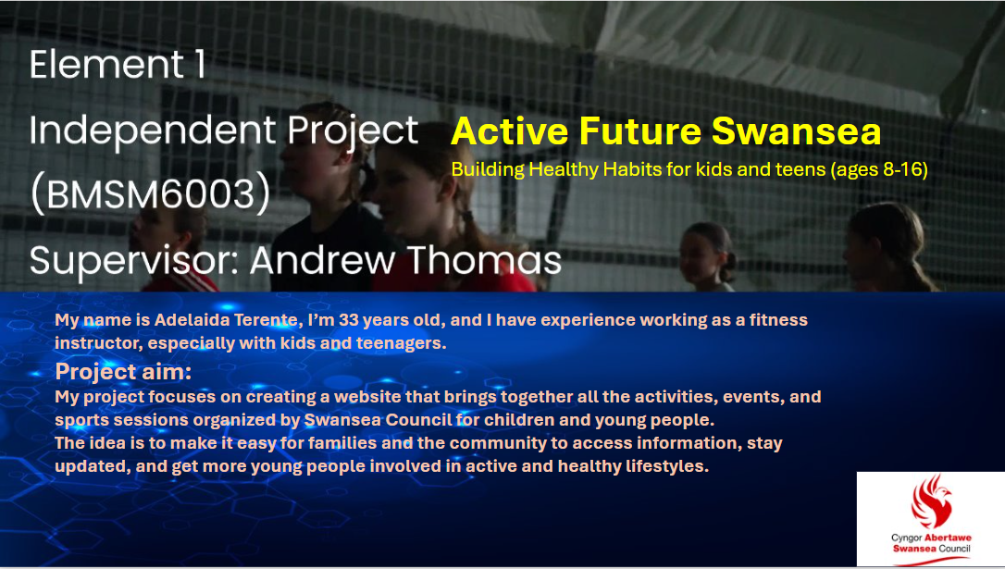

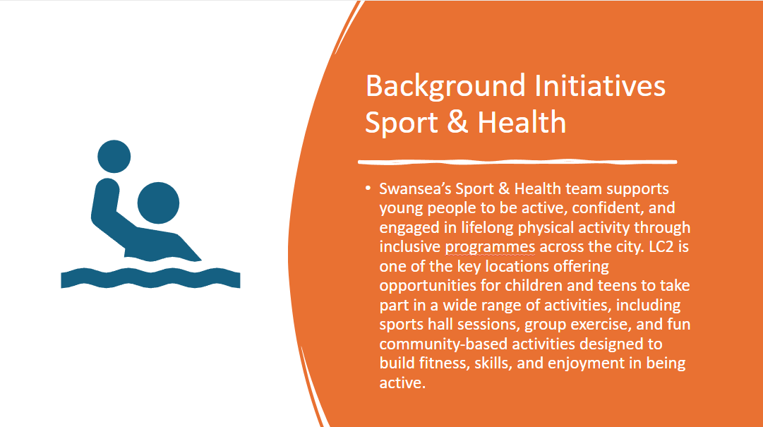
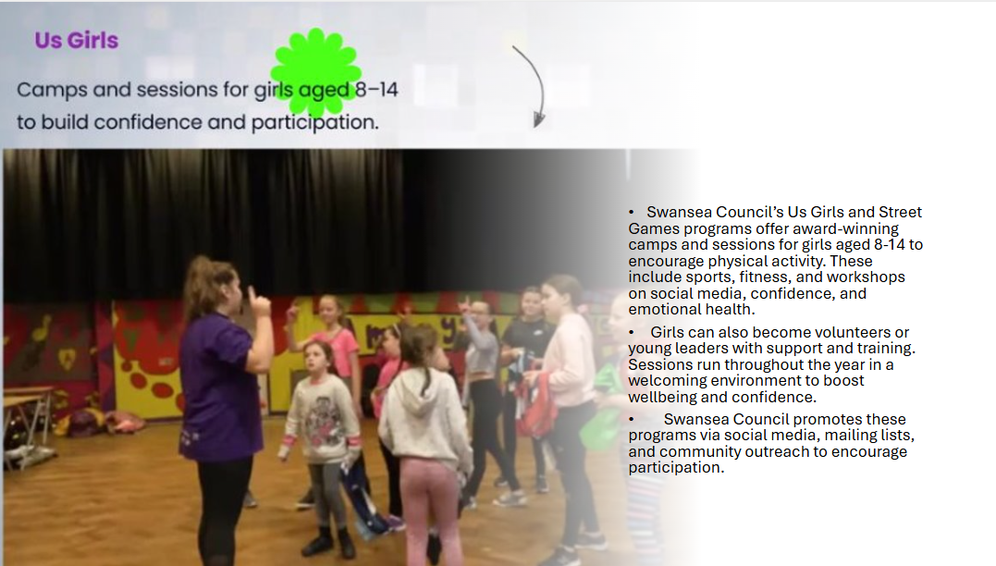
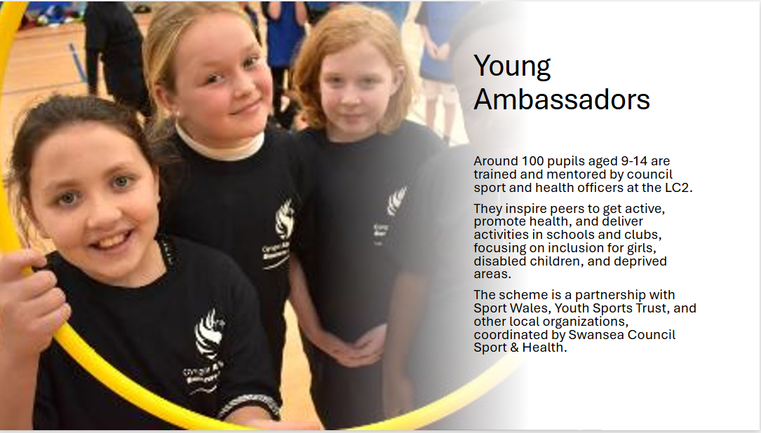
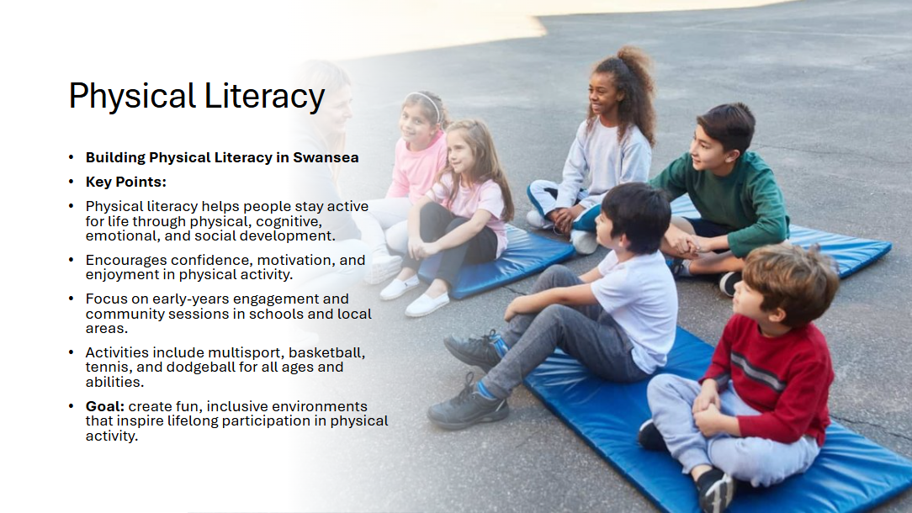
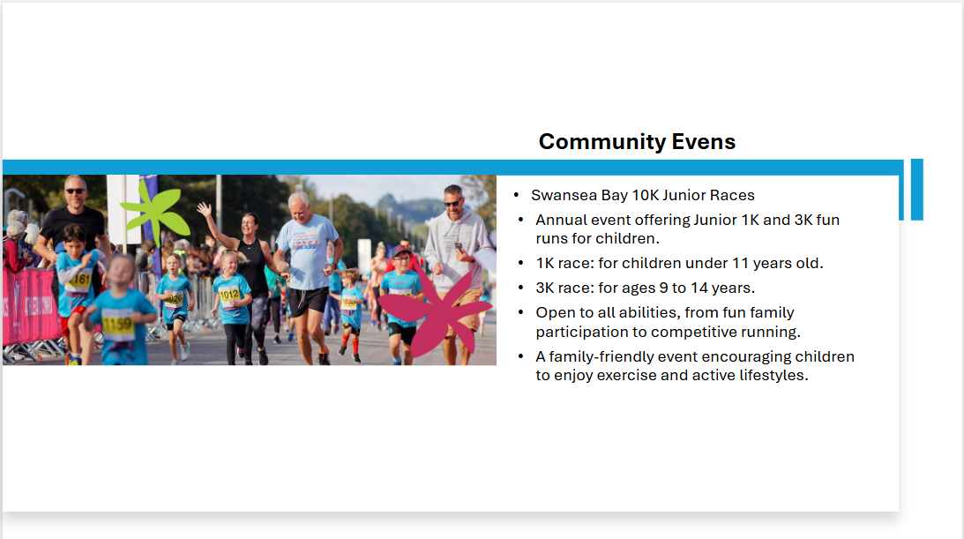
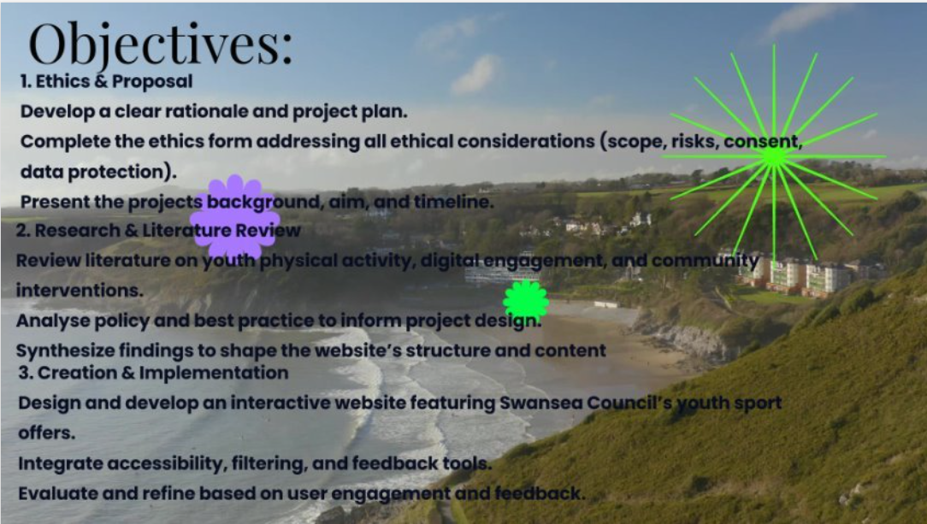



Sports Management Portfolio

Independent Project

UWTSDSport

