BREWER Jayden
2403712

ACBA5019
Building evaluation
Construction Technology 2

Contents
Site conditions and potential risks…………………………………………………………………………………………………..…1
Foundation and frame…………………………………………………………………………………………………………………1,2,3
Internal construction and fire safety…………………………………………………………………………….……………..3,4,5
Overveiw……………………………………………………………………………………………………………………………………………5
References…………………………………………………………………………………………………………………………………………6

Site conditions and potential risks
The site that is being built on is in SA1 and is situated next to a dock. With the site sitting on old docklands there is a good chance of contamination on the land that we will build on such as oil and other fuels. Thorough tests and checks must be carried out to ensure that the land is safe to build on. Borehole logs for nearby sites are available online, viewing these can be a strong indicator as to the quality of the land we will be building on. Conducting our own borehole logs will give show exactly how the condition of the site is.
Ground improvement works may be required before we begin building, works such as compaction and stabilisation will strengthen the ground in which the buildings foundations will be laid on. There may be a potential risk of erosion or movement of the ground due to the weight of the building. Completing ground improvement works will allow the ground to take the weight required. Due to being on old dockland, there may be rubble or debris buried under the surface layer of soil. Rails were used to transport materials, supplies and goods to the docks before World war 2. The remains of broken rail track may still be on site under the top soil. Evidence of historic artifacts have previously been found in the site area such as arrowheads and roman artefacts. Swansea was heavily bombed during the Second World War due to the influence of its docks. The docks were used during the war for testing and would supply resources to be shipped to war. There is a potential for live ammunition and explosives to be found on site, these would need to be removed and transported by a specialist. A desktop exercise will be required to get a full view and understanding of the areas history to hopefully highlight any potential issues that may lead to project delay or incompletion. There may be a potential risk of flooding on site due it its waterside location.

Foundations and frame
As the building will be medium to high rise it will require a strong load bearing foundation. I have decided that the use of pile foundations will be most beneficial due to the ability to successfully hold large weight. Piles will also be beneficial as if the ground quality is poor, it will allow us to bore through the poor soil and into the more stable soil. The building will be required to be slightly built up from ground level.
As the accommodation block will be mid to high rise then it will get very heavy. I have decided that the use of a reinforced concrete frame will be best suited for this building. Concrete has high compressive strength and with the use of rebar and its high tensile strength, the building will remain extremely stable. The pile foundations will allow for us to use more heavy materials as the piles will take the weight. Concrete is easily poured on site allowing for a quick pouring process, however curing times may affect progress if the correct steps/processes are not followed. Concrete is also highly fire resistant and one of the most effective materials when it comes to fire resistance.
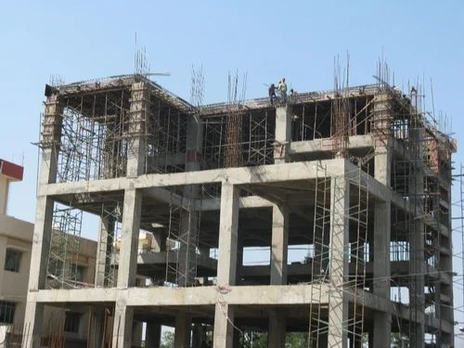

(Indiamart.com)

The above image shows the rebar within the concrete frame. Rebar is steel bars that increase the concretes strength.
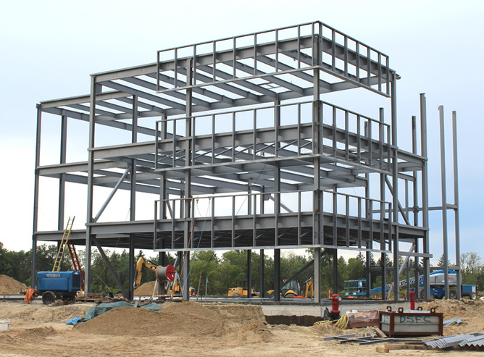

(Understandconstruction.com)

I have also considered that concrete is more cost effective than steel and is more likely to be acquired much faster than steel. Steel could potentially become an issue if a fire was to burn through the building as steel can begin to weaken under high temperatures. “Mild steel is often the type of steel used when constructing a frame. It is very strong however can lose up to half of its structural strength if exposed to fires at 500 degrees Celsius” (Understandconstruction.com). Steel can be sprayed with a specialist product to make it more fire resistant, but this will be costly in oppose to using a reinforced concrete frame which will require no specialist products to be applied due to its natural fire resistant characteristic. Steel has the flexibility that concrete lacks. High winds and poor weather conditions may slightly move the building, the characteristics of steel allow it to move and bend without cracking and breaking as concrete might. Steel frames are also time effective due to the ability to be constructed offsite. Steel beams and columns can be ordered in advance and brought to site at a set time and day. The steel is then lifted into place and fixed together with heavy duty bolts and welding to keep components together. This will greatly improve the project timeline in comparison to using a concrete frame as there is no pouring process as well as a curing process (the time it takes for the concrete to set). A steel frame will be significantly lighter in comparison to a reinforced concrete frame due to overall thickness of material and the steels strength to weight ratio.
Following the use of a reinforced concrete frame, I have decided on using precast construction to build the external walls, lift shaft, stairwells and slab of the accommodation. I have decided on this as we will want to make the building watertight as fast as possible due to its seaside location and general weather. Large panels can be brought to site and lifted into place. Using concrete will again further assist the buildings fire safety rating as it will be enclosed by a heavily fire-resistant material.

Internal construction and fire safety
When fitting out the building’s internals, fire safety must be top priority. Having clear fire exits is crucial in a large residential building. Fire resistant materials must be used in relevant areas to stop the potential spread of a fire. Compartmentalisation will need to be used throughout the building so fire is contained in the area that it started to minimise damage and potential chances of fatality.

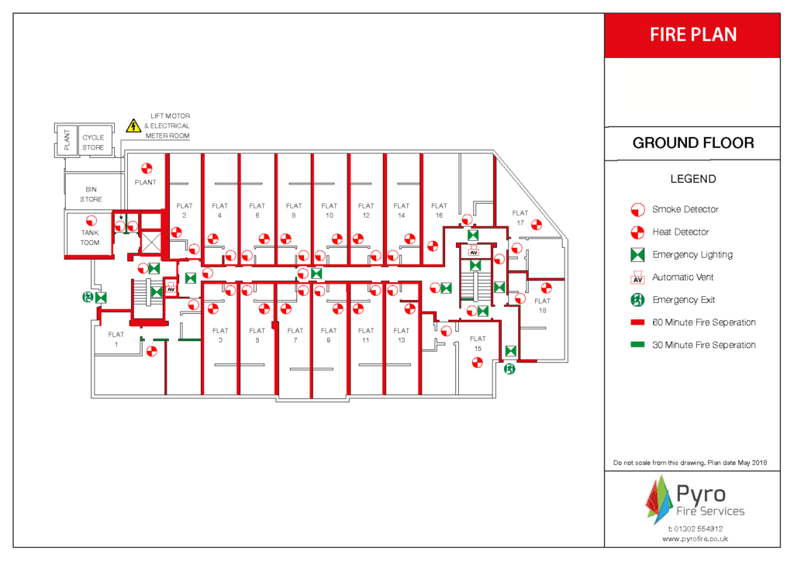

(pyro Fire)
The above image gives a good insight as to what is required within a building to make it fire safe. The image displays red lines for 60-minute fire walls surrounding each flat. If a fire was to start within a flat, it would take an hour to burn through the fire-resistant materials used. This is crucial to have as the corridor used to access the flats is a fire escape.

Fire rated board such as siniats “15mm fire board” which will be used to create fire compartments within the building. Fire rated boards can give different ratings depending on requirements. Due to the building being residential, we will use board that will give us an hour fire rating in order for residents to have safe access to fire exits. Using acoustic insulation within walls will be highly beneficial to avoid noise disturbances from surrounding rooms.
Fire doors will also be required in areas such as corridors accessing bedrooms and areas such as kitchens and stairwells. Having the correct components on the doors such as drop seals and fire and smoke seals around the door will further assist in keeping the fire under control. Fire smoke dampers (FSD) will also be used with the ventilation system. The dampers work as a fire resistant door that will close when fire/smoke is detected, stopping the spread of fire through ductwork. We will also require a specialist fire stopper on site to close up any penetrations through fire walls such as cables and pipes. Fire stoppers will use fire resistant materials such as mastic and ablative board. Key high-risk areas will need to be protected to risk the spread of potential fires. Kitchen walls will all be required to be fire rated as the potential for fire outbreak in a kitchen area is significantly high. All kitchens and flat entrances will be equipped with fire extinguishers. Being able to contain a fire within a room will help emergency services in dealing with it and will cause minimal damage to surrounding rooms.
The potential use of concrete walls can be used throughout the building. This will reduce the cost of labour as each wall will be lifted into place by a crane instead of using dryliners to fit out every internal wall. This will still be efficient when working against fires as concrete is fire resistant. The use of concrete will also be cheaper than using specialist boards as they can get expensive. Thick concrete walls will be better at reducing sound between rooms due to the thickness of the wall, this will be beneficial in a residential building. However, the use of concrete walls will make rooms cold and will take a longer period to heat up, this may be an issue during winter months.
Within the bedrooms we will use plasterboard ceilings, I have decided to use board over tiles as tiles are easily removed and services above could be accessed such as pipes and cables. Ceilings will have an access hatch in the board, so any maintenance or work is able to be done to services above without cutting through the board. Corridor ceilings will be tiled as they are easily removed to access services above. Unlike the bedrooms, the majority of maintenance work is more likely to happen corridor side due to services feeding the surrounding rooms. Sprinklers will also be fitted to every room and corridor; these will activate when the smoke detector is set off and will hopefully help in eliminating fire at the source.
The flooring used will be marmoleum, “it is up to 98% natural material” (greenbuildingsupply.com) It is fully waterproof, so spills and leaks are easily dealt with. Marmoleum is also very easy to clean, this is great for a residential building where lots of people pass through every day. If we were to use carpet it may get ruined due to dirt and water.
Cladding will be used to decorate the externals of the building. The cladding used will be fire rated as there have been previous cases of cladding rapidly burning and spreading fire up a buildings face such as the Grenfell tower Fire which occurred in 2017. Cladding must meet the requirement of “British standard BS8414, this evaluates the risk of fire spreading up the cladding and entering another area of the building” (designingbuildings.co.uk, 2024)
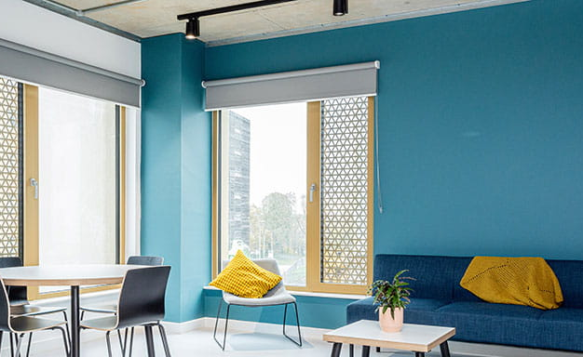
Windows are massively overlooked when it comes to student accommodation with fire and electrical safety taking priority. Windows must not open all the way due to the risk of students falling from higher floors. This can be achieved by having window that only opens from the top and will open inwards. These windows are often operated by a winding lever that allows them to open and close. The other option is to have a standard window that is hinged on the vertical side but with protection on the outside to stop anyone falling or items being dropped while still allowing for airflow.

(www.uwe.ac.uk)
The above image shows newly built accommodation in UWE Bristol. The image demonstrates the use of the anti fall window protection.

I have decided each cluster of flats will consist of 7 rooms. 4 rooms on one side of the corridor and 3 on the other side accompanied by a kitchen and living area. I have decided on this simple layout due to a previous project I have worked on. Its simple design was appealing while also having a great fire plan due to straight corridors and less crowded spaces. The building will consist of 6 floors with each floor having two clusters of flats, with one lift and one stairwell giving access to all floors. This building will require a low incline path leading to the entrance due to potential residents with a disability not being able to use steps or a steeper path.

Overview
∙A desktop exercise must be carried out to get further insight so the sits history.
∙Boreholes and ground condition will be analysed before anything is built.
∙Pile foundations and a Reinforced concrete frame will be used.
∙Internal walls will be made up of specialist fire rated boards.
∙The use other fire rated elements need to be used such as doors and dampers.
∙Cladding will be used for external decoration and protection, cladding must meet British Standards.
∙

References
(n.d.). Retrieved from greenbuildingsupply.com: greenbuildingsupply.com
(n.d.). Retrieved from Indiamart.com: https://www.indiamart.com/proddetail/rcc-frame-structure-services-2853600613712.html
(n.d.). Retrieved from Understandconstruction.com: https://www.understandconstruction.com/uploads/1/7/0/2/17029032/6943278.jpg?669
(n.d.). Retrieved from Understandconstruction.com: https://www.understandconstruction.com/uploads/1/7/0/2/17029032/6943278.jpg?669
(n.d.). Retrieved from www.uwe.ac.uk: https://www.uwe.ac.uk/life/accommodation/frenchay-campus/purdown-view
(2024, September 6). Retrieved from designingbuildings.co.uk: https://www.designingbuildings.co.uk/wiki/BS_8414_Fire_performance_of_external_cladding_systems
pyro Fire. (n.d.). Retrieved from pyrofire.co.uk: https://www.pyrofire.co.uk/what-fire-procedures-and-plans-do-i-need-for-my-building/

