Developing Innovation and Creativity for Business Advantage.

Module code: BMSW6102.
Student Name : LOUAY ALSAYED-OMAR
Student Number: 1922056
Level 6 Term 2. Group 1.
Module lecturer: Dr. Rexon Nting
Assignment title: individual report.

1

Executive summary:
Remote Smart Dashboard Programming Services of RSDPS’ organisation, in this report it might have a significant possibility to created a business gap in the UK market which has a negative impact that will slow down its opening invitation when it is in the start-up stage of operations and adaptability, but reflecting on market needs of developing innovation and creativity for business advantage DIB module norms will help it entrepreneurs increasingly to be in national and global growth demanding, this remote services has been inspired and created after the academics modules with a long term R & D and new conditions for innovation NPD process also it was examined by innovation pipeline funnel Stage-Gate Model, the knowledge of DIB in this report demonstrated the importance of following a specific criteria for business success acquisitions and entrepreneurship attraction, RSDPS innovation with a unique service proposition is a new high level of IT software installation of a remote Java software programming languages improvement, it is a vital necessity for individuals and organization departments to be updated and connect with latest daily business data, managers and employees can remote work and execute daily task anytime and anywhere in this world if they are connect with this unique service, the existing products services redefined by SCAMPER Model also by setting up online website for E-commerce that will help customers to understanding the dimensions and concepts of its business as a friendly digital services in contemporary marketing, it include the UK government compliance of legal legislations law, and the eight stages of a new product development process NPD, it had been applied as a justification that this technology innovation can be launched with an advanced marketing standards process and with a sustainable strategies within the proof of CVP break even sales volume, which is a calculation method that brings financial profits, the NPD method provide for RSDPS’ organisation the ability of transformation this IT remote Java software services into a product available for sale, this market opportunity synchronous with globally mass media campaign and commercialisation in marketing under the UK government general data protection of GDPR and PECR regulations.

2

Table of contents:
1. introduction……………………………………………………………………………………...4.
2. RSDPS innovation with a unique service proposition.............................................5.6.7.8.
3. Setting up online website for E-commerce.......................................................9.10.11.12.
4. Marketing.........................................................................................13.14.15.16.17.18.19.
5.Privacy and Data Protection.....................................................................................20. 21.
6. Conclusion.....................................................................................................................22.
7.References list.

3

1. introduction:
Remote Smart Dashboard Programming Services.
RSDPS.

The world recently facing financial crisis and also in the UK (commons library parliament.uk, 2023). as a complex business situation it forced the platform for innovation to find an effective solutions to come over this unpredicted economic situation these challenges can be faced by developing an innovation with creativity for business advantages, but it is evident that there will be market gabs and needs for a new unlocked innovation platform with a bridge to link and to transfer all data of technology developments in innovation areas with a contemporary creative thinking CT for business advantage, according to Harvard business school (online.hbs.edu, 2022). it provide the definition of innovation as a new product or a new services coming with an advanced business model and strategy but both are useful for the creativity of business advantage. Whilst the concept of innovation according to Cambridge university emphasizes on a new ideas of implementation that participate to society and or an economy in national and international levels (cam.ac.uk, 2022). RSDPS remote is an innovation created to improve national and international worldwide services, it is a development of a new innovation services of IT. information technology science with an advanced unique PCs intranet services in the UK and the worldwide, the idea created from R & D and the platform for innovation also examined by new conditions for innovation NPD method and innovation pipeline funnel Stage-Gate Model (Innovation Pipeline, 2022).
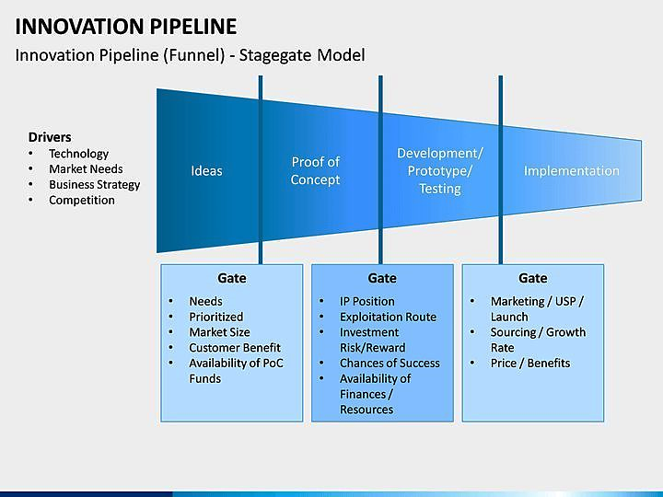
Figure 1.Innovation pipeline funnel Stage-Gate Model. (Innovation Pipeline, 2022).

4

2. RSDPS innovation with a unique service proposition:
This innovation will sell and commercialize as a new high level of IT software development for a remote Java software programming languages which obtain a fundamental role in any business in the UK and the worldwide (Indies education, 2022). It will enable organisations to manipulation business data in time by putting individually all organization data in one place then it will providing it as a comprehensive digital reports services that will be display on dashboards as a sensitive statistical data diagrams on any monitoring device connected online with the organisation browser 24 hours and saving private data which can be revived in future at any time and in any where for all organisation and all staff departments, it will bring a high level of services and business profit , this services include the senior managers, CRM, sales department also it monitoring any other organization progress services include last reports of Freeboard ,Dash builder, daily summary only one thing it is request from the user is to have the skills of SQL with individual ID. And security password (Fine report, 2022). Java dash boards tools aim to open services source of a new innovation platform for developing a business with dash board site that target users include managers, business stakeholders , IT system architects with digital diagrams analysis in all business activities domains.
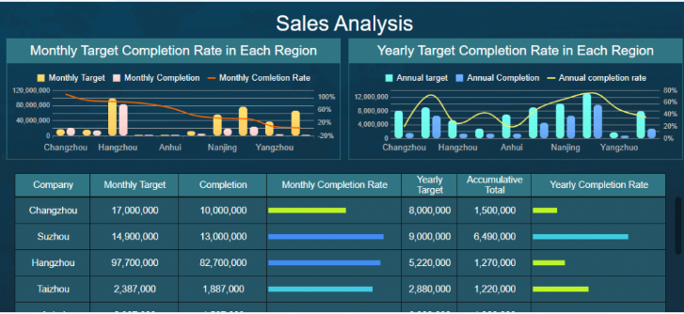
Figure 2. Free image (Fine report, 2022).

The headquarter services provide a remote smart dashboard programming based on membership contracting and an annual payments with consent to access private sensible data and to programming private innovation data of Java program that will appear on all virtual dashboards and phones screens (Primitive data type , 2022). Also with key performance indicators KPI that providing for any organisation and managers reports and files saving option (target dashboard, 2009). It is related with all Microsoft 365 programs for monitoring solutions and transforming all management data.

5

This innovation will be examined through DIB module within different skills ,models, tools, techniques and methods , at the start it was so difficult to created a new conditions for innovation NPD but the idea was discovered and applied by the academic five stages of innovation pipeline funnel Stage-Gate Model, it approve the requirement of differentiation skills between critical and creative thinking CT with abilities, this acknowledgement with critical analysis carry the positive effect of creative thinking CT with ten thoughts that are core critical thinking skills of organization performance and individual benefits, also methods of teams cooperation activities in creative high industry levels to achieve business advantage, businesses do agree with brainstorm ideas but doesn't agree if this innovation ideas doesn't practically fit the criteria of implementation which needs to be reshaped and examined by seven acronym stages of SCAMPER Model technique (marketing 91, 2021). so it can be effectively accepted by entrepreneurship and in the market without any start-up failure, before it will be arrive in selling process or launched in the market for helping other organisations to achieve their objectives in future with a high advanced level in market share.

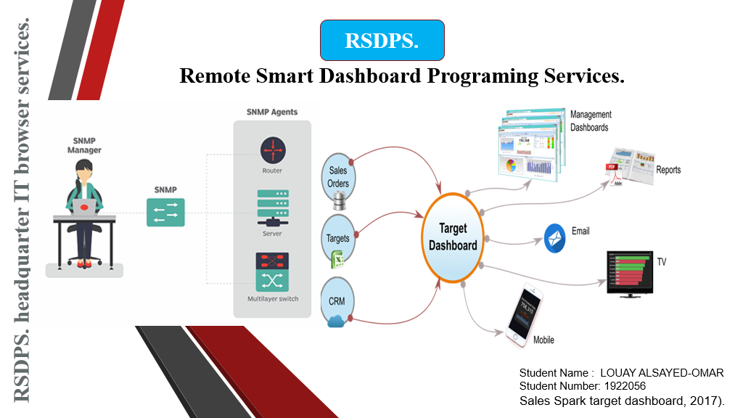

Figure 3. (Sales Spark ,2017).

6

RSDPS lateral thinking for innovation is rethinking to redefine the existing products services for entrepreneurship advantages as an effective problem solving in the market by applying (Instagantt,2023). SCAMPER Model technique that will help to understand how entrepreneurship in market perceived this unique service proposition (Consuunt,2023). With acronym of seven stages analyses which helps to identify this innovation in different points of view and how it designed to be applied in market as the following:
SCAMPER Model:
S – substitute: Free remote Java installation are with no fees in programming download but it can be utilize after that with annual contracting services fees.
C – combine: Receiving all organizational information diagrams combined with file saving process of all Microsoft 365 programs.
A – adapt: Customers can ask and apply any missing information from our unique service as an adapt purpose.
M – modify: Customers will receive a new modified IT services value in organisation business and in commerce problematic system.
P – put to another use: Users are able to reply in any specific time also any where backwards and forwards any required information including data of Microsoft 365 programs.
E – eliminate: It minimize organisation cost by helping managers and employees to do their tasks remotely with less effort and time.
R – reverse: Without our speed patterns it request more efforts for delay duty tasks in administrations reports.

After identifying and evaluating validity of this innovation also how it will be perceived in the market and other people's views OPV, RSDPS looking forward to find business benefits based on creativity and opportunity thinking OT. by applying an academic tools for thinking and three keys of success DATT. This unique service needs a sustained stage from a private investor sector as a problem solving process PSP. That can provide a financial support if not this innovative business proposition it can be sustained from government funding of innovation GOV.UK it is a government policy to develop innovation (funding innovation GOV.UK, n. d.).

7

also it can be sustained from UKRI UK’s national innovation agency that support innovation technologies in all sectors to help businesses growth and the development of any new products, processes, and services including the ecosystem (UKRI , 2022). Competitors in this area are with limitation because they are providing IT technologies only to connect user with software internet networks services such as USA Open X cell, ELEKS, SPEC, INDIA, Ba choo, for JAVA development companies (good firms, 2023). but RSDPS is a digital partner services with an advantage of putting a unique new part that providing all organizational information separately with a security passwords ID and private contract ,staff members can ask and they will be provided with any organisation information which can be reviewed in any time and anywhere of the year by registering and saving files in internal and external organisation environment separately with Java programming diagrams because it is already related with all Microsoft 365 programs. RSDPS after obtaining legal documentation of registrations can start business activities and commerce sales procedure in any London business centres for example the BE offices (be offices, 2022).

8

3. Setting up online website for E-commerce:
In business sales products and services online is a vital requirement of success, electronic commerce E-commerce will help RSDPS businesses to bring the biggest economic growth and to achieve an advanced entrepreneurship level by a modern sales systematic method with a new opportunity (Investopedia, 2022).according to CEO E-commerce Learning Center (ecommerce CEO , 2023). E-commerce definition is a website platform that presents basic customer sales touch point online store, it also provides the definition of E-commerce as a commercial transaction managed by internet browser, the propose of setting up this online website is to build a sustainable commercial channels in a short-term for e-commerce digital marketing in national and international levels to reach out customers and remotely providing this network innovation with a unique online service in the marketplace, it easily enable customers to have a clear vision about the importance of RSDPS innovation services existence with its unique innovation characteristics that will develop and improve organisations with a new business models in IT. platform of information technology and science, it is a proof of PSP problem solving process in how to lead an improvement for a successful digital global e-commerce through online selling store that will encourage customers to seek for signing business contracts with RSDPS, e-commerce is a top seniority for businesses success (NEKLO, n. d.). businesses owners and private entrepreneurs have challenges related to their businesses online website so they emphasis at CRM recruitment procedure an agile global software development team as an effective PSP for a lot of unexpected arising problems because they need employees with a talent in management , according to Statista data ecommerce sales worldwide arrived but unlimited to more than 4.206 trillions USD in 2020 (Statista, 2022).
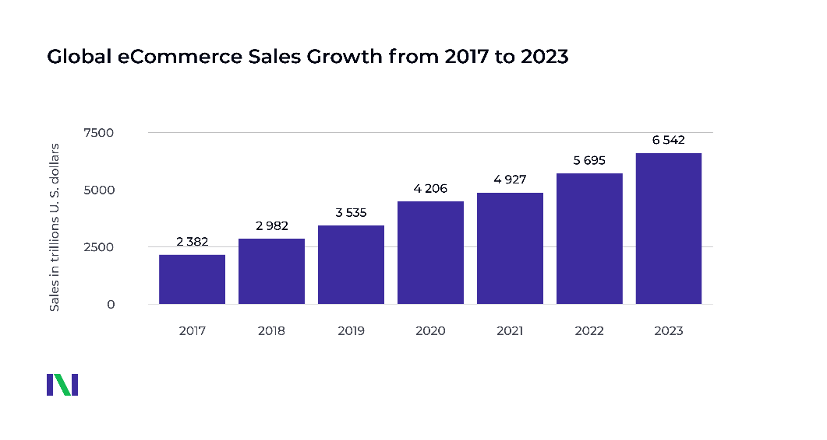
Figure 4. (NEKLO, n. d.).

9

RSDPS online website for E-commerce:

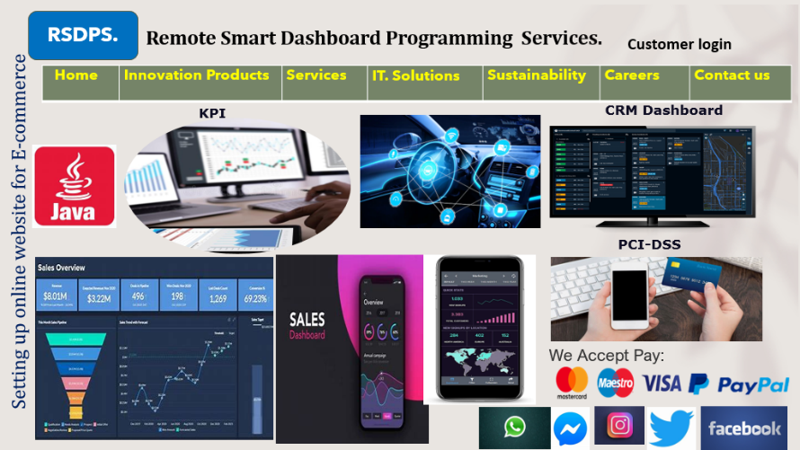
Figure 5. free images for smart dash programming (Bing n. d.).
RSDPS online website for E-commerce is a digital revolution with digital transformation it reflect and take in consideration all learned lessons concepts from Module of developing innovation and creativity for business advantage DIB, which present efficiently the academic concepts of digital e-commerce also as an evident that this new innovation can obtain many factors of success in online marketplace business, the five spheres of digital transformation module is included in this innovation developments and creativity, by explaining with clarity how do RSDPS online website interact with sales process that can face many competitors challenges with a successful return on investment ROI and business growth, according to Harvard business review digital transformation (hbr.org ,2021). digital transformation main concept is not only about substitute an old technologies with a new one or acquire any data from Google and Amazon but the core concept of digital transformation is to become a data driven organization, this is the business purpose of setup online marketplace occupation, this online store has a new contemporary concept it will mention on wibesite all organisation commercial logos individually if they will have a private contract with RSDPS organisation as a win-win business method normally after their consents, this means it will add a new value of traditional user research to have an idea about any products or actual market services before they make any decision or purchase process by their personal computers or their personal phones within any device precisely connect with an internet browsers (Business insider, 2016). Therefore, at the start using SaaS software as a service platform is a suitable start up solution because it is connected.

10

directly with Microsoft Office 365 office tools with security of cloud services and different internet web secure browsers, SaaS platform include SaaS apps which is free to download and install for any software users it need only a plain browser to run, it has the ability to meet software infrastructure requirements because SaaS user can modify and customize some parts of their business implementation, SaaS apps extended to reach functionally all organisations departments such as enterprise resource planning system ERP and organization new business environment of large data analysis related to customer relationship management CRM. (SaaS Applications, 2021).
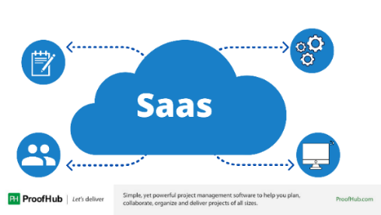
Figure 6. free images SaaS Applications (proof hub, 2021).
RSDPS online website E-commerce innovation services possess the perception of improving organisations and customers experience with a unique upgrade e-commerce journey with mapping as a fundamental tool for their business interactions it is a project plan strategy supported by a comprehensive selling steps starting with uses of SaaS software platform for marketplace and the next step is Shopify platform for a global e-commerce extension insights stream into internal and external markets (Shopify, 2023). Then it can uses amazon or eBay stores marketplace, RSDPS e-commerce website designed to be well known and linked with another WWW. world wide web (TECHOPEDIA, 2020). for example 3M United Kingdom is a global company based on technology science it apply website E-commerce that will never stop inventing and adopting developing innovation with creativity for business advantages (3M United Kingdom n. d.). then gradually but unlimited RSDPS organisation will be linked with most worldwide internet search engines list to reach out customers also organisations devices that are interconnected with networks (Study Smarter, n. d.). these organisations and customers devices will receive by social media Apps an advertisements campaign from marketplace of RSDPS online website and the cost will be paid online as a monthly debit account, both RSDPS organisation with new Java programs services and online website for E-commerce are a disruptive innovations because they meet disruptive business models with concept that will bring a new business ideas and technology value to the existing markets linked with unlimited web browsers such as Google, Bing, Baidu, Yahoo, Yandex ,Ask.com , DuckDuckGo , AOL.com,

11

According to a KPMG report (The week, 2019). Amazon, Apple , Alibaba are in the top list of disruptive organisations, RSDPS is a disruptive organisation because it possesses the creativity of a new digital transformation that will enable RSDPS to become a market leader in data driven, its e-commerce platforms contain a new part of technological progress which is relevant to the key elements of disruption and reflect on the path of disruptive innovation model which sustaining innovation that will be utilized in world wide range by customers with a high disruptive unique services performance, it will present a powerful new market business entrance with conditions of success concentrated on two disruption types and solve business dilemma according to Harvard Business School (Christensen, 1997). via avoiding competitors challenges in a new market with low end, RSDPS venture norm in practice critically reflect on DIB module concepts and its entrepreneurship categorization including commercialization corresponding with business benefits and advantages of two models tools the closed innovations and the open innovation (Go tech innovation , 2021). By controlling IP intellectual property in internal organisational environment and encourage business to sharing knowledge as an approach in external organisation environment, these two models explain the positive impact and the importance of unique RSDPS venture strength in macro and micro organisation's business environment, it develop an innovative technological solutions in internal organisation environment and swift increase technological progress in external organisation environment this means effectively organisations have this possibility as proposal to retaining and combine internal sources of innovation with dynamic external practices as a layout of acquisition with a contemporary management business model and advanced key performance indicators KPIs, regarding customer’s payment services acceptance issues and compliance PCI-DSS all global payments of Pay Pal, Master Card, Visa , Maestro Card, national and international banks transactions are accepted, RSPS organisation follow PCI DSS standards to protected all customers and organisations credit card data, if there will be any customer’s compliance RSDPS organisation will apply an investigate research for customer’s card holder details and ask for card information and bank swift numbers in data storage which it must conform and identical with bank transaction otherwise it will be rejected because it has not respected security policy of PCI. payment card industry data security standard DSS. Schumpeter’s innovation theory (research gate, 2014). introduced exactly this issue as a huge contemporary banks problem of customer’s with details. According to Schumpeter’s innovation theory banks must motivate innovations implemented by entrepreneurs in the economy.

12

4. Marketing:
Every organisation in the market possesses a product or a special service that needs the action of successful marketing strategy to promote and to enhance sales process by attracting customers towards its marketing targets in entrepreneurship , According to Dr Philip Kotler (Libre Texts Business, 2022). identified the definition of marketing as the science of searching, creating, and adding a value that satisfy the needs of target market with a potential profit after measurement and quantify the size of the identified market. following the previous definition RSDPS organisation will apply an academic steps and analysis to evaluate the new product with unique services also how it will be promoted with a successful strategy and marketing R&D. starting to evaluate RSDPS it is an organisation that applying the key features of innovative marketing advantages with a new technology innovation, but it is still unknown in the market this will create a gap between innovation technology platform and marketing, so it is seeking for an opportunity in market with a real options solutions, F. Peter Boer by real options theory approaching marketing with the following concept, marketing investment is progressively in a dominated risks and in a volatile marketplace (black wells, 2002). RSDPS technology of innovation examination and promotion will be by applying the eight stages of a new product development process NPD including the interaction between two departments creativity product life cycle development department and product management department to be as a guide for organisation managers and teams that introduce this advanced technology innovation towards customers to buy it and to promote it by a new designed clear roadmap that will brings this technology innovation into the market (Shopify, 2023). the aim of this examination is to avoid any marketing risk or failures for this new technology innovation and to be far of competitors challenges with factors of success that will obtain a real options with modern opportunity as a product available for sales and marketing with high standards, NPD process will help to launching this technology innovation with an advanced marketing standards supported by setting up online website e-commerce and contemporary e-business strategy with an efficient global marketing as a new leader in the global business of digital data revolution.
Eight stages of a new product development process NPD are as the following:
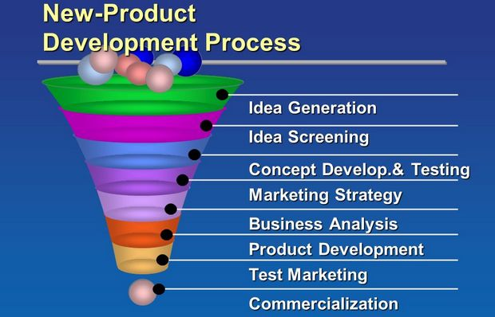
Figure 7. free Image NPD ( Bing images n. d.).

13

Stage 1 – Idea generation:
At the start there were many ideas available in this stage for a new remote programming services but after a long term of R & D and critically reflecting on the main concept of DIB module with creativity for a new conditions of innovation NPD the idea discovered through platform for innovation with strategic thinking and innovation pipeline funnel Stage-Gate model as it was mentioned in the start of this report.
-Internal idea sources:
long term of R & D and reflecting on the main concept of DIB module and CT creative tools for thinking.
-External idea sources:
Customers in marketing needs of innovation venture that could overcome and to beat modern marketing competitors challenges as a business proposition of an innovation.

Stage 2 – Idea screening:
Eliminating and throwing out unfitted ideas Remote Smart Dashboard Programming Services RSDPS is a new innovation targeting all customer marketing segments in internal market in the UK and the international global market target levels, the idea screening demonstrate and provide the evidence that this new innovation is a unique services the R & D website Google search engine provide the result of Programming ‎Services ‎RSDPS is missing and it is a new unknown existing innovation with a middle delete line sign of a new services which need to be introduced in internet access to all data engines research browsers as much as possible as an existing product in the market (the home remote, n. d.).
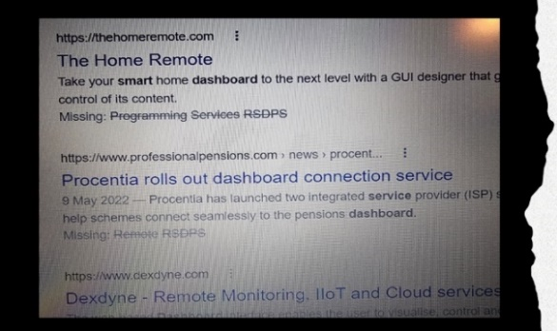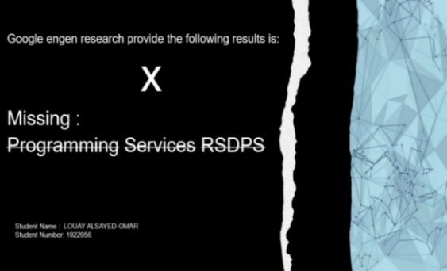
Figure 8. Google engine research for Remote Smart Dashboard Programming Services RSDPS’ is not find. as an evidence.
(the home remote, n. d.).

14

it will be a valuable insight into contemporary marketing for customer technology problems, analysis provide that it is the missing part in software customers current digital IT platform in the market, competitor analysis demonstrate that they have the ability and the knowledge of IT programming formerly in the market but they don't have this remote programming technology advantage which it make a big differences, indeed this innovation have prioritization that all customers can have their organisation data with remote tracking system something which considered as a new business daily digital revolution necessity and needs, it will reach customers anywhere in anytime.

Stage 3 – Concept of development and testing:
Consumers interactions will have at the start a free ten days trial after remote Java software programming languages downloaded it is a testing period so they can understood and evaluate the importance of this digital services concept before they will start using it in their daily routine business application, it is like a short customer product presentation that will encourage and maximize their experience to buy it before they will start their own customer journeys and integrating with RSDPS organisation platform in the internal and external business development environment with legal annual services contracting, that will take in consideration the three ways entrepreneurship innovation limitations in marketing trend towards remote local public and global market target, as the above mentioned researches results this new open services innovation can be applied with any organisation size in the market which win and attract customers audience , it power and control demographically major socioeconomics status class of individuals or groups for both genders that will play a dynamic factor in bringing economic growth after launching this unique services, it deploying a successful global sales development concept and emerging market through STM as a powerful tool of simulation test markets results in depth with a specific qualitative research method (Drive research, 2019).

Stage 4– Marketing strategy development:
When the information about the concept of testing are gathered and analysis testing prove that remote smart dashboard programming organisation platform is missing from Google and from the other browsers this logically characterize that this services product positioning achieved already the target of marketing strategy also it will bring a revenue at that start which is a positive financial indicator, RSDPS flat organisational structure strongly allow IT engineers, employees to have also their part in setting and achieving strategic objectives of bottom-up in global management they will sharing knowledge with a low cost in a long term for mix marketing strategy with four pillars of economy science.

15

Stage 5 – Business analysis:
Will be based on the CVP break even sales volume calculation method that effectively can provide and determine the factor of marketing profit success between cost, sales, and profit projections of break-even point it is an active beneficial business planning analysis tool (Will Kenton ,2022).
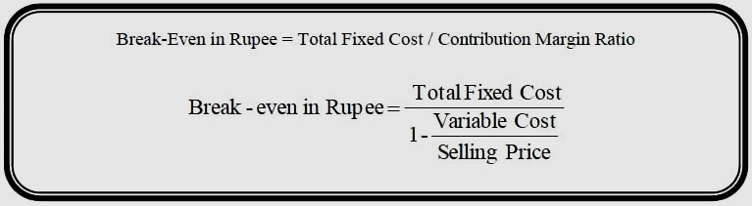
Figure 9. (Accountancy knowledge n. d.).

The CVP break even sales volume formula is:
Break Even sales volume of FC / CM FC= fixed costs.
CM= contribution margin (sales – variable cost).
-Estimated monthly fixed costs FC £ 500,000. this include marketing, taxes, payable , rent, insurance, salaries and additional expenses, monthly one customer services providing contract cost £200. each contract sells for £ 2200. earning a profit of each contract is £ 2000.
-Break-even sales volume = FC £ 500,000. / CM (£2200 - £200) = £ 2500.
-The minimum estimated monthly contracts are ten so 10 x £ 2500.= £ 25.000.

The revenue of any business investment generally is around 40 % but here we have 45% reviewing business analysis that achieved profit of 45%, ROI percentage of costs, sales, profit projections they are quite appropriate to market target so this unique services as a succeeded product it can now move across the next product development stage.

16

Stage 6 – Product development:
Determining that this product is in the development stage at the first B2B customers touch point virtually when they will receive the first paid e-business marketing advertisements by social media campaign from their own researching engines such as Facebook on Google some of them would not understand the dimensions and the advantages of this new data remote programming in the market, so to give them directly a clear idea about the size of this new innovation and to avoid any marketing error from the start in the website e-business profile the original designed model version based on prototype module of development with computing that allow customers chatting to ask about any information they need, it is an opportunity with low cost to gather and to provide valuable answers that will meet customers requirements with positive feedback, prototype module is a friendly business ecosystems it include two prototyping types for user interactions techniques and testing, one with low fidelity prototyping method which is included in the basic website structure with Wireframes and storyboards on ABC App, and the other type with high fidelity prototypes that include UI Mock up as a navigable tool, RSDPS organisation consider it an effective business ecosystems module to become a leadership of data management in marketing.

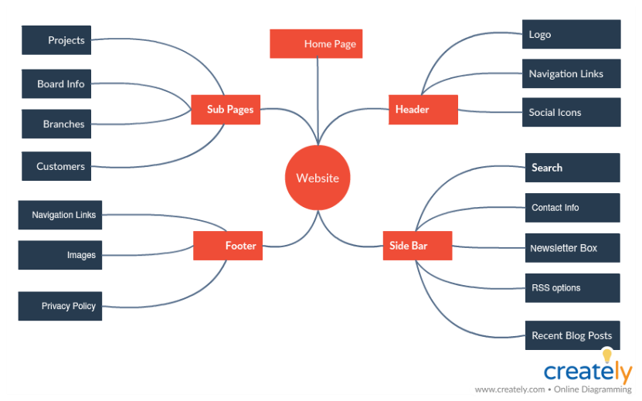
Figure 10. (Prototyping , 2022).

17

Stage 7 – Test marketing:
In this stage the new RSDPS data of remote programming is so near from launching and e-business commercialization stage , the simulated test markets STM methodology is included during customers interactions with social media campaign because RSDPS organisation website have the robot icon chatting that will ask browser user individually some information about name and E-mail address with their consents, also any organisations will be asked for their commercial brands name and Email address consents which usually start with info@....., then RSDPS organisation website employees will send a qualitative research survey questionnaire under form of PDF (Drive research, 2019). It is an important process of test marketing for a new product development strategy, within simulated test markets STM customers feedback of the questionnaire survey as a mechanism allow and enable RSDPS organisation to understand the new customers requirements with high level of international test marketing standards, any website user that do not provide the above mentioned information, RSDPS organisation doesn't have the legal rights to contact user under any categories or sending any further e-commerce marketing emails without customers consents.
Stage 8 – Commercialization:
Commercialisation definition according to university of York (york.ac.uk, n. d.) is the process of developing an idea into a commercial product or services created by R&D with commercial licensing of intellectual property, IP protection for an existent organisation that provide this product or services in the market, the above simulated test markets STM methodology is an evidence that this product as a services are ready for commercialisation process with factors of success also it adding an economic value.
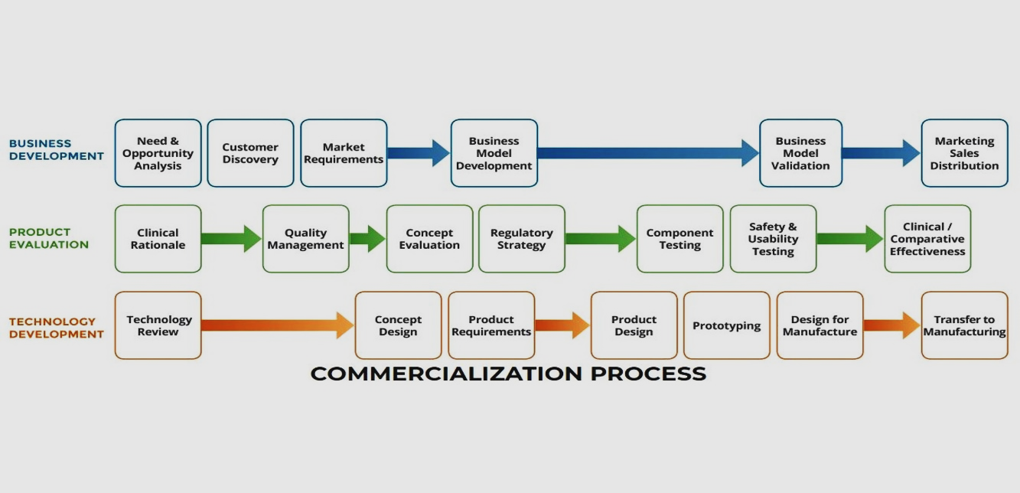
Figure 11. (Treat Center, 2018).

18

According to the Center for the translation of rehabilitation engineering advances and technology TREAT (Treat Center, 2018). this process of innovation management is identical with marketing commercialisation modules dimensions with a criteria that specify the functional effectiveness role of creativity and commercialisation within the basic concept of marketing stability, the decision making and marketing launching implementation will take in consideration the basic two challenges of IP system and the concept of oriented economy technology of push linear model which can be interact and provide positively business marketing benefits in all changing in economic eras with a real criteria and facts of global e-business marketing concept to start very simple and to grow so fast , Remote its commercialisation encompass the brainstorming assessment of Dr. Edward de Bono (concept board, 2021). And critical thinking of PMI framework tool that will create a new advanced opportunity in marketing prosperity and increase economic growth in marketing for RSDPS organisation in e-business, it will attract customers as a marketing target with an advertising campaign on SaaS and Shopify platforms also it will be supported with a powerful payed start up campaign on Facebook, Amazon, eBay, Tik Tok App, because it is an effective method of a unique selling proposition to decentralized competitors that forces in governmental planning and also it will enhance the performance appraisal by optimization business with three components of environment ,social, economic, these are the meaning of scientific application of sustainability resources and early community development model also the popular sustainability theory of Ideal’ scientific model, all together they will sustain this innovation in a green friendly environment with a high ROI revenue in e- business models of buyer controlled in markets with IM 3 pillars of technological standards for contemporary developing of a successful marketing.

19

5.Privacy and Data Protection:
Every person or organisation have their owns personal private sensitive data this privacy needs data protections law to regulate and protect them and their commercial registered brands and products
, the general data protection regulation (GDPR) is a set of regulation implemented in 2018 by EU. European Union with legislations about how can personal data of EU citizens in a legal way should be collected, processed, and protected , data protection Act 2018 is the UK implementation of GDPR provides a guidelines for data processing in the UK including the government rights of individuals and organizations to access and control their personal data and what exactly are their responsibilities and their penalties fees during enforcement of data protection regulations (GOV.UK, 2018). RSDPS organisation guaranty national and global privacy data protection laws of the digital age after system users consent by providing a privet digital numeric verification code and API software testing (Geeks for Geeks , 2023). This applications of software is a testing act as an encrypt safety communication bridge between different software systems during exchanging data with each other, RSDPS organisation is so aware about its legal marketing limitation and the importance of encrypting security data traffic in transit accurately which are highly recognised in electronic commercial communications also it support the right of erasure that included in Art. 17 GDPR in data protection regulation, particularly when user withdraws consent at point A of Article 6 (GDPR. EU. 2020). RSDPS organisation in e-commerce website and e-business agree and apply this consent under PERC legislation of 2003 (Law Bite, 2021). It is the PECR regulations that specified in the UK GDPR data protection with a controlled business law which have the purpose of protecting customers under PECR regulations in direct marketing of emails, texting messages , calls, B2B, the key privacy and data protection will include the following GDPR and PECR regulations :

1-Consent:
Obtaining an explicit consent from the organizations and individuals before starting to send any electronic marketing communications.
2-Opt out:
Organizations and individuals will have the option to opt out of receiving any electronic marketing communications.

20

3-Privacy:
Regulations require to protect the privacy of electronic communications, and only use personal data for a specific purposes that have been disclosed within a specific policy.

4-Cookies:
Regulations require to obtain consent before using cookies technology for tracking and advertisements purposes.
5-Enforcement:
When information utilised illegally it authorize commissioner's office ICO to issue fines and take any legal actions against any organization that breach this governmental regulations.

These regulations of GDPR and PECR are an important tool for protecting privacy in the digital age and RSDPS organisation ensure that employees whose using personal and sensitive data adhere and follow this law.

21

6. Conclusion.
Remote Smart Dashboard Programming Services RSDPS’ organisation aims to include comprehensively the effectiveness of DIB module knowledge and concepts, but it has also a recognition of its global market share limitation and some weakness as an unknown development of a new innovation and creativity for a global business advantages, the success will be based on the above academic models and theories analysis which are mentioned in this report in the future, this unique services it will provide the evidence of it's brainstorming by adding a new value that will help organisations also peoples and communities to achieve at least a contemporary digital data resources needs, to keep them directly connected with their business thorough globally distribution services and best commercial practices, It demonstrate the importance of innovation in business and development within a vital role of creativity, it critically apply the knowledge and concepts of DIB module with different characteristics of innovation process to enhance further developing, it will brings and present efficiently an advanced business advantage with a significant entrepreneurship attraction and improvement with enormous sustainability at the market share occupation in the future especially in the contemporary technological trajectories science.

22

References list:
Commons library parliament.uk (2023). Rising cost of living in the UK - House of Commons Library [online] available at: https://commonslibrary.parliament.uk/research-briefings/cbp-9428/#:~:text=The%20cost%20of%20living%20increased%20sharply%20across%20the,the%20affordability%20of%20goods%20and%20services%20for%20households.(Accessed: 20 MAR. 2023).

Harvard business school online (2022). Innovation in Business: What It Is & Why It’s So Important [online] available at: https://online.hbs.edu/blog/post/importance-of-innovation-in-business (Accessed: 03 MAY. 2023).Innovation | University of Cambridge (2022). [online] available at: https://www.cam.ac.uk/topics/innovation (Accessed: 21 MAR. 2023).

Innovation Pipeline in 2022 - br.pinterest.com [online] available at: https://br.pinterest.com/pin/534028468323608990 (Accessed: 04 MAY. 2023).IndiesEducationOnline (2022). Java Programming FREE | Basics IndiesEducationOnline…[online] available at: https://indieseducation.com/learn-java (Accessed: 21 MAR. 2023).

Finereport (2022).Four popular Java Dashboards for 2021——Examples – Fine Report[online] available at: https://www.finereport.com/en/dashboard-tools/java-dashboard-examples.html (Accessed: 22 MAR. 2023).

Primitive data type (2022). Primitive data type vs. Object data type in Java with Examples [online] available at: www.geeksforgeeks.org/primitive-data-type-vs-object-data-type-in-java-with-exa (Accessed: 22 MAR. 2023).

Targetdashboard (2009). KPI and Management Dashboard Software by …[online] available at: https://www.targetdashboard.com (Accessed: 07 MAY. 2023).SCAMPER marketing 91 (2021). SCAMPER – Technique For Creative Problem Solving [online]availableat:https://www.marketing91.com/scamper/#:~:text=As%20a%20creativity%20and%20ideageneration%20technique%2C%20SCAMPER%20is,ideas%20for%20improving%20any%20specific%20product%20or%20service. (Accessed: 23 MAR. 2023).

SalesSpark (2017). How It Works Target Dashboard [online] available at : https://www.targetdashboard.com/site/sales-dashboard/how-it-w…(Accessed: 23 MAR. 2023).

SCAMPER Model technique Instagantt (2023). What is scamper? Definition, uses and examples. [online] available at: https://instagantt.com/project-management/what-is-scamper-definition... (Accessed: 24 MAR. 2023).

Consuunt (2023). SCAMPER Model explained with lots of Helpful Real Examples. - …[online] available at: https://www.consuunt.com/scamper-model /#:~:text=The%20SCAMPER%20Model%20is%20a%20Tool%20that%20helps,Actions%20it%20proposes%20to%20Redefine%20Products%3A%20Substitute.%20Combine. (Accessed: 25 MAR. 2023).

Funding-innovation GOV.UK (n.d.). funding-innovation GOV.UK [online] available at: https://www.gov.uk/apply-funding-innovation (Accessed: 25 MAR. 2023).

UKRI (2022). Innovate UK – UKRI - We support business-led …[online] available at: https://www.ukri.org/councils/innovate-uk (Accessed: 25 MAR. 2023).

JAVA development companies good firms ( 2023).Top Java Development Companies - Reviews 2023 [online] available at: https://www.goodfirms.co/.../top-software-development-companies/java (Accessed: 26 MAR. 2023).

BE offices (beoffices, 2022). Business Centres in London | BE Offices - Business … [online] available at: https://www.beoffices.com/servicedoffice-locations (Accessed: 26 MAR. 2023).

Investopedia (2022). Ecommerce Defined: Types, History, and Examples [online] available at:https://www.investopedia.com/terms/e/ecommerce.asp#:~:text=The%20term%20electronic%20commerce%20%28ecommerce%29%20refers%20to%20a,over%20computers%2C%20tablets%2C%20smartphones%2C%20and%20other%20smart%20devices. (Accessed: 27 MAR. 2023).

Ecommerce Definition e commerce CEO (2023). What Is Ecommerce? [Definition, How to, & More] [online] available at: https://www.ecommerceceo.com/learn/what-is-ecommerce (Accessed: 27 MAR. 2023).

NEKLO (n.d.). NEKLO DIGEST #2: 8 Reddit eCommerce Questions …[online] available at: https://neklo.com/reddit-questions-about-ecommerce-answered (Accessed: 28 MAR. 2023).

Statista 2022 E-commerce worldwide - statistics & facts | Statista 2022 [online] available at: https://www.statista.com/topics/871/online-shopping (Accessed: 29 MAR. 2023).

Free images for smart dash programming (bing n.d.). [online] available at: https://www.bing.com/search?pc=CBHS&ptag=N9155D113022AAA0D337D47&form=CONBDF&conlogo=CT2174808&q=free+images+for+smart+dash+programming (Accessed: 30 MAR. 2023).

Digital Transformation hbr.org (2021).The Essential Components of Digital Transformation [online] available at: https://hbr.org/2021/11/the-essential-components-of-digital-transformation (Accessed: 31 MAR. 2023).

Business insider (2016). Most Online Shoppers Are Using Search Engines Before …[online] available at: https://www.businessinsider.com/most-online-shoppers-are-using-search... (Accessed: 31 MAR. 2023).

SaaS Applications (2021). Top 19 SaaS Applications To Help Businesses Grow [online] available at: https://www.proofhub.com/articles/saas-applications (Accessed: 1 APR. 2023).

Proof hub (2021). Top 19 SaaS Applications To Help Businesses Grow [online] available at: https://www.proofhub.com/articles/saas-applications (Accessed: 1 APR. 2023).

Shopify (2023). What Is Shopify and How Does It Work? (2023) - We …[online] available at: https://www.shopify.com/blog/what-is-shopify (Accessed: 1 APR. 2023).

TECHOPEDIA (2020). What is the World Wide Web (WWW)? - Definition from …[online] available at:https://www.techopedia.com/definition/5217 (Accessed: 2 APR. 2023).

3M United Kingdom (n.d.). About 3M | 3M [online] available at: www.3m.co.uk/3M/en_GB/company-uk/about-3m/ (Accessed: 2 APR. 2023).

Study Smarter (n.d.) .Internet Search Engines: Examples and List | StudySmarter [online] available at: https://www.studysmarter.co.uk/.../internet-search-engines (Accessed: 2 APR. 2023).

The week (2019). Amazon, Apple and Alibaba are most disruptive companies: Report [online] available at: www.theweek.in/news/biz-tech/2019/10/30/amazon-apple-alibaba-most-disruptiv…(Accessed: 3 APR. 2023).

Harvard Business School (Clayton M. Christensen,1997).The Innovator's Dilemma [online] available at:https://www.hbs.edu/faculty/Pages/item.aspx?num=46(Accessed: 3 APR. 2023).

Go tech innovation (2021). Closed Innovations VS Open Innovations – Go Tech … [online] available at:https://gotechinnovation.com/closed-innovations-vs-open-innovations/ (Accessed: 4 APR. 2023).

research gate (2014). SCHUMPETER’S VIEW ON ENTREPRENEUR AND …[online] availableat:https://www.researchgate.net/publication/272221598_Schumpeters_View_on_Entrepreneur_and_Credit_Versus_Contemporary_Mega-Banks_Problem (Accessed: 5 APR. 2023).

Dr Philip Kotler Libre Texts Business (2022). 1.3: What is marketing? - Libre Texts Business, 2022[online]availableat:https://biz.libretexts.org/Bookshelves/Marketing/Book:_eMarketing__The... (Accessed: 6 APR. 2023).

Black wells (2002). The Real Options Solution : F. Peter Boer : …[online] available at: https://blackwells.co.uk/bookshop/product/The-Real-Options-Solution-by-F-Peter-Boer/9780471209980 (Accessed: 6 APR. 2023).

Shopify (2023). 7 Step Product Development Process Explained (2023) [online] available at:
https://www.shopify.com/blog/product-development-process (Accessed: 6 APR. 2023).

Free Image NPD (bing images n.d.) [online] available at: https://www.bing.com/images/searchview=detailV2&ccid=uxOtWLNN&id=3BDFE6B7C6A03B18AA9220512C26D410A83D5D52&thid=OIP.uxOtWLNN3K6iK- (Accessed: 7 APR. 2023).

The Home Remote (n. d.) [online] available at: https://thehomeremote.com (Accessed: 8 APR. 2023).

Drive research (2019). What is a Simulated Test Market (STM)? | Qualitative …[online] available at: https://www.driveresearch.com/market-research-company-blog/… (Accessed: 8 APR. 2023).

Will Kenton (2022 ).Regression Basics for Business Analysis - Investopedia [online] available at: https://www.investopedia.com/.../09/regression-analysis-basics-business.asp(Accessed: 9 APR. 2023).

Accountancy knowledge (n. d.). Cost Volume Profit Analysis - [online] available at: https://www.accountancyknowledge.com/cost-volume-profit-anal (Accessed: 10 APR. 2023).

Prototyping (2022). The Easy Guide to Prototyping | Prototyping Types and … [online] available at: https://creately.com/blog/diagrams/what-is-prototyping-techniques-process/ (Accessed: 11 APR. 2023).

Drive research (2019). What is a Simulated Test Market (STM)? | Qualitative …[online] available at: https://www.driveresearch.com/market-research-company-blog/what-is-a-simulated-test-market-stm-qualitative-research-company/(Accessed: 12 APR. 2023).

University of York (n.d.) .Commercialisation process – Commercialising [online] available at: https://www.york.ac.uk/staff/research/commercialising-research/commercialisation-process/ (Accessed: 12 APR. 2023).

Treat Center (2018). NEW! TREAT Commercialization Learning Modules …[online] available at:https://www.treatcenter.org/new-treat-commercialization-learning (Accessed: 13 APR. 2023).

Concept board (2021). Plus Minus Interesting (PMI) framework for lateral thinking [online] available at: https://conceptboard.com/blog/plus-minus-interesting (Accessed: 14 APR. 2023).

GOV.UK (2018). Data Protection Act 2018 - GOV.UK [online] available at: https://www.gov.uk/government/collections/data-protection-act-2018 (Accessed: 15 APR. 2023).

Geeks for Geeks (2023). API Testing in Software Testing – Geeks for Geeks [online] available at: https://www.geeksforgeeks.org/api-testing-in-software-testing/ (Accessed: 16 APR. 2023).

GDPR. EU. (2020). Art. 17 GDPR Right to eras…gdpr.eu [online] available at:
https://gdpr.eu/article-17-right-to-be-forgotten/ (Accessed: 18 APR. 2023).

Law Bite (2021). The Privacy and Electronic Communications Regulations …[online] available at: https://www.lawbite.co.uk/resources/blog/what-are-the-privacy-and-electronic-communications-regulations-2003(Accessed: 19 APR. 2023).

