Presentation Notes

Presentation on
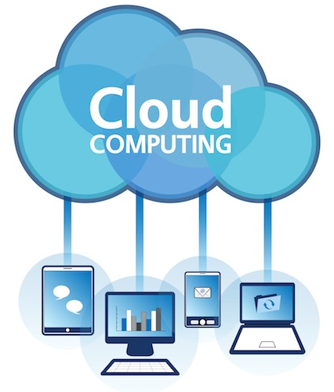

Notes prepared by
Oliver Smith (219240)
2017/18
BSc (Hons) in Computing & Information Systems
M2X8630 – Research and Development Methods



Presentation delivered by
Oliver Smith | Scott Davies | Josh Lapham
Contents
1. Notes for slide “What is cloud computing?” 3
1.1. What is a cloud? 3
1.2. Types of cloud computing 3
Infrastructure as a service (IaaS) 3
Platform as a service (PaaS) 3
Software as a service (SaaS) 4
1.3. Types of cloud deployments 4
Public Cloud 4
Private Cloud 4
Hybrid Cloud 4
2. Notes for slide “Origins” 5
2000s 5
3. Notes for slide “Who uses it?” 6
Bibliography 7

Notes for slide “What is cloud computing?”

What is a cloud?
The word “Cloud” typically refers to the Internet (1). It is defined by Cambridge dictionary as “the use of services and computer programs, which are on the Internet rather than ones that you buy and put on your computer” (2).

Microsoft describes it as “the delivery of computing services e.g. servers, storage, databases, networking, software, analytics and more over the Internet (3).
SERVERS | A lot of e-Commerce websites use this.
STORAGE | OneDrive, Google Drive, iCloud
DATABASES | Oracle – you can use the “Application Express” version and access your database via the cloud
SOFTWARE / applications | Microsoft Office “Cloud” Packages

Companies that offers these computing services are called cloud providers and typically charge for cloud computing services based on usage (3).

Notes for slide “Types of cloud computing”
Most cloud computing services fall into three broad categories which are:

Infrastructure as a service (IaaS)
This is the most basic category of cloud computing. With this, you will need to rent IT infrastructure – servers and virtual machines, storage, networks, operating systems – from a cloud provider on a pay-as-you-go basis (3).

Platform as a service (PaaS)
This refers to cloud computing services that supply an on-demand environment for developing, testing, delivering and managing software applications. It is designed to make it easier for developers to quickly create web or mobile apps, without having to worry about setting up or managing the underlying infrastructure of servers, storage, network and databases needed for development (3).

Software as a service (SaaS)
This is a method for delivering software applications over the Internet, on demand and typically on a subscription basis. With this, cloud providers host and manage the software application and underlying infrastructure, and handle any maintenance, such as software upgrades and security patching. Users connect to the application over the Internet (3).

Notes for slide “Types of cloud deployments”
There are three different ways to deploy cloud computing resources which are: public cloud, private cloud and hybrid cloud.

Public Cloud
These type clouds are owned and operated by a third-party cloud service provider, which delivers computing resources such as servers and storage over the Internet. Microsoft Azure is an example of a public cloud. You can access these services and manage your account using a web browser (3).

Private Cloud
Private clouds refers to cloud computing resources used exclusively by a single business or organisation. A private cloud can be physically located on the companies on-site data centre. Some companies also pay third –party service providers to host their private cloud. A private cloud is one in which the services and infrastructure are maintained on a private network (3).

Hybrid Cloud
These combine public and private clouds, bound together by technology that allows data and applications to be shared between them. By allowing data and applications to move between private and public clouds, hybrid clouds gives businesses greater flexibility and more deployment options (3).

Notes for slide “History”

2000s
2000 | This is when cloud computing properly came into existence.
August 2006 | Amazon introduced Elastic Compute Cloud (4)
April 2008 | Google released Google App Engine in beta (5)
Early 2008 | NASA's OpenNebula, enhanced in the RESERVOIR European Commission-funded project, became the first open-source software for deploying private and hybrid clouds, and for the federation of clouds (6)

2010s
February 2010 | Microsoft released Microsoft Azure (they had announced this in 2008) (7)
July 2010 | Rackspace Hosting and NASTA both launched an open-source software (known as OpenStack). This was designed to help organisations offering cloud-computing services running on standard hardware. (8)
March 2011 | IBM announced IBM SmartCloud (9)
May 2012 | Google Compute Engine was released in preview (10)

Bibliography
1. Carnegie Mellon University. Cloud Computing. [Online] [Cited: 9th January 2018.] http://www.contrib.andrew.cmu.edu/~dyafei/CC.html.
2. Cambridge Dictionary. Cloud Computing. [Online] [Cited: 9 January 2018.] https://dictionary.cambridge.org/dictionary/english/cloud-computing.
3. Microsoft Azure. What is cloud computing? [Online] [Cited: 16 January 2018.] https://azure.microsoft.com/en-gb/overview/what-is-cloud-computing/.
4. Amazon. Announcing Amazon Elastic Compute Cloud (Amazon EC2) - beta. [Online] 24 August 2006. [Cited: 16 January 2018.] https://aws.amazon.com/about-aws/whats-new/2006/08/24/announcing-amazon-elastic-compute-cloud-amazon-ec2---beta/.
5. Google. Introducing Google App Engine + our new blog. [Online] 7 April 2008. [Cited: 16 January 2018.] http://googleappengine.blogspot.co.uk/2008/04/introducing-google-app-engine-our-new.html.
6. Rochwerger, B, et al. The Reservoir model and architecture for open federated cloud computing. IEEE Xplore Digital Library. [Online] July 2009. [Cited: 16 January 2018.] http://ieeexplore.ieee.org/document/5429058/.
7. Microsoft. Windows Azure General Availability. [Online] 1 February 2010. [Cited: 16 January 2018.] https://blogs.technet.microsoft.com/microsoft_blog/2010/02/01/windows-azure-general-availability/.
8. Datta, Milta. Apache CloudStack vs. OpenStack: Which Is the Best? DZone / Cloud Zone. [Online] 9 August 2016. [Cited: 2018 January 2018.] https://dzone.com/articles/apache-cloudstack-vs-openstack-which-is-the-best.
9. Oracle Cloud. Why Move to the Oracle Cloud. [Online] [Cited: 16 January 2018.] https://cloud.oracle.com/home.
10. Balogh, Ari. Google Compute Engine is now Generally Available with expanded OS support, transparent maintenance, and lower prices. Google Developers. [Online] 2 December 2013. [Cited: 16 January 2018.] https://developers.googleblog.com/2013/12/google-compute-engine-is-now-generally.html.

