
Master of Business Administration (MBA)
Module: International Business Concepts
Module code: LCMB7034

Competitive Analysis of Marriott International in the UAE's Tourism and Hospitality Sector

Student Name: Shifat Hossain
Student ID: 2436037

Word count: 5065
Date of Submission: 27 April 2026

AI use acknowledgement
Note: One acknowledgement is needed for each used AI tool.

I acknowledge the use of Grammarly (https://www.grammarly.com/) on 16 April to check my grammar mistakes. I used the prompt:
1. Please check the following text for readability, grammar and syntax

I confirm that I have not presented any AI-generated text as my own work. I confirm I have copies of my drafts, notes, and other resources I used before and after the use of AI tools, which I may be asked to provide in evidence.

Table of Contents
AI use acknowledgement 2
1. Introduction to the Report 5
2. Industry and Country Overview 5
2.1 Overview of the UAE 5
2.2 UAE’s Tourism & Hospitality Industry 6
2.3 Major Domestic and International Players 6
3. Application of Michael Porter’s Diamond Model 8
3.1 Factor Conditions 8
3.2 Demand Conditions 9
3.3 Related and Supporting Industries 9
3.4 Firm Strategy, Structure and Rivalry 10
3.5 Government 10
3.6 Chance 10
4. Evaluation of Marriott International in the UAE 11
4.1 Overview of Marriott International 11
4.2 Political, Economic, Legal, and Cultural Factors Impacting Marriott’s Operations 12
Political Environment 12
Economic Environment 12
Legal and Regulatory Environment 13
Cultural Environment 13
4.3 Market Attractiveness and Challenges for Marriott: Hofstede Cultural Model 14
4.4 Marriott’s Adaptation to Local Needs and Consumer Preferences 16
Cultural Sensitivity 16
Localisation of Offerings 16
5. Conclusion to the Report 17
6. Reflective Account 17
Research Process 17
Learning Outcomes 18
Gibbs Reflective Cycle 18
Reference 22

1. Introduction to the Report
This report is intended to be a critical view of the competitiveness of the Tourism & Hospitality industry in the UAE, with the presence of Marriott International in the country. The industry of tourism in the UAE is vibrant, thanks to government initiatives and strategic global presence (Fang et al., 2018). This can be both an opportunity and a challenge for international hospitality businesses. Marriott's growth in this competitive environment can shed some useful insights. That is how multinational corporations (or MNCs) deal with the intricacies of markets (Fang et al., 2018). The report aims to provide a broad overview of the industry and apply Porter's Diamond Model to examine the industry's global competitiveness and assess Marriott’s decision-making regarding strategy in the UAE. While Porter's model gives a good idea of understanding MNC's in the UAE, it can ignore some factors and local issues which may affect the success of MNCs, such as regulatory constraints or cultural barriers.

2. Industry and Country Overview

2.1 Overview of the UAE
The United Arab Emirates (UAE) is a federation of seven emirates located in the Arabian Gulf region, which has been described as a strategic location at the crossroads of the three continents (Europe, Asia and Africa) (Alsuwaidi, Eid and Agag, 2022). This position has made the UAE a major global business centre. The economy is very diversified, with a move away from being oil dependent to non-oil sectors such as tourism, real estate and finance. The GDP in the UAE has rapidly increased, and that has been due to investments in infrastructure, real estate and innovation. The government has taken active steps in strengthening the tourism and hospitality sector through strategic policies. Vision 2021 is targeted at establishing the UAE as a global-class tourism destination (Gabriela, Kurt and Mehmet Gumus, 2025). The Dubai Expo 2020, which was postponed but held in 2021-2022, was a major factor in the attraction of visitors from around the world, hence making the tourism industry proliferate. However, together with the government's attempts to improve growth, the pace at which the sector is developing is exposing it to pressure on sustainability and the competitive advantage of the sector.

2.2 UAE’s Tourism & Hospitality Industry
The tourism and hospitality sector plays an important role in the UAE's economy. As of 2019, it accounts for more than 11% of GDP. The significance of this industry is not just reflected in the economic contribution of the amount of direct activities of the industry, but also the number of persons employed by the industry, which is more than 10% of the total number of jobs in the country (Goh, Richardson and Thomas, 2025). The UAE has emerged as an international tourism sensation, with millions of international tourists visiting the country every year, with Dubai and Abu Dhabi being the hot spots. According to the UAE's Department of Tourism and Commerce Marketing, over 16 million visitors came to Dubai alone in 2019 (Marriott International, 2026). The forecast for the increase in the tourism sector can be observed in the increase in hotel incomes of almost $7.5 billion in 2019 (Ahmad, Ahmad and Papastathopoulos, 2019). This is supported by infrastructural non-stoppers like an increase in airport expansion and the coming up of luxury resorts and entertainment complexes. Furthermore, the occurrence of several major events in the UAE, such as the Formula 1 Grand Prix in Abu Dhabi and Dubai hosting global events, has given the UAE increased recognition around the world (Ahmad, Ahmad and Papastathopoulos, 2019). Emerging trends in the sector have been identified as being in the field of eco-tourism, since the UAE is striving to diversify its offering in the sector, rather than just luxury tourism, and it is looking at sustainable tourism and green resorts. The country also has a growing demand for business tourism, especially as a result of the development of international trade fairs, exhibitions and conferences (Griffin and Pustay, 2020). While the industry shows promising growth, problems, like competition from the surrounding areas, together with the world economic fluctuations, are still prominent.

2.3 Major Domestic and International Players
The UAE boasts some of the leading players in the domestic hospitality industry. The Jumeirah Group, with its portfolio of luxury hotels including the iconic Burj Al Arab, has well and truly established itself as a leader (Alameeri et al., 2018). Another player of note is another local player known as Emaar Hospitality, which is a part of a real estate giant, Emaar Properties, and is behind some of the upscale hotels like Address Hotels & Resorts. These firms are engaged in high-end experiences as their strong point and play the premium brand in the competitive market. In terms of multinational companies, some of the top international brands like Marriott International, Hilton and Accor have a good presence in the UAE (Lehene, Jaradat and Nistor, 2024). Marriott is an operator of several brands, including the Ritz-Carlton and JW Marriott, so the potential audience is wide, both for luxury travellers and for business traveller segments. Hilton's investing strategies, particularly in the mid-range and luxury hotel sectors, have helped them withstand a large market share. Accor, focused on low to high-end, is extending its footprint through numerous acquisitions and associations.
Marriott International's position in the hospitality market in the UAE is good, yet the company is a strong player battling in a tough industry. The company's strategy is to deploy its global loyalty programs and innovative offerings, such as Marriott Bonvoy, to draw in both business and leisure tourists (Alameeri et al., 2018). In relation to competitors, Marriott has a strong brand diversity since it has many different services at diverse price points, ranging from budget to high-end luxury. However, Marriott is in constant need of innovation to maintain its positioning in the market, with several aggressive local players such as Jumeirah and a growing number of international brands such as Hilton (Lehene, Jaradat and Nistor, 2024). While the brand recognition of Marriott across the world gives the brand some edge, the challenge facing Marriott is to adapt to local market dynamics, where cultural preferences and competition in the region are an important part of the mix. Despite this, Marriott's long-term investments in luxury property and partnerships have put Marriott in a good position for challenges in a fast-evolving industry.

3. Application of Michael Porter’s Diamond Model
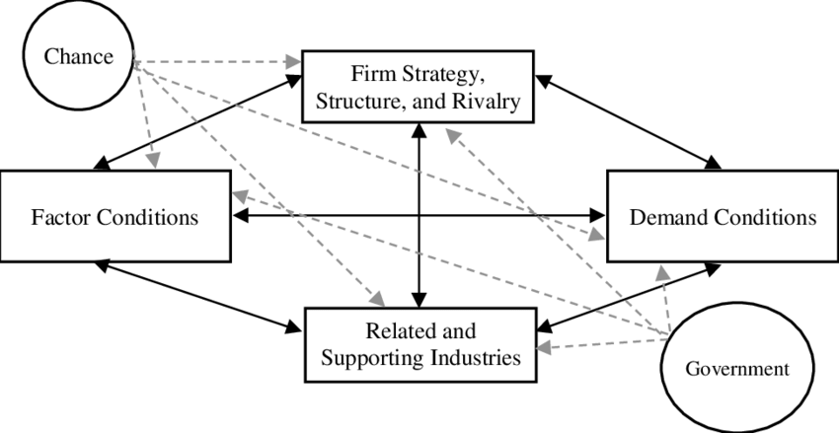
Figure 1: Michael Porter’s Diamond Model
Source: (Fang et al., 2018)

3.1 Factor Conditions
The tourism and hospitality sector in the UAE is also well-positioned with factor conditions for global competitiveness. The factor conditions for the tourism and hospitality industry in the UAE include its advanced airports, road transportation, luxury hotels, innovative technology and real-estate development. It allows international hotel giants such as the Marriott brand to provide luxury service (Bodolica, Spraggon and Saleh, 2020). Dubai and Abu Dhabi airports, luxury hotels, conference centres and theme parks enhance the UAE's ability to attract leisure and business travellers. However, there are risks to competitiveness. The hospitality industry is labour-intensive, leaving risks around labour legislation, retention, productivity and cost. Luxury hotels also have significant water and energy requirements, which could be a sustainability issue (Fang et al., 2018). Fast-growing demand suggests the UAE can further develop this industry by investing in training Emiratis in hospitality to boost participation rates of locals in the industry, implementing green practices for hotels and providing incentives for "smart" water and energy-efficient hotels.

3.2 Demand Conditions
The UAE has sophisticated demand conditions, such as visiting and local customers, expecting quality, luxury, technology and cultural harmony. Hotels are forced to keep pace in offering the best and having top-notch service (Elbanna et al., 2022). The new UAE has high-value leisure, business, conference and expatriate residents and therefore has strong demand for luxury and premium brands. Marriott can tap into this demand here with its luxury and business hotel brands. Demand can, however, be atmospheric and impacted by global or East Asian crises and developments such as pandemics, recessions, geopolitical tensions and international airline connectivity (Ramadan et al., 2023). This demand is also seasonal, especially during the summer months, when demand can drop. The UAE can enhance the demand environment by diversifying its source markets by adding more mid-market tourism, year-round cultural and eco-tourism and regional tourism. This will reduce its heavy dependence on luxury tourism and foreign tourists.

3.3 Related and Supporting Industries
The UAE hotel industry is also very closely linked with supporting industries such as airlines, retail, property development, food and beverage, entertainment, events and transport. Emirates and Etihad connect the UAE with the world; and Dubai Mall, Louvre Abu Dhabi, theme parks, beaches and Formula 1 races enhance tourism (Jayawardena, 2022). These industries support hotels and offer a tourism package. Marriott profits because its guests come to the UAE for all of these reasons: shopping, business meetings, relaxing, eating and sightseeing. However, the tourism industry needs to be supported by the synergy between hotels, airlines, attractions, transport and government tourism organisations (Tsiligiris, 2018). Differences in service quality will likely reduce brand value. The UAE can also help the industry by improving joint planning for tourism, multi-sector tourism packages, facilitating the digital tourism economy and encouraging co-operation between hotels, airlines and attractions.

3.4 Firm Strategy, Structure and Rivalry
The UAE hospitality industry is highly competitive, with Marriott facing competition with other UAE and international hotel companies, including Jumeirah, Emaar Hospitality, Hilton, Accor, IHG and Rotana. The results of competition benefit the industry as companies seek to improve service delivery, branding, websites and loyalty programs, and the overall customer experience (Tsiligiris, 2018). Marriott's strength in the hospitality industry is its brand and Marriott Bonvoy loyalty program. But the UAE market isn't just about brands. Value, location, amenities, reviews and relevance are nearly identical. This reduces market value, and this creates a need to compete on quality, culture and sustainability (Valk and Yousif, 2023). The UAE can encourage sustainable competition through quality, not numbers. It can promote niches, green building and investment in other emirates, such as Ras Al Khaimah, Fujairah and Sharjah.

3.5 Government
The government has an active role in the competitiveness of tourism and hospitality in the UAE. Policy changes to tourism, visas, infrastructure, branding, security and large international events all affect tourism and hospitality in the UAE. This is imperative as State planning and economic diversification is essential for tourism success (Seshadri et al., 2023). State support gives Marriott a stable environment (security, airport development, business-friendly policies and tourism promotion) in which to operate. However, government development could lead to competition as many international hotel chains are also attracted by the same government measures. This could increase supply but lower room rates (Tsiligiris, 2018). To help the hotel industry, the government needs to support not only more hotels, but also improved sustainability, localisation of jobs, tourism diversification and crisis readiness. Supply management could also alleviate oversupply in cities such as Dubai and Abu Dhabi.

3.6 Chance
The UAE tourism and hospitality industry is driven by chance, but this is outside the control of firms and the government. These can include events such as COVID-19, global recessions, regional conflict, oil prices, inflation and changing consumer preferences, which can have a sudden effect on the number of tourists, occupancy and spending (Valk and Yousif, 2023). The impacts of these risks can disproportionately affect Marriott due to its heavy dependence on international tourism, business and luxury financial segments. In the pandemic, the most competitive tourism destinations are disrupted. Though luck can also be the saviour. The recovery of international tourism, new air connectivity, tourism festivals and new motivation of tourists for luxury, medical and ecological tourism purposes can be a positive opportunity for the UAE (Tsiligiris, 2018). To mitigate the role of chance, the UAE should have contingency plans, promote local and regional tourism, build a variety of markets and promote sustainable tourism. This can help the local tourism industry to be dynamic and sustainable.

4. Evaluation of Marriott International in the UAE

4.1 Overview of Marriott International
Marriott International is one of the world's largest and oldest hospitality firms, which was founded in 1927 by J. Willard Marriott, with over 7,600 properties in 133 countries (Marriott International, 2026). Marriott has been successful in the UAE and has a portfolio of hotels ranging from 5-star opulent to mid-market hotels. The company has brands like the Ritz-Carlton, Sheraton and JW Marriott that cater to business and leisure travellers (Stylos et al., 2021). The location and the fact that the UAE has diversified its economy in other areas, such as tourism and hospitality, make it a prime market for Marriott in the Middle East. Marriott's strategy in the UAE is to grow and to cater to different markets. Continuing their growth with new hotels in Dubai and Abu Dhabi (and other Emirates), they target luxury and popular sites. Marriott is also in regional partnerships to become a stronger player, including partnering with real-estate developers in the UAE (Stylos et al., 2021). Creative, digital, sustainable and luxury experiences - all elements of Marriott's move towards the future. But it is competing against local brands such as Jumeirah, which promote innovation.

4.2 Political, Economic, Legal, and Cultural Factors Impacting Marriott’s Operations

Political Environment
The political stability of the UAE plays a crucial role in the ability of Marriott to do well in the region. The government's commitment to ensuring that it is a positive environment for businesses, particularly through programmes like the implementation of a 10-year golden visa for investors and the establishment of free zones, has, in fact, helped to bolster the attractiveness of the UAE for investments from other countries, and Marriott is no different (Marriott International, 2026). The vision of the UAE as a global tourism destination, which is on display through events like Dubai Expo 2020, is a direct benefit to Marriott with regard to inbound tourism (Marriott International, 2026). Furthermore, the government's proactive approach to the global pandemic by implementing stringent health measures and rolling out vaccines quickly helped to regain confidence in tourism. However, as well as political stability being an ideal context in which Marriotts can operate, the UAE's reliance on oil exports and geopolitical risks in the region are potential areas of uncertainty (Stylos et al., 2021). Marriott's profitability can be indirectly affected by the fluctuation of oil prices in the global market, which has an effect on the overall economy and the spending of consumers. Furthermore, Marriott's business is also susceptible to the political and economic policies of both the government at the federal level and local emirates, so that operations are vulnerable to changes in governance or regulations.

Economic Environment
The economy has been strong, and there has been much diversification of industries away from oil, including in tourism, real estate and finance. Marriott benefits from the economic boom of the country as it, particularly, continues to grow in tourism, hosting millions of tourists annually. Tourism in the UAE contributed to 11.5% of the GDP in 2019; this was therefore good for Marriott (Marriott International, 2026). But also, the high GDP growth of the country over the last few years has shown the need for (and so growth in) luxury "things", in which Marriott's luxury brands (like Ritz-Carlton or JW Marriott) aim their product at. But Marriott has problems in the UAE as well. Despite all the attempts to diversify the economy, the UAE's economy is still closely linked to the international economy, especially the oil price and world trade. First, the coronavirus pandemic harmed international tourism, and consequently, the hotel industry in the UAE (Stylos et al., 2021). Even though the effectiveness of a recovery plan for the UAE might assist in reopening the tourism industry, the fact that Marriott is a multinational hotel chain is a weakness.

Legal and Regulatory Environment
The UAE's regulatory and legal frameworks are important to Marriott's success, as its growth is about tourist licensing. Things are growing fast: in January to June 2024, the hotel sector in the UAE recorded turnover of AED 24.6 billion, an increase of 7% over the same period in 2023, with Dubai hosting 18.72 million international overnight stay travellers in 2024 (Marriott International, 2026). Such growth means Marriott needs more regulation, which they must keep up with in relation to licensing, safety and hygiene, food safety, IT security, human resources and service management. Marriott benefits from the UAE's strong legal framework as it offers foreign investors more security on ownership, mergers and acquisitions and hotel management laws (Stylos et al., 2021). However, this also means higher costs as luxury hotels must offer a high quality of rooms, restaurants, events, alcohol, security and training. Laws on employment are particularly significant given the high expat use. Marriott has to be careful not to cause anyone to lose their jobs, contracts, visas, salaries, hours or morale through reputational loss (Hansen, 2020). And Islamic law affects regulations on Ramadan, open alcohol, women's outfits and family life. So, Marriott's success in the UAE market comes from understanding that legal compliance is as much an asset as a liability, and building confidence in the market.

Cultural Environment
The multicultural nature of the UAE presents many Marriott opportunities as well as challenges. The country is a tourist destination for a variety of tourists from different parts of the world and thus has a diverse customer base. Marriott faces the problem of lacking the cultural and religious sensitivity to tailor its services to the expectations of the visitors, particularly from Muslim-majority countries (Peterson and Thomas, 2017). For example, facilitation of the provision of halal food, prayer rooms and alcohol-free zones is critical to the needs of religious travellers. Marriott's success in combining the standards of international luxury with local cultural sensibilities has ensured that it has a strong presence in the UAE to date (Schlegelmilch and Szőcs, 2020). However, Marriott has to deal with the ins and outs of local traditions and customs as well. Although the UAE is progressive, conservative social norms are seen, especially in dress code, behaviour and gender segregation in some public places (Sen, 2024). Marriott has to be sensitive to these nuances of different cultures so as to avoid any possible backlash. For instance, the marketing strategies and promotions need to be carefully thought out to be held within respect for the local traditions while upholding the global brand identity of Marriott.

4.3 Market Attractiveness and Challenges for Marriott: Hofstede Cultural Model
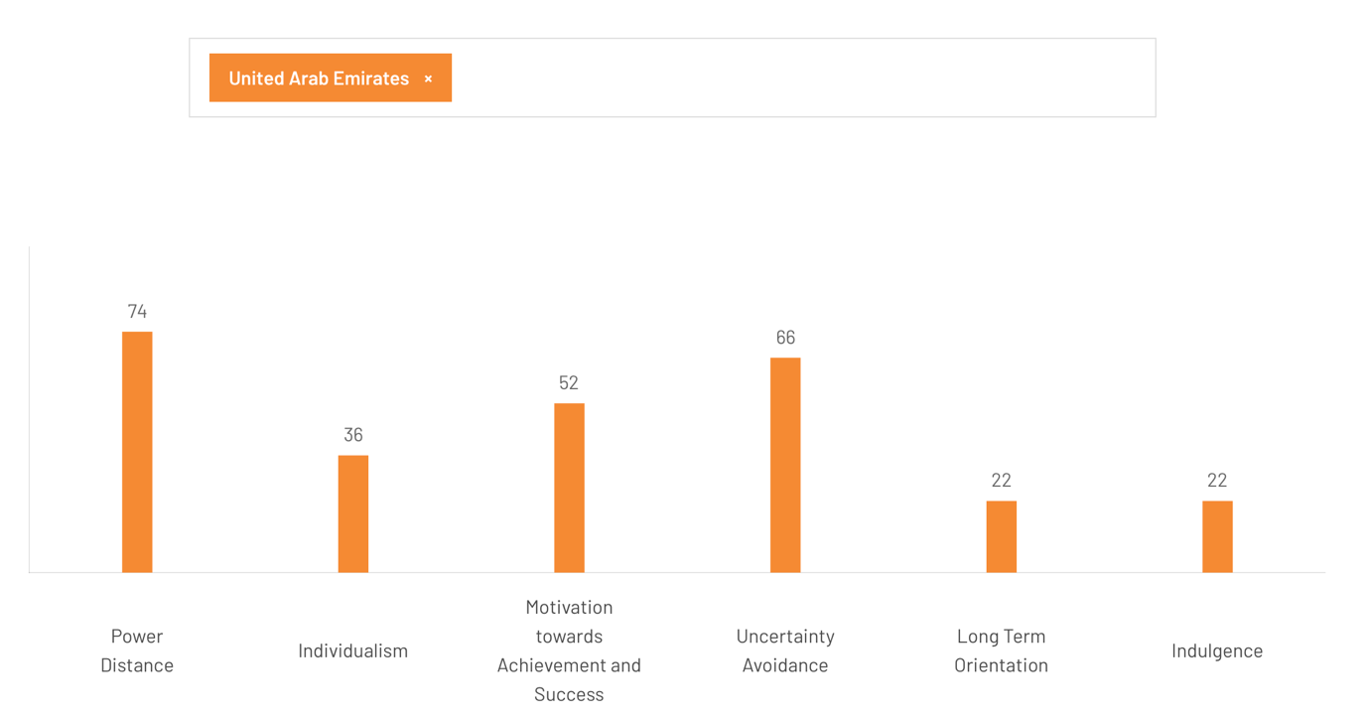
Figure 2: Hofstede Cultural Model
Source: (Hofstede Insights, 2025)
The Hofstede model is more pertinent to use to understand the market attractiveness for Marriott because the hospitality industry is heavily dependent on culture (consumers' expectations and behaviours). This is confirmed by the UAE's ranking in terms of power distance (score of 74), which suggests hierarchy, status and prestige are important to society (Hofstede Insights, 2025). This is helpful to Marriott's high-end brands as its luxury hotels, luxury hospitality opportunities and highly personalised services fit well with this need for status and prestige (Sen, 2024). However, it's likely to be less forgiving of poor service, as those with status expect their needs to be addressed promptly, respect and compensation for wrongdoings.
The UAE is ranked 36 on the individualism scale - it has a collectivist culture (Hofstede Insights, 2025). This enhances the cultural fit for family-friendly hotels, group travel, weddings and other social gatherings, corporate events and intergenerational fun. Marriott should target families, businesses or events rather than just people (Lakshman, Lakshman and Estay, 2017). But collectivist cultures are all about word-of-mouth. Bloggers and social media users will be very critical of Marriott if they are unhappy.
The achievement and success score of 52 is reflective of reflective but slightly achievement-oriented (Hofstede Insights, 2025). This creates the premium for aspirational brands and services, business hotels, executive lounges and premium brands. This could be a successful market for Marriott in business and lifestyle travel (Tsiligiris, 2018). However, Marriott should not be perceived as global and transactional; the signs of success have to be mixed up with local contextual, Arab hospitality, and context-specific messaging.
Marriott should also take into account the UAE's high uncertainty avoidance (66) culture (Hofstede Insights, 2025). Customers and suppliers will be attracted by certainty, security and rules, quality and consistency. This is a positive for Marriott as it is an international hotel chain. But it also poses a challenge (Jayawardena, 2022). Marriott needs to ensure legal, religious, health, safety and service standards are followed. Not following these could result in brand damage.
UAE's low long-term orientation (22) and low indulgence (22) scores suggest culture has a tradition, discipline and restraint (Hofstede Insights, 2025). Hence, Marriott should follow the cultural discipline and cultural restraint (besides luxury tourism) to market luxury products and services. Alcohol, marketing, entertainment, attire, Ramadan (Islamic code of fasting and prayers, meditation and charity) and privacy should be considered (Teixeira, 2020). So, Hofstede's model suggests Marriott has a good opportunity to expand in the UAE, where it would need to adapt and localise instead of globalise in the UAE market.

4.4 Marriott’s Adaptation to Local Needs and Consumer Preferences

Cultural Sensitivity
Marriott's ability to adapt to the local customs and cultural preferences has been a key factor in its success in the UAE. The company is very sensitive towards the religious and social norms of the region, and this affects the services of the company and its marketing approaches. For example, Marriott has ensured that its hotels in the UAE have halal food choices and prayers and direction towards the qiblah in its rooms for its guests (Jayawardena, 2022). Additionally, Marriott follows dress codes locally, with staff members and guests adhering to dress code guidelines in public spaces. Marriott also understands the need to target the family-centric culture of the UAE. Family-friendly amenities, such as children's clubs and multi-generational suite configurations, are built into Marriott's amenities to cater to local and international families travelling together (Ramadan et al., 2023). The company's focus on providing high levels of hospitality and service has contributed to building a strong brand loyalty among people in the region and has allowed Marriott to maintain its position as a leading provider of hospitality.

Localisation of Offerings
Marriott is not just culturally sensitive; it is also localised to local tastes. One such local taste is when it comes to food and drink. Its locations in the UAE have a great deal of international and localised cuisine and drinks, as well as lots of Arabic and Mediterranean food and drinks. The group also works with international and local chefs to develop menus of interest to locals and internationals alike (Tsiligiris, 2018). Marriott is also localising its products in other ways. Marriott also incorporates local design elements into their properties with Arab designs in modern stylish ways to include local elements. This is not only attractive to the local market, but it also contributes to the guest's visit by giving it an authentic touch. In addition, Marriott's marketing approach is also a reflection of the diverse market of the UAE (Jayawardena, 2022). In most of the marketing strategies, the hotel chains tend to emphasise the diversity in terms of international and local markets. With localisation and personalisation of marketing, Marriott can ensure that its branding is relevant to the market demands of the UAE. But the local also needs to be able to respond to the market demands, particularly with the introduction of the tech-driven new generation and millennial travellers.

5. Conclusion to the Report
The UAE's tourism industry is highly competitive and supports a world-class infrastructure, government policies that are global and an excellent presence in the international market. Marriott International's strategy of attacking the global market, including brand differentiation and regional partnerships, has helped the company to achieve a significant market share. However, difficulties such as stiff competition at the local level, saturation of the market and dependence on international tourism have not disappeared (Ramadan et al., 2023). In order to strengthen its position, Marriott needs to focus on further diversification of its offer, especially into the growing segment of eco-tourism. Additionally, investing in sustainable practices and enhancing its loyalty programs will help Marriott to stand out from its competition. Marriott should also consider further adapting to the cultural norms in the UAE to remain relevant in the local market (Jayawardena, 2022). The UAE remains a significant world tourism destination in which Marriott can have good growth prospects. The success of the company in the future is rooted in the ability to manoeuvre in the ambiguities of the markets while taking advantage of the local trends, while maintaining the global standards of luxury.

6. Reflective Account

Research Process
The process of research began with deciding that the tourism sector in the UAE and Marriott International would be the focus. I took advantage of secondary data from governmental reports, academic sources and Marriott's corporate documents. The main objective was to use Porter's diamond model to analyse the competitive environment for the UAE hospitality industry. While I believed the research to be very simplistic, there were some challenges in the application of Porter's model. It simplified the complexities of the UAE market, especially cultural and regulatory factors, which affect Marriott's operations (Trimasse, 2025). The absence of local in-depth data was another example of the limitations in implementing large-scale frameworks. This realisation led me to realise that a more comprehensive approach, which encompassed more models such as Hofstede's Cultural Dimensions, was needed in order to better catch Marriott's market dynamics.

Learning Outcomes
This assignment helped me to learn more about the tourism business in the UAE and the work of Marriott. I learnt about the contribution that governmental policies and the location of the country make to the booming tourist sector of the country. Marriott's success in the UAE is not only dependent upon economic conditions but also cultural, adapting and complying with regulations, which were not something I had fully taken into consideration before (Trimasse, 2025). Porter's Diamond Model helped, but limitations in dealing with the uniqueness issues of the UAE's markets were visible. The assignment also taught me the importance of integrating a variety of frameworks in the analysis of the operations of an MNC in a dynamic and culturally rich market such as the UAE (Nurlatifah, Purnawarman and Sukyadi, 2023). In reflecting further I now appreciate the opportunities of having wider views accessible in future analyses in order to gain a more nuanced learning of the challenges and opportunities in the market.

Gibbs Reflective Cycle
To reflect on the learning process, I used Gibbs' Reflective Cycle, which consists of 6 stages: description, feelings, evaluation, analysis, conclusion and action plan.
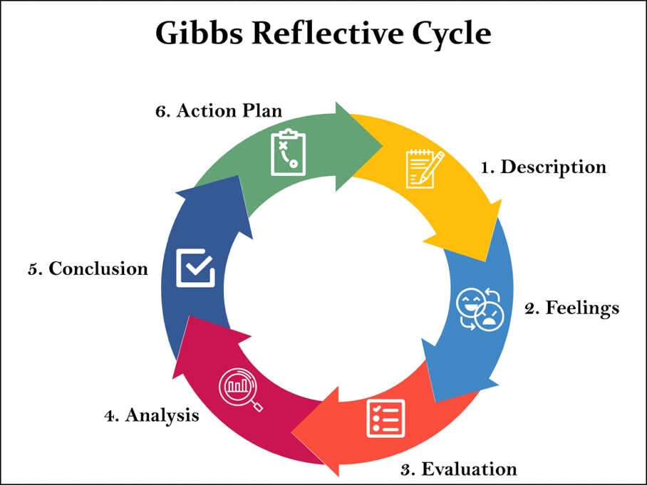
Figure 3: Gibbs Reflective Cycle
Source: Trimasse, 2025)
Description: During the assignment, I did some research regarding the operations of Marriott International in the UAE. I have used the market condition and Porter's Diamond Model for analysis (Nurlatifah, Purnawarman and Sukyadi, 2023). I have also talked about political, economic, and cultural factors that influenced Marriott's business decisions. The research included analysing various sources such as academic articles, company reports, government publications, as well as the application of theory to the existing practical world situation of the UAE.
Feelings: At the beginning of the assignment, I felt that I had the skills to collect information and employ theoretical frameworks. However, as I progressed, I began to feel challenged in the problem of making effective use of the models, Porter's Diamond Model in particular (Potter, 2015). Some factors, such as nuances of culture and the fast-paced nature of the tourism industry in the UAE, were difficult to reflect in the framework in full. This resulted in me being somewhat frustrated because it became apparent to me the limitations of the models that I was using.

Evaluation: The process of research revealed that there were highs and lows in my means of approach. On the plus side, I was able to collect useful data from a variety of other sources, which made for a strong base to do the assignment (Potter, 2015). The theoretical models helped to structure the analysis and were able to critically analyze the competitiveness of the UAE tourism sector. However, the disadvantages of using Porter's Diamond Model and the lack of knowledge of the region in depth were some of the disadvantages. In my case, I struggled to adapt the theories to the context of Marriott's operations in the UAE in particular, and, for this reason, some gaps existed in the analysis.
Analysis: Porter's Diamond Model has some limitations in what it explains when I look into Marriott. This is a great model to describe the macro conditions of the country, but also to describe the myriad of micro conditions which Marriott has to cope with in the UAE - cultural factors, local laws and regulations, etc.. Culture plays a pivotal role in the success of Marriott in the UAE's hotel industry, as economic and political factors are equally important in this country (Trimasse, 2025). This led me to make use of some other models, like Hofstede's Dimensions of Culture, which then assisted me in understanding Marriott's cultural integration strategies. Again, the assignment gave importance to the use of multiple perspectives in the analysis. While Porter's model was a good start, we realised that if we wanted to understand Marriott's presence in the UAE market, it was necessary to look at a wider perspective (Trimasse, 2025). It not only involves theoretical and empirical evidence but also offers some practical insights.
Conclusion: This report helped me to develop a critical, detailed, theory-based model, implementation in a real industry setting. I realised that while models like Porter's Diamond Model may help us in certain situations, in some markets like the very dynamic UAE's tourism industry, we need to modify it (Trimasse, 2025). Also, the research exercise taught me the importance of culture awareness in the global business environment and working across cultures in a given market.
Action Plan
Goal | Measurable Outcome | Action | Time-Frame
Integrate Multiple Frameworks | Use 3 frameworks per assignment | Select appropriate models for each case | Next assignment (1 month)
Collect Local Data And Insights | Include 2 local sources per assignment | Access local reports and databases | Ongoing
Improve Critical Thinking | Evaluate 3 frameworks per case | Reflect on model relevance | Next assignment (1 month)
Understand Cultural/Regulatory Factors | Include cultural/legal analysis in 50% of assignments | Analyze local impacts on business | By end of next term (4 months)
Table 1: Action Plan Of Gibbs Reflective Cycle
Source: (Author)

Reference
Ahmad, S.Z., Ahmad, N. and Papastathopoulos, A. (2019) ‘Measuring service quality and customer satisfaction of the small- and medium-sized hotels (SMSHs) industry: lessons from United Arab Emirates (UAE)’, Tourism Review, 74(3). Available at: https://doi.org/10.1108/tr-10-2017-0160.
Alameeri, A. et al. (2018) ‘Sustainable management practices in UAE hotels’, International Journal of Culture, Tourism and Hospitality Research, 12(4), pp. 440–466. Available at: https://doi.org/10.1108/ijcthr-10-2017-0100.
Alsuwaidi, M., Eid, R. and Agag, G. (2022) ‘Tackling the complexity of guests’ food waste reduction behaviour in the hospitality industry’, Tourism Management Perspectives, 42, p. 100963. Available at: https://doi.org/10.1016/j.tmp.2022.100963.
Bodolica, V., Spraggon, M. and Saleh, N. (2020) ‘Innovative leadership in leisure and entertainment industry’, International Journal of Islamic and Middle Eastern Finance and Management, 13(2), pp. 323–337. Available at: https://doi.org/10.1108/imefm-12-2019-0521.
Elbanna, S. et al. (2022) ‘An investigation of the causality links in the balanced scorecard: The case of the Gulf Cooperation Council hospitality industry’, Tourism Management Perspectives, 41, p. 100934. Available at: https://doi.org/10.1016/j.tmp.2021.100934.
Fang, K. et al. (2018) ‘Assessing National Renewable Energy Competitiveness of the G20: a Revised Porter’s Diamond Model’, Renewable and Sustainable Energy Reviews, 93, pp. 719–731. Available at: https://doi.org/10.1016/j.rser.2018.05.011.
Gabriela, M., Kurt, A. and Mehmet Gumus (2025) ‘Analysis of national strategic innovation objectives using adapted Porter’s diamond model: a comparison of Romania and Türkiye’, Competitiveness Review An International Business Journal incorporating Journal of Global Competitiveness, 35(1). Available at: https://doi.org/10.1108/cr-10-2023-0260.
Goh, E., Richardson, S. and Thomas, N. (2025) ‘Opportunities, challenges, and future prospects of establishing a hospitality institution in the UAE: a case study of the Abu Dhabi Hospitality Academy, Les Roches’, Journal of Teaching in Travel & Tourism, pp. 1–21. Available at: https://doi.org/10.1080/15313220.2025.2517607.
Griffin, R.W. and Pustay, M.W. (2020) International business: A managerial perspective. 9th edn. Harlow: Pearson.
Hofstede Insights (2025) Country comparison tool, Theculturefactor.com. Available at: https://www.theculturefactor.com/country-comparison-tool?countries=united+arab+emirates (Accessed: 24 March 2026).
Jayawardena, C. (2022) ‘Conclusion: what innovations would enable the tourism and hospitality industry to re-build?’, Worldwide Hospitality and Tourism Themes, 14(6). Available at: https://doi.org/10.1108/whatt-06-2022-0069.
Lehene, C.F., Jaradat, M. and Nistor, R.L. (2024) ‘An interdisciplinary and multilevel analysis of local economy determinants and their impact on firm performance—Considering Porter’s diamond model, clusters, and industry’, Systems, 12(3), p. 82. Available at: https://doi.org/10.3390/systems12030082.
Marriott International (2026) Marriott International Annual Report 2025, https://marriott.gcs-web.com. Available at: https://marriott.gcs-web.com/static-files/90ac617a-ef5f-4438-97ec-2e7cf4f8a41e (Accessed: 15 March 2026).
Peterson, M.F. and Thomas, D.C. (2017) Cross-cultural management: Essential concepts. 4th edn. Thousand Oaks: SAGE.
Ramadan, M.A. et al. (2023) ‘Application of Six Sigma methodology to enhance the productivity and performance of a hotel in the UAE’, The TQM Journal, 32(2). Available at: https://doi.org/10.1108/tqm-11-2021-0325.
Schlegelmilch, B.B. and Szőcs, I. (2020) Rethinking business responsibility in a global context: Challenges to corporate social responsibility, sustainability and ethics. Cham: Springer.
Seshadri, U. et al. (2023) ‘Marketing Strategies for the Tourism Industry in the United Arab Emirates after the COVID-19 Era’, Worldwide Hospitality and Tourism Themes, 15(2). Available at: https://doi.org/10.1108/whatt-10-2022-0120.
Stylos, N. et al. (2021) ‘Beyond smart systems adoption: Enabling diffusion and assimilation of smartness in hospitality’, International Journal of Hospitality Management, 98, p. 103042.
Teixeira, N.M. (2020) Management control systems and tools for internationalization success. Hershey, PA: IGI Global.
Tsiligiris, V. (2018) ‘An adapted Porter Diamond Model for the evaluation of transnational education host countries’, International Journal of Educational Management, 32(2), pp. 210–226. Available at: https://doi.org/10.1108/ijem-03-2017-0076.
Valk, R. and Yousif, L. (2023) ‘“Going beyond to deliver hip hospitality”: exploring motivation and job satisfaction of hospitality workers in Dubai’, International Journal of Organizational Analysis, 31(2), pp. 293–316. Available at: https://doi.org/10.1108/ijoa-12-2020-2517.

