Abstract
A multifactorial between subject’s design study was undertaken by 60 participants that intended to examine if a person’s level of sensation seeking and tempo of music would affect their ability to judge time perception. Beforehand it was assumed the higher the sensation seeking, the more likely they will misjudge time perception. The study was 15 minutes long and was completed by all consent giving individuals. Although, a hypothesis was initially created to support other research conducted although was declined as the individual’s sensation seeking level contradicted other research and did not affect their perception of time. The result was 0.508 and is >0.05 therefore the result is non-significant.

Introduction
The topic discussed in this report looks at the effects of a person’s sensation seeking and the tempo of music on time perception. Prior to this study taking place it was assumed that the higher someone’s sensation seeking the more likely they are to misjudge time perception due to research supporting this idea. For example, it has been thought that different types of music such as genre and tempo can influence a person’s behaviours and perceptions, for instance, Edworthy (2006) found a link where faster tempo and louder music increased arousal during exercises and leads to increased performance.
A study conducted by Angrilli (1997) aimed to see if arousal effects the individual’s perception of time. He studied 2 groups of participants by providing them with photographic slides. One group had to estimate the projection of picture duration by an analogue scale and the other group had to assume the intervals by pushing a button. He found that arousal interaction affected duration judgments where a person with high-arousal stimuli, judged the duration of negative slides longer than the duration of positive slides.
Another research task conducted by Droit- Volet et al. (2004) tested the effect of emotion on time perception and found emotions significantly effect time perception. As a result of this evidence and other research conducted the hypothesis for this study is assuming a person with higher sensation seeking levels will misjudge time perception with different tempos of music.

Method
Participants
The study consisted of sixty randomised participants that ranged in age from 18-51 (M=25.07 SD=8.53) and consisted of 29 males and 31 females.

Design
The study conducted was a multifactorial between subject’s design. It included 2 independent variables (IV) and 1 dependant variable (DV). The two IV’s were the level of sensation seeking (SS) where participants were categorised into high or low levels of SS by gaining information off them from a paper-based questionnaire and the tempo of music, where there were three levels delivered to them via headphones, slow, fast and no music. The DV was time perception that was measured by a short task that involved the participant having to decide whether a pink oval appeared on the screen in front of them for a long or short time. Therefore, the study conducted was a 2x3 between subject’s ANOVA.

Materials
The study consisted of two parts, the first part a questionnaire and the second a short task created on super lab. Part one of the study involved a sensation seeking questionnaire that aimed to analyse the participant’s level of sensation seeking. This questionnaire was a 4 Likert scale and was called the Arnett Inventory of Sensation Seeking (AISS) Arnett, J. (1994) (see appendix D). The participants answers were calculated by a point scoring system where each of their answers totalled to a different score, D=1, C=2, B=3, A=4. The higher the score the higher their level of sensation seeking. An example of the questions asked in the questionnaire were “If I were to go to an amusement park, I would prefer to ride the rollercoaster or other fast rides” and “I would have enjoyed being one of the first explorers of an unknown land”. Although, within this questionnaire there were 6 required reverse scored questions where answers totalled in a reverse manner, D=4, C=3, B=2, A=1. An example of this type of question is “if I had to wait in a long line, I’m usually patient about it”.
The second part of the study was a super lab experiment that was split into a practice and experimental stage for the participants. Within these stages a stimulus fixation cross appeared in the middle of the screen for 400ms and 1600ms for the practice stage and 400ms, 600ms, 800ms, 1000ms, 1200ms and 1600ms for the experimental stages while the participant was listening to either fast, slow or no music. Beforehand participants were provided with information on the screen and would receive 5 displays of the pink oval in each the practice and experimental stages. In the experimental stage the pink oval appeared on the screen randomised twenty-two times where the 1000ms oval appeared 10 times out of twenty-two and was the main fixation cross being measured to assess whether the participants over estimated or under estimated time perception based on their sensation seeking questionnaire completed previously.

Procedure
Before the study was able to take place, we needed ethical approval. We had to fill out an ethics form with information as to why we wanted to conduct this study and include other theories and studies supporting our study. As this got approved, we were able to go ahead with our study.
We recruited participants from the café in university by asking them if they’d like to take part in a study for a psychology students’ assessment, some refused, and others were happy to take part. Family members were also recruited.
Each participant was supplied with a detailed information sheet about what the study would entail with an attached consent form to assure participants wanted to take part and stated that answers would be held completely confidential and they were free to withdraw at any time. It also stated that their data would be stored indefinitely in accordance with the Data Protection Act. They also received a demographic data information sheet (see appendix A/C)
All participants completed a paper-based sensation seeking questionnaire that included their age and gender and were then instructed to read the information on the lab computer screen. This advised them to put headphones on and that they would first be given a practice task. It stated they were only to use the keyboard letters ‘S’ and ‘L’. S was to be clicked if the pink oval was on the screen for a short amount of time and L for a long time. The music would then come on through the headphones and could have been fast, slow or no music and was completely randomised to different participants. When they finished the practise task it then went onto the experimental task that was being measured.
After the task participants were thanked for taking part in the study and were given a debrief form and were provided with contact details for the researchers to discuss any issues arising. (see appendix C)

Results
A 2 x 3 between-subject ANOVA study was conducted to measure if there were any effects between the high/low sensation seeking levels and the fast, slow or no music tempos of music and assess the individual’s outcome of time perception based on these factors. As a result, the mean of time perception is 6.58 and the standard deviation 2.62. For sensation seeking the mean is 53.43 and the standard deviation 6.30.
The interaction effect between music group and sensation seeking was shown to be non-significant- F (2, 54) = .23, P. 80. Additionally, the main effect of sensation seeking is also seen to be non- significant, seen as- F (1, 54) = .037. P= .851. The music group (fast, slow, no music) is also non-significant and seen as- F (2, 54) = .34, P=.72.
As a result, 0.508 is bigger than 0.05 therefore the result is non-significant and means that the variance of the DV across the groups is equal. (see appendix E)
The main effect of study being non-significant indicates there was a not an effect or link between the level of sensation seeking on time perception. This goes against the previous assumptions that high levels of sensation seeking influence time perception, meaning the original hypothesis needs to be rejected.

Discussion

A study was carried out to discover if people with a high sensation seeking were more inclined to overestimate time perception. Due to research being found that assumed an individual would overestimate time perception with high sensation seeking the hypothesis for this study had to be rejected and showed no link to high levels of sensation seeking or tempo of music influencing time perception.
Although, there were some limitation within this study. As the study was designed on a computer in super lab, within most of the participant’s studies the computer froze, meaning the participant had to start again and may have been put off by this resulting in their answers being influenced by other factors.
As some individuals were recruited downstairs in the canteen, they may have been in a rush and may not have been fully prepared to complete the study, this would have then had a knock-on effect and not portrayed a true result.
We also run a reliability test on the scale and found the reliability was lower than expected. The results were .518, as the level is bigger that 0.05 it is not significantly reliable. As a result of this if the study was to be conducted again the scale used should be changed to a more appropriate one which may in turn result in the hypothesis being accepted. (see appendix F)
In future studies, it may also be an option to include a more varied age group, as a study conducted by Carrasco, M. C., et al., (2001) evaluated age-related differences in the recall of a short interval. They studied thirteen young adults and twelve elderly adults and results showed that time perception performed by elderly participants were shorter than the younger ones. In saying that maybe a more varied age group would have changed the study’s results and portray a more fair and accurate result.
To conclude, this study did not find a person’s level of sensation seeking and tempo of music to influence time perception.

References

Angrilli, A., Cherubini, P., Pavese, A., & Manfredini, S. (1997). The influence of affective factors on time perception. Perception & psychophysics, 59(6), 972-982.
Arnett, J. (1994). Sensation seeking: A new conceptualization and a new scale. Personality and Individual Differences, 16(2), 289-296. doi: 10.1016/0191-8869(94)90165-1
Carrasco, M. C., Bernal, M. C., & Redolat, R. (2001). Time estimation and aging: a comparison between young and elderly adults. The International Journal of Aging and Human Development, 52(2), 91-101.
Droit-Volet, S., & Meck, W. H. (2007). How emotions colour our perception of time. Trends in cognitive sciences, 11(12), 504-513.
Edworthy, J., & Waring, H. (2006). The effects of music tempo and loudness level on treadmill exercise. Ergonomics, 49(15), 1597-1610.

Consent form- Appendix A
Debrief form
Debreif form- Appendix B

Demographic data- Appendix C
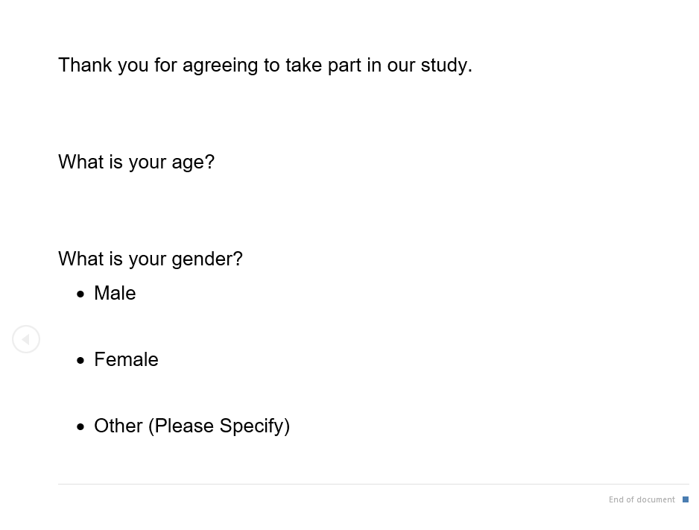
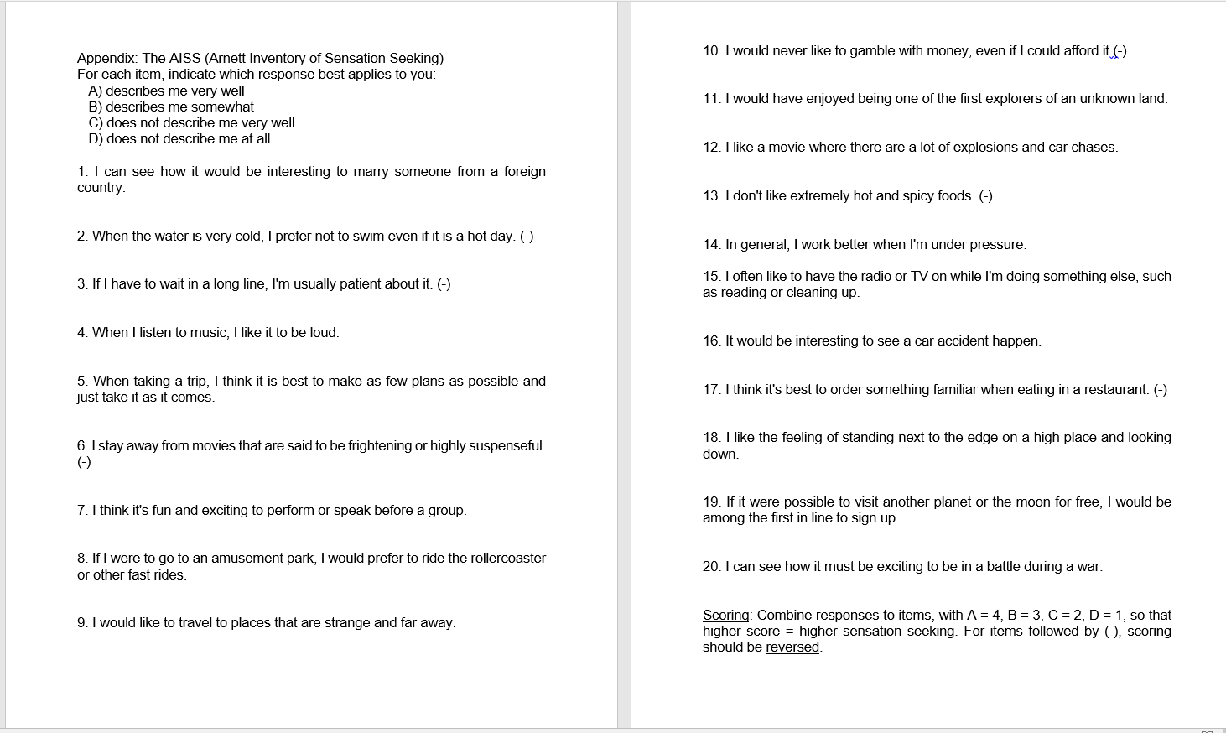
Questionnaire- Appendix D

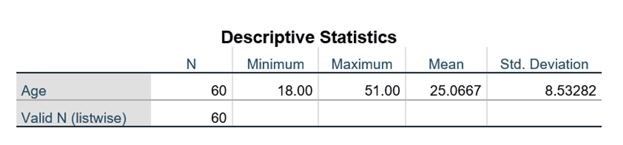
Results- Appendix E

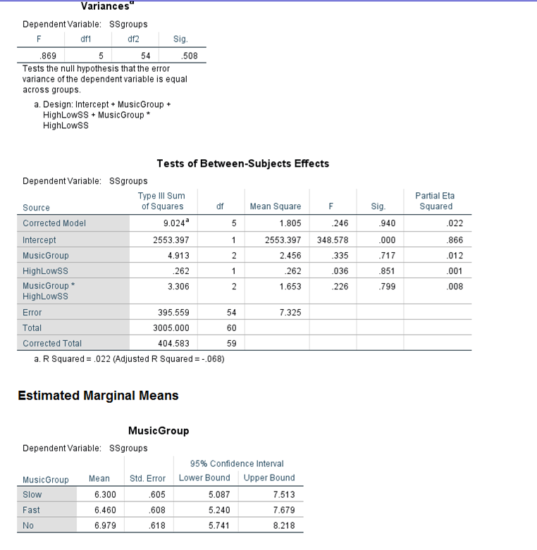

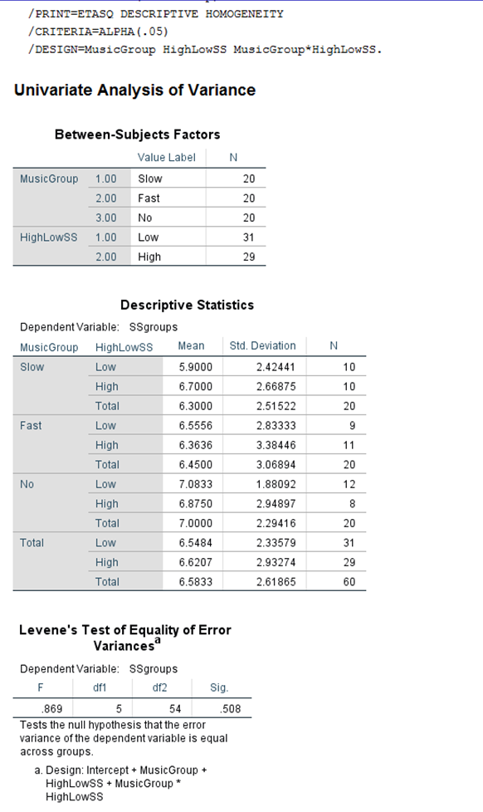

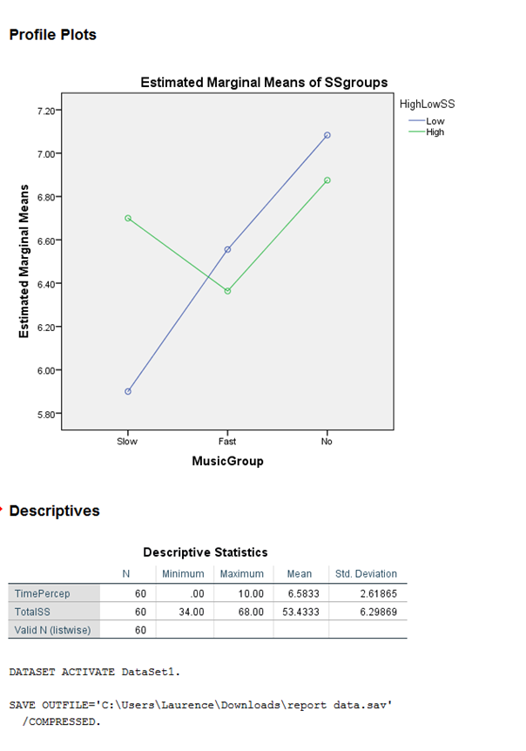

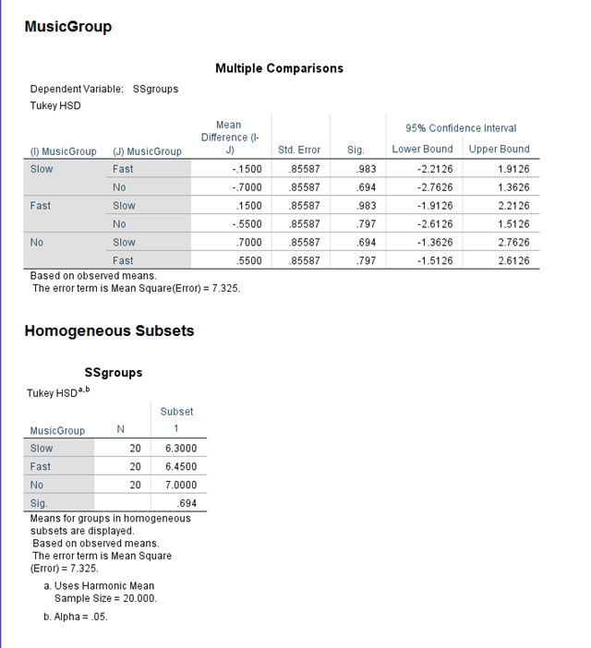

Reliability- Appendix F


