



Topic: Factors that affecting online store image and the intentions to buy in Hong Kong

Abstract
Online store image is influenced by several key factors, which can significantly impact consumer perception and purchasing decisions. Key factors include Online store image, Store Ease of Use, Store Enjoyment, Store Familiarity, Store Style, Store Settlement, Store Trustworthiness, and Store Usefulness. These factors collectively contribute to how consumers perceive and interact with online stores, ultimately influencing their purchasing decisions and loyalty. This study delves into what makes an online business seem good and whether or not a Hong Kong resident would make a purchase there. It finds that both old and new factors play a role in this context. The primary factors impacting the perception of an online store and the likelihood of making a purchase can be defined and mapped out by empirical study. This study established a valid instrument to test these parameters. It also identified seven elements linked with online business image and intentions to buy, using a robust methodological framework proposed by Churchill (1979). In order to determine the importance and reliability of our results, our study used analysis techniques such as Cronbach's Alpha and the Hypothesis Test. In contrast to previous research that placed a premium on store usefulness and store ease of use, the current study found that store trustworthiness and store enjoyment were the most important factors in determining whether or not customers would make a purchase. In order to increase customer trust and satisfaction with their online stores, this study highlights the need of online retailers focusing on both the visual attractiveness and security elements of their platforms. Potential areas for future research include expanding the age range of participants and investigating different types of online stores, as highlighted by the underrepresentation of younger consumers. As a whole, this study fills a knowledge gap regarding the factors impacting Hong Kong residents' perceptions of online stores and their intentions to make purchases in this manner, and it adds to our knowledge of online consumer behavior in the city by providing practical insights for online store marketers.
Key Words: Hong Kong, Intentions to buy, Online store image, Store Ease of Use, Store Enjoyment, Store Familiarity, Store Style, Store Settlement, Store Trustworthiness, Store Usefulness.

- Introduction

One of the most important challenges for those working in electronic commerce is finding a way to make money from their online store. Consequently, research is being conducted to identify the elements that impact the propensity to shop online. There has been a lack of focus on the online store's general image, even though these elements include specific antecedents like website functionality and store ease of use. We argue that consumers' perceptions of online stores significantly influence their propensity to make purchases made through these channels. Store image and purchase intentions have been linked by multiple researchers in empirical marketing studies. That these associations would persist in virtual spaces is a reasonable assumption to make. Another compelling argument in favor of researching the effects of online business image is that the owner or web designer has direct influence over the image, at least to some degree. For conventional retailers, the many facets of store image have been studied extensively. However, it appears that the current measurements of this construct are inadequate in an online setting. Things like "shop crowdedness" and "shop cleanliness" are examples of improper items found in these. Furthermore, things like privacy concerns and the accurate delivery of bought items—which are likely to be crucial in an online store—are not covered either. Hence, it is necessary to modify the current store image measurement tools in order to acquire a valid instrument for online store image.

In Western countries, the idea of store image has been researched extensively in relation to attitude towards purchasing at that store. For instance, when comparing hedonic and utilitarian information systems, (Van der Heijden and Verhagen, 2004) delves into the variations in user acceptance models. It emphasizes that hedonic system utilization is determined more by perceived enjoyment and ease of use than by perceived usefulness. In Asia, here is lacking of fruitful related study in recent years, not to mention a proper one in Hong Kong. In Taiwan, (Chen and Teng, 2013) found that there are underlying correlations between consumers' perceptions of online stores and their propensity to make a purchase. We need to do our own study on the circumstances of the image of Hong Kong online stores, even if the results showed that settlement performance and usefulness are favourably associated to purchase intents. (Chau, Au and Tam, 2000) studied how text, graphics and pictures affect the acceptance of online shopping in Hong Kong. Although their study started an analysis about the online shopping, they did not consider more factors like Store Ease of Use, Store Enjoyment, Store Familiarity, Store Style, Store Settlement, Store Trustworthiness, and Store Usefulness. Moreover, their study was 20 years ago which would not well represent the current situation of online store image in Hong Kong. In light of the lack of research on what makes a good online business and what motivates Hong Kong residents to make purchases there, this study can help fill that void. Other elements that impact the image of an online store in Hong Kong, according to this study, are store enjoyment, trustworthiness, style, and familiarity.

Examining what factors impact Hong Kong consumers' perceptions of online stores and their propensity to make purchases from such sites is the primary goal of this research. What are the conceptual components (dimensions) of online store image? That is, that is the specific question that guided the research. Which of these mental dimensions can be measured with what items? Do the items serve as valid and dependable assessments? And lastly, how robust are the correlations between the aspects of store appearance and the likelihood of making an online purchase? This study aims to evaluate the impact of these characteristics on online purchase intentions and to build a valid and reliable tool for evaluating the image of online stores. Finding the conceptual parts (dimensions) of an online store's image is the main goal of this research. What concrete things may be used to measure these intangible dimensions? How accurate and trustworthy are the measurements provided by the items? And lastly, how do the components of a store's image relate to customers' intentions to make an online purchase? The focus of this study is on online shops that sell tangible, secure consumer items and rely only on the Internet for delivery. This emphasis was placed on these online businesses because they are very comparable to the traditional brick-and-mortar stores that inspired the creation of the present store image tools.

In this study, we look specifically at B2C e-commerce sites that offer physical, low-risk consumer goods (e.g., electronics, books, food, toys, etc.) on the Internet. The existing store image instruments were initially built for typical high street stores, which is why this focus was driven by their similarities.

- Theoretical foundations

Our research on traditional store image, which has been around for a while, served as a foundation for our development of an online store image measurement. According to (Martineau, 1958), a store's image is the mental picture that customers have of the business based on their experiences there, which is influenced by both the store's practicality and the ambiance it exudes. The term "store image" was first used by Hirschman, Greenberg, and Robertson (1978) to describe how customers felt about a certain store. A store's image is the total of the many ways in which customers perceive it along several dimensions, often referred to as components or qualities. A store's functional and psychological aspects, along with the consumer's perceptions of its practical and emotional traits, contribute to the shopper's overall impression of the store, as stated by Houston and Nevin (1981). Many different things, called components or qualities, come together to create a store's image in the eyes of consumers. (Poiesz, 1989) characterized as the store's public persona or the web of associations that people use to describe the store.

One of the first ways to gauge a store's reputation was developed by (Kelly and Stephenson, 1967). They proposed using the semantic differential, a scale with two extreme adjectives. (Lindquist, 1974) reports that 51 products were developed with many factors taken into account, including but not limited to: size, shape, physical attributes, usability, cost, quality, promotion, and word of mouth recommendations. His groundbreaking research on visual interpretation included nine components. By including store design and amenities, pricing, merchandise, advertising, service, and employees, among other factors, Dickson and Albaum (1977) enhanced the metrics for retail store image. The reliability and validity of a tool that was developed out of 29 individual components were evaluated. A number of variables, including the attractiveness of a shopping location and the intentions to make a purchase, can be predicted by the retail image, which has grown in popularity since then. The importance of store image as a dependent variable is not surprising. (Baker, Grewal and Parasuraman, 1994) and (Grewal et al., 1998) conducted studies that looked at factors including retail atmosphere and store name. Research on consumer behaviour has looked at the links between various aspects of store image and the likelihood that a customer would make a purchase. A number of studies have linked specific aspects of a store's image—its name, prices, and perceived value for money—to consumers' intentions to make a purchase. These studies include (Dodds, Monroe and Grewal, 1991) and (Sweeney, Soutar and Johnson, 1999). One study looked at how customers' perceptions of a store influenced their desire to shop there (Houston and Nevin, 1981). Although no strong correlations were found, the closer the customer lived to the store, the better. Some could argue that these findings don't readily translate to an e-commerce context because distance is less important in the digital realm. Researchers looked at the relationship between store image and intention (Baker, Grewal and Parasuraman, 1994). Bicycles and stores selling bicycles were part of their particular real-life scenario. Their research proved that consumers' perceptions of a store had a significant impact on their propensity to buy. Store image had a limited association with purchase intentions, whereas perceived value had a stronger correlation. Many research on store image touch on the topic of perceived value, thus some would argue that it is an integral part of store image as well. All things considered, the variables accounted for 41% of the variance in intent to buy. An investigation on the relationship between consumers' impressions of a store's image and their propensity to shop there was carried out by (Bell, 1999). Five characteristics were identified in an exploratory factor analysis study: aesthetics, product diversity and quality, price equity, accessibility, and ease of use. When added together, they explained 29% of the variation in purchase attitude. The attitude idea explained thirty percent of the variation in the propensity to buy.

Similarities between the desire to use a website and the want to purchase online are striking. Using input variables from the widely-used Technology Acceptance Model construct within the context of the World Wide Web, (Davis, 1989) had explored the origins of this idea. According to Lederer et al. (2000), the characteristics that contribute to store usefulness include management, research and development, main activities, quality of information, and support information. Perceived attractiveness and its role in the Store Enjoyment experience was studied by Van Der Heijden (2004). Between evaluations of the system and plans to use it, a separate attitude framework is often shown as a go-between. Prior to and following website usability—or, to use the terminology of the Technology Acceptance Model, the impression of Store Ease of Use—a great deal of study had focused on these aspects. Within the context of this research, this is important because it shows how the online store's perception is likely to be affected by the human-computer interaction. As an example, (Huizingh, 2000) compared 150 publicly available websites based on their structure and content. What makes good website design was investigated by Liu and Arnett (2000). This study, along with others like it, proves that people's views and intentions towards accessing a website are significantly impacted by how easy it is to use. This effect, according to some authors, is indirect via utility and pleasure rather than direct. An intriguing chance to bridge studies in online consumer marketing with those on the Technology Acceptance Model exists in the possibility of using these findings to comprehend the want to visit a website for online shopping.

Considerations impacting consumers' perceptions of and propensity to purchase from online retailers were highlighted by (Van der Heijden and Verhagen, 2004), which include online Store Usefulness (the “Store Usefulness”), online Store Enjoyment (the “Store Enjoyment”), online Store Ease of Use (the “Store Ease of Use”), online Store Trustworthiness (the “Store Trustworthiness”), online Store Style (the “Store Style”), online Store Familiarity (the “Store Familiarity”),, and online Store Settlement (the “Store Settlement”):

1. Online Store Usefulness: When an online store is fast, easy, and improves user performance, it is clearly useful, especially when compared to manual shopping systems. This is in line with previous studies that have shown that Store Usefulness has a positive effect on online shopping intentions (Davis, 1989; Sarika et al., 2016; NGUYEN, 2020; Ha and Stoel, 2009), which is supported by more recent research.

2. Online Store Enjoyment: According to Beatty and Elizabeth Ferrell (1998) and Mohan, Sivakumaran and Sharma (2013), store enjoyment refers to the ways in which consumers derive pleasure from their shopping experiences. Research by Donovan (1994), Korgaonkar and Bellenger (1980), and Shannon and Mandhachitara (2008) found that consumers who enjoy shopping spend more money overall because they spend more time per visit, are less likely to stick to a strict budget, and are more likely to be creative and actively seek out new information.

3. Online Store Ease: According to (Davis, 1989), "Store Ease of Use" describes how customers feel about the perceived ease of using a store's website to make a purchase. Store Ease of Use describes how easy it is for customers to shop online without having to put in a lot of mental or physical effort. Therefore, the quality of service, the application's functioning, and the ease of information comprehension can impact consumers' decisions to shop online. According to studies conducted by Sarika et al. (2016), LE et al. (2020), and NGUYEN (2020), Store Ease of Use influences the decision to purchase online.

4. Online Store Trustworthiness: If a store is trustworthy, then data is transmitted securely and privacy is protected (Doney and Cannon, 1997; Hoffman, Novak and Peralta, 1999). Those who use the website to make purchases do so with a sense of calm assurance. The website's security is crucial to the users' confidence in it. People who utilize the site have trust that its administrators will not misuse their information. Online shoppers are more likely to complete a purchase after researching the store's reliability.

5. Online Store Style: According to Ranganathan and Grandon (2002), the Online Store Style represents the way the content on the website is organized. Attracting customers to any online store relies heavily on the website's Store Style quality. Cho and Park (2001) found that e-commerce customer happiness is correlated with the quality of the website's Store Style. Online store style also has a beneficial effect on purchase intentions, according to research (Ranganathan and Grandon, 2002).

6. Online Store Familiarity: According to (Luhmann, 2000), a strong relationship between consumers and producers develops through pleasant encounters, such as product assessment, which in turn leads to store familiarity. According to (Zhang, Ghorbani and Cohen, 2007), one's level of store familiarity is based on their own unique combination of prior experiences, education, and interactions pertaining to their own past acts. A degree of store familiarity can modify the relationship between trust, contentment, and inclinations to repurchase (Fandos Herrera and Flavián Blanco, 2011).

7. Online Store Settlement: When you shop at an online store, you can choose from a variety of delivery alternatives. The speed, precision, and correctness of your delivery are all part of store settlement. The ability of an online business to meet its obligations for each transaction is demonstrated by its exceptional store settlement performance (Culnan and Armstrong, 1999). According to Spence (1973), heuristic indicators for evaluating Store Settlement performance can be found in the public's perception of an online store, whether that perception is positive or negative.

- Method

The research followed the tried-and-true procedure for making instruments that had been previously suggested by (Churchill, 1979). He proposed a framework for developing and improving measures of marketing Factors, which has been influential in marketing research. The significance of thorough measurement in marketing to guarantee the credibility and validity of study results was highlighted by Churchill in his writings. The methods used in this process are shown in Table-1, which was originally proposed by Churchill (1979).

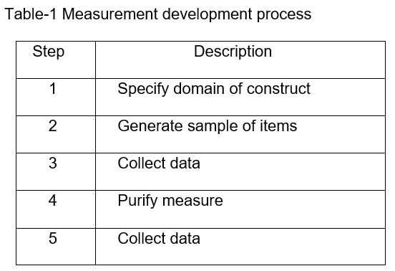
As a first step, this research divided the retail image construct from (Dickson and Albaum, 1977) into seven components: the online store's usefulness, enjoyment, ease of use, trustworthiness, style, familiarity, and settlement. (Dickson and Albaum, 1977) focuses on creating customized semantic differential scales for use in marketing research. These scales are designed to measure attitudes or perceptions by asking respondents to rate concepts on a series of bipolar adjectives.

Step two involved recruiting five friends with prior expertise purchasing online to serve as a focus group. One kind of qualitative research is the focus group, which involves interviewing a chosen few people to get their opinions and experiences. It involves open discussions led by a moderator to explore specific topics, such as new products, services, or concepts. Although results may not be statistically representative of larger populations, the focus group, it can spark new ideas for products or marketing approaches and reveal subtleties in consumer perceptions that might be missed in structured formats. Two people who actually worked in e-commerce were part of the focus group. In an online shopping context, we asked all participants to rate the goods from (Dickson and Albaum, 1977) and suggest any other elements that would influence their decision to make a purchase. Because of this, the Pilot Test Questionnaire was developed, which consists of seven factors and thirty-two items: online store usefulness (with six items), enjoyment (with three items), ease of use (five items), trustworthiness (four items), style (five items), familiarity (four items), and settlement (five items). The scales used to measure online purchase intentions were adapted from those of (Jarvenpaa, Tractinsky and Vitale, 2000) with some adjustments made in the wake of a previous study on online purchase intentions (Van Der Heijden, Verhagen and Creemers, 2003). At the conclusion of the Pilot Test Questionnaire, participants are asked to indicate their intentions to make an online purchase (four items total).

Step Three: A pilot test of the instrument was carried out by this study with 10 respondents chosen by convenience sampling. The Pilot Test Questionnaire and an overview of the HKTVmall (1137.hk) online store were distributed to the participants.

Using data from the Pilot Test's convenience sample, this study looked at the measurement scales' reliability in Step Four to see how they may be improved. Analysing the total scores of each online store component against the intentions to make a purchase from the store allowed us to illustrate the predictive accuracy of the Factors. Each measurement's Cronbach's Alpha was computed in this study. Reliability was improved by eliminating six items with alpha coefficients below 0.70 (George and Mallery, 2003). The revised items from the Pilot Test Questionnaire are displayed in Table 2.

Table-2 Items Revisions from Pilot Test
Example | Construct | Item | Revision | Reason
1 | Store Usefulness | "High price - Low price" | Deleted Item | Cronbach’s Alpha < 0.7
2 | Store Usefulness | "Little choice - A lot of choice" | Deleted Item | Cronbach’s Alpha < 0.7
3 | Store Ease of use | "Hard to navigate the site - easy to navigate the site" | Deleted Item | Cronbach’s Alpha < 0.7
4 | Store Style | "Calm - Pushy" | Deleted Item | Cronbach’s Alpha < 0.7
5 | Store Familiarity | "Unpopular among friends - Popular among friends" | Deleted Item | Cronbach’s Alpha < 0.7
6 | Store Settlement | "Poor purchase record format - Good purchase record format" | Deleted Item | Cronbach’s Alpha < 0.7

As a result, the Final Experiment Questionnaire was developed, which comprises seven factors totaling twenty-six items: online store usefulness (four items), enjoyment (three items), ease of use (four items), trustworthiness (four items), style (four items), familiarity (three items), and settlement (four items). The Final Experiment Questionnaire includes a 4-item scale for measuring online purchase intentions, which the target participants are asked to complete. To find the translated instrument, please see Appendix A.

Step five of this study involved conducting the Final Experiment with a group of professionals consisting of thirty chief financial officers or chief executive officers from Hong Kong enterprises that were either publicly listed or privately held. CEO and CFO are usually highly educated with good knowledge and communication skill who can easily observe and understand the characteristics and difference of a setting or an environment, and clearly and accurately express their meaningful opinion. The poll consisted of seven elements and twenty-seven items; at the conclusion, professionals were asked to indicate their plans to purchase online (4 items) after studying the HKTVmall (1137.hk) website.

- Results

Fifteen males and fifteen females make up the thirty-person Final Experience sample for this research. Although 26.6% and 6.6% of participants made online purchases on a monthly and daily basis, respectively, the majority of them (66.6%) are seasoned online shoppers who make online purchases at least once a week. Due to scheduling constraints, we were unable to separate participants into age groups for the Final Experience. Key characteristics of the Final Experient sample are displayed in Table-3 of this study.

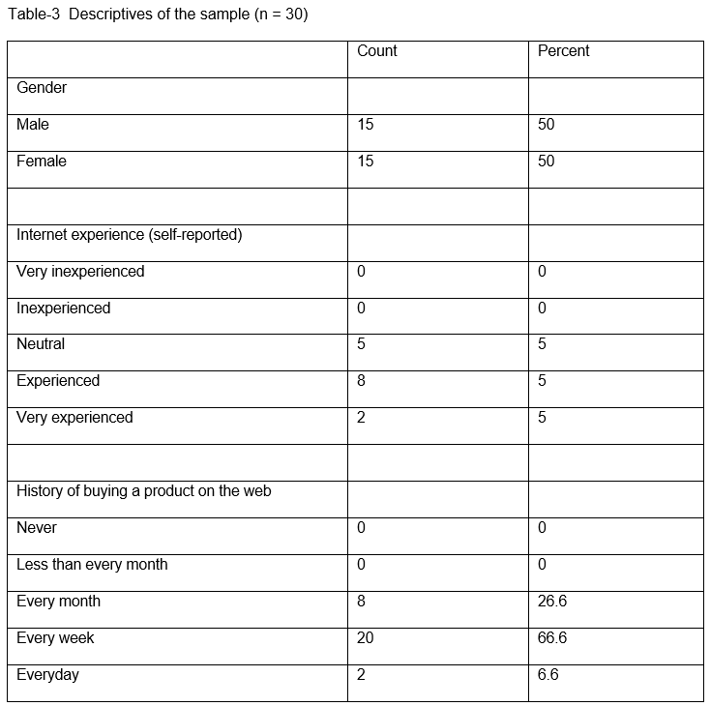
The disparities in performance between the sexes were also examined in this research. Table 4 displays the data for the two categories first. Compared to males, ladies have higher mean scores, suggesting that men are less likely to make a purchase.
Table-4 Statistics of Male and Female
 | N | Mean | SD | Variance | Range | Minimum | Maximum
Male | 15 | 6.00 | 0.845 | 0.714 | 2 | 5 | 7
Female | 15 | 6.20 | 0.862 | 0.743 | 2 | 5 | 7

The statistical results of the Final Experiment are displayed in Table 5. This includes the mean, standard deviation, range, minimum, and maximum scores for each item in the study. The box plot and the quantile-quantile plot are displayed in tables 6-7.

Table-5 Items Statistics
Scale | Item | Mean | Std. Deviation | Minimum | Maximum | Range
Store Usefulness | Item 1 | 6.07 | 0.78 | 5 | 7 | 2
Store Usefulness | Item 2 | 6.37 | 0.76 | 5 | 7 | 2
Store Usefulness | Item 3 | 6.37 | 0.76 | 5 | 7 | 2
Store Usefulness | Item 4 | 5.8 | 0.96 | 4 | 7 | 3
Store Enjoyment | Item 5 | 6.2 | 0.81 | 5 | 7 | 2
Store Enjoyment | Item 6 | 6.2 | 0.81 | 5 | 7 | 2
Store Enjoyment | Item 7 | 6.2 | 0.81 | 5 | 7 | 2
Store Ease of Use | Item 8 | 5.33 | 0.88 | 4 | 7 | 3
Store Ease of Use | Item 9 | 5.33 | 0.88 | 4 | 7 | 3
Store Ease of Use | Item 10 | 5.33 | 0.92 | 4 | 7 | 3
Store Ease of Use | Item 11 | 5.5 | 0.86 | 4 | 7 | 3
Store Trustworthiness | Item 12 | 6.07 | 0.78 | 5 | 7 | 2
Store Trustworthiness | Item 13 | 6.07 | 0.78 | 5 | 7 | 2
Store Trustworthiness | Item 14 | 6.07 | 0.78 | 5 | 7 | 2
Store Trustworthiness | Item 15 | 6.1 | 0.76 | 5 | 7 | 2
Store Style | Item 16 | 5.83 | 0.99 | 4 | 7 | 3
Store Style | Item 17 | 5.83 | 0.99 | 4 | 7 | 3
Store Style | Item 18 | 6.07 | 1.01 | 4 | 7 | 3
Store Style | Item 19 | 5.67 | 1.09 | 4 | 7 | 3
Store Familarity1 | Item 20 | 6.2 | 0.81 | 5 | 7 | 2
Store Familarity1 | Item 21 | 4.93 | 0.78 | 4 | 6 | 2
Store Familarity1 | Item 22 | 4.87 | 0.73 | 3 | 6 | 3
Store Settlement | Item 23 | 5.77 | 1.01 | 3 | 7 | 4
Store Settlement | Item 24 | 5.77 | 1.01 | 3 | 7 | 4
Store Settlement | Item 25 | 5.73 | 1.05 | 3 | 7 | 4
Store Settlement | Item 26 | 6.2 | 0.81 | 5 | 7 | 2
Intentions to Buy | Item 27 | 6.2 | 0.81 | 5 | 7 | 2
Intentions to Buy | Item 28 | 6.37 | 0.76 | 5 | 7 | 2
Intentions to Buy | Item 29 | 6.07 | 0.78 | 5 | 7 | 2
Intentions to Buy | Item 30 | 6.07 | 0.78 | 5 | 7 | 2

Table-6 Box plot
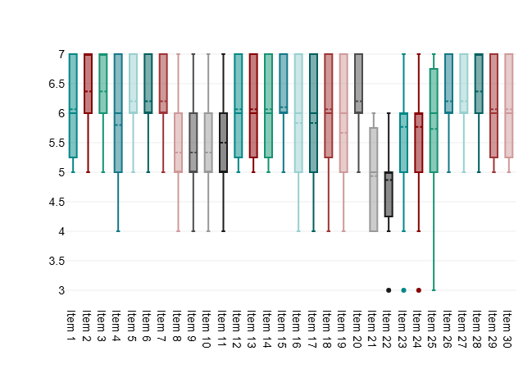

Table-7 Quantile-Quantile Plot.
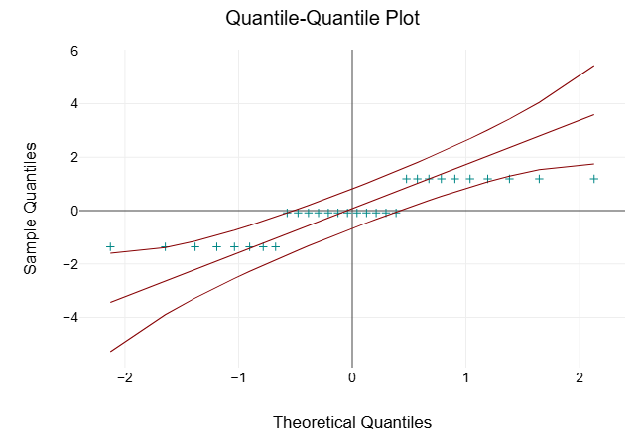

The next step was to assess the inter-question reliability using Cronbach's Alpha, as described in (George and Mallery, 2003). Each question that makes up the set is known as an item on the scale. Thus, Cronbach's alpha provides a way to evaluate a scale's reliability by looking at its internal consistency. When the value is greater than 0.9, it is deemed important since it suggests that there are too many comparable features and the same thing is being produced. Here is Table-8 from (George and Mallery, 2003) that can be used as a guide for interpreting Cronbach's alpha. The results of Cronbach's Alpha for 7 factors are presented in Table-9, and the breakdown of those results is presented in Table-10.

Table-8 Rule of Thumb of the Cronbach's Alpha
Cronbach’s Alpha | Interpretation
> 0.9 | Excellent
> 0.8 | Good
> 0.7 | Acceptable
> 0.6 | Questionable
> 0.5 | Poor
< 0.5 | Unacceptable
Table-9 Cronbach’s Alpha for 7 Factors
Cronbach's Alpha | Number of Factors
0.95 | 7

This means that seven factors were used to determine the Cronbach's Alpha value. As a general rule, Cronbach's Alpha tends to rise as the number of objects increases. While things with a high Cronbach's Alpha tend to have good internal consistency, it doesn't prove they effectively measure the intended construct. Simply said, it signifies that the products have consistent measurements. Two important pieces of information regarding Cronbach's Alpha, a statistician's go-to for gauging an item set's reliability or internal consistency, are presented in this results table. This reliability indicator has a Cronbach's Alpha of 0.95. As Cronbach's Alpha can take on values between 0 and 1, this is an extremely high value. If your set's reliability and consistency score is 0.95, then your set is excellent. A Cronbach's Alpha of 0.7 or above is generally deemed adequate, whereas 0.8 or higher is deemed good, and 0.9 or higher is deemed great. With a value of 0.95, the items measure the underlying construct fairly consistently, which is great. This means that seven items were used to generate the Cronbach's Alpha value. As a general rule, Cronbach's Alpha tends to rise as the number of objects increases. While things with a high Cronbach's Alpha tend to have good internal consistency, it doesn't prove they effectively measure the intended construct. Simply said, it signifies that the products have consistent measurements.

Table-10 Breakdown of Cronbach’s Alpha for 7 Factors
 | Cronbach's Alpha | Cronbach's Alpha if Item Deleted
Store Usefulness | 0.8 | 0.94
Store Enjoyment | 0.85 | 0.93
Store Ease of Use | 0.66 | 0.95
Store Trustworthiness | 0.92 | 0.93
Store Style | 0.77 | 0.94
Store Familiarity | 0.78 | 0.94
Store Settlement | 0.75 | 0.94
Intentions to Buy | 0.95 | 0.93

Corrected item-total correlation and Cronbach's alpha when each item is excluded are what we care about when analysing Cronbach's alpha results. It boils down to checking your scale's internal consistency and how each item affects it. Here, a low correlation indicates that the item is not in such excellent agreement with the score of the other items, but a high correlation indicates that the item aligns well with the total score of the other items, contributing greatly to the scale's internal consistency. Table-7 show the breakdown of Cronbach’s Alpha for the 7 factors. With 0.8 Store Usefulness has a very strong correlation. With 0.85 Store Enjoyment has a very strong correlation. With 0.66 Store Ease of Use has a very strong correlation. With 0.92 Store Trustworthiness has a very strong correlation. With 0.77 Store Style has a very strong correlation. With 0.78 Store Familiarity has a very strong correlation. With 0.75 Store Settlement has a very strong correlation. With 0.95 Intentions to Buy has a very strong correlation.

Taking Store Usefulness off the scale reduces its Cronbach's Alpha, which means it doesn't provide anything useful and has a negative impact on the scale's internal consistency. The fact that removing Store Enjoyment lowers the total Cronbach's Alpha indicates that it is not useful for the scale and has a detrimental impact on its internal consistency. Store Ease of Use is an important component of the scale and adds favorably to its internal consistency; removing it raises the Cronbach's Alpha from the total scale, indicating this. Taking Store Trustworthiness off the scale reduces its Cronbach's Alpha, which means it doesn't provide anything useful and hurts the scale's internal consistency. The fact that removing Store Style reduces the total Cronbach's Alpha indicates that it is not useful for the scale and has a detrimental impact on its internal consistency. Taking Store Familiarity off the scale reduces its Cronbach's Alpha, which means it doesn't provide anything useful and hurts the scale's internal consistency. The fact that removing Store Settlement lowers the overall Cronbach's Alpha indicates that it is not useful for the scale and has a negative impact on its internal consistency. By reducing the overall scale's Cronbach's Alpha, removing Intentions to Buy suggests that the item is not useful for the scale and badly impacts its internal consistency.

Using an independent samples T-test, we examined the null hypothesis that no association exists between the seven criteria that online shoppers consider important and their propensity to make a purchase. The T-test is administered with a 95% confidence interval when the score of the intents to buy from this study reaches 6.2. See the 7 Factors' T-Test results in Table-11.

Table-11 Independent T-test for 7 Factors
 | Mean | t | df | p
Usefulness | 6.15 | -0.4 | 29 | 0.693
Enjoyment | 6.2 | 0 | 29 | 1
Ease of use | 5.38 | -5.24 | 29 | <.001
Trustworthiness | 6.08 | -0.89 | 29 | 0.379
Style | 5.85 | -2.45 | 29 | 0.021
Familiarity | 5.33 | -7.18 | 29 | <.001
Settlement | 5.87 | -2.14 | 29 | 0.041

At the predetermined significance level of 0.05, we found p-values of.693, 1, and 0.379 for Store Usefulness, Store Enjoyment, and Store Trustworthiness, respectively. For these reasons, we cannot conclude that the null hypothesis is false based on the t-test results. When it comes to Store Style, Store Familiarity, Store Settlement, and Store Ease of Use, the p-values are lower than the predetermined significance level of 0.05. Thus, the null hypothesis was rejected due to the significant T-test result for the given data.

- Discussion and limitation

Several new insights regarding the public's perception of internet shopping in Hong Kong have emerged from this survey. The original purpose of this research was to develop evaluations for seven key ideas related to the concept of online store image. The measures, which include a variety of items, have been through normal reliability tests. The results of this study establish a relationship between these variables and the favorable perception of online purchasing. The two store metrics with the greatest Cronbach's Alpha coefficients are store trustworthiness and store enjoyment. On the one hand, it improves and expands upon similar empirical research in the area. However, it did address a need, as there has been very little study on what factors affect Hong Kong residents' perceptions of online stores and their intents to shop there in the past several years.

Nevertheless, the individuals' ages are a drawback of this research. We made a lot of efforts to reach out to younger generations, but they were unwilling to participate in our study. This study does not include many younger generations, and the majority of participants are older than 30. Although the purchasing power of youngsters may not be as solid as that of adults, youngsters is the next generation who uphold the purchasing power, whose current perception is our coming demand. Another limitation is that here is limited famous online store in Hong Kong. In this study, interviewee was required to study only the website of HKTVmall (1137.hk) online store before filling out the survey. The findings of study would be more representative and fruitful if interviewee could study more website of online store in Hong Kong before filling out the survey. Final limitation is the types of products of online store. As here is limited famous online store in Hong Kong, we cannot divide the online store into different category according to the types of its selling product. Therefore, this study can only base on an online store which is currently selling different kinds of products.

- Conclusions and recommendations

The focus of this research was the perception of internet stores. The literature on the topic of online store image was reviewed in this study. A preliminary measurement tool was developed by combining this approach—which was suggested by Churchill (1979)—with a focus group trial run. My Pilot Test made use of this in the end. This study enhanced the tools by analyzing the data from the Pilot Test. After that, 7 Factors were identified, each containing 26 components, that contribute to the perception of online stores.

There are a minimum of two findings from this investigation. To begin, contrary to the results of earlier studies, we find that the image of an online business has a minimal link with store ease of use and store settlement. Two, the study confirms what Van der Heijden and Verhagen (2004) found, which is that shop trustworthiness is an important part of customers' perceptions of online stores, and it suggests that store enjoyment is a major element in customers' propensity to make a purchase. Investing in making the store more noticeable and appealing is not likely to have a significant impact on the perception of online stores, according to this study. Improving the Store Trustworthiness and Store Enjoyment of one's website is a win-win for online stores. If the marketing budget needs to be prioritized, this study provides support for that.

Consumers' perceptions of physical and virtual stores have a direct impact on their propensity to shop online (Verhagen & Van Dolen, 2009). In addition, they confirmed that the offline store impressions were used as benchmarks for the internet stores. However, the prospective interactions between online and offline store image components are not addressed in this work, which focuses solely on the structural relationships between online store image. Many stores actually have both physical locations and an online presence. Therefore, it would be wise for researchers to delve further into the interconnections between different facets of a store's offline and online images in the future. However, here is the proposal that participants can be divided into different age groups in future studies. Additional categories of online stores, such as those selling books, clothing, food, electronics, etc., could be the subject of future studies. Investors and readers alike will be able to zero in on the best places to put their money to reach various types of online shoppers.

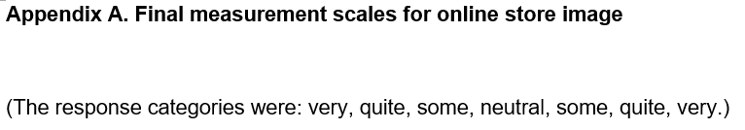
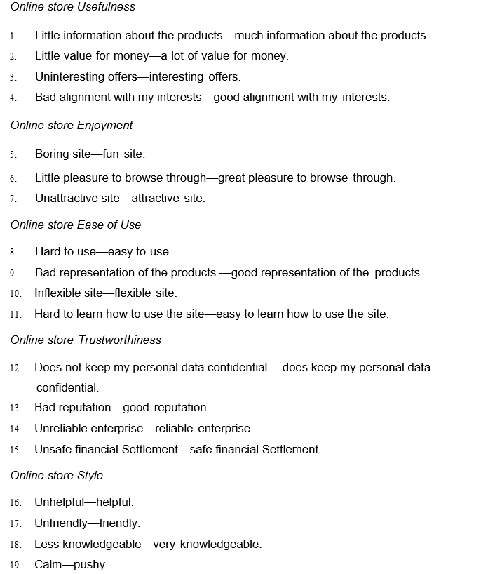

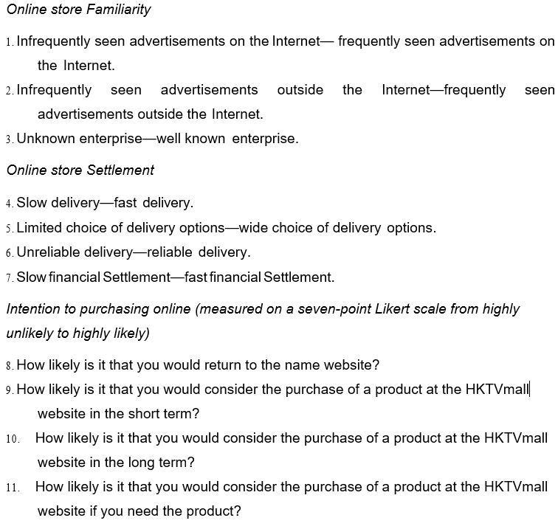

References
Baker, J., Grewal, D. and Parasuraman, A. (1994) ‘The Influence of Store Environment on Quality Inferences and Store Image’, Journal of the Academy of Marketing Science, 22(4), pp. 328–339. Available at: https://doi.org/10.1177/0092070394224002.
Beatty, S.E. and Elizabeth Ferrell, M. (1998) ‘Impulse buying: Modeling its precursors’, Journal of Retailing, 74(2), pp. 169–191. Available at: https://doi.org/10.1016/S0022-4359(99)80092-X.
Bell, S.J. (1999) ‘Image and consumer attraction to intraurban retail areas: An environmental psychology approach’, Journal of Retailing and Consumer Services, 6(2), pp. 67–78. Available at: https://doi.org/10.1016/S0969-6989(98)00015-0.
Chau, P., Au, G. and Tam, K.Y. (2000) ‘Impact of Information Presentation Modes on Online Shopping: An Empirical Evaluation of a Broadband Interactive Shopping Service’, Journal of Organizational Computing and Electronic Commerce, 10(1), pp. 1–20.
Chen, M.-Y. and Teng, C.-I. (2013a) ‘A comprehensive model of the effects of online store image on purchase intention in an e-commerce environment’, Electronic Commerce Research, 13(1), pp. 1–23. Available at: https://doi.org/10.1007/s10660-013-9104-5.
Chen, M.-Y. and Teng, C.-I. (2013b) ‘A comprehensive model of the effects of online store image on purchase intention in an e-commerce environment’, Electronic Commerce Research, 13(1), pp. 1–23. Available at: https://doi.org/10.1007/s10660-013-9104-5.
Cho, N. and Park, S. (2001) ‘Development of electronic commerce user‐consumer satisfaction index (ECUSI) for Internet shopping’, Industrial Management & Data Systems, 101(8), pp. 400–406. Available at: https://doi.org/10.1108/EUM0000000006170.
Churchill, G.A. (1979) ‘A Paradigm for Developing Better Measures of Marketing Factors’, Journal of Marketing Research, 16(1), p. 64. Available at: https://doi.org/10.2307/3150876.
Culnan, M.J. and Armstrong, P.K. (1999) ‘Information Privacy Concerns, Procedural Fairness, and Impersonal Trust: An Empirical Investigation’, Organization Science, 10(1), pp. 104–115. Available at: https://doi.org/10.1287/orsc.10.1.104.
Davis, F.D. (1989) ‘Perceived Usefulness, Perceived Ease of Use, and User Acceptance of Information Technology’, MIS Quarterly, 13(3), p. 319. Available at: https://doi.org/10.2307/249008.
Dickson, J. and Albaum, G. (1977) ‘A Method for Developing Tailormade Semantic Differentials for Specific Marketing Content Areas’, Journal of Marketing Research, 14(1), pp. 87–91. Available at: https://doi.org/10.1177/002224377701400110.
Dodds, W.B., Monroe, K.B. and Grewal, D. (1991) ‘Effects of Price, Brand, and Store Information on Buyers’ Product Evaluations’, Journal of Marketing Research, 28(3), p. 307. Available at: https://doi.org/10.2307/3172866.
Doney, P.M. and Cannon, J.P. (1997) ‘An Examination of the Nature of Trust in Buyer-Seller Relationships’, Journal of Marketing, 61(2), p. 35. Available at: https://doi.org/10.2307/1251829.
Donovan, R. (1994) ‘Store atmosphere and purchasing behavior’, Journal of Retailing, 70(3), pp. 283–294. Available at: https://doi.org/10.1016/0022-4359(94)90037-X.
Fandos Herrera, C. and Flavián Blanco, C. (2011) ‘Consequences of consumer trust in PDO food products: the role of familiarity’, Journal of Product & Brand Management, 20(4), pp. 282–296. Available at: https://doi.org/10.1108/10610421111148306.
George, D. and Mallery, P. (2003) SPSS for Windows step by step: a simple guide and reference, 11.0 update. 4th ed. Boston: Allyn and Bacon.
Grewal, D. et al. (1998) ‘The effect of store name, brand name and price discounts on consumers’ evaluations and purchase intentions’, Journal of Retailing, 74(3), pp. 331–352. Available at: https://doi.org/10.1016/S0022-4359(99)80099-2.
Ha, S. and Stoel, L. (2009) ‘Consumer e-shopping acceptance: Antecedents in a technology acceptance model’, Journal of Business Research, 62(5), pp. 565–571. Available at: https://doi.org/10.1016/j.jbusres.2008.06.016.
Hirschman, E.C., Greenberg, B. and Robertson, D.H. (1978) ‘The intermarket reliability of retail image research: an empirical examination’, Journal of Retailing, 54(1), pp. 3-12.
Hoffman, D.L., Novak, T.P. and Peralta, M. (1999) ‘Building consumer trust online’, Communications of the ACM, 42(4), pp. 80–85. Available at: https://doi.org/10.1145/299157.299175.
Houston, M.J. and Nevin, J.R. (1981) ‘RETAIL SHOPPING AREA IMAGE: STRUCTURE AND CONGRUENCY BETWEEN DOWNTOWN AREAS AND SHOPPING CENTERS.’, Advances in Consumer Research, 8(1), p. 667.
Huizingh, E.K.R.E. (2000) ‘The content and design of web sites: an empirical study’, Information & Management, 37(3), pp. 123–134. Available at: https://doi.org/10.1016/S0378-7206(99)00044-0.
Jarvenpaa, S.L., Tractinsky, N. and Vitale, M. (2000) ‘Consumer trust in an internet store’, INFORMATION TECHNOLOGY AND MANAGEMENT, 1(1/2), pp. 45–71. Available at: https://doi.org/10.1023/A:1019104520776.
Kelly, R.F. and Stephenson, R. (1967) ‘The Semantic Differential: An Information Source for Designing Retail Patronage Appeals’, Journal of Marketing, 31(4), pp. 43–47. Available at: https://doi.org/10.1177/002224296703100409.
Korgaonkar, P.K. and Bellenger, D.N. (1980) ‘Profiling the recreational shopper’, Journal of retailing, 56, pp. 77–91.
LE, H.B.H. et al. (2020) ‘Factor Affecting Customers’ Decision to Use Mobile Banking Service: A Case of Thanh Hoa Province, Vietnam’, The Journal of Asian Finance, Economics and Business, 7(2), pp. 205–212. Available at: https://doi.org/10.13106/JAFEB.2020.VOL7.NO2.205.
Lederer, A.L. et al. (2000) ‘The technology acceptance model and the World Wide Web’, Decision Support Systems, 29(3), pp. 269–282. Available at: https://doi.org/10.1016/S0167-9236(00)00076-2.
Liao, Z. and Shi, X. (2009) ‘Consumer perceptions of internet‐based e‐retailing: an empirical research in Hong Kong’, Journal of Services Marketing, 23(1), pp. 24–30. Available at: https://doi.org/10.1108/08876040910933066.
Lindquist, J.D. (1974) ‘Meaning of Image: Survey of Empirical and Hypothetical Evidence’, Journal of Retailing, 50(4), pp. 29–38.
Liu, C. and Arnett, K.P. (2000) ‘Exploring the factors associated with Web site success in the context of electronic commerce’, Information & Management, 38(1), pp. 23–33. Available at: https://doi.org/10.1016/S0378-7206(00)00049-5.
Luhmann, N. (2000) ‘Familiarity, Confidence, Trust: Problems and Alternatives’, Department of Sociology, University of Oxford, Chapter 6, pp. 94–107.
Martineau, P. (1958) ‘The personality of the retail store’, Harvard Business Review, 36(1), pp. 47–55.
Mohan, G., Sivakumaran, B. and Sharma, P. (2013) ‘Impact of store environment on impulse buying behavior’, European Journal of Marketing, 47(10), pp. 1711–1732. Available at: https://doi.org/10.1108/EJM-03-2011-0110.
NGUYEN, O.T. (2020) ‘Factors Affecting the Intention to Use Digital Banking in Vietnam’, The Journal of Asian Finance, Economics and Business, 7(3), pp. 303–310. Available at: https://doi.org/10.13106/JAFEB.2020.VOL7.NO3.303.
Poiesz, T.B.C. (1989) ‘The image concept: Its place in consumer psychology’, Journal of Economic Psychology, 10(4), pp. 457–472. Available at: https://doi.org/10.1016/0167-4870(89)90038-X.
Ranganathan, C. and Grandon, E. (2002) ‘An Exploratory Examination of Factors Affecting Online Sales’, Journal of Computer Information Systems, 42(3), pp. 87–93. Available at: https://doi.org/10.1080/08874417.2002.11647507.
Sarika, K. et al. (2016) ‘A Study of Adoption Behavior for Online Shopping: An Extension of Tam Model’.
Shannon, R. and Mandhachitara, R. (2008) ‘Causal path modeling of grocery shopping in hypermarkets’, Journal of Product & Brand Management, 17(5), pp. 327–340. Available at: https://doi.org/10.1108/10610420810896086.
Spence, M. (1973) ‘Job Market Signaling’, The Quarterly Journal of Economics, 87(3), p. 355. Available at: https://doi.org/10.2307/1882010.
Sweeney, J.C., Soutar, G.N. and Johnson, L.W. (1999) ‘The role of perceived risk in the quality-value relationship: A study in a retail environment’, Journal of Retailing, 75(1), pp. 77–105. Available at: https://doi.org/10.1016/S0022-4359(99)80005-0.
Van der Heijden, H. and Verhagen, T. (2004) ‘Online store image: conceptual foundations and empirical measurement’, University of Amsterdam, 41(5), pp. 609–617.

Van Der Heijden (2004) ‘User Acceptance of Hedonic Information Systems’, MIS Quarterly, 28(4), p. 695. Available at: https://doi.org/10.2307/25148660.
Van Der Heijden, H., Verhagen, T. and Creemers, M. (2003) ‘Understanding online purchase intentions: contributions from technology and trust perspectives’, European Journal of Information Systems, 12(1), pp. 41–48. Available at: https://doi.org/10.1057/palgrave.ejis.3000445.
Verhagen, T. and Van Dolen, W. (2009) ‘Online purchase intentions: A multi-channel store image perspective’, Information & Management, 46(2), pp. 77–82. Available at: https://doi.org/10.1016/j.im.2008.12.001.
Zhang, J., Ghorbani, A.A. and Cohen, R. (2007) ‘A familiarity-based trust model for effective selection of sellers in multiagent e-commerce systems’, International Journal of Information Security, 6(5), pp. 333–344. Available at: https://doi.org/10.1007/s10207-007-0025-y.

