Assignment (front)


Name: Md Mustakim Miah Burhani
Student Number: 2246150
Hotel Administration and Front Office operations (BMIH4004)
Lecturer’s Name: Scott James BA Hons, MBA, PGCE-PCET
Task: Student Journal (Learning Log)
Submission date: 22/02/24
Word count: 750 words

Introduction: The January 22nd placement at Holiday Inn Birmingham City Centre focused on active participation and aimed to teach various tasks. Monica Arevalo, the front office manager, introduced guests, arrival reports, and IHG Merlin. The placement brought together experienced and aspiring professionals, but some participants expressed mixed feelings due to time constraints and outdated reception systems. The hotel front desk worker is responsible for greeting guests, registering them, handling check-ins and check-outs, providing accurate information, assisting with luggage and transportation, handling guest complaints, maintaining cleanliness, processing payments, and collaborating with other departments. The ideal worker should have excellent communication, problem-solving, organizational, multitasking, fast-paced work skills, proficiency in hotel reservation systems, flexibility in shifts, strong customer service orientation, and a professional appearance.
Reception: Hotel receptionists are responsible for welcoming guests, arranging rooms, answering phone calls, and sorting daily mail. They handle various tasks such as checking booking details, arranging rooms, answering phone calls, completing administrative tasks, responding to requests for help, providing concierge services, preparing room bills, and checking guests out. They also handle administrative tasks like filing and photocopying, assisting with requests for help, and ensuring prompt payments. Their duties include greeting guests, directing them, answering screening calls, and ensuring a smooth check-out process.
Finance: (such as account settlement or currency exchange) includes everything from proper calculation and payment collection to spreadsheet management and invoice correction and printing. It manages income and spending while also ensuring that the firm runs smoothly with minimal disruptions. Aside from the typical functions, the front office department's responsibilities include economic analysis to enhance crucial company initiatives. Also, give price plan increases and decreases basis the circumstance.
Review and respond to customer feedback: as a front office worker it is very common and key administrative and operational duties are required to respond to positive and negative reviews. Any complaints going against him were also solved it or informed by the manager. When I checked reviews at Holiday Inn I found lots of positive reviews and some negative reviews. Some of their reviews were very critical, they mutually discussed and then responded.

Concierge: A concierge is a multilingual hotel staff member responsible for handling luggage, mail, reservations, and tours. They provide information on local attractions, shopping, dining, entertainment, nightlife, and recreation. They can also act as a receptionist, landlord's representatives, caretaker, resident assistant, maintenance coordinator, building news service, mail handler, and organize events for residents.:
Call handling/switchboard:
Holiday Inn must follow guidelines for phone communication with guests:
1. Including answering within three rings,
2. providing proper greetings, recognizing the hotel or employee by their first name for external calls,
3. providing assistance, and retrieving and mentioning the caller's name twice during the conversation.
4. This ensures a smooth and efficient communication process for both guests and the hotel.
The service standard for guest telephone communication at Holiday Inn, 1. Requesting permission before putting a call on hold, 2. providing a response every thirty seconds, and never sending a caller to voicemail unless they have agreed. 3. Voicemail messages must include a return option for the operator. 4. Callers moved to another department are informed of their link, calls are not screened, 5. Guest names and room numbers are never given out.
Check-in and out: The hotel check-in process is a crucial part of a guest's journey, involving registration, keys, and room settling. Implementing a user-friendly web and mobile app can improve the process and improve guest satisfaction. Hotel check-in policies are guidelines established by the property to ensure an efficient procedure. Offering flexible check-in and check-out times can set the tone for the entire guest experience and help hotels operate more efficiently.
Flexible check-in and check-out times can attract younger and solo travelers, improve guest satisfaction ratings, and attract unique competitors like Airbnb. Automating the front desk via online check-in systems can cut labor costs and attract larger hotels. However, guests may be receptive to upgrades or upsells due to fatigue or frustration.
Conclusion: A hotel front desk agent is crucial for a seamless guest experience, handling tasks like greeting guests, checking in and out, bookings, providing information, and maintaining a professional environment. Offering flexible check-in and check-out times attracts and retains travelers. Effective communication and trustworthiness are essential for a positive experience. The receptionist must work well with minimal direct supervision.
Action plan:
1. The hotel front desk agent is responsible for customer service, and managing check-ins and check-outs.
2. Handling complaints, and ensuring smooth operations.
3. Ideal workers have high school diplomas.
4. Hotel experience.
5. proficiency in multiple languages. and
6. Able to work for extended periods.
References
1.Cottrell, S. (2019) The Study Skills Handbook. Fifth edition. London: Macmillan International Higher Education/Red Globe Press.
2.Jasper, M. (2013). Beginning Reflective Practice. Andover: Cengage Learning.
3.McMillan, K, & Weyers, J (2021) The Study Skills Book. Harlow: Pearson Education Limited. 4.Microsoft Office (N.D) Download Microsoft Teams. Available at: https://www.microsoft.com/en-ww/microsoftteams/download-app (Accessed on 20th September 2022)
5.University of Wales Trinity Saint David (N.D) Quick Links. Available at: https://www.uwtsd.ac.uk/quick-links/ (Accessed on 20th September 2022
6.Canziani, B.F. et al. (2016) ‘Classifying restaurants to improve usability of restaurant research’, International Journal of contemporary hospitality management, 28(7), pp. 1467–1483.
7. National Restaurant Association. (N.D.). History of Restaurants. Available at: https://www.restaurant.org/articles/news/history-of-restaurants (Accessed on 24th of March 2023) 8.Brunner, B. (2017, October 16). The History of American Restaurants. Eater. Available at: https://www.eater.com/2017/10/16/16481834/history-of-american-restaurants (Accessed on 24th of March 2023)
9. National Restaurant Association. (n.d.). Restaurant industry timeline. Retrieved March 24, 2023, from https://www.restaurant.org/research/timeline
10.Trotter, J. F. (2020, August 20). How COVID-19 Is Impacting The Restaurant Industry And What To Expect In The Future. Forbes. https://www.forbes.com/sites/jimtrotter/2020/08/20/how-covid-19-is-impacting-the-restaurant-industry-and-what- toexpect-in-the-future/?sh=1e642c53795d 11.Institute of Hospitality (2022) Hard skills and soft skills – what’s the difference? Available at: https://www.instituteofhospitality.org/professional-development/hard-and-soft-skills-whats-the-difference/(Accessed on 20th of September 2022)

Task description component two
Practical task – scenario

Positive trip advisor post 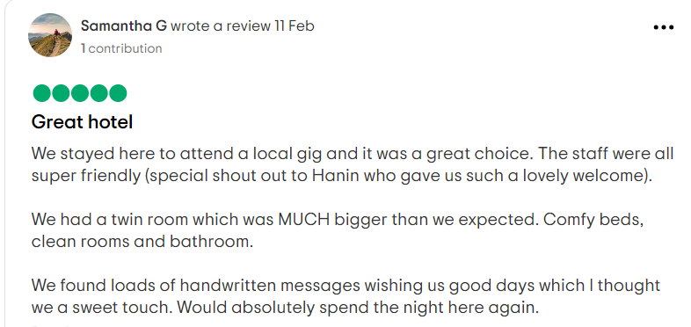

1.Mr. samantha's positive review has made our day, and we've shared it with our team. Your feedback is appreciated, and we're grateful for the valuable service you've provided. We're grateful for your choice and eager to assist you again.
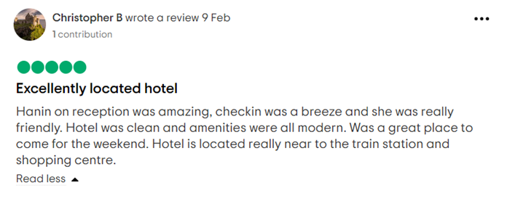
2.Dear,christopher's positive feedback on our service has been passed on to our Hanin on reception team, who are dedicated to providing exceptional experiences for clients. We hope to continue providing excellent service in the future and value customer feedback for continuous improvement. Please let us know if there are any areas for improvement.

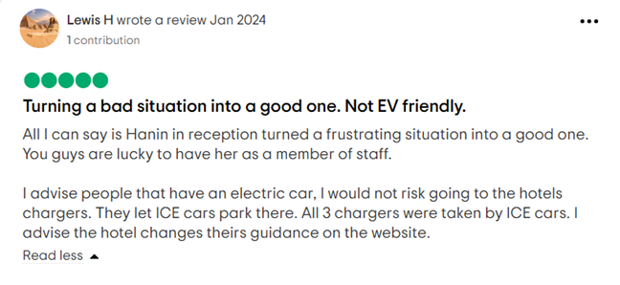

3. Hi Lewis, thanks for a 5-star rating, stating that they are committed to delivering high-quality service from receptionist Hanin, look forward to servicing the receiver again, and that they are delighted with the comments.
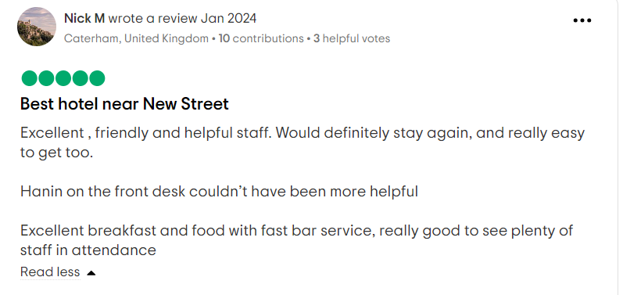
4. Dear Nick, thank you for your five-star rating and choice of our hotel. We appreciate your satisfaction and are committed to continuous improvement. Our front-desk workers (particularly Hanin) always receive high marks. We welcome any additional input and look forward to serving you again.

Letter of complaint:
Hello, Mrs. Joanna Blake.
I am most grateful for the feedback on their recent stay at a resort, stating that guest satisfaction is their top priority. I will encourage you to contact me directly to discuss their experience further. we are extremely enthusiastic about the hotel's service and its potential for improvement, and most eager to learn how to improve from the feedback.
Cleanliness / Dirty floor / Unclean bathroom:
Dear Mrs Joanna Blake, Thank you for bringing this issue to our notice. We apologise for the inconvenience caused by your room's cleaning concerns. This does not meet our typical standards, and we will take your complaint seriously and do our utmost best to improve this. Our housekeeping team will be notified, and immediate action will be taken to correct the problem and ensure that all cleaning requirements are followed. If you would like to be given the opportunity to discuss your experience further; please contact our management at 01215512520. Your pleasure and content is extremely important to us, and we hope to rebuild your confidence in us during a future visit:
Wifi Service: "Dear Mrs Blake, Thank you for providing feedback on our WiFi. We apologise for the inconvenience you had during your stay. We value your feedback and are committed to maintaining a well-equipped facility. We are continuously improving our equipment to enhance guest experience and invite you to give us another chance to provide a better stay.
Loud Noise from the neighbouring room: "Dear Mrs Joanna Blake, thank you for sharing your concerns about the noise difficulties you had during your visit. We apologise for any difficulty caused by the noises from neighbouring rooms. We appreciate the significance of providing a tranquil atmosphere for our visitors and are actively trying to improve sound insulation throughout the property. We respect your opinion, and it will help us adopt measures to improve our visitors' comfort. We would welcome the opportunity to give you a more pleasant experience in the future.
Stains on the bed: Dear Mrs Joanna Blake, I cannot begin to express how sorry I am for the discomfort you underwent during your stay. This matter was not a regular one as we have a policy on how we clean and set the bed for every one of our respected guests. I apologise profusely and promise that we will give it our all to eliminate this problem and give our visitors the best possible stay they could have. Thank you for your valid complaint and we will work upon your feedback.
Customer service is poor: We sincerely apologise for the behaviour you encountered from our employees. This poor behaviour certainly didn’t meet our expectations as members of the hotel board and are extremely sorry for what you experienced. We endeavour to deliver great service, and we apologise that we fell short of your expectations. Your issues will be handled with our team to ensure that such incidents are not repeated in the future. We invite you to discuss your experience further with our management, and we hope to have the chance to rectify any issues in the future. After the investigation, we will refund you that night your payment.

Sincerely,
Mr Mustakim Burhani, General Manager, Holiday Inn

Task description Component three (4 elements- 1000words)
Key Skill 1 Customer service:
For better customer service I will first put in professionalism, I am very passionate about my work, and I can cater to any person in a short time, I also have good patience, and a determined but calm attitude that will help serve the customer efficiently.
In addition, I am very competent, convenient, and proactive. This allows me to go on the proper road and enhance my talents effectively. To meet all the customer needs, we also look after belongings, exchanging foreign currency, call taxis for customers and guide them towards train or coach stations if needed.
Furthermore, empathy, active listening and adaptability to different situations are very common attributes for me. I am able to understand people’s emotions and perspectives and negotiate with them. Customers who reach out for customer service are generally frustrated and confused, so you must ensure that you respect their feelings and refrain from offending them, as It can give the worker and the hotel bad reviews.
Finally, I can communicate in five languages with customers who are unable to communicate English properly (such as Arabic, Hindi, Urdu, and Bangla), this is useful as some tourists are on holiday from a foreign country, and speaking a common language will be good when making reservations and communicating with them. It can also prevent misunderstanding.
I am not an expert in hotel customer service but I am improving through my work placement.I can now serve the guests including check-in and check-out and making keys.
Key skill 2 - Communication skills:
I excel in written communication, nonverbal and visual communication, listening, empathy, and stress management skills. I am adept at expressing knowledge and can calmly listen to complaints and grievances. However, I lack proficiency in oral communication and struggle with extracting contextual information from the literature. I can improve by speaking frequently and attending courses. I can also practice tackling different situations to prepare me for any difficulties in the future. I can overcome my lack of confidence by developing positive interactions, speaking to new people and overcoming emotional issues with a looking at things with a positive view. Overall, I possess strong communication skills and a positive outlook. I also can communicate in many languages (Arabic, Bengali, Urdu, Hindi) if they are more fluent in them, which helps with communication.
Key Skill 3 Organisational skills:
I have excellent organizing skills. For example, I am strong at goal planning and prioritising activities in order to reach my goals. This allows me to go on the proper road and enhance my talents, as well as working efficiently. I have strong time management abilities, which will help me save time in meetings and presentations while also allowing me time to socialize and create a healthy work-life balance. I can also gain a good grasp of prioritization, which will allow me to express things more properly to others and complete difficult tasks in a methodic way. finally, I can negotiate for extended periods, leading to better deals for the industry. I can organise my work by prioritising important tasks that cannot be done by anyone else, and pass on less urgent tasks to people who work with me.
I also have deficiencies in this area. I struggle to solve problems rapidly, which I may do better by soliciting suggestions and viewing the problem from the other persons perspective. Furthermore, I lack listening skills, which I strive to improve by focusing more and avoiding distractions. I take the time to observe nonverbal communication from many people, which may be enhanced by my teacher's explanations.

Key Skill 4 – Problem-solving skills:
I must identify the problem first, as customers often struggle with self-diagnosis and recognising their issues. Support professionals and customer service workers must understand the issue before providing a solution, determining not only the problem but also the consumer's actions and intentions. They must be able to solve the issue without upsetting the consumer as it can leave a bad reputation and reduce business. Problems should be dealt with seriously and not be ignored.
For example, if someone approaches us because they are having difficulty changing their password, it is because they wish to access their account, and the password should be given to them, to keep the customer satisfied and help them access their account.
Break the problem down: one day I saw a guest very upset because he lost his keys, I went to his room to find it inside the pillow cover.
Clarifying the solutions and issue is the foundation of any problem-solving. One guest made a phone for his reservation on Sunday 18 January, but I searched and didn't find any booking under his name, instead, I found his booking for February 17th, and then I spoke with the supervisor to resolve the matter. Miscommunication with customers can lead to problems such as arriving at the hotel on the wrong day or leaving early, so reservations should be clarified in order to refrain from causing such issues
A competent customer care contactor can anticipate requirements, perform resets, offer new login information, and teach clients how to do it themselves. They may also provide anticipatory advice or solutions that the consumer may not be aware of, ensuring a smooth customer experience.

Conclusion: I can identify strengths and weaknesses in my work and the work of others and can devise a plan to overcome them. I suggest seeking help from lecturers and university resources, using fast software and advice, and prioritizing beneficial activities. I also emphasize the importance of realistic goals and time management, as overstretching can lead to burnout and reduce work quality. finally, I will emphasize the importance of time management and resourcefulness as they improve work and customer experience, increasing the reputation of myself and my workplace.

Action plan:
1.To stay competitive, businesses should employ staff training, digital marketing and keep up with trends in the hospitality industry
2. Hotel property management systems. Managers should be competent and responsible for whatever occurs, should be able to manage all situations effectively.
3. Constant inventory monitoring and cost-cutting methods can reduce expenses. Money can be spent on improving the hotel and adding extra features.
4. Address housekeeping issues and offer contactless services.
5. Negotiate extended payment terms with clients and suppliers.
6. Secure data storage is crucial for reputation and guest attraction.
7. Utilize guest reviews, loyalty programs, and chatbots.
8. company analytics software for better decision-making.

In-text citations and references:
1.(Rose,2020). Rose, J. (2020): 10 tips for making a good first impression in hospitality | Talk Business Available at: https://www.talkbusiness.co.uk/2015/11/06/10-tips-for-making-a-good-first-impression-in-hospitality/ (Accessed: September 13, 2023).
2. (millward,2020). Millward, L., 2020. "That cross-country 1969 VW square back and holiday inn affair": lesbian mobility. Journal of Lesbian Studies, 24(3), pp. 298–310. Patel, P., 2019. Exploring Strategies to Attract AsainTravelers in Ontario, California
3.(Herrity,2022). Herrity, J. (2022),Top10 Communication Skills for Career Success. Available at: https://www.indeed.com/careeradvice/resumes-cover-letters/communication-skills (accessed September 13, 2023).
4.(Wales Government, 2016). Welsh Government (2016) Rules requiring takeaways to promote food hygiene ratings on leaflets, come into force. [online] Gov.wales. Available at: [Accessed 17 February 2021].
5. .(Fosket et al.2021, p.150). Foskett, D. et al. (2021) The Theory of Hospitality and Catering. 14th Edition. London: Hodder Education Group.
6.. (Dolce,2018). Dolce, A. (2018) Service isn’t Hospitality [video]. Available at https://www.youtube.com/watch?v=qkU3uwWyAn8. (Accessed: 7th September 2023) .
7. (Solomon,2019). Solomon, M. (2019). Heart of Hospitality. New York: Select Books, Inc.
8.(Petersen,2019). Petersen, L. (2019). Uncontrollable variables that affect the hospitality industry. Available at: https://smallbusiness.chron.com/uncontrollable-variables-affect-hospitality-industry38795.html (Accessed: September 8, 2023) 4.
9. (Dowd, 2018,p.793 ). Dowd, M. (2018) What are the duties of a guest service agent?. Available at:https://work.chron.com/duties-guest-service-agent-19946.html (Accessed: 7th September 2023) 12.Montgomery, D. (2016) ‘The Meanings of Destination: A Q Method Approach’, Journal of Travel Research, Vol. 56, No. 6, pp.793-807.
10 .(Ferguson, 2016). Ferguson, J.P. (ed.) (2016) ‘Small business success’, 5th SBE national conference. University of Kent, Canterbury, 12-15th May. Dudley: Small Business Enterprise.
11.(Cousins and Weekes, 2019, p. 95). Cousins, E.O. and Weekes, S. (2019) Food and beverage service 9th edn. London: Hodder Education.

