Marketing Management
LCMB 7001
Noussayba Bendjazia
Student Number: 2121854

Ryanair case study: Environmental Marketing Analysis

Contents
Introduction 3
Macro-environment 3
Pestel analysis 3
Analysis of porter’s five forces 5
Advantages and disadvantages of porter’s five forces 7
Swot analysis: 8
Market Segmentation 10
Market targeting 10
Positioning 11
Marketing Mix Strategy for Ryanair 11
Recommendation 12
Conclusion 13
References 14

Introduction
Today marketers should conduct an appropriate marketing environmental analysis to find out all the internal and external factors of the environment that can affect the organisation’s route of continuing working ability. We can say that the marketing environment consists of external factors that are not related directly to the company; however, they could affect either negatively or positively the company’s ability to work correctly and successfully, as the success of any business is dependent upon how to deal with those factors.
This report will exploit an inclusive environmental marketing analysis for Ryanair airline company that will address the macro-environment and threat of porter’s five forces and a swot analysis explaining the strength, weaknesses, threats, and opportunities. Moreover, the report will include the company strategy implemented to position the product in the targeted segment and how the company manage its brand image through the marketing mix. In the end, we will include some recommendations for Ryanair.

Macro-environment
The macro-environment examination investigates various environmental factors that would impact the organisation’s performance. Those factors will include political/legal, economic, sociocultural, technological and environmental factors. (Drummond, 2008)
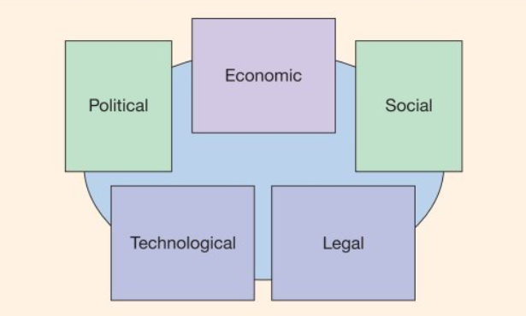
Source: (Graham, 2020)

Pestel analysis
Political/legal forces
Considering the UK has a stable political situation in general. However, the country has experienced uncertainty about the post-Brexit situation as the Brexit outcomes were unpredictable in case of leaving the European Union with an agreement. as well as any other business, Ryanair was observing the situation closely. “Since 1 January 2021, the provisions of the EU-UK Trade Deal have preserved traffic rights for UK and EU carriers between the UK and EU. However, EU airlines do not have the right to fly domestic routes within the UK and UK airlines may not fly intra-EU routes. The EU-UK Trade Deal provides that to avail of the traffic rights between the EU and the UK, each EU and UK carrier must be majority-owned and controlled by nationals of the EU or UK, respectively, must have their principal place of business in the EU or UK respectively, and must hold an aircraft operating certificate from the competent authority in the EU or UK respectively.” (Menegitti & Perrotta, 2022)
The Covid Pandemic imposed new regulations regarding travel restrictions and banned travel to numerous destinations to stop spreading the virus in the country.
In February 2022, Russia invaded Ukraine. A new crisis began in Europe, which hugely impacted air traffic. Ryanair has suspended all flights to Ukraine and Russia until further notice and has removed all flights for sale from/for Ukraine.
We can say that the current political situation is unfavourable to the company, especially after the rise in oil prices due to the Ukraine crisis and the difficulty of recovering from the pandemic, where the traffic fell 81% from 149m to 27.5m due to covid restriction. Ryanair experienced an operating loss of €839m in 2021(Group, 2021).
  - Economic forces
The economic environment has a significant impact on the aviation industry. The demand in the airline industry is generally determined by the prospect of the overall economy in general. Due to the covid pandemic, Ryanair experienced an aggressive drop in customer demand during the lockdown imposed by the government. There are no predictions about when the company will recover from this impact to return to the same as its pre-pandemic.
Another factor that is unfavourable to the company is the stability of oil prices, especially in those days when the oil prices have made a significant increase because of the Russian invasion of Ukraine; according to Michael O’Leary, the chief executive, the company has ensured 80 per cent of the fuel needed until March of the following year (Lancefield, 2022).
Ryanair has implemented an effective strategy to confront any rising or escalating prices and limited passing the cost to its customer through increased ticket prices which means Ryanair has taken advantage to compete with its rivals and change the scenario to be favourable.
Social/ cultural factors
The marketers should make a sociocultural diagnostic of the society where they are operating. The culture of people hugely affects their thinking, behaviour and consumption. (Kotler, 2020)
The number of passengers continues to rise, particularly in the pick period of travel as a response to the need to plan holidays after being stuck locally during the uncertainty of the pandemic, so many people could not devise any unnecessary travel. However, the company is recuperating operations to previous destinations and planning to expand its fleet by adding new goals.
The sociocultural environment is favourable to the airline industry, in particular Ryanair.
Technological factors
Technology and innovation are fundamental to airline companies. They can minimise the cost, improve productivity and operation and gain a competitive advantage. The vast majority of Ryanair reservations are made through its website. It also requires internet self-check-in for all passengers to ensure reduced waiting time for the customers at the airport.
With the growth of the number of users of fare comparison websites such as skyscanner.com, Ryanair must monitor their competitors' prices as much as more customers use those websites to find out the cheapest fares.
Another area where technology can be used is to reduce CO2 emissions and provide a cleaner flight option. Ryanair is investing $22bn investment in new technology aircraft that burn 16% less fuel and reduce the noise by 40% (Group, 2021)
The technological environment could be favourable for Ryanair when using the technology as part of its strategy in favour of maximising its proficiency and competing with the competitors; however, in another hand could have a negative impact related to cyber security and customer negative feedback that can affect the company reputation.
Environmental factors
The public in general and the airline’s customers, in particular, are constantly concerned about the ecological issue related to the aviation industry. And companies need to adapt fast enough to the changing need. Ryanair adopted the plan of providing more green flights to their customers.
“At Ryanair, we are committed to growing annual traffic from 150m p.a. to 200m p.a. over the next five years. We are passionate about carrying these guests and their families in a way that lowers their cost of air travel and reduces their impact on our environment.” Thomas Fowler Director of Sustainability- Ryanair.
The regulation imposed by the European Union about the environment is unfavourable for Ryanair as they impose on the airline’s companies to have plans to reduce the air contamination.
Analysis of porter’s five forces
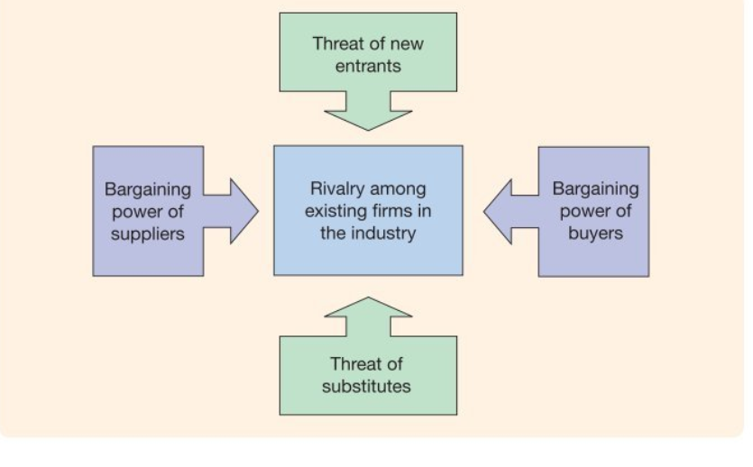
Porter (1980) indicates that competition at the level of strategic business is shaped by five principal forces, and a critical analysis of each force help to identify the keys to the competitor in a specific business industry (Graham, 2020)
Figure2: porter’s five forces
Source: (Graham, 2020)
The threat of new entrants
The main objective of a new entrant when deciding to enter the market is to share a proportion of the customer of the existing companies. To be a competitor, the new airline company must overcome the most significant entry barriers to this industry: high capital requirements, airport capacity. the cost related to the airline industry is increased as the companies need funds for aircraft, airport slots and take off/landing rights. A more delicate issue for the new entrant is achieving an airport slot to run the operation because of the limited slot availability. Existing competitors occupy all the good slots as they have the right to renew the contract with the airport. In conclusion, the threat of a new entrant for Ryanair is low.
The threat of substitutes
The substitutes of airline companies are numerous as customers can switch to different transportation ways like cars, trains or even boats. In particular, with the environmental movement, the customers are more aware of the impact of aviation on the climate, as we mentioned before in the ecological analysis.
The high-speed train has the highest threat to the airlines as it competes by reducing the time spent on the journey. The threat of substitutes is low to moderate for Ryanair as it is the minor company affected. It carefully combines the advantages of quick travel time, low price, and environmental concern.
Bargaining power of suppliers
The bargaining power of suppliers must be examined to ensure the company’s future profit. The suppliers include fuel suppliers, aircraft manufacturers, and maintenance providers for the airline industry.
Ryanair is one of the largest customers of Boeing. It has a fleet of a total number of aircraft is 422 Boeing 737-800. On 31 March 2021, Ryanair has agreed to buy 210 new Boeing 737-8200 planes, delivered between fiscal years 2022 and 2025. Deliveries began in June 2021. (Group, 2021)
The new planes will be used on new and existing routes to help the Ryanair Group expand its operations. Ryanair reduces the threat of suppliers by signing long term contracts with the aircraft manufacturers.
Michael O'Leary, Ryanair's CEO, has stated that the airline is negotiating with Airbus for future collaboration. As a result, Ryanair should either receive higher discounts from Boeing to remain loyal customers or receive values from Airbus to become a new customer. The bargaining power of aircraft manufacturers was and continues to be low to medium.
Bargaining power of buyers
The type of customer determines price sensitivity in the airline industry: leisure or business. Business travellers are less sensitive to price changes because their companies usually purchase their tickets, so their budget is more generous. The overall bargaining power of business class travellers is medium.
When it comes to ordinary travellers, they typically seek the cheapest tickets available, making them highly sensitive to price changes and providing them with greater bargaining power.
When it comes to Ryanair, customers have almost no say in ticket prices, as the company's strategy involves ultra-low fares, often at prices lower than competitors' offers.
Rivalry among existing firms
The aviation sector is one of the most competitive globally. Competition has a high impact on the firm’s share market; the risk of rivalry threat is high for Ryanair as a low-cost company. The competitive advantage can easily be imitated (shaw 2011). Price is the most competitive factor in this industry, and it is particularly reliant on the service cost. The company with the lowest costs will be more financially profitable.
There are at least three strategic groupings in the aviation business. One group comprises regional airlines that operate scheduled flights and compete on price. A group of big airlines operate globally and provide flights planned in comfortable environments with excellent service. The third group includes charter services to a variety of vacation spots. (Drummond, 2008)

Advantages and disadvantages of porter’s five forces
Advantages
- Porter's Five Factors is a widely used framework for assessing many industries’ competitive forces.
- The model outcomes the supplier and buyer forces with risk of new entrant and substitutes, which will allow the management of the company to identify the strength and where are the threats
Disadvantages
- The model has limitations, including the fact that it is backwards-looking. Its conclusions are primarily applicable only in the near term; the influence of globalisation exacerbates this shortcoming.
- Another issue is that the framework is designed to assign each firm to a single industrial group, even though some organisations operate in more than one.
- Another difficulty is evaluating all five forces equally when specific industries are not as substantially influenced by all five.
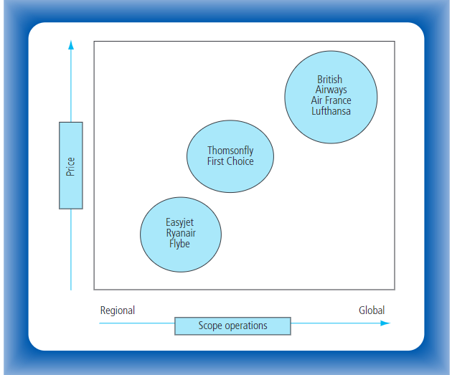

Source: (Drummond, 2008)

Swot analysis
Swot analysis is a model used to evaluate internal and external factors and identify whether they help the company gain a competitive advantage over its competitors. The overall model will determine the strength, weaknesses, opportunities and threats. The marketing management should identify those factors and develop strategies to implement its objectives (Kotler, 2009).

Strength  Leadership  A unique business model that focuses on low prices  Point to point service and use of regional airport | Weaknesses  Financial performance
Opportunities  Strategic agreement  Raise in the tourism industry | Threats  The impact of the pandemic related regulation on the industry  Intense competition and prices reduction

  - strength
- Leadership
Ryanair always presented itself as a Europe low budget airline company under the management of the CEO Michel O’Leary, who has a charismatic personality and is known for his arrogance. Ryanair was awarded as Europe’s low-cost leading airline for 2003 and 2005 (Award, 2005)
Also, Ryanair considers Europe’s largest airline and the No1 EU airline for traffic. Thanks to lower fares, superior punctuality, fewer lost luggage, a wide range of routes, the most on-time flights, the fewest cancellations, and a continuous improvement programme, Ryanair is the industry leader.
In 2020 Ryanair received B-rating climate protection from the independent carbon disclosure project (CDP) and an "A" score for environmental corporate governance and emission reduction initiatives. CDP is a non-profit organisation that manages the global disclosure system for investors, businesses, cities, states, and regions to manage their environmental impacts.
As a result, having a solid industry position allows Ryanair to improve its customer loyalty and retention numbers while also improving its brand image.
- A Unique Business Model That Is Focused on Low Prices
Ryanair’s strategy was always maintaining its competitive advantage over its rivals by reassuring to provide the lowest fares and gaining customer loyalty. The company focuses on lowering and controlling four of the highest costs of operating a big scheduled airline: aircraft equipment, staff, customer service, and airport access and handling.
Ryanair focuses on airports that offer competitive cost terms to reduce entry fees.
Also, they utilise the same set of planes, Boeing 737 planes, to keep the cost of training and aircraft maintenance as low as possible.
Internet check-in is needed for all Ryanair passengers. Internet check-in is part of a broader set of steps to cut check-in queues and passenger handling costs while lowering passenger fares. This system has been implemented across Ryanair's network. Also, it applies direct selling by encouraging the customer to purchase their tickets through the website and send promotional emails to existing customers registered on its databases to cut the cost given to intermediate agencies and be reliant on them.
Although Ryanair was accused of treating its passengers poorly and not prioritising them, the airline has continued to expand and maintain its competitive advantage through its low fare. The passenger will tolerate any inconvenience in exchange for Ryanair’s attractive prices. (MarketLine, 2022)

- Point to point service and the use of regional airports
96% of Ryanair routes are point to point flights and use a secondary regional airport destination and departure city; the reason is to avoid crowded airports, reassure punctual departure and reduce airport charges.
Furthermore, Ryanair avoids paying extra fees for connecting passengers and baggage transfer and transit passenger assistance costs by flying point-to-point flights.
  - Weaknesses
- Financial performance
According to the company’s annual report for FY2021, the company’s financial performance suffered a decline. Ryanair has a drop of 80.7%; the company received revenue of € 1,635.8 million in FY2021 compared to €8,494.8 million in FY2020. Such a decline affected its distribution returns to its shareholders and dedication to enough funding for expansion initiatives. In the 2021 annual review, Ryanair reported an operating loss of € 839.4 million against an income of €1127.4 million in FY2020. Also wrote a net loss of €1015.1 in FY2021. (Group, 2021)
  - Opportunities
- Strategic agreement
Recently Ryanair entered into a new strategic relationship that could aid in its expansion. In October 2021, Ryanair signed a new partnership agreement with Aviator Airport Alliance for aviation services; At Stockholm-Arlanda Airport, Aviator will supply the company with complete passenger and ramp-handling services.
In August 2021, Ryanair and the Greek National Tourism Organization established a collaboration in August 2021 to help Greece's tourism recovery. The cooperation aims to improve Greece's profile as a tourism destination in the United Kingdom, Germany, and Italy and attract more visitors. Strategic partnerships could help the organisation diversify its product line and increase income (MarketLine, 2022).
- Raise in the tourism industry
The global tourism industry is increasing significantly, contributing to the demand for the travel and transportation industry, particularly the aviation industry.
Ryanair works on expanding new routes and adding new destinations to maintain its competitiveness.
  - Threats
- The impact of the pandemic related regulations on the aviation industry
In March 2020, the World Health Organization (WHO) declared the covid19 pandemic; numerous governments imposed rules concerning travel restrictions and stopped travel from and to many destinations. As a result, the covid paralysed the entire industry.
- Strong competition and prices reduction
The airline industry is hypercompetitive. The principal competitive factors are ticket prices, customer service, destinations, aircraft types, safety records and reputation, code-sharing relationships, capacity, in-flight entertainment systems, and frequent flyer programmes.
Air France, British Airways, EasyJet, Deutsche Lufthansa, Alitalia, Germanwings, and Olympic Air are Ryanair's main competitors. A modest change in pricing or passenger traffic can significantly impact an airline's operating and financial outcomes. Accordingly, an intense rivalry will influence the company's ability to increase passenger volumes and profits and prohibit it from expanding its network and changing its market share.

Market Segmentation
Segmentation is dividing the market into groups of customers dependent on their needs. Buyers in any market differ in their needs, location, buying attitude and practice. So, the companies can target each group more effectively with their product or service. (Kotler, 2020)
Demographic segmentation: organisations should identify who is the customer by dividing the market into groups based on demographical factors such as age, gender, income, occupation, etc., for a reason to understand the customer needs and behaviour. Ryanair focuses on businesses, families with children, young people and even older people who desire to visit their relatives.
Geographic segmentation: companies must know where their clients live, the geographical variety and concentration areas, and the location of their firm. Ryanair’s geographical operating area is the UK, Europe, and Morocco.

Market targeting
After identifying the segment and finding out the group of customers the company is looking to serve, it creates a strategy to target them. Ryanair combines between undifferentiated strategy and a differentiated. (Graham, 2020)
Undifferentiated strategy: the majority of the European population is medium class people; therefore, the company aims is to provide low fares for the passengers who are price dependent and are seeking to save money on their travel experience, including families with kids or young people as students who want to spend their holiday with a minimum budget.
Differentiated strategy: Ryanair created the product business plus for the reason to target the business travellers, which is different to the other companies who related the business class more to the comfort; Ryanair’s purpose of targeting this segment is the importance of time for them by offering ticket flexibility, extra luggage allowance and access to fast track. Also, they provide seats suitable for families who travel with small children to make them feel more comfortable. (Gleeson, 2015)

Positioning
Positioning is the value of the offered product or service in the mind of the targeted segment or customers concerning the competitors and taking a step to shape the marketing mix strategy to communicate with the customers. Ryanair’s image was primarily created as a low-cost company that provides an airline service at a reasonable and cheap price. Ryanair positions its brand image as Europe’s leader in low-cost carriers.

Marketing Mix Strategy for Ryanair
A marketing mix combines several tools focusing on numerous areas of concentration and connecting them to create value for the customer and manage the company brand. Goods manufacturers apply the 4ps model, and service companies use the 7ps model for the marketing mix (Buttle, 2008)
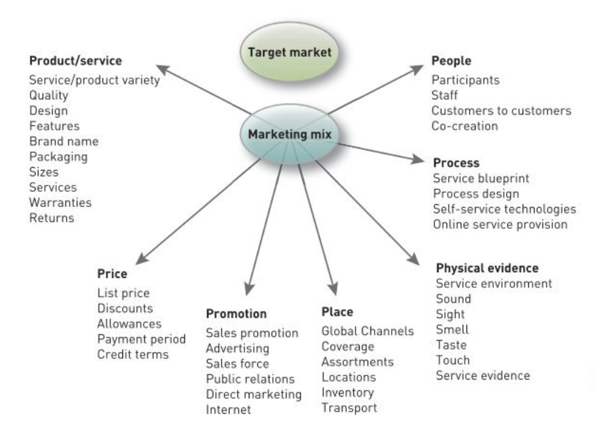

Source: (Kotler, 2009)
Ryanair’s marketing mix used to manage its brand is:
Product or service: Ryanair offers the passengers basic air transportation without any extra assistance. The company combines with market expansion strategy by opening new routes more regularly and increasing penetration strategy by frequently providing existing routes.
Price: Ryanair’s pricing strategy competes at lower prices; however, it sometimes sells tickets at higher prices. Also, they offer any extra service by additional payment.
Promotion: Ryanair’s strategy minimises the costs, so they try to spend the minimum on promotion. They do not work with an advertising agency focusing on online advertising.
Place: Ryanair is based in the Stansted airport; they use secondary airports for almost all the destinations.
Physical evidence: the critical asset for Ryanair is the Boeing 737-800 airplanes; the interior is very basic and has a minimum space for the legroom.
Process: Ryanair adopted self-service and check-in. There is no air bridge to the airplane. The passengers go walking or on a bus. They eliminate the services to cut the costs.
The complaint procedure for Ryanair is to proceed through the company website by filling a claim or sending an email or letter.
People: 15,016 (Group, 2021) the total number of employees of Ryanair: management, ground operation, administrative/IT lab, maintenance, cabin crew and pilots. Those people are responsible for delivering the service to the passengers.

Recommendation
  - Market expansion strategy
Ryanair only operates in the UK, Ireland, Europe, and Morocco. And fulfil to play a significant role in the pricing war in the European aviation industry, Ryanair can expand its routes to long haul flights to increase the number of passengers and increase the investment.
This strategy allows Ryanair to penetrate global markets to developing countries, Opening new routes to Africa and connecting the UK and Europe to north African countries such as Tunisia and Algeria and central and southern African countries where the truism industry is developing—also connecting Turkey with Europe as Turkey has become an attractive touristic destination for many Europeans.
By launching long haul flights, the company will make the travel more accessible for leisure or family visits for more people. The company could gain another competitive advantage to compete with national flag airline companies such as British airway, Air France, and Lufthansa…
  - Market penetration
this strategy is the cheapest one for Ryanair as it talks about increasing more sales for the same service to the same targeted market, making some changes to the marketing mix, setting new advertising methods, improving the service; Ryanair can increase the number of its operated flights, especially during the period of festive and holidays and maintain the offer of offering the cheapest flights to compete with the rivels.
  - Product development strategy
by introducing a new product to the existing market for Ryanair, they can invest in a tourism agency that manages all travel-related reservations, such as hotels and guided tours to a city….
  - Diversification
this strategy is about developing a new product to penetrate a new market, so the company will grow by investing in different business models (Kotler, et al., 2020) for example, Hotels, online holiday providers; however, they need to apply this strategy carefully and not to over-expand.

Conclusion
After evaluating the external environment of Ryanair and assessing the company’s strengths and weaknesses as well as the opportunities and threats by conducting an environmental analysis, defining its segmentation, targeting, and positioning strategies also identifying the combination of the marketing mix of Ryanair. In summary, this evaluation needs to be done regularly by the company's marketing department to maintain the market share in a very competitive sector such as the aviation industry, especially after the market reversal during the covid pandemic. The report at the end includes some recommendations in the form of strategies that Ryanair could adopt.

References
Award, W. T., 2005. World Travel Award. [Online]
Available at: https://www.worldtravelawards.com/profile-2168-ryanair
[Accessed 2005,2003].
Buttle, F., 2008. Customer relationship management: concepts and technologies. 2nd ed ed. Hoboken: Butterworth-Heinemann.
Drummond, G., 2008. Strategic marketing : planning and control. 3rd edition ed. s.l.:Butterworth-Heinemann.
Gleeson, A., 2015. How Digital Helped Transform Ryanair's Fortunes. [Online]
Available at: https://www.linkedin.com/pulse/how-digital-helped-transform-ryanairs-fortunes-alan-gleeson
Graham, H., 2020. Marketing Strategy And Competetive Positioning. Seventh edition ed. s.l.: Pearson Education.
Group, R., 2021. Ryanair Annual Report, Dublin: Ryanair..
Kotler, F., Amstrong, G., Lloyd C, H. & He, H., 2020. Principles of Marketing. Eighth European edition ed. Harlow, England: Pearson.
Kotler, P., 2009. Marketing Management. European ed.] ed. s.l.:Pearson Prentice Hall.
Kotler, P., 2020. Principles of Marketing. Eighth European edition ed. Harlow: Pearson.
Lancefield, N., 2022. Ryanair better protected against rising oil prices than rivals – Michael O’Leary. Evening Standard, 02 March.
MarketLine, 2022. Company profile: Ryanair Holdings, s.l.: MarketLine.
Menegitti, A. D. & Perrotta, P., 2022. Aviation Law 10th Edition , s.l.: Worldwide Airports Association.

