Assessment 2 – Cultural Awareness

Intercultural Competence Report

Module Title: Foreign Languages & Cultural Awareness

Module code: BMIH5003

Student Name: Mihai Bucur

Student ID: 2112110

Word Count: 1013

Executive Summary
A cultural overview of Finland and England has been given over four parameters, Uncertainty Avoidance, Collectivism, Power Distance and Future Orientation. Furthermore, Edgar Schein's organisational culture theory was used to provide an overview of Diversity Hotel. Finally, recommendations have been provided to Diversity Hotel to adapt to Finland’s culture. Cross-cultural communication is defined as a sub-domain of intercultural communication and is considered to be a comparison of the varied approaches in which individuals communicate across cultures. Based on this, the report has identified the concept of cultural management purposes in terms of the effective expansion purposes of Diversity Hotel from England to Finland.

Table of Contents
Introduction 4
Cultural Overview 5
GLOBE Project Country Analysis 7
Conclusion 11
Recommendations 12
Reference List 13

Introduction
Cross-cultural communication can be referred to as communication between different individuals from diverse cultural backgrounds considering every participant of culture to be valid while supporting communication without an interpreter (Hillary, 2020). In this regard, the report will determine a comparative analysis of Diversity Hotel & Spa in London and its potential expansion purposes to Finland.

Cultural Overview
The culture of Diversity Hotel is based on attracting people with royal notice and luxury, as it is a 5-star hotel. According to Edgar Schein, culture is an aspect that defines what is an organisation about and what is done within it and there are three levels to it. Artefacts are meant by the organisational processes like layout, furnishing, dress, talking style and more and these aspects are undecipherable, yet visible (Donato, 2023). Values are important aspects as they impact the people working within the organisation and Diversity Hotel prioritises effective customer service, luxury and diversity management. Assumptions are meant by the aspects that are taken for granted within an organisation and they are deeply embedded.
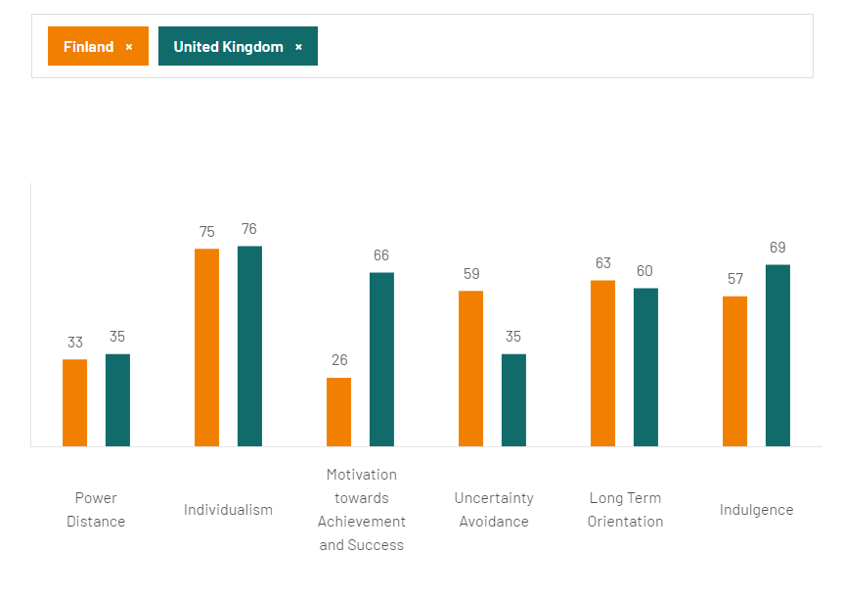
Figure 1: Country Comparison of Finland and England
(Source: Hofstede Insights, 2023)
National culture is also formed of certain aspects, attitudes and assumptions that create the personality of a group of people or citizens. The people thus carry out certain practices, which are then reflected in the workplace. England falls within Anglo culture, while Finland is Nordic Europe and thus their culture is inevitably different (GLOBE 2020, 2023). Some of the aspects of national cultures to be used are:
Uncertainty Avoidance
Uncertainty avoidance is the rate at which people deal with the fact that the future is uncertain and thus, with a low score of 35, England is more anxious and worried about this aspect (Hofstede Insights, 2023). While uncertainty avoidance is high in Finland which implies that they are casual towards ambiguity and unorthodox beliefs are welcomed.
Collectivism
Individualism and collectivism are fundamental aspects of societies that govern if people make shared decisions and the degree of interdependence. Both England and Finland show the same nature of individualism. As a result, these communities prioritise individuals over groups.
Power Distance
Power distance can be defined as the degree to which people can accept unequal distribution of power or wealth in an organisation or society (Dai et al., 2022). It can be furthermore witnessed that the power distance of both countries is low with a score of 33 for Finland and 35 for England.
Future Orientation
Both Finland and England are pragmatic societies with a high long-term orientation score where people believe that truth is dependant on context, situation and time and both show an effective ability to change in achieving results.

GLOBE Project Country Analysis
Uncertainty Avoidance for Finland when compared to England has been effective in terms of a score of 3.85 in Finland and a comparatively low score in England (Globe Project, 2020). Diversity Hotel may be able to engage in effective cultural management strategies in terms of its expansion purposes to Finland. The populace of Finland has been based on a variety of minorities established in different cultures, religions and languages (Info Finland, 2022). Based on the idea that the uncertainty avoidance index of Finland and leadership practices within the economy can emerge as issues of expansion from England.
Collectivism or a collectivist culture emphasises the goals and needs of a group in entirety based on the requirements of every individual (Cherry, 2022). The values established in Finland based on its collectivist approaches reveal 4.11. This does not differ much from England with a score of 4.08 (Globe Project, 2020). This ensures that the expansion purposes of Diversity Hotel to Finland may work out well in terms of effective cultural management approaches with the practices of involving a wide range of individuals from every background. This can emerge as a beneficial strategy to ensure growth in customer satisfaction over time.
Power Distance is the concept where the toleration of power and inequality is measured (Wale, 2023). The power distance value in Finland is 2.19 while the value identified in England is 2.8 which is again similar in terms of cultural management approaches for Diversity Hotel and its expansion purposes to Finland. 6.01 is the value of charismatic leadership in England while for Finland it is 5.94 (Globe Project, 2020). This reveals the difference in practices of leadership roles for Diversity Hotel after its expansion to Finland. Finland is mostly engaged in participative leadership while England has a comparatively low score.
Future Orientation can be identified as the approach to engage in long-term activities with an emphasis on thinking regarding exclusive approaches to undertaking strategic decisions for betterment in expansion activities. Diversity Hotel is likely to indulge in exclusive practices of future orientation over the years based on its score or value of 5.06 with England having a value of 5.07 (Globe Project, 2020).
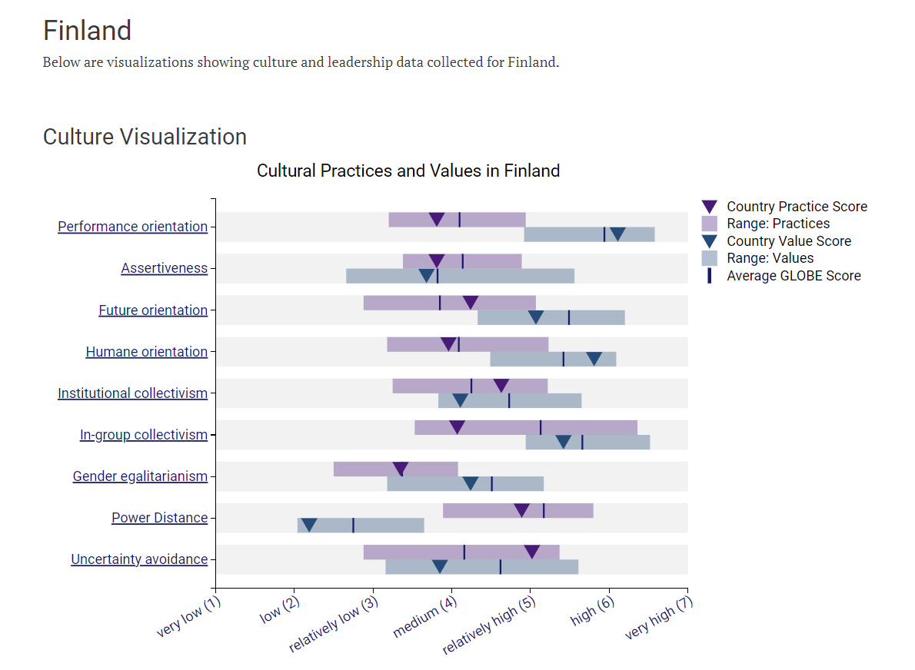
Figure 1: Cultural Practices in Finland
(Source: Globe Project, 2020)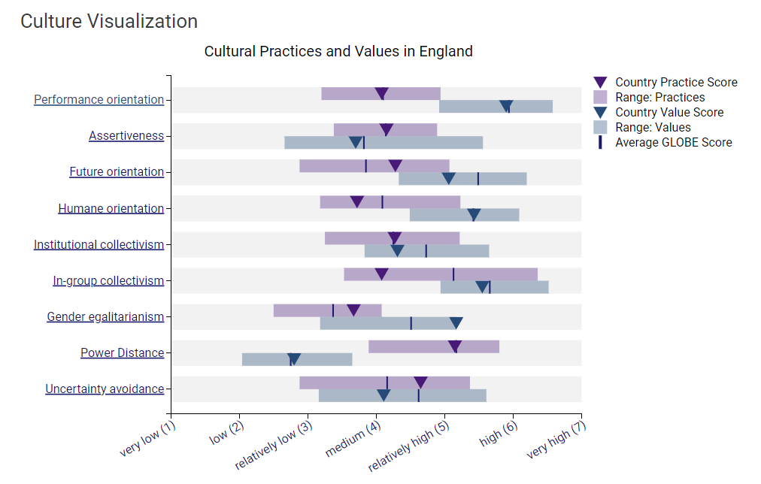
Figure 2: Cultural Practices in England
(Source: Globe Project, 2020)
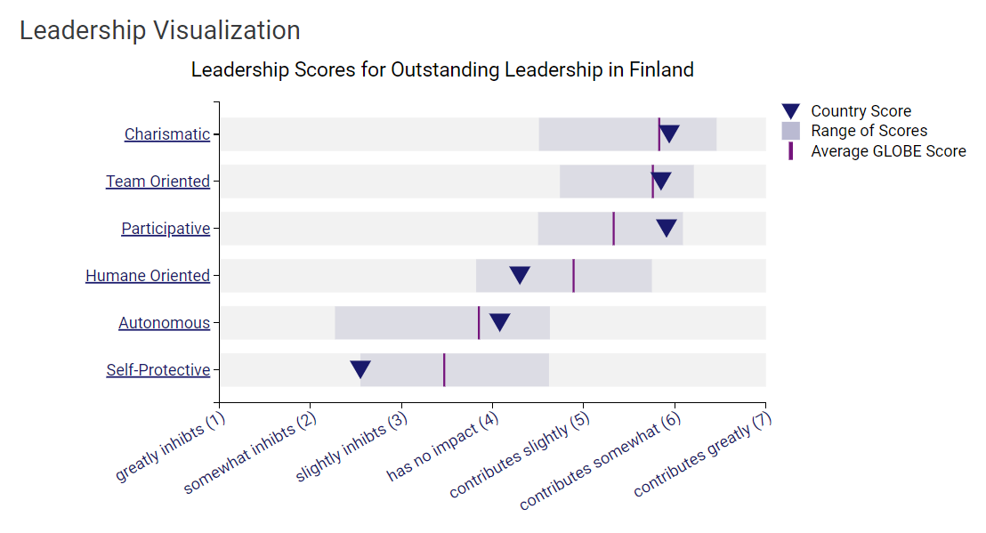
Figure 3: Leadership Scores of Finland
(Source: Globe Project, 2020)
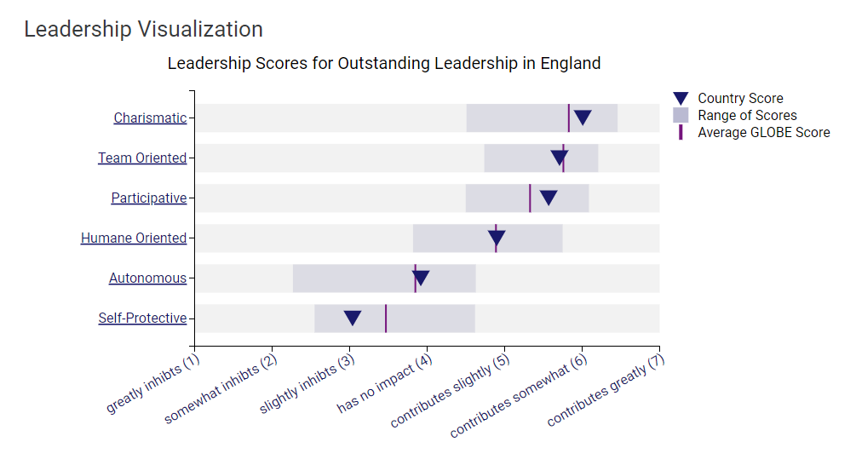
Figure 4: Leadership Scores of England
(Source: Globe Project, 2020)

Conclusion
From the above discussion, it can be derived that Diversity Hotel has been engaged in effective cultural management approaches relating to the development of strategic decisions regarding its expansion purposes to Finland. Although cultural issues have been prevalent based on differences in backgrounds, the country analysis reveals positive activities at Diversity Hotel.
Recommendations
After discussing the cultural overview of Finland and England, it is inevitable that Diversity Hotel will need to make some alterations to their organisation, based on national culture.
- It is recommended to Diversity Hotel to consider the high score of Finland’s uncertainty avoidance. In order to adapt to a country with high uncertainty avoidance, Diversity Hotel might consider maintaining rigid codes of beliefs and try not to impose any unorthodox assumptions.
- In individualist cultures, the leaders are recommended to encourage competition and take charge and this acts as a successful motivator. Businesses need to be discussed right away and not much time is spent on knowing subordinates personally (Agbo, 2022).

Reference List
Agbo, L., 2022. 12 Best Practices Business Tips In Individualism vs. Collectivism Cultures? [online] Available at: https://www.brainzmagazine.com/post/12-best-practices-business-tips-in-individualism-vs-collectivism-cultures#:~:text=In%20individualist%20cultures%2C%20leaders%20tend,team%20toward%20building%20a%20consensus. [Accessed 6 November 2023]
Cherry, K., 2022. What Is a Collectivist Culture? [online] Available at: https://www.verywellmind.com/what-are-collectivistic-cultures-2794962 [Accessed 6 November 2023]
Dai, Y., Li, H., Xie, W. and Deng, T., 2022. Power distance belief and workplace communication: The mediating role of fear of authority. International Journal of Environmental Research and Public Health, 19(5), p.2932.
Donato, J.B., 2023. Organizational Culture: Going Beyond ‘This Is How We Do Things Around Here' [online] Available at: https://www.forbes.com/sites/forbesbusinesscouncil/2023/05/18/organizational-culture-going-beyond-this-is-how-we-do-things-around-here/?sh=f122518483ef [Accessed 6 November 2023]
GLOBE 2020, 2023. Culture Groups [online] Available at: https://globeproject.com/results/clusters/nordic-europe?menu=cluster#cluster [Accessed 6 November 2023]
Globe Project, 2020. Globe 2020. [online] Available at: https://globeproject.com/results/countries/FIN?menu=list#country [Accessed 6 November 2023]
Hillary, A., 2020. Neurodiversity and cross-cultural communication. Neurodiversity studies: A new critical paradigm, pp.91-107.
Hofstede Insights, 2023. COUNTRY COMPARISON TOOL [online] Available at: https://www.hofstede-insights.com/country-comparison-tool?countries=finland%2Cunited+kingdom [Accessed 6 November 2023]
Info Finland, 2022. Cultures and religions in Finland. [online] Available at: https://www.infofinland.fi/en/information-about-finland/cultures-and-religions-in-finland [Accessed 6 November 2023]
Wale, H., 2023. What is the Hofstede’s Cultural Dimensions Theory? [online] Available at: https://corporatefinanceinstitute.com/resources/management/hofstedes-cultural-dimensions-theory/ [Accessed 6 November 2023]

