DS3
ASSESSMENT

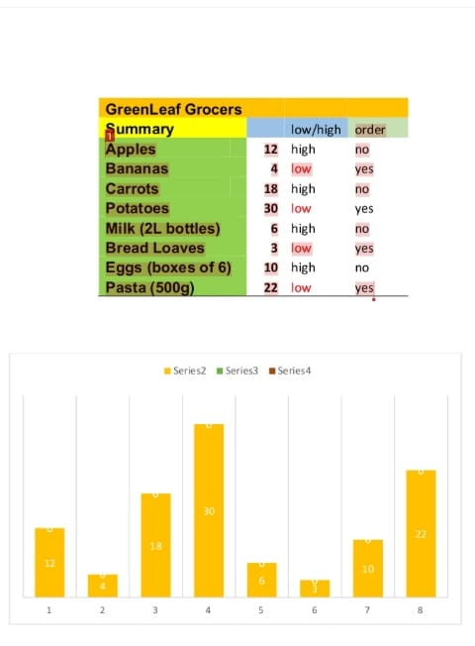
- I haven't used Excel or Word in years, so taking this course was a big step for me. I had some trouble at first and I still have more to learn, but it feels good to start using them again. I haven't used Excel or Word in years, so taking this course was a big step for me. I had some trouble at first and I still have more to learn, but it feels good to start using them again.

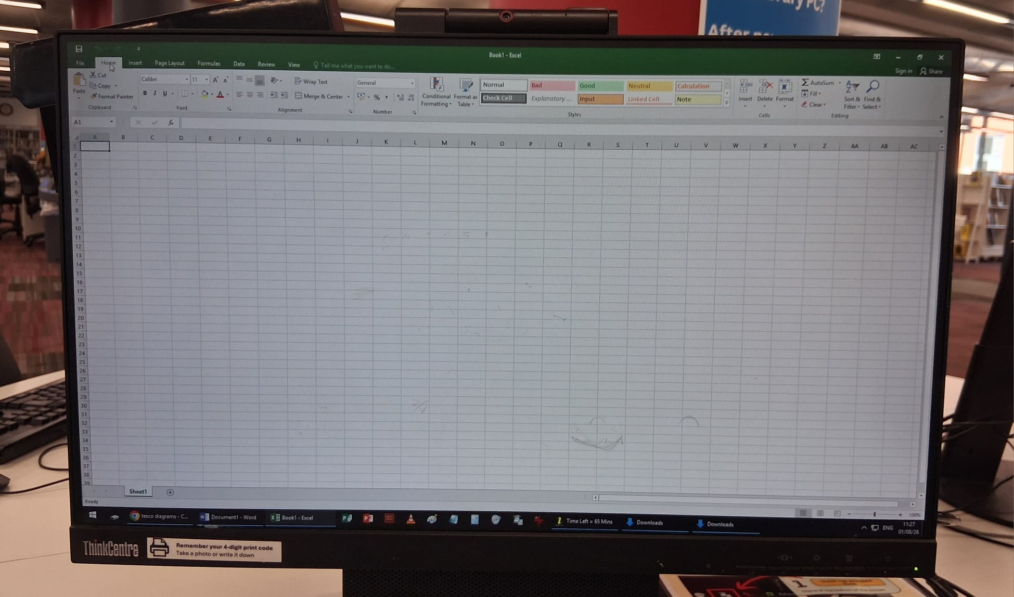
- I've been using my laptop to create diagrams in a clearer, more professional format when I usually only used it for fun and leisure. It's amazing what technology can do these days. I'm excited to learn or brush up on new tools, which are so important in today's business world.

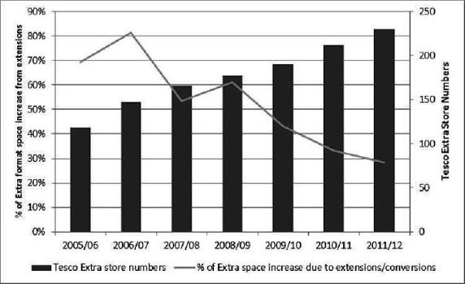

- I'm learning to read these types of patterns, which were previously difficult for me to understand. It's wonderful to discover a whole new world of information thanks to these new tools.

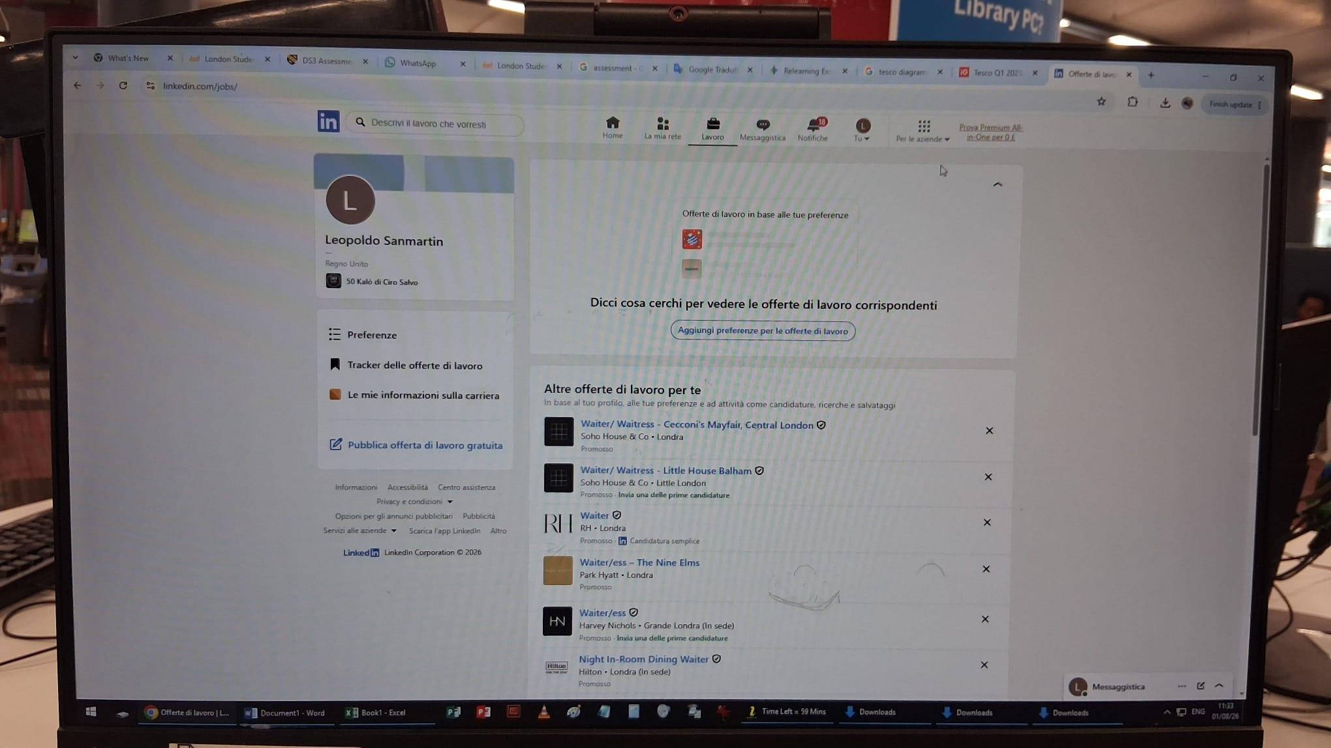

- After many years of disuse I rediscovered the potential of Linkedin in the right way to make myself known in the world of work and for greater opportunities.

