Understanding and engaging in the customer experience.

Ethical trading

By Mohammed Waseem

I.D. No 1708857

Lecturer Vajira Balasuriya

Table of Contents
Introduction 2
Literature review 7
Different quality models and theories impacting organisations 7
Critical investigation of theories helping in improving Customer Relationship Management 10
Conclusion 13
References 14

Introduction
A business is defined by how it treats its customers and its growth prospects are directly related to how they treat their customer in the first place. According to Baran and Galka (2016), Customer relationship management is a management approach an organisation undertakes to manage the interaction of the company with its existing and potential customers. Customer Relationship Management uses historical data to analyse the priorities and preferences of its customers to help improve its business relationship with the customers, specifically focusing on retaining existing customers and acquiring new ones and ultimately driving more sales and revenue growth. Management has a broader concept than marketing as it requires more input from all the aspects of organisational discipline. Customer Relationship Management requires more customer-centric organisational and business level approaches to strategically attract, acquire and retain customers; it becomes easy for organisations to build a sustainable customer base using Customer Relationship Management. According to Pokharel (2016), Customer Relationship Management requires a holistic approach from all the disciplines in an organisation for critical success. Thus, to maintain the holistic approach, the company needs to identify the factors affecting holistic growth and act on them actively to maintain the holistic nature of the organisation and thereby improving its relationship with the customers.

Task 1: Investigation of customer experience of organisations based on the following:
a) Ethical policies
Public sector organisation
In this section, the impact of policies on the NHS will be discussed. For the purpose of this discussion the theory of Virtue Ethics has been taken into consideration. Virtue ethics can be considered the approach towards ethics focusing on the specific character as well as habits of the practitioner (Mion and Beghini, 2019). In case of any alteration, the actors are the healthcare service providers and involved stakeholders in the practise of acting also involving the service users. Again, this theory demonstrates that morality must be regulated based on how well human potential is achieved (Humbyrd, 2019). In this case, the National Healthcare Serveces has provided all opportunities related to their service for their client base, in the form of activities like evidence-based healthcare, one to one approach and so on in order to ensure best customer satisfaction (Nhsproviders.org, 2020). Virtue ethics also highlights that in the course of moral philosophy, the role played by the real character as well as virtual character is very important. There are more important than the duty for acting in accordance with bringing about appropriate consequences. In this case, the aspect of terminal care or patient-based approach can be discussed. These approaches help in bringing the impact of character as well as virtue in moral philosophy. The NHS has always emphasized intervention and involvement of the patient regarding decision-making. Therefore, the involvement of patients and their connection with the selection of Health Care for treatment policy is given more importance than good consequence (NHS.UK, 2020). Therefore, keeping parity with the aspects of virtue ethics, the organisation gives more emphasis on values related to mind as well as character. By emphasising on the character of the individual as the primary element for ethical thinking, the organisation has fulfilled all criteria of the theory of virtue ethics. The interview on ethical framework determines about 15 ethical principles relatable with legal as well as statutory duties concerning NHS as a public body for Healthcare. Nevertheless, the NHS is proven to implement generic policies for commissioning along with standard procedure of operations which follow a structured governance process (Commissioning, 2020). Therefore, it can be highlighted that moral philosophy has been given prominence by the organisation. In order to ensure that the ethical framework of the organisation complements the aspect of people welfare in best possible manner the organisation must review their ethical Framework. On the other hand, the policy in partnership with their stakeholders so that both service providers and services become a part of development of their comprehensive prioritisation framework for supporting the decision making in future (Groothuizenet al., 2018).
Private sector organisation
The theory of consequentialism can be considered as an approach to analyse the approaches of Sainsbury’s, a private sector organisation towards ethical trading. Consequentialism focuses on the appropriateness or misogyny associated with consequence of the actions undertaken by a company, focusing on the intention of doing maximum good for the biggest population. This theory highlights that justice is not answered by simply doing what is right but depending on what the consequences are. Again, morality can be justified in this context by generation of the correct form of overall consequence. Actions thatare morally right will produce a good outcome. This is the ultimate perception behind consequentialism (Slote, 2020). Utilitarianism can be considered as an example of consequentialism where the actions undertaken by an entity or an agency lead towards the most positive outcome for the biggest population. In case of Sainsbury’s, that the customers, comprising of the greater population of the customer base of the company demand to remain confident regarding the fact that the people who are responsible for manufacturing, processing and packaging and rendering products by the organisation are not exploited (de Lazari-Radek and Singer, 2017). This is a reason why Sainsbury’s ethical policy highlights that the company has been committed towards establishment of some long term as well as open relationship with their suppliers, manufacturers and the employees on several levels in order to highlight that they have the skill as well as capacity to manage not only their products but also their vision, in a responsible way. In this regard, the supplier policy regarding sustainable sourcing, as highlighted in the annual report of the organisation can be outlined. It highlights that employment practices standards expected from suppliers are complementary with the national wage limit, working hour regulations as well as employment relations Act of 1996. The policy for sourcing from suppliers implemented by Sainsbury’s is complementary to the Ethical Trading Initiative BASE Code or ETI (sainsburys, 2020). It also compliments the core conventions of the International Labour Organisation as well as Universal declaration of Human Rights. The primary aim behind the development of this policy is adopting minimum standards and making it an ethical responsibility on the part of suppliers to undergo continuous performance improvement. This is because the company respects Human Rights across their value chain and reflects that by their actions like revision of training, knowledge sharing as well as engaging suppliers as well as third-party producers in collaborative industry initiatives. This initiative outlines guidance as well as directives, which demonstrate the standards that are expected from their suppliers. For evidence, Sainsbury wants a specific minimum wage limit to be paid to the subcontractors who work under their suppliers. This policy complies with the ethical trading initiative base court or the ETI (Rspo.org, 2020.).
Non-governmental sector
In context to the non-governmental sector, the deontological theory can be used to demonstrate the ethical trading and ethical operations policy of Oxfam international, an NGO based in the UK. In this regard, it can be highlighted that deontological can be considered as ethical theory using rules for differentiation of right from wrong. The actual significance in determination of model is tension of the action. This approach determined that the actions of an organisation should be focused on the rightness as well as the wrong notes of the operations. Hence it is evident that based on this theory mortality can be outlined as duty towards the other human beings (Alston, 2019). Therefore, the actions of the individual of the organisation should be focused on duties towards other people. The actions taken by the organisation in good faith should be considered as morally good. Therefore, it can be considered as a duty-based approach where ethics are concerned with the actions of people, not with the outcome of the actions. This is the reason why, the intention of most of the projects undertaken by Oxfam is to safeguard maximum number of people possible. Henceforth, it can also be highlighted that the organisation selects those projects, which has something to do with the fundamental life values of people. One of the primary examples is their commitment towards zero tolerance against sexual harassment, exploitation of children, women and abuse of any kind, whether it is domestic or societal. This implies that whatever is done by the organisation is to prevent something gruesome or negative from happening with the people that they care for. There are some safeguarding related pillars of practice in the code of conduct of the organisation and it is a framework to be followed by all employees at Oxfam (Oxfam, 2020).

Sustainability policies

Public sector organisation
The sustainability model based on which the organisation aspects of NHS, UK will be discussed in this section is the micro financing model of sustainability. Since the NHS UK is tax funded, it is assumed that NHS is well positioned in rolling out number of health innovations. Nevertheless, the market where the organisation is operating is quite complex and hardly appreciates any outside interventions. In the first-place revolution in the organisation has resulted in the outcome of differences in health infrastructure within the home countries of the UK. NHS, Scotland, Wills as well as Northern Ireland are quite contrary to that of England. Secondly, in England the organisation has a centralisation with context to policy setting, regulatory framework as well as information governance, nevertheless considerable fragmentation with the context to organisation as well as care delivery. This makes the landscape more complex and ultimately the hills companies trying to associate themselves with the organisation find it very complex to scale up innovation. In the case of sustainability, it can be highlighted that scaling-up operations is a crucial context. The dearth of digitisation clearly hinders ability of the providers in effectively sharing data between patient, care setting as well as organisation and professionals full stop there for this research study will highlight how the plethora of the incompatible patient records can be assembled in order to meet local service needs for the requirement for speciality in Healthcare provision. In this regard, it can be highlighted that dismantlement of the investment of about 7.3 billion British Pounds has not helped the organisation in any way to make the flowers bloom. In this approach for stop, the primary reason for this being the local diversity, which is still encouraged by NHS as a part of patient, cantered which nevertheless is turning out to be middle out approach. The mandatory standards regarding interoperability along with privacy as well as cyber security is rather creating a block wall by means of autonomous disposition of Healthcare service providers cannot be actualized. The hindrance towards implementation of e health control is a primary suit in this relation (Nao.org.uk, 2020).
Private sector organisation
The sustainability model, which is followed by the chosen private sector organisation, Sainsbury’s for their operations in the UK is the production on demand model. This is a sustainability model which states that in order to cut down cost, use of resources and reduce wastage, organisations make market analysis by various operations and aperture, which gives an accurate instruction regarding the current demand and the epicentre of the demand. Based on the demand, there sourcing, supply as well as production and market distribution activities take place. This is how lean production principles are realised by Sainsbury’s. This is a futuristic and innovative model of sustainability by means of which the organisation has been able to maintain their second spot in the list of top 5 retail sector organisations in the country. In the first place, they have a target of being competitive on price by opening the cost of quality products at affordable prices. They can make productions at affordable prices by following the above-mentioned lean principles. As an outcome of this policy, their food as well as grocery sales have observed an improving trend in terms of increase in revenue and faster release of units throughout the year 2019 (Corporate Responsibility, 2020). Nevertheless, the first, 20 and convenient environment is preferred by customers which help them to find the right product they are searching for. This is however a major aspect of customer satisfaction that is followed by the organisation in their operations. Lastly, the organisation is driving efficiency for every investment to start in order to invest over customer offerings; the company is aiming the delivery of inflation covering cost savings which will help in structurally bringing down their cost. The company has been able to meet their objectives in 2019 for cost saving covering impact of cost related inflation. They have a target of reducing their caused by 500 million British pounds over a 5-year hall which will end in 2024.the taking over of Argos by Sainsbury is the first step towards this. Nevertheless, then it is zero policy which the company intends to achieve by the end of 2020 can also be highlighted. The organisation is emphasized on reducing environmental impact in their business by working with suppliers closely like with the farmers, growers as well as other suppliers across all over their supply chain. With the mission of living will the company will induce sustainability by investing 1 billion British pounds over a time span of 20 years for net zero wastage production across their entire operation by the end of the year 2040. This is one of the primary targets set by the organisation regarding the seven primary areas of Focus where they are trying to reduce waste production (About.sainsburys.co.uk, 2020).

Nongovernmental sector organisation
The crowd funding theory can be considered as the sustainability theory, which is applicable towards Oxfam International, UK. The crowd funding platform is crucial for the success achieved by the company so far. Trying to accomplish their goals, the company has developed this platform with the primary intention of trying with all force and helping the charity organisations in raising funds (Vismara, 2016). By means of the platform services, other companies as well as individuals can reach out to the people for getting funds and it will help in running their project. In writing, the organisation charges for payments at small scale coming in handy for helping them in running their projects, intern. This is how the company is still lending a helping hand to participants as well as project and the project owners in accumulating funds by means of using their platform. This is a theory of mutual benefit. In the long run it will be helpful in creating crowdfunding operations by means of which organisation will be able to help more people (Clauss et al., 2020).

Task 2: Literature review

Different quality models and theories impacting organisations
According to Karim and Habiba (2020), Customer Relationship Management relies on a deep understanding of the customer’s needs, requirements and preference to cater to their demands and probably exceed them. Any company that manages the requirements best will gain an advantage over their competitors. According to Bai and Qin (2016), Customer Relationship Management helps an organisation to find the right customers, build more sustainable relationships, reduction in the cost of sales, increase the productivity of employees, offer better service to their customers and help improve customer retention. While strategically significant customer base consists of 20% of all the customers, but they account for 80% of the profit the organisation gains.
There are several models for Customer Relationship Management, in this discussion, we will cover three of the most commonly known and effective models of Customer Relationship Management. Like the IDIC model, The QCI model, Payne’s five factors model, Customer Value Proposition model etc. each of these models has its own approach towards engaging and retaining customers through maintaining better relationships, they focus on different approaches of management and psychology to build a better relationship with its customers. In the following section, the report is going to discuss, IDIC, QCI and Payne’s five factors model to give a better perspective about the process of Customer Relationship Management.
IDIC model
According to Piri (2018), the IDIC model was developed by Peppers and Rogers as a blueprint of implementing Customer Relationship Management in a variety of situations. The model focuses on four stages of implementation vide, identify, differentiate, interact and customize. In the Identify phase, the business tries to collect as much data as possible regarding the potential and existing customers to identify their needs and pressure points deeply. In the differentiate phase, the customers are segmented according to their value to the organisation and prioritise the communications towards them. The third stage is interaction with the segmented customers to identify their needs deeply and cater to them efficiently. The final stage is called the Customize phase, in this phase, the interaction with customers is documented and a one to one communication plan is formulated to engage the customers better and target them on a personalised manner. Below is a diagram of IDIC model.
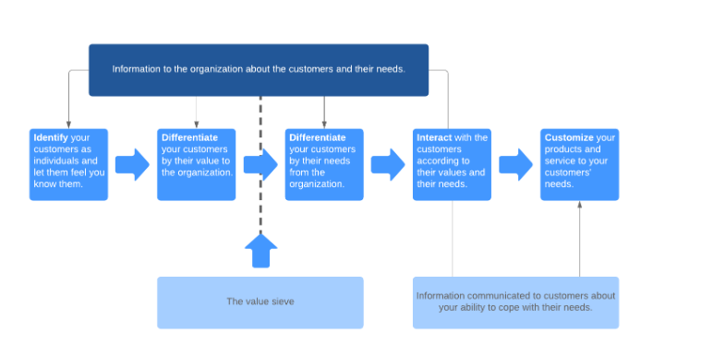
Figure1: IDIC model of Customer Relationship Management
(Source: Piri, Customer relationship management: Case Urakointiasennus, 2018)
QCI Model
According to Badsiet al. (2017), QCI model is a customer management model, rather than being a Customer Relationship model, this model focuses on three main activities, acquisition, retention and penetration. The QCI model initiates with the external environment of the customer, their pain points and other goals which will indicate if they are ready to interact with the sales team and thereby turning their pain points into a positive customer experience. The QCI model also ensures that Customer Relationship Management will start and end keeping people in mind. This model also considers the key technological involvements with the people to keep the whole system going.

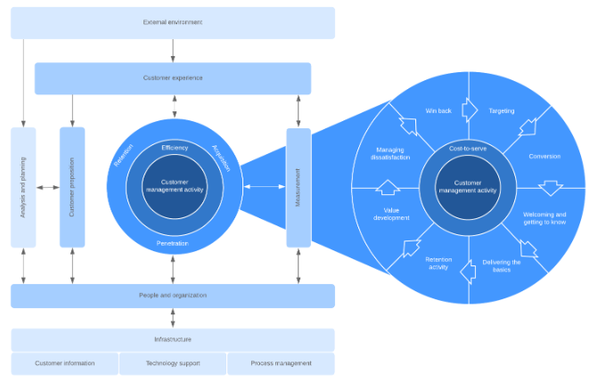
Figure 2: QCI Model
(Source: Piri, Customer relationship management: Case Urakointiasennus, 2018)

Payne’s Five Forces Model
According to Piri (2018), Adrian Payne and PennieFrow developed the Five forces model, the model has two main components, i. Cross-functional Customer Relationship Management process and Key Elements of Customer Relationship Management implementation. Strategy Development, Value creation, Multi-Channel Integration, Information management and performance assessment. As per his model, there are four elements for successful Customer Relationship Management implementation, vide, the readiness of the Customer Relationship Management, Management of Change in Customer Relationship Management, Project management in Customer Relationship Management and employee engagement. While the implementation of the Customer Relationship Management strategy all the necessary factors should be considered by the organisation for the implementation to be successful.
According to Shapiro (2017), Customer Relationship Management relates to changes in fundamentals, cultural and operational shifts in a company. And the company should implement this effectively to attain the best results. The staff and the management should be all aligned with the value proposition to the customers in order to provide the very best service, there should be open communications among various departments to ensure a smooth process flow and less delay in execution of any process inside the organisation. The holistic approach towards growth should be made a practice among the employees so that it becomes a culture of the organisation.
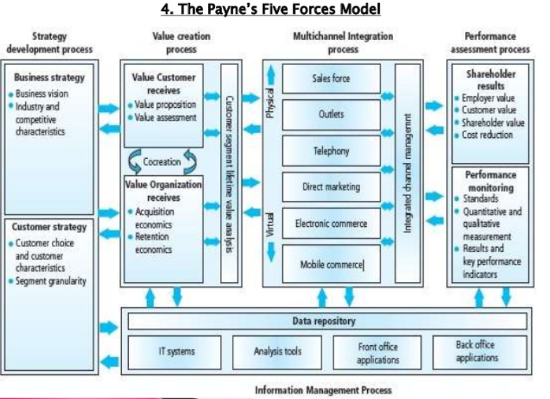
Figure 3: Payne’s Five Forces Model
(Source: Piri, Customer relationship management: Case Urakointiasennus, 2018)

According to Badsi (2018), there are multiple more models which focuses on value addition to the customer’s demand and fulfil their needs. But the above-mentioned models are most effective when it comes to implementation of Customer Relationship Management and applying that to effectively manage the relations build with individuals and business.

Critical investigation of theories helping in improving Customer Relationship Management
There are various models focused on Customer Relationship Management, and all of them focuses on various approaches to the system. According to Karim and Habiba (2020), Customer Relationship Management focuses on providing more value to the customers in a holistic approach, and all of it is focused on providing quality service to its customers. The goal of Customer Relationship Management is to boost customer loyalty, and for the same to happen, an organisation needs to focus on providing quality products and services to its customers. And their portfolio should be better than the one of the competitions in the market.
There are many advantages of implementing Customer Relationship Management, it can help to target the customers in the right manner and produce better results eventually. According to Kurlenko (2019), there are various advantages and disadvantages of implementing Customer Relationship Management in an organisation. Advantages include reduction of sales and operational cost, speeding up of sales process, increase in staff productivity, effective collaboration of internal teams with the customers improved customer experience by personalization and query resolution. Disadvantages include variance in customer experience due to over-reliance of staff on the system, time and the initial cost of implementation. Every model of CRM focuses on different approaches towards building an effective relationship of the brand with its customers, but there are some factors which are common and have to be kept in mind in order to provide the customers as per their requirement. These factors are also equally important while implementing a Customer Relationship Management model successfully. One must keep in mind that not every model will fit every business and they should be cautious while selecting the model which will make the alignment of goals feasible. According to Jalal et al. (2019), of all the factors influencing Customer Relationship, quality of product or services is perhaps the most important one. Apart from the company’s communications with its customers, they must focus on the quality aspect of the product to provide the best value to its clients. If the product is superior, it holds a benchmark in the hierarchy and the customers presume that they provide better value. According to Aghdaie and Sasani (2017), Poor quality of the product is a result of an ill-managed process and improper operations. Thus, the product or service will not be sustainable and will require frequent replacement, this will eventually affect the image of the brand and customers will avoid such products in the long run. On the contrary, when the product is subject to some problems or is in poor in quality if the company communicates with the team and its customers on the mentioned aspect and fix the defects as per the customers’ feedback, the organisation will be presumed as a better organisation and people will actually willing to try out their services and products. On another context, the company should bring a better value proposition than that of their competition to attract the right customers and retain them. It also helps build a sales plan for the existing customers to make a re-purchase from the same brand and thereby increase the flow of profit as well.

Task 3: Recommendations and conclusion

Oxfam International
In the first phase, focusing on the type of operations implemented by the company can be highlighted that Oxfam International has become a global brand creating chain operations. All the company follows the primary ethical theory and implements elementary help in the specified sector of operation, nevertheless they should implement a more widespread approach. In the age of micro financing, the company should focus on providing immediate financial and monetary help to community-based people so that they can develop their local area economy. The company has been working stress fully on projects like avoiding sexual violation of people in communities as well as abuse. Nevertheless, focusing on the current scope of inflation, the organisation should also implement local economic help to communities for withstanding the inflationary pressure. This also helps the organisation as a part of sustainable operations. This is because by increasing the scope of operations associated with government and private self-help groups or nongovernmental community help agencies and thereby increases the size of the crowd funding platform.
Sainsburys
Sainsbury’s is a typical example of a private sector organisation. The organisation currently needs to promote their net zero campaign which they mean to accomplish by the end of the year 2014, in order to join hands with potential suppliers who work on ethical lines, the organisation should pottery as well as promote the outcome there intending to achieve by the means of their environmental program as well as zero waste production related program in the future. Nevertheless, in order to beat the market competition, the organisation is acquiring small companies like Argos. As an outcome of the promotion of their brand as ecologically our company, we will be able to associate venture partners, venture capitalists as well as subsidiary farms to establish their prominence in the oligopolistic grocery market of the UK.
NHS
As a part of the problems facing nhs.uk, it can be highlighted that the organisation has focused more on information-based care approach. Nevertheless, the company faces issues like authorising doctors and other Healthcare service providers, analysing their ability and capability of providing service. Therefore, the organisation needs to implement a more seeking approach in fair and proportionate distribution of doctors in Healthcare service providers based on their educational qualification and competency level. In this relation, it can be highlighted that the organisation should start a certification policy based on customer feedback reception by respective doctors. This regard the NHS hospitals should implement a policy of collecting feedback against the name of specific Healthcare operators with which the patients have been operating.

Conclusion

The above discussion signifies that Customer Relationship Management is an integral tool of a business to gain success in the sales field, it can help in boosting the sales of an organisation as well as keeping the existing customers engaged with the brand through proper communication. As suggested by Jalal et al. (2019), implementing Customer Relationship Management can help an organisation to strategically identify and target the right audience from the crowd and retain them efficiently. It also helps streamline the process and keep the cost down for the process to become efficient. Customer Relationship Management can help in building a strong and sustainable set of assets an organisation can bank upon to make their marketing efforts a success. The report also cites the significance of maintaining and improving quality standards to improve their product and services by discussing how quality plays a major role in attracting customers and retaining them.

References

About.sainsburys.co.uk. 2020. Available at: https://www.about.sainsburys.co.uk/suppliers/ethical-trading (Accessed: 22 June 2020).

About.sainsburys.co.uk. 2020.Available at: https://www.about.sainsburys.co.uk/~/media/Files/S/Sainsburys/documents/making-a-difference/Sustainability_Update_2018.pdf (Accessed: 22 June 2020).
Aghdaie, S.F.A. and Sasani, B., 2017. Identifying and analysing components of customer relationship management influencing customer-oriented behaviour of employees: the case of Bank Mellat branches of Khouzestan Province. International Journal of Productivity and Quality Management, 22(3), pp.363-377.
Al Karim, R. and Habiba, W., 2020. Effects of Customer Relationship Management Components on Firm’s Competitive Advantage: A Case on Bangladesh Banking Industry. Management Research, 10(1), pp.1-7.
Alston, W., 2019.Deontological Desiderata.Contemporary Epistemology: An Anthology, pp.3-16.
Badsi, H.B.A., Ghomari, A.R. and Zemmouchi-Ghomari, L., 2017.A Customer Relationship Management process model for agent-based simulation.International Journal of Service Science, Management, Engineering, and Technology (IJSSMET), 8(4), pp.56-82.
Bai, F. and Qin, Y., 2016. The implementation of relationship marketing and Customer Relationship Management: How to become a customer-focused organization. Journal of Business & Economic Policy, 3(2), pp.112-124.
Baran, R.J. and Galka, R.J., 2016. Customer Relationship Management: the foundation of contemporary marketing strategy. Taylor & Francis.
Clauss, T., Niemand, T., Kraus, S., Schnetzer, P. and Brem, A., 2020. Increasing crowdfunding success through social media: the importance of reach and utilisation in reward-based crowdfunding.International Journal of Innovation Management, 24(03), p.2050026.

Commissioning, 2020.NHS commissioning » Generic policies, England.nhs.uk. Available at: https://www.england.nhs.uk/commissioning/policies/gp/ (Accessed: 22 June 2020).

Corporate Responsibility. 2020. Available at: https://www.about.sainsburys.co.uk/making-a-difference/our-values (Accessed: 22 June 2020).
deLazari-Radek, K. and Singer, P., 2017. Utilitarianism: a very short introduction. Oxford University Press.

Gilbert, B., Clarke, E. and Leaver, L. (2014) "Morality and markets in the NHS", International Journal of Health Policy and Management, 3(7), pp. 371-376.doi: 10.15171/ijhpm.2014.123.
Groothuizen, J.E., Callwood, A. and Gallagher, A., 2018. NHS constitution values for values-based recruitment: a virtue ethics perspective. Journal of medical ethics, 44(8), pp.518-523.
Humbyrd, C.J., 2019. Virtue Ethics in a Value-driven World: Ethical Telemedicine. Clinical Orthopaedics and Related Research®, 477(12), pp.2639-2641.
Jalal, A.N., Bahari, M., Tarofder, A.K. and Musa, W.M.N.M.W., 2019.Factors influencing Customer Social Relationship Management implementation and its benefits in healthcare industry.Polish Journal of Management Studies, 19.
Kurlenko, P., 2019. Customer relationship management in ride-hailing companies: case mytaxi (Intelligent Apps GmbH).
Mion, G. and Beghini, R., 2019. Developing virtue ethics in management: a case of an interdisciplinary educational approach.Development and Learning in Organizations.

Nao.org.uk, 2020. Available at: https://www.nao.org.uk/wp-content/uploads/2016/11/Financial-Sustainability-of-the-NHS.pdf (Accessed: 22 June 2020).
NHS.uk, 2020.End of Life Care-what is involved and when it starts. (Online). Available at: https://www.nhs.uk/conditions/end-of-life-care/what-it-involves-and-when-it-starts/ (Accessed: 21st June 2020)

Nhsproviders.org. 2020. Available at: https://nhsproviders.org/topics/covid-19/coronavirus-member-support/national-guidance/ethical-considerations (Accessed: 22 June 2020).

Oxfam.org. 2020.Safeguarding policy and procedures at Oxfam | Oxfam International (2020). Available at: https://www.oxfam.org/en/what-we-do/about/safeguarding#:~:text=At%20Oxfam%2C%20we%20are%20committed,and%20every%20time%20it%20happens. (Accessed: 22 June 2020).
Piri, M., 2018. Customer relationship management: Case Urakointiasennus M. RautioOy.

Rspo.org. 2020. Available at: https://www.rspo.org/file/acop/sainsburys-supermarket-ltd-j-sainsbury-plc/R-Policies-to-PNC-laborrights.pdf (Accessed: 22 June 2020).
Slote, M.A., 2020. Common-sense morality and consequentialism.Routledge.
Vismara, S., 2016.Equity retention and social network theory in equity crowdfunding.Small Business Economics, 46(4), pp.579-590.

