STRATEGIC PLAN
Student ID: 1911041
Student Name: Abel Paul Sandu
Module Name /Code: Strategic Management for SMEs BMSW6104
Subject Name: Academic Report
Lecturer name: DR Eric Osei

Executive Summary
The report illustrated the significant concept of the strategic management plan and its importance in the contemporary business world. Throughout this report-based assessment, a detailed analysis of both the micro and macro environment has been demonstrated. Through the internal analysis approach in a form of VRIO and the value chain model, the internal strengths, opportunities, weaknesses, and challenges of the selected SME (Unseen Tours) have been demonstrated. Through the detailed assessment of the balanced scorecard, the recent performance structure of the selected firm has been demonstrated. In addition, the report has also demonstrated several effective recommended strategies for Unseen Tour’s exclusive growth in the competitive tourism landscape across London.

Table of Contents
1. Introduction 5
1.1 Meaning and significance of Strategic Management and Social Enterprises 6
1.2 Background analysis with statistics 6
1.3 Purpose of the report 6
1.4 Demonstration of how the report will be organized 6
2. Overview Of the Social Enterprises Sector 6
2.1 Discussion of the Social Enterprises Sector 7
2.2 Discussion of the structure of the sector 7
2.3 Discuss the nature of the market 7
2.4 Strategic Intent/Direction 8
2.4.1 Name of Social Enterprise 8
2.4.2 Offered products and services 8
2.4.3 Subsector in the social enterprise's industry 8
2.4.4 Vision Statement 8
2.4.5 Mission Statement 8
2.4.6 Objectives of Enterprise with defining SMART objective 8
2.4.7 Consideration of Strategy Statement 9
3. Environmental Analysis 9
3.1 External Environmental assessment 10
3.1.1 Demonstration of the meaning of external/macro environment 10
3.1.2 Identification and explanation of the tool for macro environment assessment using PESTEL 10
3.1.3 Considering each factor of the tool/framework, demonstrate the factor, provide instances and mark two examples which have either a positive or negative impact on the enterprise 12
3.2 Industry / Micro Environmental assessment using Porter’s 5 Forces 13
3.2.1 Illustration of the meaning of industry/microenvironment 13
3.2.2 Recognition and illustration of the tool for microenvironment analysis 13
3.2.3 Undertaking each factor of the framework/tool, illustrate the factor, provide examples and accept two instances which are relevant to affect the corporation either negatively or positively 14
4. Internal/Firm Analysis 15
4.1 Internal/Firm assessment using VRIO Framework 15
4.1.1 Demonstrate the application of the VRIO Framework 15
4.1.2 Develop a framework and apply it to assess the enterprise’s capabilities and resources 16
4.1.3 A detailed discussion of the company analysis based on the above data 16
4.2 Internal/Firm exploration using Value Chain Framework 17
4.2.1 Illustrate the application of the Value Chain Framework 17
4.2.2 Configuration of a framework and apply it to investigate the firm’s value chains 17
4.2.3 Detailed illustration as per the above-mentioned analysis 18
4.3 Internal/Firm Analysis using SWOT Framework 19
4.3.1 Explanation of what the SWOT Framework is used for 19
4.3.2 Development of the framework and applying it to recognise the strengths, opportunities, weaknesses, and threats 19
4.3.3 Detailed demonstration based on the above-mentioned representation 19
5. Stakeholder Analysis 20
5.1 Define Stakeholders 20
5.2 Identification of all the stakeholders associated with the Social Enterprise 20
5.3 Mapping the Stakeholders in a grid and discussing the extent to which the stakeholders influence the selected enterprise 21
6. Strategy Formulation 22
6.1 Demonstration of strategy formulation 22
6.2 Identification and demonstration of the two most important strategy choices 22
6.2.1 Five Generic Competitive Strategies 22
6.2.3 Ansoff product-market mix 23
6.3 Considering each strategic choice, demonstrate their concept and importance, and next suggest which quadrant is most suitable for the firm’s positioning 24
7. Strategy Implementation 25
7.1 Balanced Scorecard 25
7.1.1 Explanation of Balanced Scorecard 25
7.1.2 Development of BSC for the chosen entity 25
7.2 Structure of Firm 26
7.2.1 Configuration of a suitable organisational structure 27
8. Recommendations 27
8.1 Recommendations for the future approach of the venture for future growth by reviewing the obstacles SMEs encounter while implementing the strategies 27
9. Conclusion 27
9.1 Summarisation of the core areas covered in the report 27
9.2 Demonstration of a final comment including speculation on future directions 28
10. References 28
11. Appendices 34
Appendix 1: Statistical Data 35
Appendix 2: Market Information 35
Appendix 3: Company Information 35
Appendix 4: Matrix Table of PESTEL Analysis 36
Appendix 5: Matrix Table of PORTER’S 5 Forces Analysis 37
Appendix 6: Matrix Table of SWOT Analysis 38
Appendix 7: Other Frameworks / Models / Tools 39

1. Introduction

1.1 Meaning and significance of Strategic Management and Social Enterprises
Strategic management is recognised as an ongoing procedure of configuring a business corporation’s high-performing structure to achieve its predefined goals. It is involved in defining business objectives, assessing the competitive atmosphere, and detailed interpretation of the internal status of the enterprise. On the other hand, social enterprises are identified as social businesses with particular social objectives that can maximise their profit score while increasing benefits to the environment and society.

1.2 Background analysis with statistics
The key reason for adopting the conceptualisation of “business” is to allow society by distributing services and goods which are highly essential for survival purposes. The key need in developing a business plan is to create a positive endowment in increasing the national GDP and overall national economy of a particular country. According to the statistical report published by the UK Government, it has been revealed that the number of public corporations is constantly increasing and represents 74% of the total U.K businesses (Shaw, 2022). The triple disruption such as Brexit, two general elections, and Covid-19 prevented the growth of SMEs in the U.K by up to 5.5 million. However, SMEs are still accounted for around 99.9% of the total population of the U.K (Young, 2022).

1.3 Purpose of the report
The key purpose of this report-based assessment is to gather an in-depth ideation of the micro and macro environment analysis of a particular SME and how it consistently overcomes business hurdles. The report also demonstrates different strategic tools to develop a strategic plan for the chosen social enterprise such as “Unseen Tours”.

1.4 Demonstration of how the report will be organized
In the first section of the report, the overview of the chosen social enterprise with its mission and vision statement would be demonstrated. Next, the external environmental assessment with PESTLE and the internal status of the firm would be demonstrated. After that, the stakeholder analysis would be done through Grid Model to consistently proceed with the strategy formulation process.

2. Overview Of the Social Enterprises Sector

2.1 Discussion of the Social Enterprises Sector
Definition of industry
The social enterprise is one type of business whose fundamental purpose is to address environmental and social complexities rather than earning profit for stakeholders and owners. This type of enterprise strictly follows the principles of “sustainable”, “diversifiable”, “easily replicated”, and “socially inclusive”.
- Competitors: There are numerous competitors in the context of social enterprises across the globe. Considering the United Kingdom, it has been discovered that there are more than 100,000 social enterprises and henceforth, the competition level for newcomers in the social enterprise world is high (Perera, 2022).
- Suppliers: The funding resources suppliers for the social enterprise are the regional financial institutions and banks.
- Customers: The targeted audience of social enterprise is the regional population without any gender, culture, or religious-based discrimination.
- Products and services: Social enterprises offer access to food, affordable energy, and employment along with other critical services to struggling individuals.

2.2 Discussion of the structure of the sector
Social enterprises indicate a business with certain social objectives and goals while implementing a commercial structure to properly run the business. All social enterprises are structured with two key goals such as profit generation and achieving environmental, social, and cultural outcomes. These types of enterprises are divided into trading enterprises, community firms, financial organisations, and non-governmental corporations. Through the consideration of the "hierarchical structure”, the Boards-of-Directors distribute the tasks to the staff based on their efficiency rate and experience level.

2.3 Discuss the nature of the market
According to the 2019 survey analysis, it has been revealed that 32% of business enterprises are recognised as industry leaders in the context of maturity level as social enterprises (Statista, 2022). The nature of the market growth rates of social enterprises is “growing” with the acquisition of the market share across 5 continents including fragile & stable, developing, and highly developed countries. Together these countries across the globe are representing more than 40% of the total global population as of 2022 (britishcouncil.org, 2022).

2.4 Strategic Intent/Direction

2.4.1 Name of Social Enterprise
The United Kingdom-based social enterprise, Unseen Tours, started its business journey in 2010 by getting inspiration from a volunteer network such as "The Stock Mob" (unseentours.org.uk, 2022). the key aim of this enterprise is to modify the public perception level of homelessness in its challenging contexts

2.4.2 Offered products and services
This is a not-for-profit social enterprise to offer alternative walking tours across London’s most interesting and vibrant neighbourhoods. Through this touring approach, a unique insight into London life can be accomplished by providing visibility and a voice to the individuals who are unheard and unseen.

2.4.3 Subsector in the social enterprise's industry
The company has no subsector and only focuses on the travel arrangement process across London. According to the ratings from TripAdvisor, the company has been rated as one of London’s top-listed social enterprise firms in 2022. This year, the number of happy and satisfied customers in London perspective is 25,000 taking assistance from 24 Homeless Guide (Our impact, 2022).

2.4.4 Vision Statement
The key vision statement of Unseen Tours is to become an innovative and top-rated tour service-providing firm for homelessness in London.

2.4.5 Mission Statement
The mission statement of Unseen Tours is to make up-gradations in the public perspective toward homelessness by offering more than 450 walks and welcoming more than 6500 guests.

2.4.6 Objectives of Enterprise with defining SMART objective
Objective | Specific | Measurable | Achievable | Relevant | Time-bound
To increase the headcount of happy customers in London | An increased number of customers in Unseen Tours improve its goodwill and reputation across the entire United Kingdom | Hiring efficient Homeless Guides and Launching virtual events can increase the customer's attention rate | Through the consideration of the "Theory of Change" strategy, the selected SME should have to make amendments to the "Training Programme", "Advanced Social media Engagement Technique", and "Signposting to outer assistance" | The company's shared social media page, Instagram stories, and Corporate Social Sustainability Programme can achieve the pre-defined objective. | Within a year

- To identify the goodwill and image reputation level of Unseen Tours in London
- To provide innovative walking experiences and happy moments for London’s homeless individuals
- To minimise the number of homeless people across London, as well as, in the entire United Kingdom

2.4.7 Consideration of Strategy Statement
The strategic statement of Unseen Tours is to offer an exclusive and eye-catching experience in London to long-time London residents, homeless individuals, and tourists.

3. Environmental Analysis

3.1 External Environmental assessment

3.1.1 Demonstration of the meaning of external/macro environment
Political: This factor indicates the extent to which the government of the specific country influence economic enhancement or degradation. The factors are associated with trade tariffs, tax policy rates, and fiscal policy style.
Economical: This factor ensures the economy’s performance that has a direct footprint on the business for its long-term sustainability. The economic factors are included in GDP, inflation, and foreign exchange rates (Vladosand Chatzinikolaou, 2019, p. 25).
Social: This factor investigates the social demands, population analytics, demographics, and cultural trends of the particular country.
Technological: These factors pertain to the innovation in digital technology to make a significant transition in the operation of the sector and the market unfavourably or favourably.
Legal: These factors are associated with certain legal paradigms and policies which affect the business territory of a particular country.
Environmental: This factor is included the surrounding environment to determine the pollution level of a particular country as a direct contribution of the particular business sector.

3.1.2 Identification and explanation of the tool for macro environment assessment using PESTEL

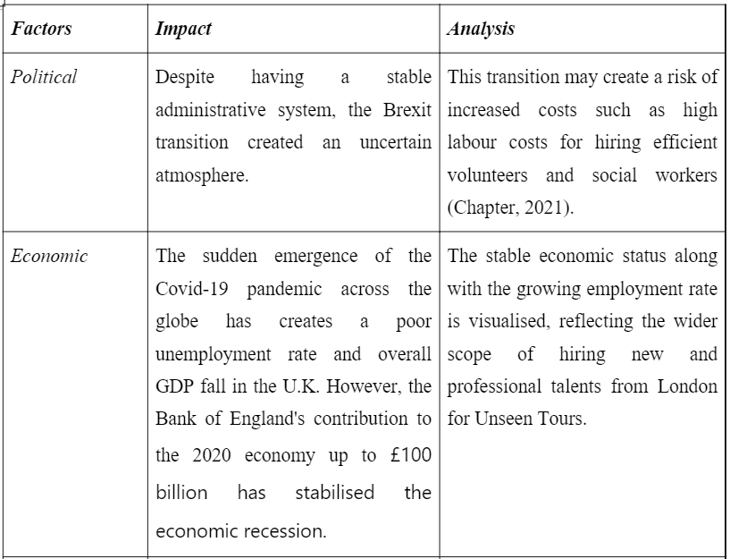
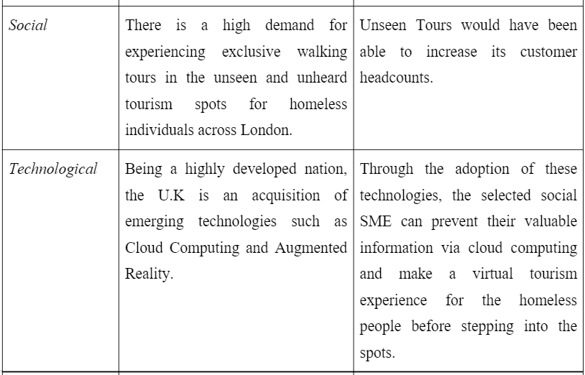
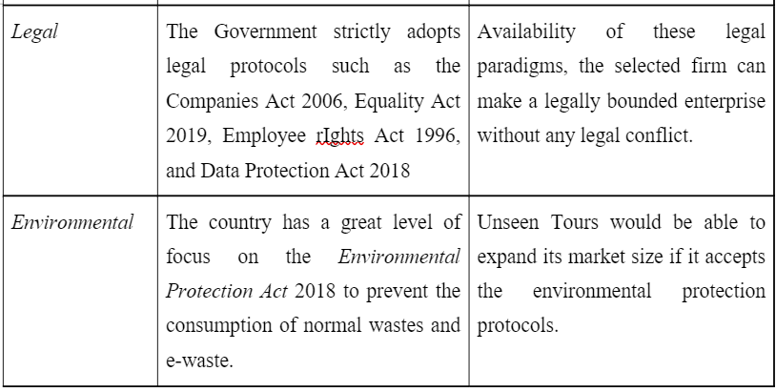

3.1.3 Considering each factor of the tool/framework, demonstrate the factor, provide instances and mark two examples which have either a positive or negative impact on the enterprise
Considering the political factor, it can be stated that the selected social SME can experience delays in the supply chain network due to the presence of the Brexit referendum. The factor has created a restricted movement of the United Kingdom throughout the European Union. Considering the economic factor, it can be demonstrated that the selected SME’s growth rate can be revived if the chosen country has stable GDP growth and a high inflation rate (Farouq and Dadwal, 2019, p. 132). Considering the social factors, it has been discovered that the global community has a high demand for exploring adventurous tours in unheard and unseen regions. Therefore, the selected social enterprise can have a scope to capture many visitors and improve its overall goodwill in the market competitiveness.
Considering the technological factors and analysing the above-outlined table, it has been determined that the selected social enterprise can prevent data hacking and data redundancy concepts. As a result, confidential business data can be safely secured in the cloud databases. Besides, the U.K government’s initiatives in Augmented Reality infrastructure generation in the tourism industry would help the selected firm to deliver a virtual touring experience for its targeted audience. Therefore, the customers can gather immense knowledge of the region and its cultural attitudes and heritages in the pre-exploring phase. Considering the legal factor, it can be steed that the selected SME would increase its productivity rate if there can be a presence of gender quality and zero discrimination policy. Undertaking the environmental factor, the selected company can have a high rate of long-term sustainability power in the competitive era through the recycling process, e-waste management process, and eliminating the global warming generating factors.
From the overall discussion, it can be stated that the economic contribution of the Bank of England and the struct adhering to the Fiscal policy by the U.K government, the stable economic status has been evaluated in the post-pandemic era. Besides, the UK government’s initiatives in the “Job Retention Scheme” have triggered the employment rate in the 2022 economy. It reflects the growth of the U. K’s GDP by 2% between the interval of August 2021 and August 2022 (Graham, 2022). As a result, the stable economic condition has been outlined in the U.K and it would have a positive influence on Unseen Tour’s sustainable performance in the market competitiveness.
By undertaking the social factor, it has been discovered that the London tourism industry's contribution toward the regional (London) economy is around £36 billion on an annual basis (atlasofthefuture.org, 2022). The homeless people's attitude towards Unseen Tours is satisfactory and henceforth, there is a huge scope for this firm to improve its goodwill and image reputation.

3.2 Industry / Micro Environmental assessment using Porter’s 5 Forces

3.2.1 Illustration of the meaning of industry/microenvironment
According to Hunger, (2020), this strategic management tool investigates and assesses five competitive forces to determine the estimated competition level of the particular business corporation in its targeted domestic marketplace. It is a frequently used guideline to evaluate the competitive attributes, influencing the business’s sustainability index. Through the evaluation of this strategic management tool in the business industry, the negotiation level of the supplier and customers, rivalry level, service/product substitution level, and new players’ penetration intensity can be measured.

3.2.2 Recognition and illustration of the tool for microenvironment analysis
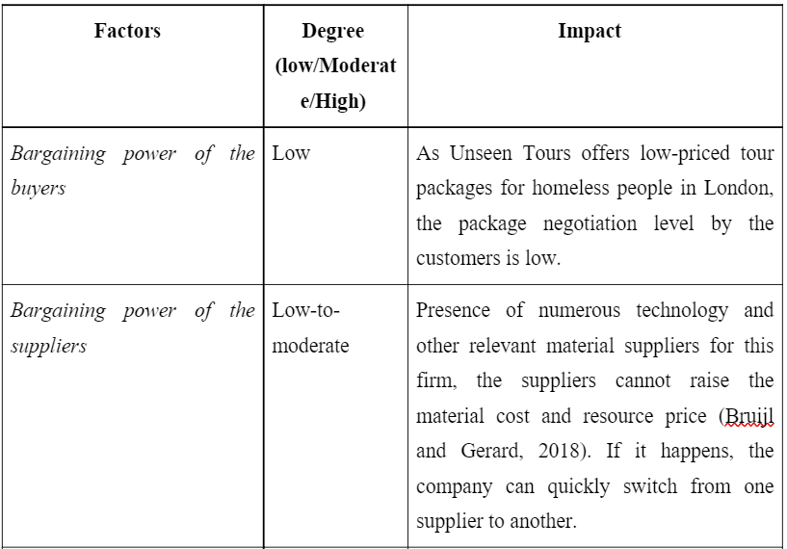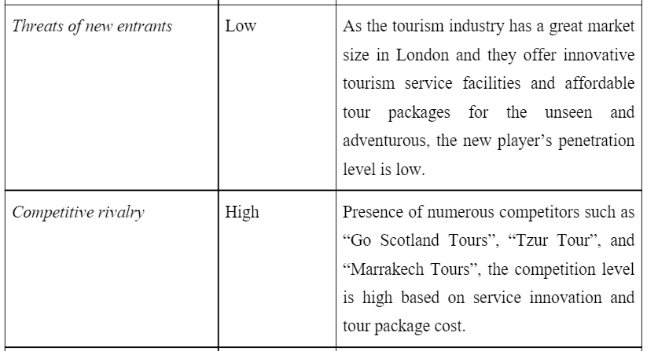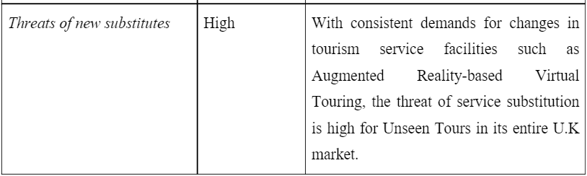

3.2.3 Undertaking each factor of the framework/tool, illustrate the factor, provide examples and accept two instances which are relevant to affect the corporation either negatively or positively
By detailed review of the above-mentioned strategic tool, it has been disclosed that the upper management of Unseen Tours can consider the factors such as “low bargaining power of the buyers” and “low rate of threats of new entrants" as positive reinforcement. Low bargaining power due to the offering of low pricing points in the unseen and unheard regions and guide-based assistance throughout the tour may increase the number of satisfied customer headcounts. Also, the new players in the tourism industry need stable capital to perfectly develop a strategic and sustainable management plan for business growth. Henceforth, it is quite challenging for start-ups and small-sized tourism firms to configure proper funding structures and provide highly innovative and satisfactory tourism services for the targeted audience.

4. Internal/Firm Analysis

4.1 Internal/Firm assessment using VRIO Framework

4.1.1 Demonstrate the application of the VRIO Framework
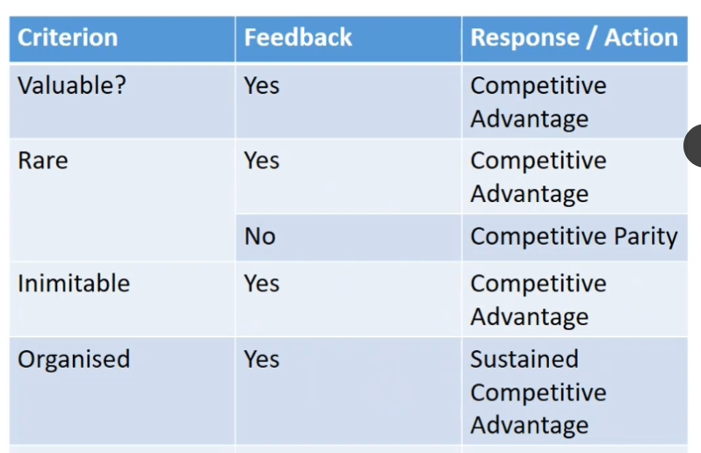
Figure 1: VRIO framework
Source: (Materials)
The VRIO framework is recognised as an imperative strategic planning tool that enables organisations to uncover capabilities and resources giving them a competitive advantage for the long term and therefore projecting the specific resources and capabilities (Chatzoglou et al., 2018). It helps an organisation identify business crucial resources by evaluating them based on their value, rarity, and imitability while simultaneously assessing whether the company is capable enough to utilise these resources effectively. While applying to a business, the firm needs to measure these criteria. For instance, a business is required to analyse the value that the particular resource adds for its consumers and whether the firm can use the opportunity and mitigate competition through an internal capability. In case the resource fails to offer value, the business is likely to be at a competitive disadvantage requiring it to re-evaluate and modify it. In terms of rarity, the business needs to assess whether the resources and capabilities of the firm are scarce and whether they are hard to find while having great demand (Ariyani and Daryanto, 2018, p. 11). In order to analyse imitability, an organisation is expected to evaluate whether duplication of its resources is possible, difficult, expensive, or easy and cheap. Finally, the criteria of the organisation determine whether the company has an organised management structure, processes, and systems so that I can capitalise on the capabilities and resources.

4.1.2 Develop a framework and apply it to assess the enterprise’s capabilities and resources
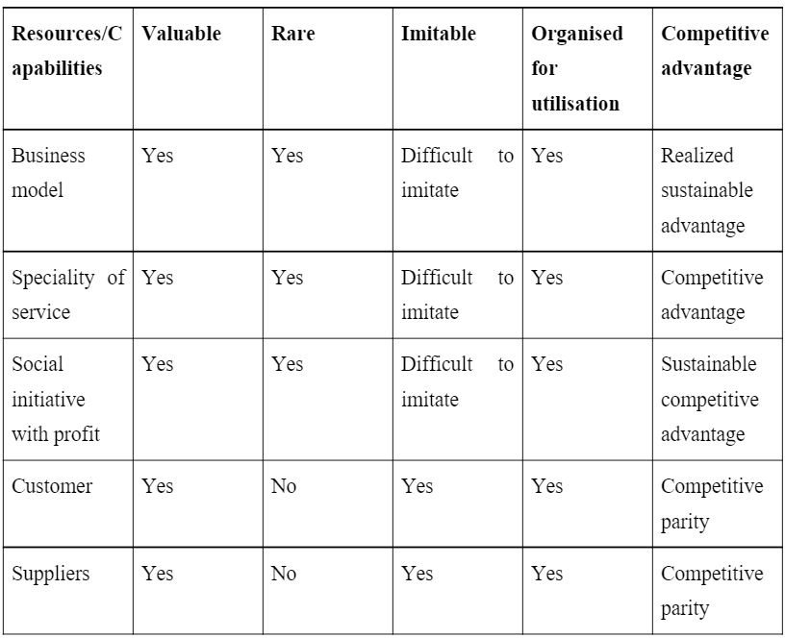

4.1.3 A detailed discussion of the company analysis based on the above data
In the above point, the VRIO framework has been applied to Unseen Tours. The key resources and capabilities identified about the organisation are its business model, the speciality of products or services, and the social initiatives with a focus on profit, customers, and suppliers. It has been found that suppliers and customers are valuable resources. However, they are not rare, and many social organisations serve the same customers and acquire funds from financial institutions and banks. Therefore, sourcing funds from these suppliers and acquiring customers become more challenging for Unseen Tours. However, the business model of Unseen Tours is rare, valuable, and difficult to imitate. The service speciality, social yet profitable initiative, and business model are all rare, difficult to imitate, and valuable. Rare resources and capabilities increase the competitive advantages of a firm (Buzatu et al., 2019, p. 247). While there are a large number of social organisations helping people in the street, the initiative of Unseen Tours is new. Moreover, managing remuneration and delegating work as well as providing food and other needs can be difficult for other organisations to imitate.

4.2 Internal/Firm exploration using Value Chain Framework

4.2.1 Illustrate the application of the Value Chain Framework
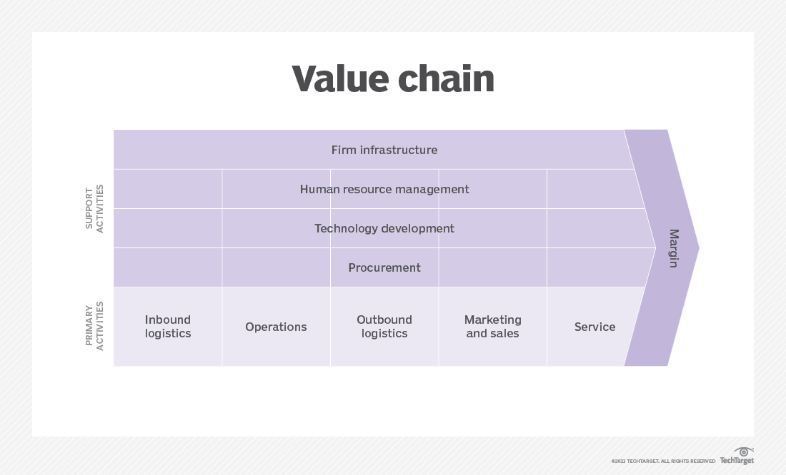
Figure 2: Value chain framework
Source: (Chai, 2021)
The framework of a value chain describes the complete chain of business activities in a company concerning the production of goods and services (Tian et al., 2019, p. 657). It traces the journey from the reception of raw materials to the delivery of the end items in the market. The framework separates primary activities and secondary activities. Primary activities mainly include inbound operations, marketing and sales, outbound logistics, and service. Secondary activities are the infrastructure of the company, technological development, procurement and purchasing, along with management of human resources.

4.2.2 Configuration of a framework and apply it to investigate the firm’s value chains
Primary activities
Inbound operations: In Unseen Tours, inbound operations involve the management of procured resources from the supply chain. In this case, inbound operations in the company mainly refer to the funding acquired from the financial suppliers, procuring food and other necessities for support, and client bookings for tours.
Operations: It signifies the transformational activities and processes to produce outputs from inputs (Ricciotti, 2020, p. 197). The firm offers vulnerably housed people the opportunity to lead, curate, and develop guided walks across various neighbourhoods in London for new and resident tourists.
Outbound logistics: Unseen Tours manages 24 guides and operates over 450 walks each year. The company serves eight separate areas across the city catering to more than 6500 guests.
Marketing and sales: The company has individual social media pages on Instagram, Facebook, and Twitter that help the enterprise market itself. Furthermore, sales are carried out through websites where customers can book their walks.
Service: The company provides customer support through emails. Moreover, the firm offers guided walks across the city of London that provide new tourists as well as long-term residents of the city with new perspectives to view and experience the city.
Secondary activities
Procurement and purchasing: As a not-for-profit organisation, Unseen Tours obtains funds from banks and other financial institutions.
Human Resources management: All people in the organisation are volunteers. The company uses a Digital HR strategy to hire individuals besides connecting with them directly.
Technological development: The firm is a digital-first company using social media and digital tools extensively.
Company infrastructure: The enterprise is based on the not-for-profit organisational model that is managed by a board of directors and tour guides.

4.2.3 Detailed illustration as per the above-mentioned analysis
The above framework of value chain applied to Unseen Tours has helped in the evaluation of primary and secondary activities within the organisation. The primary activities of the not-for-profit organisation outline the operations, inbound and outbound logistics, services, sales and marketing. On the other hand, technological development, firm infrastructure, HRM, and procurement of the business have been recognised as secondary activities. It has been revealed from the analysis that the organisation operates a not-for-profit model where people living in vulnerable conditions are uplifted through the provision of jobs where they tailor, and lead city walks for domestic and foreign tourists.

4.3 Internal/Firm Analysis using SWOT Framework

4.3.1 Explanation of what the SWOT Framework is used for
The framework of SWOT provides insight into the competitive position of a company. By visualising its strategic capabilities and setbacks as well as identifying external risks and scope, it further enables strategic improvement for the business (Vlados, 2019).

4.3.2 Development of the framework and applying it to recognise the strengths, opportunities, weaknesses, and threats
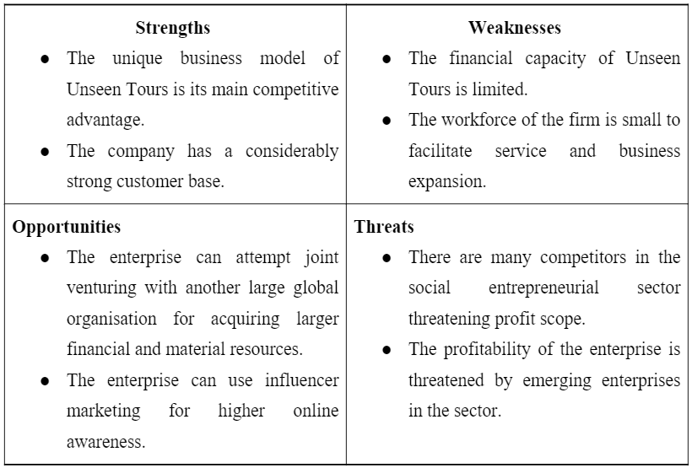

4.3.3 Detailed demonstration based on the above-mentioned representation
In the SWOT analysis of Unseen Tours conducted above the strengths and weaknesses are the first elements evaluated. These are the internal capabilities of the organisation (Benzaghta et al., 2021, p. 57). The analysis suggests that the exclusive business model and strong client base are the main advantages of the organisation that can be utilised as an opportunity to joint venture with large internal organisations for capability enhancement and further reach. On the other hand, the limited financial capacity weakens the firm’s ability to tackle the competitive threats in the market.

5. Stakeholder Analysis

5.1 Define Stakeholders
According to Dembek et al., (2020, p. 1601), stakeholders are a vital part of organisational success, and they have an immense level of interest in organisational success and business feasibility in market competitiveness. Stakeholders can be external and internal, and they can have combined performance in the organisational success in a highly saturated business landscape.

5.2 Identification of all the stakeholders associated with the Social Enterprise
External stakeholders
Regional government: Considering the case scenario of Unseen Tours, the London Government has been involved in offering permission to the Boards-of-Directors of the SME to explore the unseen tourism spots. During the final approval process, these types of external stakeholders review the safety level of the unseen and unheard tourism spots.
London Homeless Individuals: These types of stakeholders have a high interest to explore the unseen and unheard spots across London.
Resource suppliers: They are responsible for delivering electronic material, electrical equipment, and technology and application software with an ethical trading approach.
Internal stakeholders
Tourist Volunteers: The key responsibility of this stakeholder is to provide satisfactory tour guidance for visitors and London homeless people (Sapapthai et al., 2020, p. 590).
Audit personnel: They are responsible to calculate and prepare an estimated budget for each unseen and unheard travel with the assistance of smart financial tools.
Marketing Personnel: They are responsible for promoting innovative tourism services along with tour packages through its website and social media pages.
IT team: This stakeholder is accountable for installing, checking, and maintaining the advanced software and application tool for safely handling cloud-based data and evaluating the augmented reality-based virtual tourism experience.
Research-and-Development team: The team is responsible for consistently reviewing the London homeless individuals’ demands toward the service facilities and trying to make those applicable in the sector for customer retention.

5.3 Mapping the Stakeholders in a grid and discussing the extent to which the stakeholders influence the selected enterprise
High power, highly interested people (Manage Closely): The audit personnel, IT team, Research and development team, IT team, tourist volunteers, and Marketing Personnel of Unseen Tours have a high power to make a strategic tour plan, as well as, high focusing on organisational sustainability and self-career progression.
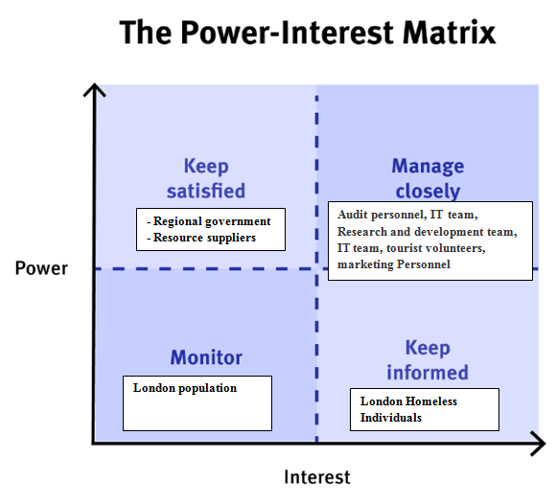
Figure 3: Stakeholder Grid model in Unseen Tours
(Source: Developed by the learner)
High power, less interested people (Keep Satisfied): The regional government and resource suppliers (external stakeholders) have high power in guiding people regarding the tourist spots and optimising the required resources with a low interest toward organisational growth.
Low power, highly interested people (Keep Informed): The London Homeless Individuals (external stakeholders) have low power in strategic planning for Unseen Tours but a high level of interest in exploring the unseen and unheard regions across London with a reasonable price point.
Low power, less interested people (Monitor): The London population (external stakeholder) has been included in this quadrant and they are informed by social media-based pages of Unseen Tours.

6. Strategy Formulation

6.1 Demonstration of strategy formulation
As explained by Tawse et al., (2019, p. 251), strategy formulation refers to the procedure of utilising existing knowledge to determine the intended business direction. The process of strategy formulation involves the development of actionable steps that helps in reaching the goals of the business. Formulation of strategy occurs at the corporate level, business level, and functional level. At a corporate level, a strategy is formulated to give the company an appropriate structure and ensure its coordination with different business units (Tawse et al., 2019, p. 255). The business-level strategy involves targeting and retention of consumers as well as competitive strategies. At a functional level, strategy formulation involves planning for the growth and improvement of the firm.

6.2 Identification and demonstration of the two most important strategy choices
The strategies concerning Unseen Tours are identified at the business and functional levels. Hence, the five generic competitive strategies and Ansoff’s product-market matrix strategy are chosen to ensure the firm can perform with a more competitive advantage and improve its product-service portfolio for market sustenance.

6.2.1 Five Generic Competitive Strategies
Following are the five generic competitive strategies that Unseen Tours can adopt:
Low-cost provider strategy: The low-cost strategy would require the company to pursue saving costs that cannot be inimitable (Danso et al., 2019, p. 887). Moreover, an organisation pursuing this strategy must ensure that product quality is retained.
Broad differentiation strategy: In this approach, an organisation needs to carry out an in-depth market study to understand consumer values, needs, and behaviours to identify a unique item that customers intend to pay for. The firm needs to produce items or services incorporating features that are distinctive and the price needs to be higher to recoup the costs of differentiation.
Focused low-cost strategy: In this strategy, Unseen Tours is required to focus on a unique customer need and introduce low-cost offerings for the market that can earn them customer loyalty. The firm in this strategic approach aims to offer products and services to niche consumers at a lower cost compared to rivals (Danso et al., 2019, p. 891).
Focused differentiation strategy: This approach refers to the strategy of differentiation aiming at a small and specified customer segment. In this case, Unseen Tours must ensure the new offering is well-specified and unique in experience.
Best cost provider: It is a hybrid strategy blending the low-cost strategies and differentiation to provide products and services at the best price possible beating competitors and fulfilling the desired quality and performance of the offerings (Islami et al., 2020, p. 10).

6.2.3 Ansoff product-market mix
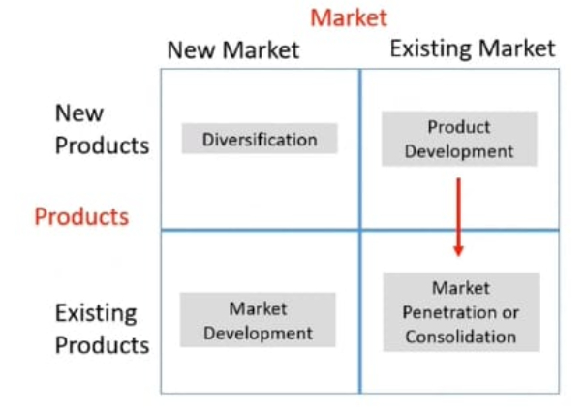
Figure 4: Ansoff's product-market matrix
Source: (Materials)
The product-market matrix of Ansoff presents growth strategies based on new and existing products and markets. Following is the strategic application of Ansoff’s matrix strategies-
Product development: In this strategy, a business needs to innovate products in the current market as existing products have become outdated or they are unable to provide adequate revenue growth desired by the firm (Candelo, 2019, p. 71).
Market development: This strategy would require Unseen Tours to enter other new markets with products that already exist so that new customers can be acquired, new market opportunities can be exploited, and the business can expand for growth.
Market penetration: This strategy emphasises the need for strategic modification for sales enhancement in the current market (Candelo, 2019, p. 77). In such as case, Unseen Tours can lower its service cost and offer discounts to generate more sales.
Diversification: In this approach, a business enters a new market with new products. Unseen Tours using this strategy can either develop services or products related to its existing offerings while entering the new market or the enterprise can develop unrelated and completely different products or services to cater to a new market.

6.3 Considering each strategic choice, demonstrate their concept and importance, and next suggest which quadrant is most suitable for the firm’s positioning
5 generic competitive strategies:
Low-cost provider strategy: Lowering the operational cost can help Unseen Tours acquire higher profit while the setback is that a low-cost strategy is not sustainable and can affect profit margin later.
Broad differentiation strategy: This strategy is expected to create premium product pricing and increase sales of units and brand loyalty (Liu and Atuahene-Gima, 2018, p. 17). However, this model is unsuitable for Unseen Tours as it is a social enterprise.
Focused low-cost strategy: It can allow the enterprise to run at a lower cost in comparison to its rivals, but it is likely to increase price competition for the company.
Focused differentiation: As opined by Islami et al., (2020, p. 14), strategic differentiation is suitable for serving different customer needs while it increases the costs of operations.
Best cost provider strategy: This is the ideal strategy for Unseen Tours as this hybrid strategy allows a balance between low cost and differentiation so that a company can be financially as well as productively competitive. In this approach, Unseen Tours can match new services and products to its competitors while beating them through low-cost operations within the markets.
Ansoff’s product-market matrix
Market penetration: As a social enterprise, Unseen Tours cannot lower its costs further as it can weaken the financial scope of the company.
Product development: This is a good strategy for differentiation; however, it involves risks of failure in case the service fails to appeal to the target audience.
Diversification: This strategy is not recommended for Unseen Tours as the cost would be exponentially high and poor market knowledge can lead to loss.
Market development: As Unseen Tours has already developed a significant customer base and acquired a team with considerable experience in the service, market development is the ideal strategy so that the firm can expand to new cities outside London for better awareness and diversify existing competitive risks.

7. Strategy Implementation

7.1 Balanced Scorecard

7.1.1 Explanation of Balanced Scorecard
According to Mio et al., (2022, p. 374), BSC is identified as a significant management system that can provide feedback on external deliverables and internal business procedures to consistently upgrade the strategic performance and sustainability level of the business. It can visualise the enterprise in different aspects such as the financial snapshot, customer satisfaction rate, business procedures, and change evaluation in a growth approach.

7.1.2 Development of BSC for the chosen entity
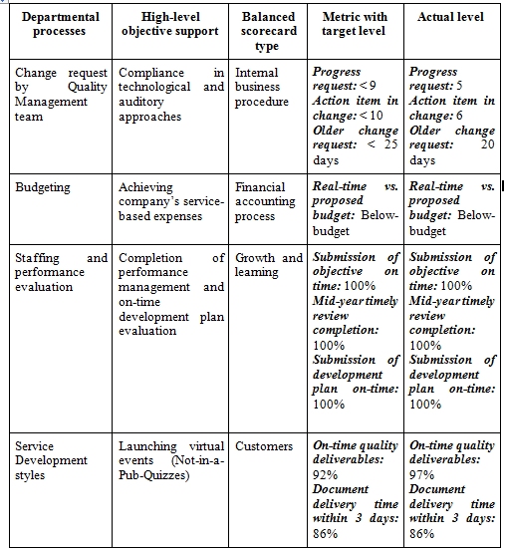
Figure 5: Balance scorecard of Unseen Tours
(Source: Developed by the learner)
By reviewing the BSC, it has been revealed that the enterprise has been able to meet the customer’s needs and henceforth a high degree of customer satisfaction level has been established. Overall, the company has a significant level of performance in the market competitiveness that can be retained by consistent upgradation and reviewing of the change requests.

7.2 Structure of Firm

7.2.1 Configuration of a suitable organisational structure
In order to sustain itself in the competitive marketplace, the selected SME can consider the “clan culture”. Through this organisational structure, a high-performing and highly coordinated work ambience can be created. This type of organisational culture would promote an integrated team culture, group innovation, and group thinking approach to resolving complex issues (Cherunilam, 2021). In addition, the company can use the “functional organisational structure" as it would focus on one specific area for improvement. This organisational structure would ensure a clear line of command and significant task delegation to complete the assigned tasks promptly (Cimini et al., 2020). Besides, the departmental integration through this structure would ensure a sustainable business standard for Unseen Tours in the competitive London market.

8. Recommendations

8.1 Recommendations for the future approach of the venture for future growth by reviewing the obstacles SMEs encounter while implementing the strategies
By reviewing the encountered hurdles by the selected SME, it can be recommended that the business should have to identify the appropriate external investors and make an ethical partnership with them to get budgetary advice for tour project planning. The second recommendation for this venture's growth is to make more investments in "AuditPro' software to evaluate 100% accurate financial planning for the travel project in Unseen Tours. The third recommendation is that the business should have to adopt the concept of the "regional talent-hiring" to evaluate a high-performing workforce in productivity enhancement in Unseen Tours.

9. Conclusion

9.1 Summarisation of the core areas covered in the report
From the overall analysis, it has been concluded that strategic planning in a business is recognised as a key pillar for organisational success in the competitive landscape. Through the consideration of the strategic tools and micro/macro environment analysis process, the competition level and operational hurdles for the selected SMEs in the London market have been significantly illustrated.

9.2 Demonstration of a final comment including speculation on future directions
In order to improve the organisational goodwill and image reputation in the competitive tourism market in London, the upper management of the SMEs including Unseen Tours should have a bird's eye at their threats. Accurate budget estimation and on-the-job training for the internal audit personnel of the selected SME is recommended so that the inaccurate budgeting concept can be eliminated. A high-performing workforce can be developed by offering staff rewarding processes and efficient talent-hiring systems, resulting in the performance growth of the selected business in the saturated business landscape.

10. References
Ariyani, W. and Daryanto, A., 2018. Operationalization of Internal Analysis Using the VRIO Framework: Development of Scale for Resource and Capabilities Organization (Case Study: XYZ Company Animal Feed Business Unit). Asian Business Research Journal, 3, pp.9-14. http://ecsenet.com/index.php/2576-6759/article/view/6
Benzaghta, M.A., Elwalda, A., Mousa, M.M., Erkan, I. and Rahman, M., 2021. SWOT analysis applications: An integrative literature review. Journal of Global Business Insights, 6(1), pp.55-73. https://digitalcommons.usf.edu/globe/vol6/iss1/5/
Bruijl, D. and Gerard, H.T., 2018. The relevance of Porter's five forces in today's innovative and changing business environment. Available at SSRN 3192207.https://www.researchgate.net/profile/Gerard-Bruijl/publication/326026986_The_Relevance_of_Porter's_Five_Forces_in_Today's_Innovative_and_Changing_Business_Environment/links/5c14165c299bf139c7593f03/The-Relevance-of-Porters-Five-Forces-in-Todays-Innovative-and-Changing-Business-Environment.pdfhttps://www.researchgate.net/profile/Gerard-Bruijl/publication/326026986_The_Relevance_of_Porter%27s_Five_Forces_in_Today%27s_Innovative_and_Changing_Business_Environment/links/5c14165c299bf139c7593f03/The-Relevance-of-Porters-Five-Forces-in-Todays-Innovative-and-Changing-Business-Environment.pdf
Buzatu, A.I., Pleșea, D.A., Iulian, C. and Valentin, W.P., 2019, May. Managing organizations for sustainable business development: Interaction between VRIO framework and Mckinsey 7s framework. In New trends in sustainable business and consumption. Bari: BASIQ International Conference (pp. 243-251). https://www.researchgate.net/profile/Ann-Katrin-Arp-2/publication/333902657_Study_on_European_funding_programmes_for_sustainable_development/links/5dbaf94d299bf1a47b05a8d3/Study-on-European-funding-programmes-for-sustainable-development.pdf#page=243
Candelo, E., 2019. Marketing Progress: A Never-Ending Story. In Marketing Innovations in the Automotive Industry (pp. 67-78). Springer, Cham. https://link.springer.com/chapter/10.1007/978-3-030-15999-3_11
Chai, W. 2021. What is a value chain and why is it important? SearchCIO. TechTarget. Available at: https://www.techtarget.com/searchcio/definition/value-chain#:~:text=The%20value%20chain%20framework%20is,technological%20development%20and%20company%20infrastructure. (Accessed: November 9, 2022).
Chapter, I.G.B., 2021. UK economic outlook: the future isn’t what it used to be. The Institute for Fiscal Studies.https://ifs.org.uk/sites/default/files/output_url_files/2-UK-economic-outlook-the-future-isn%2525E2%252580%252599t-what-it-used-to-be-.pdfhttps://ifs.org.uk/sites/default/files/output_url_files/2-UK-economic-outlook-the-future-isn%2525E2%252580%252599t-what-it-used-to-be-.pdf
Chatzoglou, P., Chatzoudes, D., Sarigiannidis, L. and Theriou, G., 2018. The role of firm-specific factors in the strategy-performance relationship: Revisiting the resource-based view of the firm and the VRIO framework. Management Research Review. https://www.emerald.com/insight/content/doi/10.1108/MRR-10-2016-0243/full/html
Cherunilam, F., 2021. Business environment. Himalaya Publishing House Pvt. Ltd. http://dspace.vnbrims.org:13000/jspui/bitstream/123456789/4950/1/business%20environment.pdf
Cimini, C., Boffelli, A., Lagorio, A., Kalchschmidt, M. and Pinto, R., 2020. How do industry 4.0 technologies influence organisational change? An empirical analysis of Italian SMEs. Journal of Manufacturing Technology Management.https://www.researchgate.net/profile/Alexandra-Lagorio/publication/338188294_How_do_Industry_40_technologies_influence_organisational_change_An_empirical_analysis_on_Italian_SMEs/links/60a2113a299bf14769a2c1ee/How-do-Industry-40-technologies-influence-organisational-change-An-empirical-analysis-on-Italian-SMEs.pdfhttps://www.researchgate.net/profile/Alexandra-Lagorio/publication/338188294_How_do_Industry_40_technologies_influence_organisational_change_An_empirical_analysis_on_Italian_SMEs/links/60a2113a299bf14769a2c1ee/How-do-Industry-40-technologies-influence-organisational-change-An-empirical-analysis-on-Italian-SMEs.pdf
Danso, A., Adomako, S., Amankwah‐Amoah, J., Owusu‐Agyei, S. and Konadu, R., 2019. Environmental sustainability orientation, competitive strategy and financial performance. Business Strategy and the Environment, 28(5), pp.885-895. https://onlinelibrary.wiley.com/doi/abs/10.1002/bse.2291
Dembek, K., York, J. and Singh, P.J., 2018. Creating value for multiple stakeholders: Sustainable business models at the Base of the Pyramid. Journal of Cleaner Production, 196, pp.1600-1612.https://researchbank.swinburne.edu.au/file/14e3b7b0-9d2b-4e4b-807a-5f36c0cf3619/1/2018-dembek-creating_value_for.pdfhttps://researchbank.swinburne.edu.au/file/14e3b7b0-9d2b-4e4b-807a-5f36c0cf3619/1/2018-dembek-creating_value_for.pdf
Farouq, T. and Dadwal, S., 2019. The Impact of Entrepreneurship on Economic Growth and Development in the UK. International Journal of Entrepreneurship Management Innovation and Development, 2, pp.116-146.https://www.researchgate.net/profile/Sumesh-Dadwal-2/publication/335106928_The_Impact_of_Entrepreneurship_on_Economic_Growth_and_Development_in_the_UK/links/5d5047e792851cd046b4c3d4/The-Impact-of-Entrepreneurship-on-Economic-Growth-and-Development-in-the-UK.pdfhttps://www.researchgate.net/profile/Sumesh-Dadwal-2/publication/335106928_The_Impact_of_Entrepreneurship_on_Economic_Growth_and_Development_in_the_UK/links/5d5047e792851cd046b4c3d4/The-Impact-of-Entrepreneurship-on-Economic-Growth-and-Development-in-the-UK.pdf
Graham, B. (2022) GDP monthly estimate, UK: August 2022, GDP monthly estimate, UK - Office for National Statistics. Office for National Statistics. Available at: https://www.ons.gov.uk/economy/grossdomesticproductgdp/bulletins/gdpmonthlyestimateuk/august2022#:~:text=Monthly%20GDP%20grew%20by%202.0,%25%20in%20our%20previous%20publication). (Accessed: November 9, 2022).
Hunger, J.D., 2020. Essentials of strategic management.http://elibrary.gci.edu.np/bitstream/123456789/718/1/BM -542 Essentials of Strategic Management, 5th Edition by J. David Hunger, Thomas L. Wheelen.pdfhttp://elibrary.gci.edu.np/bitstream/123456789/718/1/BM%20-542%20Essentials%20of%20Strategic%20Management%2C%205th%20Edition%20by%20J.%20David%20Hunger%2C%20Thomas%20L.%20Wheelen.pdf
Islami, X., Mustafa, N. and Topuzovska Latkovikj, M., 2020. Linking Porter’s generic strategies to firm performance. Future Business Journal, 6(1), pp.1-15.https://link.springer.com/article/10.1186/s43093-020-0009-1
Liu, W. and Atuahene-Gima, K., 2018. Enhancing product innovation performance in a dysfunctional competitive environment: The roles of competitive strategies and market-based assets. Industrial Marketing Management, 73, pp.7-20. https://www.sciencedirect.com/science/article/pii/S0019850116303522
Londoners who have experienced homelessness run tours in their own town (no date) Atlas of the Future. Available at: https://atlasofthefuture.org/project/unseen-tours/ (Accessed: November 9, 2022).
Mio, C., Costantini, A. and Panfilo, S., 2022. Performance measurement tools for sustainable business: A systematic literature review on the sustainability balanced scorecard use. Corporate social responsibility and environmental management, 29(2), pp.367-384.https://onlinelibrary.wiley.com/doi/pdf/10.1002/csr.2206https://onlinelibrary.wiley.com/doi/pdf/10.1002/csr.2206
More in common - british council. Available at: https://www.britishcouncil.org/sites/default/files/more_in_common_global_state_of_social_enterprise.pdf (Accessed: November 9, 2022).
Our impact (2022) Unseen Tours. Available at: https://unseentours.org.uk/our-impact/ (Accessed: November 9, 2022).
Perera, S. 2022 All about social enterprise, Social Enterprise UK. Available at: https://www.socialenterprise.org.uk/all-about-social-enterprise/#:~:text=Social%20enterprises%20are%20businesses%20which,employing%20around%20two%20million%20people. (Accessed: November 9, 2022).
Ricciotti, F., 2020. From value chain to value network: a systematic literature review. Management Review Quarterly, 70(2), pp.191-212. https://link.springer.com/article/10.1007/s11301-019-00164-7
Sapapthai, S., Leelawat, N., Tang, J., Kodaka, A., Chintanapakdee, C., Ino, E. and Watanabe, K., 2020. A stakeholder analysis approach for area business continuity management: A systematic review. Journal of Disaster Research, 15(5), pp.588-598.https://www.jstage.jst.go.jp/article/jdr/15/5/15_588/_pdfhttps://www.jstage.jst.go.jp/article/jdr/15/5/15_588/_pdf
Shaw, B. 2022. UK business; activity, size and location: 2022, UK business; activity, size and location - Office for National Statistics. Office for National Statistics. Available at: https://www.ons.gov.uk/businessindustryandtrade/business/activitysizeandlocation/bulletins/ukbusinessactivitysizeandlocation/2022 (Accessed: November 9, 2022).
Statista. (2022). Social enterprise: effect on growth of organizations worldwide 2019. [online] Available at: https://www.statista.com/statistics/1053061/increase-in-growth-of-organizations-worldwide-by-social-enterprise-maturity/ [Accessed 9 Nov. 2022].
Tawse, A., Patrick, V.M. and Vera, D., 2019. Crossing the chasm: Leadership nudges to help transition from strategy formulation to strategy implementation. Business Horizons, 62(2), pp.249-257. https://www.sciencedirect.com/science/article/pii/S0007681318301538
Tian, K., Dietzenbacher, E. and Jong-A-Pin, R., 2019. Measuring industrial upgrading: applying factor analysis in a global value chain framework. Economic Systems Research, 31(4), pp.642-664. https://www.tandfonline.com/doi/abs/10.1080/09535314.2019.1610728
Vlados, C. and Chatzinikolaou, D., 2019. Methodological redirections for an evolutionary approach of the external business environment. J. Mgmt. & Sustainability, 9, p.25.https://www.researchgate.net/profile/Charis-Vlados-2/publication/335491630_Methodological_redirections_for_an_evolutionary_approach_of_the_external_business_environment/links/5d690550a6fdccadeae4c1d0/Methodological-redirections-for-an-evolutionary-approach-of-the-external-business-environment.pdfhttps://www.researchgate.net/profile/Charis-Vlados-2/publication/335491630_Methodological_redirections_for_an_evolutionary_approach_of_the_external_business_environment/links/5d690550a6fdccadeae4c1d0/Methodological-redirections-for-an-evolutionary-approach-of-the-external-business-environment.pdf
Vlados, C., 2019. On a correlative and evolutionary SWOT analysis. Journal of Strategy and Management. https://www.emerald.com/insight/content/doi/10.1108/JSMA-02-2019-0026/full/html
Walking Tours & virtual quizzes supporting people affected by homelessness (2022) Unseen Tours. Available at: https://unseentours.org.uk/ (Accessed: November 9, 2022).
Young, H. 2022. Small business statistics UK 2022, Startups.co.uk. Available at: https://startups.co.uk/analysis/small-business-statistics/ (Accessed: November 9, 2022).

11. Appendices

Appendix 1: Statistical Data
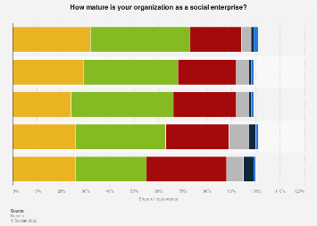

Appendix 2: Market Information
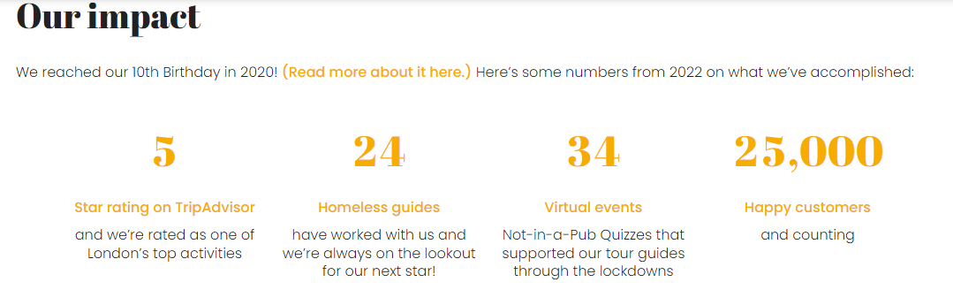

Appendix 3: Company Information
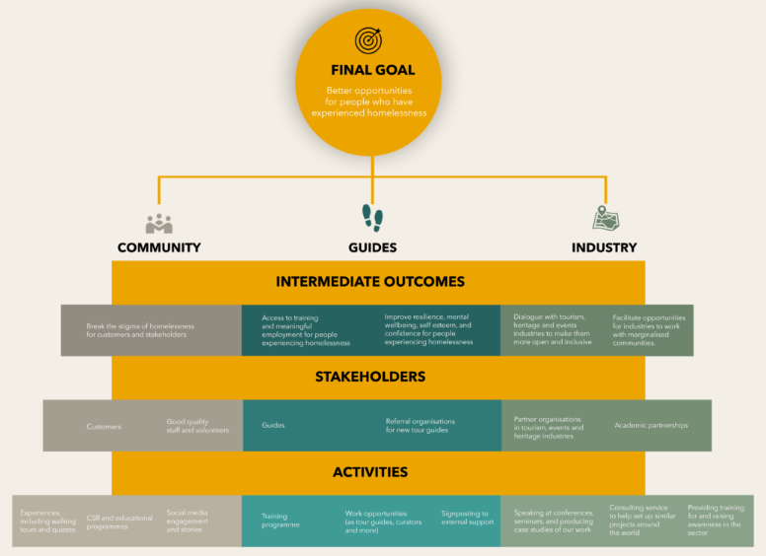

Appendix 4: Matrix Table of PESTEL Analysis
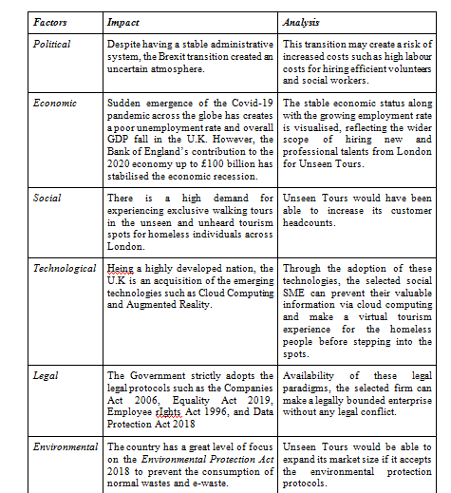

Appendix 5: Matrix Table of PORTER’S 5 Forces Analysis
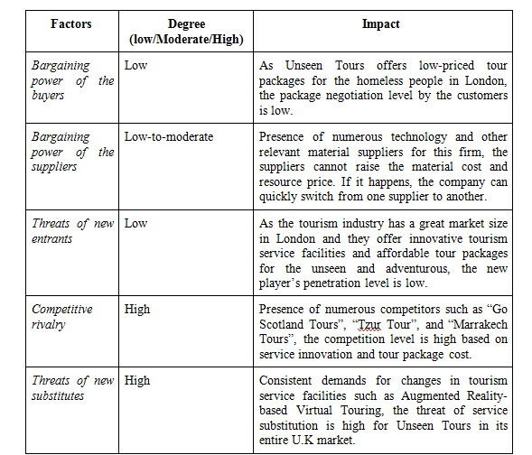

Appendix 6: Matrix Table of SWOT Analysis
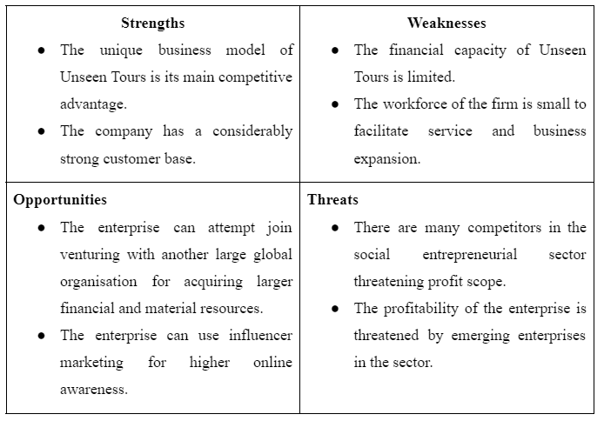

Appendix 7: Other Frameworks / Models / Tools
VRIO Framework


