Understand the Function of Logistics

Topic 1: What is meant by Logistics?

Logistics involves the planning and execution of the movement of goods, people, services and information to the point of use, and back to the point of origin if required. Effective logistics management ensures the right products are moved to the right customer in the right quantity, with the right quality, to the right place, at the right time and at the right price. This is known as the 7 rights of Logistics.

Figure 1 identifies the key activities of logistics for a typical organisation

Figure 1: Logistics Activities

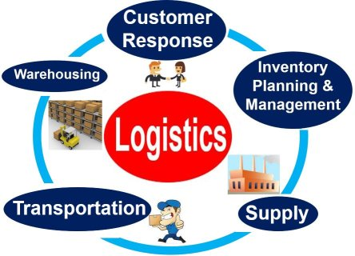

Customer Response

This is also known as Outbound Logistics or Distribution and involves the movement of a finished product or service to the customer. This activity involves liaising with the customer to agree acceptable delivery arrangements. This may also involve Handling and Packing of finished goods in appropriate, protective packaging to ensure they arrive at the customer in the desired condition.

Inventory Planning and Management

Inventory is held to protect against uncertainty in supply and to meet unexpected customer demand. The key objective is to avoid a stock-out situation whereby an organisation runs out of sufficient materials to maintain production. Whilst holding inventory can ensure continuity in operations and customer satisfaction, it also incurs significant cost to an organisation. Therefore, it is the Logistics function’s role to carefully plan and manage inventory levels to support the financial objectives of the organisation.

Supply

This is also known as Inbound Logistics and involves liaising with suppliers to plan deliveries and receive materials. Securing supplies of goods to maintain continuity of operations is an essential responsibility of the logistics function. This role is frequently known as Material Planning and it is important for a material planner to build strong relationships with suppliers.

Transportation

This involves the selection of an appropriate transport mode for the movement. Modes of transport have specific strengths and weaknesses which must be considered to ensure the most efficient methods are selected for the specific goods movements. For instance, when time is the determining factor, air freight may be appropriate but if cost is the priority, a more cost effective method such as rail or sea freight may be more appropriate.

Warehousing

This involves the storage of raw materials, semi-finished materials, consumables and finished goods in a secure, appropriate environment. A warehouse could serve a single manufacturing facility or be a central hub within a logistics network where finished goods are stored before being delivered to the customer, known as a Distribution Centre.

Specialist Logistics

Figure 2 provides a number of specialist types of logistics which have unique characteristics:

Figure 2: Special Types of Logistics
Type | Characteristics
Military Logistics | The supply, transportation and distribution of services, equipment and manpower to areas of military operations
Reverse Logistics | The movement of materials from the point of consumption to the point of origin for the purpose of recycling or disposal
Green Logistics | This involves measuring and minimising the environmental impact of logistical activities
Global Logistics | This involves cross-border, worldwide logistical movements which incur significant challenges such as customs tariffs, security, documentation, regulations and longer transit times.
Humanitarian Logistics | Providing humanitarian assistance in times of war, civil unrest or following a natural disaster. The emphasis is on speed and safety.
Third Party Logistics (3PL) | This is a specialist logistics provider that undertakes selected logistics activities on behalf of a customer

Topic 2: The Purpose and Function of Logistics

The purpose and function of Logistics can be placed into context by using Porter’s Value Chain model, which separates Primary Activities from Support Activities as illustrated in Figure 3. Primary activities are those which are easily visible to the customer whereas support activities facilitate the effectiveness of the primary activities.

The logistics role is found within the Inbound Logistics, Outbound Logistics and Sales and Marketing activities. Primary Activities are frequently the source of competitive advantage for an organisation because they are seen to have the largest influence on the customer experience of the product or service. However, the model also illustrates how all the activities add value to an organisation and are interdependent, forming a chain of value throughout the organisation which a customer is willing to pay for. This demonstrates how logistics is able to contribute to the success of an organisation through cross-functional collaboration.

Figure 3: Porter’s Value Chain

Just In Time (JIT)

Just in Time (JIT) is a disciplined approach to improving overall productivity by eliminating wasteful activities from organisational processes. It provides for cost-effective production and delivery of only the necessary quantity of material at the right quality, at the right time and place, while using the minimum amount of facilities, equipment, materials and human resource. It originated in Japan and was quickly adopted by the Toyota automotive organisation.

In manufacturing, JIT is closely associated with the shift away from the traditional Push systems to a Pull system:

- A Push System provides supplies of materials in anticipation of demand

- A Pull System is one that controls the flow of work through a factory by releasing materials into production when they are required, not before

The key objectives of JIT are illustrated in Figure 4:

Figure 4: The Key Principles of JIT

These objectives demonstrate the critical role logistics plays in a JIT strategy and it presents a major challenge for the function.

Holding inventory incurs significant cost to an organisation and JIT aims to eliminate this as much as possible. Eliminating lead times not only reduces inventory but also reduces the potential time incurred waiting for delivery which will inevitably reduce production. This requires significant flexibility and closer involvement from suppliers as they are requested to deliver materials to the point of consumption just in time to be used. Consequently, reducing inventory and lead times require a significant amount of planning and management of the supplier relationship by material planners. This also involves building a strong cross-functional relationship with the purchasing function.

Reducing waste caused by failures and delays such defective products or late deliveries is achieved through a commitment to quality. A common approach is the Total Quality Management (TQM) approach which aims to continuously improve the quality of products and processes throughout the supply-chain.

With the increase in global supply sources as well as global consumer markets, the role of the logistics function to implement and manage the JIT philosophy has become more challenging and is growing in importance.

As a consequence of JIT, the following objectives can be achieved:

- Reduction of wasteful activities reduces cost and improves the overall profitability of an organisation

- Reduction of lead-times can lead to competitive advantage and improved customer satisfaction

- Improved quality can lead to competitive advantage and improved customer satisfaction

Planning and Forecasting

Planning a forecasting demand is an important responsibility of the logistics function. Accurate forecasting ensures the right resources and materials are available when required. It is also key to effective inventory management. Listed below are characteristics of a reliable forecast:

- Timely: A forecast should have a horizon in the future within which demand is fixed beforehand and changes can be implemented afterwards

- Accuracy: A forecast should estimate how accurate it is

- Meaningful: A forecast should be expressed in meaningful units

- Easy to use: A forecast should be simple to understand and use

- Consistency: A forecast should derive from consistent, historical data

There are two common approaches to forecasting demand:

- Simple Moving Averages is a simple technique which looks at recent, historical demand and assumes that demand for the coming period will be an average of the past.

- Weighted Average / Exponential Smoothing is a technique which also uses averages of recent, historical demand but calculates the forecast by giving greater weight to the most recent demand figures, than older figures. This ensures recent trends are accounted for in the forecast.

Once a reliable forecast has been established, demand can be planned effectively by close liaison with suppliers and customers.

Demand Management

Demand management is a process which should balance the requirements of the customer base with the supply chain capabilities available. Effective demand management processes enable businesses to be more proactive to anticipated demands as well as increasing re-activeness to unanticipated demand. Identifying ways to reduce demand variances and improve operational flexibility is an important activity in the demand management process.

Reverse Logistics

Reverse logistics is the process of moving goods from the point of consumption back through the supply chain to the point of origin. This can be done for either disposal or recapturing value through recycling as shown in Figure 5:

Figure 5: Reverse Logistics

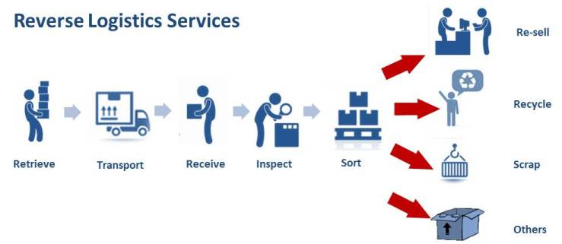

Examples of Reverse Logistics include:

- The recycling of finished goods and/or raw materials at end of life
- The return of goods due to inferior quality of unfitness for purpose

The growing importance in reverse logistics can be attributed to a number of factors, outlined below, which has meant that it has become an important responsibility of the logistics function:

- Sustainability and Environmental legislation such as:
  - Recycling legislation
  - Producer responsibility which makes manufacturers responsible for the environmental impact of products and packaging at end of life.
  - End of Life Vehicle legislation which makes vehicle manufacturers responsible for the collection, recycling and disposal of vehicles at end of life

- The growth of online retailing which generates high levels of returned goods. Indeed, returned goods are three times more likely for online retailers

Self-Assessment Questions

- What are the 7 rights of logistics?

  - Right people, right customer, right quantity, right quality, right place, right time and right price

  - Right products, right supplier, right quantity, right quality, right place, right time and right price

  - Right products, right customer, right quantity, right quality, right place, right time and right price

  - Right products, right customer, right quantity, right quality, right transport, right time and right price

- Which of the following statements is true? Choose 4 answers

  - Customer Response is an important activity of the logistics function

  - Effective inventory planning and management is good for operations but makes no contribution to the financial objectives of an organisation

  - Just in Time aims to improve overall productivity by eliminating wasteful activities from organisational processes such as inventory holding and waiting for deliveries

  - According to Porter’s Value Chain, logistics activities are classes as support activities and have little influence on the customer experience

  - Reverse logistics is the process of moving goods from the point of consumption back through the supply chain to the point of origin and has grown in importance due to sustainability and online retailing

  - Demand planning involves close liaison with suppliers and customers

  - Green Logistics involves the movement of trees, plants and flowers

- Which of the following are key objectives of Just in Time. Choose one answer:
  - Zero failures
  - Zero lead time
  - Zero Inventory
  - Zero delay
  - All of the above

