27/7/2026
University of Wales Trinity Saint David
LONDON CAMPUS
LDE Assignment 1
E-Portfolio
E-Portfolio Link: https://rellarells20.wixsite.com/my-portfolio-5
Module Name: Learning in the Digital Era
Module Code: ACCA 4025

Student Name: Rasheeda Richards
Student ID: 2434375
Group: 3

Lecturer’s Name: Anees Baqir
Table of Contents
Introduction 2
Main Body 2
Task 1: Essential Academic and Employment Skills for the future career Path 2
Task 1 (a): Report on Essential Academic and Employment Skills 2
Task 1 (b): Evaluation of Task 1 (a) based on Similarity report 2
Task 2: Collaborative Mind Map and Individual Poster 2
Mind Map (Collaborative) 2
Poster (Individual) 2
Task 3: Virtual Collaboration and RefWorks 2
Report on Virtual Collaboration 2
Step-by-step process of using RefWorks with visuals 2
Task 4: E-Portfolio Creation and Evaluation 2
Task 4 (a): E-Portfolio Creation 2
Task 4 (b): Illustrative Review of E-Portfolio tool Selection 2
Conclusion 2
References 2
Task 1 References: 2
Task 3 References: 2

Task 1
1a)
Introduction
The computer sector is constantly evolving, and employers expect graduate to demonstrate technical knowledge alongside transferable skills such as communication, teamwork, problem-solving, adaptability, and time management. Developing these skills during my studies will prepare me for a successful career in computing[1].
Communication is essential in computing because professionals must explain technical concepts to colleagues, managers, and clients. University presentations and group work will help me develop this skill for my future career.[2]
Computer projects require teamwork to achieve common goals. Group projects at university will help me develop the collaboration skills needed in professional computer environments.[3]
Problem-solving enables computing professionals to identify technical issues and develop effective solutions. Coursework and practical projects will prevent me to solve workplace challenges.[2]
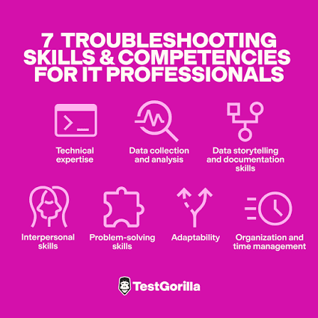

Time management helps computing professionals meet deadlines and adapt to new technologies. Managing my studies effectively will prepare for continuous professional development.[4].
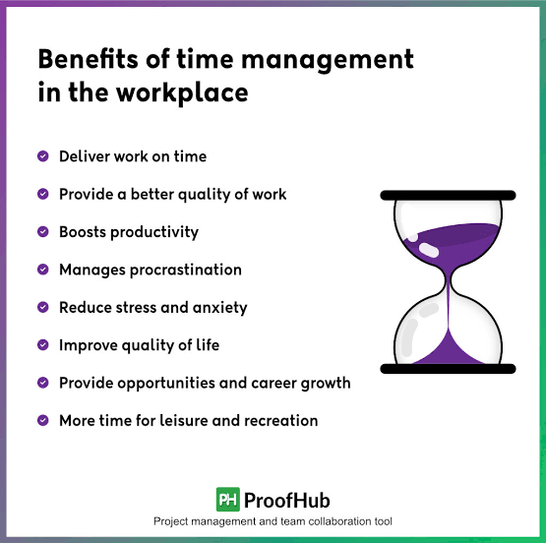

In conclusion, developing communication, teamwork, problem-solving, adaptability, time management, and technical knowledge will prepare me for a successful career in the computing industry. [4. 3. 4. 2. 3. 4. 1. 2. 3. 4]

Task 1b Similarity score
I received a similarity score 38%. Most of the matches were from my reference list, I also used correctly sources which can contribute to the similarity score. To improve future assignments old paraphrase information more effectively whilst still accurately references to my source is using IEEE based on the Generic Assignment Criteria, I would award myself 50% because I met the task requirements used the range of credible sources and applied IEEE referencing whilst also linking my discussion to my future career in computing. However, I recognise that there is room to improve my academic writing in and reduce unnecessary similarity.

Task 2 Mind Map
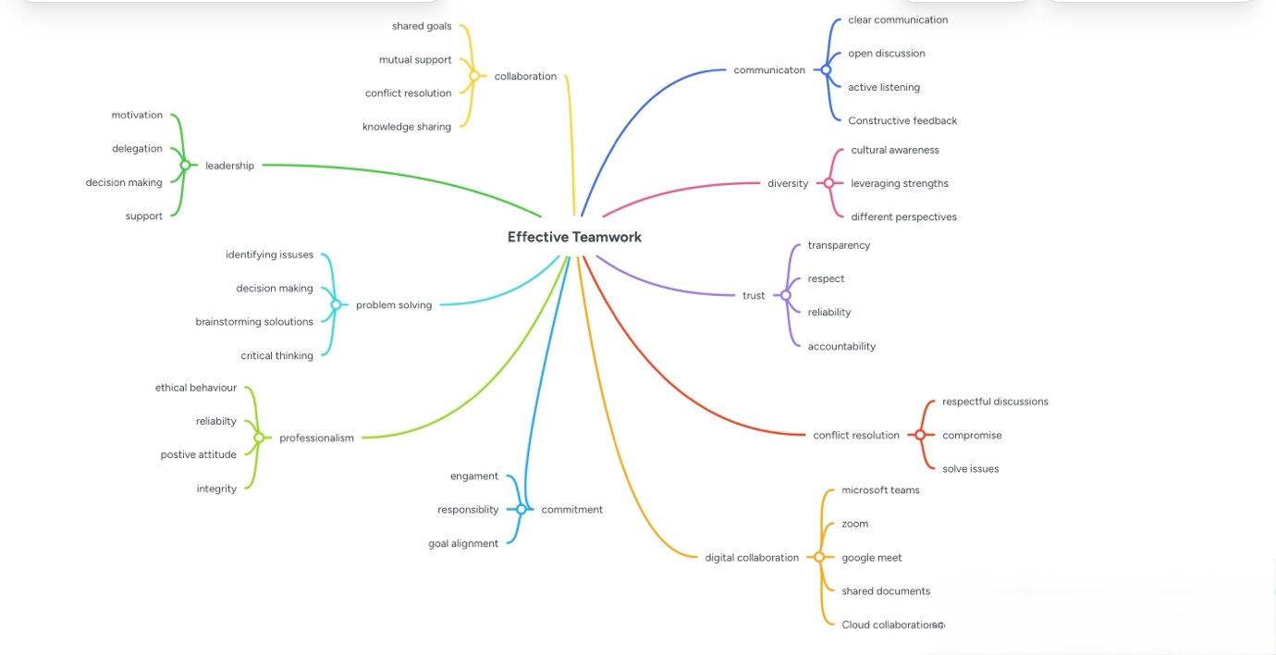
Team members: Rasheeda Richards, Ruben Dabo
Collaboration Tool: Mind Meister
https://www.mindmeister.com/app/map/4055184847?t=brpnn8OSZj

Task 2b) Academic Poster
https://uowtsd-my.sharepoint.com/:b:/r/personal/2434375_student_uwtsd_ac_uk/Documents/academic poster .pdf?csf=1&web=1&e=4iEX4d

Task 3
Task 3a)
Appropriate conflict management is a key component of working in a virtual team. Because there is less face-to-face connection in virtual environments, conflict may be challenging to settle. Conflict can merge when people have different ideas, communication styles or expectations. AlHattab (2020) claimed that because empathy and non-verbal communication are diminished in online context, dispute resolution is different from traditional settings therefore misunderstandings can happen more frequently. Team members should listen actively to one another speak openly and reserve problems before they become more serious.[5]
The five phases in Tuckman’s model of team development forming, storming, norming, performing, and adjourning explain how teams advance (Tuckman & Jensen, 1977). Team members build relationships and get to know one another during the formation phase. Conflict and disagreements are most likely to arise during the storming stage when people compete for roles and voice differing ideas. Teams go into the Norman stage, when trust and corporation grow, and the performing stage, where members corporate well toward common objectives, if the disagreement is handled well the teams work is finally completed and accomplishments are reviewed during the adjourning stage[6]
Recognising clear roles and responsibilities is essential for successful teamwork according to Mullins (2019), a role is the expected behavioural pattern connected to a specific job within an organisation. Clearly defined responsibilities help team members understand what is expected of them, improving accountability and reducing confusion. Research on virtual teams suggest that assigning clear team rules improve coordination as supports more effective collaboration, helping teams achieve the shared objectives[7]. Ensuring that work is distributed fairly and that everyone contributes to accomplishing the team goals, this helps avoid conflict.
An effective method for assessing team performance and pinpoint in areas for development is a SWOT analysis. It examines the team’s Threats, Weaknesses, Opportunities and Strengths of a team. While weaknesses point out areas that need development and strengths are the positive characteristics that promote achievement whilst opportunity show how the team can grow or perform better. SWOT analysis provides teams of a structured way to evaluate their current performance and identify strategy for improvement.[8]

Task 3b
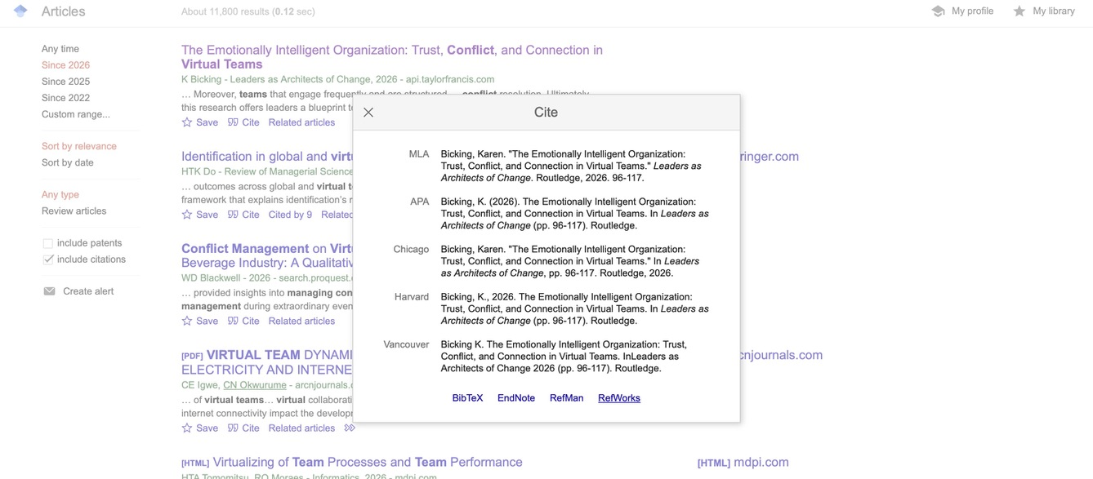
Exporting a reference from Google Scholar to RefWorks

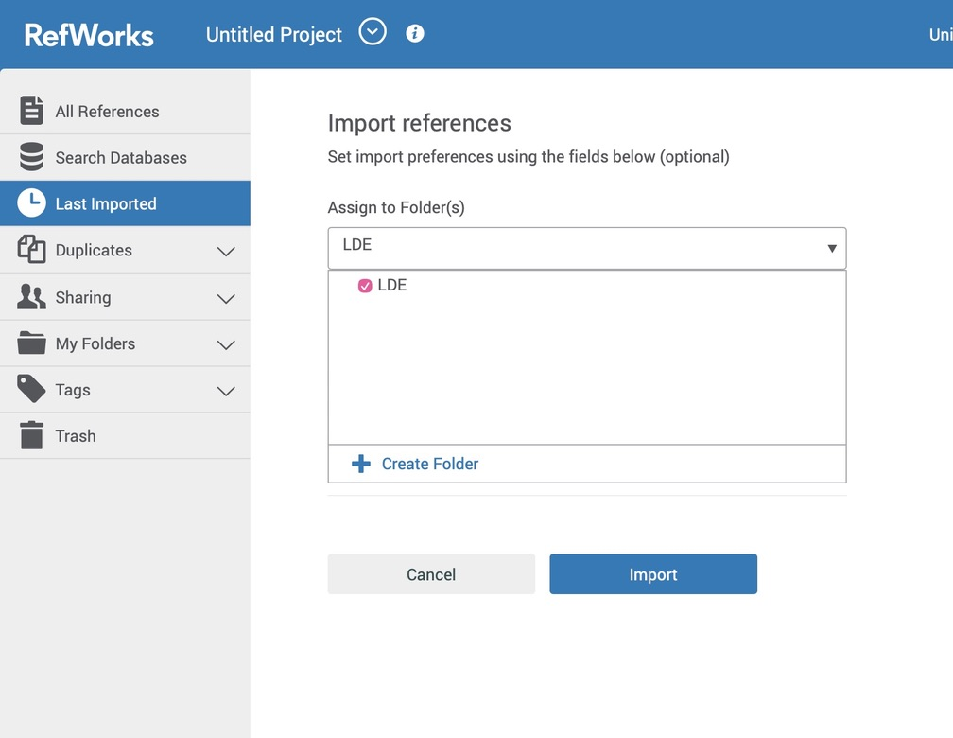
Importing the reference into RefWorks library

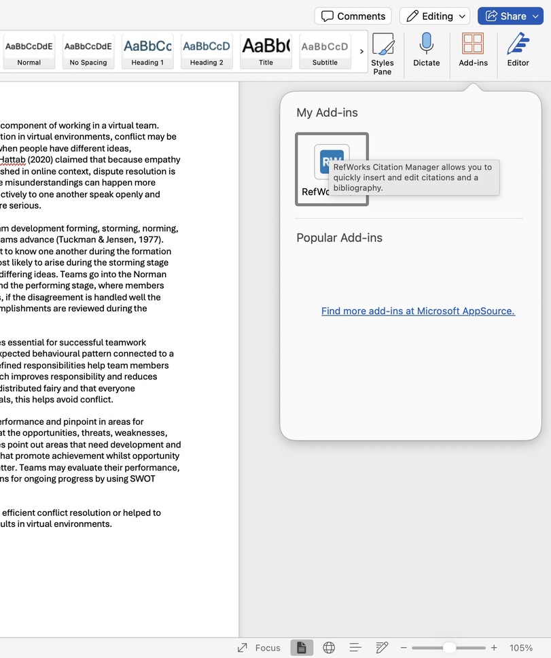
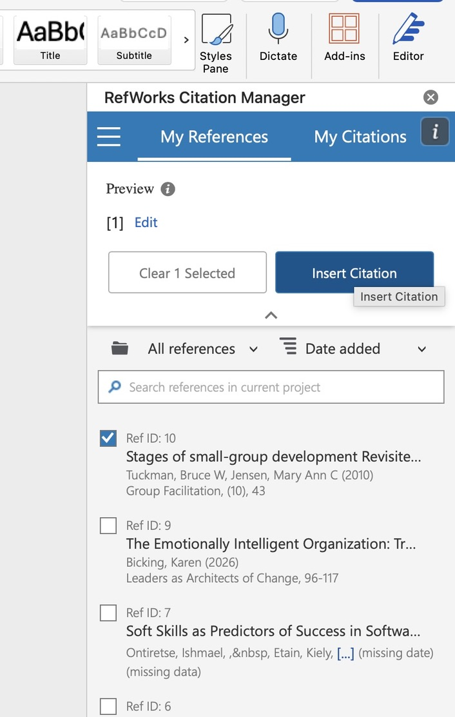
Using RefWorks Citation Manager in Microsoft Word to insert IEEE citations.
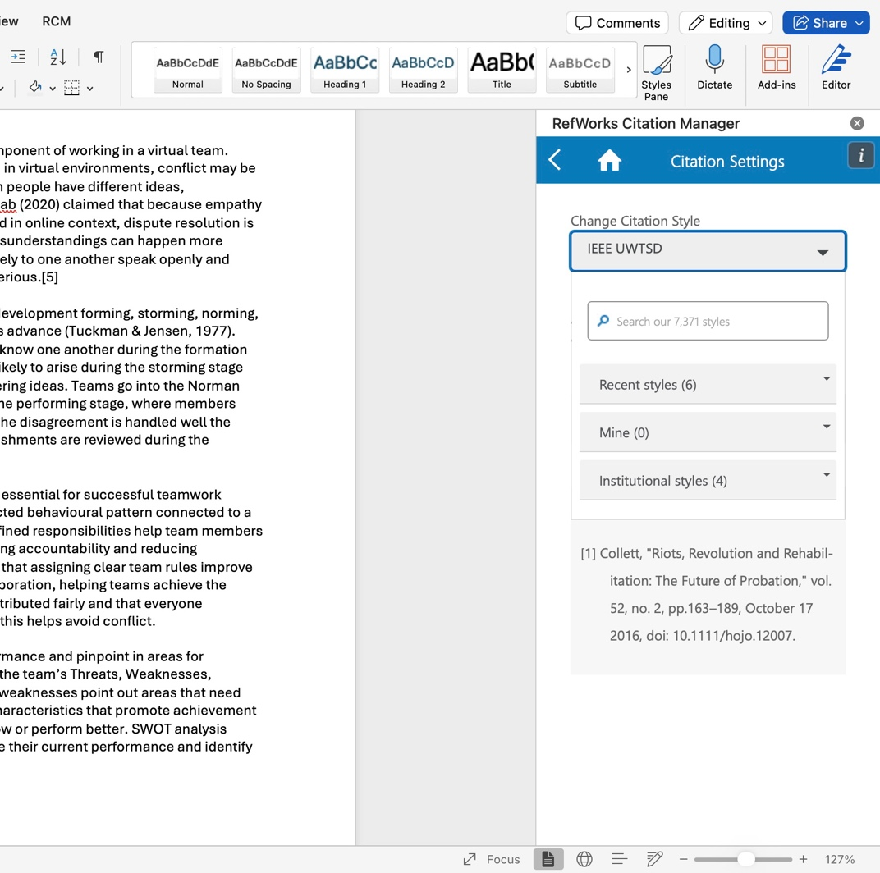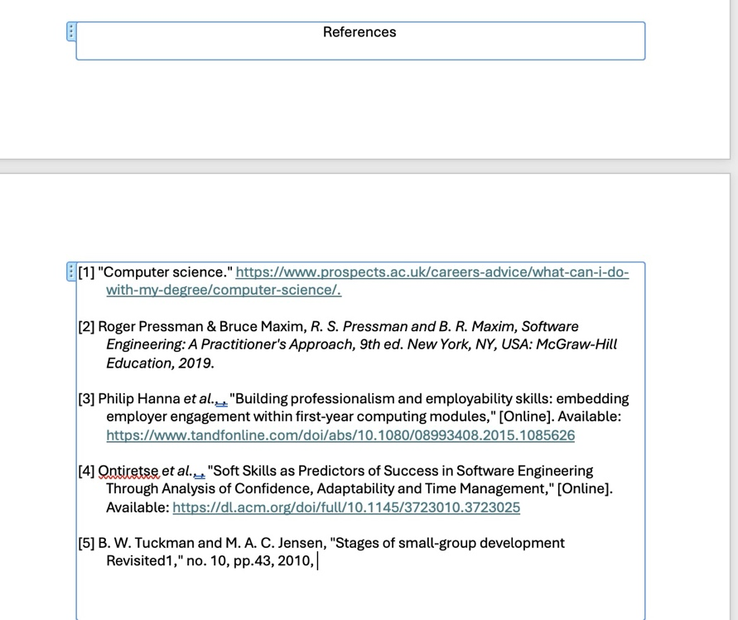

Use RefWorks to add relevant IEEE style citations and a reference list
RefWorks was used as an automatic reference in management to organise the sources used in this summary and to generate IEE citations. In the first image shows a reference being exploited from Google scholar into RefWorks. The second image demonstrates the reference being imported into the RefWorks project library. The final image shows the RefWorks Citation Manager add-in in Microsoft Word, where a reference was selected and inserted as an IEEE in-text citation. After all citations were added RefWorks automatically generated the reference list and showing all references are formatted consistently and accurately.

Task 4

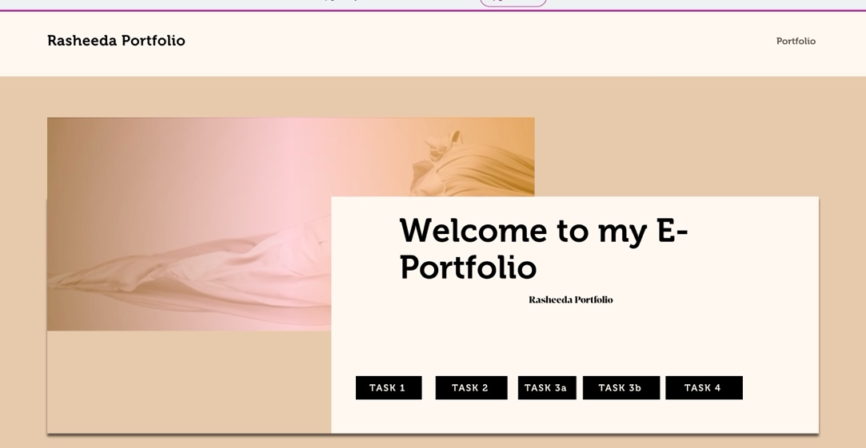

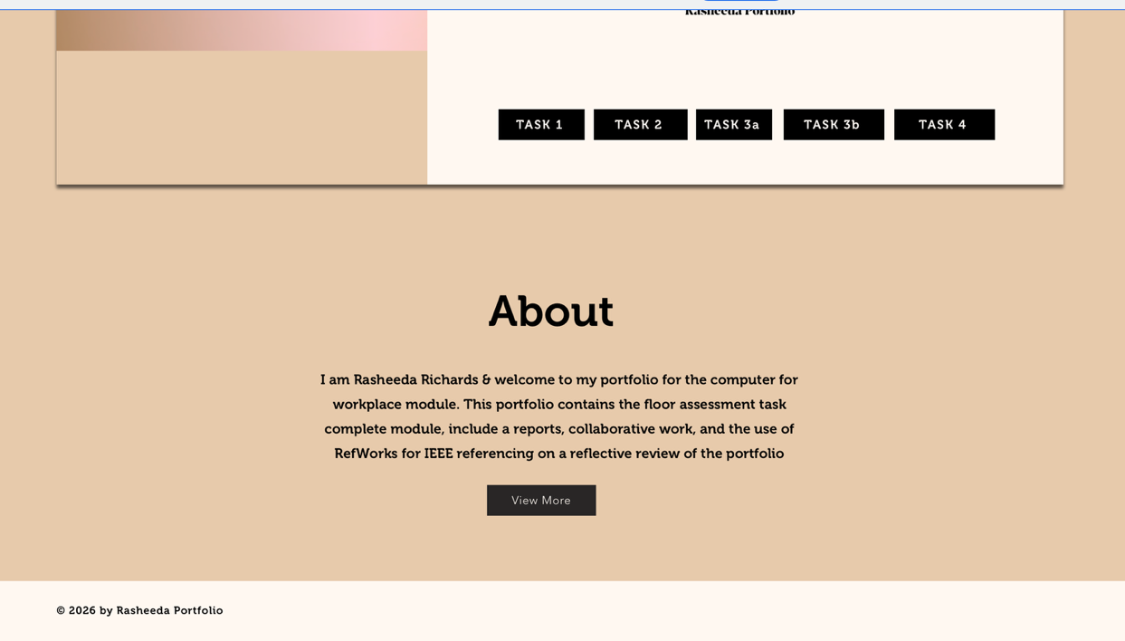
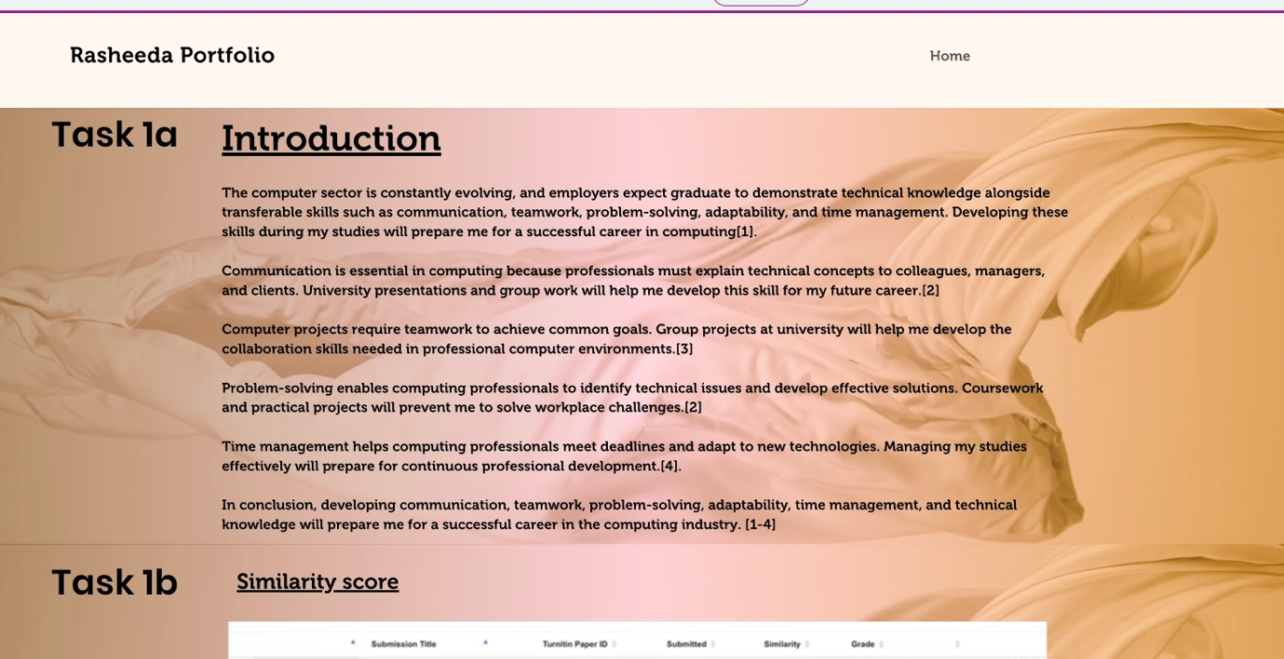
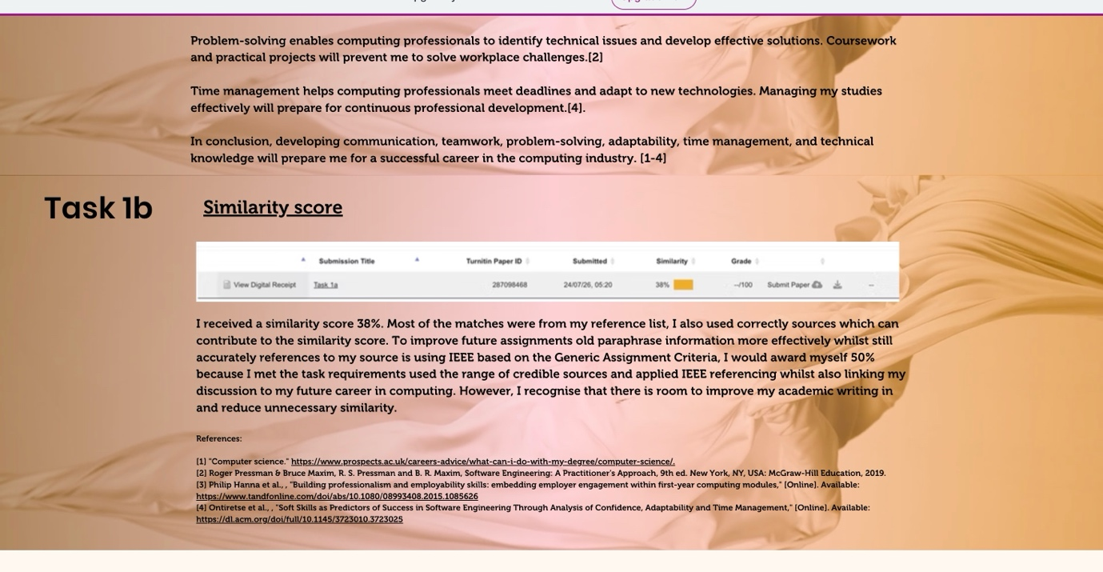

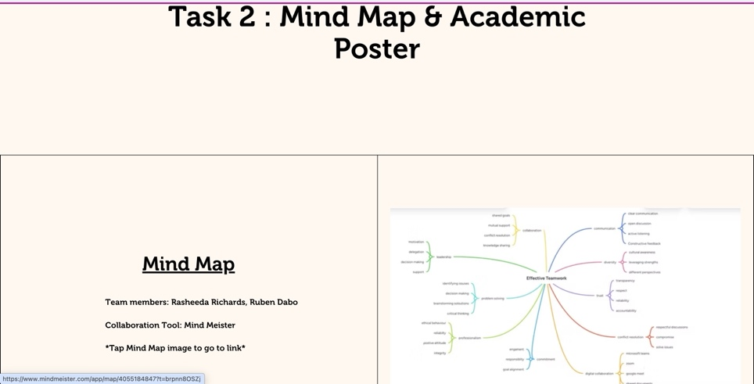
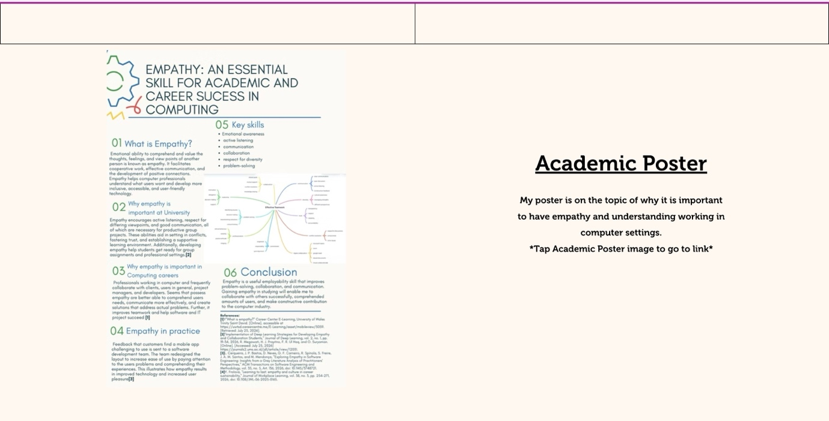

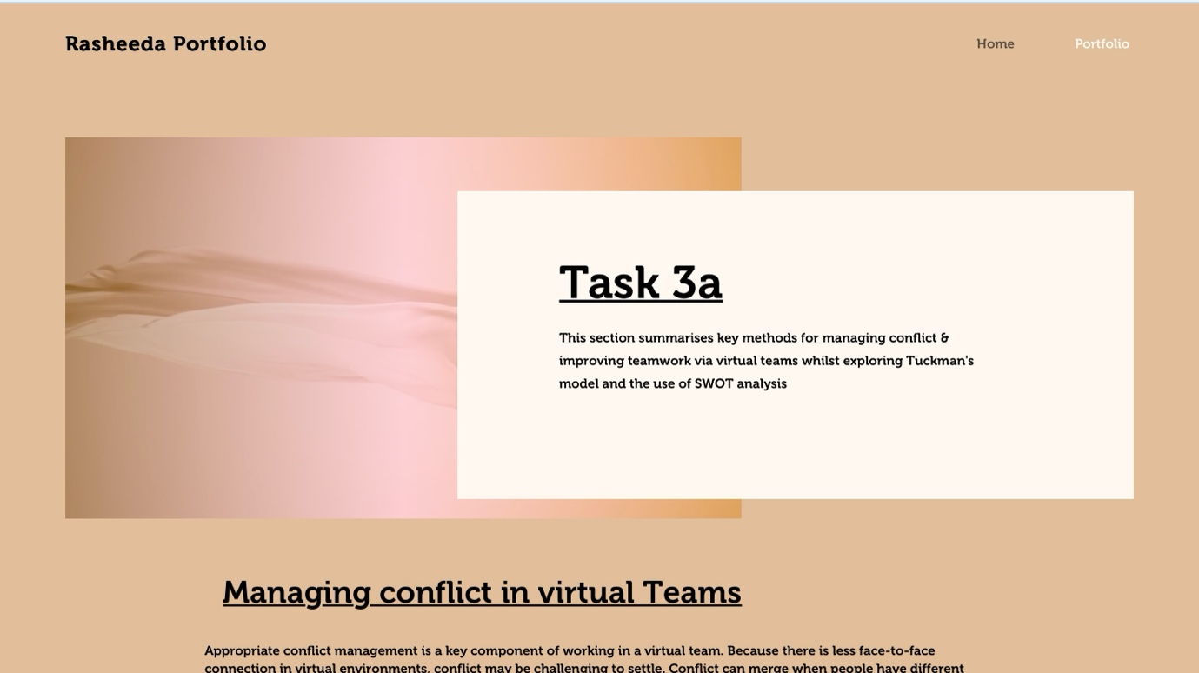

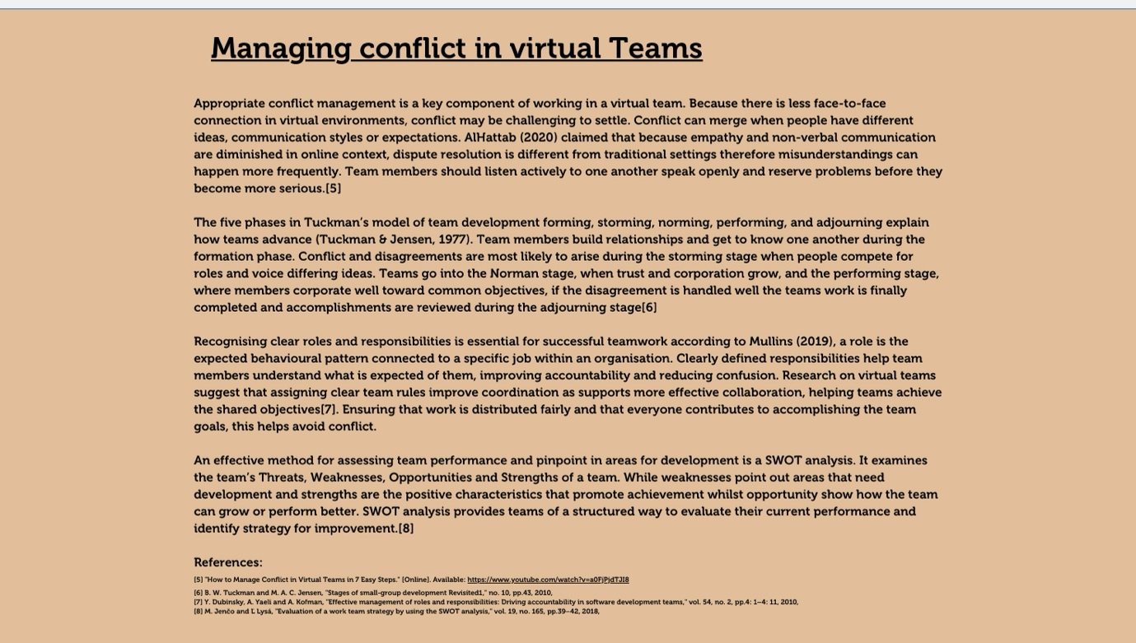
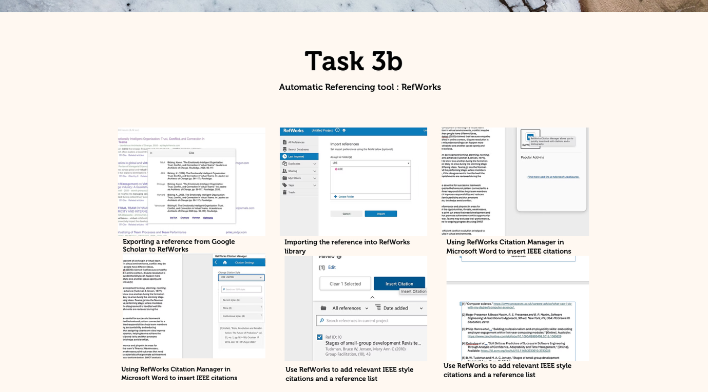

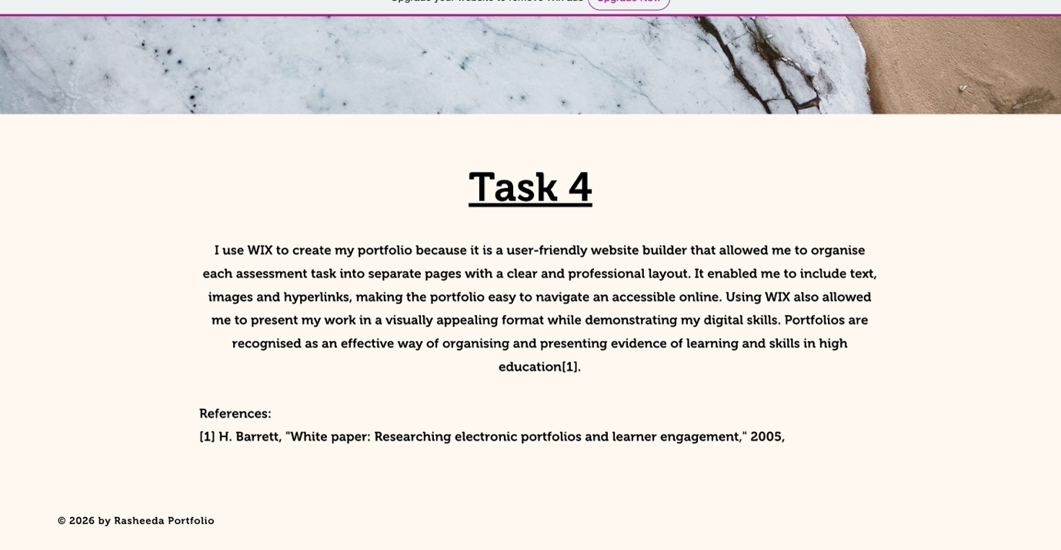

References
[1] "Computer science." https://www.prospects.ac.uk/careers-advice/what-can-i-do-with-my-degree/computer-science/.
[2] Roger Pressman & Bruce Maxim, R. S. Pressman and B. R. Maxim, Software Engineering: A Practitioner's Approach, 9th ed. New York, NY, USA: McGraw-Hill Education, 2019.
[3] Philip Hanna et al., , "Building professionalism and employability skills: embedding employer engagement within first-year computing modules," [Online]. Available: https://www.tandfonline.com/doi/abs/10.1080/08993408.2015.1085626
[4] Ontiretse et al., , "Soft Skills as Predictors of Success in Software Engineering Through Analysis of Confidence, Adaptability and Time Management," [Online]. Available: https://dl.acm.org/doi/full/10.1145/3723010.3723025
[5] "How to Manage Conflict in Virtual Teams in 7 Easy Steps." [Online]. Available: https://www.youtube.com/watch?v=a0FjPjdTJI8
[6] B. W. Tuckman and M. A. C. Jensen, "Stages of small-group development Revisited1," no. 10, pp.43, 2010,
[7] Y. Dubinsky, A. Yaeli and A. Kofman, "Effective management of roles and responsibilities: Driving accountability in software development teams," vol. 54, no. 2, pp.4: 1–4: 11, 2010,
[8] M. Jenčo and Ľ Lysá, "Evaluation of a work team strategy by using the SWOT analysis," vol. 19, no. 165, pp.39–42, 2018,

