  - 
  - Beng Motorcycle Engineering
  - Automotive Materials and Sustainability

Materials Testing and Sustainability of Composites for Motorsport & Automotive Industries

Megan Gwilym
Dr Kerry Tudor
26th April 2026
Contents
1. Introduction 3
2.Literature Review 4
3. Experimental Method 6
4. Results & Analysis 8
5. Sustainability Analysis 12
6. Conclusion 14
Bibliography 15

1. Introduction
The global automotive and motorsport industries are under increasing pressure to reduce vehicle mass while simultaneously improving sustainability credentials. Composite materials have become central to this challenge, offering mechanical performance that often exceeds conventional metals at a fraction of the weight.
However, not all composites are equal in either performance or environmental impact, and the growing availability of bio-based reinforcements and resins has broadened the scope of material selection.
This report presents the findings of tensile testing conducted on seven composite materials using a Denison Universal Testing Machine with an Epsilon extensometer. The materials tested span a range of fibre architectures and resin systems, including woven and nonwoven carbon fibre reinforced polymer with both standard petroleum and bio-based epoxy, woven and nonwoven flax fibre with bio-based epoxy, Kevlar with bio-based epoxy, and aluminium as a metallic baseline. Stress, strain, ultimate tensile strength, Young’s modulus and specific strength were extracted from the experimental data and compared across all material groups.
The aim is to evaluate mechanical performance against published benchmarks, critically assess the sustainability of each material system across its lifecycle, and provide evidence-based recommendations for material selection in motorsport and automotive structural and non-structural applications.
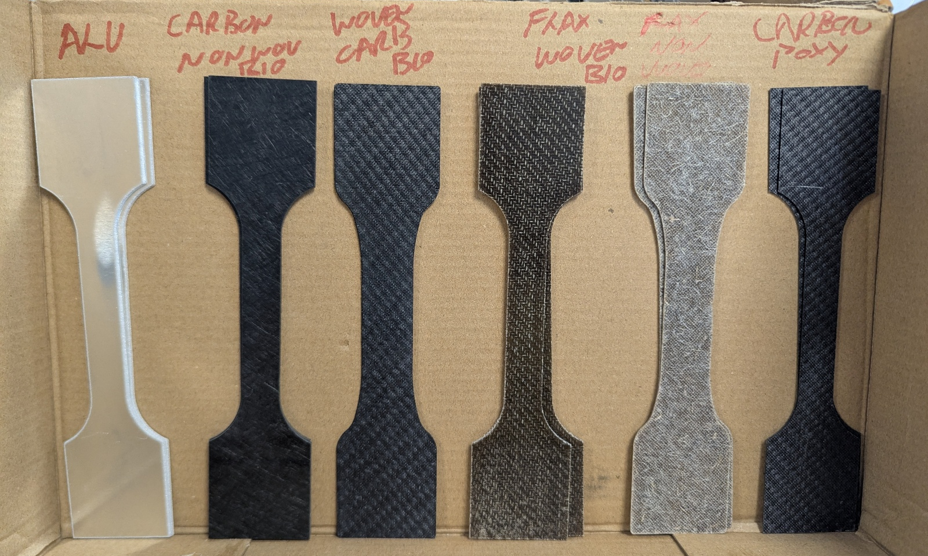
[Figure 1: Pre-test dog-bone specimens for all material groups tested.]

2.Literature Review
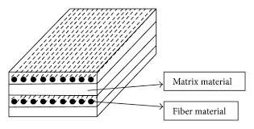
Composite materials consist of two or more constituent phases combined to produce properties superior to either component alone, figure 2 illustrates this arrangement. In structural engineering applications, this typically means a high-strength reinforcing fibre embedded within a polymer resin matrix, where the fibre carries tensile load and the resin transfers stress between fibres while providing resistance to environmental degradation (Ursache, et al., 2024). The combination of low density and high strength makes composites popular in motorsport and automotive design, where reducing vehicle mass directly improves performance, fuel efficiency and handling response.
[Figure 2: Fibre-reinforced composite laminate structure (Bavan, 2013).]


Carbon fibre reinforced polymers represent the highest-performance end of the composite spectrum, and their mechanical properties are strongly dependent on fibre architecture. Ma et al. (2022) demonstrated across four carbon/epoxy architectures that woven configurations consistently outperformed nonwoven equivalents in both tensile strength and in-plane shear resistance, attributing this improved load transfer through yarn interlocking and superior resistance to delamination. Figure 3 illustrates the structural difference between woven and nonwoven fibre architectures. High-grade carbon fibres such as T700 and T800 allow composite laminates to achieve ultimate tensile strengths of 500-900MPa at densities of approximately 1.55g/cm³, producing specific strength values that aluminium and steel cannot achieve (Ursache, et al., 2024). This performance advantage has driven widespread CFRP adoption in Formula 1 chassis, suspension components and aerodynamic structures, where stiffness-to-weight ratio is the primary design. Vacuum infusion is the primary manufacturing route used to produce the composites laminates tested in this study, drawing resin through the dry fibre stack under negative pressure to achieve consistent fibre-matrix consolidation (Vacman, 2023).
[Figure 3: Woven, nonwoven and knitted fibre architectures (Sadeghi, et al., 2021).]

Natural fibre composites occupy a different position in performance-sustainability. Flax has emerged as the most technically developed natural reinforcement for structural polymer composites, offering a tensile modulus of 50.70GPa at densities as low as 1.45g/cm³ (Ciardiello, et al., 2024). Newcomb and Kirmani (2025) reported woven flax/epoxy laminates achieving 132MPa UTS and a Young’s modulus of 14GPa under standardised tensile testing, sufficient for automotive interior panels and semi-structural components where impact resistance and cost are prioritised over raw strength. Skosana et al. (2025) further documents the adaption of flax and hemp composite panels by European manufacturers including Volkswagen and BMW, confirming that natural fibre composites have moved beyond laboratory research and into production level automotive applications.
Kevlar is a synthetic aramid fibre known for high tensile strength relative to its weight and is most recognisable from its use in ballistic protection and motorsport safety equipment. Ursache et al. (2024) report Kevlar laminates achieving tensile strengths of 400-700MPa with a fibre stiffness comparable to lower grades of carbon fibre. However, its defining feature is energy absorption under sudden impact loading rather than sustained in-plane tensile performance, and its resistance to compressive loads is notably weaker than carbon fibre composites. This makes Kevlar most suitable for applications where impact tolerance and damage resistance are the primary concern rather than structural stiffness, such as crash structures, protective panels and safety-critical components in both motorsport and road vehicles.
The resin matrix used to bind these fibres has become an important variable in composites selection as the industry seeks to reduce environmental impact without compromising mechanical performance. Bio-based epoxy resins derived from plant oils, lignin and other renewable feedstocks have reached commercial maturity where partial substitution of petroleum-derived epoxy could be viable. Capretti et al. (2023) reviews a range of bio-epoxy formulations and found that sufficient bio-content systems of 30-40% plant-derived content consistently achieved tensile strength and Young’s modulus within 5-10% of conventional epoxy. This was confirmed experimentally by Boursier Niutta et al. (2023), who found no significant difference in quasi-static mechanical properties between standard and 31% bio-content epoxy CFRP laminates, concluding that bio-resin is a structurally viable substitute that reduces the carbon footprint of the finished composite.
The motorsport sector has historically been the first adopter of advanced composite technologies before they migrate into mainstream automotive production. Formula 1 regulations incentivise the lightest structural materials available, while road car manufacturers face increasingly stringent $CO_{2}$ fleet emissions targets under European and UK regulations. Shelly et al. (2025) note that the global transitions toward battery electric vehicles have further intensified demand for lightweight composite structures. This creates a commercial driver for composite adoption that extends well beyond performance motorsport into volume production vehicles, making the evolution of both mechanical performance and lifecycle sustainability equally critical in modern material selection.

3. Experimental Method
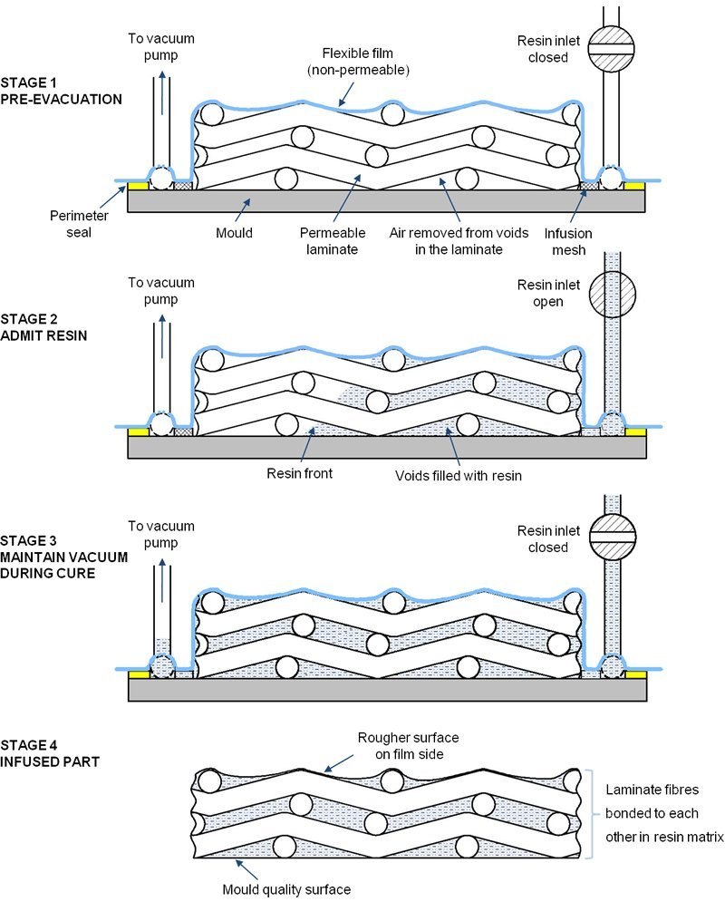
All tensile testing was conducted using Denison Universal Testing Machine, a floor-standing electromechanical load frame capable of applying controlled uniaxial loads to standard specimen geometries. Strain was measured directly on the gauge section of each specimen using an Epsilon Technology extensometer. This method of direct contact strain measurement avoids the inaccuracies associated with crosshead displacement. Figure 4 illustrates the four stages of this vacuum infusion process used to manufacture the test specimens.
[Figure 4: Stages of vacuum infusion processing (Vacman, 2023).]

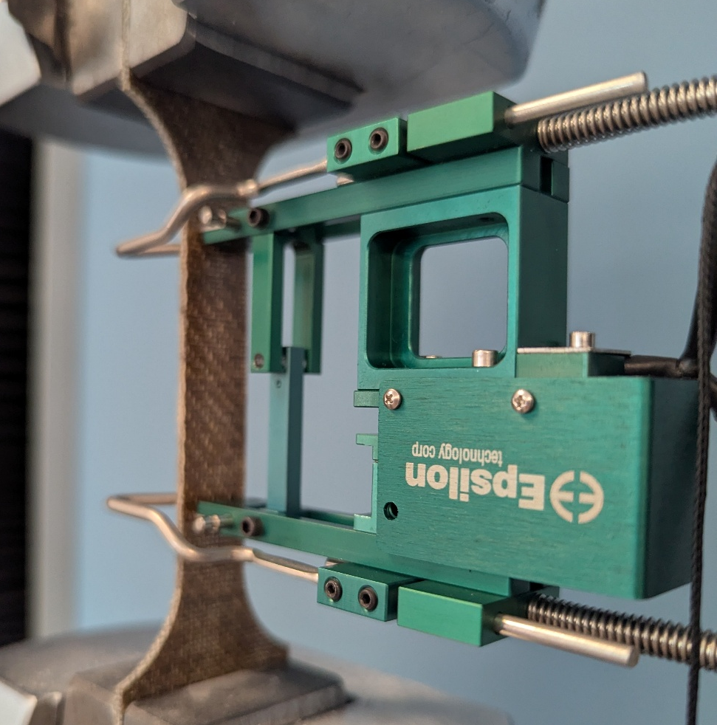
Specimen width was recorded, used alongside the applied load to calculate engineering stress. Strain output was directly from the extensometer as a percentage of the original gauge length. The machine recorded seven channels of data throughout each test – time, load, elongation, displacement, stress, strain and width – at a consistent sampling rate, producing a complete stress-strain profile from initial loading through to specimen fracture. Seven material groups were tested in total, comprising aluminium as a metallic baseline alongside six composite systems covering woven and nonwoven carbon fibre with both standard petroleum and bio-base epoxy, woven and nonwoven flax fibre with bio-base epoxy, and Kevlar with bio-based epoxy. Multiple specimens were tested per material group to account for variability. Raw data files were imported into MATLAB as numerical matrices and processed to extract ultimate tensile strength, Young’s modulus from the linear elastic region, and strain at fracture for each specimen and material group.
[Figure 5: Epsilon Technology Corp extensometer mounted on a composite dog-bone specimen during tensile testing.]

4. Results & Analysis
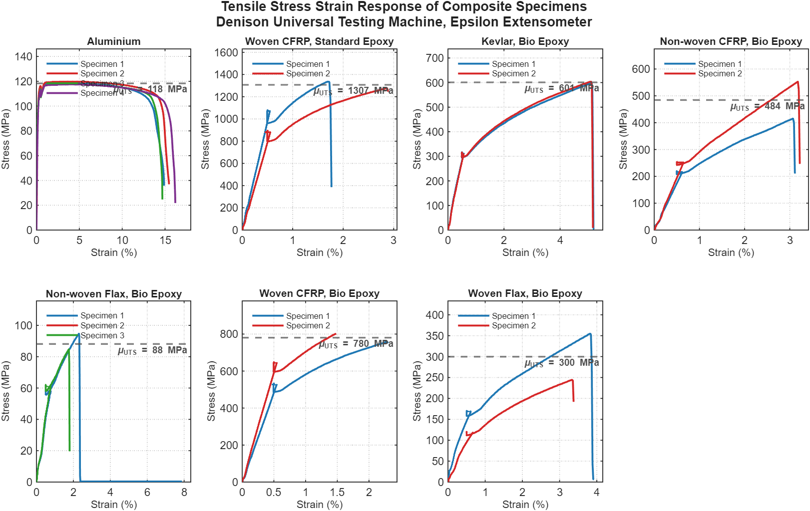
The stress-strain curves for each material group are presented in Figure 6, with a representative specimen per group overlaid for direct comparison in Figure 7. Together these figures establish the fundamental mechanical behaviour of each material system before derived properties are examined quantitatively.
[Figure 6: Tensile Stress-Strain Response of Composite Specimens.]
Aluminium displayed a clearly distinct response from all composite specimens. The initial linear elastic region was steep and short, followed by a yield point at 100MPa, after which the material deformed plastically at near-constant stress until fracture at around 18% strain. This ductile failure mode, visible as the extended flat region in Figure 7, is characteristic of the face-centred cubic metallic structure of aluminium, which accommodates significant plastic deformation through dislocation motion before fracture. In contrast, all composite specimens exhibited a linear elastic response up to catastrophic fracture mode inherent to fibre-reinforced polymer composites regardless of fibre type or resin system.
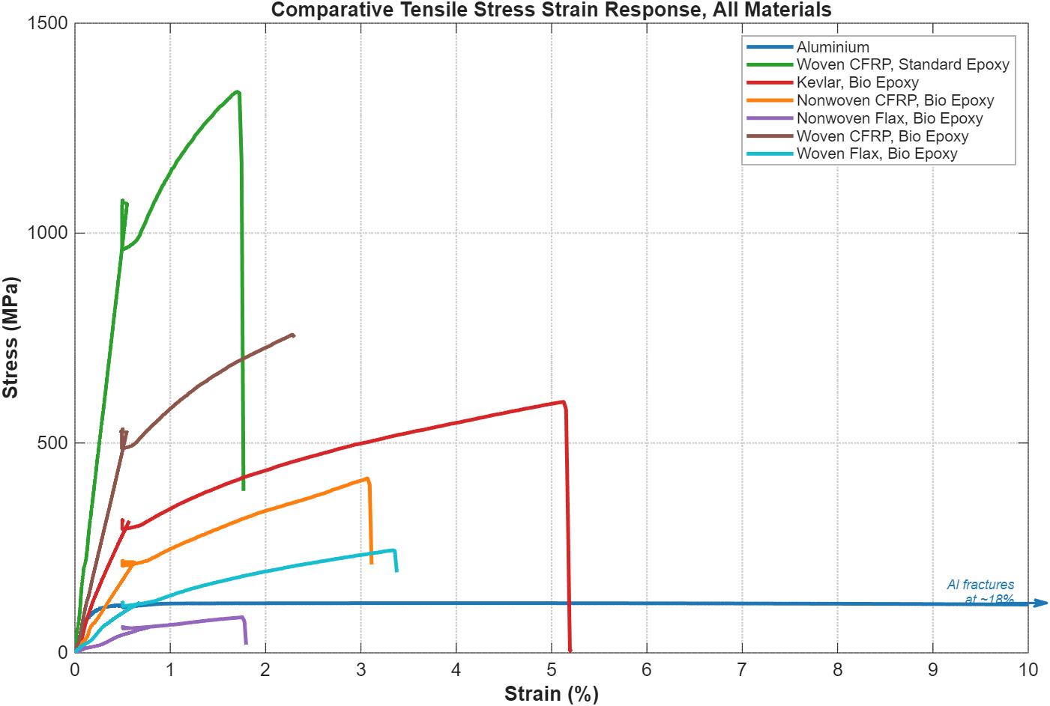
The woven carbon fibre specimens with standard epoxy produced the highest ultimate tensile strength of all materials tested, with a mean UTS of 1300MPa. Woven carbon fibre with bio-based epoxy achieved a mean UTS of 780MPa, still the second highest result across all groups but notably lower than its standard epoxy counterpart. Boursier Niutta et al. (2023) demonstrated statically equivalent quasi-static properties between standard and 31% bio-content epoxy CFRP laminates under controlled conditions, suggesting the gap observed may reflect specimen-level variability, difference in fibre volume between the two specimen sets, or minor manufacturing inconsistencies in the layup process rather than a property difference between the resin systems.
[Figure 7: Comparative Tensile Stress-Strain Response, All Materials.]
Kevlar with bio-based epoxy achieved a mean UTS of 600MPa, placing it third overall and falling within the 400-700MPa range reported for Kevlar composite laminates by Ursache et al. (2024), confirming consistency with published benchmarks. Nonwoven CFRP with bio-based epoxy produced a mean UTS of 480MPa, sitting above the East Composites CF-NWM manufacturer values of 310MPa. This is consistent with the findings of Ma et al. (2022) that woven architectures outperform nonwoven configurations in tensile strength through improved fibre-matrix load transfer, which also explains the significant gap between the two CFRP groups, woven carbon achieving 780-1300MPa compared to 480MPa for nonwoven carbon.
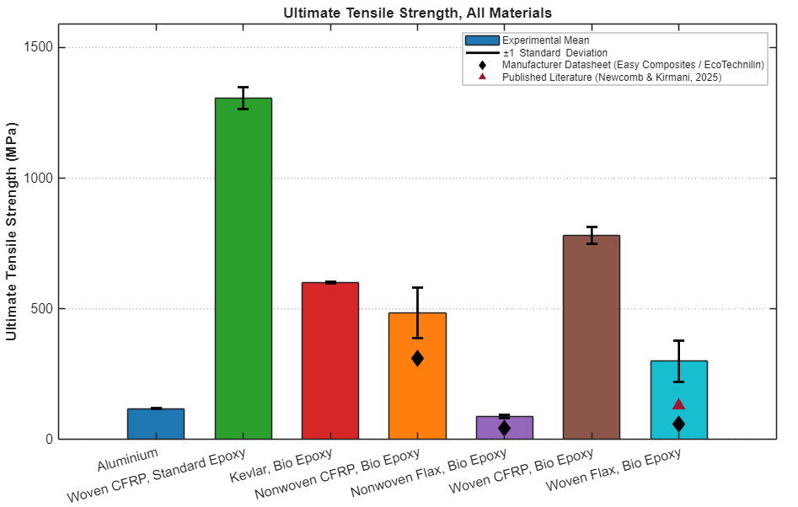
The natural fibre composites occupied the lower end of the UTS distribution. Nonwoven flax with bio-epoxy produced a mean UTS of 110MPa, above its manufacturer datasheet of 44MPa, likely reflecting the difference between the neat nonwoven mat properties written in the datasheet and the fully consolidated composite laminate tested here. Woven flaw with bio-epoxy achieved a mean UTS of 295MPa, which is notable higher than the 132MPa reported by Newcomb and Kirmani (2025) for woven flax/epoxy automotive specimens, as indicated by the literature reference in Figure 8. This results of around 120% above the published value merits critical consideration. Possible contributing factors include a higher fibre volume fraction in the tested specimens, a tighter weave architecture providing greater fibre alignment under load, or specimen geometry differences between the dog-bone configurations used in this study and the standardised coupons used by Newcomb and Kirmani (2025). Without controlling for fibre volume fraction and specimen geometry it is not possible to definitively attribute this difference to a single cause, and it represents an area where further standardised testing would strengthen confidence in the result.
[Figure 8: Ultimate Tensile Strength, All Materials. Experimental Mean with Standard Deviation.]
Woven CFRP with standard epoxy achieved the highest modulus at 138GPa, consistent with the theoretical modulus of T700-grade carbon fibre laminates. Woven CFRP with bio-epoxy followed at 105GPa, and aluminium, despite its low UTS relative to CFRP, recorded a modulus of 69GPa, consistent with the established value for aluminium alloys and placing it third in stiffness terms. Kevlar and nonwoven CFRP fell in the 21-33GPa range, while the flax composites showed modulus of 4-15GPa, consistent with the natural fibre composite literature reviewed by Ciardiello et al. (2024).
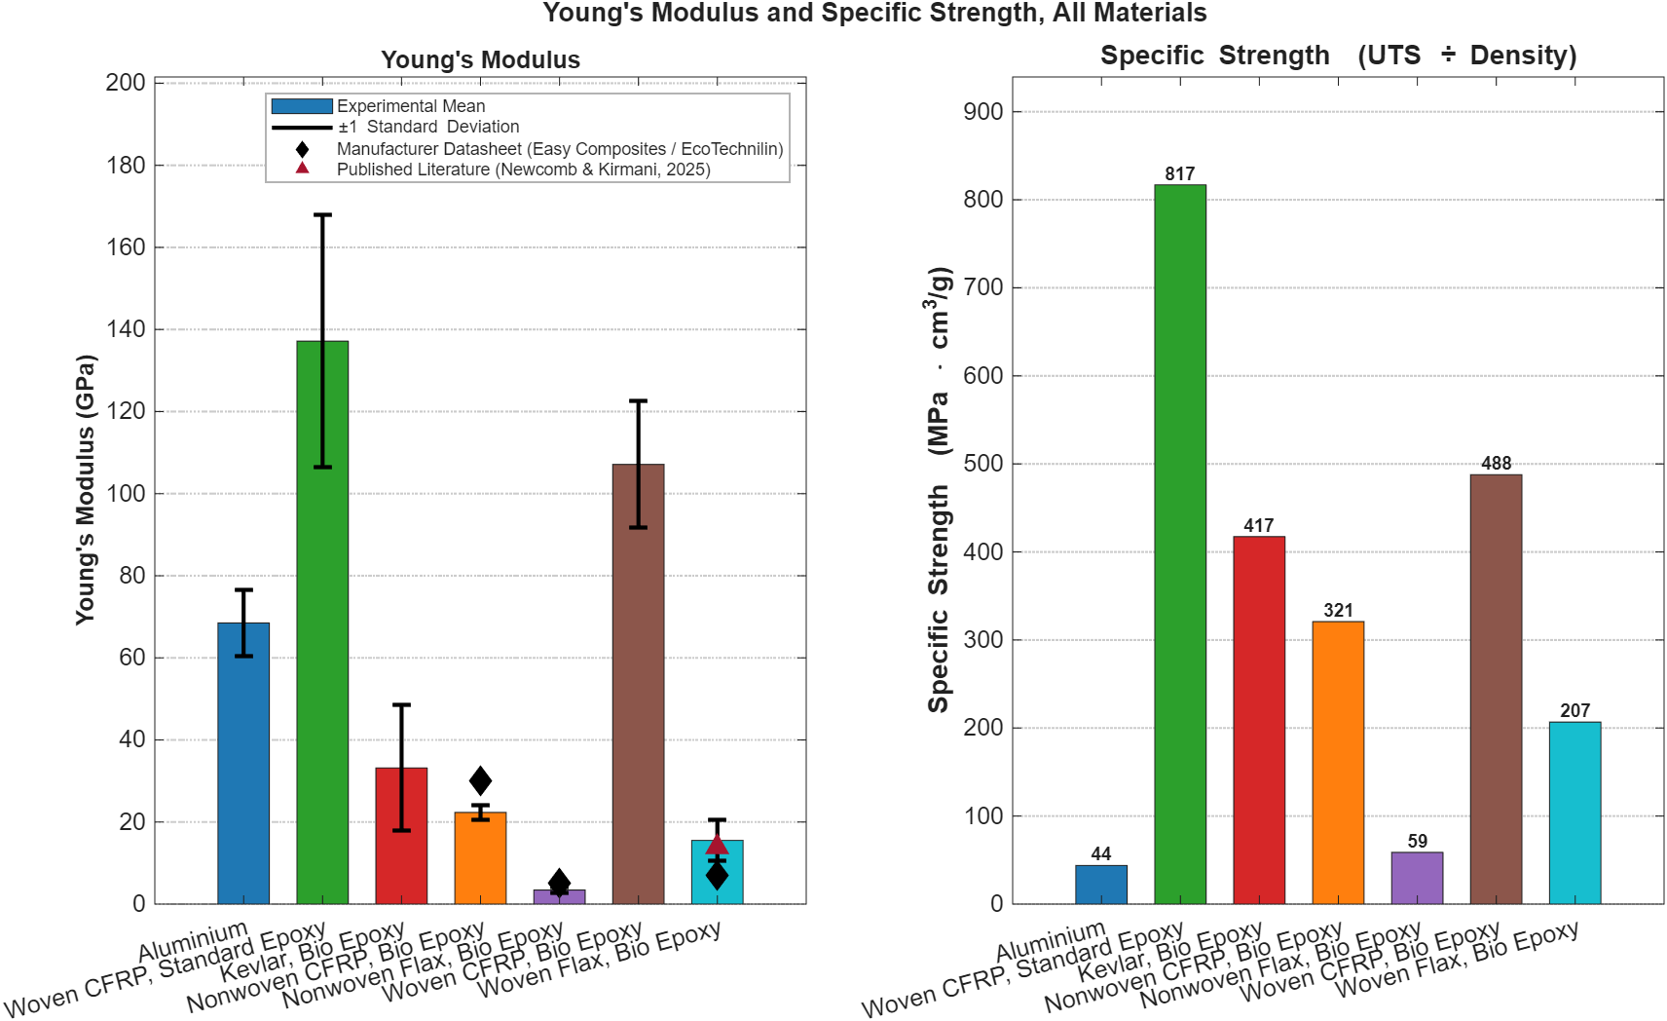
The specific strength values presented in Figure 9 offer relevant comparison for automotive and motorsport applications, where mass efficiency governs material selection rather than absolute strength alone. Woven CFRP with standard epoxy produced the highest specific strength at 817MPa·cm³/g, followed by woven CFRP with bio-epoxy at 488 and Kevlar at 417. Aluminium recorded a specific strength of only 44, the lowest of all groups tested. This confirms why CFRP has displaced aluminium in performance-critical motorsport structures, it delivers substantially more strength per unit of mass. Woven flax with bio-epoxy achieved a specific strength of 207, approximately four times that of aluminium, mass efficient advantages over metals and supporting their application in non-structural automotive components where sustainability is prioritised alongside weight reduction (Skosana, et al., 2025).
[Figure 9: Young's Modulus and Specific Strength, All Materials.]

5. Sustainability Analysis
The sustainability of a composite material cannot be assessed on mechanical performance alone. Carbon footprint across the full lifecycle, end-of-life recyclability and the infrastructure required to support it must all be considered if material selection decisions are to align with the regulatory frameworks now governing both motorsport and automotive production. The FIA’s net zero by 2030, the EU End-of-Life vehicles directive requiring 95% vehicle recoverability by mass, and the UK Zero Emission Vehicle mandate collectively ensure that material sustainability is now a compliance issue as well as a performance one. (Zabihi, et al., 2025).
Carbon fibre production is among the most energy-intensive manufacturing processes in structural materials engineering. Zabihi et al. (2025) quantify virgin carbon fibre production at 200-700MJ/kg with an associated carbon footprint of 20-30$kgCO_{2}$ of fibre produced. This compares unfavourably with aluminium at 15$kgCO_{2}/kg$ and with natural fibres such as flax, which generates as little as 2-5 $kgCO_{2}/kg$ from field to fibre. The high embodied energy of CFRP is a consequence of the polyacrylonitrile precursor oxidation and carbonisation process, which requires sustained temperatures exceeding 1000°C. In a sector under increasing regulatory and reputational pressure to reduce scope 3 emissions, this production footprint represents a liability for CFRP that its exceptional mechanical performance does not automatically offset.
The resin matrix introduces a further variable into this analysis. The bio-based epoxy used across five of the seven material groups tested contains 31% plant-derived content, partially displacing the petroleum-derived DGEBA resin used in conventional epoxy systems. Capretti et al. (2023) and Boursier Niutta et al. (2023) both confirm that this substitution does not compromise mechanical performance while reducing the resin carbon footprint. Zabihi et al. (2025) estimate that bio-based matrix systems reduce the overall laminate carbon footprint by 20-30% compared to fully petroleum-derived equivalents. The experimental results support this directly, the woven and nonwoven carbon bio-epoxy composites carry a meaningfully lower environmental burden than the standard epoxy group despite exhibiting comparable mechanical properties, making bio-resin adoption the most immediately viable sustainability intervention across composite production.
Natural fibre composites present the most compelling sustainability profile of all materials tested. Flax cultivation sequesters atmospheric carbon during growth and produces a reinforcements fibre at a fraction of the embodied energy of carbon fibre. Skosana et al. (2025) document the commercial adoption of flax and hemp composite panels by Volkswagen, BMW and Peugeot in production vehicles, confirming that the sustainability argument has already translated into industrial practice. However, the mechanical data demonstrates that natural fibre composites cannot substitute for CFRP in structural or load-bearing applications. The specific strength of woven flax at 207MPa·cm³/g, while four times that of aluminium, is less than a quarter of woven CFRP at 817 MPa·cm³/g. Natural fibre composites are therefore suited to non-structural applications, interior panels, aerodynamic body covers and trim components, where modest load requirements allow sustainability to be the primary selection criterion.
End-of-Life behaviour remains a significant challenge for CFRP. Recycling via pyrolysis and solvolysis recovers fibre at reduced mechanical properties and remains infrastructure-limited (Abbate, et al., 2022). Abbate et al. (2022) show that repair-first deign strategies can reduce CFRP lifecycle impact by up to 86%, through this requires supply chain commitment not yet standard across the industry. Natural fibre composites offer a simpler end-of-life profile, being combustible and compatible with existing waste streams.
The evidence supports a tiered material strategy: bio-epoxy CFRP for structural and load-bearing components, natural fibre bio-epoxy composites for non-structural applications where mass reduction and sustainability are prioritised, and the phased elimination of petroleum epoxy systems where bio-resin substitution is mechanically viable. This approach extracts the maximum available sustainability benefit without compromising the performance requirements of motorsport and automotive design.

6. Conclusion
Woven CFRP with bio-based epoxy represents the most balanced material choice for structural and load bearing applications in motorsport and automotive design. The experimental data confirms it delivers mechanical performance comparable to standard epoxy CFRP whilst reducing laminate carbon footprint by an estimated 20-30%, satisfying both structural and regulatory demands without compromise.
For non-structural components, woven flax with bio-based epoxy is the recommended material. Its specific strength of 207MPa·cm³/g exceeds aluminium, its production footprint is a fraction of any synthetic alternative, and its commercial adoption by volume manufacturers confirms it is a proven industrial solution rather than a research proposition.
The continued use of petroleum-based epoxy systems is difficult to justify where bio-resin sustainable is mechanically viable. The evidence here supports phasing these out across composite production wherever structural requirements permit. Further research should address, the standardised testing protocols controlling for fibre volume fraction to improve cross-study comparability, development of higher bio-content epoxy systems beyond 31% without mechanical penalty, and scalable end-of-life processing infrastructure for CFRP to resolve the recyclability that currently undermines the sustainability case for carbon-fibre in high-volume production.

Bibliography
Abbate, E. et al., 2022. Environmental and Economic Assessment of Repairable Carbon-Fiber-Reinforced Polymers in Circular Economy Perspective. Materials, p. 2986.
Bavan, S., 2013. Finite Element Analysis of a Natural Fiber (Maize) Composite Beam. Journal of Engineering, 2013(8).
Boursier Niutta, C., Ciardiello, R., Tridello, A. & Paolino, D. S., 2023. Epoxy and Bio-Based Epoxy Carbon Fiber Twill Composites: Comparison of the Quasi-Static Properties. Materials, p. 1601.
Capretti, M. et al., 2023. Use of Bio-Epoxies and Their Effect on the Performance of Polymer Composites: A Critical Review. Polymers, p. 4733.
Ciardiello, R., Benelli, A. & Paolino, D. S., 2024. Static and Impact Properties of Flax-Reinforced Polymers Prepared with Conventional Epoxy and Sustainable Resins. : Polymers, p. 190.
Ma, Z., Zhang, P. & Zhu, J., 2022. Comparative SStudies on the Effect of Fabric Structure on Mechanical Properties of Carbon Fiber/Epoxy Composites. Journal of Industrial Textiles, p. 1348–1371.
Newcomb, B. A. & Kirmani, M. H., 2025. Flax Fiber Reinforced Epoxy Composites as Potential Automotive. Polymer Composites, p. 12863–12874.
Sadeghi, B., Marfavi, Y., Aliakbari, R. & Kowsari, E., 2021. Recent Studies on Recycled PET Fibers: Production and Applications: a Review. Materials Circular Economy, 3(1).
Shelly, D. et al., 2025. Mechanical Performance of Bio-Based Fiber Reinforced Polymer Composites: A Review. Polymer Composites, p. S9–S43.
Skosana, S. J., Khoathane, C. & Malwela, T., 2025. Driving Towards Sustainability: A Review of Natural Fiber Reinforced Polymer Composites for Eco-Friendly Automotive Light-Weighting. Journal of Thermoplastic Composite Materials.
Ursache, S., Cerbu, C. & Hadar, A., 2024. Characteristics of Carbon and Kevlar Fibres, Their Composites and Structural Applications in Civil Engineering: A Review. Ploymers, p. 127.
Vacman, 2023. What is resin infusion (or vacuum infusion)?. [Online]
Available at: https://vacmobiles.com/what-is-resin-infusion-or-vacuum-infusion/
[Accessed 3 april 2026].
Zabihi, O. et al., 2025. The Sustainability Spectrum of Carbon Fibre: Balancing High Performance CFRP Composites with Environmental Responsibility. Advanced Composites and Hybrid Materials, p. 415.

