VISUAL STUDIES 1/LEVEL 4
M4X01602
SOLO
PROFESSOR SUE WILLIAMS
sue.williams@uwtsd.ac.uk

‘Art is longing. You never arrive, but you keep going in the hope that you will’
Anselm Kiefer

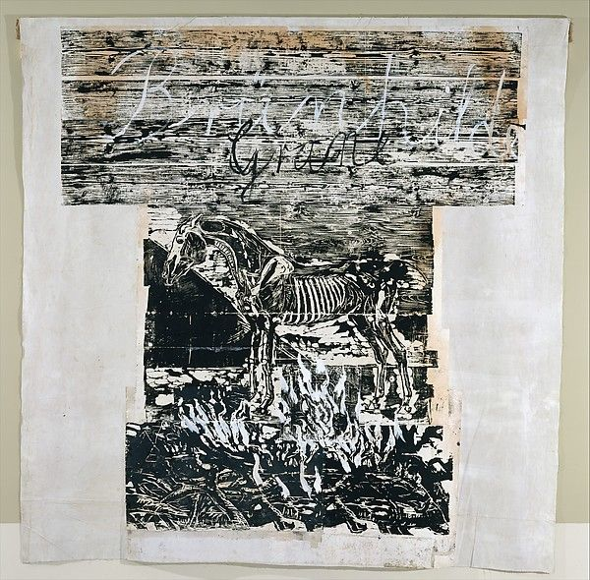
ANSELM KIEFER

ANDY WARHOL

JEAN-MICHEL BASQUIAT
REMBRANDT

DURER
WILLIAM KENTRIDGE

KATSUSHIKA HOKUSAI-YOSHITSUNE

PETER DOIG

Above are a selected number of artists who have and do worked/work with print. Research the artists given and then find another 6 contemporary artists who work with all aspects of printmaking. Make a selection that covers various types of printmaking e.g. lithography, etching etc.

