Student name: Roberta-Carmen Burdighioiu
Student number: 1909880
Module code: BMSW4002_LON
Lecturer name: Joy Botu

Effective Team Working and Communication

Table of Content
- Introduction (pag. 2)
- Benefits of team working (pag. 2-3)
- Stages of development (pag. 3-4)
- Team roles (pag. 4-6)
- Managing conflict (pag. 7)
- Successful team development (pag. 7-8)
- Conclusion (pag. 8)
- References (pag. 8)

Introduction
The objective of this report is to provide a better understanding of how efficient can teamwork and communication be. Using experimental designs and research methods, this report will present and highlight the key features of an efficient teamwork. With all this taken in consideration, each attribute will implement the importance of methodological strategies.

Benefits of team working
First of all is vital to give a short explanation of what teamwork means. “Teams are a group of people who exist to perform organizationally relevant tasks, share one or more goals, interact socially, exhibit task interdependence, maintain and manage boundaries, and are embedded in an organizational context that sets boundaries, constrains the team, and influences exchanges with other units in the broader entity.” (Maud, Schriek, Tinkler, 2017)
Businesses and corporations are very conscious about the benefits teams are for their organisations and are used regularly. By participating in a team, individuals develop skills and increase the chances for solving mutual problems.
A team not only that it motivates people, but it develops relationships between members in order to help each other. Because of the variety of talents, strengths and weaknesses often a team meets a challenge of different personalities which can cause a conflict. But working together and trying to solve the problem can lead to success.
Effective team work gives member the chance of points of view which can lead to innovate and creative ideas. Teamwork improves the productivity in a business by allocating suitable tasks to suitable kind of members. Not only that the result will be significant, but each member will be able to have the sense of success and performing. Teams to be successful should have an outstanding recruitment staff, talented people to increase efficiency. (Potential, 2020)

Stages of Team Development
In 1965 Bruce Tuckman introduced his theory regarding the path of a team development. For developing a team, Tuckman designed a five stages model as a foundation for the importance of the teams to be successful. (Toggl, 2020)
Bruce Tuckman’s stages of development
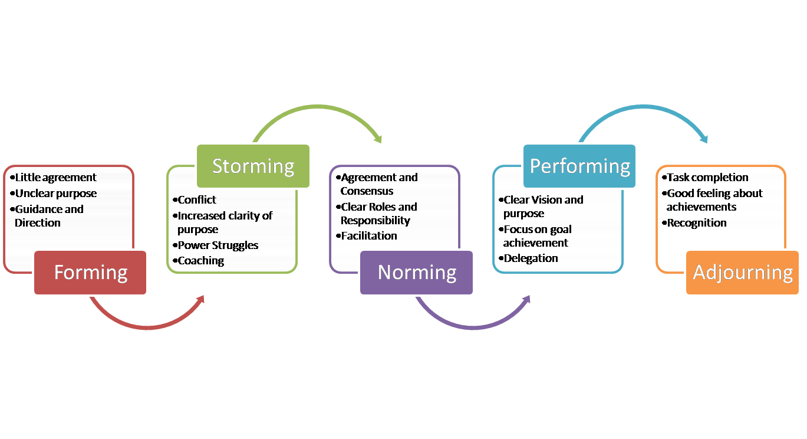
Forming
The first stage is forming which we understand the process of development. Here all the team member are being introduced and the task is presented by the leader. The first step is all about how responsibilities are shared and all the members will be aware of their own contribution, deadline and common goal.

Storming
After all the members introduced each other and the task is shared it appears the conflict. Disagreements between members and competitors arise and each individual wants to prove their idea might be better. Here the leaders needs to show their strength, as it is up to them to recognise the problem in advance to prevent any major conflicts.
Norming
After the conflict is over and members are settled finally the team will put all the conflicts aside and start to work together for the mutual goal.
Performing
After the team went through the previous three stages, now is time to focus. Trust is being established and the members are dedicated and have knowledge about the task putting all the strength towards the accomplishment.
Adjourning
The final stage is recognition. Here all the members look up and see what they accomplished. The task is over, the team is analysing what went good and what did not for future improvement. (Teamwork, 2020)

Team roles
Back in 1970, Meredith Belbin introduced two important factors to in team’s strategy. The first one is occupational function and it highlights the knowledge every member has and it can be brought in the beneficial of teamwork. Skills and abilities are the second factor important for achieving the common goal of the team. In teams each member has a different style of contributing. (Morgan, 2017)
Belbin believed that each member has different skills and can bring innovation to the collaboration. He thought that each individual has a unique ability that can be useful, and if the member has more talents than it can be beneficial to fulfil another task if is needed. After years of observing the team roles, Dr. Belbin grew the skill of expectation when a team can be successful or not. Belbin sustained his idea of involvement and discussing leads to success. (Business Coaching, 2009-2020)
Belbin’s nine team roles
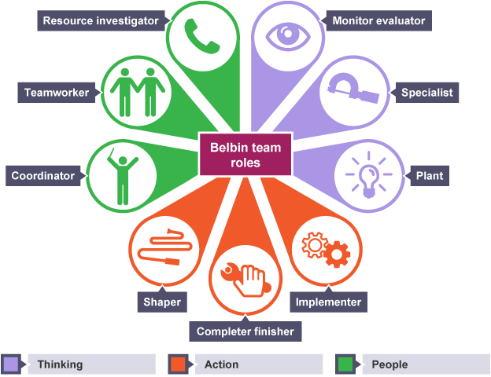

Coordinator (CO)
The member who is more like to be a coordinator is most of the times the leader. A coordinator is mature, confident and identifies other’s abilities. Often, a person who is the coordinator can be controlling and tries to allow for himself a lot more work than the others.

Implementer (IMP)
A person who is an implementer is concrete, trustworthy and well-organized. An implementer is well organise and strategic who is more likeable to make a plan of actions which are needed to be done. However, is not open to changes and is not responding to new challenges.
Shaper (SH)
The member who is the shaper is the kind of person who likes to take challenges, is dynamic, self-motivated and has the courage to pass the obstacles. However, can offend other member’s feelings and is likely to be in a conflict.

Completer-Finisher (CF)
A completer-finisher is a person who is careful, reliable and nervous. A CF is looking out for mistakes, and likes to improve. Most of the times is an overly worrying and unwilling to change.
Resource Investigator (RI)
A RI is outgoing, excited and communicative. A person who likes to search for opportunities and improve relationships. A resource investigator is over-optimistic and loses concentration after enthusiasm has passed.
Specialist (SP)
A SP type of person in a team is single-minded, self-starting, committed and offers information and skills in rare source. A specialist’s weakness is that it contributes only a slight perspective and settles on procedures.
Monitor-Evaluator (ME)
A ME finds strategies and committed to the task. ME is a member who finds all the options available and gives an accurate judgement. However, can be overly critical on other’s ideas and has a lack of ability to motivate others.
Plant (PL)
The member who finds himself more suitable for this team role usually is innovative, original and generates ideas and solves difficult problems. Most of the times is too worried to communicate successfully and ignores incidentals.
Team-worker (TW)
A team-worker participant is helpful, cooperates with others and diplomatic. Listens and prevents failure. A person who is hesitant in crisis situations and avoids conflicts is a team-worker. (Morgan, 2017)

Managing conflict
When a team is built and it meets different opinions, most of the times conflicts arise. Conflicts come with a mixture of emotions and perceptions. Most important is to replace the bad situations with good experiences.
The first step of managing conflict is to be prepared for it. The situation to be solved and managed is needed patience. Right after the problem is found, the team should come with a solution for it. Being in a team, to communicate is vital for the performance. Everyone involved needs to participate to manage the problem.
The second step is to understand the situation. Now the team is ready to solve the conflict, so each member should understand each other’s points of view. This step requires time as emotions are involved and is needed to get through them to discover the real nature of the conflict. Whatever the disagreement is, it is important to discuss the solution. Is good to make a list of each position and perspective and find the belief of it. Is important to divide the team intro smaller groups and find which the facts and expectations are more important and relevant to the team’s objective. By using this technique new ideas for solving can be found. After conveying back as a team the conflict can be seen objectively. The matter of conflict can go away and see the issue bare.
The final step is to reach agreement and to find solution. Now everyone understands each other’s position and must decide for an agreement. After conflict is over, is time to recognise the contributions everyone made for reaching agreement. The three steps explained are for helping to pass the team’s conflict effectively. The nature of this is to provide a better understanding of different opinions and to expand the beliefs regarding the problem. With all this taken in consideration, teams can prevent conflict and can gain knowledge of how to handle the conflict in case it occurs again. Is important to don’t let the conflict get emotional. (Mindtools, 2020)

Successful Team Development
Team members share the same objective. The expectations needs to be clarified and understood by everyone involved. When developing a team is important to be aware of the competencies each member has and try to make beneficial use of them for the team. Team members must find a suitable team leader for knowing where to go in case of lack of knowledge or if conflicts arise. It should be recognised every role so that the aim is achieved before the deadline. Meetings should take place regularly to be aware of the progress and to follow the systematically procedures required. Is important to have a plan so conflicts will be avoided. For an outstanding result the team needs to work and communicate with each other. A team becomes grater when working for achieving the same goal. (McQuaig, 2019)

Conclusion
There can be no doubts that working individually is better that working in a team. Implementing teamwork in an organisation can be very beneficial. It must be remembered that this report is an analyse of effective teamwork and communication. This report highlighted the benefits of team working, stages of development, team roles, managing conflict within a team and successful team development.

References
- Maud, Schriek, Tinkler, A. M. P. Certificate in Higher Education: Skills for the Workplace Student Yearbook, SAGE Publication Ltd, London, ch. 1, pag4-5
- Potential, (2020). Important reasons why teamwork matters. Accessed on 3rd May 2020 < https://www.potential.com/articles/5-important-reasons-why-teamwork-matters/ >
- Toggl, (2020). What are the 5 stages of team development? Accessed on 3rd May 2020 < https://toggl.com/stages-of-team-development/ >
- Teamwork, (2020). The five stages of team development. Accessed on 3rd May 2020 < https://blog.teamwork.com/the-5-stages-of-team-development-what-you-need-to-know/ >
- Morgan, (2017). The Business Student’s Guide to Study and Employability, SAGE Publication Ltd, London, ch.10, pag.207.
- Business Coaching, (2009-2020), Notion. Accessed on 4th May 2020, < https://www.businesscoaching.co.uk/files/belbin_team_role_theories.pdf >.
- Morgan, (2017). The Business Student’s Guide to Study and Employability, SAGE Publication Ltd, London, ch.10 pag.207-208.
- Mindtools, (2020). Resolving Team Conflict. Accessed on 4th May 2020, < https://www.mindtools.com/pages/article/newTMM_79.htm >
- McQuaig, (2019). 7 Components of Successful Team Development. Accessed on 4th May 2020, < https://blog.mcquaig.com/7-components-of-successful-team-development >

