Developing a Self-Service Dashboard to Support Data Quality Monitoring Aligned with HESA Rules in Welsh Higher Education
Research Proposal
Amina Meah
University of Wales Trinity Saint David
<Preferred Supervisor>

Contents
Figures 3
1. Introduction 4
2. Background to the Proposed Research 5
2.1 Data Quality in Higher Education 5
2.2 HESA and Data Futures 5
2.3 The Role of Medr (formerly HEFCW) 5
2.4 Business Intelligence and Self-Service Dashboards 5
2.5 Data Governance in Higher Education 6
2.6 Previous Research and Case Studies 6
2.7 Identified Gap 6
2.8 Summary 6
3. Aim & Objectives 7
Aim 7
4. Methodology 8
4.1 Research Methodology 8
4.1.1 Philosophy 8
4.1.2 Approach 8
4.1.3 Strategies 8
4.1.4 Risks & Limitations 10
4.1.5 Ethical Issues 10
4.1.6 Validity, Reliability & Generalisability 10
4.1.7 Data Evaluation Methods 11
4.1.7.1 Data Collection 11
4.1.7.2 Data Evaluation 11
4.2 Development Methodology 12
4.2.1 Software Development Methodology OR Other Relevant Major Methodology 12
5 Resources and Planning 13
5.1 Hardware Resources 13
5.2 Software Resources 13
5.3 Information Resources 13
5.4 Human Resources 13
5.5 Project Plan 13
6. Project Impact and Future Development 14
7. Reference List 16

Figures
Figure 1- Relationship between UWTSD, HESA, and Medr in the Welsh higher education data ecosystem. 5
Figure 2- End-to-end architecture for the proposed dashboard. 9
Figure 3-Prototype dashboard landing page (wireframe). 9
Figure 4 -Evaluation pipeline (SUS + interviews + thematic analysis). 11
Figure 5- MoSCoW prioritisation showing MVP scope. 12
Figure 6- Project Plan Table 13
Figure 7- Gantt Chart showing Project timeline with key milestones. 14

1. Introduction
The industrial partner for this project is the University of Wales Trinity Saint David (UWTSD), where I have been working in the Management Information Systems (MIS) data team since 2023. During this period, I have contributed to two HESA student returns, which has given me valuable insight into how universities prepare and submit statutory data to the Higher Education Statistics Agency (HESA) [1]. Through this experience, I have developed an understanding of the challenges faced by higher education institutions in ensuring that student data is accurate, consistent, and compliant with HESA’s validation rules [1].
In the Welsh higher education context, student data plays a critical role in institutional funding, government reporting, and strategic planning [3]. Universities are required to submit their student records to HESA, which validates the data against a set of rules and produces outputs that highlight errors or inconsistencies [1]. These validated datasets are then used by Medr, the Commission for Tertiary Education and Research, which replaced the Higher Education Funding Council for Wales (HEFCW) in 2024 [3]. Medr is responsible for distributing funding, regulating institutions, and monitoring compliance across the Welsh tertiary education sector [3]. As such, HESA provides the technical infrastructure for data collection and quality assurance, while Medr relies on these validated data to make strategic and funding decisions for Welsh higher education institutions [1], [3].
As a bilingual nation, Wales also introduces additional complexity in managing data and reporting requirements across both English and Welsh contexts [4]. Poor-quality data can therefore have significant consequences, including reputational damage, funding adjustments, and audit failures [1], [3]. Currently, the main outputs from HESA’s validation process are delivered in CSV or Excel formats. While technically effective, these are often difficult for non-technical staff to interpret, creating reliance on IT specialists and generating bottlenecks in the data quality process [1]. This results in delays and a reactive rather than proactive approach to compliance.
The rationale for this project is to design a self-service business intelligence (BI) dashboard that empowers non-technical staff to monitor and address student data quality issues directly. Such a tool would increase transparency, promote accountability across departments, and support collaboration. It also aligns with wider digital transformation initiatives in higher education and the HESA Data Futures programme, which emphasises real-time submissions and continuous monitoring [2], [5].
I am particularly suited to undertaking this project because of my combined technical skills and professional experience. My role within the MIS data team has given me first-hand knowledge of how HESA returns are produced and the common problems that arise when working with complex student datasets [1]. Alongside this industrial experience, my academic background in applied computing has equipped me with skills in data analysis, dashboard development, and business intelligence tools [5]. I also have a strong personal interest in data governance and in creating user-friendly solutions that make technical outputs more accessible to non-specialists. These combined experiences place me in an excellent position to deliver a practical, industry-relevant solution to the challenge of student data quality monitoring in Welsh higher education.

2. Background to the Proposed Research

2.1 Data Quality in Higher Education
Data quality has long been recognised as a critical issue in higher education, given its impact on funding, compliance, and strategic planning. Classic work by Wang and Strong [6] defined data quality in terms of dimensions such as accuracy, completeness, consistency, and timeliness. These concepts are directly applicable to student record systems, where even small errors (e.g., incorrect enrolment dates or missing qualification details) can have significant institutional consequences. In the Welsh context, validated student data feeds into national policy and funding decisions overseen by Medr, meaning that poor-quality data can result in reputational harm, reduced funding, or audit failures [1], [3].

2.2 HESA and Data Futures
The Higher Education Statistics Agency (HESA) provides the UK-wide framework for student data collection, validation, and reporting. Its Data Futures programme, launched in 2017, represents a shift towards real-time, continuous data submission, replacing the previous annual return model [7]. This initiative places increasing pressure on universities to monitor data quality proactively throughout the academic year, rather than waiting for end-of-year validation. Although HESA provides validation outputs in the form of Excel or CSV files, these are often highly technical and require specialist knowledge to interpret [1]. This creates bottlenecks where data analysts must act as intermediaries between technical systems and administrative staff [2].

2.3 The Role of Medr (formerly HEFCW)
Since August 2024, responsibility for higher education funding and oversight in Wales has transferred from the Higher Education Funding Council for Wales (HEFCW) to Medr – the Commission for Tertiary Education and Research [3], [8]. Medr uses validated HESA data to inform institutional funding allocations, monitor compliance, and evaluate sector performance [3]. This means that data accuracy is not simply an internal operational issue but a key determinant of institutional financial stability. The dual-language context of Wales further complicates reporting requirements, adding an additional layer of complexity to institutional data management [4].
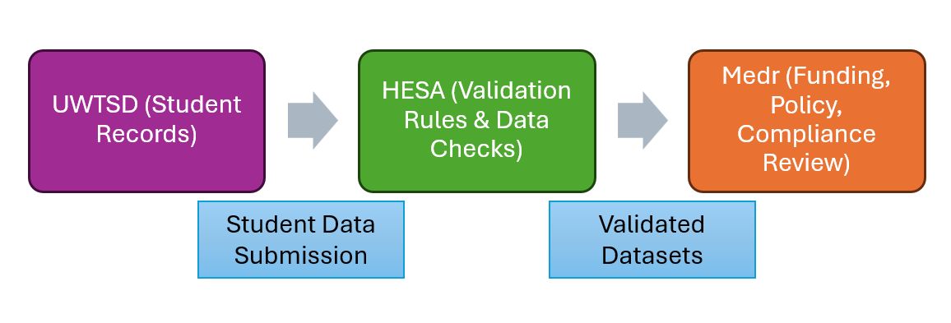
Figure 1- Relationship between UWTSD, HESA, and Medr in the Welsh higher education data ecosystem.

2.4 Business Intelligence and Self-Service Dashboards
Business intelligence (BI) tools have become increasingly important for enabling organisations to interpret large, complex datasets. Gartner [9] highlights a sector-wide shift towards self-service BI, where non-technical staff can access and explore data directly through dashboards, without needing specialist IT support. In the higher education sector, self-service dashboards have been used to support areas such as student retention monitoring, performance analytics, and compliance reporting [2], [5]. Dashboards are particularly valuable in translating technical outputs into visual formats, using features such as traffic-light indicators, drill-down functionality, and interactive charts to make data more accessible [10].

2.5 Data Governance in Higher Education
Effective data governance frameworks are increasingly emphasised within higher education, with Jisc [2] and EDUCAUSE [11] both calling for greater alignment between institutional processes, regulatory requirements, and data management practices. In Wales, universities must also comply with GDPR and bilingual reporting obligations [4]. Dashboards can serve as tools of governance by promoting transparency, accountability, and cross-departmental collaboration. However, research suggests that many institutions lack the technical capacity to build tools that bridge the gap between HESA outputs and end-user needs [12].

2.6 Previous Research and Case Studies
Several case studies have explored BI adoption in higher education. For example, Dawson et al. [13] examined how dashboards support learning analytics, while Knight et al. [10] considered the organisational challenges of embedding BI tools across universities. Although these studies demonstrate the potential of dashboards for enhancing decision-making, relatively few focus specifically on data quality monitoring for HESA compliance. HESA itself provides validation services, but their outputs are not designed for everyday operational use by non-specialists [1]. This creates a gap for institution-specific solutions that translate validation rules into actionable insights for administrative and academic staff.

2.7 Identified Gap
The literature reveals a clear gap between theoretical frameworks for data quality [6], [14] and practical tools available in higher education. While BI dashboards are widely used for strategic management and learning analytics, there is limited research on their application to compliance monitoring, particularly in the Welsh HE context. Existing HESA validation reports are highly technical [1], while sector case studies highlight ongoing struggles with usability, accessibility, and timeliness [2], [12]. This project addresses that gap by prototyping a self-service dashboard that translates HESA rules into accessible metrics, enabling non-technical staff to contribute to data quality management.

2.8 Summary
In summary, the literature demonstrates that data quality is essential for institutional compliance and funding, particularly under the new governance framework led by Medr. HESA’s Data Futures programme has increased the urgency of real-time monitoring, yet existing validation outputs remain highly technical. BI dashboards and self-service analytics provide a potential solution, but their use in this compliance context is under-explored. This project seeks to build on both theoretical and practical insights by developing and testing a self-service dashboard at UWTSD, addressing an identified gap in the sector.

3. Aim & Objectives
Aim
To design and evaluate a self-service business intelligence (BI) dashboard that enables non-technical staff in Welsh higher education institutions to monitor and improve student data quality in alignment with HESA validation rules [1], [3].
Objectives
- Identify and map key student data quality metrics against HESA validation rules and institutional reporting requirements. This will involve analysing HESA’s validation framework and selecting priority rules that have the greatest impact on funding and compliance [1].
- Develop and prototype a self-service dashboard using appropriate BI tools such as Power BI, Tableau, or SQL. The prototype will demonstrate how HESA data quality rules can be visualised in a user-friendly format, including traffic-light indicators and drill-down functionality [5].
- Test the dashboard with staff from the UWTSD MIS data team, gathering both quantitative and qualitative evidence. Usability testing will generate numerical data through the System Usability Scale (SUS), which is widely used in software usability research [15].
- Evaluate the dashboard’s effectiveness in improving data quality monitoring, reducing reliance on IT staff, and supporting institutional compliance with Medr and HESA requirements [3].
- Reflect on the development process and propose recommendations for scaling or further enhancement across the Welsh HE sector, including potential integration with HESA’s Data Futures system [2].

4. Methodology

4.1 Research Methodology

4.1.1 Philosophy
This project adopts a mixed philosophical stance, drawing on both positivism and phenomenology. The positivist perspective is appropriate for the collection of quantitative usability data, such as System Usability Scale (SUS) scores, which allow for objective measurement of dashboard effectiveness [15]. At the same time, a phenomenological approach will be used to capture the lived experiences of staff through interviews and open feedback, ensuring that their perceptions and insights are not lost in purely numerical results [16]. The combination of these approaches provides a more holistic understanding: positivism contributes rigour and replicability, while phenomenology ensures user-centred depth [16]. The main limitation is that balancing the two perspectives can complicate analysis. This will be addressed by structuring evaluation in two parts: first, statistical analysis of SUS scores, followed by thematic coding of qualitative feedback.

4.1.2 Approach
The research will primarily follow a deductive approach, starting from established theories of data quality (e.g., Wang & Strong’s framework [6]) and business intelligence dashboard design principles. The project begins with the assumption that self-service dashboards can improve the accessibility and usability of HESA validation data and then tests this through practical implementation and evaluation. This deductive stance ensures alignment with existing knowledge and provides a clear framework for testing [16]. However, an inductive element will also be present: qualitative feedback from staff may reveal unexpected themes, which can then inform future development beyond the scope of the initial assumptions [16].

4.1.3 Strategies
Three main strategies will guide the project: a literature review, software development, and a case study. This combination ensures that the project is both grounded in theory and tested in a real-world institutional environment.

4.1.3.1 Literature Review
The literature review will synthesise existing knowledge on data quality, governance, and business intelligence dashboards. It will include both academic theories (such as data quality dimensions proposed by Wang & Strong [6]) and industrial reports from HESA, Jisc, and Medr. The purpose of this review is to identify gaps in current practice and to establish a theoretical foundation for the design of the dashboard [2], [3]. This strategy is essential for ensuring that the project is informed by best practice and contributes meaningfully to both academic and professional debates.

4.1.3.2 Software development
The software development strategy will focus on building a prototype dashboard using Power BI and/or SQL. This prototype will translate HESA validation rules and error codes into accessible, user-friendly indicators, such as visual traffic-light systems and drill-down error views. The use of this strategy allows the research to move beyond theory into practice, demonstrating the feasibility of self-service tools for data quality monitoring. By iteratively developing and testing features, the project will also gather valuable insights into which design choices best support non-technical users [5], [17]. 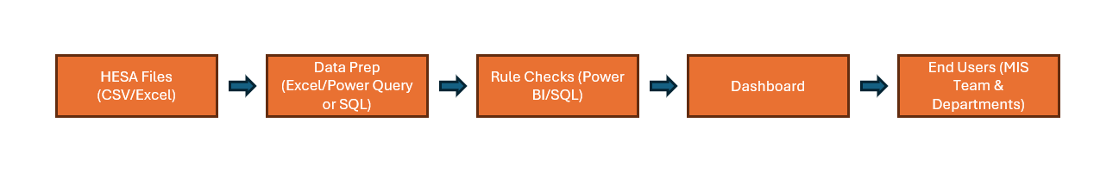
Figure 2- End-to-end architecture for the proposed dashboard.
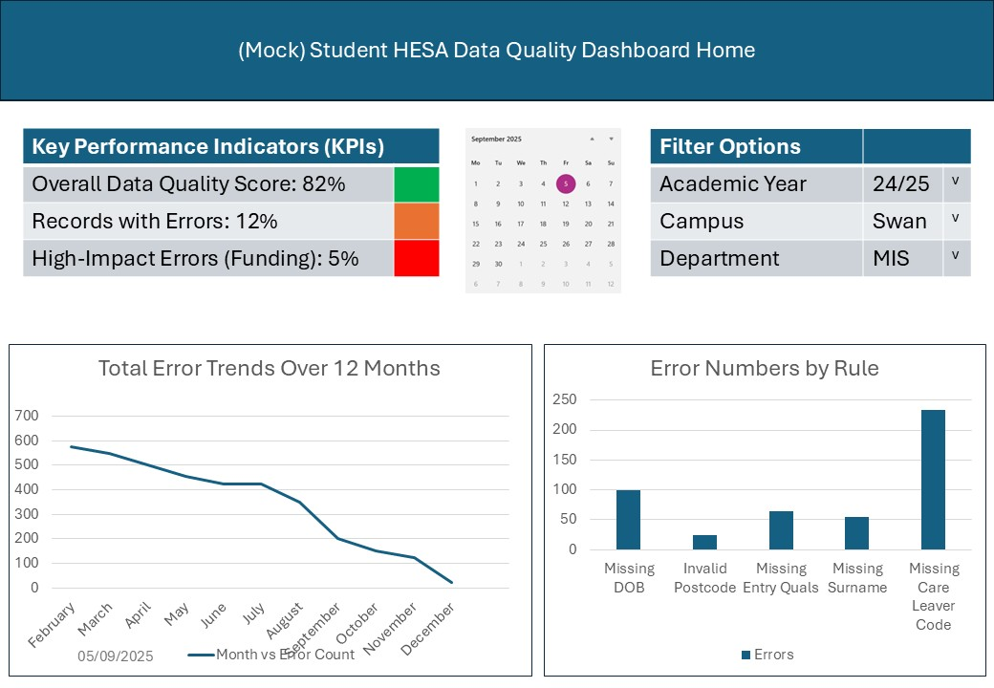
Figure 3-Prototype dashboard landing page (wireframe).

4.1.3.3 Case study
The case study strategy will be centred on the University of Wales Trinity Saint David (UWTSD), where the researcher is currently a member of the MIS data team. This context provides direct access to staff who regularly work with HESA returns and therefore experience the challenges of interpreting validation outputs. The case study approach allows the prototype dashboard to be tested in a realistic institutional environment, ensuring that findings are relevant and grounded [18]. While this limits generalisability to other institutions, it provides strong practical insights into the Welsh HE context and the specific compliance challenges associated with HESA and Medr.

4.1.4 Risks & Limitations
There are several potential risks to project success. Access to live student records may be restricted due to data protection concerns, which will be mitigated by using anonymised or synthetic datasets where necessary [19]. The scope of the project is also limited by time, meaning that only a minimum viable product (MVP) can be developed rather than a fully deployable system, which is appropriate for an iterative Agile/FDD build [17]. Furthermore, the small number of participants available for testing may reduce generalisability; this is expected in a single-institution case study, where findings generalise analytically rather than statistically [18]. This will be addressed by methodological triangulation, combining qualitative and quantitative methods to strengthen validity, while clearly acknowledging these limitations in the evaluation section [16]. Researcher bias in interpreting qualitative feedback is a potential risk, which will be mitigated through systematic thematic coding and, where possible, cross-checking interpretations with participants

4.1.5 Ethical Issues
Ethical considerations primarily relate to the use of student data and the involvement of staff participants. All student-level data will be anonymised in line with UK GDPR and ICO guidance and processed with appropriate safeguards [19]. Participation by staff will be voluntary, with informed consent obtained prior to testing, and the option to withdraw at any point [16]. To avoid reputational harm, findings will be aggregated and will not identify individuals or departments; handling of student-record extracts will follow HESA data handling expectations and institutional governance arrangements [1], [2]. The research poses minimal risk, as activities are confined to data analysis and prototype evaluation in normal working contexts [16].

4.1.6 Validity, Reliability & Generalisability

4.1.6.1 Validity
The methods chosen are valid for investigating the problem, since prototyping and usability testing directly address the research aim of improving the accessibility of HESA validation outputs [1], [5]. By developing a working dashboard and allowing real users to test it, the study ensures that findings are grounded in practical application rather than theoretical assumptions. Construct validity is strengthened by anchoring metrics in recognised sector standards (HESA rules; Jisc guidance) and by triangulating SUS scores with interview/survey themes [1], [2], [16].

4.1.6.2 Reliability
Reliability is supported using the System Usability Scale (SUS), a standardised instrument widely applied across systems and contexts, enabling repeatable, comparable measurement [15]. Reliability is further enhanced by documented, consistent procedures for task scenarios, data collection, and analysis, following good-practice research method guidance [16].

4.1.6.3 Generalisability
Generalisability is naturally limited by the single-institution case study design; results generalise analytically to similar contexts rather than statistically to all universities [18]. Findings will be most directly applicable to Welsh institutions operating under Medr/HESA requirements, but the underlying principles, self-service dashboards, translation of validation rules into user-friendly indicators, and the empowerment of non-technical staff, are transferable to wider UK HE settings with similar governance and data quality obligations [2], [18].

4.1.7 Data Evaluation Methods

4.1.7.1 Data Collection
This project will collect both primary and secondary data. Primary data will be gathered through usability testing of the dashboard prototype with staff from the University of Wales Trinity Saint David’s MIS data team. The testing will involve two components: (1) the System Usability Scale (SUS) questionnaire, which provides a quantitative measure of usability [15], and (2) short interviews or surveys, which will capture qualitative feedback on ease of use, clarity of information, and usefulness for daily workflows. It is expected that between three and five participants will be recruited, which is sufficient for a case study of this scale [16].
Secondary data will include HESA validation rules, institutional workflow documentation, and existing guidance from Jisc and Medr. These materials will inform the design of the dashboard and provide benchmarks for evaluating its effectiveness.
The minimum dataset required for the project consists of at least three completed SUS questionnaires and one round of qualitative feedback. This will allow for basic statistical analysis and the identification of recurring themes. If fewer responses are obtained, supplementary analysis will be carried out using mock scenarios and publicly available case studies from other institutions [16].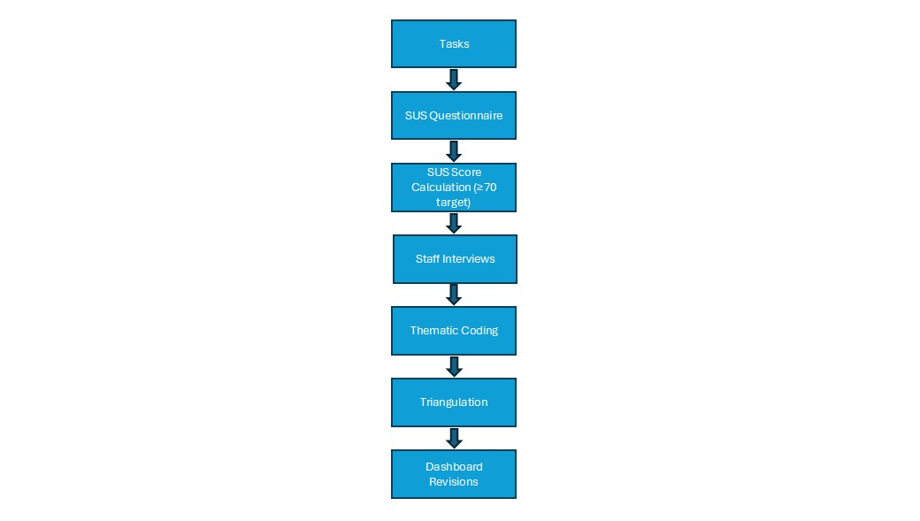
Figure 4 -Evaluation pipeline (SUS + interviews + thematic analysis).

4.1.7.2 Data Evaluation
The collected data will be evaluated using both quantitative and qualitative methods. Quantitative data from SUS questionnaires will be analysed using descriptive statistics such as mean, median, and standard deviation [15]. Scores will be compared against the established SUS benchmark (≥70 = good usability) [15]. This will provide an objective indication of how usable the prototype is relative to industry standards.
Qualitative data from interviews and surveys will be analysed thematically, following the six-step process outlined by Braun and Clarke [17]. Responses will be coded to identify recurring themes, such as ease of navigation, clarity of error indicators, or suggestions for additional features. These themes will be triangulated with the quantitative results to provide a richer evaluation.
Results will be presented in a combination of tables, charts, and annotated dashboard screenshots to illustrate how the tool addresses specific data quality challenges. This dual approach will ensure that findings are both statistically robust and contextually meaningful.

4.2 Development Methodology

4.2.1 Software Development Methodology OR Other Relevant Major Methodology
The research strategy combines software development and a case study, reflecting the project’s dual focus on creating a working prototype and evaluating it in a real institutional context [18]. Software development is appropriate because the project involves designing and testing a novel dashboard tool, while the case study approach ensures that evaluation is grounded in the University of Wales Trinity Saint David (UWTSD) setting [16], [18].
Within the software development strategy, the project adopts an Agile framework, specifically Feature Driven Development (FDD). This methodology emphasises the iterative delivery of discrete features (e.g., traffic-light indicators, drill-down error views, export options), aligning well with the scope of a single-developer project. Features will be developed and tested in cycles, with feedback from MIS staff incorporated incrementally. This approach ensures progress can be demonstrated regularly, and it reduces risk by enabling delivery of a functioning minimum viable product even if not all planned features are implemented [18]
This iterative feature-based approach aligns with the project’s deductive stance, as features are tested against existing theory, while also accommodating phenomenological insights from user feedback
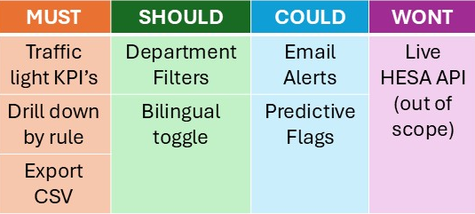
Figure 5- MoSCoW prioritisation showing MVP scope.

5 Resources and Planning
5.1 Hardware Resources
The project will primarily require a standard networked PC or laptop capable of running business intelligence tools such as Power BI and SQL. The university’s existing IT infrastructure is sufficient to support development and testing, aligning with sector expectations for digital infrastructure in HE [2].
5.2 Software Resources
The software resources required include:
- Microsoft Power BI Desktop (2023) – for dashboard prototyping and data visualisation.
- SQL Server Management Studio (SSMS) or equivalent – for database management and preparing datasets.
- Microsoft Excel (Office 365) – for handling HESA validation outputs and preparing test datasets [1].
- NVivo (or equivalent) – for qualitative coding of interview and survey data.
- SPSS or Excel statistical functions – for descriptive analysis of SUS scores [15].
All tools are available through university academic licences or open-source provision, so no additional purchase costs are expected [2].
5.3 Information Resources
Secondary data sources include HESA validation rules and guidance [1] and supporting documentation from Jisc and Medr [2], [3]. Anonymised institutional datasets will be used for prototyping, with synthetic alternatives employed as needed with a methodologically sound strategy for ensuring data access and protection [16].
5.4 Human Resources
Beyond the researcher and supervisor, input will be gathered from 3–5 UWTSD MIS team members, recruited through institutional channels. Their qualitative and quantitative feedback will inform usability and relevance assessments [16].

5.5 Project Plan
Stage | Timeline | Key Activities/Milestones
Project initiation & literature review | Sept – Oct | Finalise proposal, conduct literature review, identify key HESA rules & metrics
Dashboard design & setup | Nov – Dec | Prepare test datasets, begin dashboard prototyping in Power BI / SQL
Interim evaluation (viva) | Jan | Interim viva, present early prototype, collect preliminary feedback
Development & user testing | Jan – Mar | Refine prototype, conduct usability testing with MIS staff, collect SUS data & interviews
Analysis & reporting | Mar – Apr | Analyse results, write up dissertation, final submission after Easter break
Final viva | May | Present completed project and evaluation findings
Figure 6- Project Plan Table
This structure is informed by PMBOK® best practice for stage-based planning and flexibility within project lifecycles [20]. It ensures the project remains achievable within the available timeframe and scope [16].
The resources and planning outlined above provide the foundation for delivering a realistic and achievable project. The next section will consider the potential industrial impact of the project, highlighting how the proposed dashboard could contribute to improved data quality monitoring and compliance across the Welsh higher education sector.
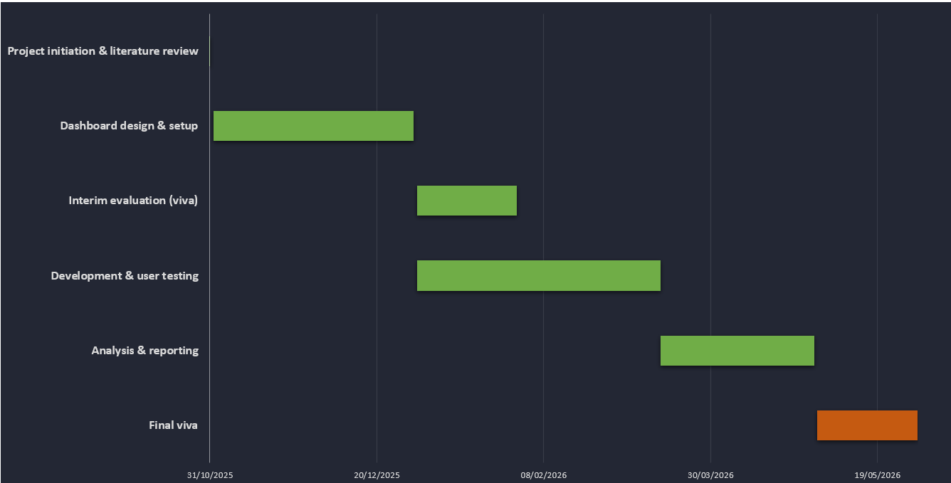
Figure 7- Gantt Chart showing Project timeline with key milestones.

6. Project Impact and Future Development
The proposed dashboard has the potential to deliver significant benefits within the University of Wales Trinity Saint David and the wider Welsh higher education sector. At an institutional level, the tool will improve the efficiency of data quality monitoring by enabling non-technical staff to identify and resolve issues directly, without relying on technical specialists to interpret HESA validation outputs. This will help reduce bottlenecks in the data correction process, leading to faster resolution of errors and fewer last-minute adjustments before statutory deadlines. In turn, this is expected to reduce staff workload, minimise compliance risks, and strengthen the university’s reputation for data quality.
At the sector level, the project aligns with national priorities around digital transformation and the HESA Data Futures initiative, which emphasises continuous monitoring rather than annual submissions. By providing a practical, user-friendly solution to a widely recognised challenge, the dashboard could serve as a model for adoption across other Welsh institutions. Its design principles such as visual traffic-light indicators, drill-down features, and bilingual adaptability are transferable to similar compliance contexts, allowing the project to contribute to a broader culture of proactive data governance.
However, there are limitations to acknowledge. The project will deliver a minimum viable product (MVP) rather than a fully integrated system, and testing will be limited to a small number of participants within UWTSD. As a result, findings will need to be interpreted cautiously, with an understanding that further development and validation are required before large-scale adoption.
Future research could build on this work by scaling the dashboard across multiple institutions, integrating directly with HESA’s Data Futures systems, and exploring applications beyond student records, such as staff or finance data. In doing so, the project could contribute to a more sustainable, sector-wide approach to data quality management in higher education.

7. Reference List
[1] Higher Education Statistics Agency (HESA), Student Data and Validation Guidance, 2023. [Online]. Available: https://www.hesa.ac.uk [Accessed: 04-Aug-2025].
[2] Jisc, Digital Transformation in Higher Education: Realising the Potential of Data, 2021. [Online]. Available: https://www.jisc.ac.uk/reports [Accessed: 04-Aug-2025].
[3] Welsh Government, Commission for Tertiary Education and Research (Medr): Policy and Guidance, 2024. [Online]. Available: https://www.gov.wales [Accessed: 04-Aug-2025].
[4] Welsh Government, Welsh Language Standards (Higher Education), 2020. [Online]. Available: https://www.gov.wales [Accessed: 04-Jul-2025].
[5] A. Sorour, C. F. Stanier, and A. S. Atkins, “The Role of Business Intelligence and Analytics in Higher Education Quality: A Proposed Architecture,” in Proc. IEEE Global Eng. Educ. Conf. (EDUCON), Porto, Portugal, Apr. 2019, pp. 1–5.
[6] Y. W. Wang and D. M. Strong, “Beyond accuracy: What data quality means to data consumers,” J. Manage. Inf. Syst., vol. 12, no. 4, pp. 5–34, 1996.
[7] Higher Education Statistics Agency (HESA), Data Futures: Programme Update, 2021. [Online]. Available: https://www.hesa.ac.uk/innovation/data-futures [Accessed: 09-Aug-2025].
[8] Higher Education Funding Council for Wales (HEFCW), Annual Report and Accounts 2023, Cardiff, 2023. [Online]. Available: https://www.hefcw.ac.uk [Accessed: 09-Aug-2025].
[9] Gartner, Magic Quadrant for Analytics and Business Intelligence Platforms, Stamford, CT, 2022.
[10] R. Knight, M. Buckingham Shum, and S. Littlejohn, “Learning analytics: A dashboard beyond numbers,” Brit. J. Educ. Technol., vol. 51, no. 5, pp. 1439–1455, 2020.
[11] EDUCAUSE, The State of Data Governance in Higher Education, 2019. [Online]. Available: https://library.educause.edu [Accessed: 15-Aug-2025].
[12] P. Sclater, “Learning analytics and student success: A higher education policy perspective,” J. Learn. Anal., vol. 8, no. 2, pp. 1–12, 2021.
[13] S. Dawson, P. J. Richardson, and G. Macfadyen, “Learning analytics and dashboards: Impact on student success,” Comput. Educ., vol. 126, pp. 1–10, 2018.
[14] C. Batini and M. Scannapieco, Data and Information Quality: Dimensions, Principles and Techniques. Cham: Springer, 2016.
[15] J. Brooke, “SUS: A quick and dirty usability scale,” in Usability Evaluation in Industry, P. W. Jordan, B. Thomas, B. A. Weerdmeester, and I. L. McClelland, Eds. London: Taylor & Francis, 1996, pp. 189–194.
[16] M. Saunders, P. Lewis, and A. Thornhill, Research Methods for Business Students, 9th ed. Harlow: Pearson, 2023.
[17] S. Braun and V. Clarke, “Using thematic analysis in psychology,” Qual. Res. Psychol., vol. 3, no. 2, pp. 77–101, 2006.
[18] R. C. Palmer and S. Felsing, A Practical Guide to Feature-Driven Development. Upper Saddle River, NJ: Prentice Hall, 2002.
[19] Information Commissioner’s Office (ICO), Guide to the UK GDPR, 2023. [Online]. Available: https://ico.org.uk. [Accessed: 04-Sep-2025].
[20] Project Management Institute (PMI), A Guide to the Project Management Body of Knowledge (PMBOK® Guide), 7th ed., Newtown Square, PA: PMI, 2021.

