User Experience Design
Development of a digital product prototype in ux
Rebecca Jones (2305750)
2026
Presentation Link:

YouTube video link to my recorded segment of the presentation:
https://youtu.be/laYR7wTdHxw

Images of Completed Work

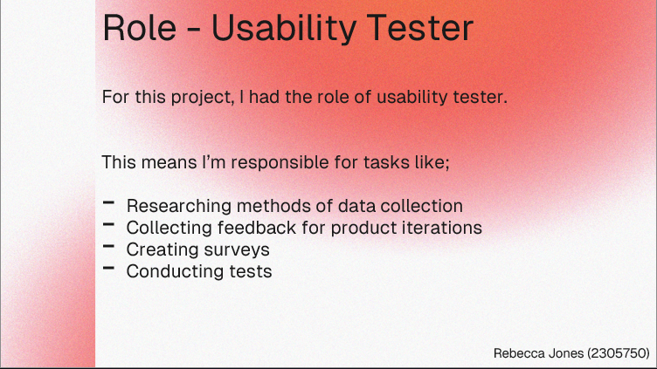
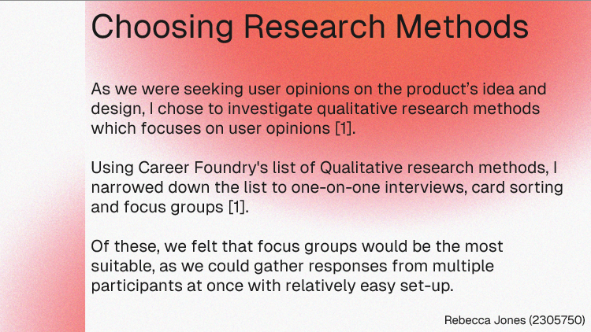
Presentation Slides:

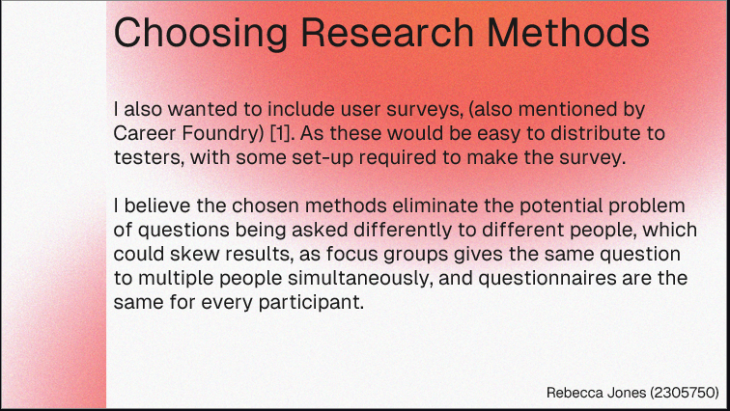

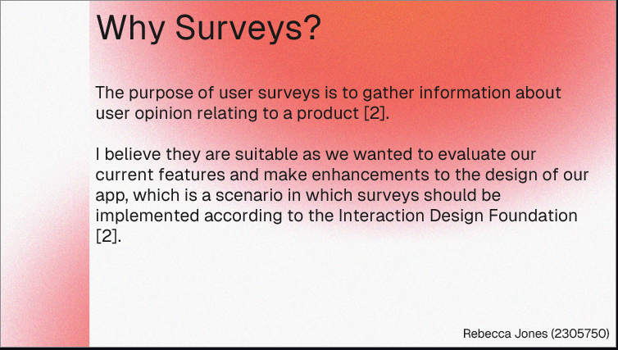

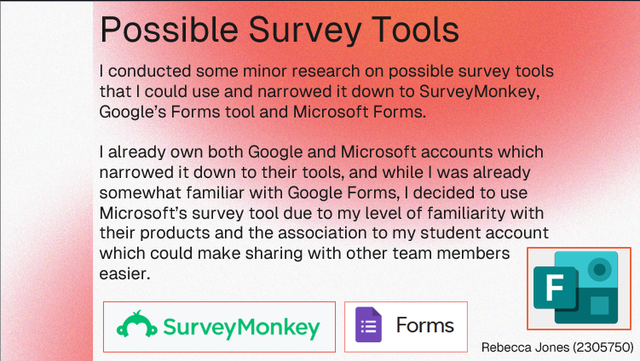

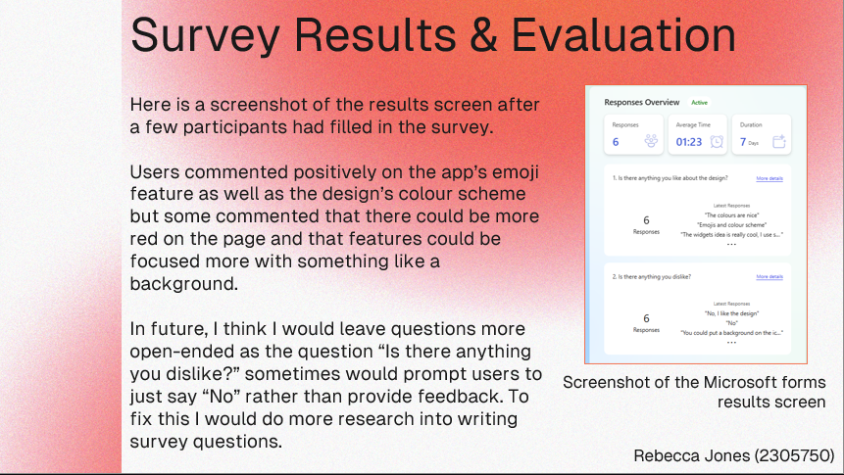

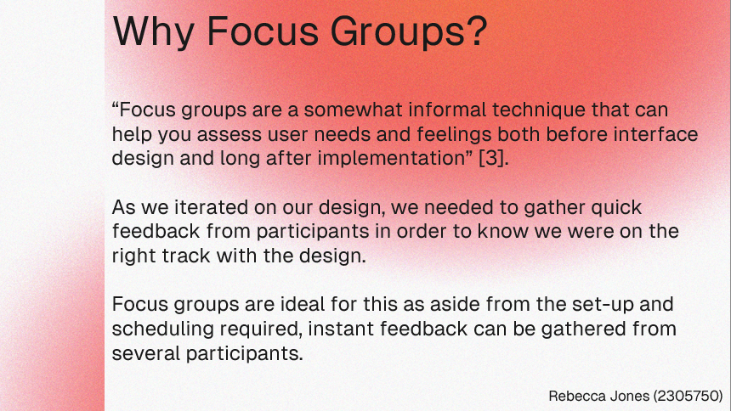

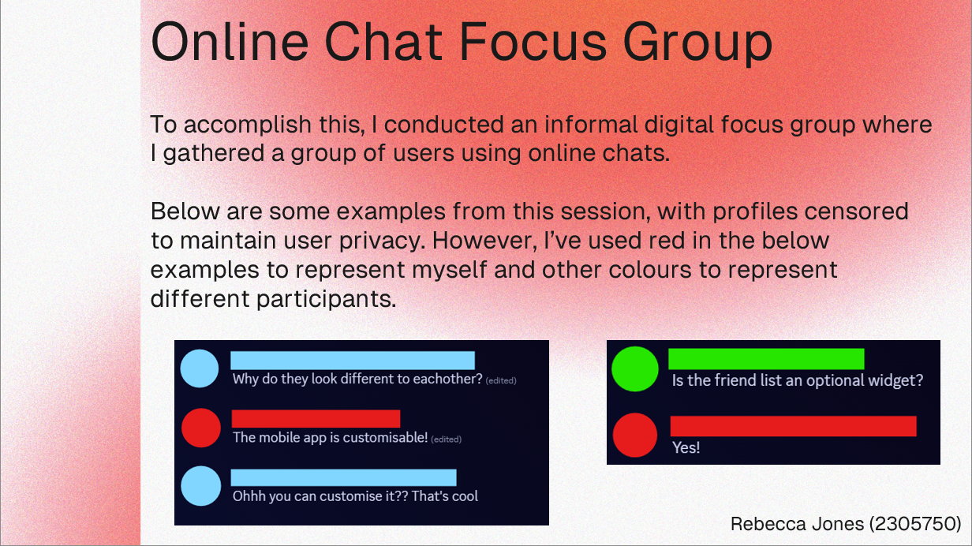

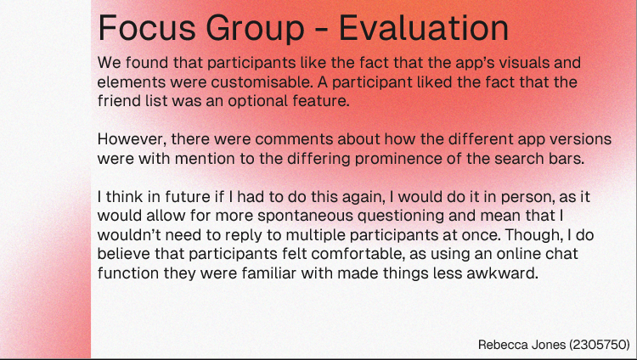

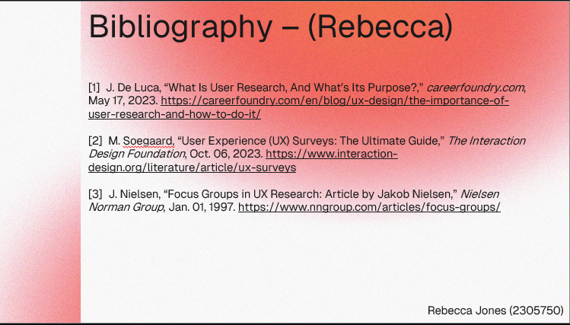
Sources:
[1] J. De Luca, “What Is User Research, And What’s Its Purpose?,” careerfoundry.com, May 17, 2023. https://careerfoundry.com/en/blog/ux-design/the-importance-of-user-research-and-how-to-do-it/
[2] M. Soegaard, “User Experience (UX) Surveys: The Ultimate Guide,” The Interaction Design Foundation, Oct. 06, 2023. https://www.interaction-design.org/literature/article/ux-surveys
[3] J. Nielsen, “Focus Groups in UX Research: Article by Jakob Nielsen,” Nielsen Norman Group, Jan. 01, 1997. https://www.nngroup.com/articles/focus-groups/

