
Name: Catrin Megan Hughes
Student Number: 2205660

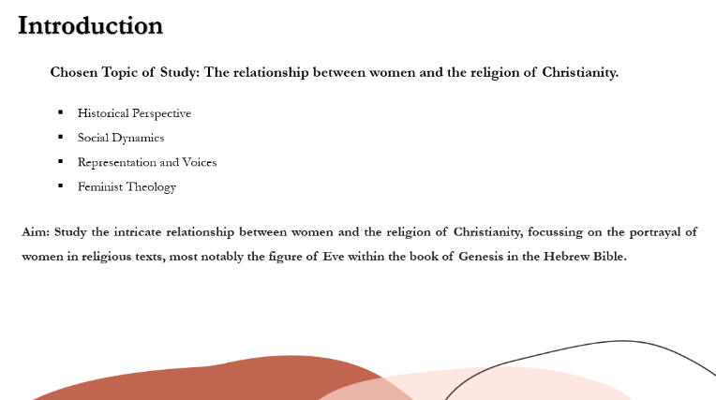
The chosen topic of study for this presentation is women and religion. The reason that I have chosen to focus on the relationship between both women and religion is that I would like to broaden my knowledge and understanding of both religious practices, and gender dynamics, contributing to broader discussions about equality, diversity, and social justice.
The study of women and religion is important to understand how women have played significant roles in religious practices, often shaping belief systems and rituals, therefore, understanding these roles provides insights into the development of various religious traditions. Equally, religion often intersects with gender roles and norms within societies, meaning the study of women in religious contexts will help to unravel power dynamics, societal expectations, and how religion both reflects and reinforces gender inequality. Keeping this in mind, women’s voices and experiences within religious narratives and institutions have sometimes been marginalised or silenced. Studying women and religion provides an opportunity to amplify these voices and gain a more inclusive understanding of religious practices and beliefs. Finally, Feminist theology examines religious texts, traditions, and practices through a gender-conscious lens, seeking to challenge patriarchal interpretations and promote gender equality within religious contexts.
Therefore, with all that in mind, the purpose of this presentation is to study the intricate relationship between women and the religion of Judaism/Christianity, providing a particular focus on the portrayal of women in religious texts, most notably the figure of Eve within the Book of Genesis in the Hebrew Bible. For centuries, the role of women in religious narratives has been a subject of both fascination and controversy. Their portrayal within sacred texts has not only shaped religious beliefs but has also influenced societal norms, cultural attitudes, and gender dynamics as mentioned previously.
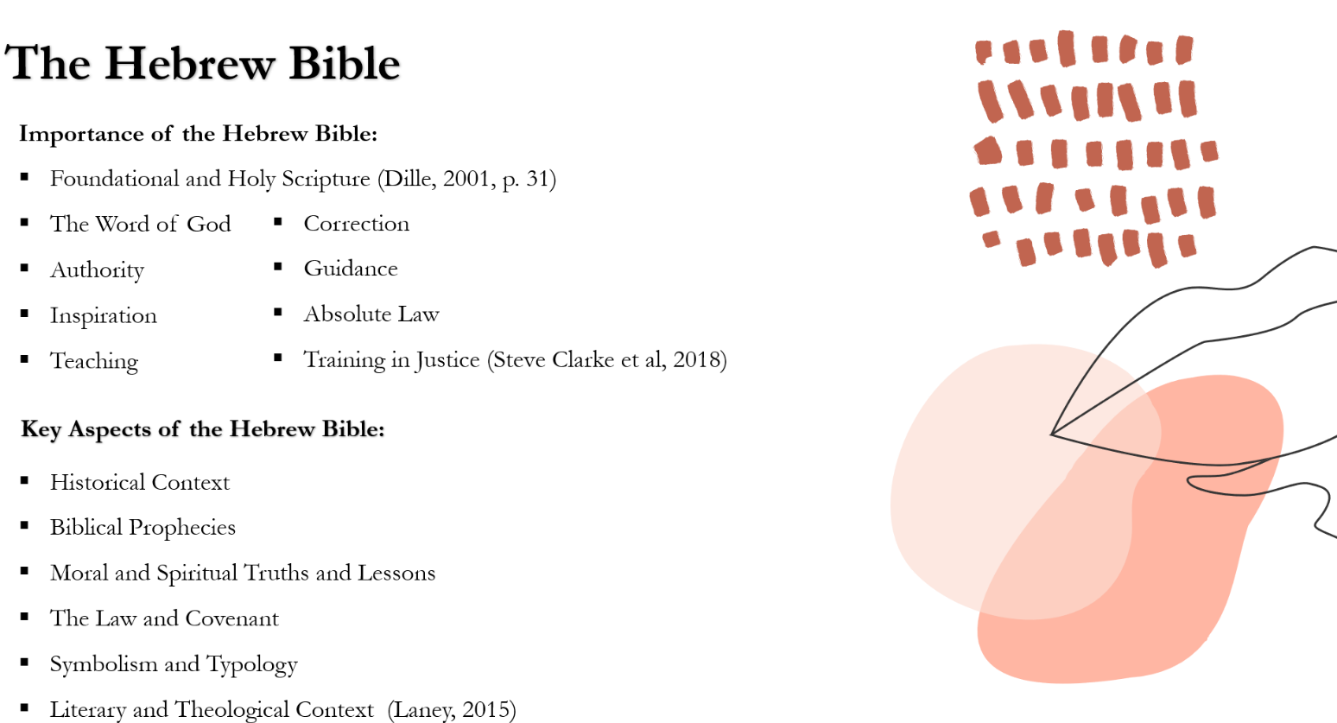
This presentation will explore and delve into the story of Eve in the book of Genesis, examining the nuances of her character, her significance within Christian theology, and the broader implications of her portrayal on the status and perception of women in both religious and secular contexts. However, it is equally important to acknowledge the complexity of this particular subject matter. The portrayal of women in religious texts is not a static phenomenon but rather a dynamic interplay of interpretation, tradition, and cultural context. Therefore, this presentation will not only explore historical perspectives but also seek to understand contemporary interpretations and their implications for gender equality and justice. Through this exploration, I hope to enlighten the multifaceted relationship between women and Christianity, inviting reflection, dialogue, and transformation in our understanding of this timeless and profound topic.

For Christianity, the Hebrew Bible, often referred to as the Old Testament, holds profound significance as the foundational scripture (Dille, 2001, p. 31) that provides context and continuity for the Christian faith. It is a holy scripture that has many purposes, some are mentioned above.
Some key aspects of the Hebrew Bible's importance for Christianity include:
- Historical Context: The Hebrew Bible provides historical context for understanding the origins of the Christian faith (Laney, 2015).
- Biblical Prophecies: Christians interpret many passages in the Hebrew Bible as prophecies foretelling the coming of Jesus Christ. These prophecies include predictions about the birth, life, ministry, death, and resurrection of Jesus, as well as his role as the Saviour and Redeemer of humanity (Laney, 2015).
- Moral and Spiritual Truths and Lessons: The Hebrew Bible contains ethical teachings, moral principles, and spiritual insights that are foundational to Christian theology and ethics. Stories of faith, obedience, repentance, and redemption found in the Hebrew Bible serve as examples for Christians to emulate in their own lives (Laney, 2015).
- The Law and Covenant: While Christians believe that Jesus inaugurated a new covenant through his life, death, and resurrection, the Hebrew Bible's depiction of God's covenant with people remains relevant for understanding the nature of God's relationship with humanity and the principles of justice, mercy, and righteousness (Laney, 2015).
- Symbolism and Typology: Christians often interpret characters, events, and rituals from the Hebrew Bible symbolically or typologically, seeing them as foreshadowing or prefiguring aspects of Jesus Christ and the Christian faith. For example, the Passover lamb is seen as a type of Christ's sacrificial death (Laney, 2015).
- Literary and Theological Context: Understanding the Hebrew Bible's literary genres, historical narratives, poetry, prophecy, and wisdom literature is crucial for grasping the theological themes and motifs that permeate both the Old and New Testaments of the Christian Bible (Laney, 2015).
Overall, the Hebrew Bible serves as an indispensable part of Christian scripture, providing theological, historical, and spiritual foundations for Christian belief and practice. Christians regard it as inspired scripture, alongside the New Testament, and study it for guidance, inspiration, and a deeper understanding of God's revelation to humanity.

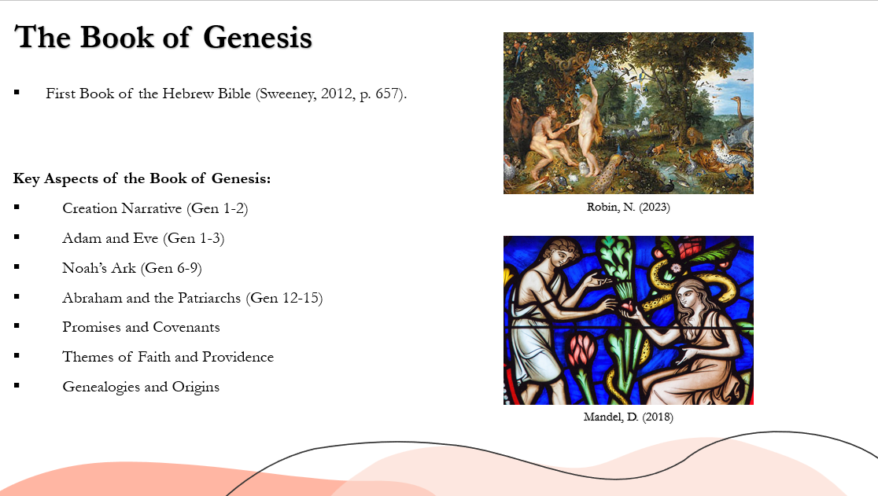
The Book of Genesis is the first book of the Hebrew Bible and the Christian Old Testament. It is a foundational piece of text in Judaism, Christianity, and Islam, detailing the origins of the universe, humanity, and the Israelite people (Sweeney, 2012, p. 657).
Some key aspects of the Book of Genesis include:
- Creation Narrative: Genesis opens with two separate accounts of creation, describing how God brings the universe into existence over six days, culminating in the creation of humanity in God's image. This narrative establishes God as the sovereign creator and sustainer of all things (Gen 1-2).
- Adam and Eve: Genesis recounts the story of Adam and Eve, the first human beings, who are placed in the Garden of Eden and instructed by God not to eat from the tree of the knowledge of good and evil. They disobey God's command, leading to their expulsion from the garden and the introduction of sin and death into the world (Gen 1-3).
- Noah's Ark: The Book of Genesis includes the story of Noah and the Great Flood, in which God destroys the corrupt and sinful world with a flood but preserves Noah, his family, and pairs of animals on an ark. After the floodwaters recede, God makes a covenant with Noah and promises never to destroy the earth again in the same way (Gen 6-9).
- Abraham and the Patriarchs: Genesis focuses on the patriarchs of the Israelite people, beginning with Abraham, whom God calls to leave his homeland and journey to the land of Canaan. God makes a covenant with Abraham, promising to bless him and his descendants, who will become a great nation. The stories of Isaac, Jacob, and Joseph also feature prominently in Genesis (Gen 12-15).
- Promises and Covenants: Throughout Genesis, God makes various promises and covenants with individuals such as Abraham, Isaac, and Jacob, reaffirming his commitment to bless and protect their descendants and to fulfil his purposes through them.
- Themes of Faith and Providence: Genesis explores themes of faith, obedience, and divine providence as individuals grapple with God's promises and navigate the challenges of life. The stories of figures like Abraham, who demonstrates unwavering faith in God's promises, and Joseph, who experiences both adversity and eventual redemption, illustrate these themes.
- Genealogies and Origins: Genesis contains genealogies tracing the lineage of various individuals and tribes, providing a framework for understanding the ancestral origins of the Israelite people.

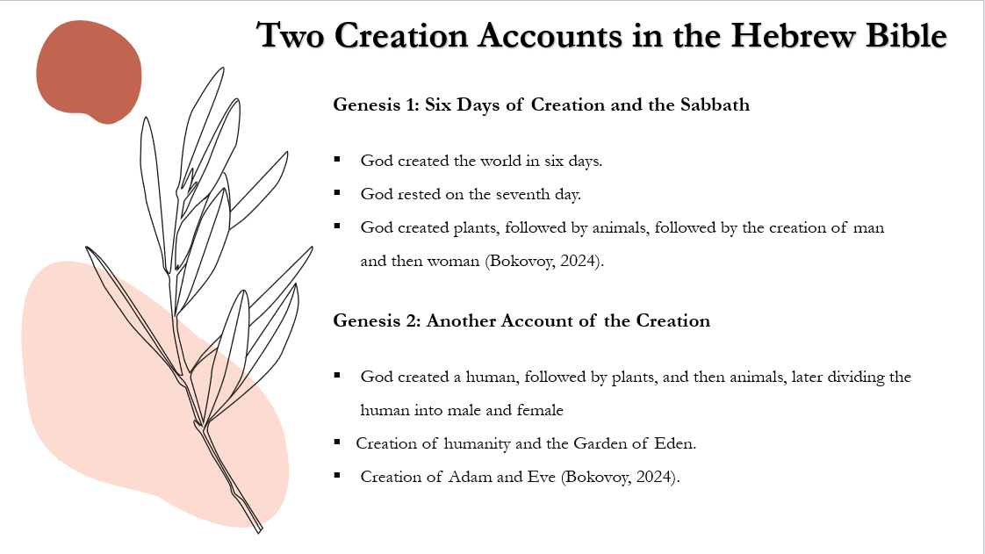
In the Hebrew Bible, particularly in the Book of Genesis, there are two distinct creation accounts presented in chapters 1 and 2. These accounts offer different perspectives on the creation of the universe, humanity, and the natural world (Ruse, 2022). While they are similar in many ways, through the description of creating humans, animals and plants, they are also distinct and even contradict one another on some of the main issues that arise (Bokovoy, 2024).
Genesis 1 provides a creation account that is often referred to as a structured and ordered narrative, with God creating the world in six days and resting on the seventh day (Gen 1-2). Each day of the creation involved specific acts of God, such as separating light from darkness, creating the sky, land, seas, vegetation, sun, moon, stars, sea creatures, birds, land animals, and finally, humanity (male and female). Humanity is created on the sixth day, in the image of God, and given dominion over the rest of creation, with a role as stewards of the world (Gen 1:2-31).
On the other hand, Genesis 2 offers a more intimate and narrative-focused depiction of the creation of humanity and the Garden of Eden. In this account, there is a focus on the creation of the first human, referred to as Adam, from the dust of the ground. God places Adam in the Garden of Eden to cultivate and care for it. However, Adam is depicted as lonely, prompting God to create animals as potential companions. None of the animals prove suitable companions for Adam, leading God to create Eve from one of Adam's ribs to be his partner/helper (Gen 2: 2-25).
While these two creation accounts present differing chronologies and details, they are complementary rather than contradictory. Together, they offer a multifaceted understanding of God's creative power and intentionality in forming the world and humanity. The differences between the two accounts could possibly reflect distinct theological emphases or literary traditions within ancient Israelite society.

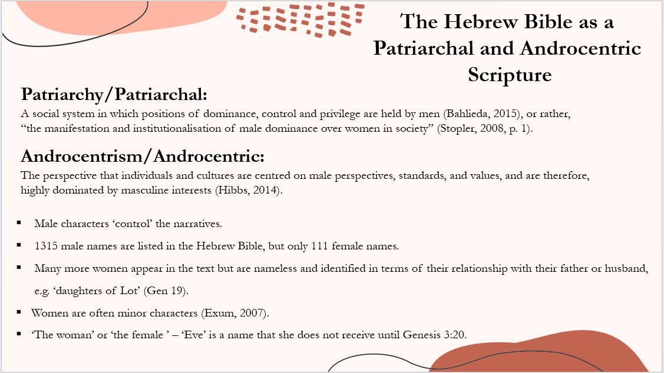
The Hebrew Bible reflects the patriarchal and androcentric norms prevalent in the ancient Near East during the time of its composition. How this is reflected in the Hebrew Bible is demonstrated below:
- Male-Centred Narratives: The narratives in the Hebrew Bible are predominately centred around male figures such as Abraham, Isaac, Jacob, Moses, David, and Solomon. Women are often secondary characters in these stories, and their roles are frequently defined in relation to men.
- Male Authorship and Perspective: The texts were predominantly written by men, and they reflect the societal norms and values of the time, which tended to prioritize male authority and perspectives.
- Legal and Social Framework: The legal and social frameworks outlined in the Hebrew Bible often prioritize men in matters such as inheritance, leadership roles, and religious authority. For example, in many passages, inheritance is passed down through male lineage.
- Gender Roles and Expectations: The Hebrew Bible reinforces traditional gender roles, with men typically depicted as leaders, warriors, and heads of households, while women are often portrayed in supportive or subordinate roles, such as wives, mothers, or concubines.
- Language and Imagery: The language and imagery used in the Hebrew Bible often reinforce male dominance and authority. For instance, God is typically referred to using masculine language and imagery, such as ‘Father’ or ‘King.’

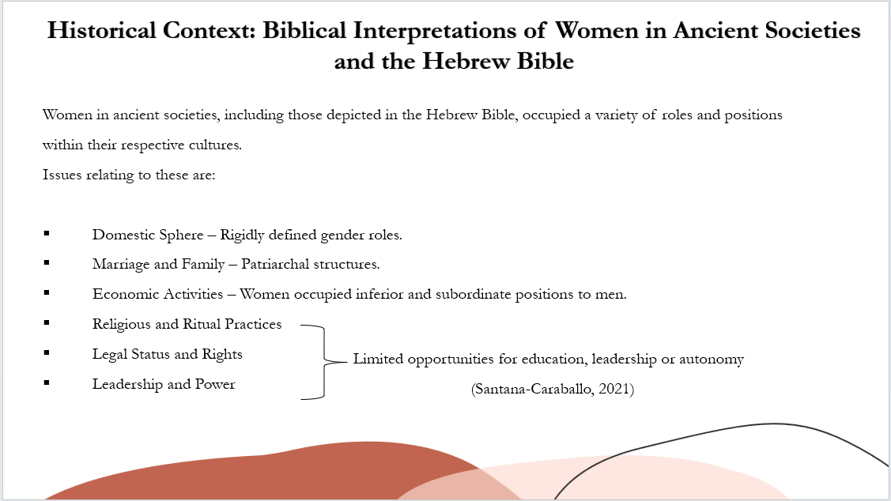
To understand the portrayal of women in Christianity, it is essential to consider the historical context in which religious texts were written and the societal norms that prevailed during those times. In ancient societies, including those of the Near East where the events of the Hebrew Bible took place, gender roles were often rigidly defined, with women typically occupying subordinate positions to men. Patriarchal structures were common, and women's roles were largely confined to the domestic sphere, with limited opportunities for education, leadership, or autonomy.
Some key aspects include:
- Domestic Sphere: Women in ancient societies were often primarily associated with the domestic sphere, responsible for tasks such as child-rearing, cooking, and managing the household.
- Marriage and Family: Marriage was a central institution in ancient societies, and women typically played key roles as wives and mothers. The Hebrew Bible contains numerous stories that emphasize the importance of marriage and family, often portraying women as wives and mothers whose primary duties revolve around their husbands and children.
- Economic Activities: While men typically held more prominent positions in economic and political spheres, women in ancient societies often contributed to the household economy through activities such as textile production, agriculture, and trade.
- Religious and Ritual Practices: Women in ancient societies participated in religious and ritual practices, although their roles in these activities varied widely depending on cultural and religious norms. In the Hebrew Bible, women are often depicted as active participants in religious rituals and ceremonies, although they generally held subordinate positions to men in matters of religious authority.
- Legal Status and Rights: Women's legal status and rights varied significantly across different ancient societies. In some cultures, women enjoyed certain legal protections and rights, while in others, they had limited autonomy and were subject to the authority of men. In the Hebrew Bible, legal codes and narratives reflect a patriarchal society where men typically held greater legal authority and rights than women.
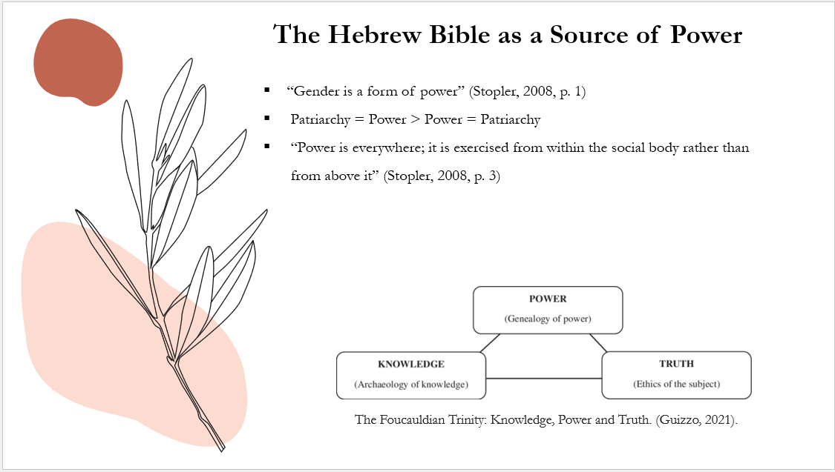
- Leadership and Power: While men predominantly held positions of political and social power in ancient societies, there were exceptions where women wielded significant influence and authority. In the Hebrew Bible, there are instances of women assuming leadership roles, such as Deborah, who served as a judge and military leader (Santana-Caraballo, 2021)

The Hebrew Bible holds significant cultural, historical, and spiritual importance for many people. While its primary purpose is religious, it has also been interpreted and utilised in various ways throughout history, including as a source of power.
The Hebrew Bible provides a foundation for moral and ethical teachings. Its commandments, stories, and wisdom literature offer guidance on how to live a righteous life. Leaders and individuals have often invoked these teachings to establish moral authority and justify their actions.
Throughout history, rulers and political leaders have invoked religious texts, including the Hebrew Bible, to legitimise their power and authority. By aligning themselves with biblical narratives or claiming divine sanction, leaders sought to gain the support and loyalty of their subjects, in this instance, the power of men over women. The Hebrew Bible as a source of power has a strong connection to Michel Foucault’s notion of power. While Foucault did not specifically focus on the Hebrew Bible, his ideas on power, discourse, and the construction of truth can offer insights into how religious texts like the Hebrew Bible can function as sources of power (Guizzo, 2021, p. 63).
Foucault argued that power is not just coercive or repressive but operates through discourse, language, and knowledge. In the case of the Hebrew Bible, its texts contain a discourse that shapes the beliefs, values, and behaviours of believers. Through its narratives, laws, and teachings, the Hebrew Bible establishes norms and codes of conduct that influence individuals and communities. Foucault examined how power and knowledge are interconnected (Guizzo, 2021, p. 61). He suggested that knowledge is not neutral but is shaped by power relations (Guizzo, 2021, p. 61). In the context of the Hebrew Bible, interpretations of its texts are influenced by power dynamics within religious communities and broader societal structures. Those who have the authority to interpret and disseminate biblical teachings wield power over others by shaping their understanding of truth and morality.
Similarly, his philosophy discusses how institutions, such as religion, contribute to the normalisation of behaviour and the disciplining of individuals. The Hebrew Bible, as a religious text, prescribes moral codes and rituals that regulate the conduct of believers. Through religious practices and adherence to biblical precepts, individuals internalise norms of behaviour and conform to societal expectations, thereby reinforcing power structures (Guizzo, 2021, p .61).
In summary, while Foucault did not specifically analyse the Hebrew Bible, his theories on power, discourse, and knowledge production offer a framework for understanding how religious texts like the Hebrew Bible can function as sources of power.

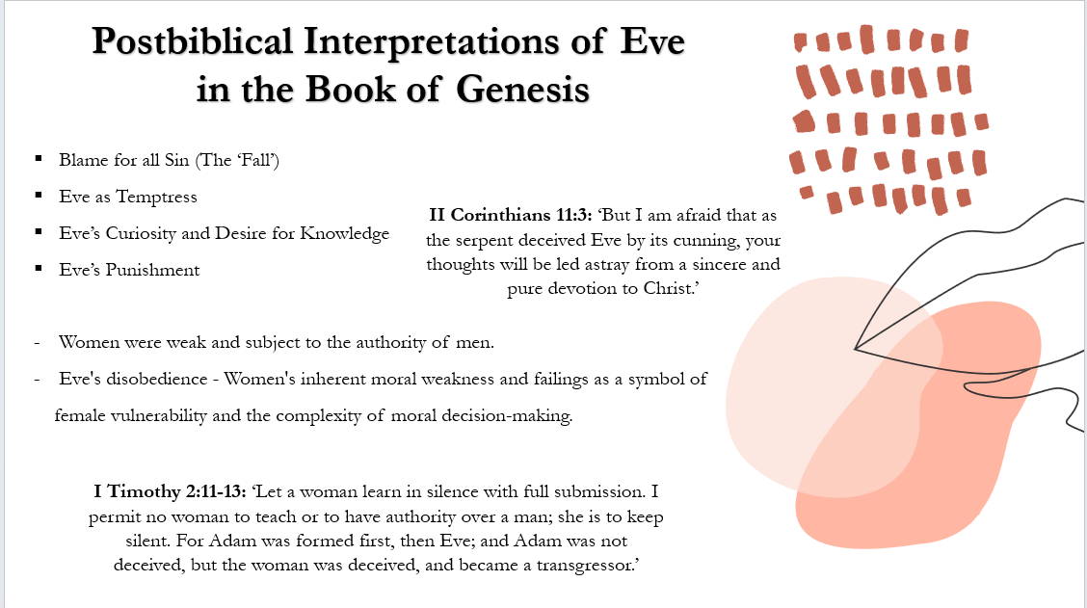

The Book of Genesis, which contains the story of Eve, was likely composed during the early stages of Israelite history, reflecting the cultural and social norms of its time.
Eve's portrayal in Genesis reflects the worldview of ancient Israelite society, where women were often depicted as weak and were subject to the authority of men. The creation story in Genesis 2-3 depicts Eve as the first woman, created from Adam's rib to be his companion. However, her creation is also accompanied by a narrative of her role in the first act of disobedience against God, leading to the expulsion from the Garden of Eden and the introduction of sin into the world. The story of Eve and her actions in the Garden of Eden has been interpreted in various ways throughout history, often reflecting the prevailing attitudes towards women within different religious and cultural contexts. In some interpretations, Eve's disobedience is seen as evidence of women's inherent moral weakness, while in others, it is viewed as a symbol of human vulnerability and the complexity of moral decision-making.
As Christianity emerged and developed in the centuries following the life of Jesus Christ, the portrayal of women continued to be influenced by cultural and societal norms. Early Christian writings, including the New Testament, contain diverse perspectives on women, with some passages affirming their equality and dignity, while others reflect more traditional gender roles.
Understanding the historical context surrounding the portrayal of women in Christianity provides important insights into the interpretation and significance of Eve's character within the religious tradition. By examining the cultural, social, and religious dynamics of the ancient world, we can better appreciate the complexities of gender relations and the ongoing dialogue between faith and culture in shaping our understanding of women in Christianity. This overview provides a foundational understanding of the historical context surrounding the portrayal of women in Christianity, particularly within the narrative of Eve in the Book of Genesis.
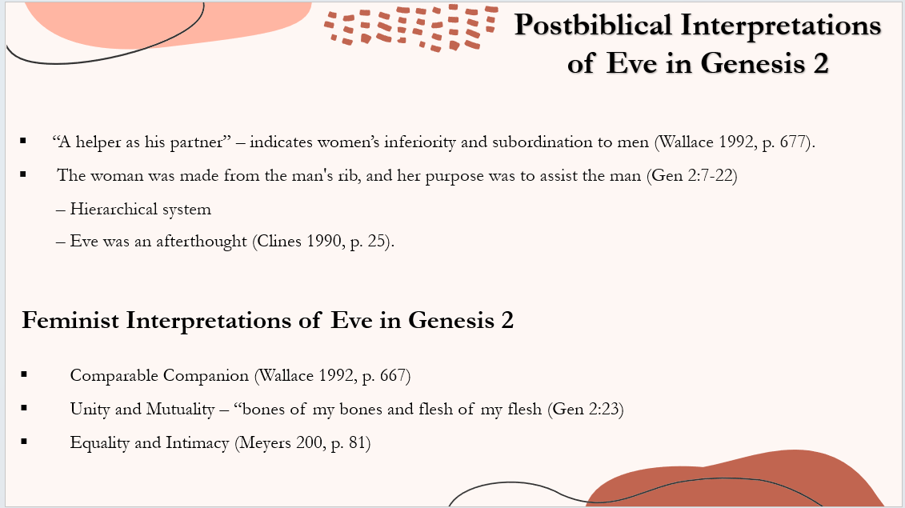
To attain a better understanding of postbiblical interpretations of Eve, it is important to acknowledge the role that she represents in both Genesis 2 and 3.
Chapter 2 of Genesis highlights the man's need for "a helper as his partner" (Gen 2:18). According to Dennis, a suitable companion (2010, p. 12), was found in a woman, and not animals (Meyers 2000, p. 80). While animals served to populate the earth, they did not fulfil God's intended purpose (Meyers 2000, p. 80). Therefore, God performs a cosmic surgery on the man, removing one rib (Gen 2:22) to create another person, referred to as a 'woman' (Gen 2:22).
Postbiblical interpretations often depict this event as indicating women's inferiority and subordination to men in society (Wallace 1992: 677). This perception arises from the sequence of creation, the woman being made from the man's rib, and her purpose being to assist the man (Gen 2:7-22), establishing a structured hierarchical system and suggesting Eve's creation as an afterthought, highlighting the man's initial solitude (Clines 1990, p. 25).
However, the priority of woman's creation does not imply male superiority but rather the necessity for a comparable companion (Wallace 1992, p. 677). This unity and mutuality between the first man and woman are expressed in the famous words "bone of my bones and flesh of my flesh" (Gen 2:23), indicating equality and intimacy (Meyers 2000, p. 81; Niditch 2016, p. 30). This unity implies that both men and women are equal, with their equality symbolising the intimacy of marital bonds, suggesting that a man is incomplete without a woman (Niditch 2016, p. 30). The phrase "an equal partner" or "an appropriate counterpart" suggests a lack of hierarchy between man and woman (Meyers, 2021), emphasising a woman's role in alleviating isolation through companionship (Clines 1990, p. 29). They form a marital partnership, integral to humankind's existence, especially in ancient Israelite villages where the productivity and value of both man and woman were equally significant (Meyers, 2021).

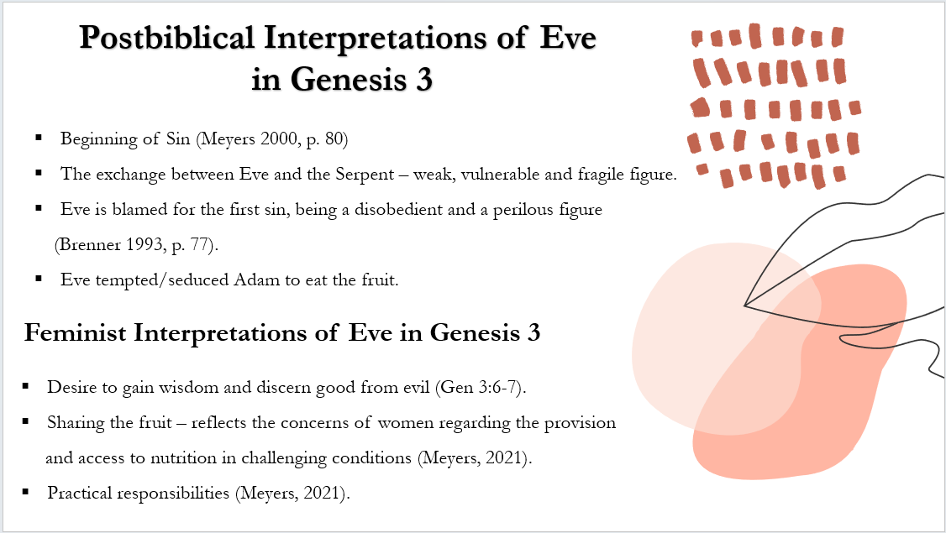
Another interpretation regarding Eve's portrayal in Genesis 3 revolves around her association with the inception of sin (Meyers 2000, p. 80). During the exchange between the serpent and Eve, she appears to be drawn to the visual appeal and presumed nutritional value of the forbidden tree and its fruit (Meyers 2000, p. 81). Eve's desire to gain wisdom and discern good from evil led her to eat from the forbidden tree and share the fruit with her husband (Gen 3:6-7). Eve is often blamed for the first sin, depicted as a disobedient and perilous figure (Brenner 1993, p. 77). However, it's a misconception to suggest that Eve tempted or seduced Adam, as the original text does not support this notion. Instead, her actions of sharing the fruit reflect the’] concerns of Israelite women regarding provision and sustenance in challenging conditions (Meyers, 2021). Thus, Eve's behaviour is better understood as a reflection of practical responsibilities rather than temptation or seduction (Meyers, 2021).
The concept of Eve committing the first sin is linked to the broader theme of 'the fall,' signifying humanity's descent from innocence to a sinful existence (Brenner 1993, p. 77). This idea has had a profoundly pessimistic impact on Western culture's perception of life, often leading to the marginalisation of women and their portrayal as the source of immorality and death (Brenner 1993, p. 77). However, neither the Genesis 2-3 narrative nor the term "sinner" is explicitly attributed to Eve until the Cain-Abel narrative (Meyers 2000, p. 80). Both Eve and Adam disobeyed God's command not to eat from the tree of knowledge (Gen 2:17), despite Adam's attempt to shift blame onto Eve (Gen 3:12).
A critical perspective challenges the traditional interpretation of 'sin and fall,' arguing that the Genesis narrative does not depict Eve and Adam as representatives of sin, fall, and punishment elsewhere in the Hebrew Bible (Brenner 1993: 78).
The conventional narrative of human origins considers the first humans, Adam and Eve, as archetypes representing all humanity (Meyers 2000, p. 81). Eve's naming as 'Eve' (Gen 3:20) symbolizes her role as the mother of all living beings (Wallace, 1992, p. 676). The narrative of Genesis is predominantly male-centric, as seen in Adam naming his wife Eve (Gen 3:20), reflecting centuries of male domination and the moral vulnerability of women (Brenner 1993, p. 78). In ancient traditions, the act of naming was a demonstration of authority and control over women (Clines 1990, p. 38). This notion of control is evident in God's directive for Eve to be subject to her husband's rule (Gen 3:16), which poses significant challenges to gender equality (Meyers 2000, p. 81).

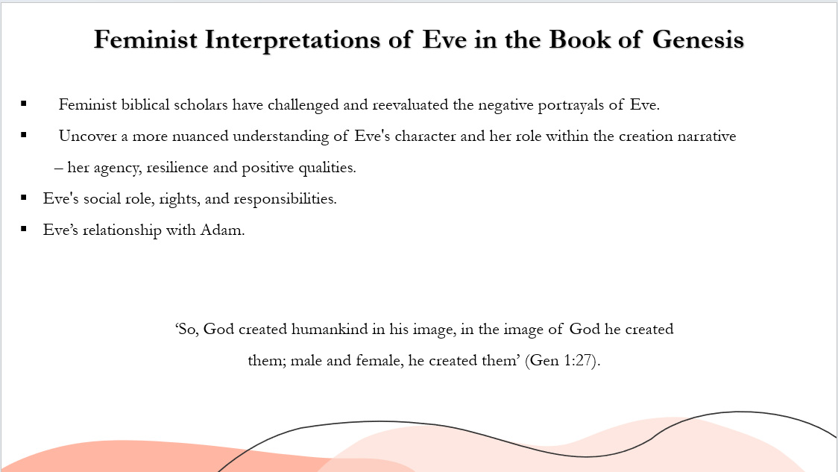
The interpretations of chapters 2 and 3 of the book of Genesis, particularly concerning the character of Eve, have indeed been influential in shaping Western beliefs and attitudes towards women. Historically, Eve has often been depicted in negative theological terms, viewed as the instigator of sin and the source of humanity's fall from grace. This interpretation has had significant implications for gender relations and the perception of women's roles within Western culture.
However, recent feminist biblical scholars have sought to challenge and reevaluate these negative portrayals of Eve. By examining the text through a feminist lens, they aim to uncover more nuanced understandings of Eve's character and her role within the creation narrative. Rather than viewing Eve solely as a temptress or the cause of humanity's downfall, feminist interpretations seek to highlight her agency, resilience, and potential positive qualities.
In Account 1 of the Creation, God created humankind in his image, in the image of God he created them; male and female, he created them’. From this quote, there is no suggestion of sexual hierarchy or the absence of the divine image in the female. Their unity is highlighted; both are blessed by God and receive a command to multiply and fill the earth (1:28).
These interpretations emphasise Eve's social role, rights, and responsibilities within the context of ancient Israelite culture. They explore Eve's relationship with Adam, her role as a partner and companion, and her participation in the act of creation. Additionally, feminist scholars analyse the cultural and theological significance of the creation narrative, seeking to understand its implications for gender relations and power dynamics within ancient Israelite society. By engaging with these feminist interpretations, scholars and readers can gain a deeper understanding of the complexities of Eve's character and the broader themes of gender, power, and identity within the Hebrew Bible. These interpretations also contribute to ongoing discussions about the relevance of biblical narratives for contemporary issues related to gender equality, social justice, and human flourishing.

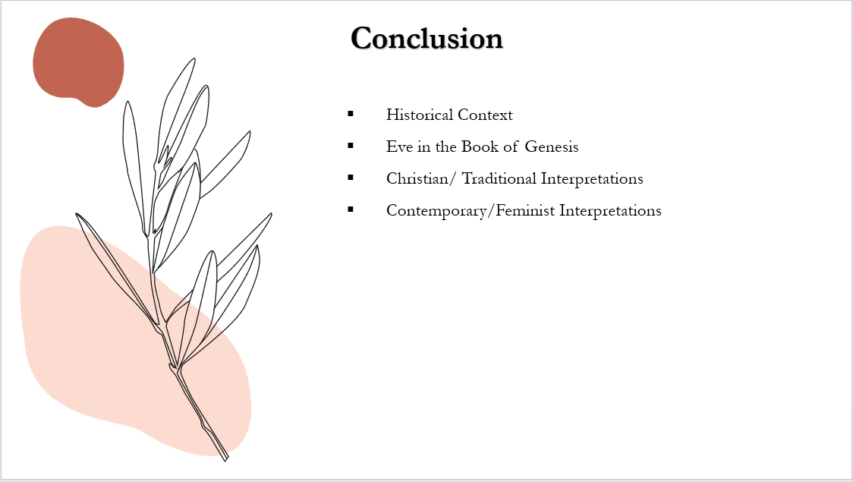
In conclusion, the portrayal of Eve in Christianity has revealed a tapestry rich with complexity, nuance, and enduring significance. From her appearance in the Book of Genesis to her relevance in contemporary discussions on gender and equality, Eve's narrative serves as a prism through which we can explore the evolving relationship between women and Christianity.
Through several key examinations of Eve's story, we have traversed historical contexts, delved into theological interpretations, and grappled with the implications of her portrayal of women's roles and perceptions throughout history. Evidently, Eve's character has been subject to diverse interpretations, ranging from traditional views that cast her as the archetypal temptress to more feminist perspectives that challenge prevailing notions of her moral culpability. Moreover, this exploration has underscored the enduring influence of Eve's narrative on attitudes towards women within Christian theology and tradition. Going forward, it is suggested to continue challenging the legacy of gendered interpretations and explore efforts within Christianity to reevaluate and reinterpret Eve's story in ways that empower women and promote gender equality.
Across history, ancient gender norms have shaped societal perceptions, often legitimising the dominance of patriarchy and androcentrism in religious traditions and academic interpretations of the Bible (Scholz 2020, p. xxvi). The portrayal of Eve as inferior, sinful, tempting, and responsible for 'the fall' represents postbiblical interpretations not explicitly found in the literature of Genesis. Instead, these interpretations stem from damaging stereotypes regarding gender relations in ancient Israel, where Israelite women were often marginalized and subject to male domination. Feminist biblical scholarship endeavours to challenge these misrepresentations, advocating for the equal standing of women in human nature and affirming their rights, roles, and responsibilities within society.
In our discussion of contemporary perspectives on Eve, we have encountered voices that challenge traditional understandings and seek to reclaim her narrative as a symbol of resilience, agency, and liberation. From feminist readings that reframe Eve's disobedience as an act of courage to initiatives within Christianity that promote inclusive and egalitarian interpretations, Eve’s relevance in today’s world is witnessed. Ultimately, exploring the portrayal of Eve in Christianity invites us to confront not only questions of gender and identity but also broader themes of morality, human nature, and the pursuit of justice. As we reflect on Eve's narrative, we are reminded of the enduring power of religious stories to shape our understanding of the world and inspire transformative dialogue and action. Therefore, it is significant to continue engaging critically with our theological and cultural traditions, to confront the complexities of gender dynamics, and to strive for a future where all individuals, regardless of gender, are valued, respected, and empowered within religious communities and beyond.



