Amazon packaging waste issue – diagnosing the problem, finding and implementing solutions.



MAY 2018

MODULE NAME: Community Engagement (M4X00799)
Name: natalia mendel
Student Number: 1702150

Table of Contents

1. eXECUTIVE sUMMARY 1
2. Introduction 2
2.1 Report Remit 2
2.2 Brief background the organisation 2
2.3 Amazon packaging waste issue 3
3. Problem solving techniques 4
3.1 Solving the problem 6
3.2 Problem solving implementation 10
4. Conclusion 11
5. References 12

List of Figures

FIGURE 2.3-1- UK GREENHOUSE GAS EMISSION………………………………………………………. 4
FIGURE 3-1- ISHIKAWA DIAGRAM…………………………………………………………………………. 5
FIGURE 3-2- “5 WHYS” TECHNIQUE……………………………………………………………………….. 6
FIGURE 3.1-1- PUMA’S “CLEVER LITTLE BAG”………………………………………………………….. 8

APPENDICES
APPENDIX A – EXAMPLES OF WASTEFULL AMAZON PACKAGING

eXECUTIVE sUMMARY

The purpose of this report was to discover the possible solutions to minimalise the negative impact of Amazon packaging waste. Amazon is the world’s leading online retailer, shipping large number of items in cardboard packaging to its customers.
The Amazon packaging waste issue was diagnosed, and the following findings were discovered. Excessive packaging and excessive use of materials, as well as double or triple packing customer orders leads to the excessive waste produced. Excessive waste, as well as Amazon not taking responsibility for recycling the empty packaging were identified as factors contributing to the excessive production of greenhouse gasses and in turn, contributing to global warming.
To solve the problem of Amazon’s waste issue the following techniques were implemented, the use of an Ishikawa diagram and the “5why” method.
Based on the techniques used, the following factors were identified as the potential root causes of the problem, the environment, material, method/process and management.
In analysing the potential root causes a variety of issues were identified, as well as potential solutions being found. A faulty system showing the wrong box recommendations was identified as the main root of the problem and the factor leading to an excessive waste being produced.
To solve the issue of the faulty recommendations, a detailed plan was developed with the main aim being to update the sizes of the boxes. A new separate department was established to deal with the faulty system. To cover the extra expenses caused by this department the “Eco-Prime” service was created. The new solutions allow Amazon to reduce the amount of unnecessary waste, as well as decrease their negative environmental impact.

Introduction

Global warming, depletion of natural resources and pollution, these are just some of the environmental issues impacting our society and businesses. It might not be attainable to replace the exhausted resources, but it is possible to minimalise the destructive process. Many companies are consciously aware of their environmental impact and try to reduce their carbon footprint while others neglect this aspect of their business. One of the companies failing at this field is the biggest online retailer Amazon. The packaging practices applied by the company are wasteful which in turn have a harmful environmental impact.

Report Remit

The report is seeking to discover the possible solutions to minimalise the negative environmental impact of Amazon packaging. The issue of Amazon packaging waste will be diagnosed, and the popular problem-solving techniques will be implemented. The detailed plan for implementing a solution will also be developed and the appropriate monitoring techniques will be introduced to ensure successful implementation of the solution.

Brief background the organisation

Amazon is the world’s biggest online retailer, offering variety of items and services to its customers. The company was created in 1995 with the clear mission to “to be Earth’s most customer-centric company, where customers can find and discover anything they might want to buy online, and endeavours to offer its customers the lowest possible prices.” (Amazon, 2018) Amazon does not reveal the number of its customers or the number of total items sold, however, the company reported net sales of $177,866 million in the financial year 2017, (Amazon, 2018) which suggest the enormous number of items shipped to the customers. These items are shipped using cardboard packaging and paper filler.

Amazon packaging waste issue

In today’s largely urbanised world it is important to make sure that the natural resources that we use are sustainable, as the consumption of the natural resources increases every day. Hence the importance of sustainable development. This kind of development takes into consideration the environmental consequences of economic activity, as well as it promotes the use of recourses that can be replaced, renewed and cannot be depleted. (Allaby, 2010) Amazon claims to support sustainable development. In 2008 the company designed the frustration free packaging initiative, promoting 100% recyclable packaging, eliminating any additional packaging, as well as eliminating any unnecessary waste. (Amazon, 2018) However, there is a great distance between their statements and the facts. The company ships a large number of items every day and applies poor packing practises. The carboard packaging is often excessive and little items are shipped in boxes that are often far too big for the items and wrapped in an absurd amount of paper. The poor proportions of the boxes are not the only bad habit of the organisation. Often the original items are double or triple packed. These packaging practises are simply wasteful. The latest statistic shows that in 2015 the UK generated 202.8 million tonnes of total waste and only 45.2% were recycled. (Government Statistical Service, 2018) With massive amounts of waste overfilling the UK’s landfills the amount of unnecessary waste generated by the company should be significantly reduced. Also, the company does not take any responsibility for the packaging after the items get to the customer. Some of the users might choose to recycle the box while the others may not. When the carboard gets to landfill it breaks down and generates methane. Methane is a main gas causing global warming, 21 times more powerful than carbon dioxide (CO2). (The University of Melbourne, 2018) Furthermore, the production of the carboard also emits the greenhouse gasses (Government Digital Service, 2018) and drives deforestation which further increases the speed of global warming. (Morrison, 2011) The UK government aims to lower greenhouse emissions by 80% (from the 1990 baseline) by the year 2050. (Government Digital Service, 2015) As the statistics show (figure 2.3-1) the UK is on track in fulfilling this goal. The business emissions contribute to 17% of total greenhouse emissions, (Government Digital Service, 2017) hence it is important for a major corporation like Amazon to join this initiative. Amazon should consider improving their packaging practices, as well as taking
greater responsibility of recyclable waste in order to reduce their carbon footprint and contribute to the UK’s aim in reaching the next CO2 budget.

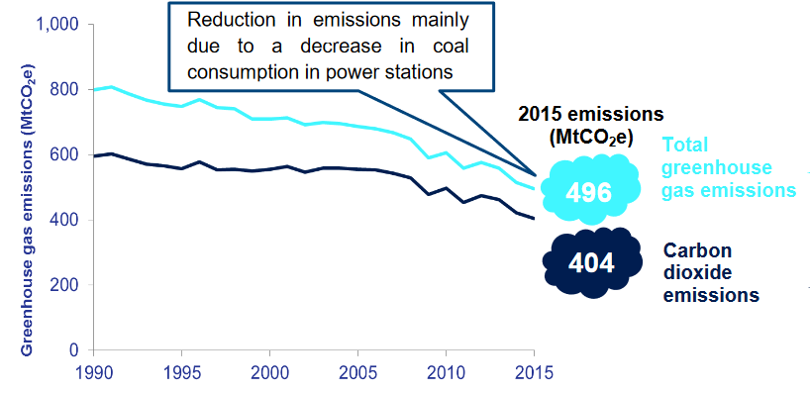
Figure 2.3-1- UK greenhouse gas emissions

Problem solving techniques

To solve the problem of negative Amazon packaging practises the popular problem solving techniques will be implemented. Problem solving is an “act of defining a problem; determining the cause of the problem; identifying, prioritising, and selective alternatives for a solution; and implementing a solution.” (Siebels, 2004, p. 183) There are many problem-solving techniques to help resolve the issues. However, according to Wojtaszak & Biały (2005) “if a problem or problems are going to be fixed, the real root cause needs to be understood”. (Wojtaszak & Biały, 2005, p. 135) A popular technique used to identify the root of the problem, as well as the technique that will be used in this report is an Ishikawa Diagram.
An Ishikawa diagram (figure 3-1) is a way of illustrating the causes of a specific event. Going from left to right there are the causes which are drawn as the ribs of the fishbone. On the right side there is the defect at the “head” of the fish. Each rib is labelled by a major cause then there are sub-branches for root causes. There is no limit to how many branches there can be, so more can be added as required. The possible causes of the
problem can be identified through discussion or brainstorming. These are categorised on the fishbone main branches. Identifying or analysing the root causes helps to reveal important relationships among the different variables, also the possible causes can show the behaviour of the process. (Ishikawa, 1976)

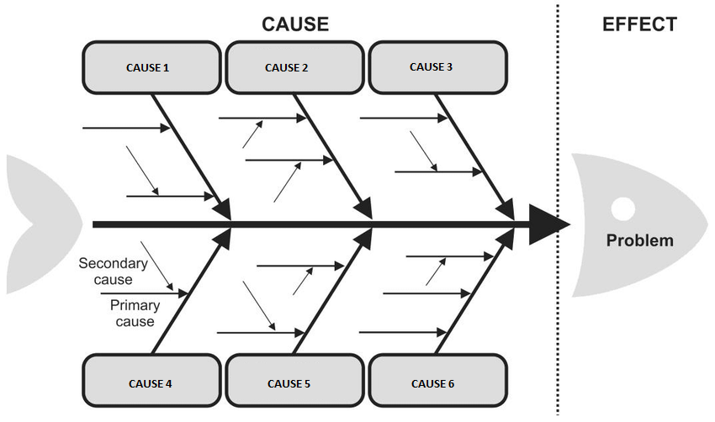
Figure 3-1- Ishikawa Diagram

To help identify the root causes and investigate them in more detail the “5 whys” method will also be implemented.
“5 whys” (figure 3-2) is a simple and easy to use technique which works well in combination with Ishikawa Diagram to determine the secondary causes. Repeatedly asking the question “why” allows individuals to get to the real root cause. The clear problem statement must be identified then the first question “why” can be asked. Typically, the answer to this question will prompt a second “why” and so on until the real root cause is found. When using this technique, it is important to keep on going with the question “why” until the question can not be asked again. Doing this ensures that the real root-cause is found. This usually takes 3-5 times of asking “why” but can take more. Even though the “5 whys” method is simple, users must be certain to answer honestly to the questions insuring that the “whys” go towards the right direction and the real root-cause is found. Otherwise the problem will still be there, or it will come up again sometime in the future. (Kane & Kane, 2014)

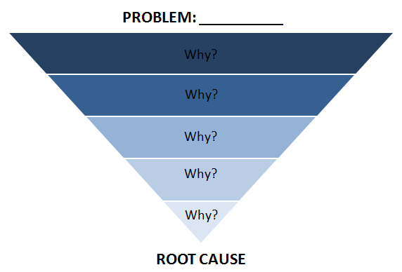
Figure 3-2- “5 whys” technique

Solving the problem

To find the major root cause of Amazon packaging waste issue the Ishikawa diagram will be implemented in combination with the 5-whys. In identifying the potential causes of the problem, the 5M model will be used as a tool for categorising the different causes. The 5M model consists of five elements, which are, machine, method, material, man power, money. (Irani, et al., 2001) It is often used in the manufacturing industry; therefore, it will be helpful in identifying the main root of the problem. The other potential causes of this problem will be found through brainstorming.
Based on the 5M model and the results of the brainstorming, the potential causes of the problem were identified and placed onto the Ishikawa Diagram. These were: environment, material, method/system and management.

Environment. Producers or users of cardboard packaging are obligated to follow certain rules and regulations. They must help to lessen the amount of packaging produced, as well as to help to decrease the amount of packaging waste which goes to landfill. (Government Digital Service, 2017) As mentioned in the section 2.3 Amazon don’t show any interest in what happens to their packaging after the item is delivered to the customer. As the company ships out a large number of cardboard packaging, they should take greater responsibility for the recycling process. A potential answer to this problem could be a ‘dunnage recovery’ service, in which Amazon come and collect the used boxes from customers. In this way the company can make sure the packaging will be recycled and reused and the amount of cardboard getting to landfills will be reduced. However, this would increase the carbon footprint as the fuel from the trucks collecting the boxes will generate more greenhouse gasses. To decrease the negative environmental impact Amazon could also adopt a ‘plant-a-tree’ policy similar to other companies for example IKEA. The furniture retailer has a relationship with the Woodland Trust, where the trees that they used are replaced and the sustainability of the material is increased. (IKEA, 2017) These ideas will increase the expenditure of Amazon, but it will significantly improve the negative environmental impact. However, these solutions don’t solve the whole problem. Even though the packaging will be recycled, and the sustainability of the material increased the issue of excessive use of the materials still exist. This leads to the next potential cause which is material.

Material. Although the use of cardboard packaging has variety of negative environmental implications, it is also the most common. It is fit for the job, widely available and 100% recyclable. There are other materials and processes that can be used, for example Naturally Clicquot 2, which is a starch and fibre-based material that is non-hazardous, renewable, biodegradable and creates pollution free waste products. (Paperfoam, 2018) Another example is Mushroom Packaging, which as the name suggests is a packaging that is grown from mycelium, the root structure of mushrooms. (Ecovative , 2018) Even though these examples and others like it are new and innovative, there are risks involved in going for these types of options. The expense will be increased as the technology is still in the young stage of development, also each box would need to be personalised to each item. Using eco-type packaging is a good idea, however it will be better to invest in it when the process has matured and is more widely available at a cheaper price. Even though these options could be something to invest in some time in the future, there are some changes that could be made immediately. There are big companies like Puma that have come up with a material bag for their shoes. (Fuseproject, 2016) Not only does the “Clever Little Bag” cut out the cardboard, these bags can also be reused by the buyer (figure 3.1-1).
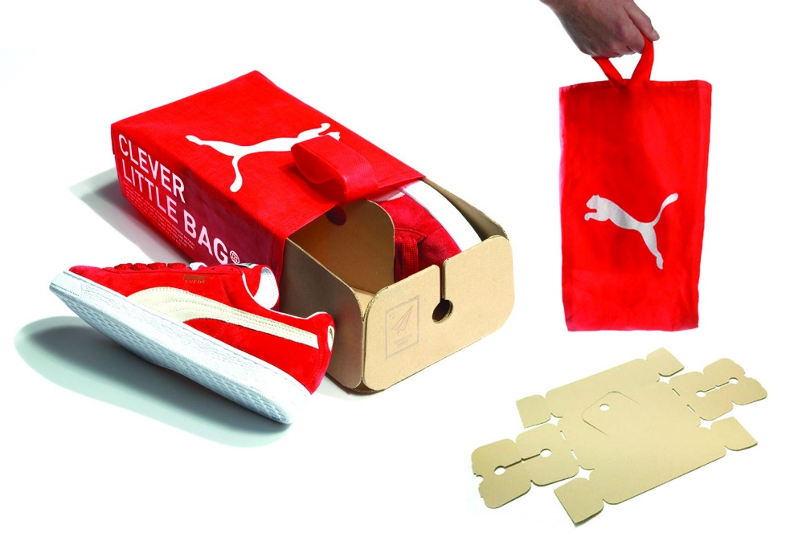
Figure 3.1-1 – Puma’s “Clever Little Bag”

This idea could be adopted by Amazon for their non-fragile items to reduce the amount of carboard packaging. However, it does not deal with the whole problem as fragile and obscure shaped objects aren’t suitable for material bags. The problem of the excessive use of cardboard boxes still exists, and a different approach must be used. As Amazon has millions of different items of all different sizes, one way of dealing with the excessive use of material could be to have a machine that can personalise each box to the size of the item. This way the minimum use of material is used, however a machine like this obviously will cost a substantial amount of money, plus employees will take a long time in using the machine so will find it hard to reach the targets. As Amazon prides itself on how quickly and efficiently they can complete orders this solution is not the best one to use.
At this point the 5-why method can be applied to find the root cause of the excessive box use.
- The items are packed in excessive boxes, why?
Because the packers are told to follow the recommended box size that is on the screen, which are often wrong.
- Why are these recommendations often wrong?
Because the information stored on the system are old and aren’t updated to the correct ones.
This brings us onto the next potential cause which is the method/system being used.
Method/System. In every Amazon warehouse, items are packed by the employees. However, these employees don’t choose the box to use for each item, the computer system does this for them. On the production line, each packing station has its own computer which shows the employees the recommended box that should be used. The employees are told that the procedure is to follow the recommendation that the system tells them to use, but in cases where the employee feels that this recommendation is wrong they should contact the manager or team leader to rectify it. The employees themselves can not rectify the problem as this could potentially slow down the production line which in turn will slow down the whole process of the item being shipped, and Amazon pride themselves on the speed and efficiency that they send out items to customers. The problems that occur regularly are that the system will recommend a box that is not the perfect choice, sometimes the boxes can be far too big for the item being packed which is obviously using an excessive amount of material. Another common occurrence is that the employee is told to pack items that are already boxed by the suppliers to begin with. These items are ready to be shipped as is and don’t need to be packed into a box provided by Amazon. In this scenario the obvious improvement that can be made is to not double-pack these items when they are perfectly safe to ship the way they are. However, this problem wouldn’t exist if the system was up to date and the recommendations which employees had to follow were right. Each item should be measured, and the new recommendation should be entered into the system. In this way the amount of material used will be significantly reduced and the negative environmental impact improved. Even though the system will be updated there may still be some mistakes. In this scenario both managers/team leaders and the workforce should be encouraged to use their initiative and not just relying on what the computer is telling them to do. This brings us to the next potential cause which is the management.

Management. The management, especially the ones at the higher levels are more concerned about the numbers being pushed out by the employees on the warehouse floor then environmental impact. This carelessness could cause the loss of customers as the taboo of excessive waste is only growing in popularity with the media and with the general public. In this case, it would be a good idea to educate the management team in the importance of making Amazon an eco-friendly business and to pass on this knowledge to the lower ranked employees. To rectify this problem an ‘eco-training’ programme could be implemented and in turn managers would give more time and resources to the production line workers. This could potentially slow down the process of shipping out an item but will increase the overall ‘eco-image’ of the company.

Problem solving implementation

In the problem solving process there were many potential solutions found. However, the main problem lies with the system giving wrong recommendations and causing confusion for both employees and management. The whole internal system for the packing process needs to be changed. If the recommendations were correct, then the production line could still do their job efficiently and waste will be reduced. Also, to further decrease the amount of cardboard used, Amazon could consider the idea of material packaging for non-fragile items. This will not completely eradicate the waste however it is the best solution to minimalise the use of cardboard.
To implement this solution a sustainability department will be created by Amazon. This department would be responsible for analysing and changing the recommended packaging sizes for each item, as well as determining which packaging can be replaced with material bags. There would be a department within each Amazon warehouse in the UK, creating a network of information and analysis. This way the work load will be spread and the time in which the stock is checked will be reduced.
A timeframe is hard to estimate with a change such as this, but each department will be given deadlines and targets in which a certain number of items must be checked. Using spreadsheets for the analysed stock data can make a more accurate prediction of timeframe. The spreadsheet is easy to use and any adjustments to the deadlines as the department becomes familiar with the process can be easily made. This will also allow the company to monitor the process and easily track the results to improve the efficiency of the department.
New agreement with vendors must also be established. All companies, as well as individual sellers must be contacted to gain permission to use new packaging methods for their items. This can be done via email and through notifications sent to their Amazon accounts.

There are also extra resources which must be invested into the project. More employees need to be hired and the training needs to be provided. Also, extra computing resources will be needed, as well as more office space. The extra resources are associated with increased costs.
To cover these extra expenses and to fund this new department Amazon can create an ‘Eco-Prime’ membership. The membership will be paid by the customers on an ‘opt-in’ basis. This membership will give customers a variety of benefits, such as a choice of using the new material bags for shipping. If there is a large interest in this service, then Amazon can even consider using the more innovative packaging mentioned earlier. This will give even more choices and benefits of being an ‘Eco-Prime’ member.
The Eco-Prime can be advertised on TV, on the Amazon website and via emails sent to existing Amazon customers. This will allow Amazon to communicate their new services to customers and gain interest and popularity.
The creation of “Eco-Prime” will consist of changes to their website. The changes can be easily made by people that are already working there and already deal with the website development. There are some extra costs associated with advertising the new service, however if the idea gains popularity Amazon can increase the number of its customers, as well as increase their profits from new “Eco-Prime” memberships.
To monitor the success of “Eco-Prime” the customer feedback can be analysed, as well as the number of “Eco-Prime” customers can be easily monitored. If the service is hugely successful, the normal service can give way to the new ‘Eco-Prime’.

Conclusion

Although, the carboard packaging used by Amazon can not be eliminated there were a variety of solutions found to improve the negative environmental impact. By applying the problem solving techniques, the main root of the problem could be identified and an appropriate solution could be implemented. As the internal Amazon system was identified as the main cause of the packaging waste, a detailed implementation plan was created to solve the problem. Although the plan is associated with extra resources, the issue of Amazon packaging waste can be significantly improved, and the negative environmental impact can be reduced.

References

Allaby, M., 2010. A dictionary of ecology. 4th ed. s.l.:Oxford University Press.
Amazon, 2018. Annual Reports, Proxies and Shareholder Letters: Amazon. [Online]
Available at: http://phx.corporate-ir.net/phoenix.zhtml?c=97664&p=irol-reportsannual
[Accessed 16 04 2018].
Amazon, 2018. Our DNA: Amazon. [Online]
Available at: https://www.amazon.jobs/working/working-amazon
[Accessed 16 04 2018].
Amazon, 2018. Packaging: Amazon. [Online]
Available at: https://www.aboutamazon.com/sustainability/packaging/packaging
[Accessed 17 04 2018].
Ecovative , 2018. Ecovative: Packaging. [Online]
Available at: https://shop.ecovativedesign.com/collections/packaging
[Accessed 20 04 2018].
Fuseproject, 2016. Fuseproject: Puma Clever Little Bag. [Online]
Available at: https://fuseproject.com/work/puma/clever-little-bag/?focus=overview
[Accessed 25 04 2018].
Government Digital Service, 2015. Government Digital Service: 2010 to 2015 government policy: greenhouse gas emissions. [Online]
Available at: https://www.gov.uk/government/publications/2010-to-2015-government-policy-greenhouse-gas-emissions/2010-to-2015-government-policy-greenhouse-gas-emissions
[Accessed 25 04 2018].
Government Digital Service, 2017. Government Digital Service: 2015 UK Greenhouse Gas Emissions. [Online]
Available at: https://assets.publishing.service.gov.uk/government/uploads/system/uploads/attachment_data/file/589602/2015_Final_Emissions_Statistics_one_page_summary.pdf
[Accessed 25 04 2018].
Government Digital Service, 2017. Government Digital Service: Packaging waste: producer responsibilities. [Online]
Available at: https://www.gov.uk/guidance/packaging-producer-responsibilities
[Accessed 25 04 2018].
Government Digital Service, 2018. Preventing pollution from paper and cardboard production: Government Digital Service. [Online]
Available at: https://www.gov.uk/guidance/prevent-pollution-from-paper-and-cardboard-production
[Accessed 19 04 2018].
Government Statistical Service, 2018. UK Statistics on Waste: Government Statistical Service. [Online]
Available at: https://assets.publishing.service.gov.uk/government/uploads/system/uploads/attachment_data/file/683051/UK_Statisticson_Waste_statistical_notice_Feb_2018_FINAL.pdf
[Accessed 17 04 2018].
IKEA, 2017. IKEA: Becoming People and Planet Positive. [Online]
Available at: https://www.ikea.com/gb/en/doc/gb-link-category/ikea-2016-uk-ie-sustainability-report-pdf__1364337953353.pdf
[Accessed 25 04 2018].
Irani, Z., Sharif, A. M. & Love, P. E., 2001. Transforming failure into success through organisational learning: an analysis of a manufacturing information system. European Journal of Information Systems, 10(1), pp. 55-56.
Ishikawa, K., 1976. Guide to Quality Control. Tokyo: Asian Productivity Organization.
Kane, R. & Kane, R., 2014. FiveWhys.pdf. [Online]
Available at: https://www.cms.gov/Medicare/Provider-Enrollment-and-Certification/QAPI/downloads/FiveWhys.pdf
[Accessed 17 04 2018].
Morrison, J., 2011. The Global Business Environment. Meeting the challenges. 3rd ed. s.l.:Palgrave Macmillan.
Paperfoam, 2018. Paperfoam: Naturally Clicquot 2. [Online]
Available at: https://www.paperfoam.com/naturally-clicquot-2/
[Accessed 20 04 2018].
Siebels, D., 2004. The Quality Improvement Glossary. Milwaukee, Wisconsin: ASQ Quality Press.
The University of Melbourne, 2018. Cardboard: The University of Melbourne. [Online]
Available at: https://sustainablecampus.unimelb.edu.au/a-z/c/cardboard
[Accessed 19 04 2018].
Wojtaszak, M. & Biały, W., 2005. Problem Solving Techniques as a part of implementation of Six Sigma Methology in tire production. Case Study.. Management Systems in Production Engineering, 19(3), p. 135.

APPENDIX A



