Patrik Tolog, 2026788, digital skills and research methods bmsw4003, Abdi Rahman, individual report

In this individual report I will be discussing my research results and the contents of it. We conducted a questionnaire to find out if students were comfortable using technology as well as including questions regarding their personal information. The questionnaire was used to test and discover how confident students’ digital skills were. Digital skills are vital in many ways, for some, digital skills will be necessary in their day to day lives as well as in their careers. In this current century, everything is done technologically and therefore it is vital to understand technology. Therefore, in my prediction I believe that mostly every one of my peers will score highly in confidence. Nearly the whole world uses technology to communicate through social media and emails, to receive important information you must know how to use technology as everything is done electronically including job adverts, interviews and many more. Digital skills are currently more useful in this era as during covid everything was done electronically, those who do not understand how to use media and any digital devices would have found it extremely tough as everything was online including schoolwork, interviews, most jobs were done through the internet.

My chosen research question included queries regarding students’ confidence with digital skills. Digital skills include emails, using Microsoft word, presentations, Microsoft teams etc. Before presenting my questions to the class, I had to create a hypothesis of my own rough viewpoint of the responses I would receive. Within my research, I had to come up with a set of questions and then convert it into Microsoft forms where my peers were able to answer. Gathering responses allowed me to get a rough view of each of my peers’ understanding. With the responses I received, I had to analyse the data and provide a chart which outlined all the responses in one place. I conducted pie and bar charts for most of my questions, I then also created a table to portray my results. The use of bot these data allowed my results to be seen visually and therefore understood easily. I recruited participants for my questions by asking 16-17 of my peers to fill out my questionnaire, I had to ask for their phone numbers in order to get in contact with them regarding information of how to complete the questionnaire, this was also helpful in getting to know my peers and getting a way to contact them in regard to our shared course. I then contacted them via messages and sent them a link to complete my questionnaire. I received 10 responses out of the 16-17 I expected which resulted in a fewer representation of the class. In my questionnaire I had 8 questions, 7 of them were simple questions in which the participants just had to tick a box reflecting their answers, this was so it was easier to then interpret my answers and get a rough outlook of everyone’s understanding. My questionnaire included only closed questions which made it simpler for my peers to answer. One of the questions I included was to rank 5 digital skills in order of their confidence. The questions I included were: one ethical question, if they consent to taking part, if they are confident in using Microsoft Teams, if they are confident using technology, if they are confident in presenting, if they require help with one drive, how old they are and their gender.

Within my questionnaire I included one ethical consideration of consent. The question I included was if they consent to taking part voluntarily. This question is informed consent, its important as ‘it assures the researcher that the participant knows every aspect of their participation in the trial’. Informed consent is important as it allows the participant to be aware of what type of research they are getting into as well as assures the researcher that the participant is voluntarily involved. ‘Informed consent is crucial in research as it ensures individuals have an informed choice about whether to participate in a research study.’

The average score in the questionnaire was 3.4. The first question which was about consent received all 10 scores, the second question about confidence in using MS teams had 8 yes responses 1 no and 1 maybe, the technology question received all 10 yes responses, the presentation question received mixed responses as well as the one drive question. My peers all scored highly on my questionnaire as it was about knowledge. General questions about technology scored high points however the more specific questions received a variety of responses e.g. the confidence in presenting question. The presenting question received one nervous answer, 4 maybe’s, 2 no’s and 4 yes answers, the highest responses were yes and maybe. The ranking question received a mode of 7, as 7 people said they were most confident using MS teams, WhatsApp and MS word. One drive received the lowest confidence as it only received 3 responses and Moodle gained 6 marks which was not far from the other 3 answers. My age question did not receive one under 20 answer instead, everyone proportionally answered under 25 or 30-35 as both questions received an equal response.
Rank these applications in order of how confident you feel using them.
MS Team | 7
Moodle | 6
One drive | 3
WhatsApp | 7
MS Word | 7
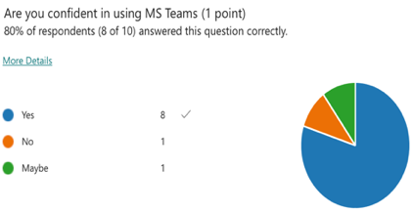
Are you confident in using MS Teams (1 point)
80% of respondents (8 of 10) answered this question correctly
I consent to take part voluntarily (1point)
100% of respondent (10 of 10) answered this question correctly
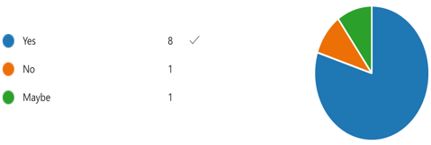
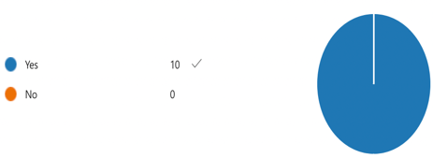

Are you confident using technology (1 point)
100% of respondents (10 of 10) answered this question correctly

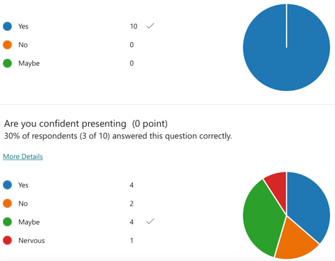

Are you confident presenting (0 points)
30% of respondents (3 of 10) answered this correctly.
Are you male or female?
4
3
2
1
0

Female
Male

The high points in my questionnaire reflect my peers’ understanding of digital skills which portrays that our whole class is learning and is slowly becoming confident in using technology, or that they were already experienced in using technology. The questions that received mixed points was either because it was a question about gender, or it was a multiple choice in which they had to order a list in their own preference. Using the data I collected, I can conclude that more females took part in my questionnaire than males this can roughly link to an interpretation that there are generally more females within my class than males. My question which required my peers to rank their confidence of using a set of social media generally received high confidence marks of WhatsApp, MS word and MS teams this can be because they are well known platforms and therefore are more likely to be used frequently which would increase people’s confidence in using them. 0 peers answered that they are under 20 which conveys that my course includes students above 20 and not younger, in my opinion younger generations are now more confident in technology as that is what they are taught and bought up with, therefore if they had more under 20 students the results would be a little higher. The app that received one of the lowest confidence rankings was Moodle, this can be due to the fact that everyone started this course in May and maybe previously were not aware or familiar of such app, I personally only used Moodle this first time during my academic experience therefore, confidence of using Moodle was less than other more familiar apps. The lowest confidence app was one drive, this can be due to the fact that one drive can be quite complicated in using and any ‘data saved on that app can be accessed by any technology product with the help of the internet’ meaning that many may not be confident in using the app with the fear that their hard-earned work will be stolen and copied by another. The question I included in my questionnaire about confidence of using MS teams received all but 2 yes answers one of which was a maybe answer, the results of this question fit in with what I said in my introduction as covid had many students use Microsoft teams and therefore nearly everyone’s skills were enhanced as they had to learn how to use that app in order to carry on learning. Microsoft teams in my opinion before covid was not used as often due to nearly everything being done face to face, with the help of Teams students were able to learn as though they were in class and sitting in front of the teacher, Teams allowed both students and teachers to see each other and proceed to learn in the same format as previously done. Generally, everyone knows how to use MS word and that is why it received a high confidence ranking as it is the most used app in the academic world as it allows students to complete homework, do assignments, exams and many more, Microsoft word is one of many accepted formats to completing exams on therefore high experience is necessary. My results fit with the literature that I have included in my introduction as high confidence marks reflect the importance of technology in this era. The results I received confirmed my hypotheses as the data did in fact convey most students are confident in using technology however, some do struggle with using some apps which can be improved with perseverance and more frequent usage of technology.

In conclusion, with this questionnaire experience I was able to obtain other students’ confidence and knowledge of technology. I could reflect my own answers with theirs and see where I could improve in digital skills. Most students did score highly which portray no risk to their academic life of studying skills for the workplace. The responses I received roughly portray the importance of technology as everyone had knowledge of technology and its compartments, this conveys how advanced society is and again the importance of digital skills in the wider world as well as the academic world. The questionnaire shows exact responses and therefore portrayed a clear outline of what everyone understands and was easier to form data based on the responses.

‘informed consent: when, why and how its obtained’, ‘advarra’,< https://www.advarra.com/blog/informed-consent-when-why-and-how-its-obtained/>, accessed 9 August 2022.
‘Why is informed consent required?’, ‘genome’, < Informed consent is crucial in research as it ensures individuals have an informed choice about whether to participate in a research study>, accessed 19 August 2022.
‘one drive recommendations’, ‘uwm’, < Informed consent is crucial in research as it ensures individuals have an informed choice about whether to participate in a research study> accessed 19 August 2022.

