

BA LEADERSHIP AND MANAGEMENT
Figure 1

Emergent Leadership Skills In the Workplace

Paula Louise Canning

Sujeewa Hearth

BMSW 6102 – BIRM

Table Of Contents.

Introduction……………………………………………………...p2
Effective Leadership Skills……………………………………. p3
Effective Leadership Styles…………………………………… p5
Challenges To Leadership in Uncertain Times………………p10
Ethical leadership Within The NHS…………………………. .p12
Conclusion ……………………………………………………. .p13
References………………………………………………………p14
Appendix…………………………………………………………p17

Introduction

Within this report in will be explaining the skills and the styles of leadership, critically examining them, seeing which leadership is best used within any organisation and workplace. Many Leadership models have changed within time as we all must move with the times don’t, we! Thus, how the true narrative with different leadership style’s and how, the NHS use and why they use a leadership style, or styles and how this works for them.
The theory models used in this report will be Transformational leadership what is it and why it’s used in some organisations what is its purpose why do business’s use this leadership. The other model will be Transformational Leadership, why organisations use this model, why this model works for that organisation. Which model works perfectly for one organisation, and maybe not for another. There is also a model called Laissez-faire whom Douglas McGregor in the 1950’s used called Theory X and Theory Y, which is a model which breaks down in the workplace as on one side you have the lazy individuals that are happy plodding on which is theory X and then the opposite employees who are happy to work and work hard is Theory Y. These different theories show what impact they have on different organisation and how well each one works better.

Effective Leadership Skills.

To be a good leader you must be able to have these traits.
- Confident
- To be able to think outside the box.
- Corrector
- Good listener (empathy)
- Critical Thinker
- Team Player

Self-confidence.
Is important for leaders, having to take risks and to be able to accomplish high goals within any organization. Leaders that are self-confident usually deal directly with any problems and any conflicts, rather than ignoring or passing the problem on to others. Being self-confident is one of the most necessary qualities. A confident leader would choose his words carefully, and his sense of motivation influences the team members.
He is expected to make big decisions directly and appropriately to have such confidence is crucial for the workforce. Having confidence being a leader he can make spontaneous decisions without having any doubt, and not being afraid to commit to the conclusions.
Confidence allows to be able to conduct meetings sufficient power and influence on others. The more faith the employees have on their leader there is more of a chance the company will be on a mission. (2020):45-54

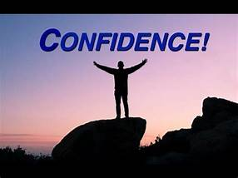

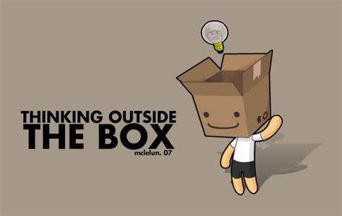
Thinking Outside The Box by mclelun on DeviantArt by Unknown Author is licensed under CC BY-NC-ND

Thinking outside the box.
Been able to think outside the box meaning you are creatively addressing any problems with new ideas and innovative ways of doing things rather than the Norm! Good leaders are not afraid to make mistakes, they need to have the confidence to take risks, by thinking outside the box this gives you chance to brainstorming with managers. Thinking outside the box when it comes to be great leadership is style can be the difference, most managers fear change, but being able to look at situations differently but more effectively and more fun. Why have boards meeting around a table why not have a meeting on a walk or on a golfing range! This is exactly what it means by thinking outside the box, and more staff/employees’ managers would appreciate the change, they wouldn’t be working within a stale boring environment.
Corrector.
A corrective leaders identify past mistakes within their organization and are willing to find any solutions to correct actions, so that the organisation can be back on track, which facilitates any collaboration with team members. A corrective leader provides for the future. Though this is not an easy job this is probably the toughest roles, the responsibility cannot be passed on or ignored for the correction to be effective. Nothing goes according to plan you need to have the vision of clear long-term goals. Leadership corrector must have the quality within and guarantee the prospect of success, believe in the power and adaptability, self-knowledge, and change.

Good Listener/Empathy.
employees and followers, it can help understand their needs and motivations. This also creates a positive environment to work in. A leader would have more of better understanding on how decisions can be made and how any impacts can make of employees. You can make better decisions of different situations Empathy is very important whilst be a leader, this helps build strong relationships withing their responsibilities overtime and more.
enough to approach Your employees will feel a sense of respect towards the leader and would not shy away of asking questions or to have a conversation they feel comfortable you. Listening to others and being a good listener shines in a dynamic leadership, they are more likely to have more moral within their workplace, more positive work happier team and great productivity. (2009):87-101.
To develop empathy, you must put yourself in other people’s situations, to do so practice using your own imagination and listening.

Critical Thinker.
Critical thinking is an analytic approach to problem solving and decision making. Their critical thinking skills allows leaders to take action to improve decision-making for their organization. Leaders develop critical thinking; it trains their minds to think instead of learning the facts. They can embrace any changes, inspire others, creating a vision, that empowers the employees to be more positive within their work. By using these methods, it helps understand different parts of the organisation, and work together as a whole.
Critical thinking is a core component of strategic thinking, less than one’s ability to lead. This enables leaders to apply their knowledge and everyday challenges to their work. With their knowledge and wisdom, they are a huge asset for any organisation and employees.
- The ability to recognise assumption.
- Evaluate arguments.
- Draw conclusion.
Any organisation needs a leader with such critical thinking without this talent any business or organisation would fail due to an incompetent leader. (2021):1-7.

Team Player.
Being a team player in leadership is vital as you must be able to encourage your team, by praising their work and helping. A leader must take full accountability for any failures as well as success. Organisations expect their leaders to be honest and take full responsibility for everything that happens under their position. A great leader never forgets that they are a team player. (2010).

Effective Leadership Styles.

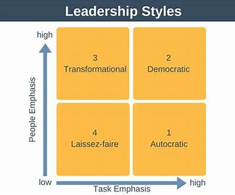
There are many Philosophy Styles a leader would use within their organisation.
- Democratic Style
- Autocratic Style
- Transformational
- Transformed

Democratic.
Using Democratic style of leadership are usually guide rather than, direct. Often seek feedback and inputs, they promote any conversation in decision making. This gives everyone the opportunity to participate freely in ideas and discussions. This style of leadership is very relaxed and brings more of a positive friendlier work environment this enables them to create more group satisfaction, working in a stronger communication. These Leaders achieve more success a with mutual respect without losing one’s power of authority. (2018):1-110.
This leadership style tries too hard to please all.
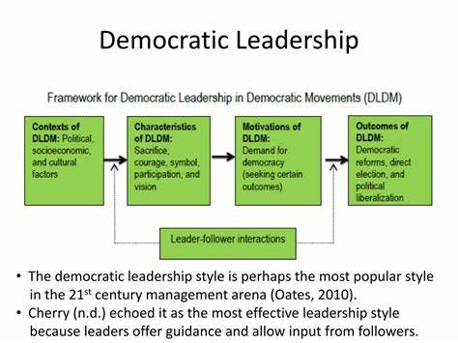
Democratic leadership style is the most effective in the 21st century (Oates,2010).
Cherry (n.d) echoed it as the most effective leadership style because no leaders offer guidance and allow input from followers.

Transactional Leadership Styles | Transformational Leadership Styles
Needs to Be Motivated  Needs Stimulation  Influenced  Not Self Motivated  Motivated By Rewards / Rewards  Must Be Monitored  Thinking Inside the Box | Recognise Change  Proactive  Implementing New Ideas  Thinking Outside of The Box  Emotional Needs/ Empathy  Copes With Any Changes Within Organisations

Autocratic.
This is also known as authoritarian leadership. There is no question who has the final say. Whether it be on a business decision or critical thinking how an organisation will be run. Autocratic style processes when roles and rules are defined, usually this style things are run effectively and smoothly, as only one person is calling the shots. Such leader has full control of their team. They characterized by individual control over all decisions. (2014):57
Which can lead to lower motivation, higher stress levels, and disinterested workers.

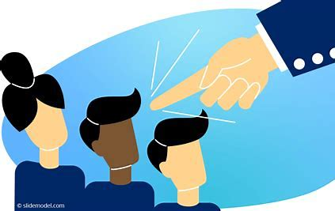

Ivyhouse.co.uk

Working in scenarios where high levels of skills where a high level of knowledge/wisdom is needed. They rarely take advice from other teak fellows, they make all the important decision making, making highly structured work environments, and dictate work methods to other team members. This leadership style would work greatly in
- Military
- Construction
- Manufacturing
Thus, leadership is a demanding style with no time for making any mistakes.
Authoritarian leadership is beneficial in industries where decisions need to be made urgently to be used in any critical tasks. Using authoritarian skills in leadership has a high-pressure working environment, faster decision making and a large productivity, retain control over any problems with little room for mistakes.

Transformational / Transaction.
Transformational leadership style focuses on creativity, empathy, communication, and guidance. Transformational leader is those who lead by their example. They put process into place by empowering growth improve interests and ensure that skills and any interests.
- Encourage team members in all areas of their work.
- Empathy/ Trust
- Motivate their team.
- Increasing pride in their work
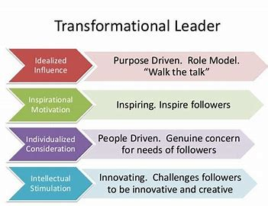
A Transformational leader is one that encourages and leads, but also understands all aspects he/she is an idealized influence to be a good role model to workforce, as they are driven by their work and get the job/jobs done! They Create Empathy and trust within the workplace crates a good environment to work in as your work colleagues trust within their work environment and empathy is a large impact, being able to have these two categories makes such a happy environment, your employees feel confident to approach you if any concerns or problems occur. Motivation is one of the transformational leadership roles this creates a well worked and positive environment whilst motivating your team you can get all work done, while motivating your team you’re more likely to get the work done, and by having a sense of reward to let them know they are doing a good job. When you motivate your team, they are more likely to work harder even under pressure (2016):87-117.

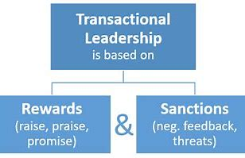

Transaction Leadership.

A Transaction Leader may go back and forth with both transformational and transaction, they focus on a strict management structure. This style of leadership is totally different to transformation as they tend to manage people to do things rather than the business. Transactional concentrates on day-to-day operations rather than the long-term goals. They concentrate in change or improving the organization. The advantage of this leadership has goal achievement, motivation, structure. These usually have a lack of low morale, creativity, and motivation, and can make costly mistakes for the organisation. (2013):355.
A Transformational leader would be the best style of leadership as they are good with people and have trust and empathy towards their employees/workforces. This works well with any work environment as the employees find it easy to approach management with any problems before they occur also, they motivate their staff by rewards and praising their work, whilst Transactional leader is based on reward and sanctions with negative threats and feedback, and little praise and promises with their work which will make work environment dull. (2007):80.

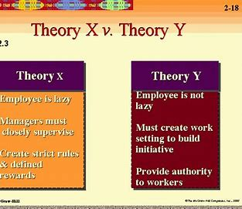

Douglas McGregor in the 1950’s whilst working in the MIT Sloan School of Management, McGregor’s work was rooted the motivation theory. The contrasted model’s theory X and theory Y. (2003):569.
Self-motivation. This style is people that like and enjoy their job they are self-motivated and committed to their work, they enjoy the challenge of work. use their initiative to guide them through they have self-direction, people usually take them seriously because they are happy to carry out their duties. This gives the employees responsibility to make decisions.
Theory X explains the highest importance of supervision, external rewards, and some penalties. They can be extremely lazy and need close supervision, they have no self-motivation and would be happy to sit back and let their fellow workers do all the work having a negative attitude towards their work. Passing the book. (2014):177.
This style of leadership is also known as Laissez- Faire
- Lazy
- Minimum Influence
- Laid Back
- Negative Outcome
They need constant feedback.

Challenges To Leadership in Uncertain Times.


The NHS suffered considerably uncertain times when COVID hit us and the whole nation went into lockdown. The key challenge is that they get the proper support from outside governmentlike the politicians. The NHS has many strengths. Free fundamental care to our lives in the UK, and is admired all over the world, more loved by us. Covid19 has put pure pressure on the NHS, but with all their hard work and good management the NHS seen us through what we can say one of hardest times we have ever seen in History. Well-functioning, resilient health system that helped individuals, communities throughout the entire country.
Angela Pritchard is the new Chief Executive of the NHS, and she has got her work cut out, with the pressure of the past 3 years of backlogs in an exhausted workforce as COVID-19 hit the whole Nation. These challenges for the NHS were so vast, and never experienced before. This was a huge challenge that hit the NHS. Other challenges that hit the NHS, and how their leaderships deal with their challenges are that. (2013):22-49.
- NHS review of their leaderships that they act and thinking, facing new ideas, new challenges, the challenges that face the NHS. These usually happen when debating on any purpose of leadership.
- Challenging new ideas - which must come to the leadership, with a theory and then be put into practice. It is recognised that a particular leadership will be required for that kind of challenge for it to be addressed.
- Leaderships within the NHS have a specific key role to play, having to analyse what the problems are and how the problems can be and how the problem will be tackled correctly. (2015):1-6.
- These are different types of leadership challenges. Heifetz.\ adaptive leaderships theory (1994) has been the arguing type certain strategies, the styles, and the behaviours, these are all challenges and suitable for the unknown and the unknowable, and how they are to be handled.
The NHS uses the nine dimensions of the Health Leadership Model, this Model used is leading with care, sharing the same vison, influencing for the results they engage on their team, which allows them to evaluate all information, this inspires their change of purpose, connect their service with development and capability to be able to hold to account.
All the following leadership models can be accounted for and used within the NHS as, Transformational leadership, Transactional leadership, Democratic leadership also in terms can be also Laissex-faire styles. (2007):23-55.



The NHS use Transactional leadership and Transformational leadership theories and Democratic leadership style. The transformational leadership focus on motivating their team or employees to share their vision whilst navigating uncertain situations so their defined tasks are done correctly with minimum errors, which can involve performance, monitoring and correcting. Meanwhile Transformational leadership will be focusing on motivating their team or employees making sure that work is being done correctly and to avoid any backsliding situations. (2011):1546-2559. These leadership models work well within the NHS as you have got a Transformation Leader making sure that all employees are being motivated and been navigated and giving their team a vision, and keeping a close eye on their work, making sure all errors are being accounted for this type of leadership crates an engagement with their colleague enabling them to be more approachable, decision making, regarding a safety environment by creating climate of psychological safety, which all team members feel welcome enough to speak up, transformational leaders not are only there for their teams but also this helps their teams be motivated and engaged in their goals.(2016). Both these Leadership styles work very well for the NHS as you have got the leader who has empathy and respect towards their team members, and then you have the more directional leader for who is making sure all work criteria are set in concrete and completed without any mistakes being made. (2016):190-216.

Ethical leadership Within The NHS.

An ethical leader will have traits of professional behaviour for their team. For example, a leader that avoids responsibility and lies or doesn’t help or do little work in their job, are not being an ethical leader, they are not demonstrating ethical behaviour and there team members will not have any respect for them at all, as they will be classed as being non approachable ang being lazy, by being any leader you must lead your team, if you don’t lead your team they will have zero respect for you and any organisation.(2003):207.
There are 4 ethical principles working for the NHS, these four-pillar ethics are defined as. (2020) Feb,25;(1).
- Autonomy – Meaning be respectful to all especially for all patients, and self-determination. Helping others, be professional in yourself, making sure you are maintaining your work on a high level and performance, be determined to help others, and be kind.
- Beneficence – Duty to-do-good.
- Justice – Maximising benefit to society and patients, while enduring equality, fairness and impartially
- Non – Maleficence the duty no to do bad, to treat people with the utmost respect be equal.

The Four Quadrant Approach.

Conclusion

Transformational leadership in the NHS and nursing is to be able to manage staff and try to motivate all employees within the organisation, enabling them to create new skills and develop patient care. This style of leadership can form to Transformational leadership, making the workplace improve new patient care. Neither of these leadership is better than the other, despite their differences, the two are virtually mutually exclusive. Both styles of these leaders work well with their blended approach, these two-leadership style work well, because both styles work, they both work well In different circumstances and depending on the outcomes on the leader With its Transformational change in the NHS fundamentally in these coming years across the country has undergone transformational change, they need to find ways of delivering more care to be more effective whilst doing this in return will require new capabilities with a new process. Maybe the NHS need to have little more Empathy towards patients, it’s the vast amount of patients that they see makes it so much more harder to reach there goals or projects due to a lack of nurses and Dr’s, pay is also a bit problem with the NHS at the minute they are overworked and underpaid like most organisation at the minute with all inflation going up and working all the hours your not getting an increase in your wages, I totally understand why these do go on strike because they do work really hard, but unfortunately all the other patients suffer too those who are waiting on operations, this is a sad outcome foe those or people that are on a waiting list these can take months or even years. The NHS will not exist soon I think that they will get rid of it, and we will have to pay private like other countries do over the world because the NHS are over run and underpaid.

Reflective Essay

Whist learning this assignment I have learnt a lot about different Leadership Styles, and I have to say I did not realise how many types there were. Learning all the different styles has enabled me to be more open to which one works best for one organisation than another. Some of the different styles of leaderships styles also work well together as they are very similar. The NHS use both Transformational and Transactional because this works well for them as I explained there virtually the same but different, depending on the outcome. (2014):1-11.
I have done a lot of reading and researched a lot on these Leadership Styles what works well for one may not work well for the other some are lazy some are very motivated within their career or work. I must say myself that I would class myself as an individual as a Transformational Leader, I am purpose driven and I have an important role to play within my character. When I used to have my own business I would always inspire my employees everyday encouraging their work and always praising there work, making new challenges for them to create and always making them comfortable within the workplace, doing this I had made such a good work ethic in the salon that the staff used to love coming to work and they didn’t mind working overtime also because they knew that I was very respectful and they had so much respect for me as a boss.(2013):1-9. By innovating different challenges every week or sometime on a daily, my staff was always happy to work hard and progress with their careers. Once a week we used to do a model night when all trainees used to get family and friends into the salon to create new colours new hairstyles when training by doing this this makes the students/trainers feel very happy with there own work environment. By working alongside your fellow work colleagues and understanding there need this makes for such a strong team, leading from the front if you are a good leader your employees/ staff will be happy to follow with little drama and unnecessary drama within your organisation.
The most important thing about being a good leader, is that you need to listen and understand, and respecting what others have to say and listen to them. By doing this you gain a lot of trust and respect, in your work and your private life. Having Empathy goes a very long way your employees or friends will feel happy to approach you and not feel intimidated with any concerns they have thus can be work involved or even a problem outside work, being approachable as a leader is such a good trait to have. Understanding and respecting others, in return you get the same respect back as individual. “Treat others how you want to be treated”.

References.

Arikan, Cenk Lacin. "An overview on leadership styles for organizations." Romanian Economic and Business Review 15.3 (2020): 45-54.
Al Khajeh, Ebrahim Hasan. "Impact of leadership styles on organizational performance." Journal of Human Resources Management Research 2018 (2018): 1-10.
Bass, Bernard M., et al. "Predicting unit performance by assessing transformational and transactional leadership." Journal of applied psychology 88.2 (2003): 207.
Bhargavi, Swapna, and Ali Yaseen. "Leadership styles and organizational performance." Strategic Management Quarterly 4.1 (2016): 87-117.
Clarke, Sharon. "Safety leadership: A meta‐analytic review of transformational and transactional leadership styles as antecedents of safety behaviours." Journal of occupational and organizational psychology 86.1 (2013): 22-49.
Iqbal, Nadeem, Sanusi Anwar, and N. Haider. "Effect of leadership style on employee performance." Arabian journal of business and management review 5, no. 5 (2015): 1-6.
Ismail, Azman, et al. "Transformational and Transactional Leadership Styles as a Predictor of Individual Outcomes." Theoretical & Applied Economics 17.6 (2010).
Jaafar, Syaiful Baharee, Noraihan Mamat Zambi, and Nor Fathimah Fathil. "Leadership style: Is it autocratic, democratic or laissez-faire?." ASEAN Journal of Management and Business Studies 3.1 (2021): 1-7.
Korkmaz, Mehmet. "The effects of leadership styles on organizational health." Educational research quarterly 30.3 (2007): 23-55.
Mohammed, Umaru Danladi, et al. "The relationship between leadership styles and employees’ performance in organizations (a study of selected business organizations in Federal Capital Territory, Abuja Nigeria)." Leadership 6.22 (2014): 1-11.
Nanjundeswaraswamy, Terakanambi Shivashankar, and Devappa Renuka Swamy. "Leadership styles." Advances in management 7.2 (2014): 57.
NAGENDRA, ASHA, and SAFIA FAROOQUI. "Role of leadership style on organizational performance." CLEAR International Journal of Research in Commerce & Management 7.4 (2016).
Odumeru, James A., and Ifeanyi George Ogbonna. "Transformational vs. transactional leadership theories: Evidence in literature." International review of management and business research 2.2 (2013): 355.
Özsahin, Mehtap, Cemal Zehir, and A. Zafer Acar. "Linking leadership style to firm performance: the mediating effect of the learning orientation." Procedia-Social and Behavioral Sciences 24 (2011): 1546-1559.
Purwanto A, Bernarto I, Asbari M, Wijayanti LM, Hyun CC. Effect of transformational and transactional leadership style on public health centre performance. Journal of Research in Business, Economics, and Education. 2020 Feb 25;2(1).
Puni, Albert, Samuel B. Ofei, and Abednego Okoe. "The effect of leadership styles on firm performance in Ghana." International Journal of Marketing Studies 6.1 (2014): 177.
Shafie, Bizhan, Saeid Baghersalimi, and Vahid Barghi. "The relationship between leadership style and employee performance: Case study of real estate registration organization of Tehran P
Singaporean Journal of Business, Economics and Management Studies 51.1119 (2013): 1-9.
Skogstad, Anders, et al. "The destructiveness of laissez-faire leadership behavior." Journal of occupational health psychology 12.1 (2007): 80.
Stein, Steven J., et al. "Emotional intelligence of leaders: A profile of top executives." Leadership & Organization Development Journal 30.1 (2009): 87-101.

Yahaya, Rusliza, and Fawzy Ebrahim. "Leadership styles and organizational commitment: literature review." Journal of management development 35.2 (2016): 190-216.

APENDIX



