

Student name: Saheny Yesenia Robalino Vallejo
Student ID: 2515875

Module name: Introduction to Health and Social Care

Module code: LCHS4003_LON

Lecturer name: Muhammad Aliyu

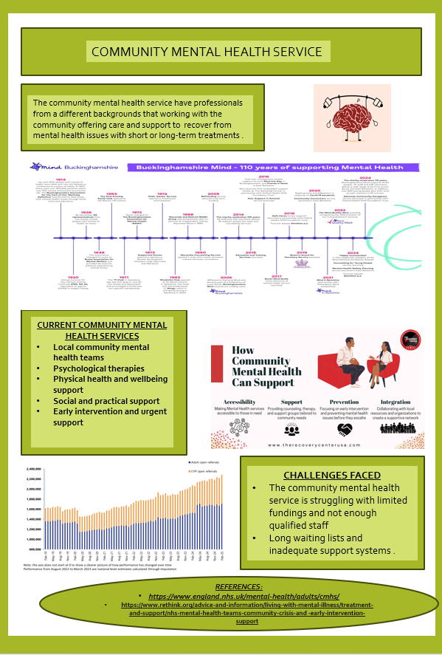
TASK 1:
Task 2:

COMMUNITY ANTENATAL MIDWIFERY SERVICE

These services support the wellbeing of the baby and the mother during pregnancy, making healthcare accessible, personalised and improve the quality during the maternal care, be flexible and adaptive at the future mother circumstances.
The midwife current functions are, monitoring mother and baby, provide health education and offering emotional support, normally the appointments are every moth on clinics or social care homes, but sometimes they can do home visit if is required.
The normal antenatal care involves, blood pressure measure, check the baby’s growth, and screens for prevent complications. Midwife also provide advice on nutrition, exercise and pregnancy lifestyle.
The midwife service help to reduce the risks and prevent complications working hand by hand with the specialist in necessary cases and with the doctors for give it a better care.
The accessibility of community made the woman able to attend appointments close home, feel supported in every session and empower give it to them the correct information and clarify any question that they have during and after the pregnancy period.
The close and continue contact with midwife is important for identify individual needs, including mental health help.
They are facing a big challenges like demand increasing, short staff, and limited resources what is give it a lot of pressure on the midwifes what potentially affecting the quality of the care or including in some areas the women do not have access to a midwife care, this show us that apart of the changes we still do not have equality access to the services in all the places, because in the rural area is most difficult access to a midwife care.

HISTORICAL ORIGENS
Is one of the oldest healthcare professions, thousand years ago the communities had a midwife, who was helping to manage the childbirths at home, and this knowledge was passing generation to generation.
In 18th and 19th centuries the big cities, request the midwifes to have a formal training and be register, this change help to reduce maternal and baby mortality.
In 20th century with the medical, technology and safety advances, the hospital births were increase, helping to have a better control for the mother and the baby.
Now a days, midwife is part of the maternity cares systems, providing close care, especially for the vulnerable people.
The government and healthcare organisations see during the years how important is patient centred care.

ENHANCING QUALITY OF LIFE
The community antenatal service has a great impact in the quality of life with the regular monitoring and the early illness detections.
With this, we help to reduce risks and improve health for mother and baby.
At the same point emotional and psychological support during pregnancy is important because can be a time of anxiety, stress and fears to the mother.

CONCLUSION
In conclusion, the community antenatal midwifery services, is a essential professional help for the future mother during her pregnancy, that was progress during the years for be complete and professional and can be a better help and reduce the risks for the future mothers and make them feel supporting, save and caring during pregnancy.
Until we still having challenges and inequalities, the impact of the antenatal midwifery care has in these days is significative in the life of the future new mother at the same point of the combination of emotional and physical help for the future mother and baby.
Of carse we still needed to work in the inequalities and the challenges and try to find the way that we can help everyone in the same line, because I think that the community antenatal midwifery in one of the most important cares that we get it.

REFERENCES:
- Department of Health and Social Care (2019) Better births: Improving outcomes of maternity services in England. London: DHSC.
- National Institute for Health and Care Excellence (NICE) (2021) Antenatal care. Available at: https://www.nice.org.uk/guidance⁠� (Accessed: 20 March 2026).
- NHS England (2023) Antenatal care and services. Available at: https://www.nhs.uk⁠� (Accessed: 22 March 2026).
- Royal College of Midwives (RCM) (2020) The role of the midwife in antenatal care. London: RCM.

