Name: Gillean Yves Jofre
Student Number: 2207830
Course: BA Games Design
Module: Changemakers: Building Your Personal Brand for Sustainable
Employment
Assignment: Create a logo and 3D Assets for promotion in Fortnite

Contents:
- Logo Design
- Research into logos and inspiration
- Design iterations and experimentation
- Final design and uses

- 3D Asset creation and porting into UEFN
- Images from project file and 3D Models

- References and bibliography

1: Logo Design
Research into logos and inspiration
According to an article written by Kylie Goldstein for a blog post on ‘wix.com’ [1], a good logo design consists of the following ‘golden rules’; It must be simple, memorable, versatile and relevant.
With this I conducted research on logos related to my subject of logo design: my game idea Leper.
- UTOPIA (TV Series)
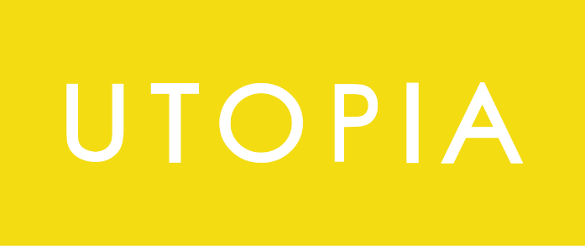

The logo design for the tv series ‘UTOPIA’ is very simplistic, using either black of white for the font colour and a yellow background. [2]

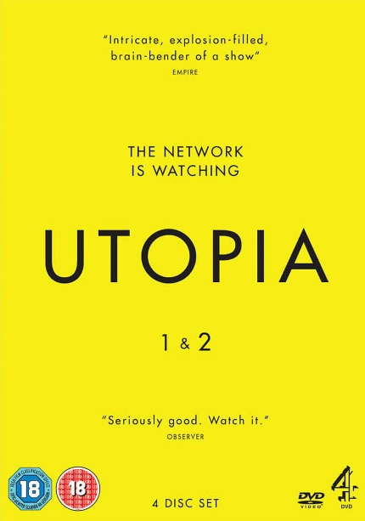
The lack of any further imagery or the use of a more illustrative font makes people who look at it intrigued by its clinical nature and makes them want to know more about the subject.
Images:
White logo for Utopia [3]

Example poster of Utopia [4]

The simplistic nature of the logo can also be the reason of why it rather memorable for fans of the show.

- Loki (TV series)
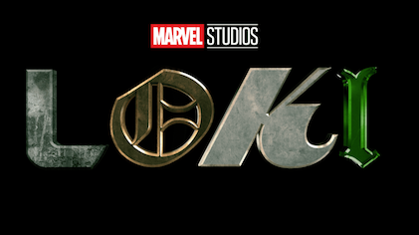
The logo for the TV Series ‘Loki’ makes use of different fonts to represent different aspects for the show, for example the ‘L’ being used to represent the TVA, a sort of government agency at the centre of the show, while the ‘O’ represents He Who Remains, a character also pivotal to the show. This might help to give the audience a quick idea of what the series is about, as well as attracting those who might already know the significance behind the symbolism and types of fonts. [5]
Image: Loki Logo [6]


- Ultrakill (Video game)
Image:
Ultrakill Logo [7]

The logo of ultra kill follows a similar principle to the other two logos, going for a straightforward design utilising just text. The font used represent the mechanical nature to the look of several of characters and environments. [7]

- Portal (Video Game)
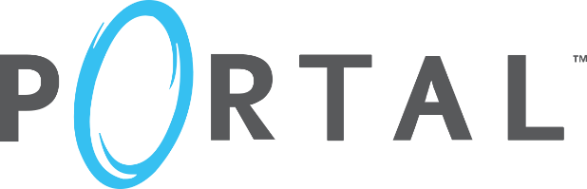
Portal’s logo makes use of aspects of keeping the logo simple and purely text based but they add in a blue portal drawing as a replacement for the ‘O’. This helps push and quick visualise the idea of the portals used in the game as well to make the logo unique to other video games released at the time. [8]
Image: Portal Logo [9]

- Half-life 2 (Video game)
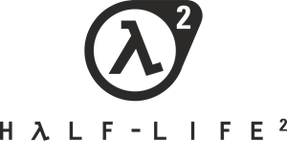
Half-Life 2’s logo is a set towards the use of more imagery that text than the previous logo, featuring the iconic lambda symbol popularised by the series. This makes it so that the logo is almost instantly recognisable by fans and to an extent the public. This logo is equal parts memorable and simplistic.[10]
Image: Half-life 2 Logo [11]

Taken what I’ve learnt from these logos, I decided to experiment and created two different styles of logo that are both featured in my final iterations. One of the styles combines that of ‘Loki’, ‘Portal’ and ‘Half-life 2’ [6][9][11]. The other will be made in the style more of the ‘Utopia’ logo [3].

Design iterations and experimentation and final designs.
For my logo I created three icons that can be used interchangeable that each represent an aspect of my game, Leper.
The icons are:
- A motif of a skull with or without an everyday accessory to represent the rather bleak and deathly nature of the environment in my game.
- An eyeball inside a mouth to show the more weird, disturbed feeling of Leper, for example body-horror.
- A hand doing a religious symbol to represent the aspect of a god controlling the world of Leper.

Skull Iterations
The second skull sketched, a more anatomical drawin, with a party hat, to symbolise the idea of dark humour that will be present in the game.

The first skull sketched, followed a more cartoonish style of drawing a skull.

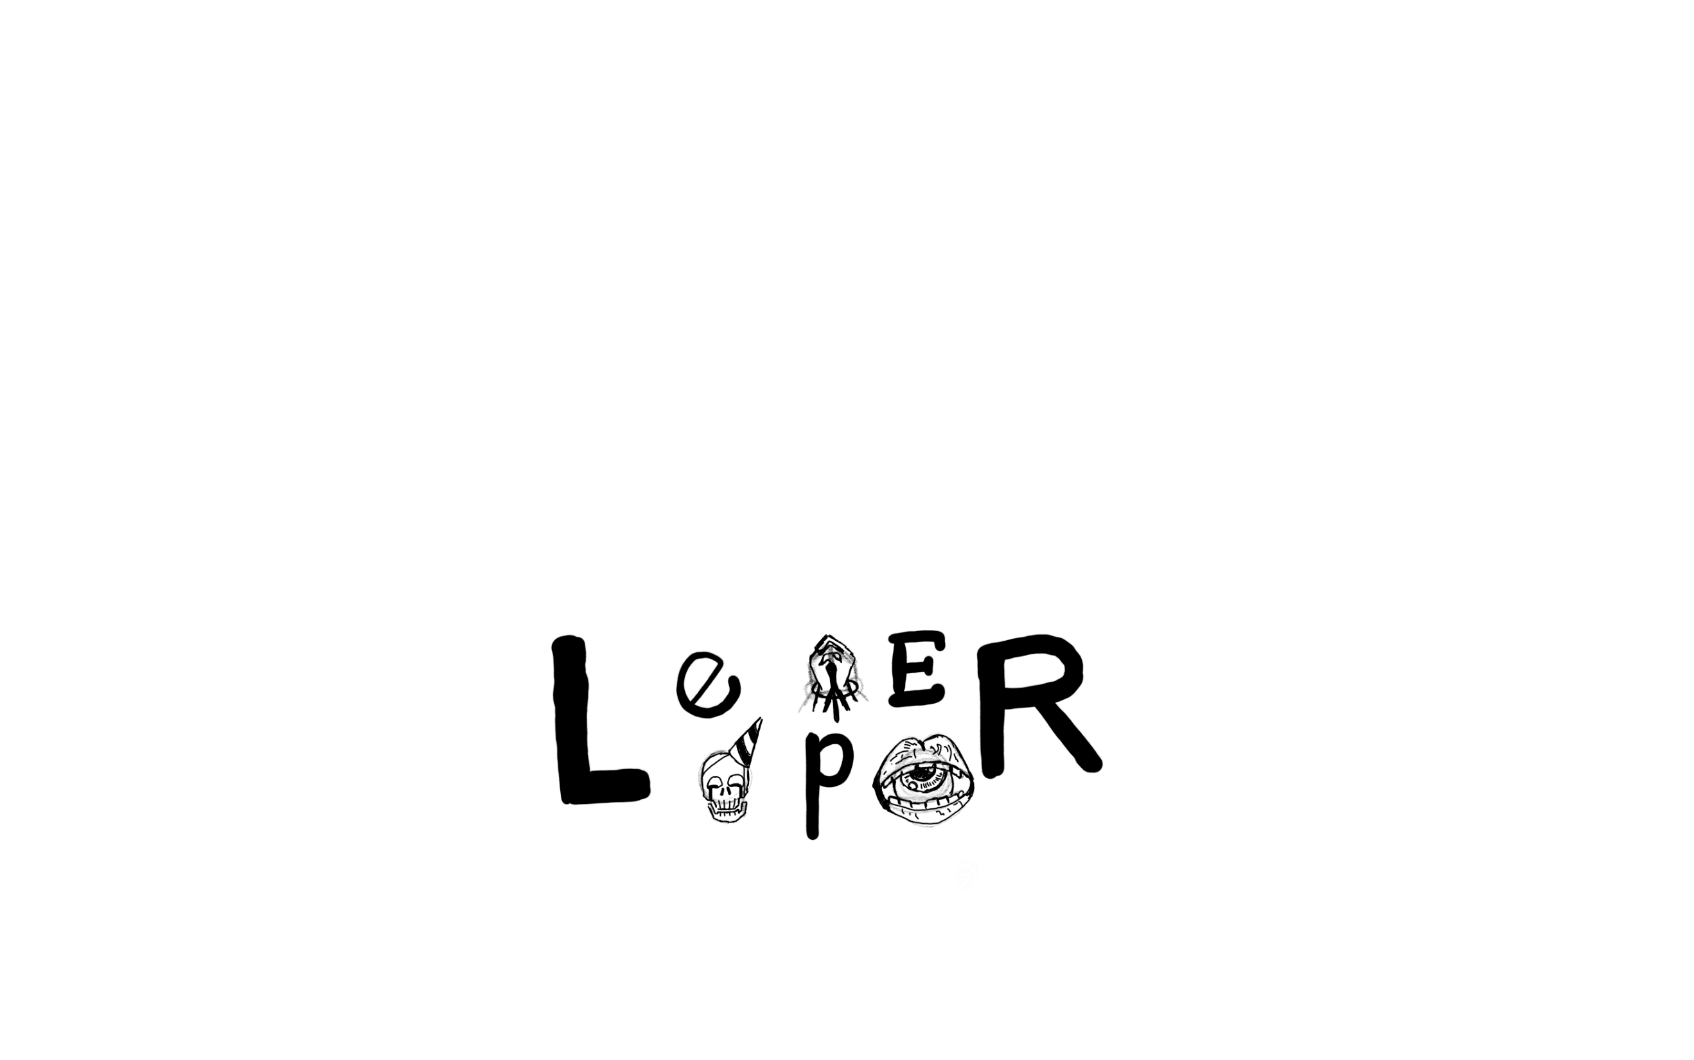
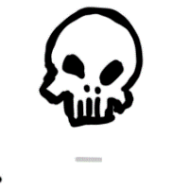
The third skull, more cartoonish but broader, trying to take up more space visually to help with the final logo compostion.
The fourth skull, more alien and simiplified, trying to show more of the alien aspect of Leper in this design.
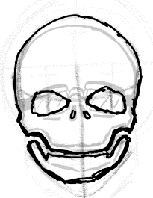
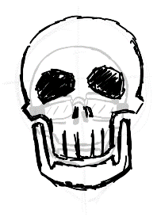
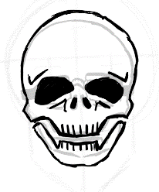
An iteration of the previous design with less detailing and a party hat.
The fifth skull, kept the overall shape of the previous skull but decided to add in more human feature to make it more distinct.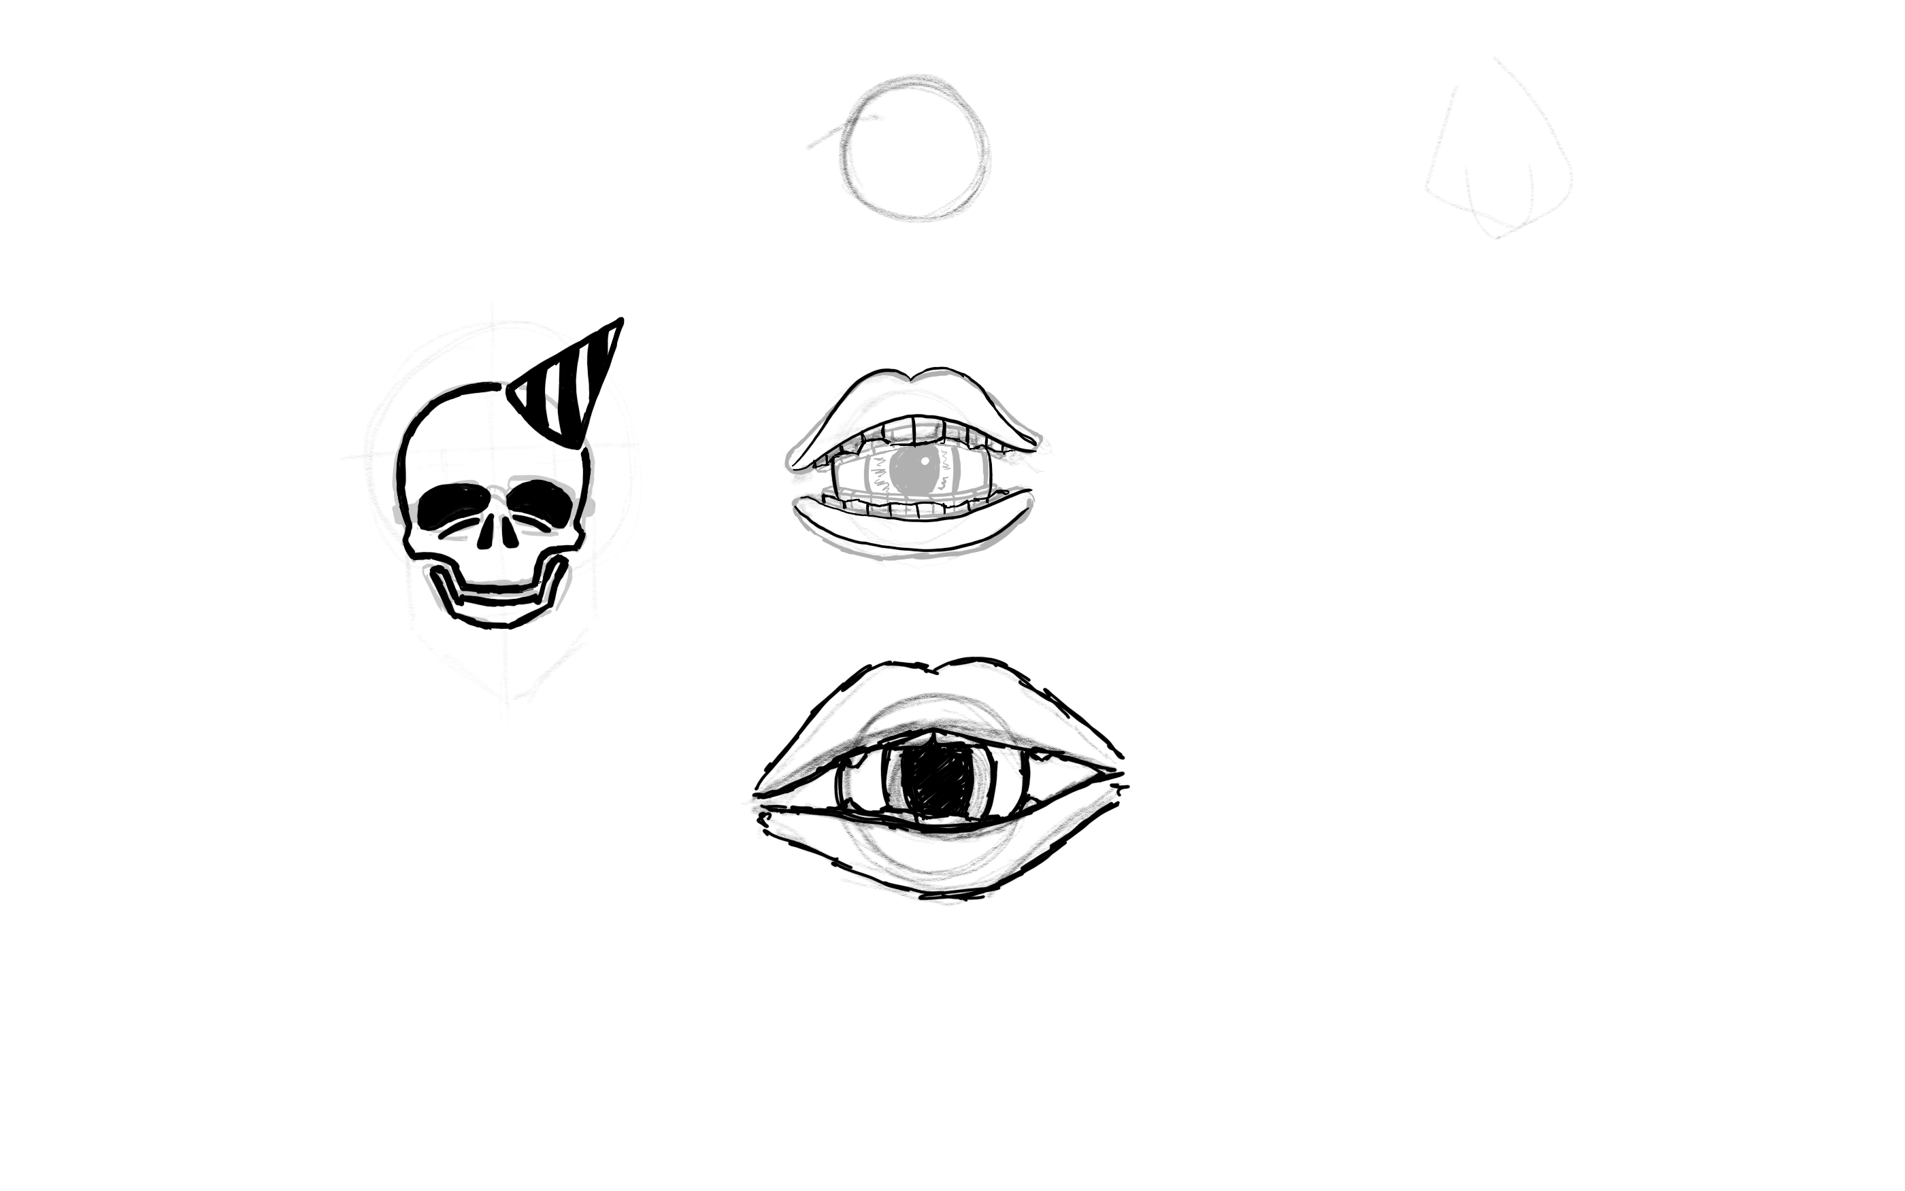
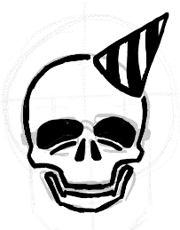

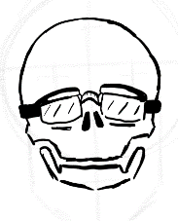
In this design I used a pair of spectacles instead of a party hat to symbolise the fact that the main character in Leper is an office worker.

Eye-in-mouth iterations
In the second iteration, I add in more detailing with the lip wrinkles and teeth, however this made it seem out of place with the other icons.
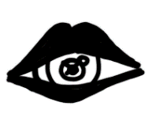
In this first design, I used lips to act as the eye lids, however this made the overall icon look clunky with how thick the lips were.

In this fourth iteration I decided to separate the lips more, simplify but showcase more of the teeth details and include a more detailed eye.
In the third design I decide to remove most of the detailing, only leaving a small amount of the teeth visible, though this ended up making the icon messy again to use in the context of logo.
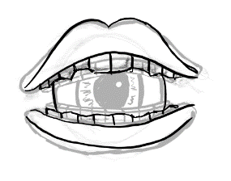
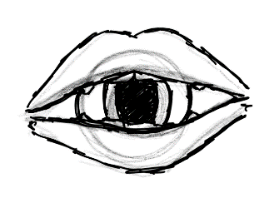
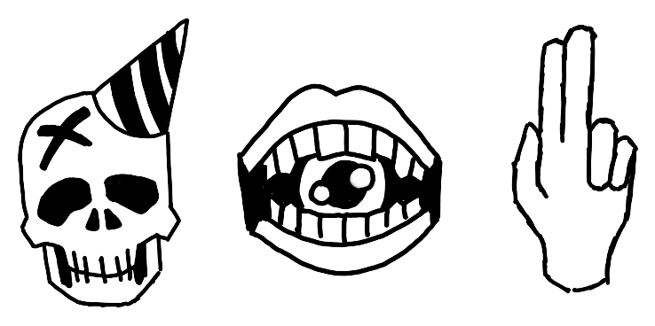
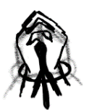
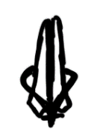
Final Design of Icons
In the second design I chose to make a more detailed depiction of two hands clasped together, however this would be difficult to see in smaller sizes.
In this first design, I used the symbolism of two hands put together to pray with a rosary surrounding the hands, however, it was too simplified for the audience to identify what the icon represented.
Hand symbol iterations.
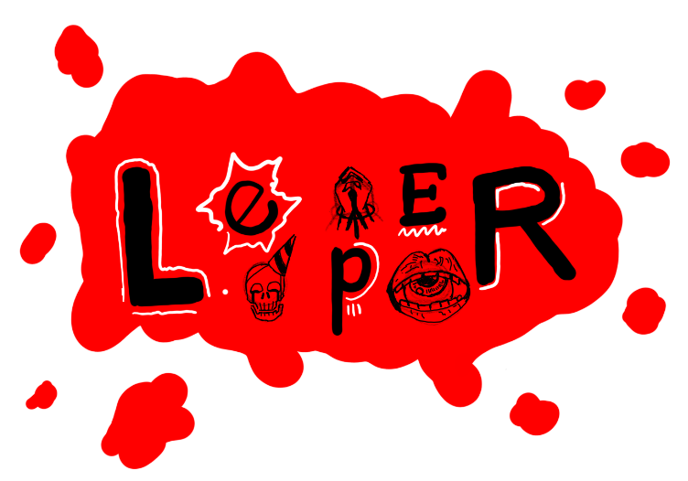
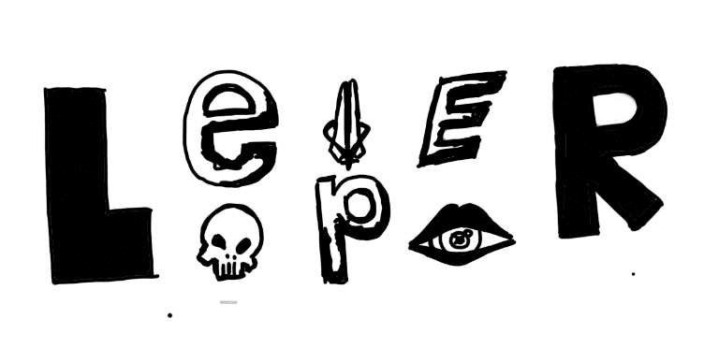
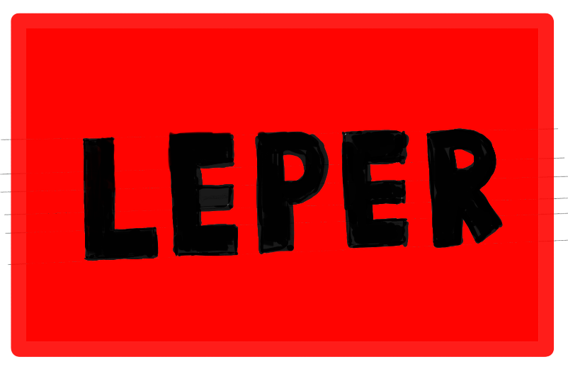
This is my third iteration of the logo that develops on the second iteration. This makes use of the mismatched font and icons but uses a splatter of red behind. There are also white lines around the letters to highlight them and add in a more chaotic and energetic feeling to the logo.
This was the second sketch, using the same thick block letter but distorting the middle letters, arranging them differently as well as adding in early iterations of my icons. This was inspired by the logo of ‘Loki’. [6]
This was my first sketch of my logo. Inspired by the ‘Utopia’ logo, I sketched out simple block letters on top a rectangle of Red. [3]
For my logo, I chose the colour red as the background and as the main colour in focus as it represent danger and anger [12], both representing the dangers, anger and hostile environment that Leper takes place in.
Composition iterations and colour choice
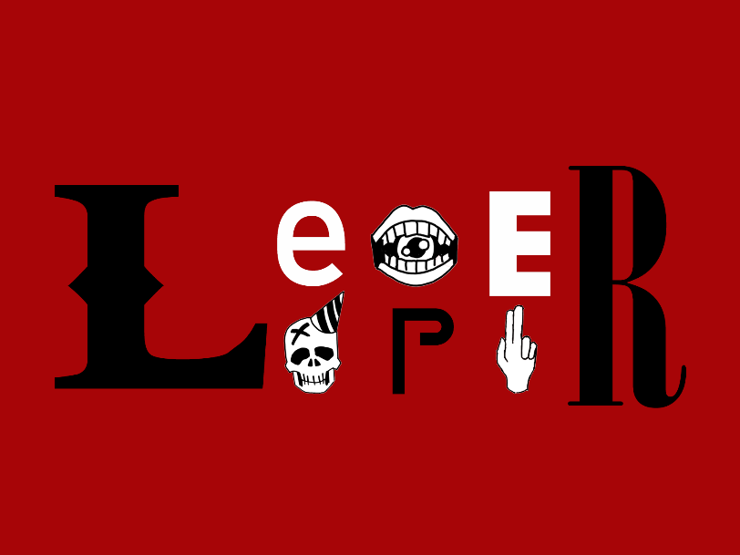
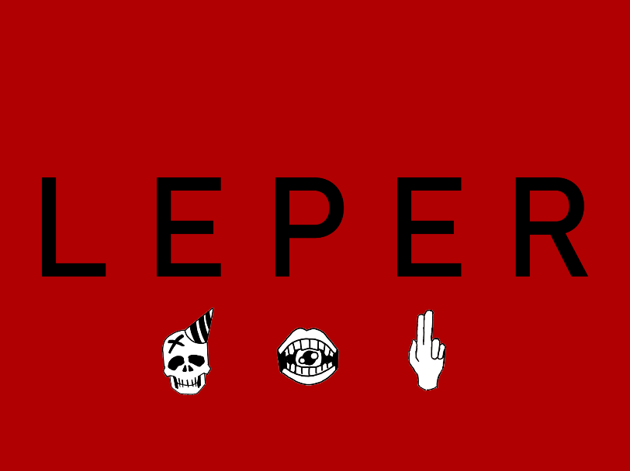
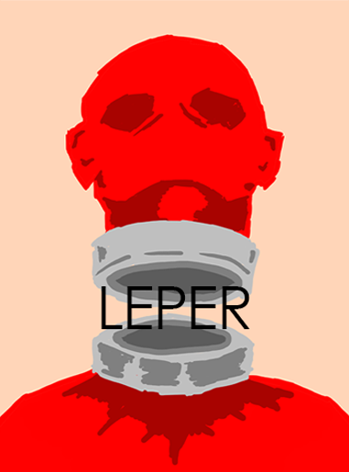
This logo combines the idea of the previous logo and the first and second composition iteration to create a more cohesive ‘chaotic’ logo. The unique fonts used are ‘god of war’ and ‘game of squids’.
(For use in main title screen and for billboards)
This logo makes use of the same font in the previous logo but is instead placed onto a solid red background with the icons placed below.
(For use in animated intro sequences or load screens)
The first logo is an evolution of the first composition iteration, using the font ‘Century Gothic’ and simple black colouring. This creates a similar effect to that of the logo that inspired it, making it clinical and mysterious, peaking the audience’s curiosity. (For use in posters)
Final Logo Designs

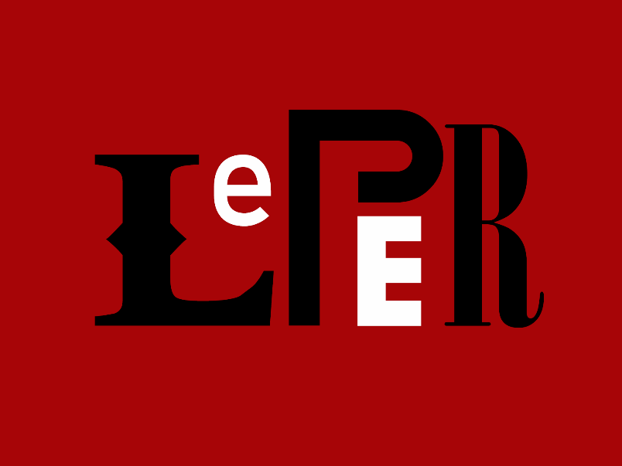
2: 3D Asset creation and porting into UEFN
This logo makes use of the previous logo to create a smaller and more compact logo while keeping the ‘chaotic’ look to it.
(For use in graffiti’s, business cards, publications, social media)
1: Billboard
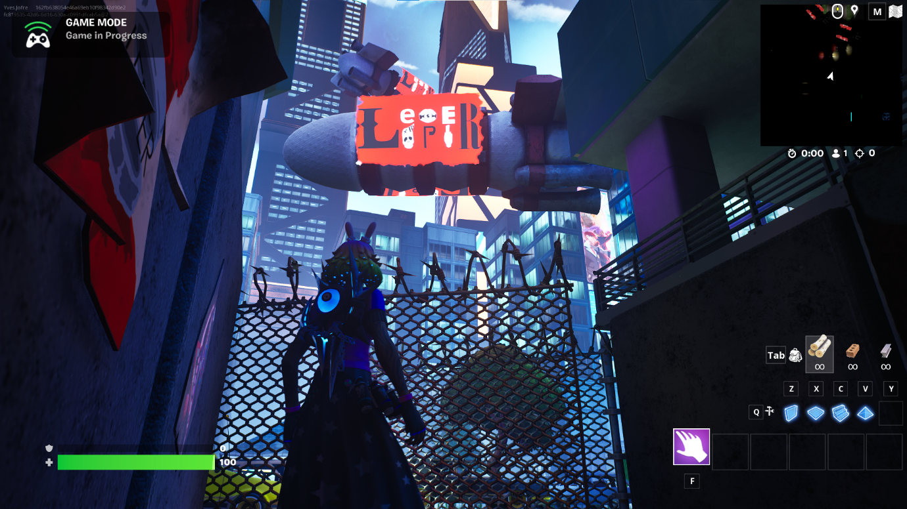
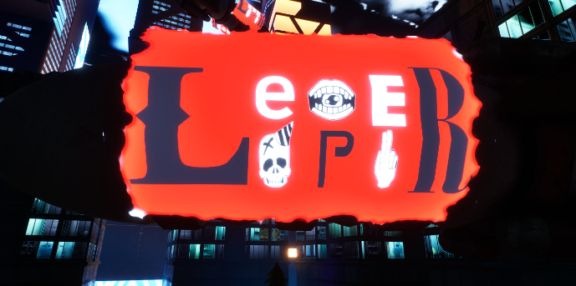
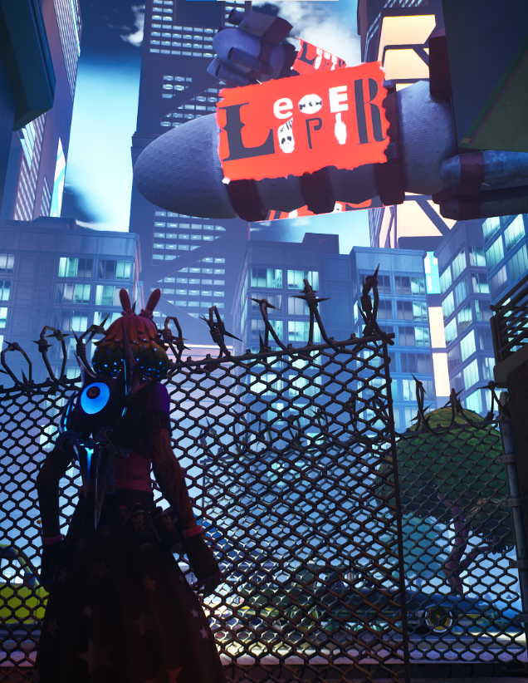
For my billboard, I made a blimp that had publicity on the side showcasing the logo of Leper in the approximate size of a billboard.
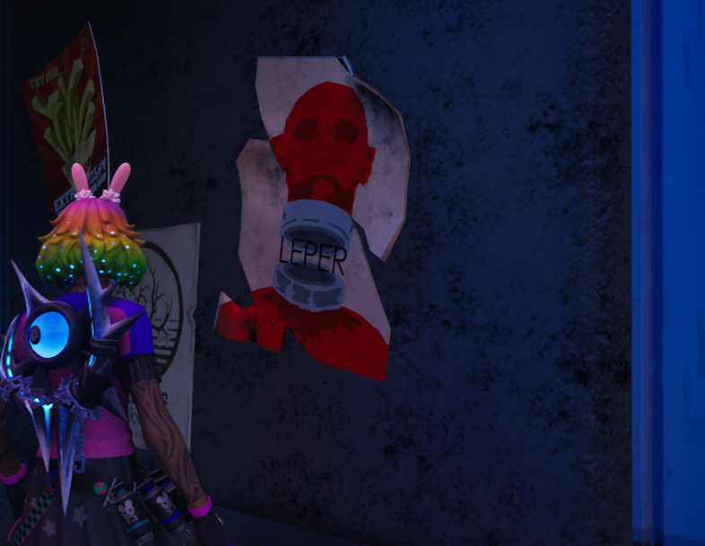
2: Poster
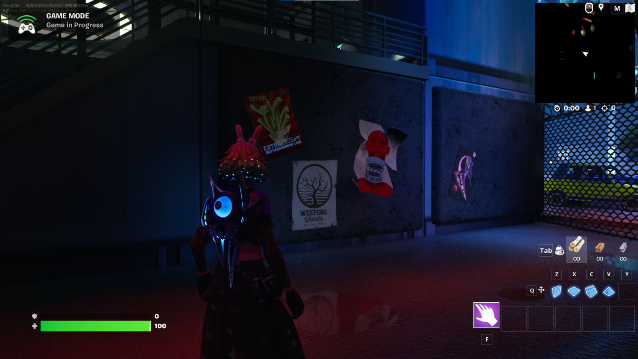
For my poster I made a poster that was styled to be torn up and slightly more dynamic that other Fortnite posters but keeping with Fortnite’s style
3: Wall and Graffiti
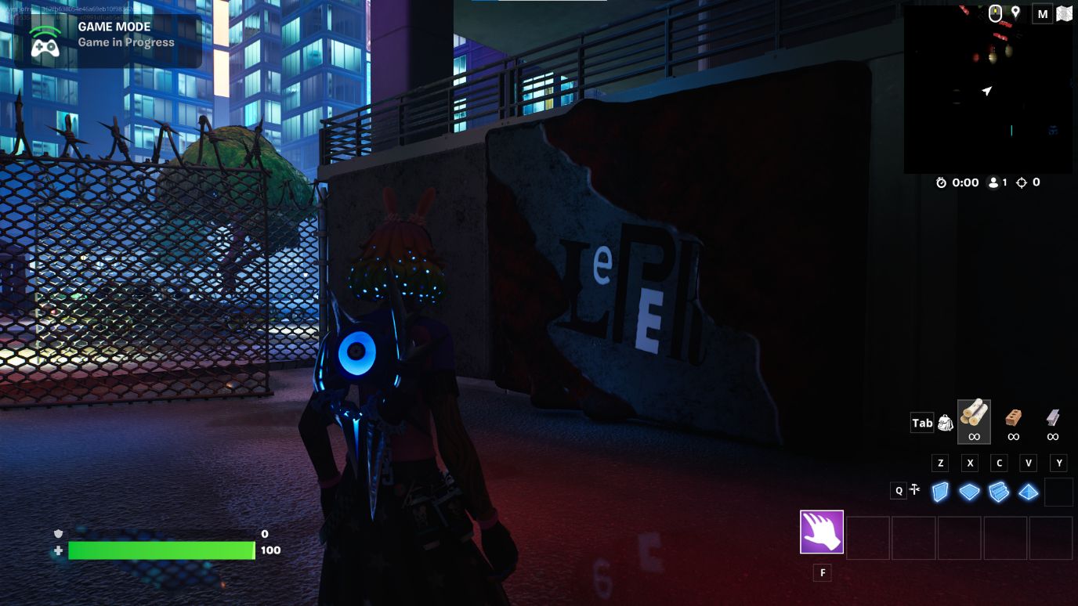
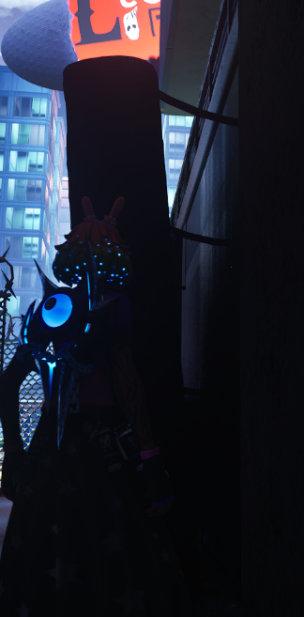
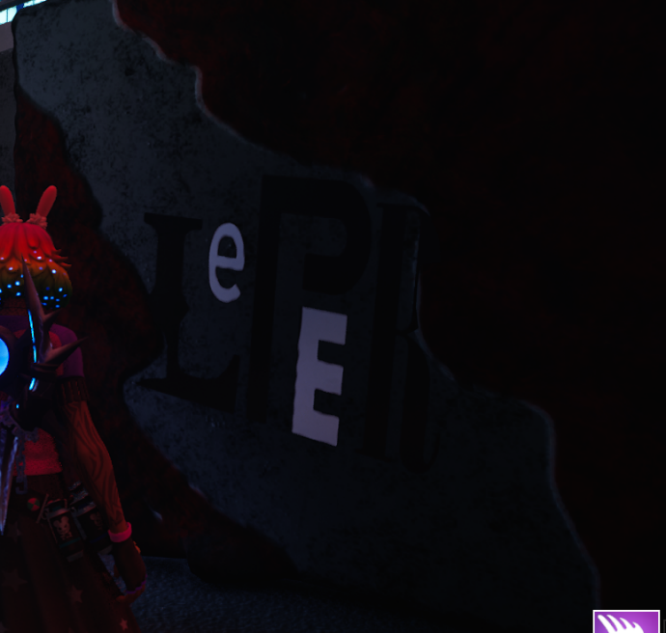
For my wall with graffiti decaling, I used a distorted version of my last logo design and put on a wall that is heavily damaged and being taken over by some of sort of alien mass. Walls are styled to be concrete padding design in the world of Leper to protect city buildings.

References:

[1] K. Goldstein, “How to make a good logo: The DOS and don’ts,” Wix Blog, https://www.wix.com/blog/good-logo-design-tips#:~:text=The%20golden%20rules%20of%20logo%20design&amp;text=Simplicity%3A%20A%20good%20logo%20should,stands%20out%20from%20the%20competition. (accessed Nov. 15, 2023).

[2] D. Kelly, Creator, Utopia, [Television Broadcast], London, Channel 4, Jan 15, 2013.

[3] “Utopia (British TV series),” Wikipedia, https://en.wikipedia.org/wiki/Utopia_%28British_TV_series%29 (accessed Nov. 16, 2023).

[4] “Utopia - series 1 and 2,” Zavvi UK, https://www.zavvi.com/dvd/utopia-series-1-and-2/10876145.html (accessed Nov. 16, 2023).

[5] M. Waldron, Creator, Loki, [Online Broadcast], Georgia, Marvel, Jun 9, 2021.

[6] Marvel, “SDCC 2019: All of the Marvel Studios news coming out of hall H at san diego comic-con,” Marvel, https://www.marvel.com/articles/movies/sdcc-2019-all-of-the-marvel-studios-news-coming-out-of-hall-h-at-san-diego-comic-con (accessed Nov. 16, 2023).

[7] “Ultrakill prelude by Hakita,” itch.io, https://hakita.itch.io/ultrakill-prelude (accessed Nov. 14, 2023).

[8] Portal. [Software], United States, Valve, 2007

[9] “File:portal logo.svg,” Wikipedia, https://en.m.wikipedia.org/wiki/File:Portal_Logo.svg (accessed Nov. 16, 2023).

[10] Half-life 2. [Software], United States, Valve, 2007.

[11] “Half-life 2 logo PNG Vector (EPS) free download,” Seeklogo, https://seeklogo.com/vector-logo/399134/half-life-2 (accessed Nov. 17, 2023).

[12] “Red color meaning: The color red symbolizes passion and energy,” Color Meanings, https://www.color-meanings.com/red-color-meaning-the-color-red/ (accessed Dec. 5, 2023).

Bibliography:
- K. Goldstein, “How to make a good logo: The DOS and don’ts,” Wix Blog, https://www.wix.com/blog/good-logo-design-tips#:~:text=The%20golden%20rules%20of%20logo%20design&amp;text=Simplicity%3A%20A%20good%20logo%20should,stands%20out%20from%20the%20competition. (accessed Nov. 15, 2023).
- D. Kelly, Creator, Utopia, [Television Broadcast], London, Channel 4, Jan 15, 2013.
- “Utopia (British TV series),” Wikipedia, https://en.wikipedia.org/wiki/Utopia_%28British_TV_series%29 (accessed Nov. 16, 2023).
- “Utopia - series 1 and 2,” Zavvi UK, https://www.zavvi.com/dvd/utopia-series-1-and-2/10876145.html (accessed Nov. 16, 2023).
- M. Waldron, Creator, Loki, [Online Broadcast], Georgia, Marvel, Jun 9, 2021.
- Marvel, “SDCC 2019: All of the Marvel Studios news coming out of hall H at san diego comic-con,” Marvel, https://www.marvel.com/articles/movies/sdcc-2019-all-of-the-marvel-studios-news-coming-out-of-hall-h-at-san-diego-comic-con (accessed Nov. 16, 2023).
- “Ultrakill prelude by Hakita,” itch.io, https://hakita.itch.io/ultrakill-prelude (accessed Nov. 14, 2023).
- Portal. [Software], United States, Valve, 2007
- “File:portal logo.svg,” Wikipedia, https://en.m.wikipedia.org/wiki/File:Portal_Logo.svg (accessed Nov. 16, 2023).
- Half-life 2. [Software], United States, Valve, 2007.
- “Half-life 2 logo PNG Vector (EPS) free download,” Seeklogo, https://seeklogo.com/vector-logo/399134/half-life-2 (accessed Nov. 17, 2023).
- “Red color meaning: The color red symbolizes passion and energy,” Color Meanings, https://www.color-meanings.com/red-color-meaning-the-color-red/ (accessed Dec. 5, 2023).
- D. Carson, “How to pick a font for your brand: Guide to choosing fonts - 2023,” MasterClass, https://www.masterclass.com/articles/how-to-pick-a-font (accessed Nov. 22, 2023).
- Sangita, “The Art of Icon Design: Crafting Memorable Digital Experiences.,” Medium, https://medium.com/@mysangi28/the-art-of-icon-design-crafting-memorable-digital-experiences-ca61662a7d8f (accessed Nov. 22, 2023).
- B. S. Barron, “Creating memorable icons, logos and Favicons,” 1stWebDesigner, https://1stwebdesigner.com/icons-logos-favicons/ (accessed Nov. 24, 2023).
- K. Goldstein, “The psychology of Logo Design: The impact of colors, shapes and fonts,” Wix Blog, https://www.wix.com/blog/logo-psychology#:~:text=Pay%20attention%20to%20color%20schemes,contain%20more%20than%20three%20colors. (accessed Nov. 25, 2023).
- [1] T. May, “11 of the best gaming logos of All time,” Creative Bloq, https://www.creativebloq.com/features/best-gaming-logos (accessed Nov. 10, 2023).
- Adobe Substance 3D Painter, Version 9.1.1, [Software], United States, Adobe, 2023.
- Fortnite. [Software], United States, Epic Games, 2017.
- Unreal Editor for Fortnire, Version 28, [Software], United States, Epic Games, 2023.

