How to use an outdoor environment to promote and support children’s scientific/mathematical thinking.
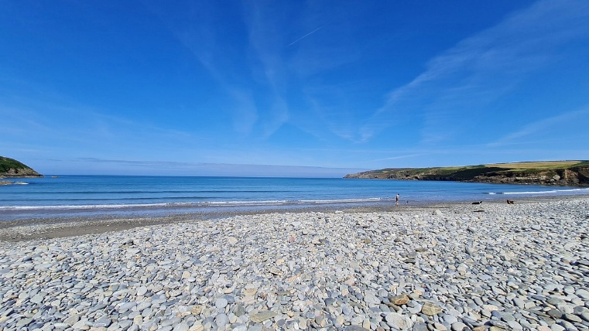

(Tripadvisor, 2026)

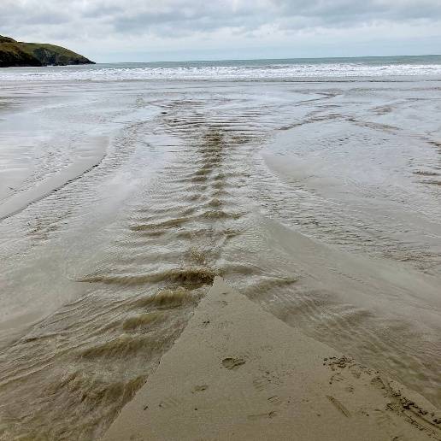
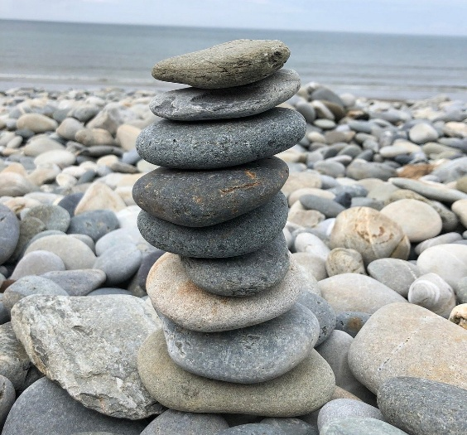

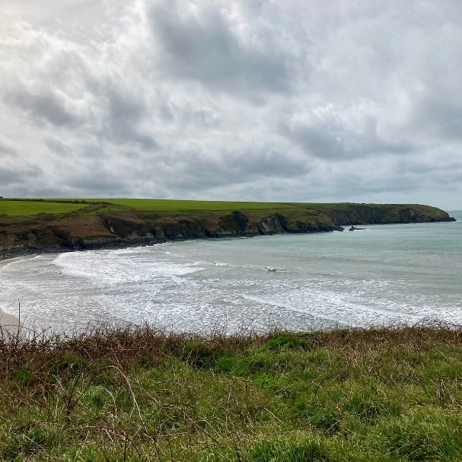
(Tripadvisor, 2026)
(Tripadvisor, 2026)
(Tripadvisor, 2026)
Part 2
The areas provided in the photographs of Aber Mawr beach can help to develop specific scientific and mathematical concepts and ideas to help young children. This can be done by exploring the beach, sand, water and pebbles. During the trip to the beach there will be 10 5-year-old children present and 4 members of staff, this is to have a higher volume of a ratio to ensure all children are kept safe, this is by following guidance of the current ratio in Wales for a 5-year-old is 1 adult to 8 children.
Through attending the trip to the beach, the children will take part in an activity of building towers with the pebbles. A small group of children will carry this activity out with staff members supervising them to ensure everyone is safe, children are gaining knowledge and understanding and to be there if the children need any help.
Building a tower using pebbles helps children mathematically as when they are building the tower they can touch each pebble individually and count each one to know how many pebbles they have used to build their tower. This can be done multiple times as they continue to build different towers which will help them reinforce counting numbers. (Welsh Government (n.d) Children can also sort and group pebbles into size and shape which can help them as they compare the pebbles to which pebble is bigger? Which pebble is smaller? Are any of the pebbles flat? Do they feel heavy? Do they feel light? The activity could be taken further and enhance the children’s skills more by judging the position, orientation and how to balance the pebbles to build a taller tower. Some children may also be able to create simple patterns by using a big pebble, small pebble, big pebble so on or even by using a light pebble, dark pebble, light pebble so on. (Welsh Government (n.d)
Children can learn a lot through science by building a tower using pebbles as they are balancing the pebbles they are involving exploring shapes and weights and how it can affect the stability of the tower due to friction and gravity. It takes a lot of experimenting to build the tower as it may wobble and fall which may mean they need to readjust the structure to make it more stable which is a form of trial and error. It may mean children need to predict what they think may happen as they balance more pebbles on top of one another. Welsh Government (n.d)
Another activity which will be carried out will be scooping and pouring water. Scooping and pouring water strengthens early maths skills like volume and comparison and builds scientific understanding of flow, cause-and-effect, and material properties through hands-on exploration. Children learn that containers hold different amounts as they fill, empty, and compare them, repeated filling helps them estimate more, less, full, empty, and compare levels in containers. Each scoop corresponds to a measurable change, supporting early counting and quantity awareness with different container shapes change how fast or slowly water fills, building spatial and quantitative thinking. Welsh Government (n.d) Science is also an important part of learning whilst children are exploring water. Children will see what happens when water is poured into funnels, narrow openings and will gain knowledge in cause and effect. The children will observe how water travels through tools, tubes, and containers, noticing speed and direction changes and notice how water has a change of behaviour if there is sand mixed in. (Welsh Government (n.d)
Overall, through going to the beach the children will have a better understanding of science and maths in the open environment as they are counting with items they have found out in the nature and through using water they have taken from the sea.

Part 3
Experience exploring outdoor space in photograph | How will young people BENEFIT from this activity? | Hazards and associated risks | Who is at risk? | PRECAUTIONS in place to reduce the risk of injury | Overall risk after precautions RATING:  L/M/H
Walking on pebbles | It will help strengthen small foot muscles by walking on uneven grounds and surfaces. It also helps with brain development as nerve signals are sent from the soles of your feet to the brain, this helps build a clearer internal map of body positioning which helps with coordination and helps with improving balance and posture. There are also sensory benefits as different textures and temperatures of pebbles provide sensory inputs that help develop bodies sense of positioning and movement. | Balancing could result in falling as pebbles may shift as you are walking on them and some children may not be stable whilst walking on even ground let alone uneven ground. Pebbles may be wet which may make them slippery and easier to fall on as you are walking on them. | Everyone is at risk | Walking in pairs on the pebbles until we reach the sandy part of the beach which helps with control and no pushing. Also, by having a adult walking closely to the children to keep the children under control and to help them if they need. To do this the adults need to be in ratio to the children and possibly with a few extra staff members than the ratio. | Low risk
Building with pebbles | Outdoor play teaches children to judge surfaces, stability and their own limits whilst building with pebbles. The activity will also help children to count and sort whilst also learning about gravity and force as there balancing pebbles on top of one and another. | Young children may pick up pebbles and put them in their mouths this causes a risk of chocking. Pebbles may also fall and land on the children which may result in injuries to their hands, toes or feet, but also depending on how high the children build their towers there could be a risk of the tower of pebbles doing damage to a child’s face or body. | Children at risk | Have a adult supervising a group of 3-4 children building a tower using pebbles this will help reduce the risk and maintain a close eye on the children present. Ensure children are building their towers using pebbles that are bigger than a £2 coin to prevent the risk of chocking and supervise what types of pebbles they are using. | Medium risk
Exploring the water with jugs and containers. | Scooping and pouring water helps young children build fine-motor control, early maths and science understanding, sensory regulation, and confidence through hands-on exploration. Children will understand cause and effect by seeing what happens when they pour quickly and slowly from different heights and containers, they will also learn about full and empty and more and less as you speak about what is happening. | The main hazards are silent, rapid drowning in shallow water, sudden changes in sea conditions, and loss of supervision when children bend, lean, or wander while filling containers, all of which can happen within seconds. | Children are at risk | Children need to be supervised closely where one adult is watching two children at a time whilst they are playing and exploring the water with jugs, containers and buckets this will help prevent the risk of drowning. | High risk

Part 4
Outdoor environments provide valuable opportunities for young children to develop their understanding of mathematical and scientific concepts through play, exploration and first-hand experiences. The outdoor environment allows children to investigate natural materials, observe changes, solve problems, compare objects and develop their understanding of the world around them. Adults working with early years children have an important role in supporting this learning by providing stimulating experiences, modelling appropriate language, asking open-ended questions and scaffolding children’s thinking.
One-way adults can support mathematical and scientific development outdoors is through child-led play and exploration. Piaget’s constructivist theory suggests that children actively construct their own knowledge through interacting with their environment. Outdoor experiences provide children with opportunities to investigate real objects and situations rather than learning concepts only through adults explaining. For example, children collecting leaves may naturally begin to count, sort and compare them accordingly into their size, colour or shape. Similarly collecting stones can encourage children to explore concepts such as quantity, weight, size and pattern. Adults can recognise these opportunities and introduce mathematical vocabulary such as more, less, larger, smaller, heavier and lighter. This can make mathematical learning meaningful because children are applying concepts within their own play. (Educational Psychology (n.d)
However, simply providing access to an outdoor environment does not automatically result in mathematical or scientific learning. Adults need to observe children’s play and recognise opportunities to extend their thinking. The Education Endowment Foundation highlights the importance of developing mathematical language and building on children’s existing knowledge. Therefore, practitioners need to find an appropriate balance between allowing children to explore independently and intervening when their support could extend learning. (Education Endowment Foundation, n.d)
Vygotsky’s sociocultural theory is also relevant because it emphasises the importance of social interaction in children’s learning. Vygotsky’s concept of the zone of proximal development suggests that children can achieve more with appropriate support from a knowledgeable adult than they may be able to achieve independently. Adults can therefore use scaffolding to extend children’s mathematical and scientific thinking. For example, if children are building a tower with natural materials an adult could ask ‘What stick do you think would make the strongest base?’ or ‘What could we do to stop the tower falling over?’ This encourages children to think about balance, size, weight and stability while developing problem solving skills. (Psychology Notes HQ, n.d)
Adults can also use open ended questions to encourage scientific investigation. For example when children find a puddle the practitioner could ask, ‘Where do you think the water came from?’ or ‘What do you think will happen when the sun comes out?’ Children can then make predictions and observe what happens over time. This supports early scientific skills such as observation, prediction, investigation and communication. The adult does not necessarily need to provide the correct answer immediately, instead they can encourage children to develop and test their own idea.
Bruner's theory of scaffolding can further explain the adult's role. Adults can initially model a skill or provide guidance before gradually reducing their support as children become more confident. For example, an adult could demonstrate how to measure a plant using a ruler and then allow children to measure other plants independently. The practitioner could ask children to compare their measurements and discuss why some plants may be taller than others. This provides opportunities to develop mathematical skills such as measurement and comparison alongside scientific understanding of plant growth. (Bruner, 1966)
Another important approach is sustained shared thinking. This occurs when adults and children work together to solve a problem, develop an idea or understand something. Research into effective early years pedagogy has identified sustained shared thinking as an important feature of high-quality practice. Outdoor environments provide many opportunities for this type of interaction. For example, if children are trying to construct a bridge from sticks and it repeatedly collapses, an adult could encourage them to discuss why this is happening rather than immediately fixing it for them. Questions such as "What could we change?" or "Would a thicker stick make a difference?" encourage children to develop their own explanations and test different solutions.
The outdoor environment can also support mathematical learning through natural and open-ended resources. Leaves, sticks, stones, shells, pine cones and water can be used for counting, sorting, measuring, ordering and pattern-making. The Welsh Government recognises that natural outdoor resources provide opportunities for mathematical exploration and problem-solving. For example, children could create a repeating pattern using leaves and stones, estimate how many objects are in a collection or investigate which natural materials are heavier. These activities can help children develop mathematical concepts without the learning necessarily feeling formal.
Scientific learning can similarly be developed through children's experiences of the natural world. Children can observe insects, plants, weather, soil and water and develop an understanding of living things and natural processes. For example, planting seeds provides opportunities to observe growth and investigate what plants require to survive. Children can measure the plants as they grow, record changes and compare different plants. This demonstrates how mathematical and scientific learning can be integrated within one activity.
The use of language is particularly important. Children may initially describe an object as ‘big’, but the adult can extend their vocabulary by introducing words such as longer, shorter, wider, narrower or heavier. Similarly, when investigating nature, adults can introduce scientific vocabulary such as observe, predict, change, grow, living and non-living. The Early years framework recommends that practitioners deliberately develop children's mathematical language through modelling, repetition, questioning and extending children's responses. (Department for Education, 2024)
Nevertheless, adults need to be careful not to make outdoor learning excessively adult-directed. If practitioners continually interrupt children's play with questions or provide solutions too quickly, children may become dependent on adults and have fewer opportunities to develop independence and creativity. Conversely, if adults provide resources but do not interact with children at all, valuable opportunities for extending mathematical and scientific understanding may be missed. Effective practice therefore requires practitioners to be responsive, observing children's interests and intervening when their involvement can extend learning.
The Curriculum for Wales supports this approach by placing importance on children's experiences, exploration, play and development. The Welsh Government guidance recognises that outdoor environments can provide opportunities for children to explore mathematical concepts, investigate the natural world and develop problem-solving skills. This demonstrates that outdoor learning should not simply be viewed as an opportunity for physical activity; it can provide a rich context for developing children's cognitive, mathematical and scientific understanding. (Welsh Government n.d)
In conclusion, adults play an important role in supporting and encouraging young children's engagement with mathematical and scientific concepts in outdoor environments. Theories such as Piaget's constructivism, Vygotsky's sociocultural theory and Bruner's concept of scaffolding demonstrate the importance of children's active exploration, social interaction and appropriate adult support. Outdoor environments provide authentic opportunities for children to count, measure, compare, classify, predict, observe and investigate through meaningful experiences.
However, the effectiveness of outdoor learning depends on the quality of adult interactions rather than simply providing access to an outdoor space. Adults need to provide stimulating resources, model appropriate vocabulary, ask thoughtful questions, observe children's interests and use scaffolding to extend learning while still allowing children to remain active participants in their own investigations. A balance between child-led exploration and intentional adult support is therefore important. When this balance is achieved, the outdoor environment can become a valuable context in which mathematical and scientific concepts are developed naturally through children's curiosity, play, problem-solving and direct experiences.

Reference list
Bruner, J.S. (1966) Toward a theory of instruction. Cambridge, MA: Harvard University Press. Available at: [PDF] Toward a Theory of Instruction by Jerome Bruner | 9780674897014, 9780674253087 (Accessed: 25/09/2026)
Department for Education (2024) Statutory framework for early years foundation stage: For group and school based providers. Available at: Early years foundation stage (EYFS) statutory framework - GOV.UK (Accessed: 25/09/2026)
Education Endowment Foundation (EEF0 (n.d) Available at: Education Endowment Foundation | EEF (Accessed: 24/09/2026)
Educational Psychology (n.d) Psychological constructivism: Piaget’s theories. Available at: Psychological Constructivism: Piaget’s Theories – Educational Psychology (Accessed 24/09/2026)
Pyschology Notes HQ (n.d.) Vygotsky’s theory of cognitive development. Available at: Vygotsky's Theory: ZPD, Scaffolding, Play & Social Learning (Accessed: 24/09/2026)
Tripadvisor (2026) Abermawr Beach – All You Should Know Before You Go 2026 (w/Reviews and photos) Available at: ABERMAWR BEACH - All You SHOULD Know Before You Go 2026 (w/ Reviews) (Accessed 20/09/2026)
Welsh Government (n.d) Curriculum for Wales. Available at: Curriculum for Wales - Hwb (Accessed 20/09/2026)

