
Problem Analysis and Solution Development.
Assegnment_2
Module Name: Analysing & Solving Problems
Module Code: ACCA4019
Student Name: Gaddisa Abelt
Student ID: 2516444
Group: 3
Lecturer Name: Dr Adam Philpot

1. Introduction 2
2. Deconstruct the Problem 3
1. Must Have (Essential Requirements) 3
2. Should Have (Important) 3
3. Could Have (Nice-to-Have Requirements) 4
4. Won’t Have (Out of Scope) 4
2.2 Variable Identification 4
3. Proposed Solution 4
3.1 Flowchart 5
3.2 Flowchart Explanation 5
Algorithm Steps 7
4.How the Solution Meets College Requirements 8
Key Decision Points 8
4.1 Abstract Thinking 8
4.2 Subdividing 9
4.3 Justification of the Solution 9
4.4 Limitations 10
4.5 Assumption 10
5. Conclusion 11
References 11

1. Introduction

Organizing group project meetings is a challenge for students in a college computing course. It is challenging for all group members to meet on a regular basis because many students have part-time jobs, varying schedules, and personal obligations. Because of this, some groups find it difficult to finish their assignments on time, which causes delays in project submissions and unequal workloads among members.

An organized examination and solution to this issue are provided in this report. The goal is to create a general, logical solution that:
1. Chooses meeting times that work for everyone in the group.
2. Reduces scheduling conflicts and problems
3. Makes certain that every meeting is held prior to the weekly project deadlines.

The paper deconstructs the problem, identifies requirements and limitations, and designs a solution using systems thinking and abstract thinking methodologies. The method is backed by pertinent research on heuristic optimization, scheduling, and constraint satisfaction.

2. Deconstruct the Problem
The problem was broken down into four related sub-problems using a systems thinking approach:
Sub Problem, Description, Important Elements, Availability, Coordination, Identifying shared free time for all group members. Personal obligations, part-time work schedules, and individual schedules Avoiding conflicts with other academic obligations, Lectures, labs, and other group gatherings Conflict Minimization Deadline Compliance Making sure meetings take place prior to weekly deadlines Weekly project deadlines, meeting frequency Workload Distribution Ensuring equitable participation from each member Task delegation, personal capability [1].

2.1 MoSCow Technique Requirement

The MoSCoW prioritization framework (Wiegers & Beatty, 2013) was utilized to categorize requirements according to their significance. This framework was selected as it offers a systematic method for differentiating between essential and desirable features [2].

1. Must Have (Essential Requirements)
Requirement | Justification
Attendance of all group members | The meeting is ineffective if not all members are available to participate.
Meeting scheduled before the weekly deadline | Ensures that sufficient progress is made before the submission deadline.
Consideration of all members’ availability | Ensures that no group member is excluded from the meeting.
Meeting scheduled within working hours | Makes the meeting practical and convenient for all members.

2. Should Have (Important)
Requirement | Justification
Minimal travel between commitments | Reduces unnecessary travel time and improves scheduling efficiency.
Meeting room availability | Ensures that suitable spaces are available for group meetings.
Schedule notifications for members | Keeps all members informed and allows them to prepare in advance.

3. Could Have (Nice-to-Have Requirements)
Requirement | Justification
Lecturer or TA attendance at selected meetings | Provides additional support, advice, and guidance when needed.
Preferred meeting location | Improves student comfort and convenience.
Automated meeting reminders | Helps prevent members from forgetting scheduled meetings.

4. Won’t Have (Out of Scope)
Requirement | Justification
Integration with online meeting platforms | Considered a separate system and is outside the project scope.
Changes to group composition | Groups are fixed and cannot be altered.

2.2 Variable Identification
Variable | Symbol | Type | Description
Member Availability | MA | Input | The weekly free time slots available for each student.
Group Size | GS | Input | The total number of members within the group.
Project Deadline | PD | Input | The deadline for completing and submitting the project each week.
Meeting Duration | MD | Input | The amount of time required for each group meeting.
Number of Meetings | NM | Input | The number of meetings the group needs to hold each week.
Lecturer Supervision | LS | Input | The availability of a lecturer or teaching assistant to provide guidance and support.
Meeting Frequency | MF | Calculated | The frequency at which the group holds meetings.
Task Allocation | TA | Calculated | The distribution of project tasks among group members.
Meeting Schedule | MS | Output | The final time slots assigned for the group's meetings.

3. Proposed Solution

3.1 Flowchart
The flowchart below illustrates the proposed process for optimising group project meeting schedules. The solution uses a constraint-based scheduling approach combined with optimisation heuristics to identify suitable meeting times while considering member availability, project deadlines, meeting duration, and scheduling conflicts [3].

3.2 Flowchart Explanation

Core Algorithmic Approach [[3]
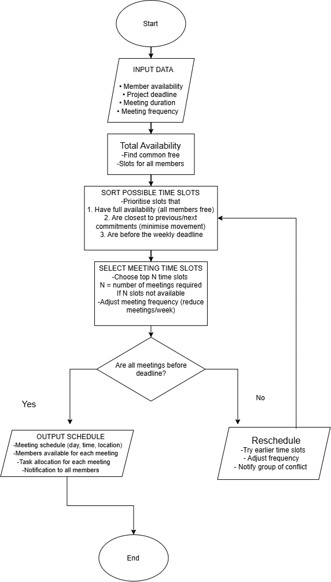

Link:Untitled Diagram - draw.io
Satisfaction Theory: - a widely used approach for addressing timetabling and scheduling problems [4].

Definition of Key Terms

Term | Meaning
Constraint Satisfaction Problem (CSP) | A problem in which a solution must meet a defined set of constraints and requirements.
Heuristic | A practical method or rule used to efficiently guide an algorithm towards a suitable solution.
Majority Rule | A fallback approach where a meeting can proceed when most members are available, even if one member cannot attend.

Algorithm Steps
The proposed algorithm operates through the following stages [5]:
- Data Input:
All necessary information is collected, including individual member availability, project deadlines, meeting duration, and the required meeting frequency.
- Aggregate Availability:
The individual schedules of all group members are combined to identify common available time slots. Any slot that conflicts with a member's existing commitments is removed from consideration.

- Sort Possible Time Slots:
The available time slots are ranked according to the following criteria:
  - Full availability: Time slots where all group members are available receive the highest priority.
  - Proximity to other commitments: Slots positioned close to existing commitments are prioritised to minimise unnecessary travel or idle time.
  - Deadline compliance: Only time slots that occur before the weekly project deadline are considered.
- Select Meeting Time Slots:
The highest-ranked time slots are selected based on the required number of meetings per week (N). If fewer than N suitable slots are available, the algorithm considers the following alternatives:
  - Majority attendance: A meeting may proceed if at least 80% of group members are available, with absent members being informed of the meeting outcomes.
  - Reduced meeting frequency: The number of meetings per week may be reduced to a feasible level when scheduling sufficient meetings is not possible.
- Validate Against the Deadline:
The selected meetings are checked to ensure that they occur before the weekly project deadline. If a meeting falls after the deadline, the algorithm attempts to reschedule it to an earlier suitable time slot. If no feasible alternative can be found, the group is notified of the scheduling conflict so that it can be resolved manually.
- Generate Output:
The final schedule provides the meeting dates and times, locations, member availability, and task allocation for each meeting. Notifications are then sent to all group members to ensure that everyone is informed of the schedule.

4.How the Solution Meets College Requirements
Requirement | How the Solution Addresses It
Suitable meeting times | Combines individual availability to identify and select time slots when all group members can attend.
Minimising conflicts | Removes time slots that overlap with existing commitments and prioritises those with minimal scheduling conflicts.
Deadline compliance | Checks all proposed meetings against the weekly project deadline to ensure sufficient time for progress and submission.

Key Decision Points
Decision Point | Logic | Justification
Full vs. Majority Attendance | Full attendance is preferred, with majority attendance used as a fallback when necessary. | Full attendance ensures that all group members can participate and contribute.
Priority Sorting | Availability -Proximity Deadline | Member availability is the primary constraint when selecting suitable meeting times.
Deadline Validation | All meetings must occur before the weekly deadline. | Ensures that meetings contribute to project progress before submission.
Notification | All members are notified of the final schedule. | Ensures that members are aware of the meeting arrangements and can prepare accordingly.

4.1 Abstract Thinking
The problem was simplified into a general group scheduling problem, in which individuals with different availability constraints must identify suitable time slots that satisfy the requirements of the group. This abstraction allows the proposed solution to be applied to a range of scheduling situations, such as team projects, staff meetings, and clinical appointments.
According to systems thinking theory, abstraction and generalisation help identify the essential elements of a complex problem while removing unnecessary context-specific details. By focusing on the fundamental task of finding common availability among individuals with different schedules, the proposed solution can be adapted to contexts beyond the college environment [6].

4.2 Subdividing
The overall scheduling problem was divided into three smaller and more manageable sub-problems:
- Availability Aggregation – combining individual schedules to identify common available time slots.
- Slot Selection – evaluating and ranking suitable time slots based on the defined constraints and priorities.
- Deadline Validation – checking that the selected meetings take place before the required project deadline.
This approach follows the divide-and-conquer principle, which involves breaking a complex problem into smaller components that can be addressed individually. Decomposing the scheduling problem reduces its complexity, makes each stage easier to understand and implement, and allows the individual components to be integrated into a complete solution.

4.3 Justification of the Solution
Aspect | Justification
Aggregate Availability | Provides an effective method for identifying time slots that are suitable for all group members.
Priority Sorting | Ensures that member availability is treated as the primary constraint when selecting meeting times.
Deadline Validation | Helps prevent delays by ensuring that meetings are scheduled before the required project deadline.
Majority Attendance | Provides a practical alternative when a suitable time for all members cannot be identified.
The proposed approach is appropriate because it:
- Is practical and can be implemented using existing scheduling tools and systems.
- Is transparent and easy for students to understand and explain.
- Scales effectively to different group sizes and multiple project groups.
- Balances individual availability with group requirements, ensuring that personal constraints are considered while maintaining project progress.

4.4 Limitations
Although the proposed solution addresses the main scheduling requirements, several limitations should be considered.
Limitation | Mitigation / Improvement
Assumes accurate availability | Require members to regularly update their weekly availability to ensure that scheduling decisions are based on current information.
Majority attendance | Allowing meetings without all members may reduce individual participation and accountability. Meeting notes or catch-up information can be provided to absent members.
No use of historical data | Previous attendance and scheduling patterns could be recorded and analysed to improve future meeting recommendations.
Fixed meeting duration | Introduce flexible meeting durations based on the activities or tasks that need to be completed.
Manual conflict notification | Automate conflict detection and notifications to inform members when scheduling problems occur and suggest alternative time slots.

4.5 Assumption

1. All members provide accurate availability information.
2. Meeting duration is fixed and known.
3. Weekly deadlines are fixed and known.
4. Members are willing to attend meetings.
5. A majority (≥80%) attendance is acceptable if full attendance is not possible.

5. Conclusion
This report presented a structured approach to addressing the problem of scheduling college group project meetings. Using systems thinking, the problem was broken down into key areas, including availability coordination, conflict minimisation, deadline compliance, and workload distribution. The MoSCoW prioritisation technique was used to identify essential and desirable requirements, while a constraint-based scheduling algorithm was developed to identify suitable meeting times while considering individual commitments and project deadlines.
The proposed approach is justified by its practicality, transparency, scalability, and ability to balance individual requirements with overall group objectives. Existing literature on scheduling, constraint satisfaction, and heuristic optimisation provides further support for the chosen approach. Although limitations remain, such as reliance on accurate availability information and the potential use of majority attendance, these issues can be addressed through effective communication, regular updates, and further automation.
Overall, the key contribution of this work is demonstrating how abstract thinking, decomposition, and structured problem-solving techniques can be applied to address a common real-world challenge faced by students in higher education. The proposed solution provides a practical framework that can improve meeting coordination, support project progress, and potentially be adapted to other group scheduling scenarios.

References
[1] C. Norris et al, What is Deconstruction? 1988.
[2] K. S. Ahmad et al, "Fuzzy_MoSCoW: A fuzzy based MoSCoW method for the prioritization of software requirements," in 2017 International Conference on Intelligent Computing, Instrumentation and Control Technologies (ICICICT), 2017, .
[3] N. Ensmenger, "The multiple meanings of a flowchart," Information & Culture, vol. 51, (3), pp. 321–351, 2016. .
[4] M. Dorigo and T. Stützle, "Ant colony optimization: overview and recent advances," Handbook of Metaheuristics, pp. 311–351, 2018. .
[5] J. W. J. Williams, "Algorithm 232: heapsort," Commun ACM, vol. 7, (6), pp. 347–348, 1964. .
[6] P. Checkland, "Soft systems methodology: a thirty year retrospective," Syst. Res. Behav. Sci., vol. 17, (S1), pp. S11–S58, 2000. .

