
PROGRAMME: MSC PUBLIC HEALTH AND SOCIAL CARE IN PRACTICE
MODULE: SOCIAL EPIDEMIOLOGY AND PUBLIC HEALTH DEVELOPMENT
MODULE CODE: LCHS7000
Name: Rajput Kajalsingh Rajendra
Student id: 2534452
Lectuter name: Muhammad Aliyu
ASSIGNMENT TITLE: COMPONENT 2 ANALYTICAL REPORT
TASK 1: TOPIC: DISABILITY AND HEALTH INEQUALITIES
TARGET GROUP: ADULTS WITH LEARNING DISABILITIES IN ENGLAND
TITLE: HEALTH INEQUALITIES AMONG ADULTS WITH LEARNING DISABILITIES IN ENGLAND
TASK 2: NON-COMMUNICABLE DISEASE: HYPERTENSION
POPULATION: BLACK AFRICAN AND CARIBBEAN ADULT IN LAMBETH
TITLE: HYPERTENSION AMONG BLACK AFRICAN AND CARIBBEAN ADULTS IN LAMBETH

Executive Summary
Task 1 examines health inequality experienced by adults with learning disabilities in England. It analyses major social and health disparities, including premature mortality, obesity, isolation, healthcare accessibility and employment disadvantage. National responses including RADF and LeDeR, alongside the work of Mencap demonstrator approaches to improve equitable healthcare accessibility and reduce inequality.
Task 2 examines hypertension among Black African and black Caribbean adults in Lambeth. It analyses epidemiology, health requirements, determinants, public health consequences and the surveillance system. It also evaluates existing management and prevention approaches and proposes targeted intervention combining community screening, improved monitoring and culturally responsive care while recognising limitations affecting epistemological evaluation and accuracy.

Table of Contents
Task 1: Social Epidemiological Analysis 4
Introduction 4
Contextual background and underlying factors 4
3 diseases/illness 4
3 social issues 5
National Response to reduce health inequalities in your chosen group 7
Organisations that support chosen group 8
Conclusion 9
Task 2: Epidemiological Analysis 11
Introduction 11
Consequences and definition 11
UK and global prevalence 11
Main Body 11
Public Health measures applying 3Ps 11
Major risk factor and determinant 12
Health need assessment and epistemological studies 13
Servillians system and epistemological monitoring 14
Public Health consequences and impact 14
Proposed health intervention and evaluation 15
Epistemological limitations, strengths, and weaknesses 18
Conclusion 19
Task 1 21
Task 2 23

Task 1: Social Epidemiological Analysis

Introduction
Adults with learning disabilities are people aged 18 and above experiencing significant difficulty with adaptive skills and intellectual functioning. It impacts independence and everyday activities (NHS England, 2024). The group in England faces a lack of proportionate health equality because social exclusion, communication barriers, difficulty in accessing appropriate health care and socioeconomic disadvantage increase exposure to health risks. The inequality contributes to poor mental and physical health, unmet healthcare requirements and premature mortality. As a result, examining health outcomes, social determinants and national responses affecting adults with learning disabilities is important for reducing avoidable inequality.

Contextual background and underlying factors

3 diseases/illness

Higher rate of obesity
Obesity impacts 37% of adults with learning disability compared to 30.1% without the disability (Public Health England, 2020). It reflects the reduced opportunity for physical activity, difficulty understanding health information and limited accessibility to healthy food. Accessible dietary advice, routine weight management through annual health checks, and supported physical activity can help in reducing the inequality.

Higher avoidable and premature mortality
The median age at death in 2023 for people with learning disability was 62.3 years compared to approximately 82 years among the general population (NHS England, 2025). It highlights that 39% of the deaths were considered avoidable. Diagnostic overshadowing, communication difficulties, and delays in treatment collectively contributed to poor health outcomes. Reasonable adjustments, better annual health checkups, and professional training are effective to support earlier treatment and diagnosis.

Lower accessibility to preventive healthcare
Inaccessible communication, difficulties arranging appointments and limited awareness can contribute to reduced accessibility to preventive healthcare. Only 34.5% of eligible people aged 14 and above receive annual health checks as of 2023 (NHS England, 2024). The practices should proactively invite patients, followed by providing them with accessible information and offering reasonable adjustments.

3 social issues

Higher level of social isolation and loneliness
Adults with learning disabilities can experience greater social exclusion because of dependence on service providers, communication difficulty and limited opportunity for community participation and employment. 15% of disabled adults reported feeling lonely often in 2023 and 2024 compared to only 3% of non-disabled adults (DCMS, 2024). Inclusive community service, supported social activities, and peer-supported programs can improve social connections.
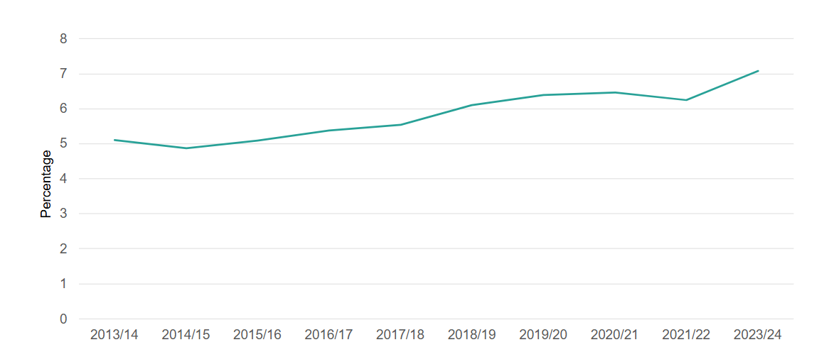
Figure 1: Adults feeling lonely in England
(Source: Department for Culture, Media and Sport, 2024)

Lower employment and economic disadvantage
Limited employment reduces income and opportunity for social participation. Only 6% of working-age adults with learning disability receiving long-term social care support were in self-employed or paid employment between 2017 and 2018 (Public Health England, 2020). The lack of employment and income opportunities potentially makes wider health inequality even worse. Vocational training, supported employment and reasonable workplace adjustment improve social and economic inclusion.
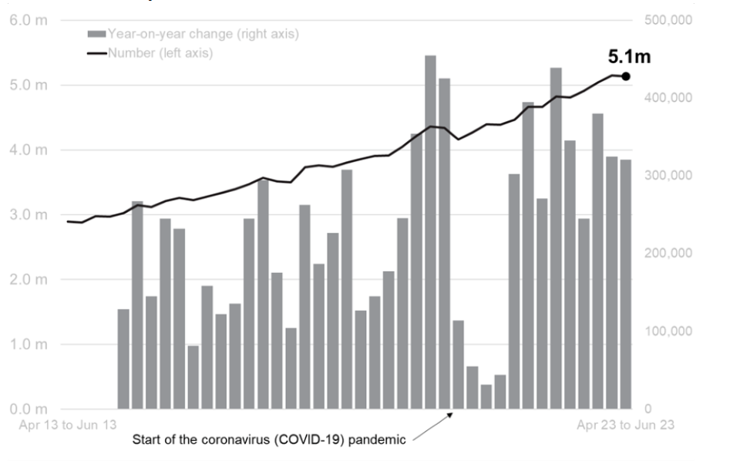
Figure 2: Number of disabled people in employment
(Source: Department for Work and Pensions, 2023)

Disability related employment inequality
The employment rate of disabled people was 53.6% in 2023 compared to 82.5% of non-disabled people (Department for Work and Pensions, 2023). Anti-discrimination measures, stronger employer support, disability inclusive recruitment and flexible working can reduce the gap.
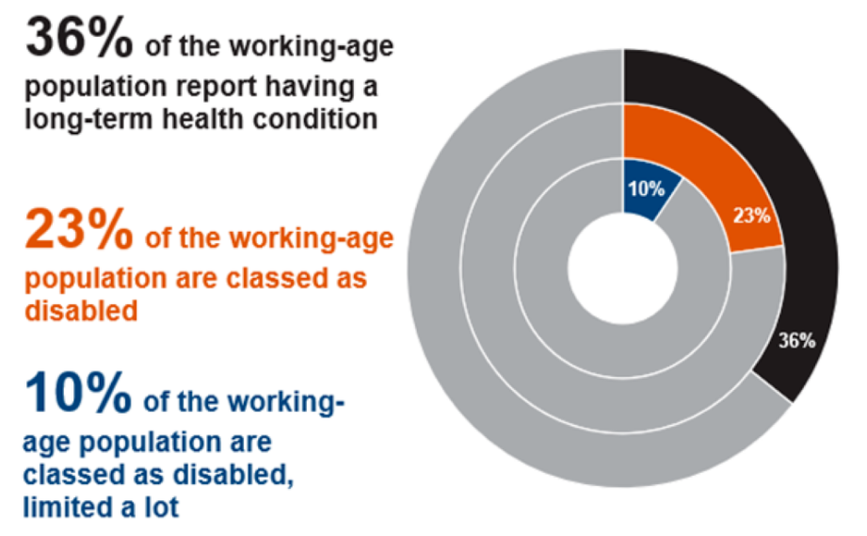
Figure 3: Disabled population class with long-term health complications
(Source: Department for Work and Pensions, 2023)

National Response to reduce health inequalities in your chosen group

Learning from Lives and Deaths of people with learning disability (LeDeR)
The LeDeR program is a national NHS England mortality review program that examines the deaths of people with learning disability to identify avoidable causes and improve services. The avoidable mortality between 2021 and 2023 fell from 46% to 39% (NHS England, 2025). Even though the percentage remained substantially higher compared to 22% recorded for the general population, converting to system-level learning helped in identifying recurring failures in the system (NHS England, 2025). Therefore, the program supports service improvement, action plan and accountability by identifying the treatable and preventable conditions requiring earlier intervention.

Reasonable adjustment digital flag
The reasonable adjustment digital flag, or RADF, was nationally introduced for improving equitable accessibility to social and healthcare. The National Information Standard requires all publicly funded health and social care providers and the NHS to achieve complete compliance by September 2026 (NHS England, 2026). It addresses structural inequality because people with learning disabilities should not have to explain accessibility and communication need repeatedly. Consistently sharing and recording can make health care more accessible and reduce missed opportunities for treatment and diagnosis.

Organisations that support chosen group
Mencap is a significant learning disability charity based in the UK whose wider role extends beyond direct support to research, public awareness, organising campaigns, challenging discrimination and policy advocacy. The ‘Treat me Well’ campaign of Mencap specifically focuses on tackling health inequalities and transforming NHS treatment through practical changes including reasonable adjustments, better communication and improved staff training (Mencap, 2024). A significant achievement has been the charity's contribution to securing mandatory training on learning disability and autism for Oliver McGowan.
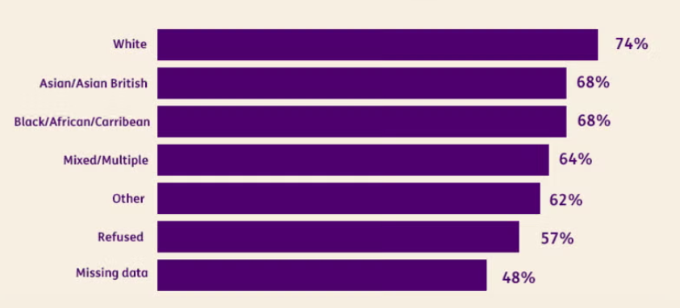
Figure 4: Percentage of people with learning disability registering for annual health check
(Source: Mencap, 2024)
The charity conducted a campaign for mandatory training after the research found that one in four healthcare professionals have never received learning disability training (Mencap, 2026). The program therefore focuses on improving staff confidence and knowledge so that healthcare professionals and service providers can recognise the need and provide adequate care to the individual. The recent analysis of LeDeR highlighted evidence which reports that only 4 in 10 people with a learning disability reach their 65th birthday, and it also highlights failure to provide required reasonable adjustments (Mencap, 2024). The charity also enables people with learning disabilities and their families to influence national decision-making and report problems.

Conclusion
In England, adults with learning disabilities experience substantial inequality in healthcare service provision that is influenced by socio-economic disadvantage, preventable health risks, and barriers to health care and social isolation. National initiatives, including RADF and LeDeR, focus on improving health care equality. Organisations like Mencap further support change through research, awareness and campaigning, which highlight the importance of coordinated actions for fair health outcomes.

Task 2: Epidemiological Analysis

Introduction

Consequences and definition
Hypertension is persistently elevated blood pressure generally defined as ≥140/90 mmHg. Being usually asymptomatic, it increases the risk of heart disease, stroke, heart failure and kidney disease, creating substantial social and health consequences (WHO, 2025). Caribbean and black African populations experience disproportionate hypertension burden and associated cardiovascular inequalities.

UK and global prevalence
An estimated 1.4 billion adults aged 30 to 79, which is approximately 33%, had hypertension in 2024, globally (WHO, 2025). On the other hand, only 23% had controlled blood pressure (WHO, 2025). 30% of adults in England aged above 16 years had hypertension in 2024 (Lambeth Council, 2023). The Lambeth inequality is particularly pronounced due to registered hypertension prevalence of 19% black residence as compared to only 8% among white residents (Lambeth Council, 2025). It highlights the severity of the issue within the selected population.

Main Body

Public Health measures applying 3Ps
Hypertension is a major public Health issue because it is usually asymptomatic but substantially increases the risk of heart failure, stroke and chronic kidney diseases. Over 34% of adults in Lambeth have higher than average blood pressure, while black Caribbean and black African residents experience particularly poor control over blood pressure (Lambeth Together, 2024). The 3 Ps-primary, secondary and tertiary prevention provide a framework for reducing and containing the burden. Primary prevention focuses on reducing exposure to modifiable risk factors through reduced salt intake, a healthy diet, physical activity, limited smoking, weight management and reduced consumption of alcohol. Secondary prevention involves early detection through GP blood pressure management, NHS health check, and ambulatory blood pressure monitoring and community pharmacy check. The NHS community pharmacy blood pressure check service specifically provides checks to adult aging over 40 years without previously identified hypertension (NHS England, 2025). Calcium channel blockers are first-line treatment for adults of African Caribbean and black African family origin without T2DM, recognising differences in the treatment responses (NICE, 2026). The tertiary prevention focuses on preventing complications through appropriate antihypertensive medication, regular monitoring and adherence support.

Major risk factor and determinant
The epidemiology reflects interaction between behavioural, biological and social determinants rather than ethnicity itself being a simple causal factor. The black Caribbean and black African populations have higher prevalence of hypertension. However, white British prevalence is approximately one third of the Caribbean prevalence and almost half of the African prevalence (Lambeth Council, 2022). Modifiable determinants include higher intake of salt, obesity, overweight, smoking, lack of physical activity and alcohol consumption (Lambeth Together, 2025). Social determinants are also important, as South East London evidence identifies overcrowded housing, deprivation, educational barriers, lack of employment and racism as major contributors to inequalities in treating hypertension (South East London ICB, 2023). Therefore, attributing the disparity completely to biological and genetic differences risks overlooking the wider social environment and also leads to a lack of effective intervention.
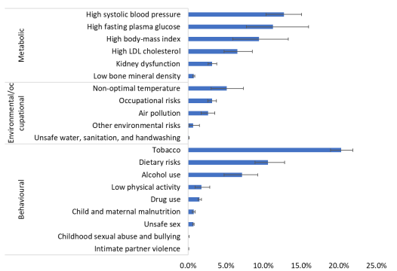
Figure 5: Major risk factors
(Source: Lambeth Council, 2022)

Health need assessment and epistemological studies
A Lambeth health need assessment highlights a clear local requirement for targeted action. 28000 residents were estimated to have hypertension, with black Caribbean and black African residents less likely to monitor and reduce their blood pressure (Lambeth Together, 2023). The local profile found that the prevalence of hypertension was higher among African, Caribbean, Asian and other black patients compared to other ethnic groups and was also higher among residents from more deprived neighbourhood localities (Lambeth Council, 2022). A UK retrospective cohort study that used 30379 South Asian, 731506 European and 20256 African Caribbean and African population primary care patients found ethnic differences in the management of hypertension (Eastwood et al. 2022). Thus, registered prevalence should not automatically be interpreted as true population prevalence.

Servillians system and epistemological monitoring
A combination of surveillance systems is required because no single system captures the complete burden. QOF is effective in identifying changes in diagnosed prevalence and management but excludes undiagnosed cases and cannot completely explain inequality in ethnic factors. Active case finding is provided through community pharmacy blood pressure check service and NHS health check where the pharmacist identifies raised readings and arranges ABPM (NHS England, 2025). Community surveillance or sentinel is demonstrated by health and well-being bus and community engagement research of Lambeth involving black Caribbean and black African residents (Lambeth Together, 2024). Stroke, hospital and cardiovascular data sets provide outcome surveillance. Collectively using the system improves triangulation, even though differences in recording practice, definition and coverage reduce comparability.

Public Health consequences and impact
The immediate public Health impact includes increased demand for medication, primary care and monitoring, while uncontrolled hypertension increases the probability of acute cardiovascular events. People of African Caribbean descent present with acute stroke around 10 years younger compared to White stroke patients in South London (Lambeth Together, 2024). Uncontrolled hypertension in the short term, therefore, increases healthcare costs and emergency admissions. On the other hand, the long-term consequences include chronic kidney disease, stroke disabilities, dementia, heart failure and premature mortality.
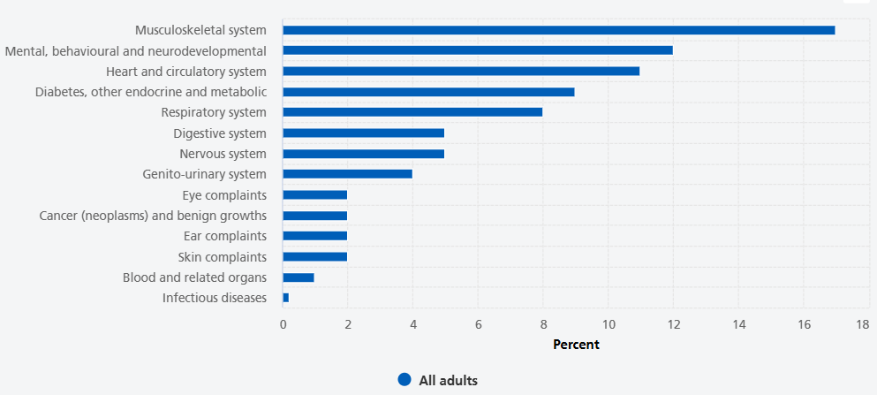
Figure 6: Prevalence of longstanding conditions
(Source: NHS England, 2026)

Proposed health intervention and evaluation
Lambeth blood pressure equity program should combine community case finding with culturally responsive primary Care management. The Lambeth health and well-being bus and community pharmacy should firstly provide free blood pressure checks in locations used by Black Caribbean and black African communities, including faith settings and community centres. Secondly, patients with raised readings should receive rapid GP follow-up and ABPM. It then needs to be followed by practices using ethnicity-stratified registers for identifying patients with uncontrolled hypertension and proactively recalling them for medication review. Fourthly, culturally appropriate education needs to address physical activity, diet, salt intake, and self-monitoring and medication adherence. The proposed strategy builds on an existing project of Lambeth where 2 GP practices eliminated a 12% Black-White control gap and diagnosed more than 300 previously identified patients (NHS England, 2024). Evaluation should compare 12-month outcomes and baseline for ABPM-confirmed diagnosis, detection rate, medication adherence, treatment initiation and the proportion achieving target blood pressure. Deprivation stratification and ethnicity outcomes should determine whether intervention reduces inequality rather than only improving overall outcome.
Intervention competent | Activities | Target population | KPI/expected outcome
Community screening | Providing free check-up through community pharmacy, health and well-being bus, faith organisations and community centres | Black Caribbean and black African adults, particularly in deprived locations | Increased identification and screening uptake of undiagnosed hypertension
Confirming diagnosis | Refer people with increased readings for ABPM and GP assessment | Adult with repeated raised BP reading | Increased proportion receiving confirmed diagnosis in appropriate time frame
Medication and treatment management | Provide NICE-guided antihypertensive treatment, adherence support and medication review | Adult diagnosed with hypertension | Increased medication adherence and treatment initiation
Lifestyle intervention | Providing culturally appropriate advice on healthy diet, salt reduction, weight management, physical activity, alcohol reduction | Adult with high cardiovascular risk or hypertension | Improve lifestyle behaviour and reduce cardiovascular risk factors
Culturally responsive support | Work with faith groups, community leaders and voluntary organisations for addressing health literacy, language, healthcare accessibility and trust barriers | Black Caribbean and black African community | Improved engagement with primary care, screening and hypertension management
Evaluation and monitoring | Compare diagnosis, BP control and treatment outcome before and 12 months after implementation | All program participants | Reduction in black-white blood pressure control gap and improved overall BP control
Table 1: Evaluation framework and Intervention pathway
(Source: Self-created)

Epistemological limitations, strengths, and weaknesses
The approach benefits from multiple data sources, routine primary care records, local population evidence and existing Lambeth intervention with measurable outcomes. Combining cohort evidence with descriptive epidemiology also allows possible determinants and scale of inequality to be examined. Observational and ecological data, however, cannot establish that ethnicity independently causes hypertension. Confounding by deprivation, age, healthcare accessibility and obesity can partly explain observed differences. Passive surveillance occurs through quality and outcome framework and GP recording. Hypertension in 2024 and 2025 was the most prevalent QOF-recorded condition nationally, accounting for 15.2% (NHS England Digital, 2025). QOF measures diagnosed patients and can miss undiagnosed diseases, and ethnicity categories will be effective in concealing substantial heterogeneity in Caribbean and African populations. Community intervention can also experience selection bias because people who voluntarily attend screening can be more health conscious. Lastly, improving detection initially can increase recorded prevalence, making the prevalence trend difficult to interpret. Lambeth therefore should triangulate surveillance data and use sex, age, deprivation and ethnicity-adjusted measures while evaluating progress.
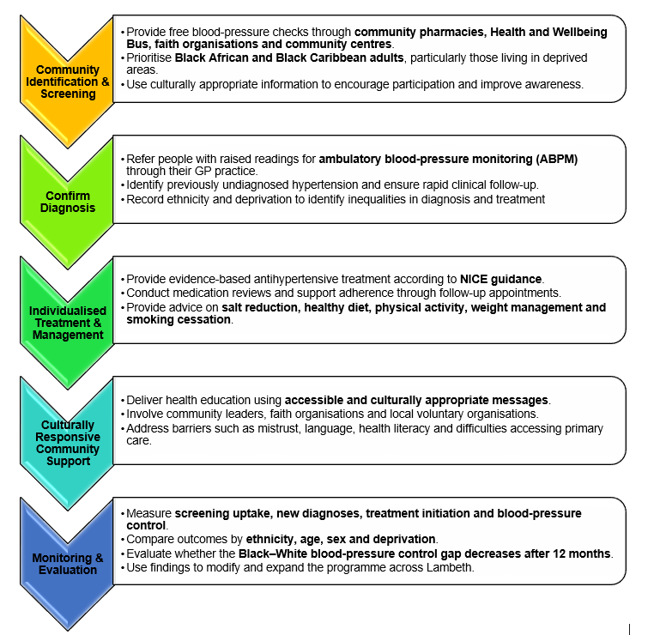
Figure 7: Lambeth Targeted Blood Pressure Equity Programme
(Source: Self-created)

Conclusion
Hypertension represents a preventable and significant public health issue among Black African and black Caribbean adults in Lambeth. According to the evidence, substantial ethnic inequality in prevalence, blood pressure control and diagnosis reflects an interaction between behavioural, biological, healthcare accessibility and socioeconomic factors. Epistemological surveillance using community, primary care and outcome data is essential to identify unmet requirements and monitor inequality. Early detection, targeted prevention, appropriate treatment and culturally responsive management are effective in reducing cardiovascular complications. Limitations, including confounding, under diagnosis, selection bias and incomplete ethnicity recording, however, need to be recognised. Combining routine surveillance with targeted community intervention therefore is effective to support a more equitable hypertension outcome in Lambeth.
References

Task 1
Department for Culture, Media and Sport (2024) Community Life Survey 2023/24: Loneliness and support networks. Available at:https://www.gov.uk/government/statistics/community-life-survey-202324-annual-publication/community-life-survey-202324-loneliness-and-support-networks--2 (Accessed: 8 August 2026).
Department for Work and Pensions (2023) The employment of disabled people 2023. Available at:https://www.gov.uk/government/statistics/the-employment-of-disabled-people-2023/employment-of-disabled-people-2023 (Accessed: 8 August 2026).
Mencap (2024) Health inequalities for people with a learning disability. Available at:https://www.mencap.org.uk/what-we-do/campaigns-and-activism/our-campaign-reports/health-inequalities-people-learning (Accessed: 8 August 2026).
Mencap (2024) Learning disability and autism training for health and care staff. Available at:https://www.mencap.org.uk/get-involved/campaign-mencap/treat-me-well/learning-disability-and-autism-training-health-and-care (Accessed: 8 August 2026).
Mencap (2025) NHS – Do you include me? Available at:https://www.mencap.org.uk/get-involved/campaigns-and-activism/nhs-do-you-include-me (Accessed: 8 August 2026).
Mencap (2026) Learning disability: health inequalities research. Available at:https://www.mencap.org.uk/learning-disability-explained/research-and-statistics/health/health-inequalities-research-and-statistics (Accessed: 8 August 2026).
NHS England (2024) Health and care passports: implementation guidance. Available at:https://www.england.nhs.uk/long-read/health-and-care-passports-implementation-guidance (Accessed: 8 August 2026).
NHS England (2024) Learning disability and autism programme. Available at:https://www.england.nhs.uk/learning-disabilities/improving-health/annual-health-checks (Accessed: 8 August 2026).
NHS England (2025) Learning from lives and deaths – people with a learning disability (LeDeR) annual report. Available at:https://www.england.nhs.uk/learning-disabilities/improving-health/learning-from-lives-and-deaths (Accessed: 8 August 2026).
NHS England (2025) Update on Learning Disability and Autism Programme. Available at:https://www.england.nhs.uk/long-read/update-on-learning-disability-and-autism-programme (Accessed: 8 August 2026).
NHS England (2026) Reasonable Adjustment Digital Flag action checklist. Available at:https://www.england.nhs.uk/long-read/the-reasonable-adjustment-digital-flag-action-checklist-what-you-need-to-do-to-achieve-compliance/ (Accessed: 8 August 2026).
NHS England (2026) What is the Reasonable Adjustment Digital Flag? Available at:https://www.england.nhs.uk/learning-disabilities/improving-health/what-is-the-reasonable-adjustment-digital-flag (Accessed: 8 August 2026).
Public Health England (2020) Obesity and weight management for people with learning disabilities. Available at:https://www.gov.uk/government/publications/obesity-weight-management-and-people-with-learning-disabilities/obesity-and-weight-management-for-people-with-learning-disabilities-guidance (Accessed: 8 August 2026).
Public Health England (2020) People with learning disabilities in England: employment. Available at:https://www.gov.uk/government/publications/people-with-learning-disabilities-in-england/chapter-2-employment (Accessed: 8 August 2026).

Task 2
Department of Health and Social Care (2021) Health: Commission on Race and Ethnic Disparities. Available at:https://www.gov.uk/government/publications/the-report-of-the-commission-on-race-and-ethnic-disparities/health (Accessed: 8 August 2026).
Eastwood, S.V.,Hughes, A.D,Tomlinson, L.,Mathur, R.,Smeeth, L.,Bhaskaran, K., Chaturvedi, N. (2022) ‘Ethnic differences in hypertension management, medication use and blood pressure control in UK primary care, 2006–2019: a retrospective cohort study’, The Lancet Regional Health – Europe, 18. Available at:https://pubmed.ncbi.nlm.nih.gov/36818236/
Lambeth Council (2022) Health Profile for Lambeth 2022: Metabolic – Hypertension. Available at:https://www.lambeth.gov.uk/sites/default/files/2022-10/health-profile-for-lambeth-2022-section-6.pdf (Accessed: 8 August 2026).
Lambeth Council (2023) Help us research hypertension and heart health in Lambeth. Available at:https://love.lambeth.gov.uk/help-us-research-hypertension-and-heart-health-in-lambeth (Accessed: 8 August 2026).
Lambeth Council (2025) Lambeth Pharmaceutical Needs Assessment 2025. Available at:https://www.lambethtogether.net/long-read/neighbourhood-and-wellbeing-delivery-alliance-progress-report-2022-23/strategic-priority-1-prevention (Accessed: 8 August 2026).
Lambeth Together (2023) Strategic Priority 1: Prevention. Available at:https://www.lambethtogether.net/long-read/neighbourhood-and-wellbeing-delivery-alliance-progress-report-2022-23/strategic-priority-1-prevention (Accessed: 8 August 2026).
Lambeth Together (2024) NWDA project: high blood pressure. Available at:https://www.lambethtogether.net/delivery-alliances/nwda/nwda-projects/nwda-project-high-blood-pressure (Accessed: 8 August 2026).
Lambeth Together (2024) Strategic Priority 3: Living well for longer. Available at:https://www.lambethtogether.net/long-read/neighbourhood-and-wellbeing-delivery-alliance-progress-report-2023-24/strategic-priority-3-living-well-for-longer (Accessed: 8 August 2026).
Lambeth Together (2025) High blood pressure – advice and useful links. Available at:https://www.lambethtogether.net/delivery-alliances/nwda/nwda-projects/nwda-project-high-blood-pressure/high-blood-pressure-advice-and-useful-links (Accessed: 8 August 2026).
NHS England (2024) How Lambeth is closing the health inequality gap for Black and minority ethnic patients with high blood pressure. Available at:https://www.england.nhs.uk/about/equality/equality-hub/case-studies/how-lambeth-is-closing-the-health-inequality-gap-for-black-and-minority-ethnic-patients-with-high-blood-pressure/ (Accessed: 8 August 2026).
NHS England (2025) NHS Community Pharmacy Blood Pressure Check Service. Available at:https://www.england.nhs.uk/primary-care/pharmacy/pharmacy-services/nhs-community-pharmacy-blood-pressure-check-service (Accessed: 8 August 2026).
NHS England (2025) NHS Community Pharmacy Hypertension Case-Finding Advanced Service. Available at:https://www.england.nhs.uk/publication/advanced-service-specification-nhs-community-pharmacy-hypertension-case-finding-advanced-service (Accessed: 8 August 2026).
NHS England (2026) Health Survey for England 2024: Adults’ health. Available at:https://digital.nhs.uk/data-and-information/publications/statistical/health-survey-for-england/2024/adults-health (Accessed: 8 August 2026).
NHS England Digital (2025) Quality and Outcomes Framework, 2024–25. Available at:https://digital.nhs.uk/data-and-information/publications/statistical/quality-and-outcomes-framework-achievement-prevalence-and-exceptions-data/2024-25 (Accessed: 8 August 2026).
NICE (2026) Hypertension in adults: diagnosis and management (NG136). Available at:https://www.nice.org.uk/guidance/ng136/chapter/recommendations (Accessed: 8 August 2026).
Office for National Statistics (2023) Risk factors for undiagnosed high blood pressure in England. Available at:https://www.ons.gov.uk/peoplepopulationandcommunity/healthandsocialcare/healthandwellbeing/articles/riskfactorsforundiagnosedhighbloodpressureinengland/2015to2019 (Accessed: 8 August 2026).
South East London Integrated Care System (2023) A guide for Lambeth General Practice: Hypertension. Available at:South East London ICB – Lambeth Hypertension Guide (Accessed: 8 August 2026).
WHO (2025) Hypertension. Available at:https://www.gov.uk/government/publications/the-report-of-the-commission-on-race-and-ethnic-disparities/health (Accessed: 8 August 2026).

