STUDENT NAME: Cristina Tudureanu
STUDENT NUMBER: 1917153
PROGRAMME: Business Management
MODULE NAME: International Financial Management
ASSIGNMENT TITLE: Assessment 1
MODULE CODE: LCBB6002
LECTURER’S NAME: Dr. Rexon Nting

International Financial Management

Assessment 1
McDonald’s
IMF report

Table of contents

- Introduction………………………………………………………………………4
- Company overview………………………………………………………………4
- McDonald’s the s dividend distribution policy……………………………………………………………………….……...5
- McDonald’s methods of appraising projects……………………………………5
- Financial Analysis…………………………………………………………………6
  - Ratio analysis……………………………………………………………..6
    - Revenue………………………………………………………………..6
    - Profitability……………………………………………………………..8
    - Market value…………………….……………………………………12
    - Liquidity ratios………………………………….…………………….13
    - Dept management ratios…………………………………………….14
    - Asset management ratios……………………………………………15
- Efficient market hypothesis (EMH) theory analysis……………………...…...17
- Conclusion…………………………………………………………………………18
- References ………………………………………………………………………..19

- Introduction

This research is about McDonald's 5-year financial performance. This corporation is a global food giant who among time strived many competitors. This examination will focus on the last five years' financial data. McDonald's financial analysis should reveal the future of the company, stock market, and economy. As financials alone can't measure a company's performance. Furthermore, this report will employ a SWOT analysis to assess the company's strengths, weaknesses, opportunities, and threats.

- Company overview

In 1940, McDonald's opened its doors to the public in California. In June of this year, the company moved to Chicago. In terms of income, McDonald's is the world's largest restaurant chain, with 37,855 restaurants in 100 countries serving 69 million people per day (O.Walton,2017).
McDonald's employs 1.7 million people, making it the second-largest private employer in the world (behind Walmart with 2.3 million employees). McDonald's will be ranked seventh by the year 2021.
McDonald's restaurants are the company's and franchisees' focus. These restaurants serve more than 100 nationalities with a limited yet diversified menu. The company also has a minority stake in Pret A Manger in the UK. Donatos was sold in 2003. McDonald's restaurants account for almost all of the company's operating performance, unless otherwise specified. All eateries are company-owned or franchised (companies with which the company has licencing relationships) (W.Kenton,2022).

- MCDONALDS THE S DIVIDEND DISTRIBUTION POLICY
The dividend policy is "how management decides dividend pay-out alternatives" and "the amount and pattern of cash pay-outs to shareholders over time" (Lease, 2000).
Quarterly dividends will be $1.38, up 7.5%. All stockholders with excellent accounts as of December 1 will get a dividend on December 15. Fourth-quarter dividends will reach $1 billion.
The company's dividend distribution has climbed every year since 1976. For 45 years, McDonald's has raised its dividend.
McDonald's is a good investment now. Always invest in a company that pays dividends. Investors seeking regular dividend income favour firms with a history of growing dividends.
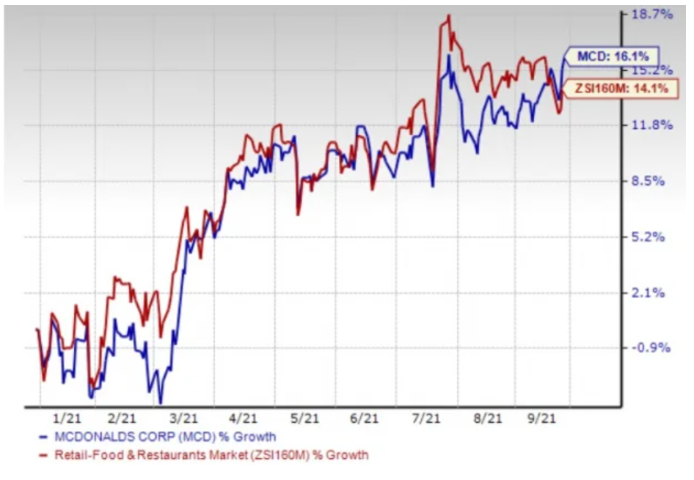
Fig.1: MCD dividend distribution policy
Source: Zacks, 2021

Price Performance
Corporate goals include drive-thru, delivery and takeaway. It was about this time that McDonald's unveiled its first customer loyalty programme in the United States. Over 80% of the company's restaurants in 100 markets are able to ship their food to customers. Efforts are being made to expand their reach on a global scale (E.Mcconell, 2019).

With 500 restaurants expected to launch in 2020, despite the pandemic, There was opened 1,300 restaurants in the company's global network by the year 2021. In June, it opened its 4,000th restaurant in China, and it expects to open another 500 this year.
Direct stock purchase and dividend reinvestment are two features of McDonald's Computershare Investment Plan. Investing in McDonald's Corporation common stock and reinvesting dividends is made easier by this strategy.
- MCDONALD’S METHODS OF APPRAISING PROJECTS
A project's approval or rejection is determined by reviewing its content and conducting a feasibility analysis of its solution options (alternatives), selecting the most feasible option, creating the solution statement, and identifying all individuals and organisations impacted by or involved in the project. The initiative's viability and cost-effectiveness may justify it (DK.Sinha, 2022).
There are many methods to use when and appraisal project analysis is conducted:
- Financial analysis
- Market analysis
- Economic analysis
- Life-cycle segmentation analysis
- Technical feasibility
- Management competence

- FINANCIAL ANALYSIS

  - Ratio analysis
Using statistics extracted from financial accounts, financial ratios are built in order to obtain meaningful information about a company. Using a company's financial documents - the balance sheet, income statement, and cash flow statement - quantitative analysis is done to evaluate the firm's financial health (W.Kenton,2022).

    - Revenue
Sales revenue analysis may be used to evaluate your company's performance and forecast its future. An investigation into year-over-year or quarterly sales figures is the focus of this research (sales forecast). Sales revenue is more than just the total amount of money earned. The launch dates of new items, demographics of potential customers, and advertising budgets are all taken into account (W.Kenton,2022).
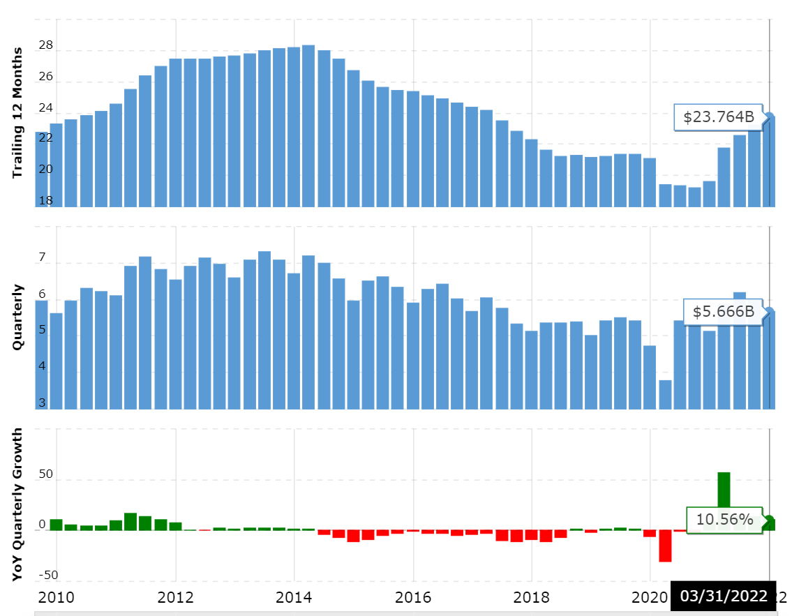
Fig.2: MCD revenues from 2010 to 2022
Source: Stock Analysis, 2022

This graph shows McDonald's yearly and quarterly revenue increase from 2010-2022. A company's revenue is the money it makes from selling goods and services. Deducting sales and expenditures yields net income (stockanalysis, 2022).
McDonald's quarterly sales grew 10.56 percent to $5.666 billion in March 2022.
McDonald's finished March 31, 2022 with $23.764 billion in sales, a 21.13 percent gain from the previous year.

    - Profitability
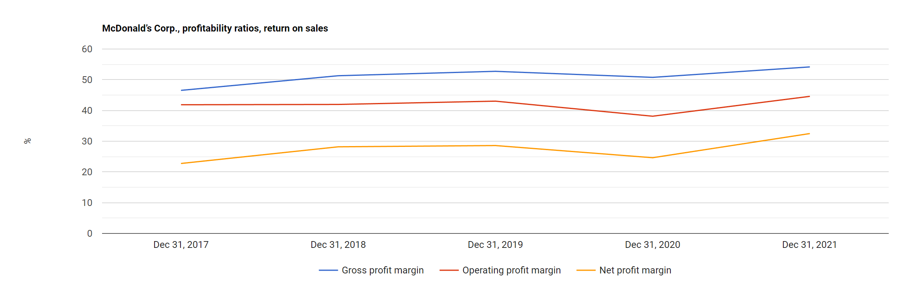
Fig.3: MCD profitability ratios
Source: Stockanalysis,2022

Gross profit margin measures how much money is left after costs (CFI, 2022).
As can be seen in Fig.3, the McDonald’s gross profit margin ratio has an overall rise during 2017 until 2021 with a quite stabile period in 2018 to 2019 and going down in 2020. A strong rise came in 2021 when the company showed resilience after the pandemic.

The operating profit margin
Profitability is measured by net profit/revenue. Profitability is measured by net profit/revenue ratio of McDonald's Corp (CFI, 2022) improved from 2020 to 2021, surpassing 2019.

Net profit margin ratio
Profitability is measured by net profit/revenue. McDonald's Corp.'s net profit margin ratio decreased from 2019 to 2020 but increased from 2020 to 2021.

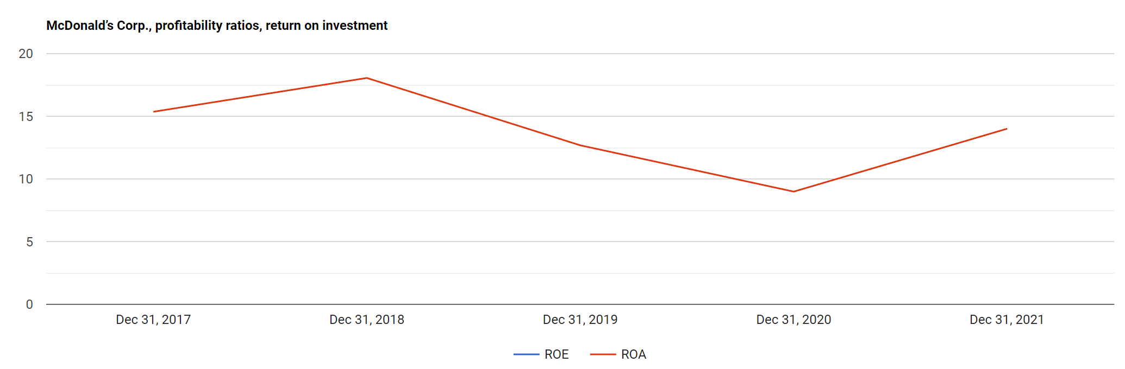
Fig.4: MCD profitability ratios return on investment
Source: Stockanalysis, 2022
ROA IS calculated as net income/total assets (CFI, 2022).
Fig.4. illustrates ROA for McDonalds where cand be clearly seen that the year 2018 registered the highest rise going down continuously until 2020 and taking all strength and climb from 2020 to 2021.

Gros Profit Margin

Gross profit margin measures how much money is left after costs (CFI,2022).
McDonald's gross profit margin ratio registered a fall from 2019 to 2020 and after the pandemic returned to 2019 gross profit registered again in year 2021.D
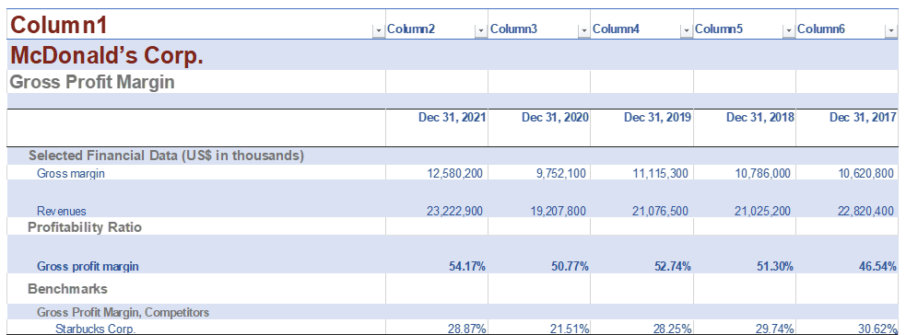
Fig.5: MCD gross profit margin calculations
2021 Calculation
Gross profit margin = 100 × Gross margin ÷ Revenues
= 100 × 12,580,200 ÷ 23,222,900 = 54.17%
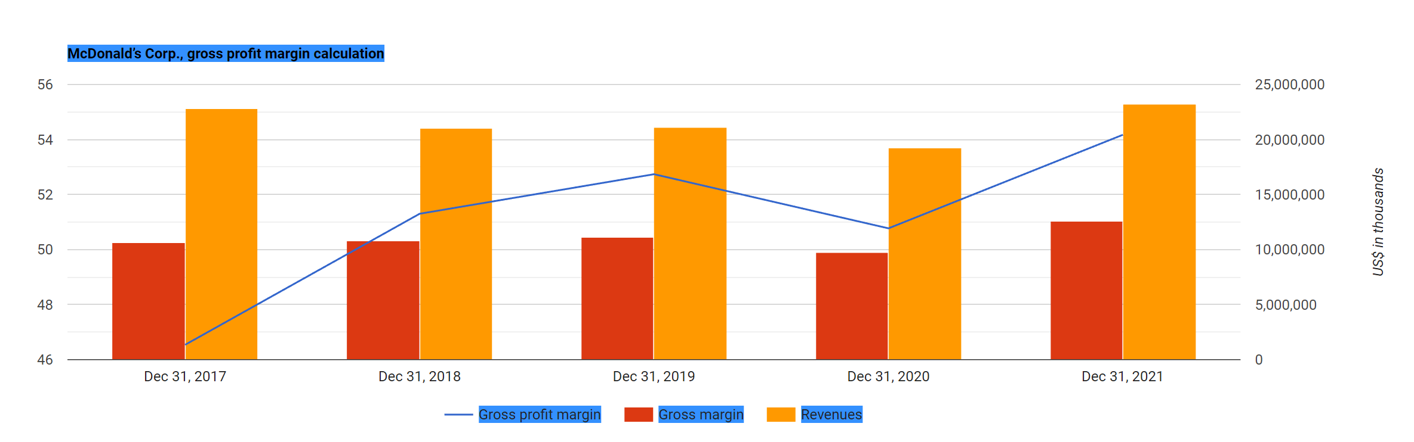
Fig.6: MCD gross profit margin calculations
Source: Stockanalysis, 2022

Operating Profit Margin

Calculate profitability by dividing operating income by revenue (Stockanalysis, 2022).
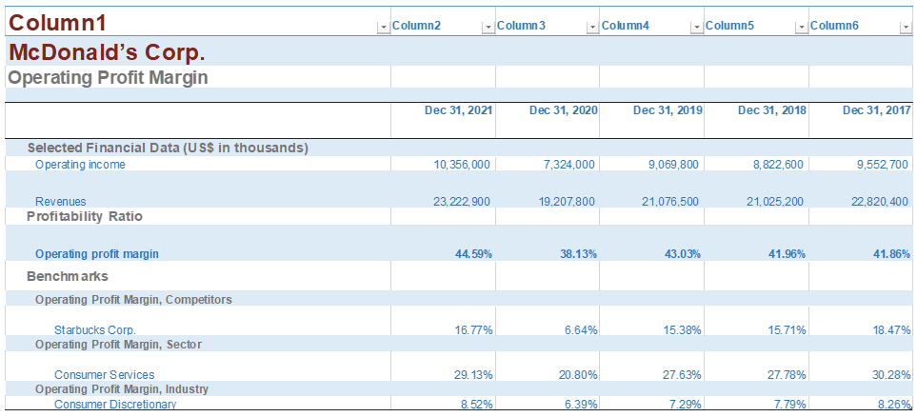
Fig.7: MCD operation profit margin calculations

2021 Calculation
Operating profit margin = 100 × Operating income ÷ Revenues
= 100 × 10,356,000 ÷ 23,222,900 = 44.59%
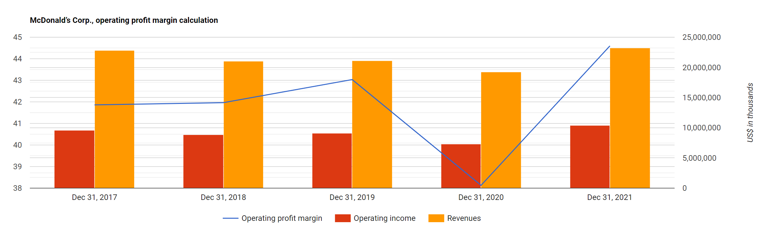
Fig.8: Operating profit calculations
Source: Stockanalysis, 2022
McDonald's Corporation's operating profit margin ratio has overall grow 2017 to 2019 with a big drop during pandemic.

    - Market value

Certified Financial Planner Bobbi Rebell defines "market value" as a company's "total actual value" after considering its financial achievements, debt levels, and industry health (A.Saad, 2021).

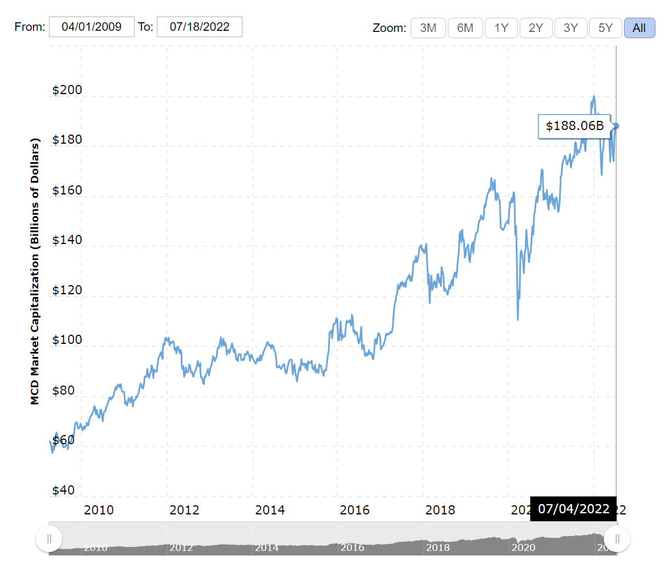
Fig.9: MCD market value
Source: macrotrends.com, 2022

The graph above shows McDonald's market cap from 2010-2022. To determine a company's market capitalization, multiply its stock price by its outstanding shares (or market value). On July 12, 2022, McDonald's was worth $187.31B (A.Saad, 2021).

    - Liquidity ratios

Current ratio gauges a company's short-term liquidity. Total Current Assets divided by Total Current Liabilities.
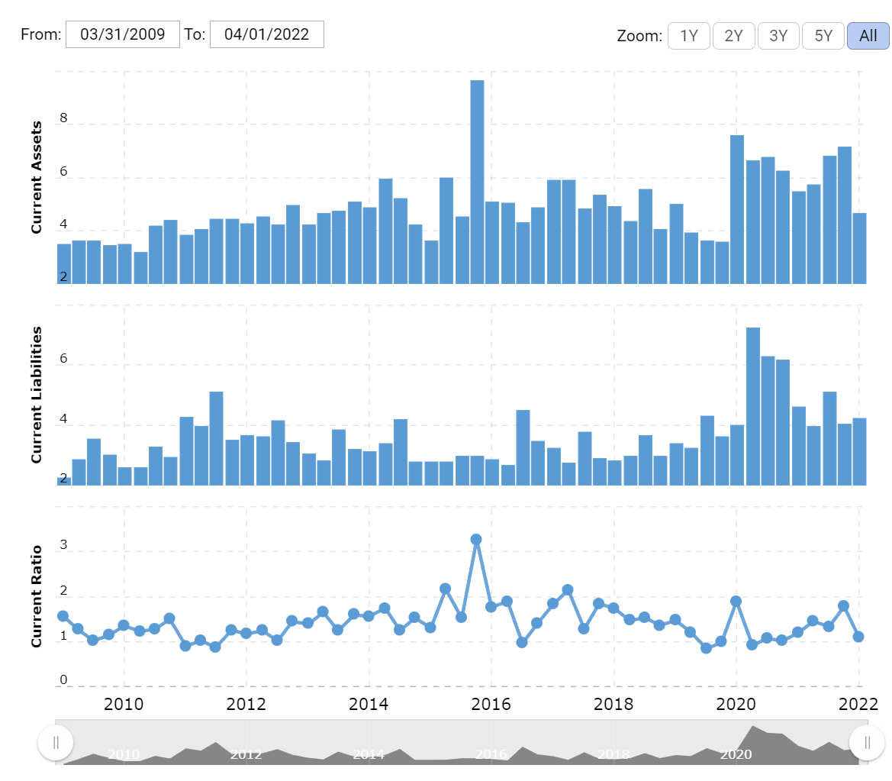
Fig.10: MCD LIQUIDITY RATIO
Source: macrotrends.com, 2022
McDonald's (MCD) 2010-2022 current ratios. Current ratio measures a company's short-term debt. McDonald's current ratio was 1.10 in Q4 2022.

    - Dept management ratios

D/E ratio divides total liabilities by shareholder equity to measure financial leverage. D/E ratio is essential in corporate finance. It compares how much a firm relies on borrowed vs. own funds to operate. It assesses a company's ability to pay its debts in a crisis using shareholder equity. Debt-to-equity is a gearing ratio.
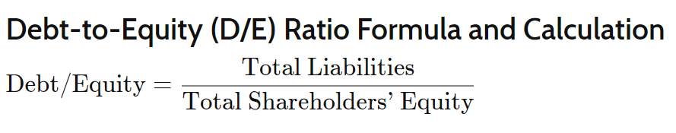
Investor confidence and stock value change annually. Growth or crisis recovery techniques affect a company's leverage. An annual D/E graph shows the company's risk or leverage profile over time.
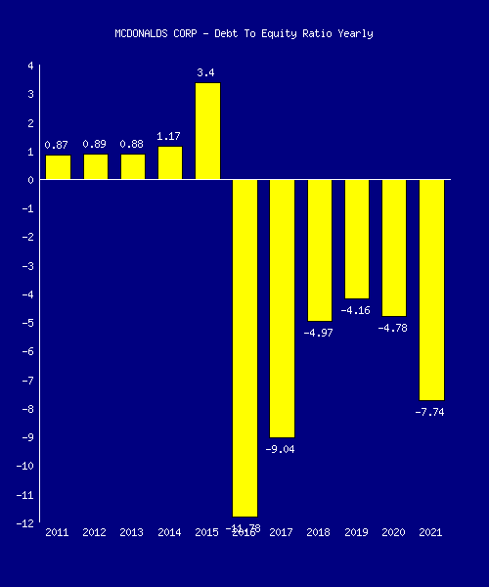
Fig.11: MCD dept to equity ratio
Source: J.Fernando, 2022

Below is MCDONALDS CORP's D/E. Last column represents year-over-year change.

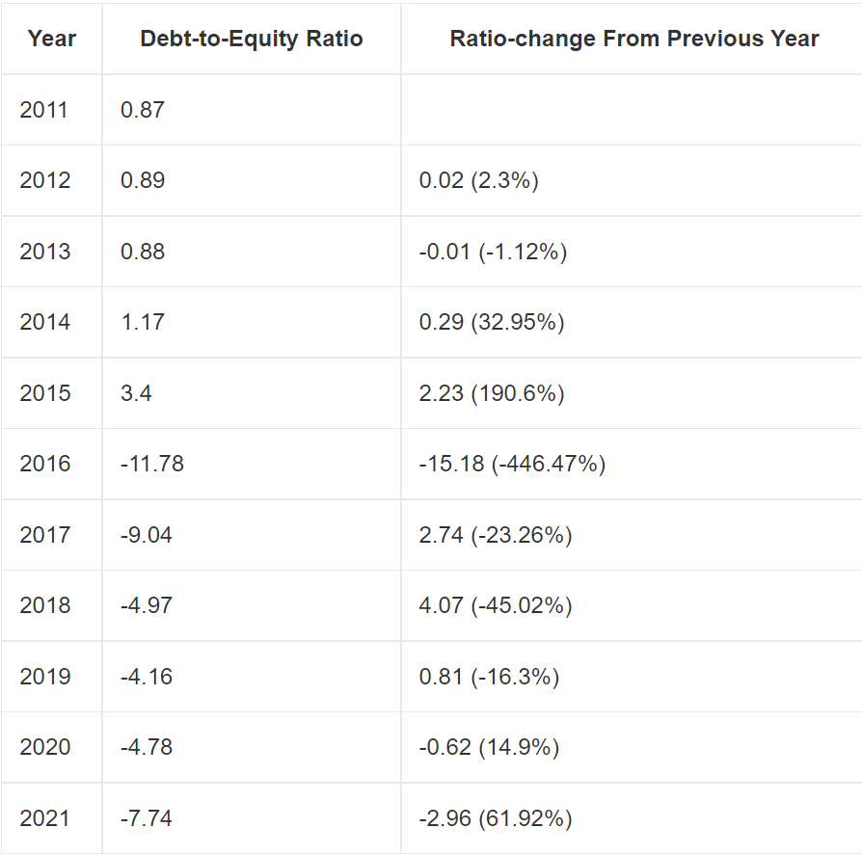
Fig.12: MCD dept/equity
Source: J. Fernando, 2022

    - Asset management ratios
The asset turnover ratio compares an organization's sales to its assets. The asset turnover ratio measures a business's capacity to generate income from its assets (A.Hayes,2022).
A high asset turnover ratio helps companies maximise earnings. A low asset turnover ratio shows that a business is not using its assets to generate money.
The formula and the calculations for asset turnover is shown below
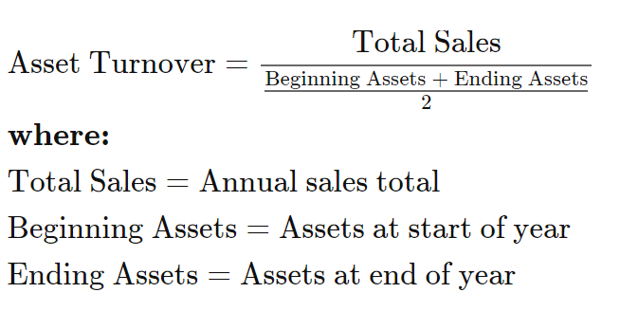
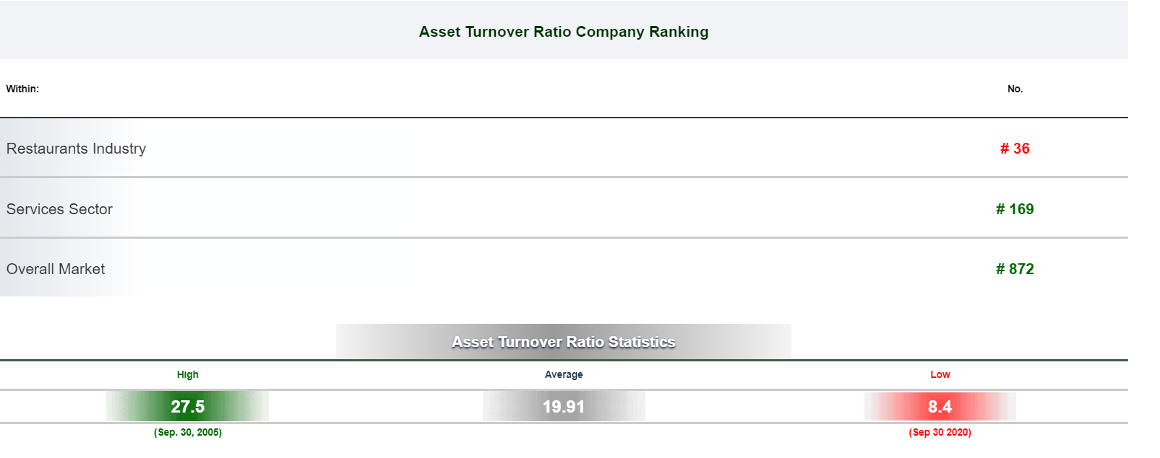
Fig.13: MCD Asset turnover
Source: A.Hayes, 2022

Mcdonald S's asset turnover ratio grew to 0.45 in Q1 2022, which is lower than normal.
McDonald S.'s asset turnover ratio is lower than 168 Services firms, the asset turnover ratio stayed at the same level as previous quarter.

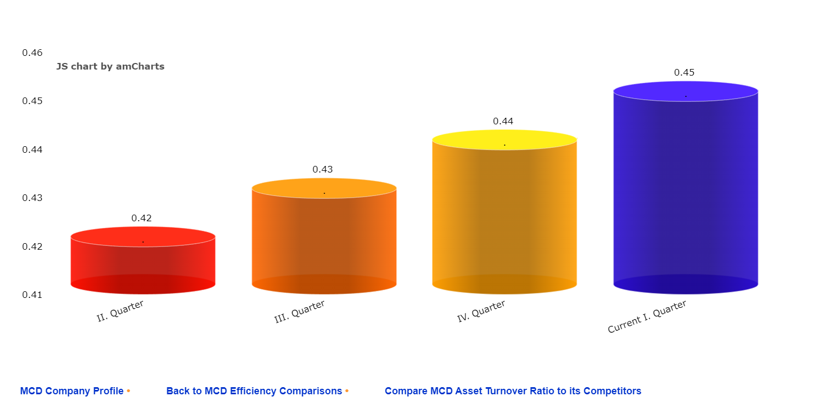
Fig.14: MCD asset turnover
Source: A.Hayes, 2022
- EFFICIENT MARKET HYPOTHESIS (EMH) THEORY ANALYSIS
According to the Efficient Market Hypothesis, a security's price represents all available information. EMH has enormous impacts. Most investors think the purchase price is lower than the security's value and the selling price is greater. Trying to outperform the market by trading securities is more a question of luck than aptitude if current prices contain all relevant information. The Efficient Markets Hypothesis includes three variations because various types of information affect asset values (hereafter EMH).

Weak EMH solely considers the past when valuing assets. According to the EMH, technical analysis of past prices cannot consistently beat the market.
Semi-Strong EMH uses all publicly available information to evaluate stocks. This data includes a company's financial statements, accounting processes, earnings and dividends, and rivals' finances.
Strong Form EMH says the current stock price includes all public and private information. It's hard to beat the market without intimate knowledge. EMH proponents think asset prices correctly represent future market projections. As the financial analysis shows McDonald has a strong form of EMH.

- Conclusion

McDonald's revamp might reflect today's woke generation. Fast-food restaurants are often seen as unhealthy, contrary to the trend of customers choosing better choices and avoiding them.
This trend might affect McDonald's future profitability, necessitating a rebranding effort. Fast-food competitors have increased in recent years..
According to this study, McDonald's brand image is one of the company's most precious assets, thus it must be preserved, enhanced, and protected forever. Franchises' supply chain management must also be monitored.
Given current trends and financial analysis, this fast-food giant will continue to prosper and perform well in future.

- References

W.Kenton, (2022), “Research and Development (R&D)”, Available at: https://www.investopedia.com/terms/r/randd.asp , Accessed:10.07.2022.
O.Walto, (2017), “McDonald s Corporation Analysis of Financial Statements”, Available at: https://silo.tips/download/mcdonald-s-corporation-analysis-of-financial-statements , Accessed: 11.07.2022.
CSI, (2022), “Mcdonald s Corporation”, Available at: https://csimarket.com/stocks/MCD-Business-Description.html , Accesssed: 12.07.2022.
Stock Analysis.net, (2022), “McDonald’s Corp. (NYSE:MCD)”, Available at: https://www.stock-analysis-on.net/NYSE/Company/McDonalds-Corp/Ratios/Profitability#Ratios-Summary , Accessed: 12.07.2022.
Macrotrends.net, (2022), “McDonald's Market Cap 2010-2022 | MCD” , Available at: https://www.macrotrends.net/stocks/charts/MCD/mcdonalds/market-cap , Accessed: 12.07.2022.
A.Saad, (2021), “How market value can help you determine the true worth of company or asset” , Available at: https://www.businessinsider.com/personal-finance/market-value?r=US&IR=T , Accessed: 13.07.2022.
MCD, (2021), “A year of resilience and great progress, Annual Report 2021.” Available at: https://corporate.mcdonalds.com/ , Accessed: 13.07.2022.
J.Fernando, (2022), “Debt-to-Equity (D/E) Ratio”, Available at: https://www.investopedia.com/terms/d/debtequityratio.asp , Accessed: 13.07.2022.
A.Hayes, (2022), “Asset Turnover Ratio” , Available at: https://www.investopedia.com/terms/a/assetturnover.asp , Accessed: 14.07.2022.
CFI, (2022), “Financial Ratios”, Available at: https://corporatefinanceinstitute.com/resources/knowledge/finance/financial-ratios/ , Accessed: 14.07.2022.

