3/24/2026

Design and Implementation of a Relational Database System
Module Name: Introduction to Web and Database
Concepts
Module Code: ACCA4023

Student Name: Alison Sherman Vas
Student ID: 2513127
Group: 1

Lecturer’s Name: Koushik Modak

University of Wales Trinity Saint David
LONDON CAMPUS

Table of Contents
Table of Contents 3
Task1 3
1. Introduction 3
2. Scenario Overview 4
3. Scenario Analysis 4
3.1 Identification of Entities 4
3.2 Attributes of Entities 4
3.3 Relationships Between Entities 6
4. Entity Relationship Diagram (ERD) 7
5. Data Structure Development 7
6. Database Normalization (Up to Third Normal Form) 9
First Normal Form (1NF) 9
Second Normal Form (2NF) 9
Third Normal Form (3NF) 9
7. Sample Data Population 9
8. Query Development 9
Query 1 – Low Stock Medicines 10
Query 2 – Medicines Expiring Soon 10
Query 3 – Sales by Customer 10
Query 4 – Most Sold Medicines 10
9. Validation and Testing 10
Task 2 11
10. Design Reflection and Future Improvements 11
11. Conclusion 11
12. References (IEEE Format) 11

Design and Implementation of a Relational Database System
  - MediLink Pharmacy Management System

Table of Contents
- 1. Introduction
- 2. Scenario Overview
- 3. Scenario Analysis
- 3.1 Identification of Entities
- 3.2 Attributes of Entities
- 3.3 Relationships Between Entities
- 4. Entity Relationship Diagram (ERD)
- 5. Data Structure Development
- 6. Database Normalization (Up to Third Normal Form)
- 7. Sample Data Population
- 8. Query Development
- 9. Validation and Testing
- 10. Design Reflection and Future Improvements
- 11. Conclusion
- 12. References (IEEE Format)

Task1

1. Introduction
Modern pharmacies rely heavily on information systems to manage medicine inventories, customer prescriptions, supplier records, and sales transactions. Manual record-keeping methods often lead to data redundancy, misplaced records, and inefficiencies in daily operations.
This report presents the design and implementation of a relational database system for MediLink Pharmacy, a community pharmacy chain seeking to improve operational efficiency through digital data management.
The database system was developed using Microsoft Access, which provides tools for table creation, relational design, queries, and reporting. The system automates processes related to medicine stock control, prescription management, supplier information, and customer purchases.
The primary objectives of this database system are:
- Improve data accuracy and reduce manual errors
- Provide efficient storage of pharmacy information
- Enable quick retrieval of records through queries
- Support management reporting for decision-making

2. Scenario Overview
The CEO of MediLink Pharmacy identified several operational problems due to the pharmacy’s reliance on manual record-keeping systems. These issues include difficulties in tracking medicine inventory, managing supplier relationships, maintaining accurate prescription records, and monitoring daily sales.
The purpose of the database system is to automate these tasks by organising pharmacy information into structured relational tables. The system manages key information related to medicines, suppliers, customers, prescriptions, and sales transactions.
By implementing a relational database system, the pharmacy will benefit from improved record management, faster information retrieval, and better monitoring of stock levels and business performance.

3. Scenario Analysis

3.1 Identification of Entities
Based on the scenario requirements, several core entities were identified to represent the key components of the pharmacy’s operations.
The main entities include:
- Suppliers
- Medicines
- Customers
- Prescriptions
- PrescriptionDetails
- Sales
- SalesDetails
Each entity represents a specific type of information required by the pharmacy system.

3.2 Attributes of Entities
Each entity contains attributes that describe the characteristics of the data being stored.

Suppliers
Attribute | Description
SupplierID | Unique identifier for supplier
SupplierName | Name of supplier
ContactNumber | Supplier contact number
Email | Supplier email
Address | Supplier address

Medicines
Attribute | Description
MedicineID | Unique medicine identifier
MedicineName | Name of medicine
Category | Medicine category
UnitPrice | Price per unit
StockQuantity | Quantity available
ExpiryDate | Expiry date of medicine
SupplierID | Supplier reference

Customers
Attribute | Description
CustomerID | Unique customer identifier
FirstName | Customer first name
LastName | Customer last name
PhoneNumber | Contact number
Address | Customer address
DateOfBirth | Customer date of birth

Prescriptions
Attribute | Description
PrescriptionID | Unique prescription ID
CustomerID | Customer reference
DoctorName | Prescribing doctor
PrescriptionDate | Date issued

PrescriptionDetails
Attribute | Description
PrescriptionDetailID | Unique detail ID
PrescriptionID | Linked prescription
MedicineID | Medicine prescribed
Quantity | Quantity prescribed
Dosage | Medicine dosage

Sales
Attribute | Description
SaleID | Unique sale ID
CustomerID | Customer making purchase
SaleDate | Date of sale
TotalAmount | Total transaction value

SalesDetails
Attribute | Description
SaleDetailID | Unique detail ID
SaleID | Associated sale
MedicineID | Medicine sold
Quantity | Quantity sold
UnitPrice | Price per unit

3.3 Relationships Between Entities
Relationships define how tables are connected.
Key relationships include:
- One supplier supplies many medicines
- One customer can have many prescriptions
- One prescription can contain multiple medicines
- One customer can make multiple purchases
- One sale may contain multiple medicines
These relationships ensure that the database reflects real-world pharmacy operations.

4. Entity Relationship Diagram (ERD)
The ERD visually represents the relationships between the entities identified in the database design.
The diagram shows primary keys, foreign keys, and the cardinality between tables.
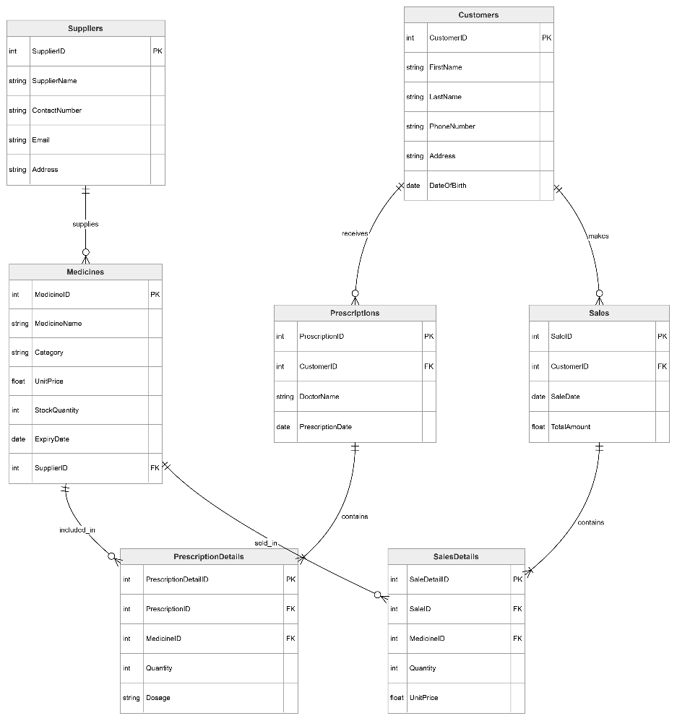
Figure 1: Entity Relationship Diagram for MediLink Pharmacy Database
The ERD demonstrates the relational structure and ensures data is connected correctly across all tables.

5. Data Structure Development
The database structure was implemented in Microsoft Access by creating tables corresponding to the entities defined in the ER model.
Each table includes a primary key to uniquely identify records and foreign keys to establish relationships with other tables.
Referential integrity was enforced to maintain consistent relationships between tables. This prevents invalid data entry, such as recording a sale for a customer that does not exist in the system.
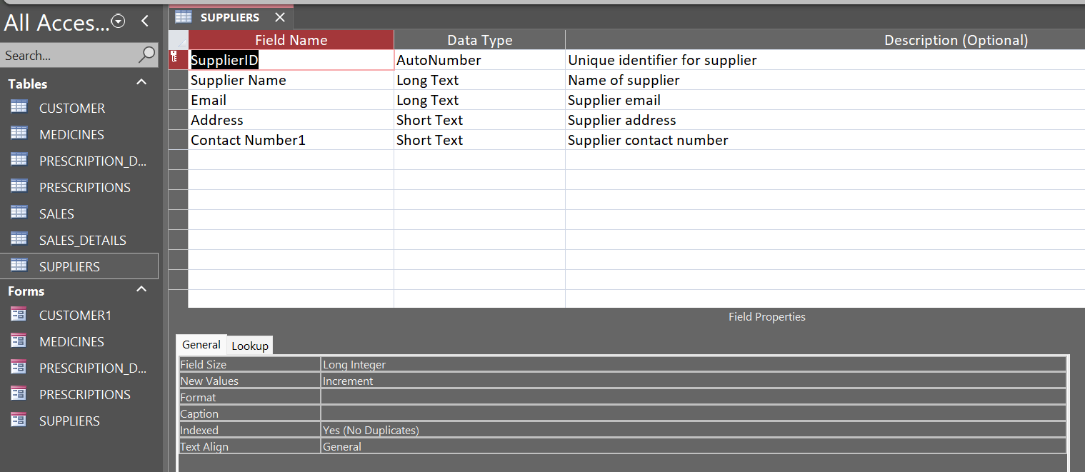
Figure 2: Suppliers Table Design

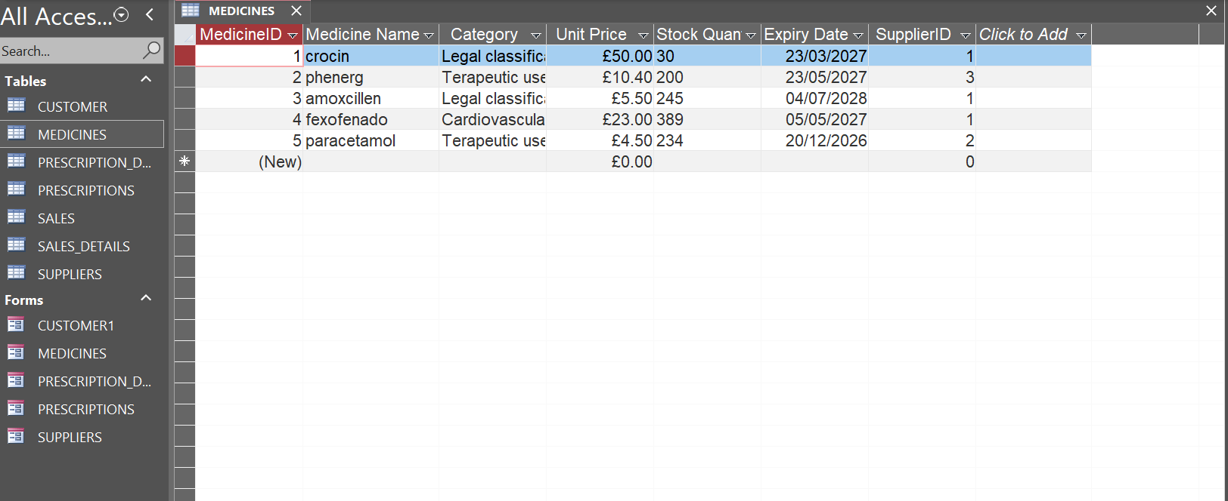
Figure 3: Medicines Table Structure

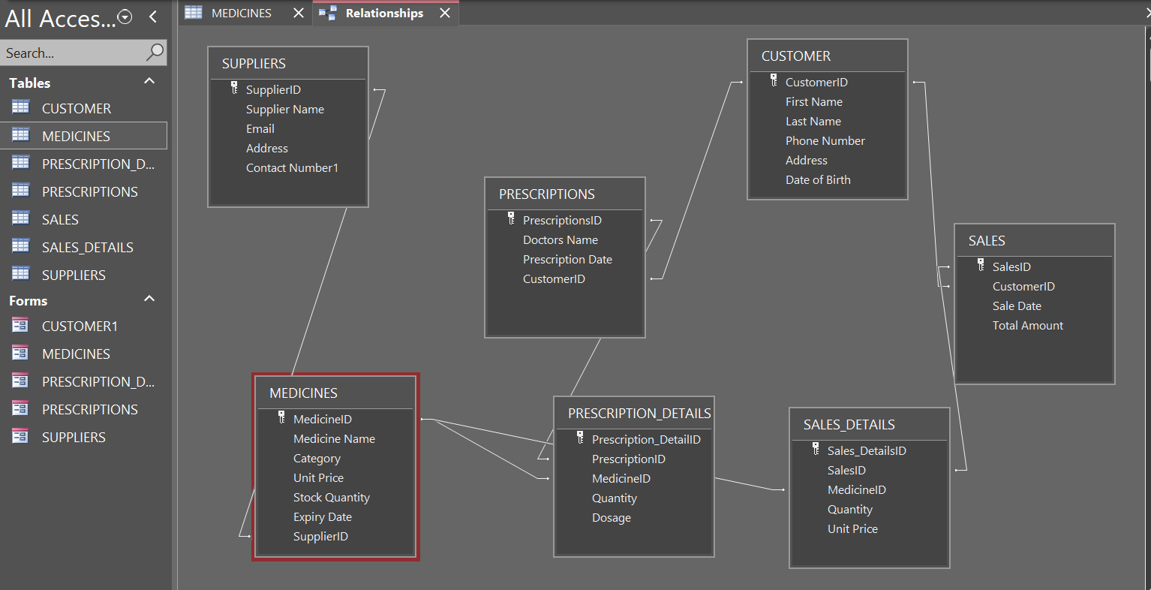
Figure 4: Database Relationships Window
These tables collectively form the foundation of the pharmacy database system.

6. Database Normalization (Up to Third Normal Form)
Normalization was applied to the database to eliminate redundancy and ensure efficient data storage.

First Normal Form (1NF)
In the first normal form, all tables contain atomic values, and repeating groups are removed.
Each field contains a single value, ensuring consistent data storage.

Second Normal Form (2NF)
Second normal form removes partial dependencies. Non-key attributes must depend on the entire primary key.
This was achieved by separating complex data into new tables such as:
- PrescriptionDetails
- SalesDetails

Third Normal Form (3NF)
Third normal form eliminates transitive dependencies.
For example, supplier information is stored only in the Suppliers table rather than repeated within the Medicines table.
Normalization improves:
- Data consistency
- Database efficiency
- Ease of maintenance

7. Sample Data Population
After creating the database tables, sample data was entered to simulate real pharmacy operations.
Example data included:
- Five supplier records
- Five medicine records
- Five customer records
- Sample prescriptions and sales transactions
Figure 5: Sample Data Entry – Medicines Table
The sample data allows testing of queries and database functionality.

8. Query Development
Queries were created to retrieve meaningful information from the database.

Query 1 – Low Stock Medicines
This query identifies medicines that need restocking.
Example result fields include:
- Medicine name
- Current stock quantity

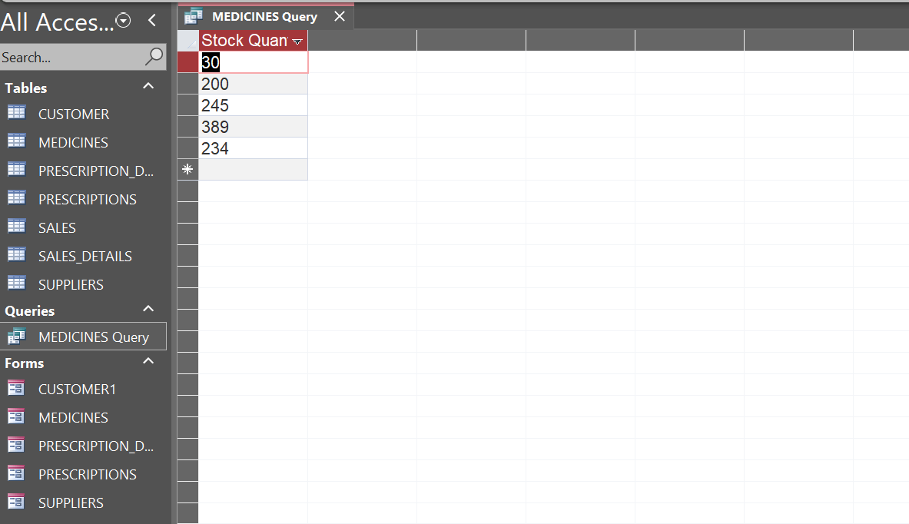
Figure 6: Low Stock Medicines Query

Query 2 – Medicines Expiring Soon
This query identifies medicines approaching their expiry date.
This helps pharmacy staff prevent expired medicines from being sold.

Query 3 – Sales by Customer
This query shows which customers have made purchases and when the sales occurred.

Query 4 – Most Sold Medicines
This query identifies the medicines most frequently sold by the pharmacy.
Such information helps management identify popular products.

9. Validation and Testing
Testing was conducted to ensure the system meets functional requirements.
Test Case | Action | Expected Result | Outcome
Add supplier | Enter new supplier record | Record saved | Successful
Add medicine | Insert new medicine linked to supplier | Record saved | Successful
Run stock query | Identify medicines below threshold | Results displayed | Successful
Invalid customer ID | Create sale with invalid ID | Error message | Successful

These tests confirm that the database operates correctly and maintains data integrity.

Task 2

10. Design Reflection and Future Improvements
The database designed for MediLink Pharmacy successfully organises pharmacy data into a structured relational system.
The use of normalization and relational design ensures that data redundancy is minimised while maintaining data integrity.
One of the main challenges encountered during the design process involved implementing many-to-many relationships between prescriptions and medicines as well as sales and medicines. This was resolved through the creation of junction tables such as PrescriptionDetails and SalesDetails.
Future improvements may include:
- Barcode scanning for faster product identification
- Automated stock alerts for low inventory
- Integration with electronic prescription systems
- Advanced reporting dashboards for management analysis
Such improvements would further enhance the efficiency and usability of the system.

11. Conclusion
The implementation of a database system using Microsoft Access provides MediLink Pharmacy with an efficient solution for managing pharmacy data.
The system supports medicine inventory tracking, supplier management, customer prescription records, and sales monitoring.
By replacing manual processes with a relational database system, the pharmacy can improve accuracy, reduce administrative workload, and enhance overall service delivery.
The database design demonstrates how structured data management can significantly improve operational efficiency in a pharmacy environment.

12. References (IEEE Format)
- T. Connolly and C. Begg, Database Systems: A Practical Approach to Design, Implementation and Management, 6th ed. Pearson, 2015.
- R. Coronel and S. Morris, Database Systems: Design, Implementation, and Management, 13th ed. Cengage Learning, 2019.
- Microsoft, “Microsoft Access Documentation,” Microsoft Learn, 2024.

