Essay on
Market Structures
By
Asen Asenov
Student ID:2028526
Course: Business and Management
Module: Managing Economics (LCBB5003_BIRM)
Module leader: Vasilios Tavlaridis
University of Wales Trinity and Saint David



Table of Contents
Market structure 3
Perfect Competition 3
Diagram- Perfect Competition 4
Monopoly 5
Diagram- Monopoly Market Structure 6
Monopolistic competition 7
Diagram- Monopolistic Competition 8
Duopoly 8
Diagram of Duopoly- The Cournot Model 9
Oligopoly 9
Oligopoly- Graph 10
Conclusion 10
References 11

Market structure

The essay explains each type of market, from Perfect Competition to Monopoly, using relevant economic theories. Competition among monopolies, oligopolies and duopolies,. The essay uses examples to illustrate the impact of market structure on management decision making, and it includes graphs for each market structure to illustrate how that influence plays out in each organisation.
The type and level of competition in the market for goods and services is what is meant by "market structure." The way a market is set up depends on how competitive it is. This is true for both the goods market and the service (factor) market. Market structure is the way the different parts of a market work together. These parts include the number and relative strength of buyers and sellers, the amount of freedom buyers and sellers have in setting prices, the level and types of competition, how different products are, and how easy it is to enter and leave the market. The best way to describe market structure is as the way a market is set up and how it works. (Jain R.,2022)

Perfect Competition

In general, demand-supply analysis is used in markets where there is a lot of competition, or "perfect competition." Perfect compulsion is defined by the following:
- The product is the same all over. (Png I., 2013, p.82-83)
- There are many buyers, and each of them buys a small amount compared to what is on the market. (Png I., 2013, p.82-83)
- There are many sellers, and each of them only has a small amount of what the market needs. (Png I., 2013, p.82-83)
- New buyers and sellers can join at any time, and those who are already there can leave at any time. (Png I., 2013, p.82-83)
- All buyers and all sellers know about the same things about the market. (Png I., 2013, p.82-83)
- In real life, there aren't many markets that meet all of the requirements for perfect competition. This means that the demand-supply model doesn't really work. Even so, this method of Marker equilibrium analysis is still useful because, even if a market isn't perfectly competitive, many of the management implications are still the same. (Png I., 2013,p.82-83)

Some argue that perfect competition does not exist in practise. This statement is true up to a certain extent. In the past, when trade in commodities was the primary driver of economic activity, perfect competition may have occurred. Essential components of the local economy included coal, oil, metals, and maize. All the while, they were consistent with the norms and shared the necessary qualities. (Collaborative Research Group,2022)
The identical thing would have numerous buyers and sellers if we travelled back in time a few centuries to a traditional market. For instance, the market may attract a large number of bakers who bring their wares to sell. A vast pool of potential customers and vendors for a standardised good or service. (Collaborative Research Group,2022)
What was formerly acceptable is no longer the case. These days, businesses compete with one another by releasing a wide variety of merchandise. (Collaborative Research Group,2022)
Nowadays, consumers rely on companies as credible sources of data. Because of the wide variety of goods we purchase, "perfect information" is unrealistic to expect. (Collaborative Research Group,2022)
When there were fewer goods on the market, "perfect information" was less of a challenge to obtain. But there are now millions. While examples of truly competitive markets are few, they do exist. (Collaborative Research Group,2022)

Diagram- Perfect Competition
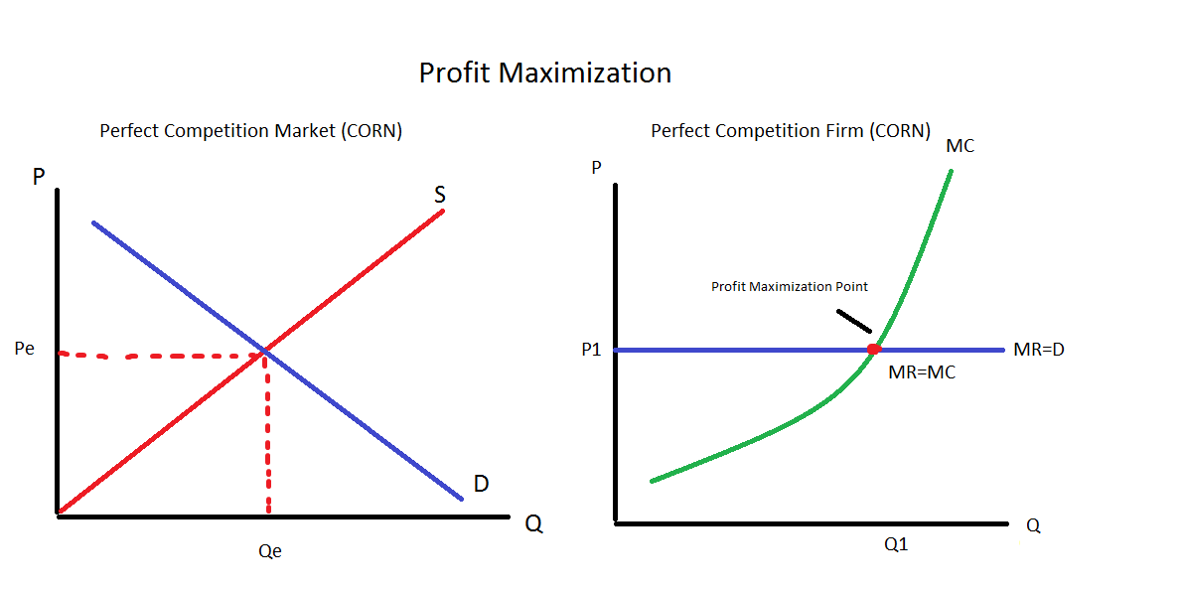
(Kennethpfblogspot, 2013)

Monopoly

The term "monopoly" refers to the single seller of a thing or a commodity since it is made up of the two terms "mono," which means "one," and "poly," which means "sell." (Muhamed N., Magdy Y., 2020)
There are many kinds of monopolies, including simple monopolies, pure monopolies, and natural monopolies. Here are some of the more prevalent kinds:
- A pure monopoly market is one in which there is only one seller (provider) of a specific commodity. Because of regulatory requirements, pure monopolies are uncommon in the actual world. Instead, we define a market as a monopoly when one firm or seller controls at least 25% of it. (Muhamed N., Magdy Y., 2020)
- Natural advantages, like a special location, lead to a natural monopolistic market structure. (Muhamed N., Magdy Y., 2020)
- State monopolies, in which the state is the exclusive owner of a certain industry and the sole producer of a particular good. (Muhamed N., Magdy Y., 2020)

Examples:
- First Monopoly Example: Railways
The government provides services such as railroads. Therefore, they are a monopolist because they do not allow new partners or privately held enterprises to operate railways. However, the ticket prices are affordable, allowing the majority of people to utilize public transportation. (Srivastav A., 2022)
- Monopoly Example 2 — Luxottica
Luxottica is a firm that owns all of the major sunglass’s brands. The business has acquired nearly every significant eyewear brand. However, their names remain distinct. It gives the buyer the impression that they have a selection of sunglasses to pick from, even if they are all manufactured by the same firm. Luxottica makes more than 80 percent of the world's eyewear. (Srivastav A., 2022)
- Third Monopoly Example: Microsoft
– Microsoft is a manufacturer of computers and software. It has a market share of over 75% and is the industry leader and near monopoly in the technology sector. (Srivastav A., 2022)
- Fourth Monopoly Example – AB InBev \sAB InBev, a firm founded by the merger of Anheuser-Busch and InBev, distributes more than 200 brands of beer, including Budweiser, Corona, Beck's, etc. Although these beers have various names and are brewed with distinct ingredients, they are all produced by the same firm. Therefore, when individuals consume various Beers, they are, in a sense, funding a single firm. (Srivastav A., 2022)

- Monopoly Illustration 5 - Google
Google has become a household name, and whenever we don't know the solution, we likely find it by searching on Google. Using its proprietary algorithm, the largest web search engine controls over 70% of the market. In addition, the corporation has expanded into a network of interconnected services, such as maps, Gmail, and search engines. As a result, Yahoo and Microsoft have been left in the dust by the company's ingenuity and technological growth. (Srivastav A., 2022)

- Monopoly Illustration 6 - Patents
Patents grant a firm a legal monopoly, although for a limited time. When the patent is in effect, no other corporation is permitted to use the invention for its own objectives. A casino in Genting Highlands, Malaysia, for instance, owned an exclusive patent for authorized casinos and enjoyed a legal monopoly in Malaysia for years. (Srivastav A., 2022)

- Monopoly Illustration 7 - AT&T -AT&T, a telecommunications company, was the sole provider of telephone services across the United States in 1982, in violation of antitrust rules. Due to its monopolistic operations in key telecommunication services, the business was compelled to separate into six "Baby Bells" companies. (Srivastav A., 2022)

Diagram- Monopoly Market Structure
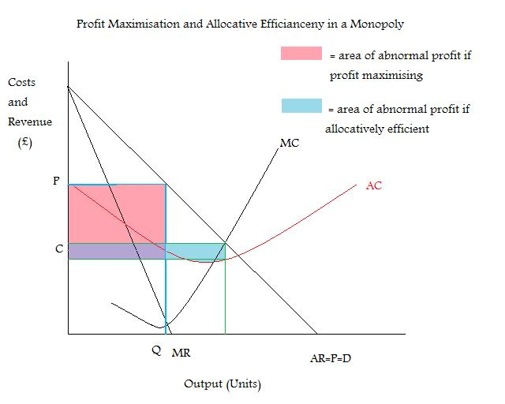
(Gordon S.,2016)

Monopolistic competition

Monopolistic Competition is a market system in which there are numerous enterprises, but each offers a product that is somewhat different. It is characterised by minimal entry and exit barriers, which fosters vigorous rivalry. (Boyce P.,2021)
As a result of the low barriers to entry, there is a steady influx of new competitors into the market, preventing current businesses from earning abnormally high profits. Hairdressing is an example of monopolistic competition. There are numerous businesses that offer somewhat varied services, and competition is intense. (Boyce P.,2021)
A market with a Monopolistic structure resembles a combination of monopoly and perfect competition. While monopoly and perfect competition are at opposite ends of the spectrum, monopolistic competition lies in the middle. It is analogous to monopoly in that a company might generate abnormally high profits in the near term. Nevertheless, market entry and exit are simple, and there are minimal barriers to entry, this is comparable to ideal competition. (Boyce P.,2021)
In brief, monopolistic competition is a market structure in which numerous competitors sell products that are only marginally dissimilar. In turn, they compete based on considerations besides price, like quality and dependability. (Boyce P.,2021)

Monopolistic Competition- Example
Food service establishments with Burger King and McDonald's market share are examples of monopolistic competition. Similar customers can choose between these two quick food establishments. These two businesses are in direct competition with one another, each attempting to set itself apart from the other in terms of brand recognition, pricing, and the variety of food and drink packages it offers. (Investopedia Team, 2022)

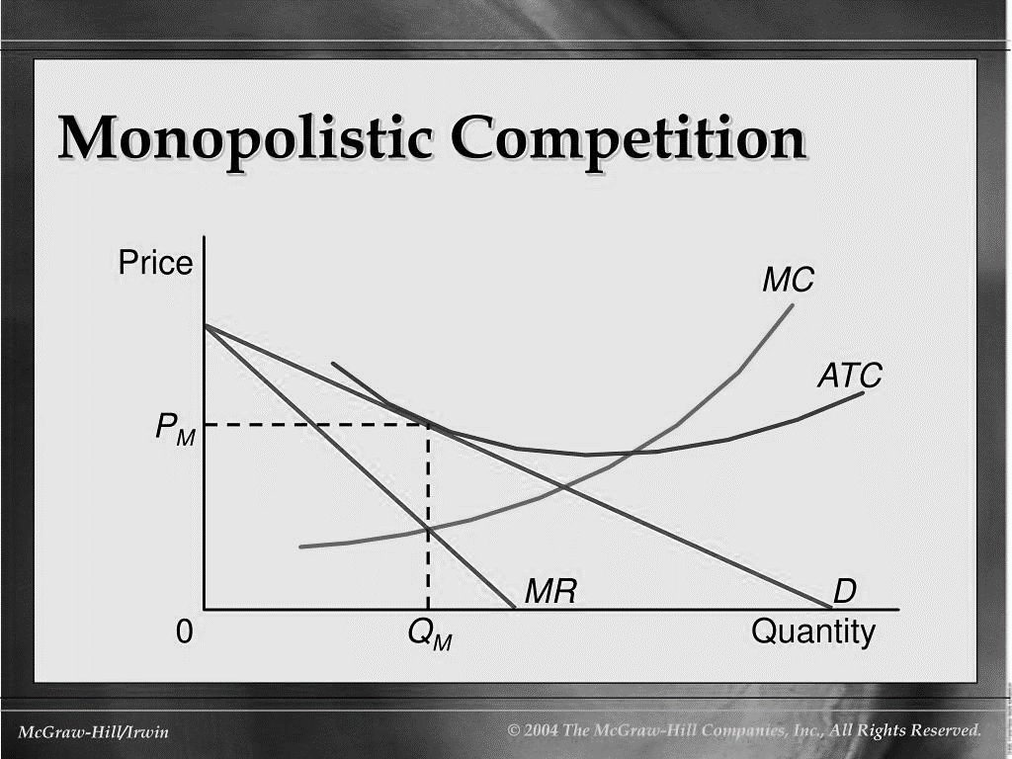
Diagram- Monopolistic Competition

Duopoly

Two dominant firms in a market or industry that make equivalent or nearly equivalent products constitute a duopoly, a subset of oligopoly. The firms' relationships and effects on one another are the foundations of a duopoly. (CFI Team,2021)
When just two businesses offer a product or service, the market is said to be a duopoly. A duopoly is characterised by the presence of only two large participants, notwithstanding the presence of additional firms in the same market. The market in which the two firms compete is shaped by their activities and the interactions between them. (CFI Team,2021)
Duopoly- example
Duopoly and competition in the American mobile phone industry
The American cellular telephone industry consists of hundreds of local duopolies, a market structure that is uncommon. A study of the first 28 markets in the United States to offer cellular service revealed that aspects of competitive behaviour were present in each location, although the strength of rivalry varied significantly. During the six-year span, prices decreased in practically every market. Although duopoly appears to have facilitated price competition, the substantial variation in performance across markets implies that factors other than market structure have a significant impact on the firm's behaviour. The American cellular telephone industry consists of hundreds of local duopolies, a market structure that is uncommon. In 1981 and 1982, when the Federal Communications Commission authorised cellular telephone service, the market structure choice appears to have been based more on political than economic or technological considerations. As a result, the government adopted a duopoly structure for the industry, establishing arguably the largest experiment in duopoly market structure ever. (H. S. Fullerton,1998, p. 593-607)

Diagram of Duopoly- The Cournot Model
The French economist A.A. Cournot provided the earliest conclusive solution to the duopoly problem in 1838 by using the example of two mineral water springs that were adjacent to one another and were controlled by two different companies, A and B. The graph below exemplifies his concept. (Kwatiah N.,2022)
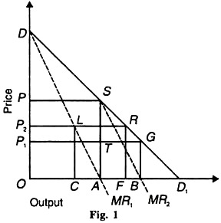

Oligopoly

Oligopoly is a term used in economics to describe a market structure characterised by the dominance of a few large firms over a given sector by means of restrictive trade practises, such as collusion and market sharing. Oligopolists aim to maximise market profits while minimising market competition by means of non-price competition and product differentiation. (Wallstreetmojo Editorial Team,2022)
Examples of Oligopoly
Most parts of the economy are run by oligopolies in the modern world. Except for monopolistic public goods (like defence) and textbook-only perfect competition markets (like street food in South-East Asia), oligopolies can be seen all along the value chain, from the wholesale level (like making tyres) to the retail level (like selling groceries), in both commodity industries (like steel) and branded goods (like alcoholic beverages) in small, local markets (for example, consumer electronics markets). Oligopolies also have many different parts. They include companies of all sizes and types, from those that rely on labour (like mail delivery companies) to those that rely on capital (like pharmaceutical companies and banks), from those that are vertically integrated (like movie production and distribution) to those that are not (for example, athletic sportswear). In brief, oligopolies are prevalent. (Petit, N., 2013, p. 259-349)

Oligopoly- Graph
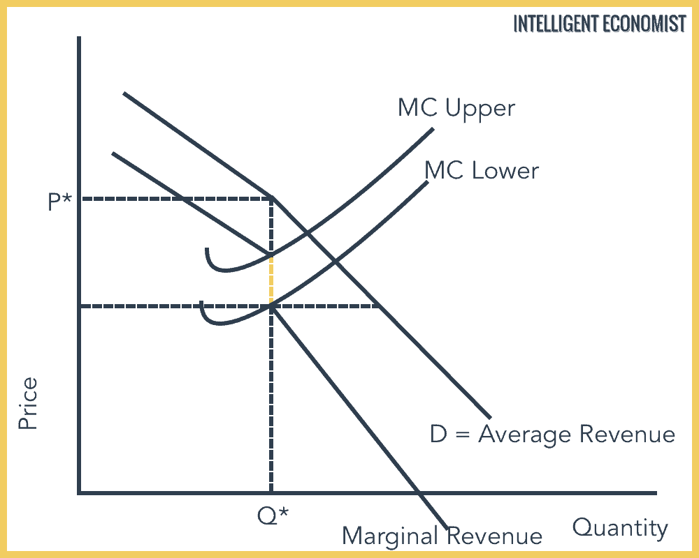

Conclusion
The essay defined and described each market type and market structure, including Perfect Competition, Monopoly, Monopolistic Competition, Oligopoly, and Duopoly. Using pertinent case studies and real-world examples, the article demonstrated the implications of market structures in the real world and illustrated the structures using diagrams.

References

Agarwal P. (2022), Oligopoly Market Structure, 2nd February, Available at: https://www.intelligenteconomist.com/oligopoly/ (Accessed:19th October 2022)
Boyce P. (2021), Monopolistic Competition Definition, 16th March, Available at: Monopolistic Competition | Definition and 7 Examples | BoyceWire(Accessed:19th October 2022)
CFI Team (2021), Duopoly, 9th February, Available at: Duopoly - Overview, Examples, and Types of Oligopolies (corporatefinanceinstitute.com) (Accessed:19th October 2022)
Collaborative Research Group (2022), Perfect Competition: Characteristics, Examples, Features, and Benefits, Available at: Perfect Competition: Characteristics, Examples, Features, and Benefits (crgsoft.com) (Accessed: 11th October 2022)
Gordon S. (2016), Monopoly Diagram, Available at: Monopoly Diagram (thinglink.com) (Accessed:13th October 2022)
Hugh S Fullerton (1998), Duopoly and competition: The case of American cellular telephone,Telecommunications Policy, Volume 22, Issue 7, Available at: Duopoly and competition: The case of American cellular telephone - ScienceDirect (Accessed:19th October 2022)
Investopedia Team(2022), Monopolistic Competition: Definition, How it Works, Pros and Cons, 3rd August, Available at: Monopolistic Competition: Definition, How it Works, Pros and Cons (investopedia.com) (Accessed: 19th October 2022)
Jain R.(2022), DIFFERENT MARKET STRUCTURE, Jiwaji University, Available at: DIFFERENT MARKET STRUCTURE (jiwaji.edu)(Accessed:24th September 2022)
Kennethpfblogspot (2013), Perfect Competition -Brazil vs USA in the corn industry, 13th September, Kennet Ng, Available at: Perfect Competition (kennethpf.blogspot.com) (Accessed: 11th October 2022)
Kwatiah N. (2022), Top 3 Models of Duopoly (With Diagram), Avaiable at: Top 3 Models of Duopoly (With Diagram) (economicsdiscussion.net) (Accessed:19th October 2022)
Muhamed N., Magdy Y. (2020), Market Structure Analysis (perfect competition, monopolistic competition, monopoly, oligopoly), June, Available at: (PDF) Market Structure Analysis (perfect competition, monopolistic competition, monopoly, oligopoly) (researchgate.net) (Accessed: 13th October 2022)
Petit, N., (2013), The oligopoly problem in EU competition law. In Handbook on European Competition Law , Edward Elgar Publishing, Available at: Chapter 7: The oligopoly problem in EU competition law in: Handbook on European Competition Law (elgaronline.com) (Accessed:19th October 2022)
Png I. (2013), Managerial Economics,11th September, Routledge, Available at: https://r2.vlereader.com/Reader?ean=9780203116098# (Accessed: 11th October 2022)
Srivastav A. (2022), Monopoly Examples, Available at: Monopoly Examples -Top 8 Real-Life Examples, Explanations (wallstreetmojo.com) (Accessed: 13th October 2022)
Wallstreetmojo Editorial Team (2022), Oligopoly, Vaidya D., Available at: Oligopoly - Definition, Market, Characteristics, How it Works? (wallstreetmojo.com) (Accessed:19th October 2022)

