

Programme: Master Of Business Administration
Module: Strategic Management
Module Code: LCMB7003
Assignment Title: A Critical Analysis of Strategic Management Practices: The Case of Tesla, Inc.

Student Name: Marzana Hasan Mita
Student Id Number: 2504068
Lecturer: Dr Hoang Dang Nguyen

AI use acknowledgement
I confirm that I have not presented any AI generated text as my own work. I confirm I have copies of my drafts, notes, and other resources I used before, and after the use of AI tools which I may be asked to provide in evidence.
Table of Contents
SECTION 1 1
1. Organisational Context and Overview 1
1.1 Historical Perspective and Summary 1
1.2 Mission, Vision, and Business Model 1
1.3 Industry and Market Position 2
2. External and Internal Environment Analysis 3
2.1 External Factor Analysis (PESTEL) 3
2.2 Critical Success Factors (CSFs) and Strategic Challenges 5
2.3 Internal Environment: Resource and Capability Audit 6
2.4 The VRIO Framework Analysis 7
2.5 Strategic Capabilities and Competitive Advantage Synthesis 8
3. CSR and Sustainability Objectives 9
3.1 CSR Strategy and Strategic Alignment 9
4. Comprehensive and Holistic View of the Organisation 11
4.1 The Balanced Scorecard 11
4.2 Analysis of Perspectives 12
4.3 Synthesis of Holistic View 13
5. Strategic Choices and Implementation 14
5.1 Business-Level Strategy: The Integrated Hybrid Model 14
5.2 Corporate-Level Strategy: Vertical Integration and Diversification 14
5.3 Strategic Implementation and Management of Change 15
6. Strategic Evaluation and Recommendations 17
6.1 Evaluation using the SWOT Framework 17
6.2 Evaluation using the BCG Matrix 17
6.3 Strategic Recommendations and Justification 18
SECTION 2 20
Reflective Account 20
REFERENCES 24

List of Figures
Figure 1: Tesla Revenue Trend (2018–2025) 2
Figure 2: PESTEL Macro-Analysis 5
Figure 3: Ansoff Matrix Application 15
Figure 4: Tesla’s Portfolio in the BCG Matrix 18
Figure 5: Gibbs Reflective Cycle. 20

List of Tables
Table 1: VRIO Analysis of Tesla’s Strategic Resources 7
Table 2: Tesla’s Strategic Balanced Scorecard Application 12
Table 3: Tesla Strategic SWOT Matrix 17

SECTION 1

1. Organisational Context and Overview

1.1 Historical Perspective and Summary
Tesla, Inc., a global automotive manufacturer established in 2003 by Martin Eberhard and Marc Tarpenning and propelled by CEO Elon Musk, has essentially destabilised the worldwide auto industry paradigm (Thulin and Povlsen, 2024). Tesla, as a strategic direction of a company, has been shifting towards a multi-industry ecosystem: electric vehicles (EVs) (Abbes, 2025); battery energy storage; and solar energy solutions. The company was established initially as a niche manufacturer of high-performance electric sports cars, such as the Roadster (Chen and Li, 2023). Tesla was not a legacy manufacturer but a so-called tech-first company, making software integration and vertical manufacturing the core focus, unlike legacy manufacturers, who switched to EVs as a regulatory requirement.

1.2 Mission, Vision, and Business Model
Tesla has a mission statement, which is to increase the use of sustainable energy in the world. This is a key statement to its strategy; the company is not an automaker but an energy and AI company. It envisions staying the world leader in the 21st-century move towards carbon neutrality.
Tesla's business model is based on two distinct pillars:
- Direct-to-Consumer (D2C) Sales: Since the company bypasses the third-party dealerships, Tesla will have full control of the brand experience and price point, gaining the margins that would fall to middlemen in the traditional OEMs (Wróblewski, 2022).
- Vertical Integration: Tesla produces its own battery cells, creates its own chip (FSD Computer) and owns its worldwide charging system (the Supercharger Network) (Perkins, 2024).

1.3 Industry and Market Position
Tesla competes in the global EV market, which is inherently undergoing a shift in terms of early adopters to mass-market customers (Cho et al., 2025). Although Tesla sells fewer cars compared to Toyota or Volkswagen, Tesla remains the most highly valued company in the automobile market over any other company in the world. This is because it has high profit margins, and it is a leader in Software-Defined Vehicles (SDV). Nevertheless, Tesla is becoming increasingly the victim of a price war initiated by Chinese producers such as BYD, which now in some quarters outsells volumes of pure battery-electric vehicles (BEVs) in Tesla. This graph substantiates the argument that Tesla has found its way out of Production Hell and scaled into the international arena. While Figure 1 illustrates consistent revenue growth, recent financial results (Tesla, 2025) indicate that net profit margins are narrowing due to the fierce price reductions mentioned previously.

Figure 1: Tesla Revenue Trend (2018–2025)
Source: (Tesla, 2025).

2. External and Internal Environment Analysis

2.1 External Factor Analysis (PESTEL)
In order to offer a critical analysis of the strategic decisions of Tesla, we need to assess the macro-environmental forces on the basis of the PESTEL framework.
Political Factors:
One of the major sources of Tesla's revenue is the governmental policy. The Inflation Reduction Act (IRA), in the United States, is offering manufacturing tax credits that will radically reduce the price of Tesla battery production (Bown, 2023). On the other hand, there is a strategic threat of geopolitical conflicts between the US and China. Since Tesla has the most prolific factory in China (Giga Shanghai), any change in trade policy or regulations governing data security may place half of the Tesla world production at stake.
Economic Factors:
Macroeconomic instability, namely increasing levels of interest rates, has caused a large-scale strategic change in Tesla in 2024-2025. The high cost of vehicles is a high-ticket item that is paid with debt, which implies that a high interest rate will make the vehicle expensive to the consumer. Tesla reacted through aggressive predatory pricing, reducing the prices by as much as 20% to keep its market share at the cost of the profit margins (Wenger, 2023).
Social Factors:
There is a colossal societal transition into green consumerism. The brand name of Tesla is connected with the social status of sustainability. Social risk, however, is a problem of labour relations in the company. In places such as Scandinavia, Tesla has refused to sign collective bargaining agreements, and this has resulted in strikes (Eddy, 2023). This situation has made Tesla culture of Silicon Valley in America conflict with European social values.
Technological Factors:
The main competency of Tesla is technological innovation. Other than the 4680-battery cell, Tesla has its biggest strength in the fact that it has shifted to software-defined vehicles (SDV). Tesla uses a centralised 'end-to-end' AI architecture (Chinta, 2025) instead of legacy manufacturers that use up to 100 separate Electronic Control Units (ECUs) in their design. This makes it possible to update the core vehicle performance overnight, so-called, over-the-air (OTA). To duplicate this, a total redesign of electrical architecture is needed that would establish a high barrier to entry, ensuring Tesla keeps ahead during the 2024-2026 window.
Environmental Factors:
Given that Tesla is a company based on a mission of climate-centricity, it is one of the major beneficiaries of global carbon emission obligations. Tesla received in the year 2023, alone, 1.79 billion dollars in regulatory credits – pure profit – which was sold to other car companies that were not able to reach zero-emission targets (Chinta, 2025). Nevertheless, Tesla has been put under the environmental scrutiny of mining lithium and cobalt. Its strategic reaction has been developing a closed loop of recycling in its Gigafactories, and this will recover 92% of battery materials (Fan et al., 2025).
Legal Factors:
Tesla is a company that works in a risky legal environment. Tesla Autopilot and Full Self-Driving (FSD) software have been the frequent subject of investigations by the National Highway Traffic Safety Administration (NHTSA) of the US after accidents. A legal move to Level 4/5 autonomy is a grey space, and a single unfavourable court decision touching on AI liability would put the FSD program into bankruptcy (Mirejovsky, 2026; Chinta, 2025). Moreover, the legal struggles of Tesla to sell its products via the so-called 'direct-to-consumer' in the US states such as Texas and Connecticut make the tension between the innovative business model and the old-fashioned franchise laws quite obvious.
Figure 2 draws a summary of the major macro-environmental forces that will affect Tesla's strategic decision-making based on political, economic, social, technological, environmental and legal aspects.

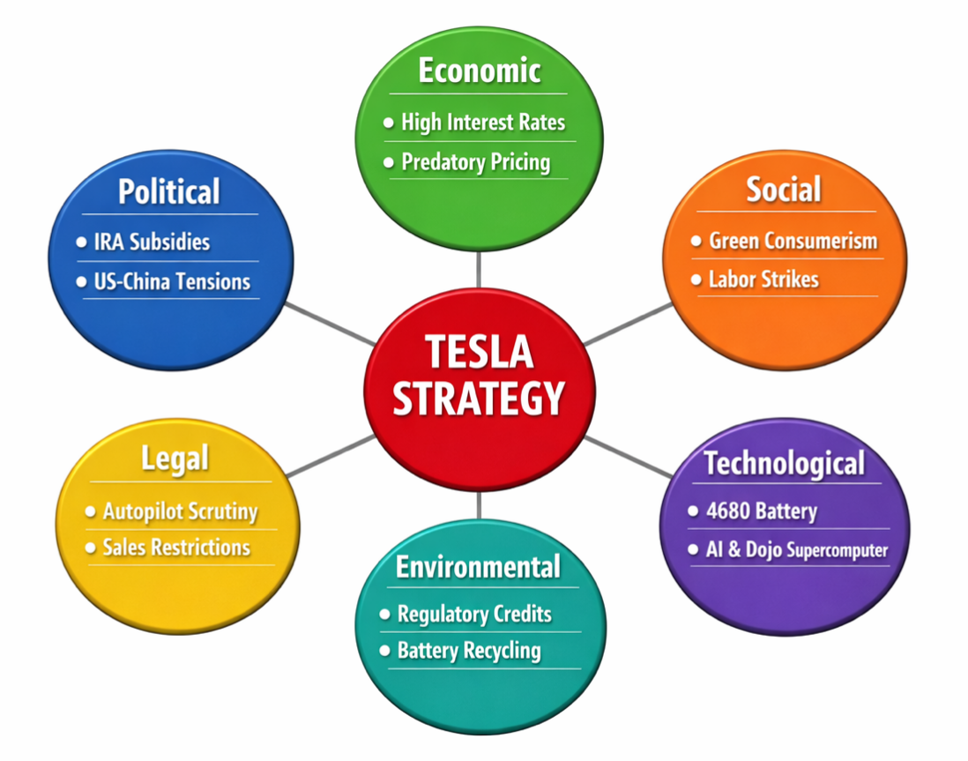
Figure 2: PESTEL Macro-Analysis
Source: (Author’s Construction, 2026).
By synthesizing these PESTEL factors, the primary strategic opportunities for Tesla emerge from favorable US political subsidies and the global social shift toward green consumerism. Conversely, the strategic threats are centered on US-China geopolitical volatility and the legal risks associated with autonomous AI liability. These external drivers directly populate the 'Opportunities' and 'Threats' quadrants of the SWOT matrix discussed in Section 6.1, ensuring a cohesive link between environmental scanning and strategic evaluation.

2.2 Critical Success Factors (CSFs) and Strategic Challenges
Tesla’s competitive position is underpinned by three Critical Success Factors (CSFs) (Brotherton and Bradley, 2012). First, charging density eliminates consumer range anxiety. Second, Battery Unit Cost, in which Tesla is targeting the $100/kWh level. Third, data flywheel velocity (Malik et al., 2026). Comparing it to its competitors such as BYD, a strategic divergence is evident: the CSF used by Tesla is intelligence, whereas BYD uses total cost leadership, which is the control of the raw minerals. Tesla has an intelligent gap that its competitors cannot effectively compete with at the moment by using a fleet of 5 million cars as edge sensors.
Strategic Challenges:
Tesla is experiencing the Inno Dilemma. As it grows, it will have to transition from its “niche luxury to a mass-market commodity. The Chinese EV price war is the main problem. Rivalry brands such as BYD and Xiaomi possess better product cycles and lower labour expenses. Also, Tesla is exposed to key man risk, as the long dependence on the personal brand of Elon Musk is a two-sided sword – his personal scandals can make brand attitudes towards environmentally responsible consumers poor.

2.3 Internal Environment: Resource and Capability Audit
In order to assess the internal environment of Tesla, we use the Resource-Based View (RBV). Tesla has not only a competitive advantage in its factories but also in its dynamic capabilities (Teece et al., 1997) in its capability to adapt its internal capabilities to external changes.
- Physical Resources: Tesla has so-called Gigafactories with the largest die-casting machines in the world, called Gigapresses. This enables Tesla to make the entire rear underbody of an automobile a single part instead of 70 different parts. It is a huge physical asset that is lower in weight and can be assembled with fewer complications.
- Intangible Resources: Intangible resources are the strongest weapons of Tesla. They consist of its proprietary AI algorithms, its brand equity, and its petabytes of real-world driving data. A competitor may acquire a factory, but not 5 billion miles of training data, which is autonomous.

2.4 The VRIO Framework Analysis
The VRIO framework helps us to establish whether the resources offer a sustained competitive advantage (SCA) (Barney, 1991).
Resource / Capability | Valuable? | Rare? | Inimitable? | Organised? | Competitive Implication
Brand Equity | Yes | Yes | Yes (Social Complexity) | Yes | Sustained Advantage
Supercharger Network | Yes | Yes | Yes (Path Dependency) | Yes | Sustained Advantage
AI Training Data | Yes | Yes | Yes (Causal Ambiguity) | Yes | Sustained Advantage
Giga-press Hardware | Yes | No | No (Competitors buying same machines) | Yes | Temporary Advantage
Vertical Integration | Yes | Yes | Hard to Copy (Legacy Barriers) | Yes | Sustained Advantage
Table 1: VRIO Analysis of Tesla’s Strategic Resources
Source: (Basile, 2026).
Table 1 gives a systematic analysis of the resources of Tesla in terms of the VRIO framework, identifying the sources of long-term and short-term competitive advantage.
Critical Analysis of VRIO:
The VRIO analysis demonstrates that Tesla is competitive due to the path dependency and social complexity (Basile, 2026). Automakers with a long history, such as Ford or GM, can hardly copy the Tesla approach of the Direct-to-Consumer (D2C) model, as they are legally and contractually bound to the thousands of independent dealerships. The fact that Tesla is only organised (the 'O' in VRIO) around one software stack allows it to have a sustained competitive advantage. Nevertheless, its hardware (Giga-presses) is just a transient strength since Chinese competitors are now buying the same machines from the same vendors (LK Technology). This VRIO analysis confirms that while hardware is a temporary advantage, the AI training data is a sustained advantage, which justifies Recommendation 1 regarding the licensing of FSD software.

2.5 Strategic Capabilities and Competitive Advantage Synthesis
Architectural innovation is the major strategic capability of Tesla. Tesla is not burdened by the technological debt of older systems since the car is designed from a 'blank sheet' as a computer on wheels (Malik et al., 2026). This can be vertical integration that their competitors cannot replicate; when a global chip shortage struck in 2021, Tesla engineers rewrote their own firmware in a few weeks to run on alternative chips, whereas legacy companies such as Volkswagen were forced to close their factories because they had to depend on external Tier-1 suppliers to provide them with the code. It is a high-order strategic ability that determines its survival in the changeable business environment called BANI (Brittle, Anxious, Non-linear, Incomprehensible).

3. CSR and Sustainability Objectives

3.1 CSR Strategy and Strategic Alignment
The strategy of corporate social responsibility (CSR) adopted by Tesla is exceptionally embedded in its core value statement. Contrary to the case of legacy companies in which CSR is a marginal offsetting behaviour, Tesla's business model is an expression of Creating Shared Value (CSV). All economic profit is theoretically connected to an environmental benefit by the company mission, which is to speed the world's sustainability to the use of energy.
Environmental Performance:
Environmental goals of Tesla regard its products as the lifecycle analysis (LCA). The worldwide fleet of Tesla vehicles avoided about 50 million metric tonnes of CO₂e. Tesla has also changed its strategy to battery circularity. The company is said to recycle all its manufacturing scrap and has achieved 92 per cent recovery on some of its materials such as lithium, nickel and cobalt. This is in line with its business mission of eliminating reliance on oscillating raw material markets (Tesla, 2025).
Critical Evaluation of the "ESG Paradox":
Although Tesla is an industry leader in the so-called E (Environmental) component of ESG, however, the situation in the S (Social) or G (Governance) pillars is quite strained:
- Social Friction: Tesla has created a culture of high-speed innovation that employs Silicon Valley culture, which conflicts with international labour standards. Indicatively, Tesla has had a major industrial action in Sweden and Germany due to the failure to sign collective bargaining agreements. This poses a strategic threat: the progressive environmental image of the brand is becoming more and more inconsistent with its retrogressive labour image.
- Governance Concentration: A single person (Elon Musk) has concentrated power, which causes key man risk. Corporate governance gurus have raised the issue of board independence and CEO distraction that could happen after acquiring X (previously Twitter).
Tesla has a product-centred CSR as opposed to a stakeholder-based CSR. Although it manages to overcome the problem of global decarbonisation, it should transform its social and governance systems to satisfy the expectations of the institutional ESG investors more extensively (Dako, 2023).
One of the most important tensions in the CSR strategy of Tesla is governance (G) and social (S) shortage. The company has high scores on the 'Environmental' metrics, but on the other hand, the social performance is tarnished with the high-profile labour conflicts in Giga Berlin and Sweden over the collective bargaining. According to stakeholder theory, Tesla focuses on the priorities of the 'mission' and the shareholders more than on the employees and the union relations. This poses a strategic risk: with the EV market becoming mainstream, Tesla will be disadvantaged in drawing the best engineering talent in Europe by its perceived retrogressive approach to labour, which could undermine the brand image of Tesla as progressive in terms of environmental friendliness.

4. Comprehensive and Holistic View of the Organisation

4.1 The Balanced Scorecard
In order to give a balanced picture of the performance of Tesla in terms of operations, we make use of the Balanced Scorecard (BSC) (Kaplan & Norton, 2005). The framework is vital since it helps to avoid the so-called 'financial myopia' since it compels the strategist to look at the internal and external forces behind the success in the future (Hegazy et al., 2022).
Table 2 presents the strategic goals and performance measures of Tesla in the four perspectives of the Balanced Scorecard.
Perspective | Strategic Objective | Key Performance Indicator (KPI) | Target (2026-2027) | Strategic Initiative
Financial | Maintain industry-leading profitability. | Operating Margin % and Free Cash Flow (FCF). | >15% Operating Margin; $5B+ Annual FCF. | Implementation of the "Next-Gen" modular assembly platform.
Customer | Dominant brand loyalty & infrastructure reach. | Net Promoter Score (NPS) & Supercharger Uptime. | NPS > 75; 99.9% Supercharger uptime. | Opening the NACS (Charging Standard) to non-Tesla EVs.
Internal Business Processes | Manufacturing efficiency & vertical integration. | Vehicle Cycle Time & Manufacturing Cost per Unit. | 50% reduction in assembly cost vs. Model 3. | The "Unboxed Process"—parallel assembly of vehicle sections.
Learning and Growth | Leadership in AI & Autonomous Technology. | FSD Training Miles & Number of AI Patents. | 1 billion+ autonomous miles trained per quarter. | Development of the "Dojo" Supercomputer for neural net training.
Table 2: Tesla’s Strategic Balanced Scorecard Application
Source: (Hegazy et al., 2022).

4.2 Analysis of Perspectives
Financial Perspective:
The new financial policy of Tesla has shifted to the principle of margin maximisation into that of market share preservation. Tesla has the only chance of fighting a sustained price war in the EV market, as it has the highest margins in the industry. As Figure 1, however, illustrates, as the revenue increases, the increase in profit is decreasing, as a result of fierce price reduction. The 5B+ FCF target will be crucial in financing the enormous research and development involved in the production of the products of the "Question Mark" in the BCG matrix.
Customer Perspective:
The Tesla customer strategy is constructed on the basis of an ecosystem moat. The most important customer-facing differentiator is the Supercharger network. This network to Ford, GM, and Rivian also places Tesla in a strategically significant transition that will see it shift away to a walled garden (such as Apple) and become the utility provider of the EV era. This generates high-margin recurrent inflow of revenue, which is not subject to vehicle sales cycles.
Internal Business Processes:
Innovation of the unboxed process by Tesla is a significant breakthrough, as it was 100 years of the Ford assembly line. Tesla does not assemble an entire chassis and pass it down a production line but rather assembles parts of the vehicle (front, rear, and interior) and assembles them at the end. This saves factory space by 40% as it has a direct impact on the financial goal by cost leadership.
Learning and Growth:
It is here that Tesla stands out of the pack with Old Auto. Tesla is creating a learning flywheel by allocating billions towards the Dojo supercomputer and Optimus robot. The more cars are operated, the more data they generate; the more data trains the AI, the better the FSD software, which will result in more customers. The cycle forms a barrier to entry which is virtually unsurmountable by traditional engineering by rivals (Malik et al., 2026).

4.3 Synthesis of Holistic View
The Balanced Scorecard unveils the fact that Tesla is a manufacturing company that has software as the core (Kaplan and Norton, 2005). The dominant cause that drives the other forces is the learning perspective (AI/Data) that drives internal efficiency of the giga-casting customer experience (FSD/Charging), which ultimately achieves financial results (market cap). One of the strategic failures in any of the perspectives (e.g., a safety recall in FSD) would instantly flow into the other three.

5. Strategic Choices and Implementation

5.1 Business-Level Strategy: The Integrated Hybrid Model
As described by Porter's Generic Strategies (Porter, 1985), the companies have a choice of either cost leadership or differentiation to avoid being stuck in the middle (Acar, 2024). Nonetheless, Tesla has been able to follow an integrated cost leadership and differentiation strategy.
- Differentiation: Tesla differentiates with its proprietary software (FSD), better battery range and the cool factor of Tesla brand equity.
- Cost Leadership: The Unboxed Process and Gigafactories Tesla is pushing the cost of EV manufacturing down to levels that legacy competitors could only reach by using the old technology.
- Strategic Choice: I suggest that Tesla keep on this hybrid course but lean more on cost leadership in the next generation of its platform, its Next-Gen. Since the EV market transitions into the price-conscious mass-market consumers, the capacity to make a $25,000 car with high margins will be the factor that will win the EV price war.

5.2 Corporate-Level Strategy: Vertical Integration and Diversification
Backward vertical integration is the corporate strategy of Tesla. Tesla has greater value capture in comparison to Ford or GM, which are dependent on third-party suppliers, by dominating the battery supply chain as well as the software stack.
Tesla's strategic decisions can be easily explained through the use of the Ansoff Matrix (1957):
- Market Penetration: Intense discounting of the Model 3 and Model Y to take market share in the US and Europe.
- Product Development: the introduction of the Cybertruck and construction of the Optimus Humanoid Robot.
- Other Diversification: Tesla Energy (Megapacks) uses the identical technology as a grid-scale battery to develop a counter-cyclical revenue stream besides vehicle sales.
Figure 3 shows the strategic growth alternatives that Tesla can choose in the market penetration strategy, product development strategy, and diversification strategy.

Figure 3: Ansoff Matrix Application
(Source: Author’s Construction, 2026).

5.3 Strategic Implementation and Management of Change
Making these decisions involves great organisational dexterity. Tesla operates on a flat organisational structure, which excludes conventional middle management, and a culture of 'fail fast' is possible.
Critical Evaluation of Change Management:
Based on the 8-step change model developed by Kotter, Tesla is good at building a sense of urgency. The company shifted to a hybrid between a manual and automated process in a few weeks when the company was in the Model 3 production hell (Trawick, 2023). This illustrates the dynamic capabilities – the capability of the reorganisation of internal competencies to respond to external shocks. Nonetheless, the implementation has a strategic weakness of key man risk. The strategy implementation is much too closely connected to the personal participation of Elon Musk. To make the Next-Gen platform successful, Tesla will need to shift to a more institutionalised implementation paradigm based on professional management systems and not founder-led crisis management.

6. Strategic Evaluation and Recommendations

6.1 Evaluation using the SWOT Framework
In assessing the current strategy at Tesla, we need to integrate the internal and external drivers. Table 3 presents a reflection of the main strengths, weaknesses, opportunities and threats of Tesla that impact its strategic position.
Strengths (S) | Weaknesses (W)
- Vertical Integration (Battery/Software).  - Global Supercharger Network.  - Vast AI Training Data Library. | - Reliance on single high-profile leader.  - Perceived assembly quality gaps.  - Aging vehicle lineup (Model S/X).
Opportunities (O) | Threats (T)
- FSD Software Licensing to rivals.  - Expansion into the Indian mass-market.  - Robotaxi network launch. | - Chinese Price War (BYD/Xiaomi).  - Fluctuating raw material prices.  - Regulatory pushback on Autopilot safety.
Table 3: Tesla Strategic SWOT Matrix
Source: (Abdelazim, 2022).

6.2 Evaluation using the BCG Matrix
Using the BCG matrix, the portfolio of Tesla can be measured in terms of the growth of the market and the market share.
Cash Cows: Model 3 and Model Y are the most significant sources of Tesla revenue and are highly popular in the market. Despite the increasing popularity of the EV market, these models have a relatively mature segment, which leads to stable cash flow.
Stars: Tesla Energy (Megapack and Powerwall) is in an emerging renewable energy sector and growing rapidly, which will be a major growth engine in the future.
Question Marks: Full Self-Driving (FSD) and the Optimus robot are still of high potential with a lot of uncertainty about regulation and adoption. They demand a large amount of investment.
Dogs: Both the Model S and Model X are in a low growth, low share segment, and a harvesting strategy is best suited to handle them.
Tesla invests Model 3/Y cash in high-growth/risk innovations to support long-term competitive advantage. Because market growth and market share depend on the product portfolio of the Tesla company, they are visualised in the BCG matrix in Figure 4.
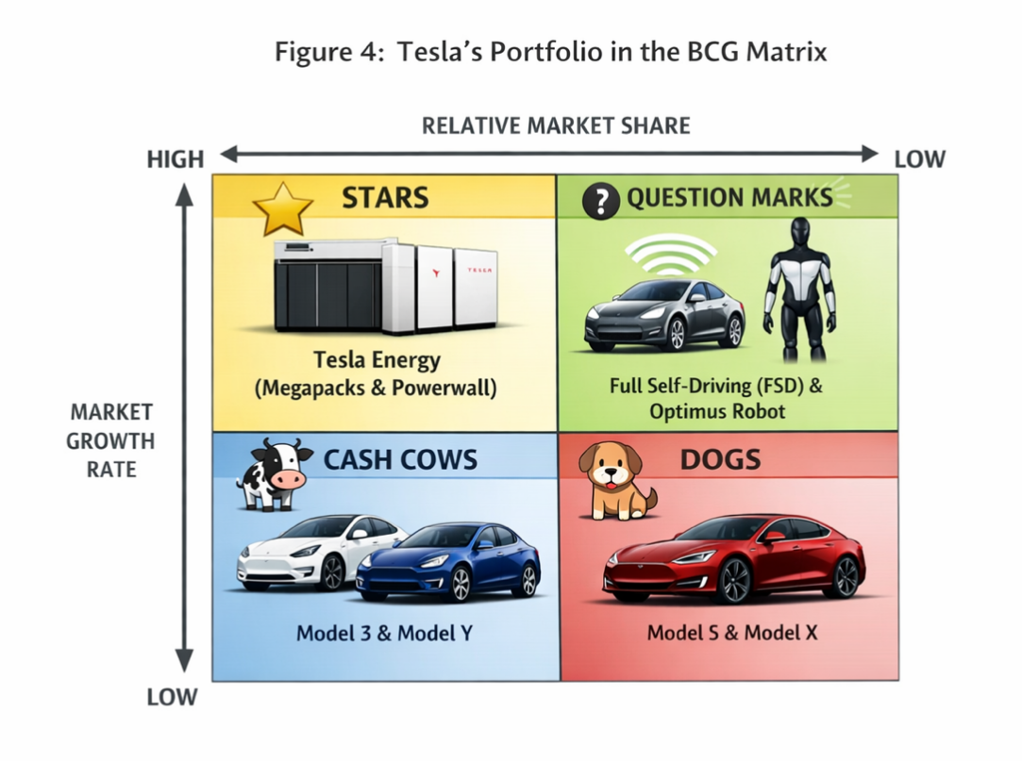
Figure 4: Tesla’s Portfolio in the BCG Matrix
Source: (Lei, 2025)

6.3 Strategic Recommendations and Justification
Recommendation 1: Licensing the FSD Software (SaaS Pivot)
Tesla ought to sell its autonomous driving stack to traditional car manufacturers (e.g., Ford or Volkswagen).
-Justification: According to the Resource-Based View (Barney, 1991), the AI data of Tesla is a resource that is rare and inimitable. Licensing will be a high-margin recurring source of revenue that will make Tesla a Software-as-a-Service (SaaS) company, which explains its enormous market valuation.
Recommendation 2: Accelerated Launch of the "Model 2" platform
Tesla needs to focus on the products smaller than 25,000 in the Indian and Southeast Asian markets.
-Justification: This is an Ansoff Matrix strategy of market development. In order to retain its Star status, Tesla needs to gain volume in the new markets where the Model Y is prohibited by its high cost.
Recommendation 3: Governance Reformation
To enable Musk to concentrate on R&D, the Board should put in place a Chief Operating Officer who will oversee the automotive division.
- Justification: This will reduce one of the pillars of CSR/ESG, which is the key man risk, and cover the S and G pillars and ensure long-term institutional investor trust.

SECTION 2

Reflective Account
This paragraph provides a systematic reflection of my learning experience according to Gibbs's Reflective Cycle. Figure 5 represents the Gibbs Reflective Cycle that is used to organise this reflective analysis.
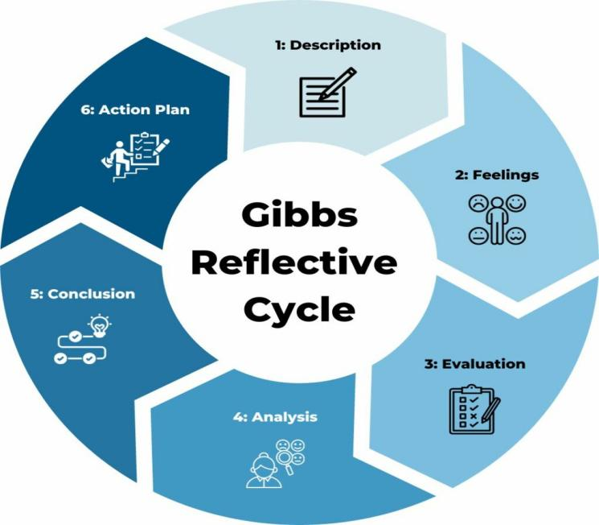
Figure 5: Gibbs Reflective Cycle.
Source: (Gibbs, 1988)
1. Description
I have recently conducted an extensive strategic audit of Tesla, Inc. based on the compulsory academic frameworks of PESTEL to scan the macro-environment, VRIO to audit internal resources, the Ansoff Matrix to assess growth and the BCG Matrix to evaluate the portfolio. One of the key demands was the use of the Balanced Scorecard in order to integrate both financial and non-financial data. This was done in the systematic phases of the Gibbs (1988) Reflective Cycle, and evidence-based strategic recommendations were made at the end.
2. Feelings
I experienced a lot of academic pressure in the beginning. The change of the so-called descriptive writing to the master-level writing of so-called critical analysis is quite a jump. I felt overwhelmed at first by the sheer amount of media noise behind Tesla; I was concerned that my own analysis would be detected as a reflection of mass media and not a serious investigation. Nevertheless, when I was able to map the resources of Tesla onto the VRIO framework, the anxiety was changed by the clear understanding. I also had a moment of eureka when I understood that Tesla has a competitive edge in path dependency in terms of its charging system and social complexity in terms of its software design. The creation of the Balanced Scorecard helped to boost my self-esteem and showed me how high-level theories can be used as a practical prism to deconstruct a multi-billion-dollar company.
3. Evaluation
One of the biggest advantages was the finding of vertical integration as one of the major pillars of the strategies. In the past, I used to perceive Tesla as a pure innovation. This study has compelled me to consider the unboxed process and reverse integration into battery materials, which demonstrated that Tesla is the true genius, and its strength is the power to manage the supply chain and move with it.
Conversely, I experienced information overload and lack of objectivity. Tesla is highly divisive, with all biased coverage taking a long time to sift through to establish factual information. Besides, it was difficult to use the BCG Matrix in a high-growth sector; the products within the EV industry can become a Dog quickly after turning into a Star because of the obsolescence brought about by technology. This helped me learn that strategy is a dynamic process, not a fixed report, and that it needs a balance between market reality and academic models.
4. Analysis
Using Gibbs's (1988) reflective cycle, I was able to identify that my research process was in a non-linear manner. The first research of the external environment (PESTEL), especially the political risk as applied to the US-China trade relations, was the one which led me directly to an eventual recommendation of market development in India. This showed the significance of environmental scanning in long-term decision-making.
In addition, this assignment enhanced my knowledge about the Resource-Based View (Barney, 1991). I needed to critically assess the reason Tesla is doing better even though it was selling less as compared to Toyota. Using VRIO, I evaluated the inimitable nature of the petabytes of real-world driving data of Tesla. This information is a dynamic capability (Teece et al., 1997) – a capability that allows rearranging the internal capabilities to suit the changing needs. The most difficult one was probably the analysis of the so-called ESG Paradox (environmental leadership vs. social labour disputes). It compelled me to apply the stakeholder theory (Freeman, 1984) to suggest that the Tesla Silicon Valley culture can be a liability in the European social-market economy, eventually. Such critical synthesis is concerned with how to manage strategic paradoxes and not only to find correct answers.
5. Conclusion
To sum up, this assignment has helped me to understand that strategic thinking involves the capacity to see beyond the product and look at the processes. Now I understand that I was too concentrated on Tesla cars and not enough on its centralised AI architecture. This assignment has changed my point of view: I have now realised that the processes of internal businesses of a company and its Learning Flywheel are usually more relevant in terms of long-time competitive advantage compared to the end product.
I also made a conclusion that my selective information-processing skills should be enhanced. I will have to use more primary financial reporting (10-Ks) in the future and less secondary news in the industry. Above all, I have learned that the strategy should be successful, and the possibility of it occurring, as the Balanced Scorecard demonstrated, is that the failure in the "Social" or “Learning" perspective will ultimately lead to a failure in the "Financial" perspective despite the innovative nature of the technology (Hegazy et al., 2022).
6. Action Plan
In case I would use these skills again or when using them in my professional career, I would use the following three-step action plan:
- Focus on Primary Data: At the beginning of the project, I will give much more time to the analysis of raw financial data and investor transcripts. This will give my financial perspective a more objective basis.
- Expand the Scope of CSR: I will provide more room to corporate governance and "key man risk". In this report, I made a large emphasis on the sustainability of the environment, yet now, I realise that the G component of the ESG may be the most valuable element of the institutional investor confidence at the MBA level.
- Adopt the Balanced Scorecard Now: I intend to use the Balanced Scorecard (Kaplan and Norton, 2005) in my immediate workplace. It is a better method of gauging departmental performance instead of relying solely on budgetary expectations, and I will apply it to have my staff's departmental success of our organisation match the efficiency of our organisation of the internal process.
In conclusion, the strategic performance of Tesla is supported by its holistic approach towards innovation, vertical integration, and data-driven capabilities, making it a frontrunner in the EV and energy industries. However, the growing competition, regulatory risks and internal governance are a big challenge. These will be critical to deal with strategically to sustain its competitive advantage in the long run.

REFERENCES
Abbes, I., (2025). Strategic pathways for innovation and sustainability in digital transformation: Insights from leading global companies. Social Sciences & Humanities Open, 12, p.101906. https://doi.org/10.1016/j.ssaho.2025.101906
Abdelazim, Z., (2022). Business Strategy-Automotive Business Case-Tesla. Available at SSRN 4453857.
Acar, S., (2024). A review of Porter’s generic strategies: Strategy examples in international firms. International Social Sciences Studies Journal, 10(11), pp.1902-1918. https://doi.org/10.5281/zenodo.142
Ansoff, H.I., (1957). Strategies for diversification. Harvard business review, 35(5), pp.113-124.
Barney, J., (1991). Firm resources and sustained competitive advantage. Journal of management, 17(1), pp.99-120.
Basile, V., (2026). Strategy and Competitive Advantages. In Resilient Business Models: Innovating Through Global Challenges to Creating Sustainable Futures (pp. 5-81). Cham: Springer Nature Switzerland.
Bown, C.P., (2023). Industrial policy for electric vehicle supply chains and the US-EU fight over the Inflation Reduction Act. Peterson Institute for International Economics Working Paper, (23-1). https://dx.doi.org/10.2139/ssrn.4449020
Chinta, R. and Chinta, R., (2025). Tesla PESTEL Analysis-Harvard. Tesla PESTEL Analysis-Harvard (September 25, 2025). https://dx.doi.org/10.2139/ssrn.5539158
Cho, M.J., Bae, K., Byun, J. and Shin, J., (2025). Expanding the identification of key resource combinations for mid-to long-term growth in electric vehicle market entry. PLoS One, 20(8), p.e0328563. https://doi.org/10.1371/journal.pone.0328563
Dako, O.F., Onalaja, T.A., Nwachukwu, P.S., Bankole, F.A. and Lateefat, T., (2023). Integrating ESG performance metrics into financial reporting frameworks to strengthen sustainable investment decision-making processes. International Journal of Advanced Multidisciplinary Research and Studies, 3(2), pp.1239-1252.
Eddy, M. (2023). Tesla Is Fighting with Sweden’s Unions. Here’s What to Know. The New York Times. [online] 7 Dec. Available at: https://www.nytimes.com/2023/12/07/business/tesla-sweden-union.html [Accessed 27 Apr. 2026].
Fan, E., Zhang, X., Lin, J., Wu, F., Li, L. and Chen, R. (2025). Battery Recycling-Driven Material Looping for Sustainability: Opportunities and Challenges. Accounts of Chemical Research, 59(1), pp.52–65. doi:https://doi.org/10.1021/acs.accounts.5c00605.
Freeman, R.E., (1984). Strategic management: A stokcholder approach. Boston, MA: Pitman.
Gibbs, G., (1988). Learning by doing: A guide to teaching and learning methods. Further Education Unit.
Hegazy, M., Hegazy, K. and Eldeeb, M., (2022). The balanced scorecard: Measures that drive performance evaluation in auditing firms. Journal of Accounting, Auditing & Finance, 37(4), pp.902-927. https://doi.org/10.1177/0148558X20962915
Hillebrand, P. and Westner, M., (2022). Success factors of long-term CIOs. Information Systems and e-Business Management, 20(1), pp.79-122.
Kaplan, R.S. and Norton, D.P., (2005). The balanced scorecard: measures that drive performance (Vol. 70, pp. 71-79). Boston, MA, USA: Harvard Business Review.
Lei, C., (2025). Analysis of Tesla International Strategies. In Sustainable Data Management: Navigating Big Data, Communication Technology, and Business Digital Leadership. Volume 1 (pp. 237-246). Cham: Springer Nature Switzerland.
Malik, P., Mittal, V. and Chaudhary, K., (2026). Engineering Innovation Meets Strategic Excellence: Navigating the Technological Revolution. In Technological Advancements in Engineering and Management Sciences (pp. 169-191). Cham: Springer Nature Switzerland.
Mirejovsky, S. (2026). Autonomous Vehicles in 2026. [online] Sam and Ash Law. Available at: https://samandashlaw.com/resources/autonomous-vehicles-and-self-driving-cars-in-2026-updates-on-zoox-ford-and-audi/ [Accessed 27 Apr. 2026].
Qin, K., (2023), February. Analysis of Tesla's Innovation Strategy. In Proceedings of the 2022 2nd International Conference on Financial Management and Economic Transition (FMET 2022) (Vol. 227, p. 228). Springer Nature. https://doi.org/10.2991/978-94-6463-054-1_26
Teece, D.J., Pisano, G. and Shuen, A., (1997). Dynamic capabilities and strategic management. Strategic management journal, 18(7), pp.509-533. https://doi.org/10.1002/(SICI)1097-0266(199708)18:7%3C509::AID-SMJ882%3E3.0.CO;2-Z
Tesla, Inc. (2025) Tesla Q4 and Full Year 2024 Financial Results. Available at: https://ir.tesla.com (Accessed: 26 March 2026).
Thulin, C.K. and Povlsen, S.B., (2024). Navigating the road ahead: Tesla’s resilience in the face of emerging rivals (Doctoral dissertation, Master’s thesis, Copenhagen Business School, MSc Economics & Business Administration Program).
Trawick, S. and Carraher, T., (2023). Contextualising Kotter’s 8-step model to a sustainable digital transformation: A qualitative study from the perspective of organisational change.
Wenger, L., (2023). Open Innovation or Anti-Competitive Abuse? A Case-Study on the Tesla Patent Pledge under European Union Competition Law.

