University of Wales Trinity Saint David.
School of Engineering.



Subject: Stress Analysis and Dynamics.

Title: Analysis and Simulation of a Centrifugal Clutch.



Name: George Griffiths (0901007).

Date: 18th October. 2021.

Contents page:

Introduction. ~ Page 3.

Assembly and material Selection ~ Page 4.

Advantages of a centrifugal clutch. ~ Page 5.

Application of electromagnetic clutches . ~ Page 6.

Numerical Analysis . ~ Page 8.

Conclusion. ~ Page 12.

Bibliography . ~ Page 13.

1.0 Introduction
A centrifugal clutch operates through centrifugal force being generated from the engine which increases as per the RPM. The rotating shaft of the clutch is connected with the engines crankshaft through the center hub of the clutch. The clutch generates its force from the rotary motion generated from the crankshaft, thus meaning when the RPM Increases due to the driving shaft, the shoes that are installed on the inner side of the assembly to extend to the inner wall of the drum. In the event of the RPM of the engine decreasing, the clutch will immediately disengage so the driven shaft will no longer receive the rotary motion from the crankshaft (Toulas, 2018).

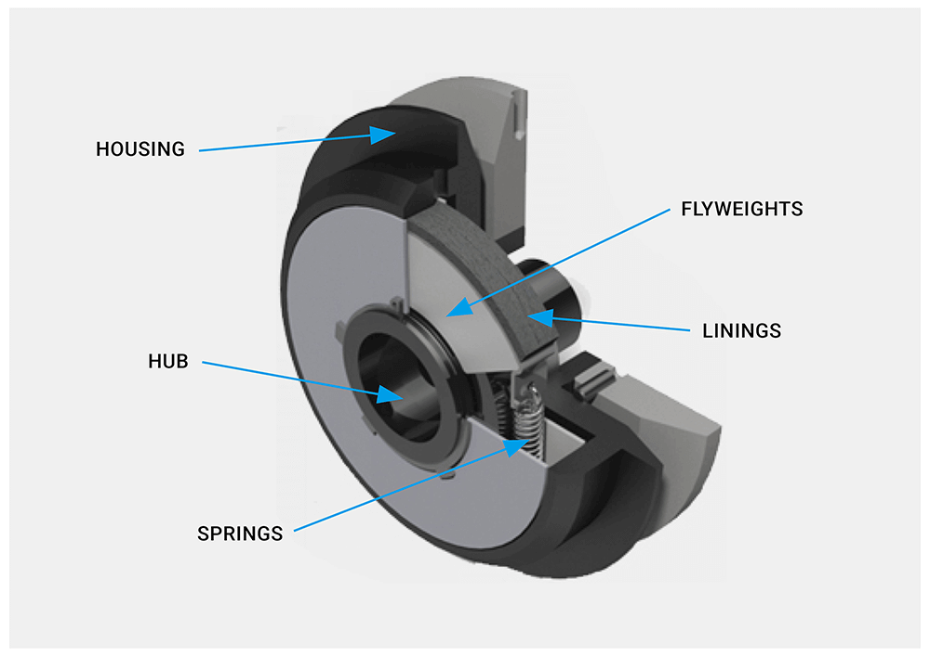

(Image 1 – Image of the contents within a centrifugal clutch
Reference - (Lanceral, 2021).

2.0 Assembly and Material Selection
Determined by clutch size, the retaining components of a centrifugal clutch are fabricated from a three piece construction, including a spring, drum and a shoe.

Shoe : The Shoe of the centrifugal clutch, when exerted to centrifugal force (Which exceeds the force of the spring as per rpm increase) extends in a linear plain outwards towards the housing of the clutch. The component will be manufactured to a specified diameter from a heat resistant material, as heat is a byproduct during the process of generating friction. The body of the shoe will generally be produced from a metal/steel, with a friction material around the circumference diameter of the component, “friction disc plates or friction plates, are used in automotive brake systems. They consist of a metal plate bonded with friction material. Friction discs are commonly made from metal. However, the use of metal has a drawback, which is the grinding noise created when friction is applied. (Materials, 2021). Friction materials are utilised to prevent slipping between the shoes and the inner housing of the clutch. Initially, asbestos was utilized as a industry standard as a friction material within centrifugal clutch, “but due to the increase of health concerns associated with exposure to asbestos, ceramic has become a popular material to use as an alternative.” (Materials, Friction Materials, 2021). Alternatively, manufacturers utilize semi metallic materials such as brass and copper for they’re durability properties. Semi metallic materials have a better capability with regards to heat generation and therefore are a adequate substitute within a centrifugal clutch, “Semi-metallic friction materials with a high iron or steel content can handle heat much better than ceramics, low-metallics and non-asbestos organic (NAO) materials. Semi-metallics will wear less and fade less as brake temperatures rise. But the trade-off to switching to a semi-metallic may be increased noise and rotor harshness. (Carley, 2005).

Drum : The drum of the component is the part within the clutch hat receives the torque from the friction material via the shoe as per the rotary motion increasing, thus allowing the drive to be collected. The drum of the clutch is generally manufactured from steel, of which will interact directly with the friction material around the circumference of the shoe.

Spring: The spring component is utilized to restrict the shoe from moving in a linear plane to collide with the inner circumference of the clutch drum. As per the RPM increasing, the centrifugal force of the clutch will overcome that of the force of the spring, thus allowing the two to engage. However, the springs may be modified/changes to “adjust the revolutions required for engagement of the clutch as they act against the radial force generated by the clutch to retain the arms as revolutions increase/decrease” (LTD, 2011).

3.0 Advantages of a Centrifugal clutch

Whilst considering advantages of the centrifugal clutch, due to the shoes being released by the spring via force, the clutch can be considered to be released automatically which does not require manual intervention from the user, “Centrifugal clutches automatically engage and disengage. You don’t need any type of control mechanism. Centrifugal clutch relies on the laws of physics” (BLM, 2019). Also, due to the shoes engaging with the drum when the centrifugal force generated by the rotary motion of the crankshaft exceeds the force of the spring, this results in the unit being considerably cheaper to purchase as that of its competitors, as there fewer parts involved (No battery included etc), “Centrifugal clutches are relatively inexpensive compared to other clutch types. Partly because there are fewer parts involved, no battery or additional components necessary.” (BLM, 2019). The clutch, due to the force on the spring being slowly overcome by centrifugal forces exerted on it, also decreases the chances of the engine stalling, due to large loads not being exerted on the engine, “It is safer for both the user and the systems since huge loads won’t stall the engine and letting the throttle free disengages the driving shaft almost immediately.” (BLM, 2019). When considering the usage of the centrifugal clutch, its maintenance costs are low to the user due to design and material of manufacture, therefore promoting the centrifugal clutch as a cost-effective resolution to effectively transmit power to the remainder of the engine, “The servicing and maintenance cost of the centrifugal clutch is low. As the construction and primary design is good so there is a little chance of breaking down or wearing away of the system” (Baksiin, 2021).

4.0 Application of Electromagnetic Clutches

A electromagnetic clutch operates through allowing power to be transferred from a primary drive shaft to a secondary drive shaft through electrical engagement. Component is typically assembled from 3 primary components – the drive shaft which is a fixed item, this is where stationary electromagnet is joined to the assembly, a rotor which is fixed to this shaft, and ultimately a armature to connect the hub of the clutch to a secondary shaft (This commonly has a belt attached to it). The clutch operates when a magnetic field is crated around the drive shaft when voltage is applied, thus transferring through the rotor and armature ensuring the primary shaft engages with the secondary shat – thus creating output.

Whilst considering the application of electromagnetic clutches, they are utilized in “many types of high speed, high cycle rate and long life machines including printers, packaging machines, food processing equipment, industrial mixers, and cash counting machines.” (JBJ, 2021). The component is utilized in the above appliances due to its ability to “convey or cut power from the motor to the conveyor without stopping the power (without turning off the motor) by being mounted between the motor and conveyor” as seen in figure 2
(Pulley, 2021).
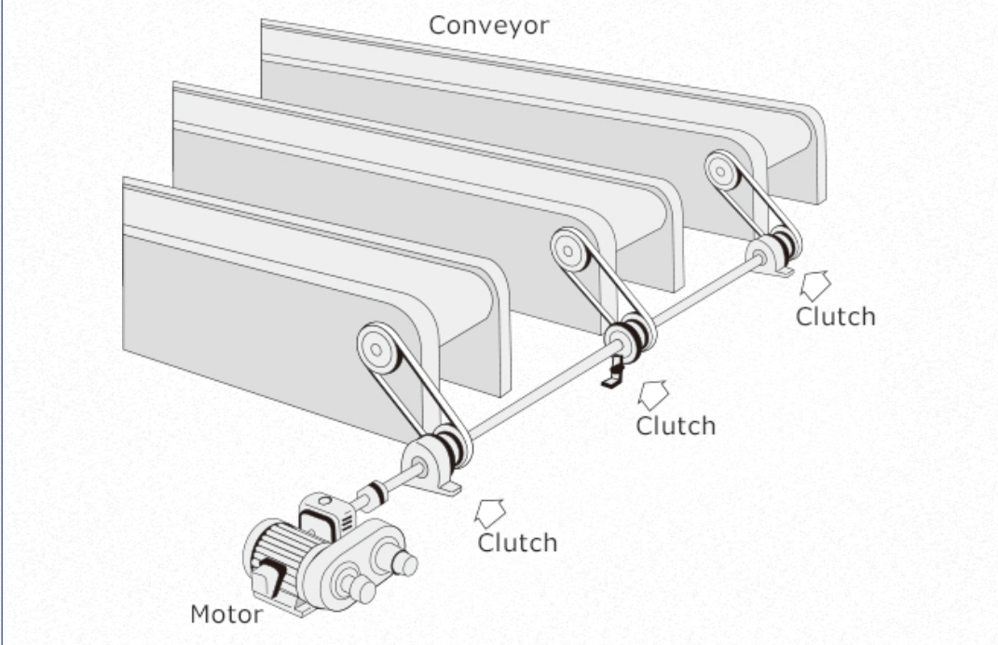

(Figure 2 – Demonstration of function of a electromagnetic clutch.
Reference - (Pulley, 2021).

As seen in figure 2, a advantage of a business utilizing a electromagnetic clutch is that it has the capability too achieve automatic transmission whilst requiring no linkage to operate the clutch. The system also allows for immediate response time when activated with minimal complexity to maintain (MECHANICALFUNDA, 2020).

Having argued its advantages, there are also disadvantages associated with the electromagnetic clutch, the component “dissipates energy as heat in the electromagnetic actuator every time the clutch is engaged, thus creating a risk of overheating which is a major limitation” (Clutch, 2019). The clutch also has a high initial instalment cost, which may cause limitations as lesser businesses may seek alternative clutches/systems.

Therefore to conclude it has become apparent electromagnetic clutches are vastly utilized within high-speed industry’s due too they’re ability to disconnect and connect power without stopping power supply to other systems.

Question 2 – Numerical Analysis.

1)
Internal radius is the addition of distance from centre of clutch to edge of the shoe, plus the displacement the shoe will move to engage with with inner surface of the drum; then multiplied by 2 for diameter.

Shoes centre of gravity from centre of shaft = 95mm.
Distance between outer drum and centre of mass of shoe = 9mm.

Therefore,
Radius (r) = 95+9 = 104mm.

Thus meaning,
Diameter = Radius x 2
Diameter = 104 x 2
Diameter = 208mm.

Outer radius (r) = 95+9+4 = 108mm

Therefore,

Total outer diameter = 108mm x 2 = 216mm.

2)
Initially, determine value of force required to engage spring (Spring force):

Ensuring SI Units are used :
$x$ = 9mm = 0.09m.

$F=K$x$x$
F = 7.5x${10}^{3}$ x 0.009
F = 67.5N.

Post successful determination of force required to engage spring, interpolate centripetal force formula to make ${}^{2 }$subject to determine engagement speed.

Conversion to SI units :
R = 104mm = 0.104m.

$F=m{}^{2 }r$ (Division of both sides by $mr$allows for ${}^{2 }$to become subject of formula)

Hence,
${}^{2 }\frac{F}{Mr}$

Therefore,

${}^{2 }= \frac{67.5}{0.275 x 0.104}$

${}^{2 }$= 2360.13986
${}^{2 }=$ $\sqrt{2360.13986}$
${}^{2 }=48.58 rad/s^{2}$.

3)
Use of centrifugal force formula, re-arranged to ensure F is subject of formula to be utilized to determine centrifugal force.

Conversion to SI units :
550rpm = 57.595 rad/$s^{2}$

$$F=m {}^{2 }r$$

Therefore,

$F=0.275$x 57.59$5^{2 }$x 0.104 – 67.5 (Sum must eliminate spring force as it opposes the drum).
$$F=27.37N \left(Force generated by 1 shoe\right).$$

As there are four shoes on the clutch in question :

Overall force on clutch = 27.37 x 4
F = 109.48N. (Force generated by 4 shoes).

4)
Torque = friction x (Centrifugal force – spring force) x radius x Number of shoes
Torque = 0.35 x (109.48 – 67.5) x 0.104 x 4
Torque = 6.11Nm.

5)
When considering the transmitted torque at the driven shift against the incremented rotary speed of the shaft, from a variation of speeds the below was found:

(Image 3 -Force at a variation of Radiuns/$s^{2}$
Reference – Microsoft Excel, 2021).

In the above graph, we see at 450rpm a negative value, which indicates that the force generated by the springs (also known as the Centripetal force) is exceeding the centrifugal force – due to the lack of rotations. Whilst considering the graph at 475rpm, it is a valid argument to a be of the assumption between this increment in speed, the centrifugal force begins to outweigh the force generated by the spring which results in a positive Force being generated, thus meaning the shoes have began to move in a linear plain towards the inner drum. As analytically proven during question 3, we see the clutch colliding with the inner circumference of the drum at 550rpm where 109N of force is generated, thus aligning both the graphical and analytical analysis completed . The maximum force applied to the clutch was 344.7228N at 700 rotations per minute.

6)

(Figure 4 - Visualization of how Torque behaves when Friction increases
Reference – Microsoft Excel 2021).

When considering the incremental increase in friction, it has become evident all results corresponded re-cyclically. It became apparent that where friction is increased, the torque can also be increased. The above numerical changes have been made under the assumption that no outstanding circumstances have effected the performance of the clutch. For example, if Grease was to be added to the inner drum of the centrifugal clutch the torque can be engaged at a higher rpm to reduce slip which would neglect the data collected in Figure 4. We are also under the assumption here that the total area of the friction surface is reciprocal across all shoes.

5.0 Conclusion

Due to the nature and primary function of the centrifugal force, it has become apparent its material of manufacture is of paramount importance to ensure the centrifugal force generated within the clutch is transmitted efficiently to the drive shaft.

Under the assumption of perfect operating conditions, during part B of the above report it was possible to both analyze through both analytical and graphic means of how the centrifugal clutch reacts under different rotary speeds to reinforce the theoretical findings in segment A.

6.0 Bibliography.

Baksiin, S. (2021, 01 01). Centrifugal Clutch: Definition, Parts, Working Principle, Advantages, Disadvantages, and Applications. (S. Baksiin, Producer, & Learn Mechanical) Retrieved 09 27, 2021, from https://learnmechanical.com/centrifugal-clutch/

BLM. (2019, 08 27). Advantages and Disadvantages of Centrifugal Clutches. (B. Team, Producer, & BLM Team ) Retrieved 08 2021, from Advantages and Disadvantages of Centrifugal Clutches: https://www.blm-cm.com/blog/advantages-disadvantages-centrifugal-clutches/

Carley, L. (2005, 01 01). Brake friction materials. (L. Carley, Editor, L. Carley, Producer, & Lee Carley) Retrieved 09 17, 2021, from Brake friction materials: https://www.counterman.com/brake-friction-materials/

Clutch, E. (2019, 05 19). Electromagnetic Clutch. (Ram, Editor, Ram, Producer, & Electromagneti Clutch) Retrieved 10 17, 2021, from Electromagneti Clutch: https://www.autoprotips.com/author/admin/

JBJ. (2021, 01 01). Electromgnetic Clutches. (JBJ, Editor, JBJ, Producer, & JBJ) Retrieved 09 27, 2021, from Electromgnetic Clutches: https://www.jbj.co.uk/electromagnetic-clutches.html

Lanceral. (2021, 01 01). Centrifugal Clutch Explained – An Engineer’s Guide to a Centrifugal Clutch. (Lanceral, Editor, Lanceral, Producer, & Lanceral) Retrieved 10 16, 2021, from Centrifugal Clutch Explained – An Engineer’s Guide to a Centrifugal Clutch: https://www.lancereal.com/centrifugal-clutch-explained/

LTD, I. F. (2011, 01 01). Centrifugal clutches - Manufacturer of Clutches. (I. F. LTD, Producer, & LTD, Industrial Friction Materials) Retrieved 07 2021, from LTD, Industrial Friction Materials: http://www.industrialfriction.com/centrifugal-clutches/

Materials, F. (2021, 01 01). Friction Materials. (F. Materials, Producer, & Friction Materials) Retrieved 07 2021, from Friction Materials: https://www.frictionmaterials.com/tag/centrifugal-clutch/

Materials, F. (2021, 01 01). Friction Materials. (F. Materials, Editor, F. Materials, Producer, & Friction Materials) Retrieved 10 11, 2021, from Friction Materials: https://www.frictionmaterials.com/tag/centrifugal-clutch/#read

MECHANICALFUNDA. (2020, 01 01). MECHANICALFUNDA for Mechanical Engineers. (MECHANICALFUNDA, Editor, MECHANICALFUNDA, Producer, & MECHANICALFUNDA) Retrieved 09 28, 2021, from MECHANICALFUNDA for Mechanical Engineers: https://www.mechanicalfunda.com/2019/08/advantage-disadvantage-electromagnetic-clutch.html

Pulley, M. (2021, 01 01). MIKI PULLEY TOP > Product Information > ELECTROMAGNETIC CLUTCHES & BRAKES > What Are Electromagnetic Clutches and Electromagnetic Brakes? Their Types and Structures. (M. Pulley, Editor, M. Pulley, Producer, & Miki Pulley ) Retrieved 09 24, 2021, from MIKI PULLEY TOP > Product Information > ELECTROMAGNETIC CLUTCHES & BRAKES > What Are Electromagnetic Clutches and Electromagnetic Brakes? Their Types and Structures: https://www.mikipulley.co.jp/EN/Products/ElectoromagneticClutchesAndBrakes/about.html

Toulas, B. (2018, 09 23). How does a Centrifugal Clutch work? What are the pros and cons? (Engineeringclicks, Producer, & Engineeringclicks) Retrieved 09 2021, from How does a Centrifugal Clutch work? What are the pros and cons?: https://www.engineeringclicks.com/centrifugal-clutch/

