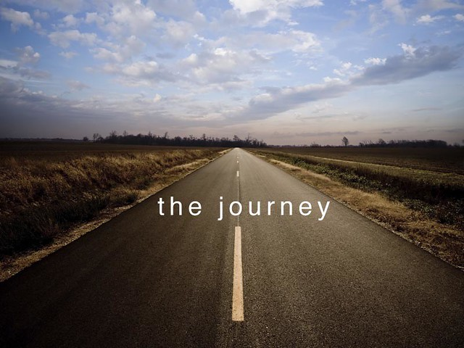

Reflective review of learning journey

  - University of trinity st david
Lyndsey Copp| Skills for the Workplace | 09/03/2022
Student number 2118579

Contents
Contents Error! Bookmark not defined.
Introduction…………………………………………………………………………………………………………………………2
SWOT Analysis…………………………………………………………………………………………………………………………….3/4
VARK………………………………………………………………………………………………………………………………5/6
Johari Window………………………………………………………………………………………………………………….7/8
Honey & Mumford……………………………………………………………………………………………………………………..9/10/11
SMART Goals………………………………………………………………………………………………………………11/12
Personal Development Plan (PDP)……………………………………………………………………………….13/14
Conclusion…………………………………………………………………………………………………………………...…..15
References……………………………………………………………………………………………………………………16/17
Appendix A………………………………………………………………………………………………………………………18
Appendix B……………………………………………………………………………………………………………………….19
Appendix C……………………………………………………………………………………………………………..20/21/22
Appendix D………………………………………………………………………………………………………………23/24/25

Introduction
The purpose of this report is to establish the skills and knowledge, which contribute to working efficiently, to understand my personal strengths and weaknesses assess my preparation for employment, establishing employment goals and to develop and share my personal, action and development plan. Students have different learning styles and these can affect how they learn. I have spent some time thinking about how we, as individuals learn, through attending my lectures. In my opinion, learning is a process by which the learner takes responsibility for their learning. Of course, there are factors in life, which affect ones learning, these factors could include maturity, knowledge and understanding. They affect the way that we all learn.
I am a manager; therefore, I intend to focus specifically on becoming a development officer. I will complete a SWOT Analysis, Honey & Mumford questionnaire, VARK questionnaire, a Personal Development Plan (PDP) and a Johari Window to help me to establish my skills and prepare for my goal of becoming a Development Officer in the future.

SWOT Analysis
For the benefit of this assignment, I have completed a personal SWOT Analysis. The SWOT Analysis highlighted a need for training in Management and leadership to improve my weakness in delegating. A need for me to improve my confidence and ability to talk in front of a group and for me to find a way of managing my time more productively. I am very determined and ambitious. I have good communication skills and I am currently learning British Sign Language. I would like to see myself working as a Development Officer. A personal SWOT Analysis can be used as a tool to analysis my skills/weaknesses and help me to develop my abilities, talents and opportunities whilst improving my weaknesses in order to help me to achieve my ambition.
A SWOT Analysis Worksheet highlights strengths, weaknesses, opportunities and threats. It is considered that this analysis was created in the 1950’s by Harvard School professors, nevertheless, some people claim that Albert Humphreys between 1960 and 1970 created it. (Friesner 2016) My completion of the SWOT Analysis helped me to reflect on my strengths and not just my weaknesses, which has always been what I have done in the past. Furthermore, the SWOT Analysis does not show a plan of action. However, I am aware that it is a personal SWOT/viewpoint and others may identify other needs. I have completed this SWOT Analysis as my first step towards creating my Personal Development Plan (PDP) and as a self-assessment. See below.
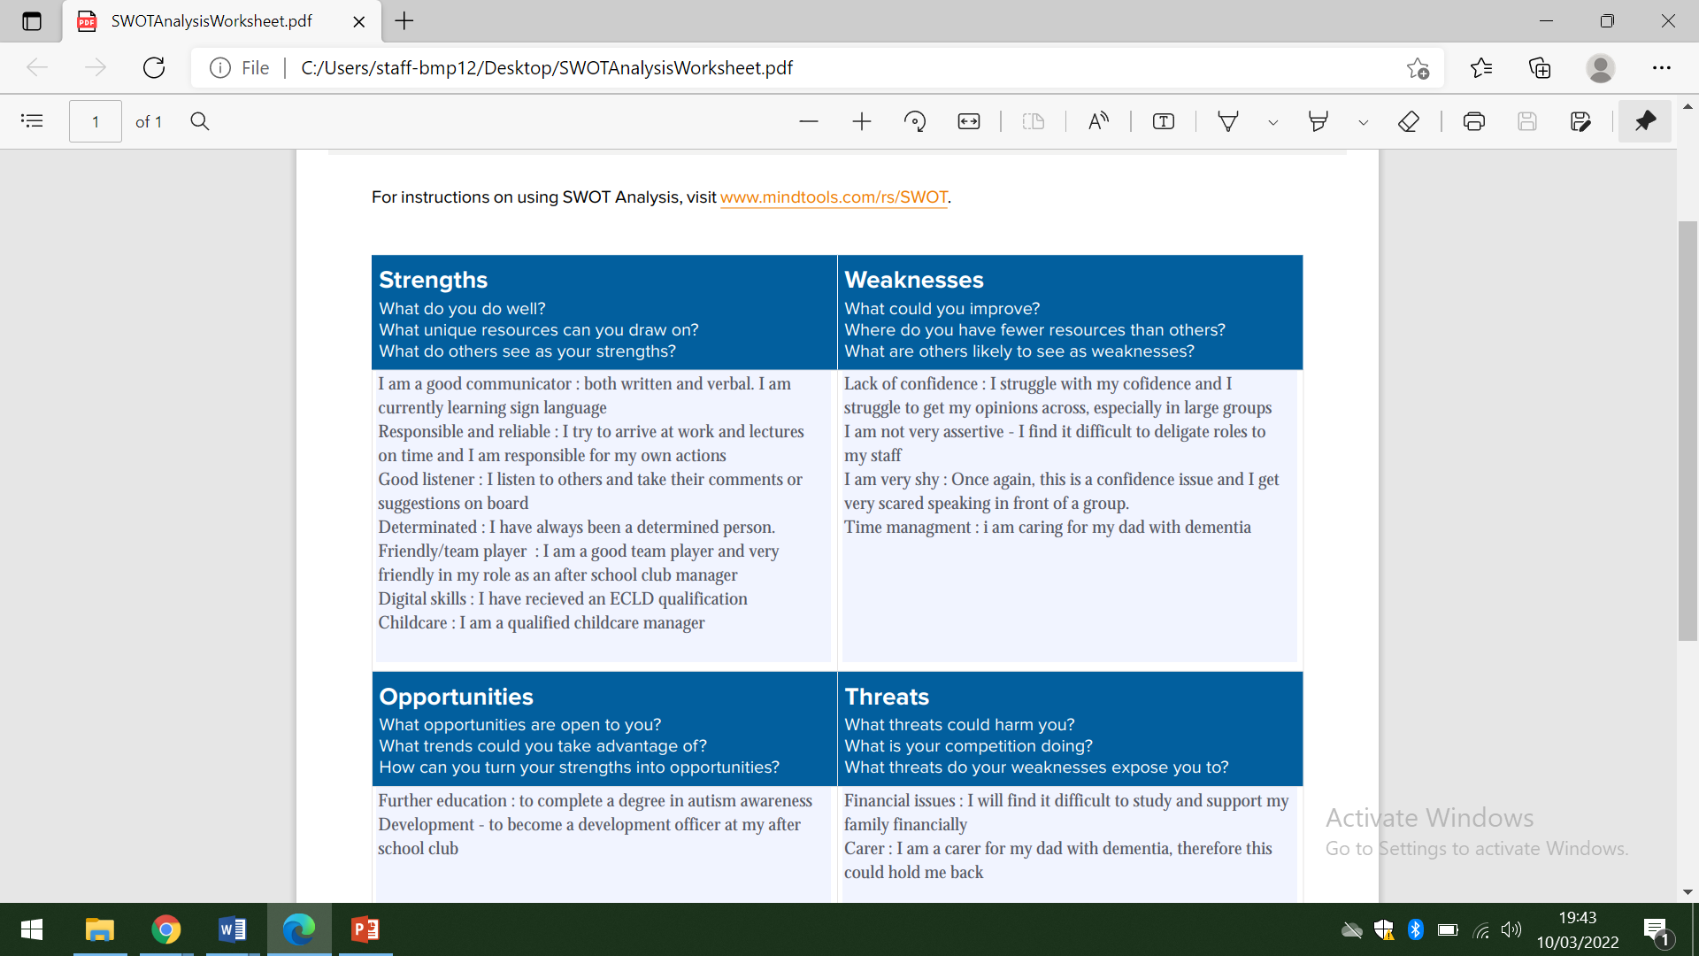

Vark

I have completed the VARK questionnaire. This questionnaire shows an individual’s preference for the way that they learn and work with information. It gives students the opportunity to maximise their learning journeys by suggesting strategies to use.

What is the VARK Learning model?
The VARK model was designed by Neil Fleming in 1987. In this model, Fleming developed a way to help students learn more about their preferences (Dene Poth 2022)
The term VARK is an acronym for the four types of student learning style: visual learners, auditory learners, reading or writing learners, and kinesthetic learners. (See figure 1)
- Visual learners – learning by seeing or observing (charts, diagrams, photographs, videos etc.)
- Auditory learners – learning by listening e.g. lectures or listening to podcasts.
- Reading and writing learners – learning by reading textbooks, information books, journals, PowerPoints and by making notes.
- Kinesthetic learners – learning through life experiences and through hands on and physical/tactile activities.
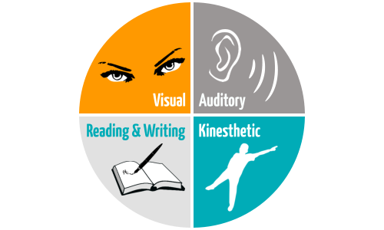

Figure 1: VARK Learning Styles (Mysimpleshow 2016)
After taking the online learning style quiz, it came out that I am an auditory learner. After reading a description of what auditory learning is all about, I am convinced that I am an auditory learner. To be honest, I was quite surprised when I saw my quiz results but then when I thought about my learning habits and I compared them to an auditory learner, I could see that the quiz was accurate. I prefer to listen to information in order to learn anything from it.

Johari Window
The Johari Window is a model used to help us to understand our relationships with others and how we collaborate with them as well as ourselves. It is a simple and useful tool for clarification and improving self-awareness within an association.
A Johari window is a psychological tool created by Joseph Luft and Harry Ingham in 1955. It is a simple and useful tool for understanding and training: (self-awareness, 2012)
- self-awareness
- personal development
- improving communications
- interpersonal relationships
- group dynamics
- team development; and
- inter group relationships

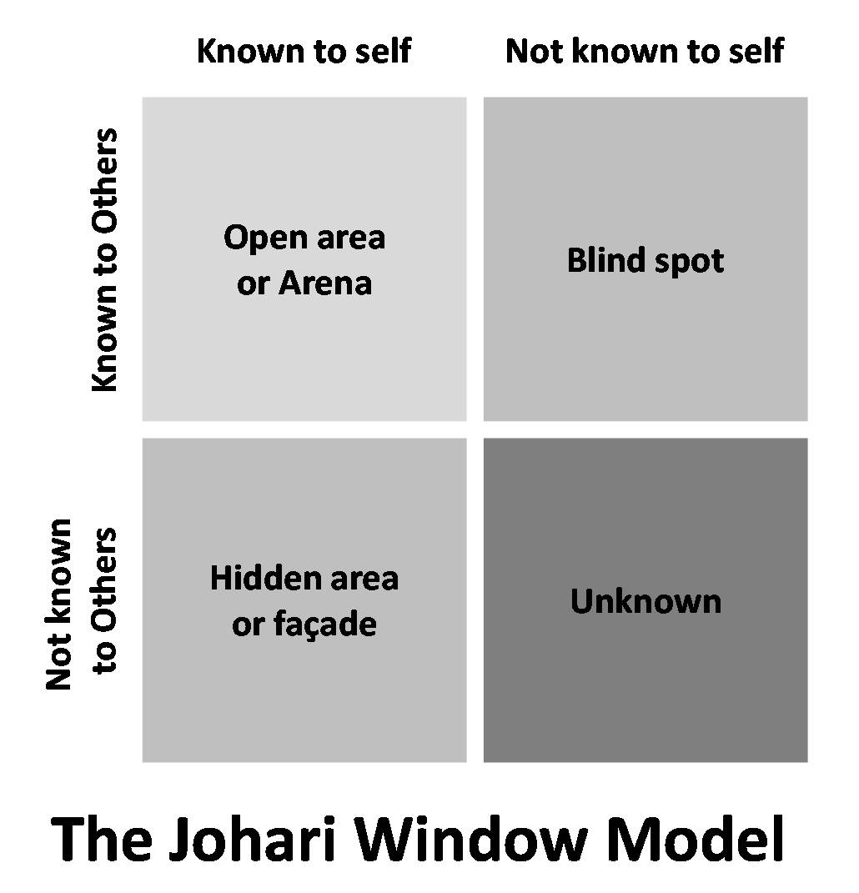
Figure 3. The Johari Window Model (Communication Theory 2014)

I completed my own Jihari Window along with four of my colleagues. This Johari Window has helped with my self-awareness and mutual understanding between colleagues of mine and myself. The feedback that my colleagues have given is particularly helpful in showing me how people perceive me. The results are below:

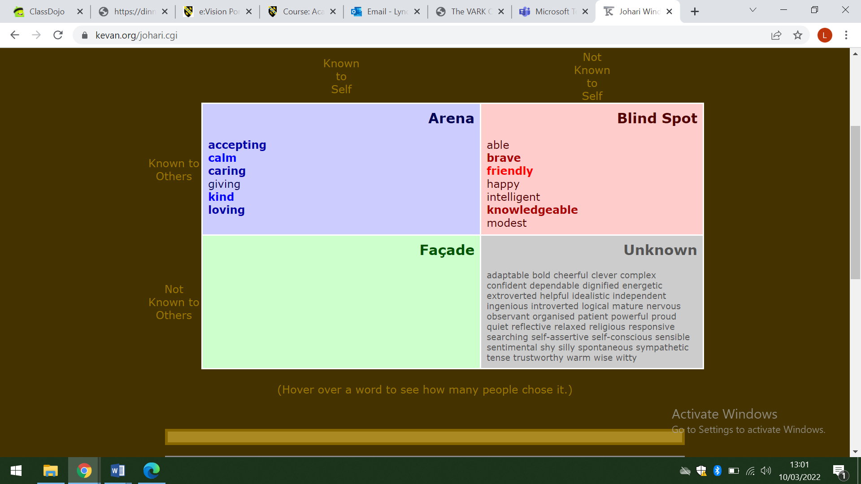

Honey and Mumford
Honey and Mumford is a learning style that was published by Peter Honey and Alan Mumford in 1986. This model identifies four different learning styles that individuals use to require new skills. (Geoghegan) These skills are:
- Activist
- Theorist
- Pragmatist
- Reflector

Most people usually stick to one particular style, although some people can vary between two different styles depending on the synopsis. Each of these styles comes with different educational activities.
Honey said that “Learning to learn is your most important capability since it provides the gateway to everything else you want to develop.” (Peter Honey)
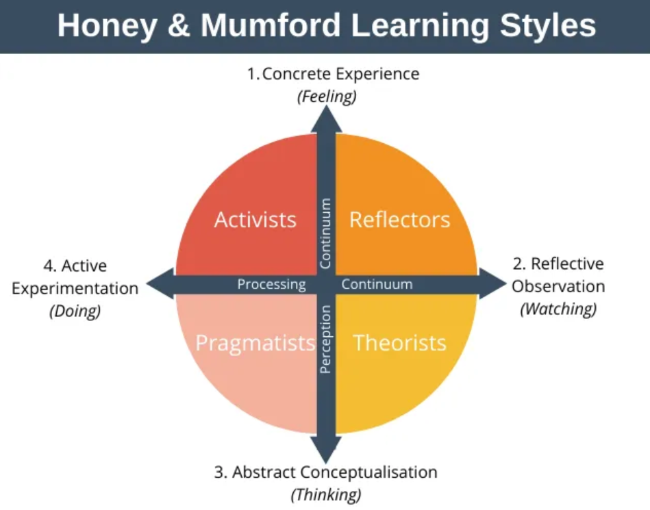

Figure 2 (Geoghegan, “Honey and Mumford Learning Styles”)

These are the four Honey & Mumford Learning Styles:

- Activists – These are “do-ers” and “go-getters” who like to fully immerse themselves into learning. They tend to be open-minded and are willing to try new things. They are eager and adapt well to high-pressured tasks. They are good team workers.
- Theorists – These think about things very carefully and are logical. Theorists are able to adapt and interrogate observations in a logical way. They use step-by-step guides and think problems through carefully (Beever 2017)
- Reflectors – Reflectors like to collect data, stand back and observe experiences from different perspectives. They like to think thoroughly and analyse situations before coming to any conclusions (Australian Government 2004)
- Pragmatists – Pragmatists are eager to try new things, they experiment and search for new ideas and opportunities.

The results of my Honey & Mumford questionnaire shows that I am a reflector. This is defiantly true, as I do not like to be rushed into anything. I like to take my time and analyse situations in order to process things rationally before coming to any conclusions.
Being a reflective learner works well with being an auditory learner (VARK) for me as it means that I learn best through listening, then reflecting, which gives me a chance to process and evaluate the information which has come my way.

SMART Goal
SMART goals stand for Specific, Measurable, Achievable, relevant and time-bound. Goals give us opportunities, motivation, focus. They also give us a purpose and sense of direction. SMART goals help us to achieve our goals through effort and determination.
SMART goals are:
- Specific: Well defined, clear, and unambiguous
- Measurable: With specific criteria that measure your progress toward the accomplishment of the goal
- Achievable: Attainable and not impossible to achieve
- Realistic: Within reach, realistic, and relevant to your life purpose
- Timely: With a clearly defined timeline, including a starting date and a target date. The purpose is to create urgency. (Corporate finance institute, 2015)

My SMART Goals
to become a Development Officer

Lyndsey Copp | 14/03/22 |  | 14/09/2022
GOAL OWNER | DATE PREPARED |  | DATE REVIEWED
 | Specific:  Who: Who is involved in this goal?  What: What do I want to accomplish?  Where: Where is this goal to be achieved?  Why: Why do I want to achieve this goal? | I would like to become a Development Officer for the company that I work for. I will achieve this at my employment. I want to fulfill my full potential.
S | Measurable:  When: When do I want to achieve this goal?  How do I know if I have reached my goal?  What is my indicator of progress? | I would like to achieve this by September 2023.  I will apply for the vacancy when it is advertised.  Attend regular training.
S | Achievable:  Do I have the resources and capabilities to achieve the goal? If not, what am I missing?  Have others done it successfully before? | I will continue to access training opportunities to help to develop my skills.
 | Relevant:  Is the goal realistic and within reach?  Is the goal reachable given the time and resources?  Are you able to commit to achieving the goal? | This goal is realistic and something that I have worked hard to try to achieve. I am very committed to achieving this target.
S | Time-Bound:  Does my goal have a deadline?  By when do you want to achieve your goal? | My goals begins on 14/03/2022 and ends on 14/03/2022.

Personal Development Plan (PDP)

What is a Personal Development Plan (PDP)?
A Personal Development Plan (PDP) is a practical tool that helps us to reflect on our learning, performance and achievements. It is an important process as it helps to organise our personal, educational and career opportunities.
I have created a Personal Development Plan (PDP) for my SMART Goals (linked in my preferred learning styles. (Honey Mumford) and ways of learning i.e. reading, researching, observing.
Development  objective | Specific actions | Blockers and how they will be removed | Support required | How I will know when I have achieved the objective
To finish the skills for the workplace course | Attending lectures regularly | By attending all lectures, studying well and completing my assignments | Family  Lectures  Tutors  Colleagues | I will have completed my skills for the workplace course
Improving my confidence | Participate in social activities | Practice more in order to boost confidence | Widening participation  Peer support  Reflection | When I have completed by first presentation
Leadership skills | Involve myself more in group work | Plenty of practice and confidence | Family  Peers  Tutors  Colleagues | When I am confident enough at presentation and lead multiple presentations
Organise my time better | Complete to do lists  Manage my time more efficiently | Being kind to myself and freeing up time to get things done. Accepting help | Family  Friends  Tutors  Colleagues | When I am completing tasks on time

Conclusion
In order to become a Development Officer at the After School Club that I currently work at, I conducted a vast amount of research. Personal development is a structured process undertaken by an individual to reflect upon his or her own learning, performance and achievements and to plan for their personal and career development. It is clearly a cycle which requires feedback from others, self-awareness and underpinning knowledge of theoretical and methodological approaches. I used a SWOT Analysis to confirm my strengths, weaknesses, threats and opportunities. I noticed that despite having a number of strengths to become a Development Officer (e.g., good communication, I am fair and a good motivator), my biggest weakness is my confidence. Moving forward this is something that I will need to address. I have also decided to educate myself by completing a degree in Business Management in order to actively seek my goal of becoming a Development Officer. Adair (2010:10) cites, ‘don’t imagine that having the appropriate technical or professional knowledge in itself qualifies you for leadership’ A leader also has to have professional qualities and is a person that others want to follow. I also looked at other learning styles, which included VARK, Honey & Mumford and the Johari Window. I wanted to establish which method of learning is best for me.
The VARK method indicated that my best learning method is listening. The Honey & Mumford method showed that I am a reflector.
Taking all of these learning styles into consideration, I then developed a Personal Development Plan (PDP) to help me to achieve my ultimate goal of becoming a Development Officer. If I follow this plan then hopefully I will achieve my goal by 2024. On completion of this assignment, I now feel that I have many opportunities to build upon my skills needed to move forward with my continuous personal development.

References
Beever, Gavin. “Peter Honey and Alan Mumford Learning Styles.” Extension Practice, 1 May 2017, extensionaus.com.au/extension-practice/peter-honey-and-alan-mumford-learning-styles/#:~:text=Peter%20Honey%20and%20Alan%20Mumford%20recommend%20that%20to%20maximise%20personal. Accessed 14 Mar. 2022.
Communication Theory. “The Johari Window Model.” Communication Theory, 10 July 2014, www.communicationtheory.org/the-johari-window-model/. Accessed 14 Mar. 2022.
Corporate finance institute. “SMART Goal - Definition, Guide, and Importance of Goal Setting.” Corporate Finance Institute, 2015, corporatefinanceinstitute.com/resources/knowledge/other/smart-goal/. Accessed 14 Mar. 2022.
Dene Poth, Rachelle. “What Are VARK Learning Styles?” Blog.definedlearning.com, 2022, blog.definedlearning.com/blog/what-are-vark-learning-styles. Accessed 22 Mar. 13AD.
Friesner, Tim. “(PDF) History of Swot Analysis.” ResearchGate, Jan. 2011, www.researchgate.net/publication/288958760_History_of_swot_analysis.
Geoghegan, Denis. “Expert Program Management.” Expert Program Management, 13 Oct. 2020, expertprogrammanagement.com/2020/10/honey-and-mumford/#:~:text=The%20Honey%20and%20Mumford%20learning%20styles%20model%20is%20based%20on. Accessed 10 Mar. 2022.
---. “Honey and Mumford Learning Styles.” Expertprogrammanagement.com, 2022, expertprogrammanagement.com/wp-content/uploads/2020/10/Honey-and-Mumford-Learning-Styles.png?ezimgfmt=ng:webp/ngcb2. Accessed 13 Mar. 2022.
Government, Australian. “Department of Health | Identifying Your Personal Learning Style.” Www1.Health.gov.au, 2004, www1.health.gov.au/internet/publications/publishing.nsf/Content/drugtreat-pubs-front1-wk-toc~drugtreat-pubs-front1-wk-secb~drugtreat-pubs-front1-wk-secb-2~drugtreat-pubs-front1-wk-secb-2-5~drugtreat-pubs-front1-wk-secb-2-5-ide#:~:text=Theorists%20%2D%20Theorists%20like%20to%20analyse. Accessed 14 Mar. 2022.
“Mysimpleshow.” Assemblrworld.com, 2016, blog.assemblrworld.com/content/images/2021/04/what-is-VARK-learning-style.png. Accessed 13 Mar. 2022.
self awareness. “Understanding the Johari Window Model.” Self Awareness, 10 Nov. 2013, www.selfawareness.org.uk/news/understanding-the-johari-window-model. Accessed 14 Mar. 2022.

Appendix A

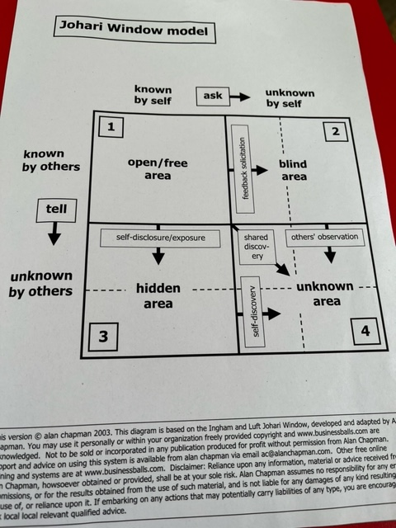

Appendix B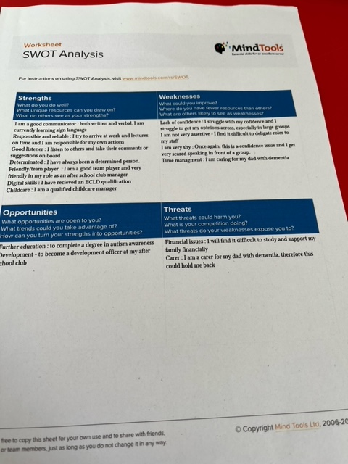

Appendix C

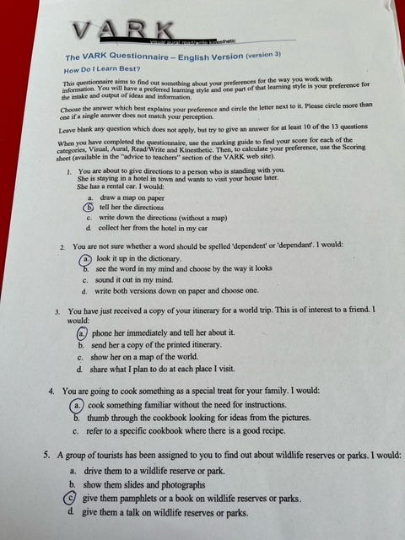

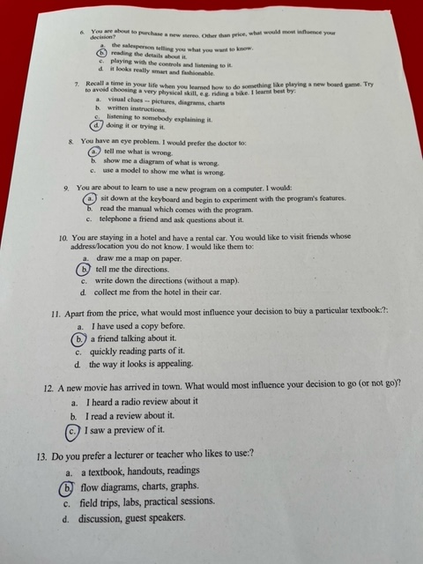

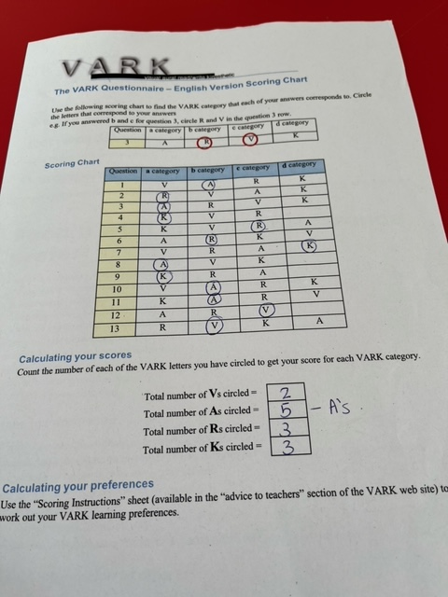

Appendix D


