0351709
Information Systems and Engineering

Neil O’Mahoney
Cyber Security Networking Course Undergraduate.
Contents
Report 3
3NF Tables 7
Dylan’s Book Store 9
Task 2 – User Documentation 9
User guide 16
Conclusion 22
Bibliography 23
Annex A: Entity Relationship Diagram of Dylan’s Book Store in Visio 24
Annex B SQL Code 25

Report
An entity is: ‘A group of objects with the same properties which are identified by the by the enterprise as having an independent existence.’ (Connelly & Begg, 2005) Entries that have been identified as meeting that criterion within the context of ‘Dylan’s Book store’ are as follows: Book, Courier, Customer, Employee, Newsletter, Newsletter Recipient, Supplier, Order and Stock.
Within the above there are Primary Key’s and Foreign Keys. A primary Key is defined as ‘ ..a single field or combination of fields that uniquely defines a record. None of the fields that are part of the primary key can contain a null value. A table can have only one primary key’. (TechOnTheNet, 2019) To that end, each table as its own primary key built in. In the case of ‘Book’ table its primary key is ‘BookID’, each other tables have a similar layout to uniquely identify them in the same way I have chosen ‘<name of table>ID’ to simplify them. Although this conflicts with another unique identifier of a book (such as the ISBN) this would make it much simpler for a human to understand when ordering books etc.
‘When a table contains a column (or concatenation of columns) that is the same as a primary key of a table, the column is called a foreign key.’ (Harrington, 2009). Put another way; a foreign key is ‘A attribute or set of attributes within one relation that matches the candidate key of some (possibly the same) relation’. (Connelly & Begg, 2005)P79
Not all the tables have foreign keys, Order table has very many however this is to be expected as it references many different others to makeup its data. In the case of writing more complex queries the foreign keys are vital to link the data and fields across them.
Database Relationships are classed as ‘..Associations between tables that are created using join statements to retrieve data’. (IBM, 2019) They can also be referred to as ‘Associations between entities‘(Kendall & Kendall, 2011)I will be using these relationships to benefit my queries and reports as detailed above. Getting the right sort of relationship is also important. There are 3 different types: one-to-one, one-to-many and many-to-many. When designing Dylan’s book store these will have to be looked at carefully i.e. customers can exist without orders but orders cannot exist without customers.
While considering the joins in the tables and what potential queries are needed I recommend the following:
- Single book store in south wales area.
- Unknown reason why titles become popular
- Staff needs to be able to place orders with suppliers
- Customers need to be able to place orders (based on title and popularity)
- Newsletter service inside and out of the Swansea area.
- Requirement to store customer’s details
- Menu Driven
- Make queries into the system of titles and first editions and availability
- Flexible
- MUST include: add, delete information from any table
- MUST view book, stock, order and customer details
- MUST view ongoing orders
- MUST query and print relevant reports.
Recommendations based upon the above requirements:
- No need to add an additional store table.
- Add a stock sales field into stock to help with identifying popular sale.
- Create an order table that would link to the suppliers and possibly to the books they supply. Within the order table allow customers to place an order and base this on stock sales or first editions.
- Create an attribute that captures marketing choices for the sending of a quarterly newsletter for users based inside and out of Swansea.
- Create a table that captures customer’s details.
- Make the whole thing graphical and menu driven (buttons creating reports and running queries).
- Make individual buttons that search based on the title of a book and edition including their availability.
- Use Microsoft Access as it is flexible and will expand and contract with ease, allowing for additional fields to be added, removed or edited if necessary.
- Create add, delete buttons on each table.
- Ability to view, book, stock, order and customer details. Create a dispatch on status that shows if the order is ongoing or not. Button to create reports on relevant pages.

‘Normalization is the process of efficiently organising data in a database’. (A.Condor, 2018)
The rationale behind normalisation is to remove redundant data and that relationships between entities are logical. This will benefit the database as it reduces the size of the database and cause less confusion. With reference to the primary key I made earlier, the whole point of having a primary key is that all the other fields logically can relate to it somehow.
‘1NF - Each table contains all atomic data items, no repeating groups and a designated primary key.
2NF - Each table contains all atomic data items, no repeating groups and a designated primary key.
- Each able has all on-primary key attributes fully functionally dependant on the whole primary key.
3NF - Each table contains all atomic data items, no repeating groups and a designated primary key.
- Each able has all on-primary key attributes fully functionally dependant on the whole primary key.
- All transitive dependencies are removed from each table.’
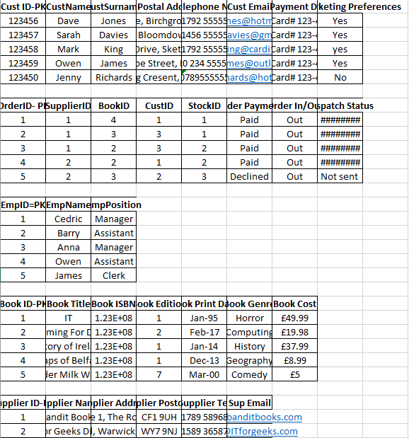
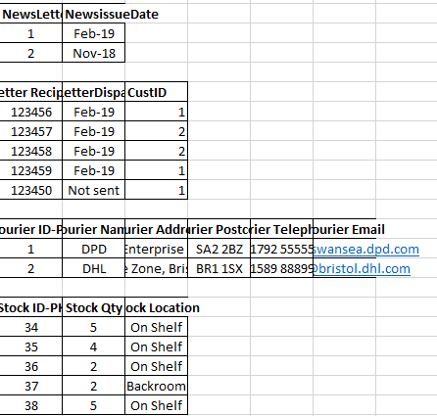
3NF Dylan’s Book Shop Table.

(A.Condor, 2018)

3NF Tables
Book:
PK BookID | Numerical
BookTitle | Text/Mix
BookISBN | Num
BookEditor | Text
BookPrintDate | Date
BookGenre | Text
BookCost | Currency

Courier:
PK CourID | Numerical
CourName | Text
CourAddress | Text/Mix
CourPostCode | Text/Mix
CourTelephone | Num
CourEmail | Text/Mix
Customer:
PK CustID | Numerical
CustName | Text
CustAddress | Text/Mix
CustPostCode | Text/Mix
CustTelephone | Num
CustEmail | Text/Mix
CustPaymentMethod | Text/Mix
FK CustMarkPref | Yes/No

Employee:
PK EmpID | Numerical
EmpName | Text
EmpPosition | Text

Newsletter:
PK NewsLID | Numerical
NewslIssue | Numerical
FK NewsRID | Numerical

Newsletter Recipient:
PK NewRID | Numerical
FK CustID | Numerical
NewsRDisplay | Numerical
CustMarkPref | Yes/No

Order:
PK OrdID | Numerical
FK CustID | Numerical
FK BookID | Numerical
FK EmpID | Numerical
OrdPaymentStatus | Text/Mix
DispatchOnStatus | Date
OrdIn/Out | Text
OrdDate | Date

Stock table:
PK StocID | Numerical
FK SupID | Numerical
FK BookID | Numerical
StocQty | Numerical
StocLocation | Text
StocSales | Numerical

Supplier:
PK SupID | Numerical
SupName | Text
SupAddress | Text/Mix
SupPostcode | Text/Mix
SupEmail | Text/Mix

Dylan’s Book Store

Task 2 – User Documentation

Screen Capture from the Relationship Diagram

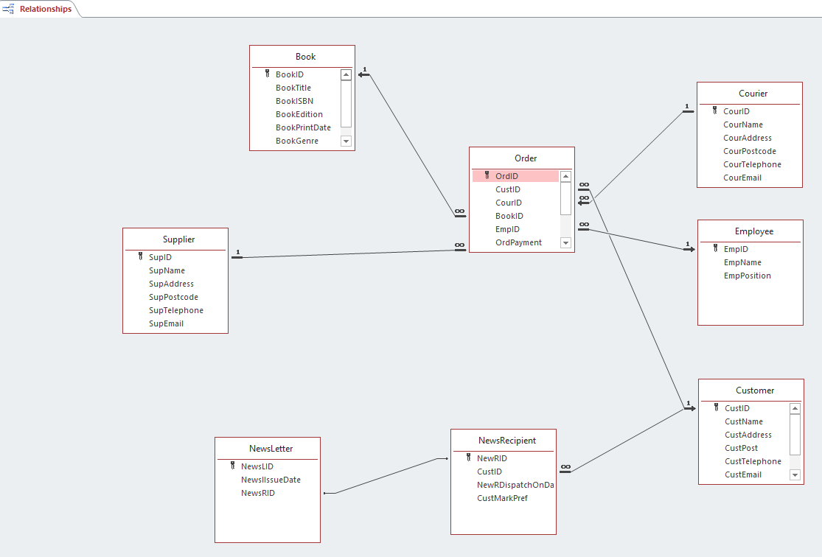

Query Marketing Preferences report (people who have ticked yes)
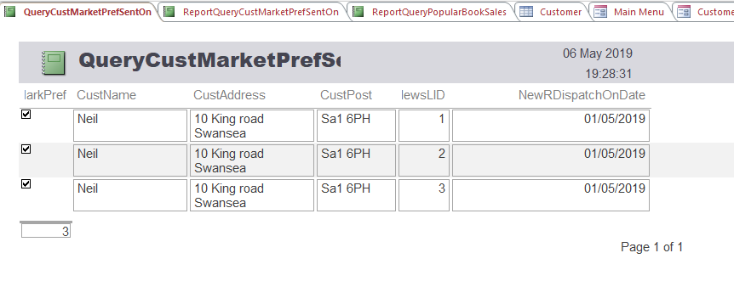

Popular Book Sales Report

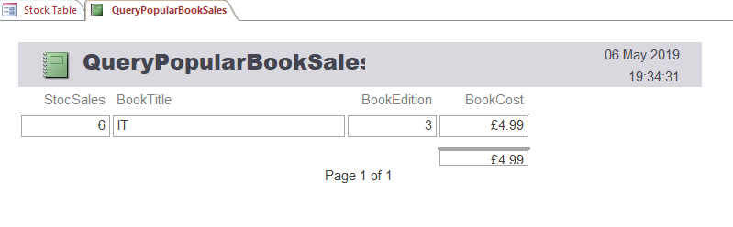

Main Menu
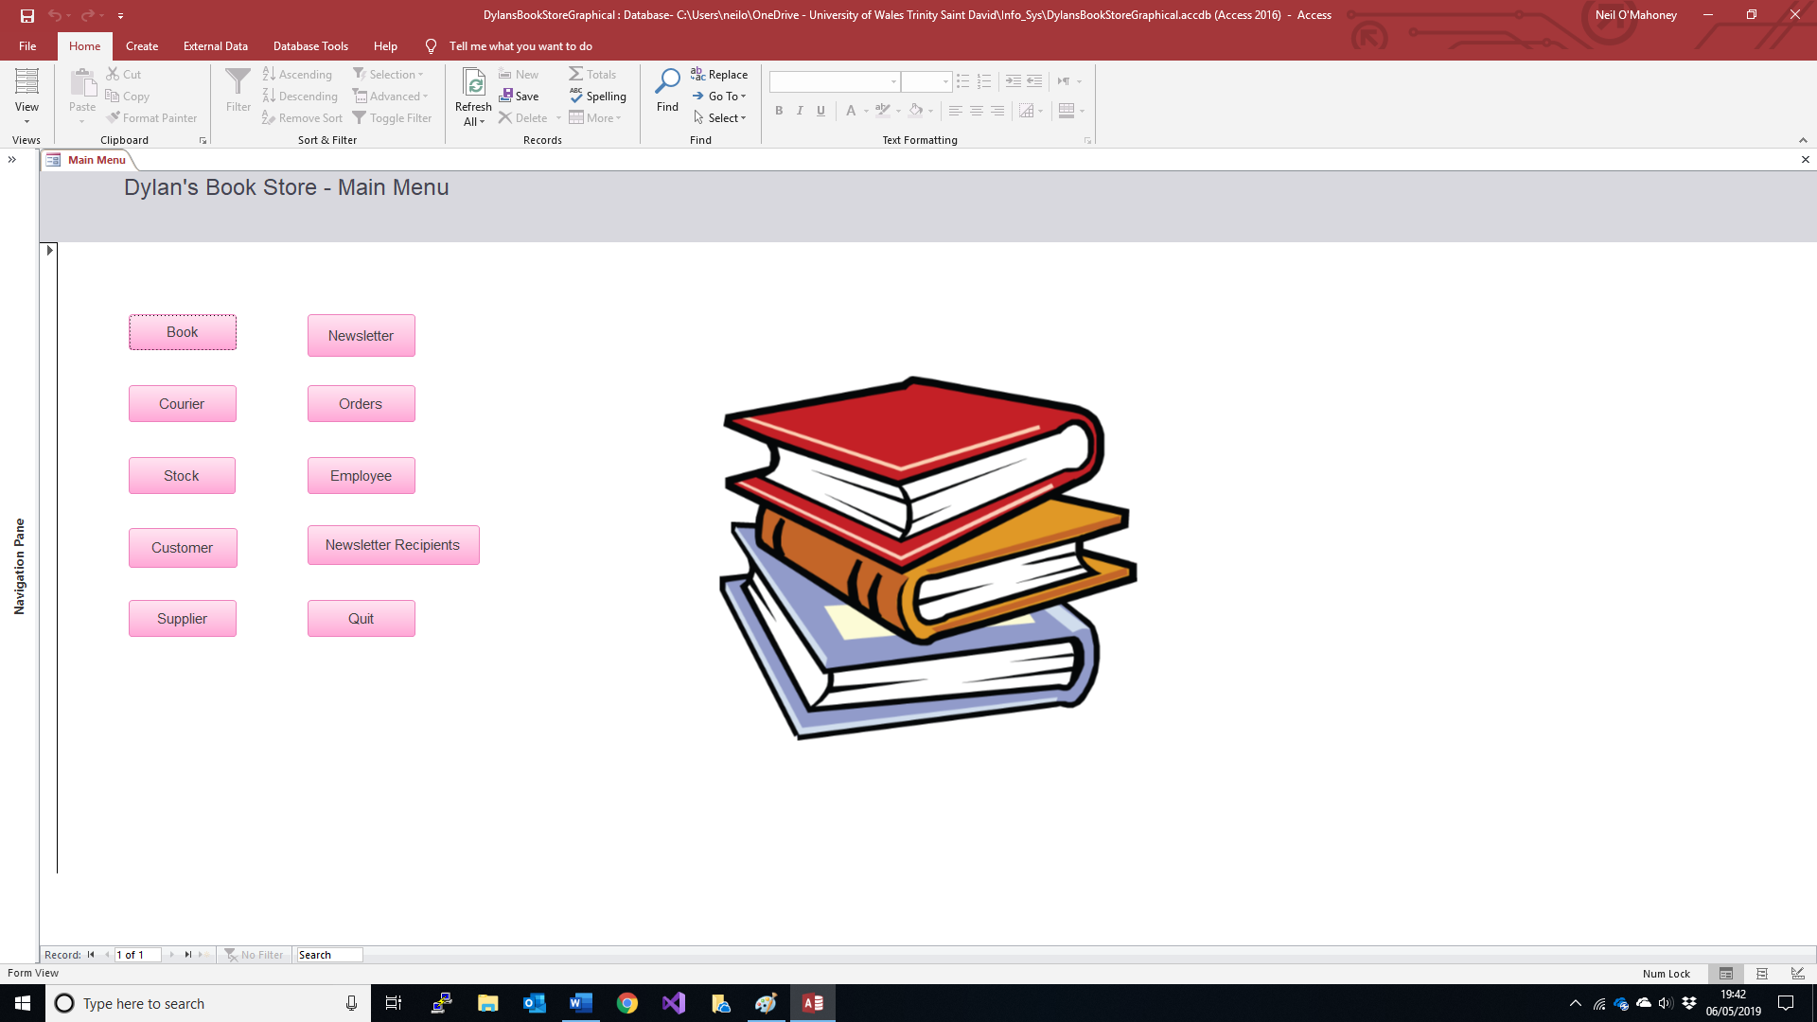
Employee
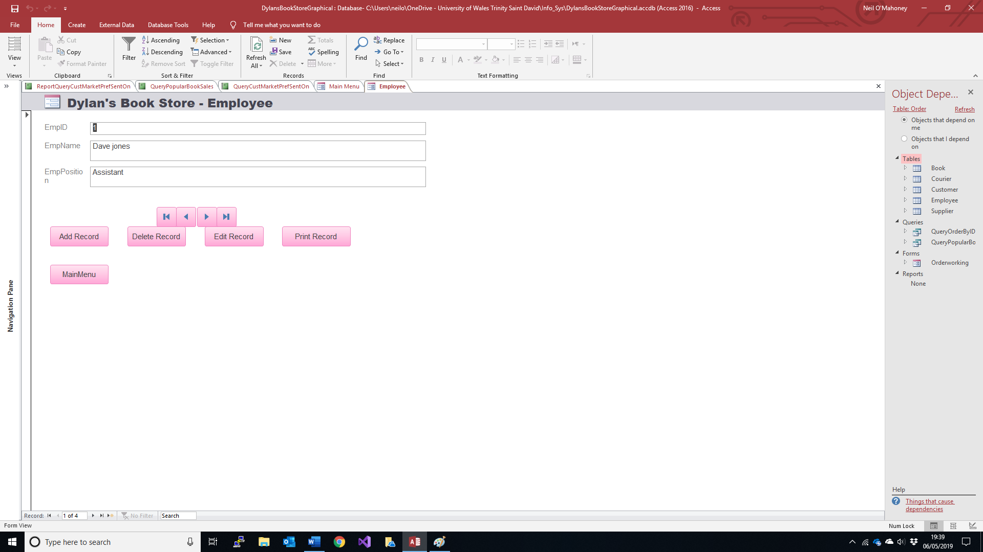

Supplier
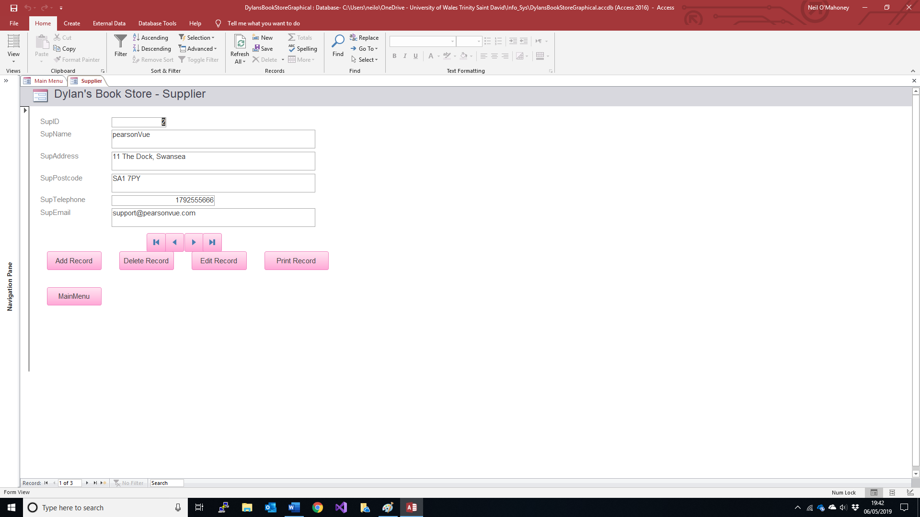

Customer
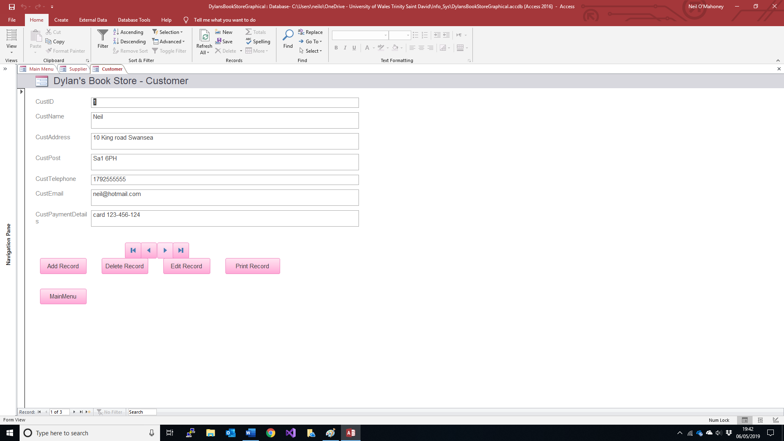

Stock
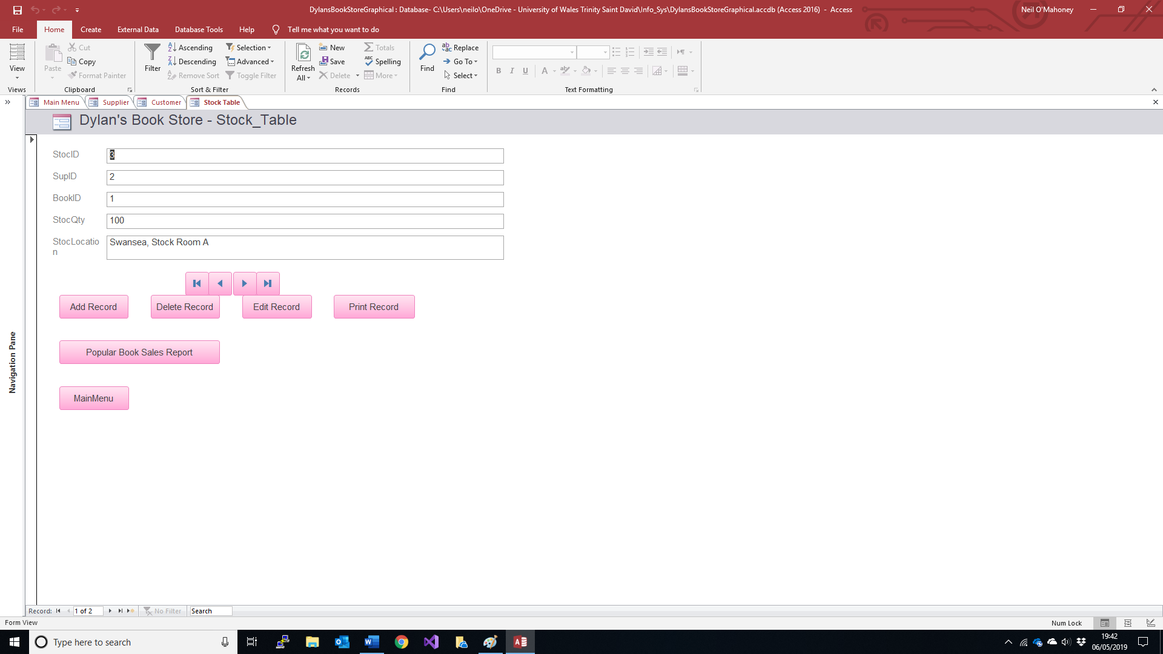
Courier
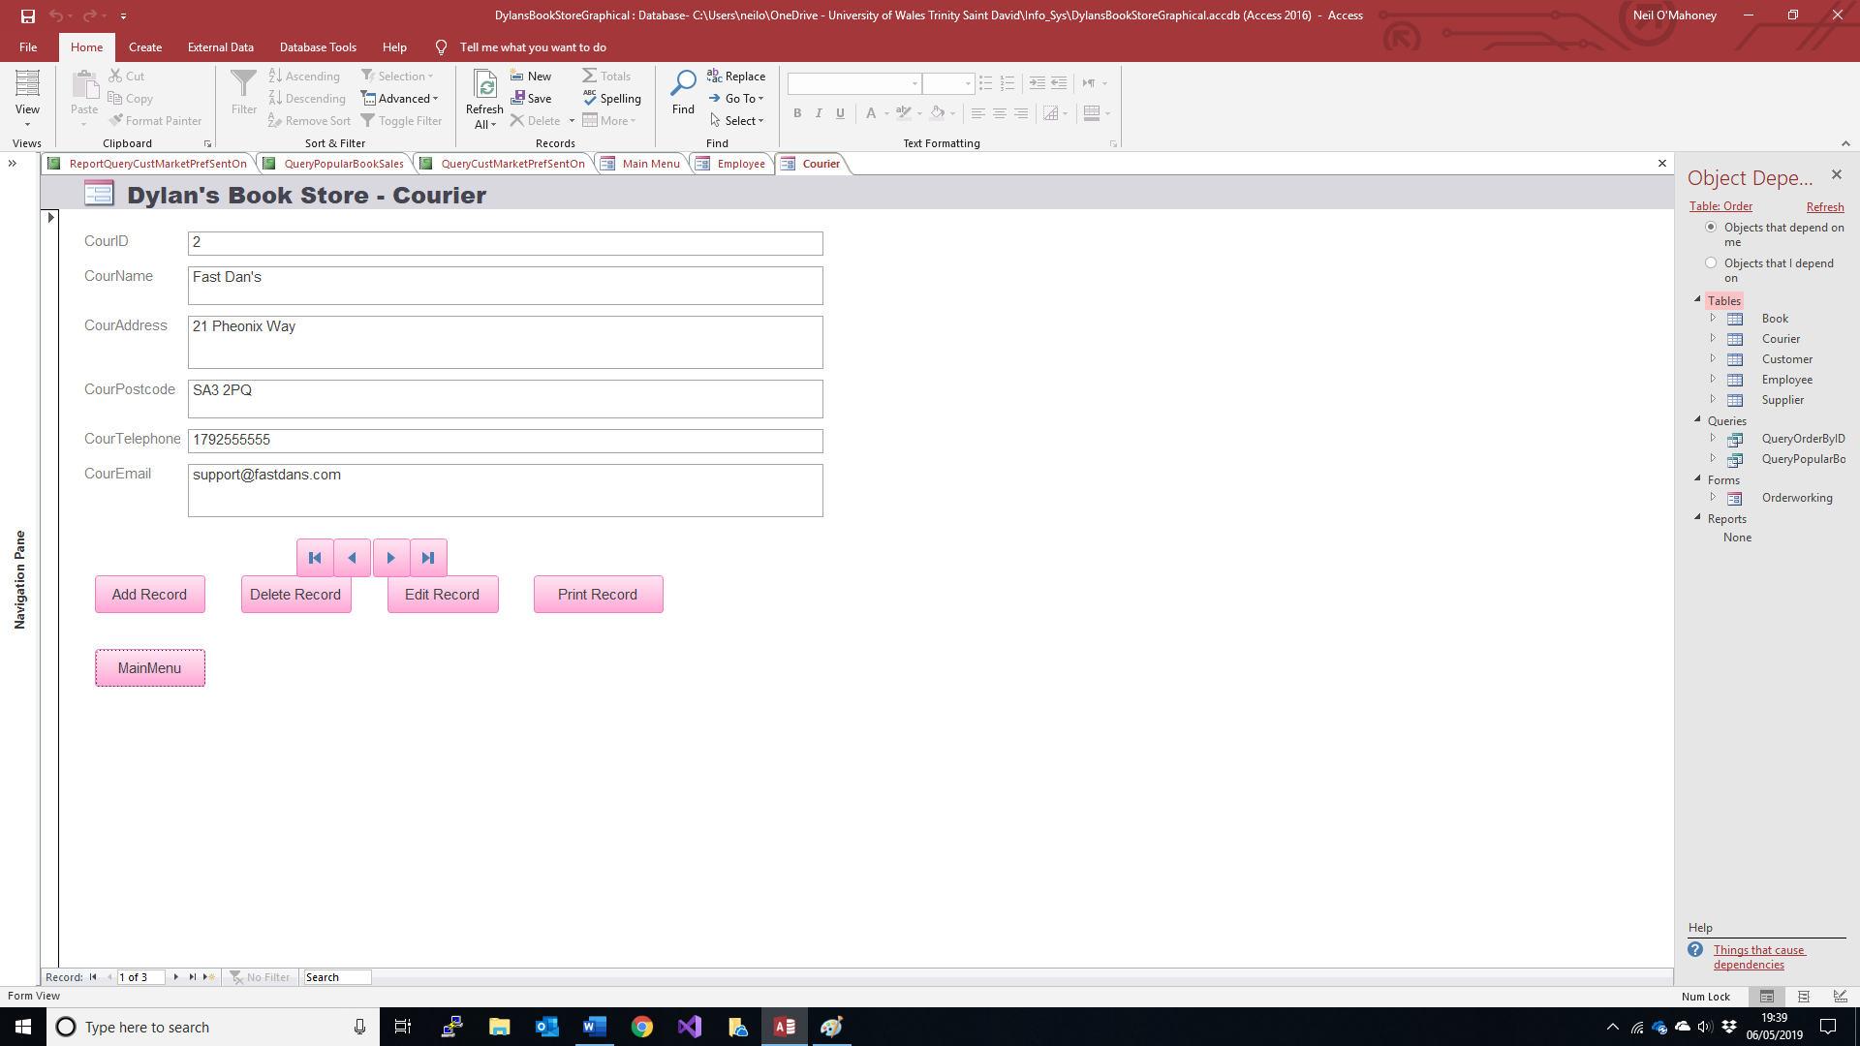

Newsletter
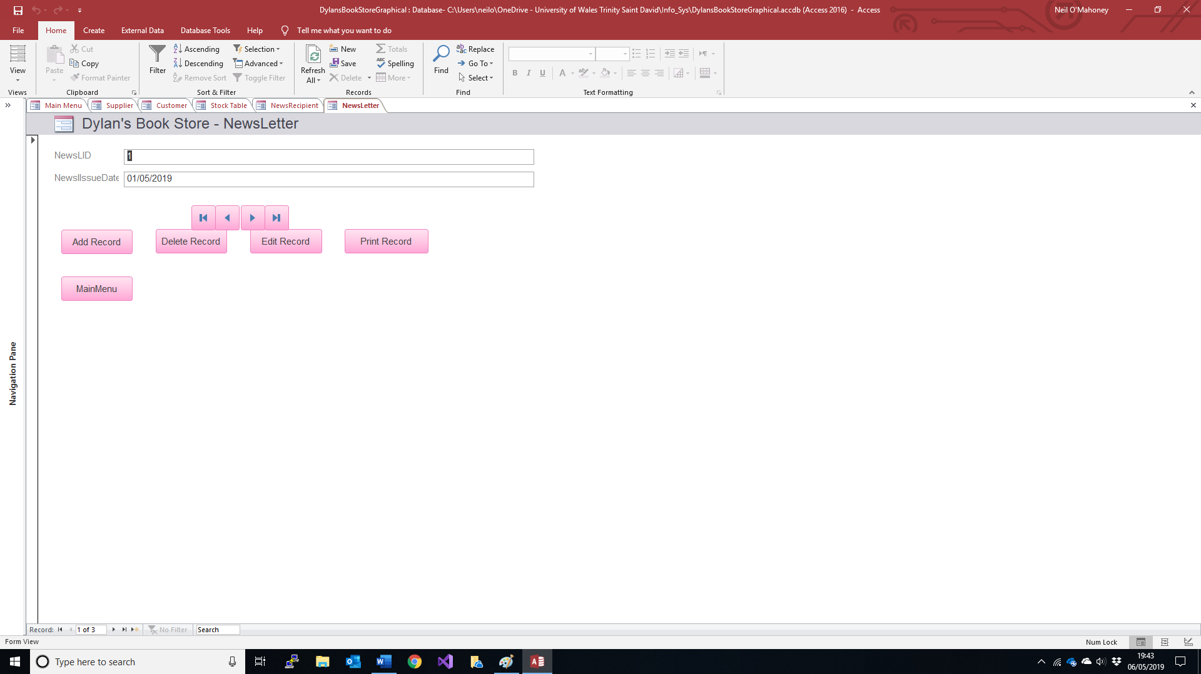
News Recipient
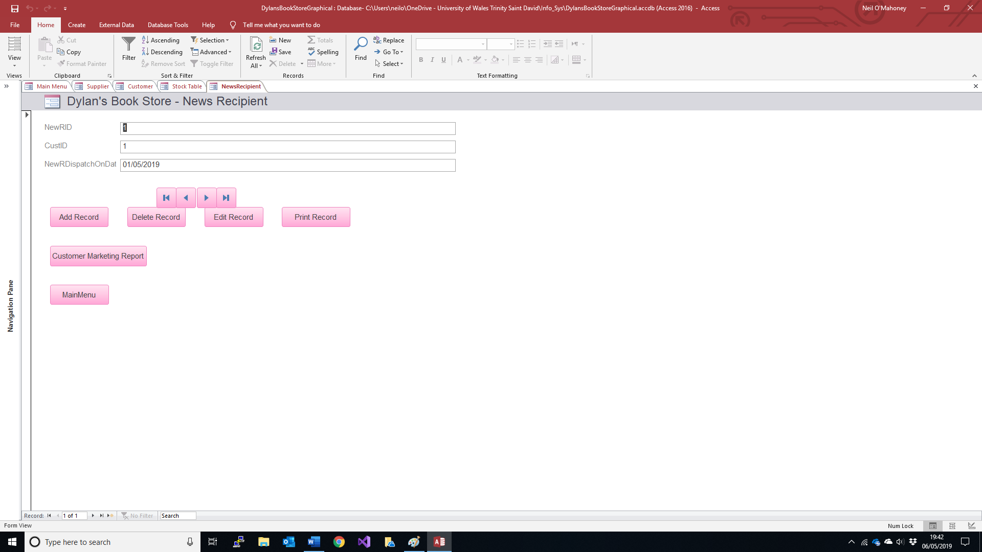
For Evidence of SQL Please see Annex B

User guide
Welcome to the Dylan’s Book Store user guide.
The Main menu page has links to all other pages (including to quit)
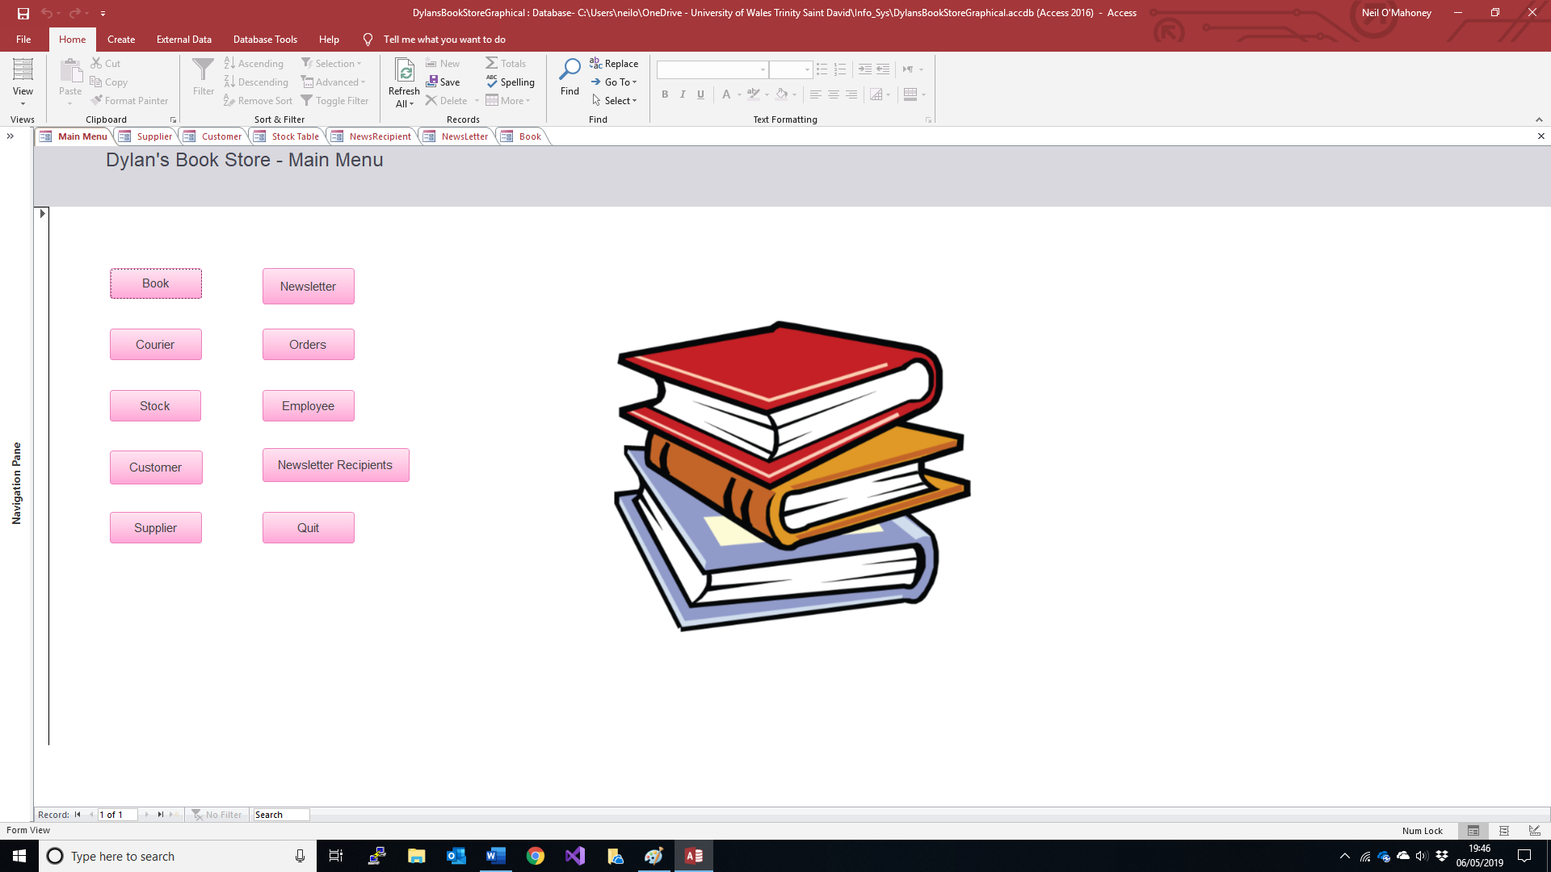
To add a new book click the ‘>’ button until it comes blank and start typing
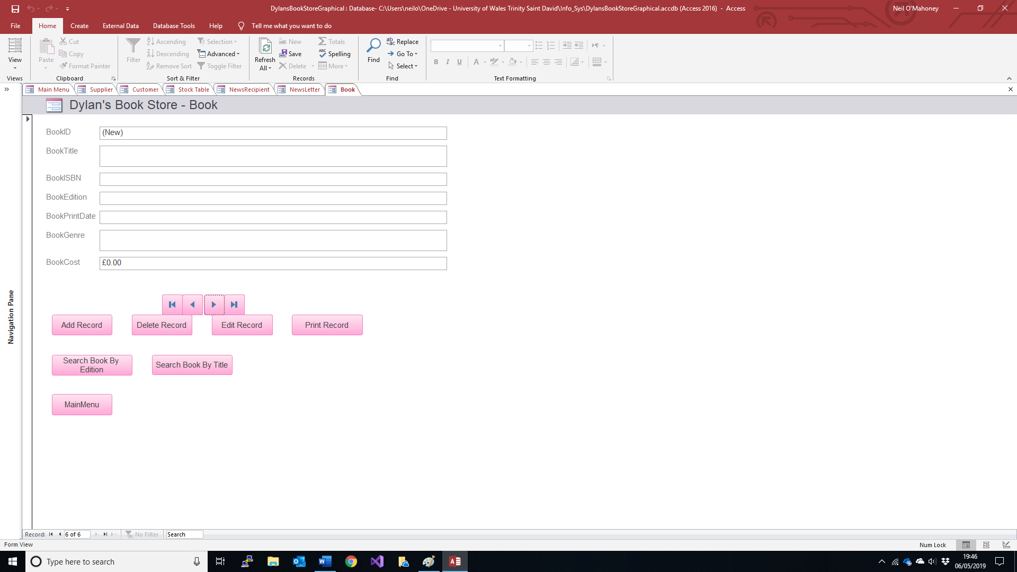
When you are done click ‘add record’ if you wish to add it. You can browse back and forth through the records to find others and amend if you so wish.

I you wish to search for a particular title click on ‘Search for a title’ and the following box will pop up
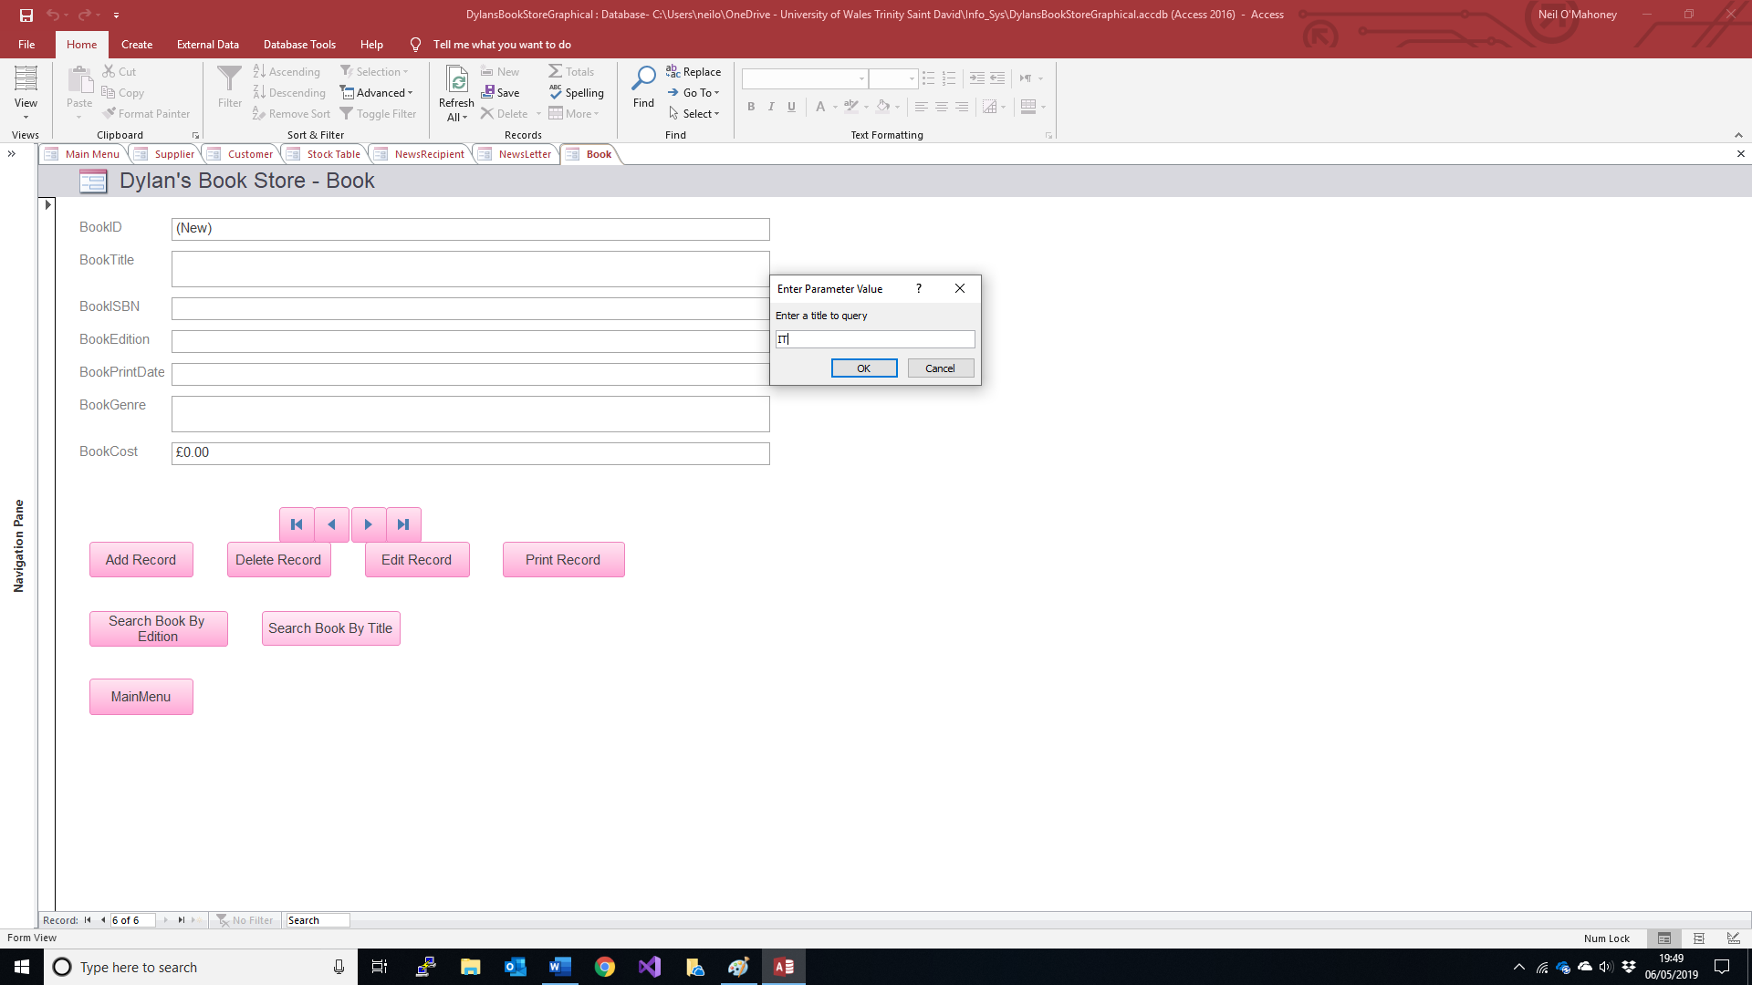
Simply type the name and then ‘ok’ the following is then displayed:
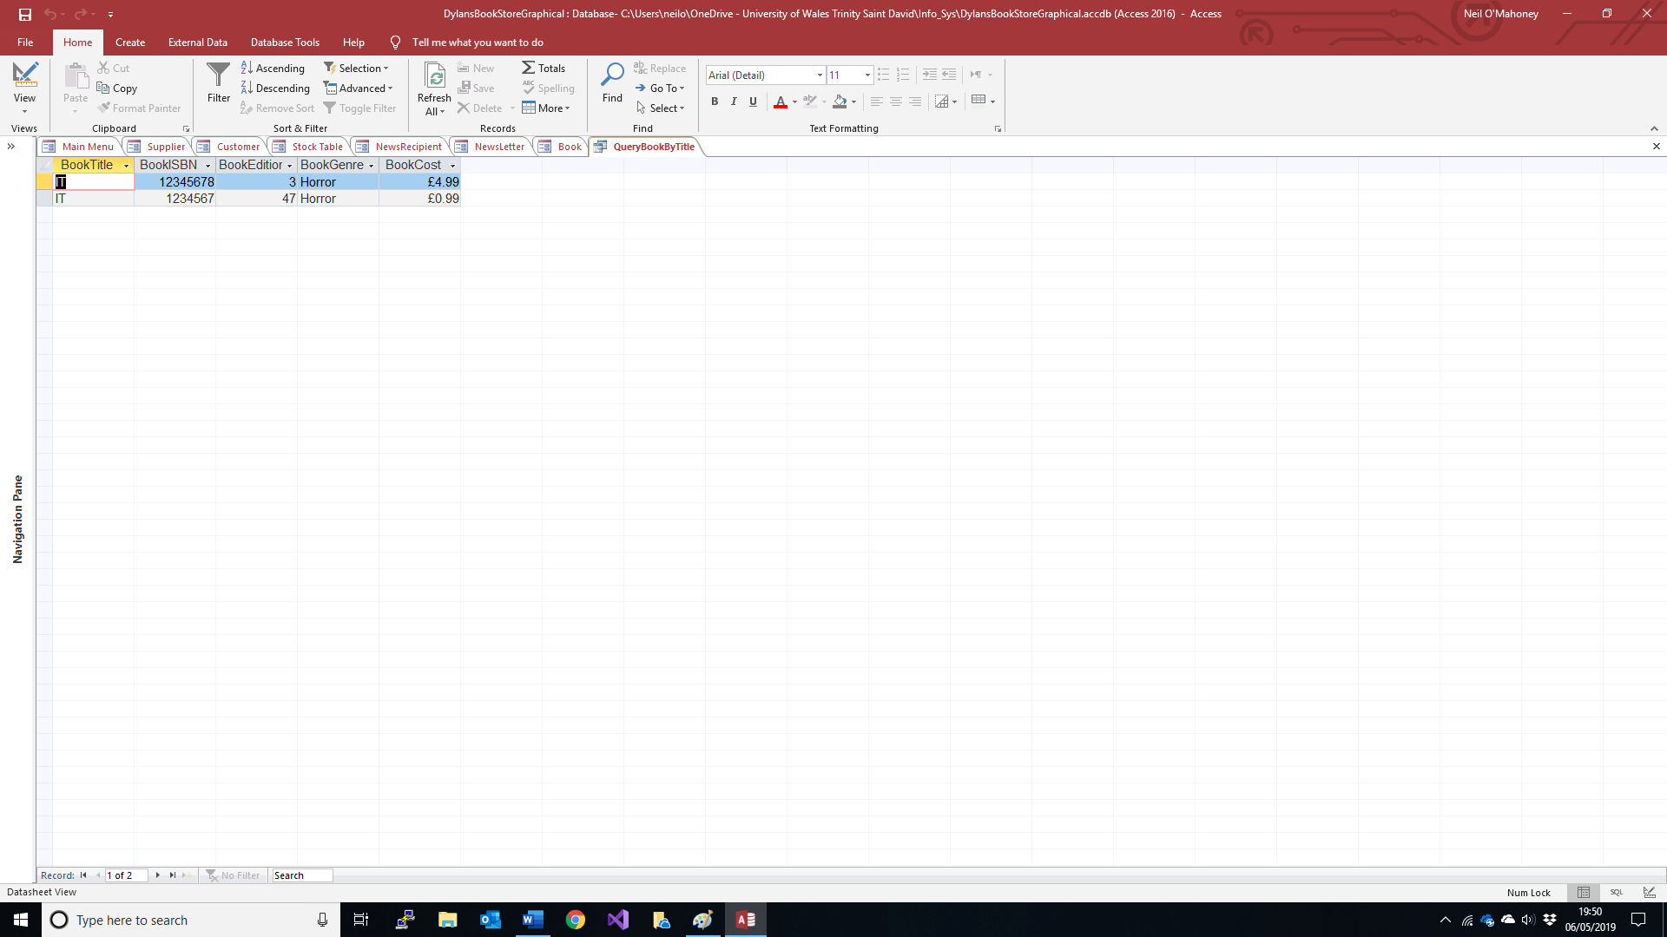
If you wish to search by edition then just click the ‘search by Edition’ button:

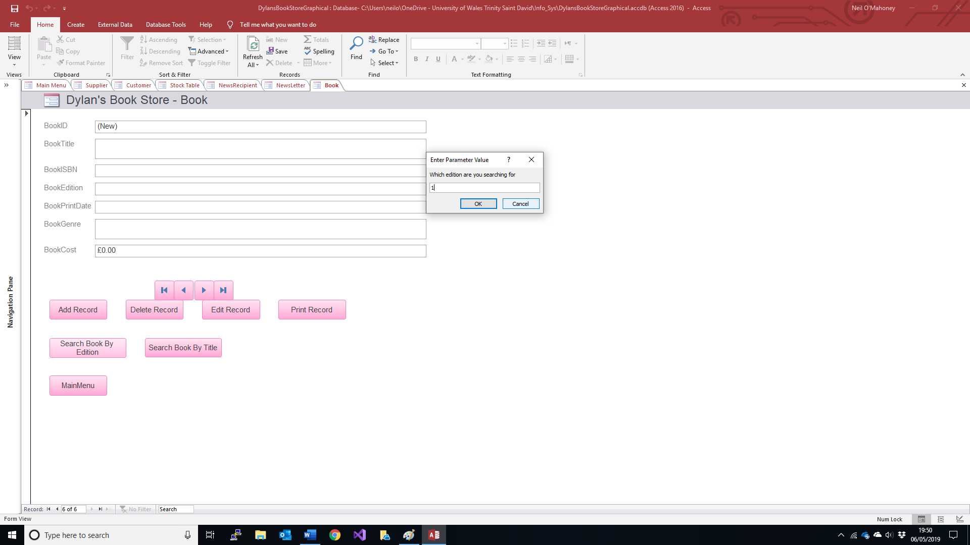
And the following will be displayed:
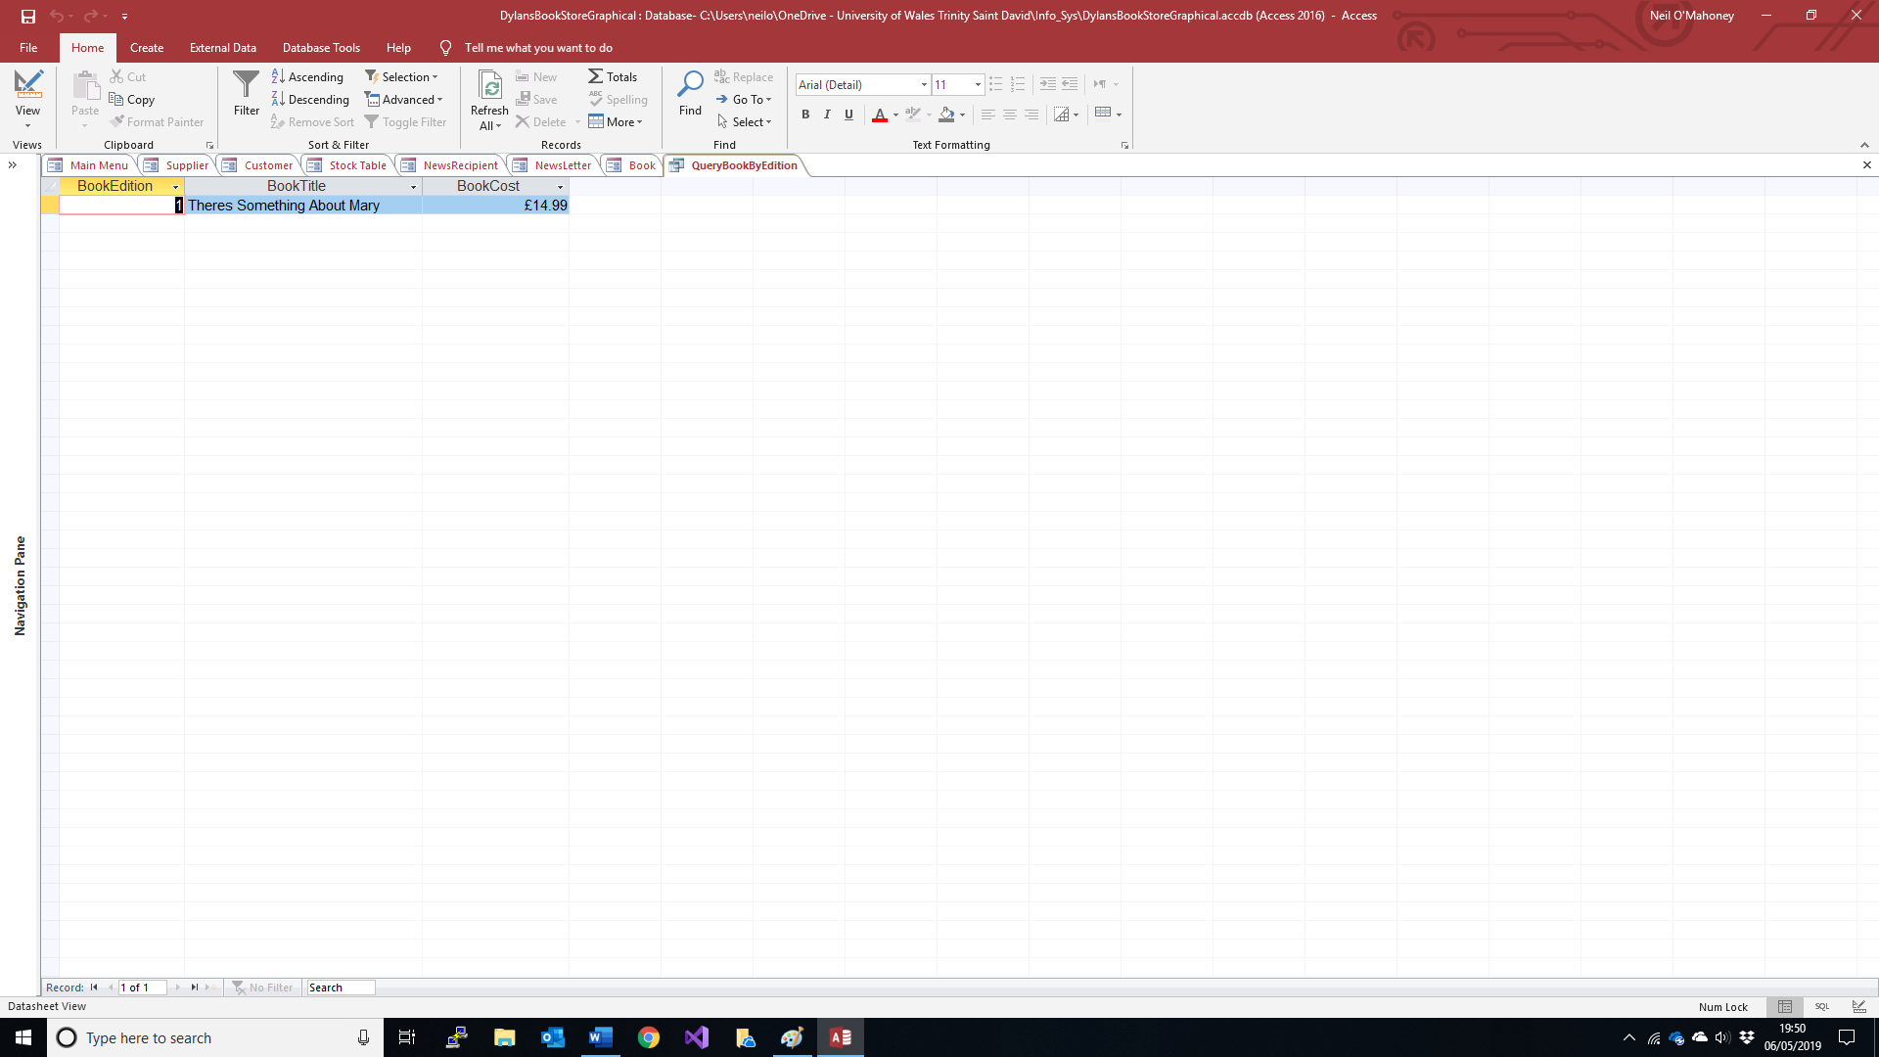

If you wish to create a new order then click ‘Orders’ on the main page:

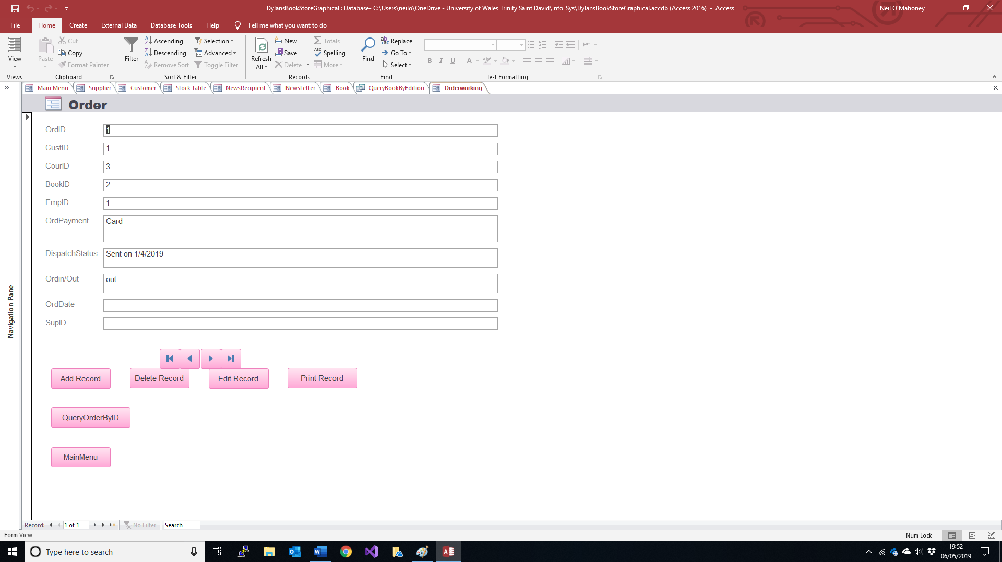
Type in the required fields and click ‘add record’

If you wish to query an order, please have the order number to hand, click the query order button, type in the order id number (in this case ‘1’)
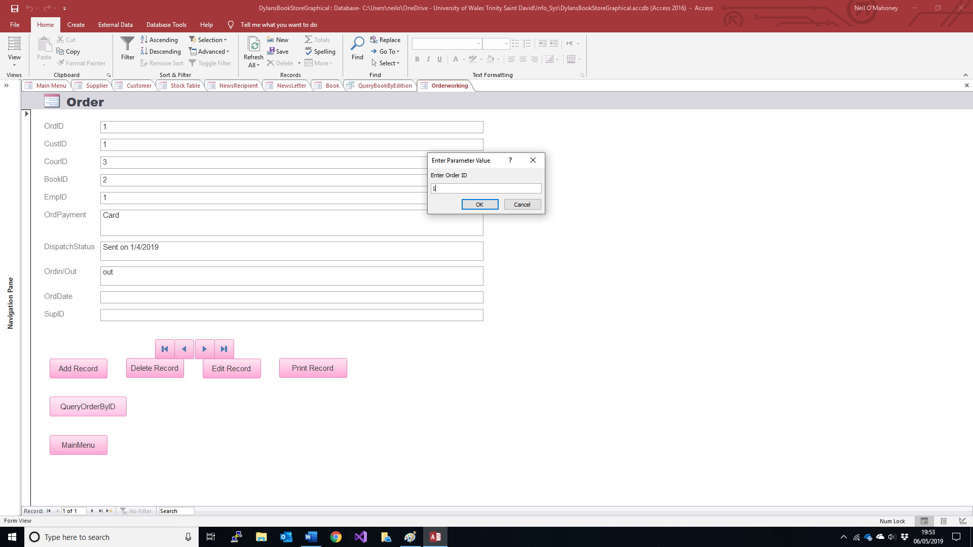
And click ‘ok’

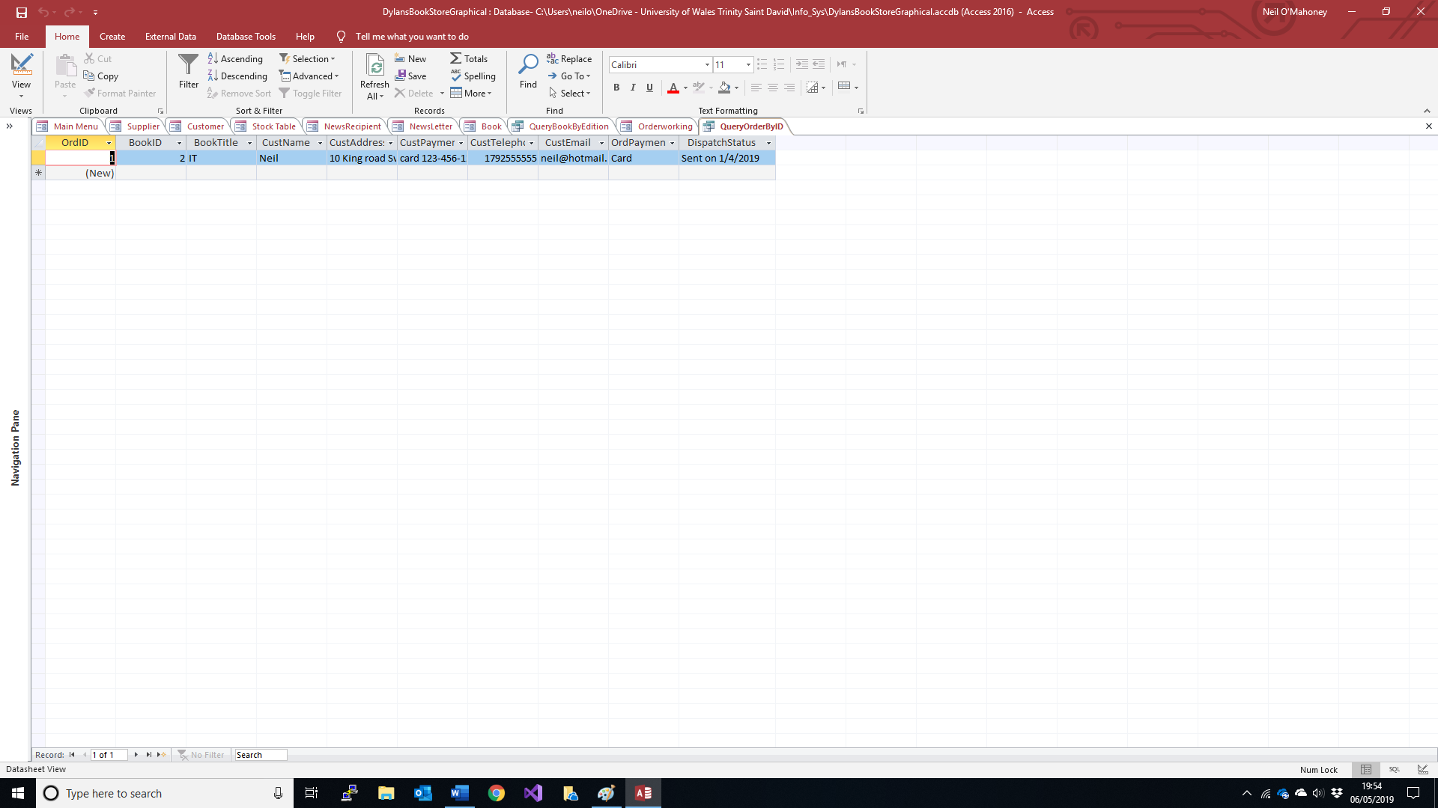
The information about order 1 is displayed on screen.
If you wish to display a marketing customer preferences report then click on the news recipient button on the main menu
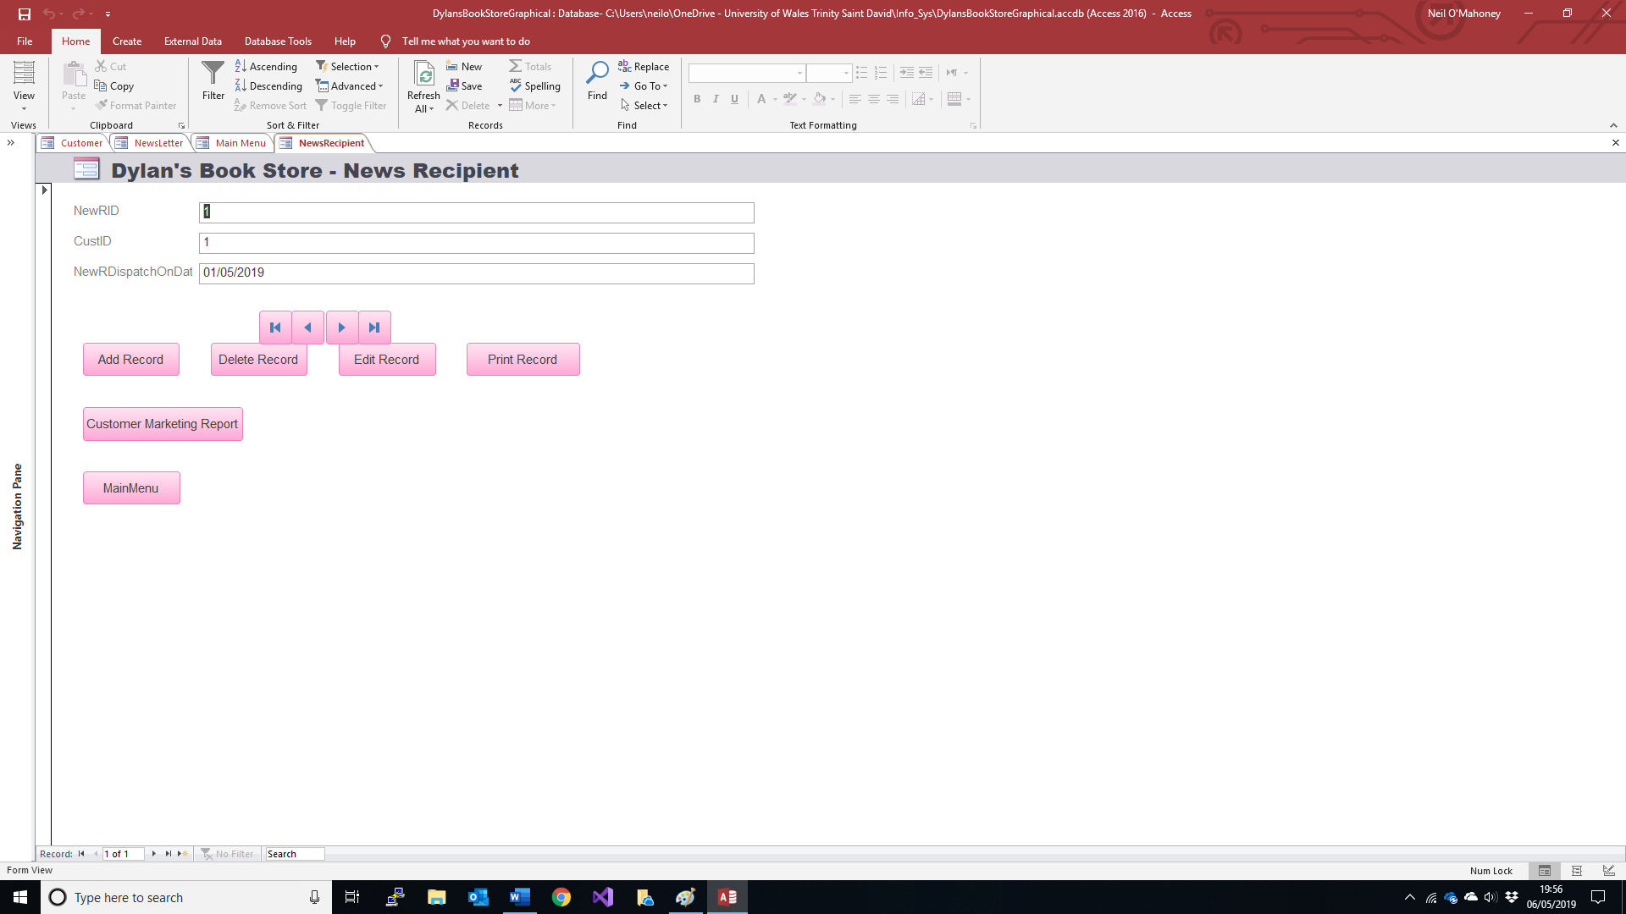

And click on the ‘Customer market report’ button

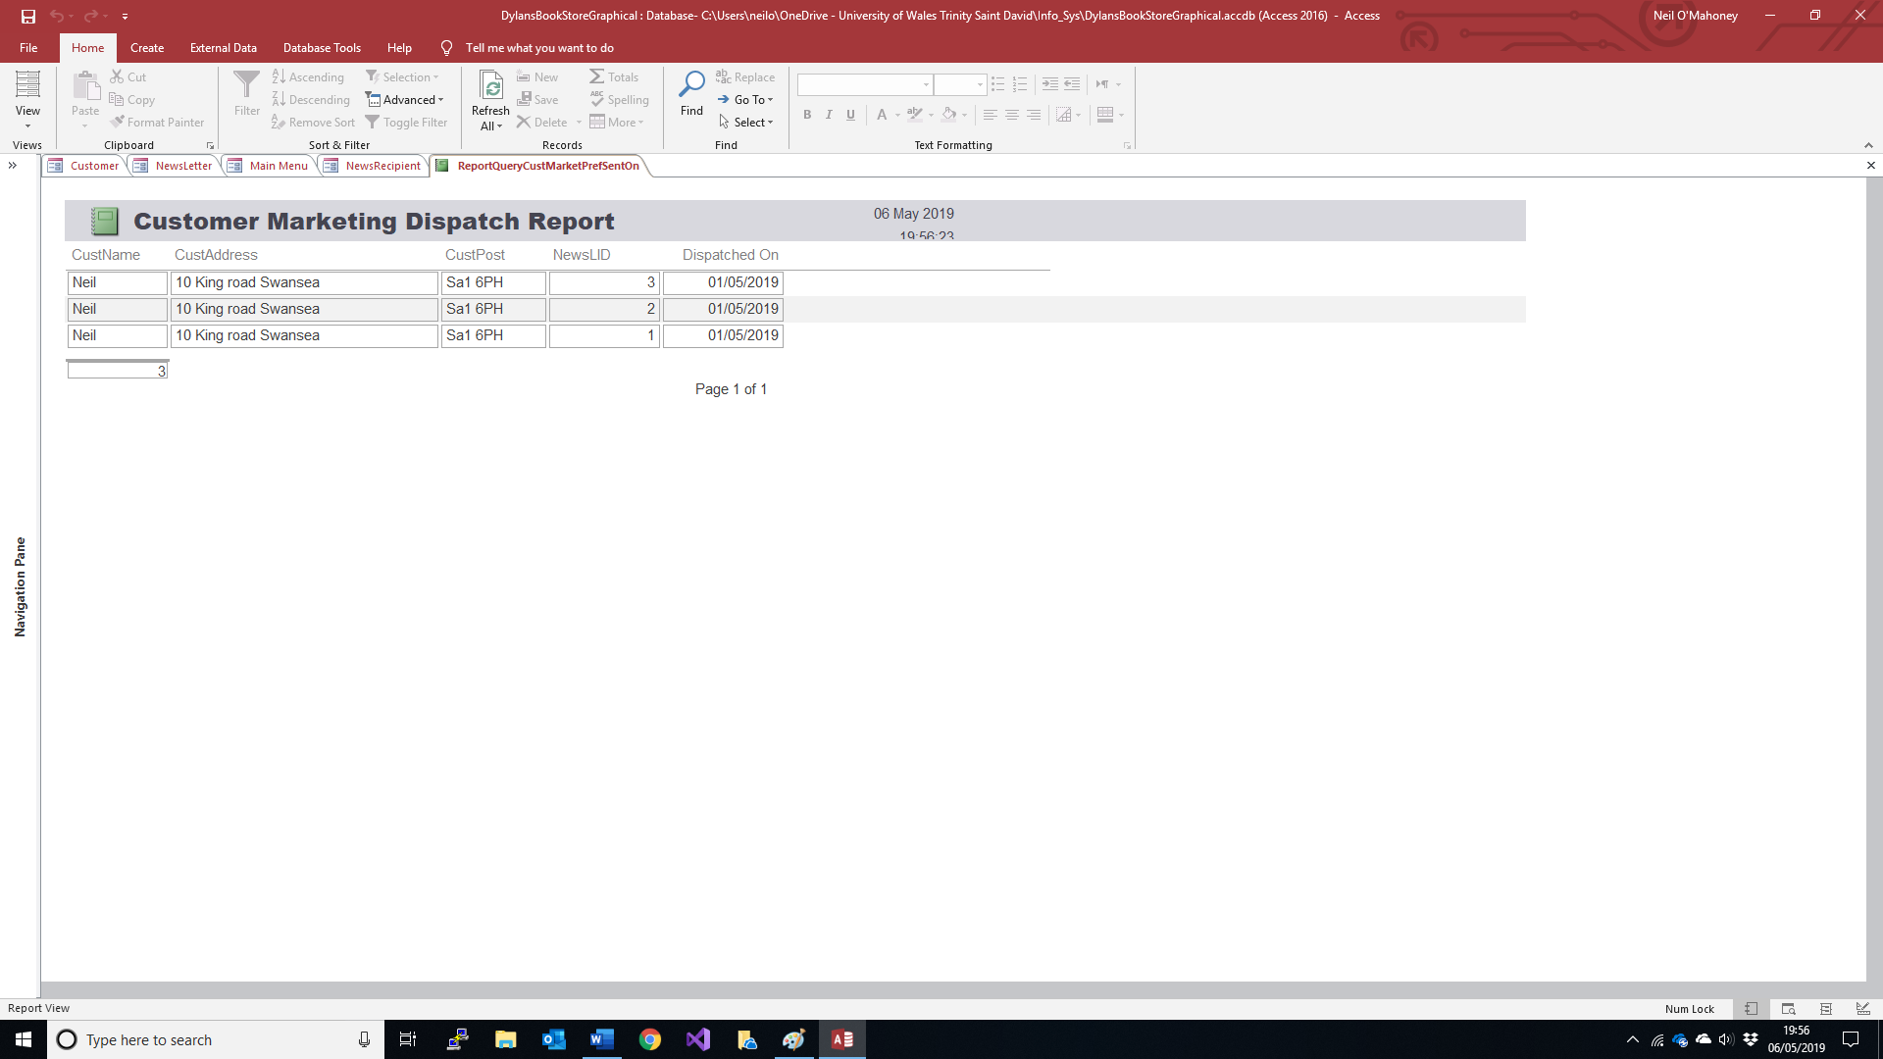

Conclusion

I am fairly happy with the outcome of the Dylan’s book shop access program. I have created a searchable database that retains information about suppliers, couriers and alike. I would have liked to create a mail merge document that included the user’s preferences and genes rather than a document which listed the users who wished to subscribe to marketing preferences.
The simplicity of the menu driven system is at odds with the programming element behind it. The relational database allows for dropdown menus to navigate through the different options to make it easier for the user to get the right information.
A key point earlier on was that the staff were unable to keep up with the current best sellers, with this new system it identifies the key books and places them into order so that they can be selected on a monthly basis as a book of the month etc. This will also help ordering stock when one becomes more popular.
If books need ordering they are now searchable via title. This means that all editions will crop up that are in our database and we can target the correct supplier.

Bibliography
A.Condor. (2018). Normalization. Retrieved from Depaul Edu: http://condor.depaul.edu/gandrus/240IT/accesspages/normalization3.htm
Connelly, T., & Begg, C. (2005). Database Systems - A Practical Approach To Design, Implementation and Management. (4, Ed.) Harlow, England: Addison Wesley.
Harrington, J. L. (2009). Relational Database Design Clearly Explained. Burlington, MA, USA: Morgan Kuffmann.
IBM. (2019, jan 04). Database Relationships. Retrieved from IBM Knowledge Centre: https://www.ibm.com/support/knowledgecenter/en/SSWT9A_7.6.0/com.ibm.mbs.doc/configur/c_db_relationships.html
Kendall, J. E., & Kendall, K. E. (2011). Systems Analysis and Design. Harlow, England: Pearson Education Ltd.
TechOnTheNet. (2019, May 05). Oracle / PLSQL: Primary Keys. Retrieved from Tech On The Net: https://www.techonthenet.com/oracle/primary_keys.php

Annex A: Entity Relationship Diagram of Dylan’s Book Store in Visio

Annex B SQL Code
CREATE TABLE Book(
bookID INTEGER PRIMARY KEY,
bookTile CHAR (30),
bookISBN CHAR (13),
bookEditor CHAR (20),
bookPrintDate INTEGER (20),
bookGenre CHAR (20),
bookCost INTEGER (20));

CREATE TABLE Courier(
courID INTEGER PRIMARY KEY,
courName CHAR (30),
courAddress CHAR (40),
courPostCode CHAR (10),
courTelephone INTEGER (20),
courEmail CHAR (20));

CREATE TABLE customer(
custID INTEGER PRIMARY KEY,
custName CHAR (30),
custAddress CHAR (40),
custPostCode CHAR (10),
custTelephone INTEGER (20),
custEmail CHAR (20),
custPaymentMethod CHAR (25),
custMarkPref CHAR(3));

CREATE TABLE employee(
empID INTEGER PRIMARY KEY,
empPostion CHAR (15),
empName CHAR (20));

CREATE TABLE newsletter(
newsLID INTEGER PRIMARY KEY,
newsLIssue INTEGER (4),
empName CHAR (20));

CREATE TABLE newsRID(
newRID INTEGER PRIMARY KEY,
newsRDISPLAY INTEGER (4),
custMarkPRef CHAR (4));

CREATE TABLE order(
ordID INTEGER PRIMARY KEY,
custID INTEGER (4),
bookID INTEGER (4),
EmpID INTEGER (4),
OrdPaymentStatus CHAR (10),
DispatchOnStatus INTEGER (10),
OrdIn/Out CHAR (3),
OrdDate INTEGER (10));

CREATE TABLE stock(
stocID INTEGER PRIMARY KEY,
supID INTEGER (4),
bookID INTEGER (4),
StocQty INTEGER (4),
StocLocation CHAR (20),
StocSales INTEGER (5));

CREATE TABLE supplier(
supID INTEGER PRIMARY KEY,
supNAME CHAR (20),
supAddress INTEGER (30),
SupPostcode CHAR (10),
supEmail Char (20));

