Managing People

Student’s Name: Anastasiya Petrova
Student’s Number: 1816952
Module Title: Managing People LCBB5004
Assignment Title: Assignment 2
Module Lecture’s Name: Dr Ze Zook

Table of Contents

Introduction 3
Concept and drivers of employee engagement 3
Diagnostic tools to measure the employee engagement 6
An employee value proposition from the ideas and analysis covered 11
Strategies to raise levels of engagement 13
Conclusion 15
References 16

Introduction
In the modern era, most businesses employ diversity during recruitment, and this is based on skills, age, gender, and background. The ability to manage such individuals in the workplace requires a manager with relevant skills to handle such diversity. At times, managing people can be quite challenging, but it is important to remember that they are essential in ensuring business goals are attained. Proper management of employees has shown to promote their engagement in the workplace hence improving individual performance as well as promoting work culture in their respective workplace.
The COVID19 pandemic has required changes in the way of work, and the measures taken by companies are working from home, flexible working time, making the workplace “Covid-19 safe” and jobs restructuring. This report has been designed, to review the concept and drivers of employee engagement. Also, it assesses the various diagnostic tools that measure employee engagement. At the end of the report, an employee value proposition has been constructed, and strategies that improve employee engagement analyzed.

Concept and drivers of employee engagement
Concept of employee engagement
In 1990, Khan introduced the concept of employee engagement. According to him, engaged employees participating physically, cognitively and emotionally in their work position, it is necessary to have a sense of appreciation, trust and security in the workplace, and the availability of the necessary resources related to the performance of work tasks. The literature review also cites other researchers of employee engagement, some of whom are Schaufeli, Salanova, GonzalezRoma, and Bakker, who in 2002 defined work engagement as a mental state defined by dedication, energy, and assimilation. They are developing the Utrecht Work Engagement Scale (UWES) to measure engagement, which will be discussed below (Knight, et.al., 2017).
The Institute for employment studies (IES) in 2004, defines employee engagement as an approach in the workplace that promote a conducive environment for every individual in an organisation through motivating them, enhancing commitment towards attaining business goals, promoting a sense of well-being and improving individual output. It is built through effective communication, trust and commitment between employees and managers. Engagement is an essential aspect to any business, especially during this period of the Covid19 pandemic as it increases chances of success, enhances productivity and performance of employees.
Employee engagement entails understanding the roles of every person within an organisation and determine where it fits to promote objectives and purpose of an organisation. It can also be identified in terms of clear understandings on how employees fulfil the objectives and purpose of an organisation as well as ways of changing such objectives to attain better results. Employee engagement can also be determined when an individual is included as a team member hence focusing on clear goals, engaging in empowering activities, receiving constructive feedback, being supported and recognised. The concept of employee engagement can be linked to positive behaviours and attitudes that promote positive results. It also relates to employees when they can feel pride and loyal to their organisation while going extra miles to complete their tasks (Kruse, K., 2015). In most cases, it decreases conflict, accidents and absenteeism at the workplace.
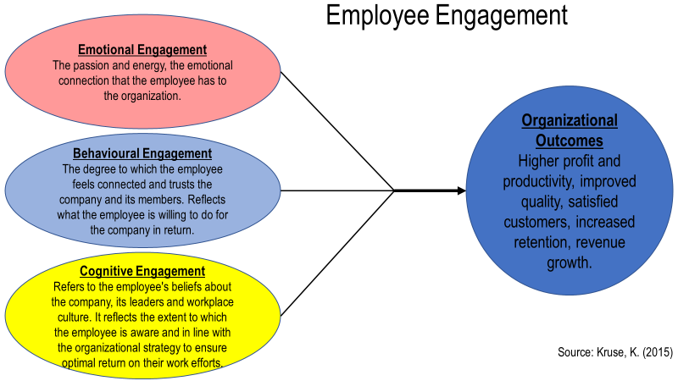
Employee retention is influenced by high levels of engagement, and this is related to the actions of management, managers and employees teams. Conducting a survey helps the organization to better understand the drivers of employee engagement. This increases the efficiency of the actions that the company needs to take. With this feedback, management has the opportunity to answer the strategic questions that have the strongest impact on engagement.
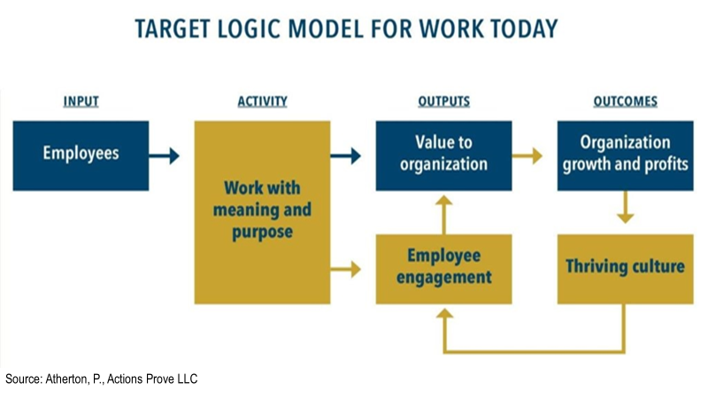
This model represents the relationship of input data, actions and results developed over time to achieve high levels of employee engagement to achieve the company's goals.
Drivers of employee engagement. It is necessary to understand the factors that influence engagement to take action to increase it.
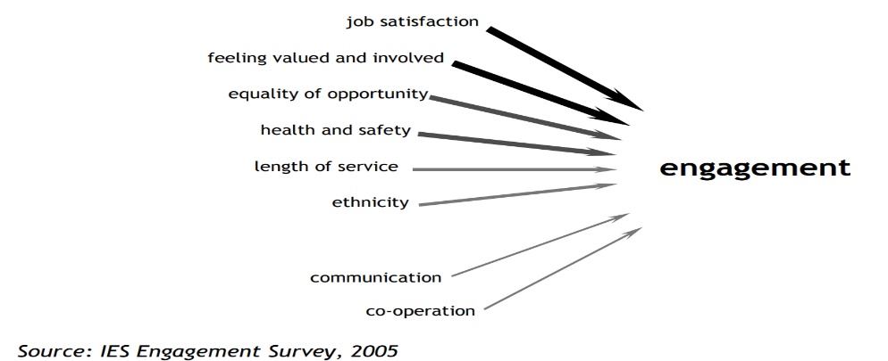
Constant and constructive feedback. One of the most important factors for employee engagement is the work environment. Employees can understand whether they are meeting business expectations and goals or not when they receive adequate feedback promptly. They can assess their success and determine appropriate ways of improving their skills when they receive adequate feedback (Anitha J., 2014). With this aspect, employees’ engagement is enhanced because such feedback indicates that there is a positive relationship between employees and managers, which promotes individual success.
Recognition. Every employee needs to be recognised in terms of their efforts and positive performance in the workplace to become more engaged in their duties (IES, 2009). Employers need to recognise the accomplishment of employees, utilise fair and equitable remuneration while determining creative programmes in the workplace to allow team members to reward one another hence promoting engagement and measuring their contribution towards business success.
Dedication. Most modern companies have a diverse and mobile workforce that makes management to have various expectations from employees in terms of time and place of work. When such organisations can offer responsibilities and projects that are adapted to the individual employee, such employees become more engaged in performing their duties and attain the business goals (Bedarkar and Pandita, 2014).
Fairness. It is regarded as an essential driver in the modern workplace since it plays a critical role in determining how employees feel they are treated and valued by management. As a driver of employee engagement, fairness at workplace offers a range of important indicators such as employees’ attitude towards their job, level of openness that exist between various teams and level of respect that management is giving them. Most employees are constantly comparing their works to those of their colleagues; hence managers need to set clear expectations that are fair to all and promote them in realising the business goals.
Clarity. According to Barreiro, Treglown (2020), most employees in the company are evaluating the importance of their roles based on set visions and missions of the company. Managers can enhance employee engagement through communicating a link that exists between business goals and their defined roles. Also, clear roles enable employees to work consistently with the intention and focus of attaining set goals.
Shared values. When an employee shares common values in the workplace, they can express common principles and attitudes while working. This promotes the feeling of working together in realising common success because it demonstrates how individual values are aligned with organisation goals hence promoting employee engagement.
Drivers determine the presence or absence of a quality workplace, and this affects engagement. They do not work independently, they are connected and this is presented in the following figure.

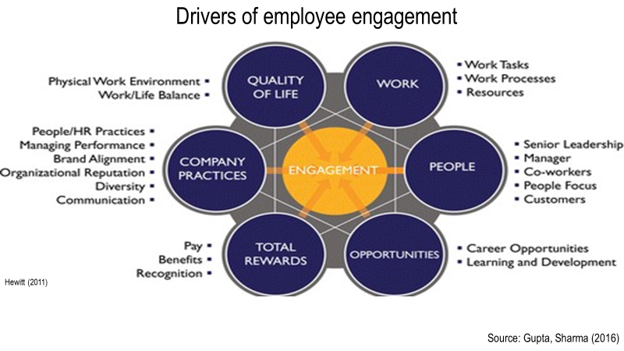

Diagnostic tools to measure the employee engagement
To get a clear idea of ​​engagement levels, they need to be measured and analyzed. Otherwise, when there is no clear picture, the necessary changes cannot be made in time. Measuring employee engagement is a complex process because it is a combination of human emotions. The use of some combinations of methods can give a clearer idea of ​​the extent to which staff are motivated and organized. According to Rich Hein (2014), senior managing editor of the CIO, as a start, it is necessary to form groups, which allow focusing on good questions about the commitment of employees to which each group to answer. After analyzing the answers, the necessary actions can be taken, focusing on the things that affect the preservation of talents. According to the theory of maximizing talent in an organization (Gallup, 2020) Per-Person Productivity = Talent x (Relationship+ Right Expectation + Recognition/Reward).
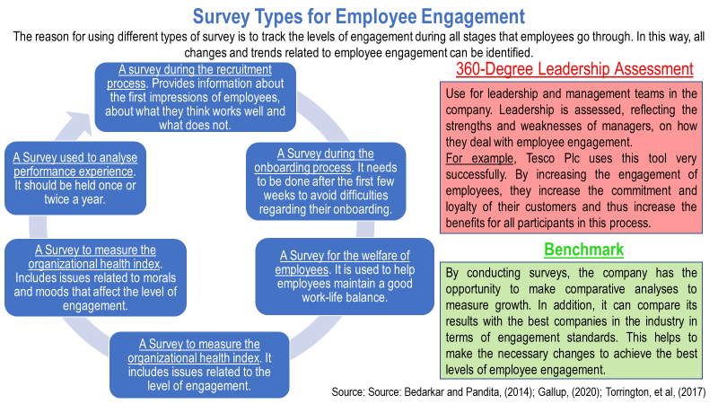

As already mentioned, work engagement can be assessed with the Utrecht Work Engagement Scale. For this work, a nine-element version was used, which demonstrates good psychometric properties (Zecca, et al, 2015).
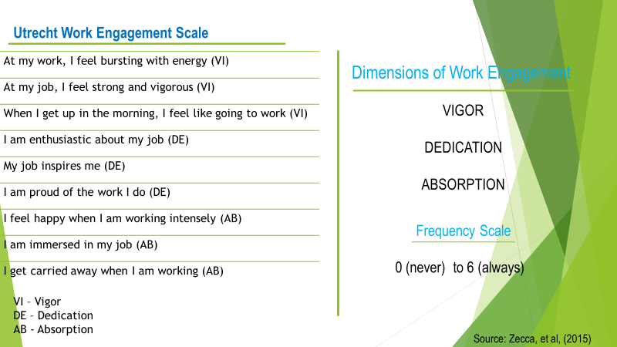
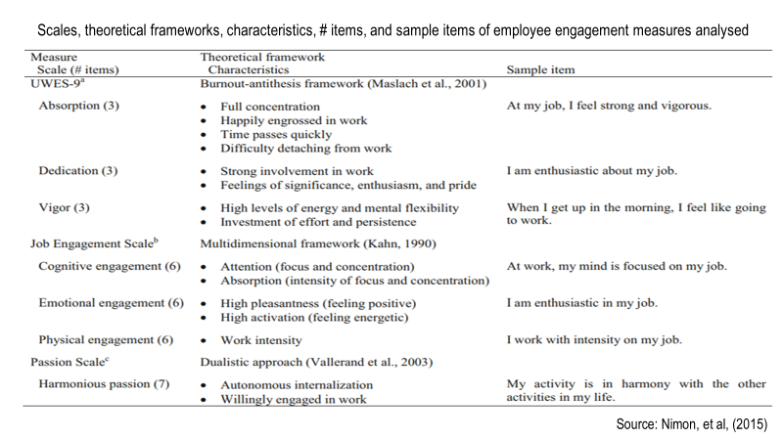
The standard Gallup's Q12 tool measures current management issues that supervisors and managers can influence (Gallup, 2020). The included 12 elements are reduced to the level of supervisors and managers because they can influence the attitude and problem solving of the rest of the employees. Elements such as clarity of role, availability of necessary resources, an adaptation of abilities to requirements, feedback and evaluation are included. In the difficult times of a pandemic, leaders need to pay even more attention to people to maintain their productivity. To this end, it is advisable to use an additional tool that includes elements related to the universal needs of people, namely trust, stability, compassion, hope. For example, they could be: I am presented with a clear action plan from the employer related to the COVID-19 pandemic; My preparation is at the level necessary to perform my duties; My line manager informs me promptly about what is happening in the company; I maintain social communication with my colleagues every day; I feel my company's concern for my well-being. This measure directly reflects how employees feel in the organization, why they are satisfied and committed to achieving high results.

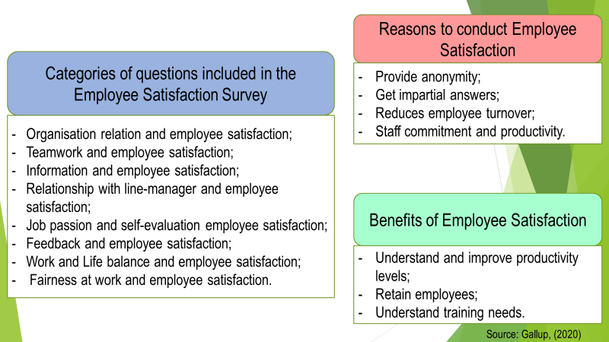
It can be concluded that the focus of surveys to measure employee engagement needs to be on Satisfaction - how satisfied the employee is with the tasks they perform, pay, working conditions, benefits, the manager; Alignment - to what extent the employee is motivated by the goals and mission of the company; Future orientation - whether the employee foresees his future in the current company or intends to move to another company. It is necessary to ensure the anonymity of the surveys so that employees feel at ease and give real answers without any consequences for them. This will ensure a more realistic and accurate assessment, respectively more correct actions to increase the level of employee engagement.
The components of a sense of valued and involved need to be carefully monitored and analyzed because they have a direct impact on levels of engagement.
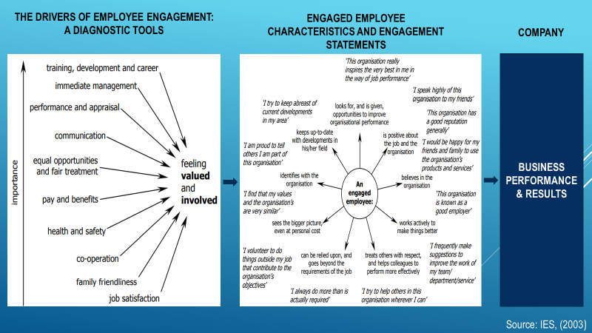
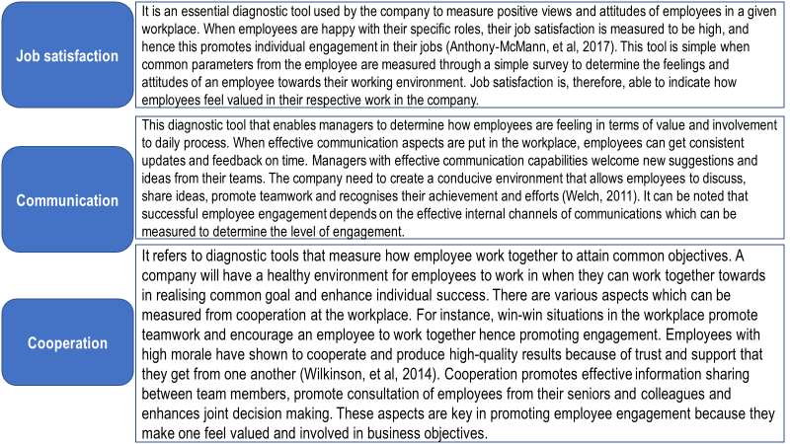
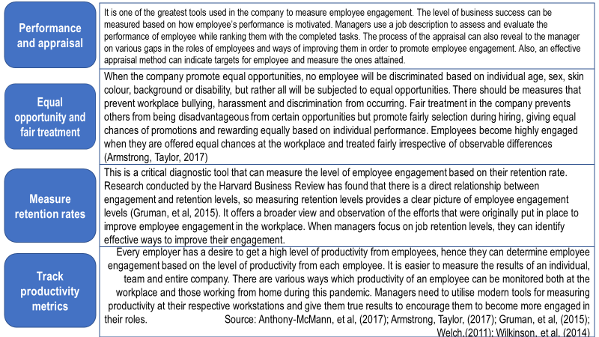
The main diagnostic tools in human resource management related to promoting employee engagement are Selection; Socialization; Performance Management; Training, Learning and Developing.
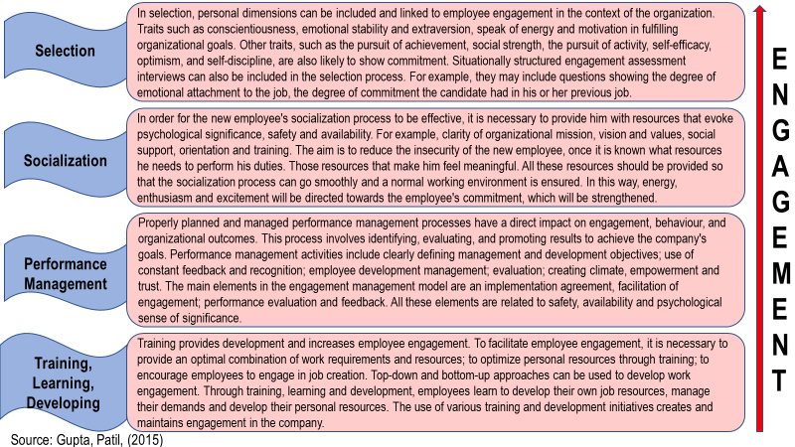

An employee value proposition from the ideas and analysis covered
One of the main goals of the HR Professional is to ensure that employee engagement is a top priority in the company. With his knowledge and skills, he/she helps the organization to develop its organizational culture (MacLeod and Clarke, 2015). To achieve this, attention is focused on improving the skills of managers to achieve high levels of employee engagement. To this end, the HR Professional uses tools and techniques that facilitate effective line-managers management. Until a few years ago, the focus on engagement was mainly on reward, benefits, efficiency. In today's age of globalization, high technology, a highly competitive environment, and besides the challenges of a global pandemic, Professionals are increasingly paying attention to people's problems, focusing on talent management, leadership development and workforce productivity.
Employee Value Proposition (EVP) is the relationship between employer and employees that represents the expectations and commitment between the two parties (Pawar and Charak, 2016). The new challenges and the pandemic have changed the expectations of both employers and employees. That is why companies strive to meet new expectations by updating their value proposals to employees, ensuring support, recognition and values. By targeting overall rewards and EVPs to better reflect the changing needs of their employees, companies are also changing their strategies. Revenues and rewards are given to employees based on their abilities, skills and individual commitment to business success. Therefore, it enables employees to improve their brand to create a positive perception that attracts and retains top talented people. The following example can be given to the employee value proposition for the company: “Our company is best to work globally, as chosen by the employees. The company has a culture in which every employee can be the best and stay engaged. We believe that we provide employees with the appropriate resources and tools to increase individual productivity. We believe that happy and committed employees are successful”.
Talent Management Framework
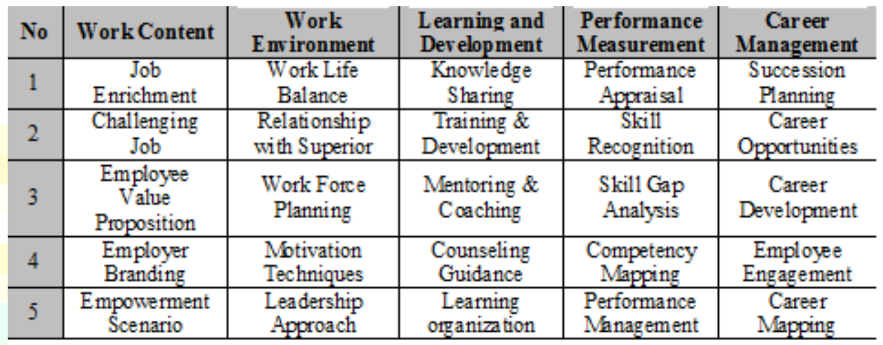
Source: Pawar and Charak, (2016)
According to Pawar and Charak, (2016), analyzing the IT sector in India, EVP has the highest growth. This requires the companies in this sector to expand EVP and branding. For the effectiveness of this process, it is necessary to propose the workforce, to check the implementation, to make a mapping of competence, and the recognition of abilities to be carried out effectively. There needs to be a friendly working atmosphere and employees to be stimulated and encouraged. Companies need to strive to improve knowledge through preparation, different knowledge-sharing practices and empowerment. In this way, they can keep their talents, which will help them achieve higher efficiency and productivity. This, respectively, will increase their competitiveness. EVP needs to be promoted through appropriate channels to be well communicated and meaningful.
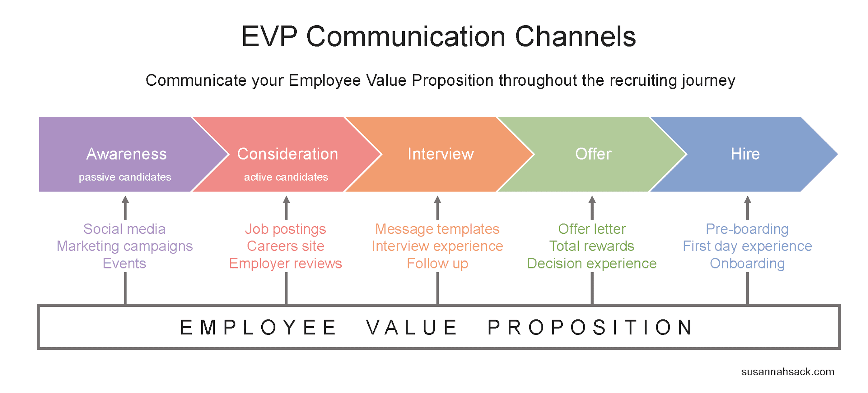Source: Sack, Susannah, (2019)

Strategies to raise levels of engagement

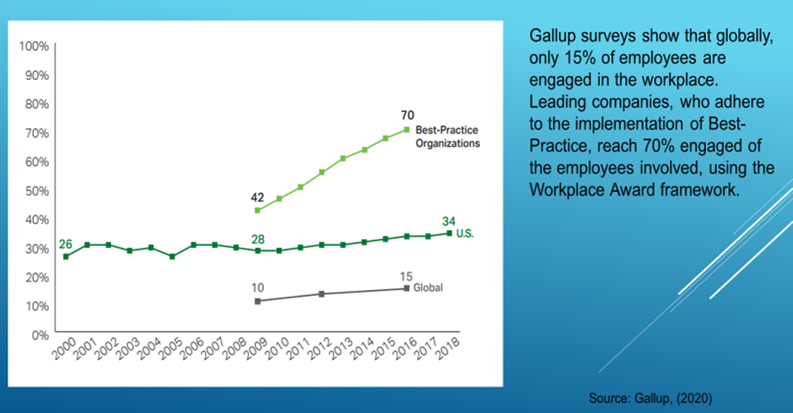
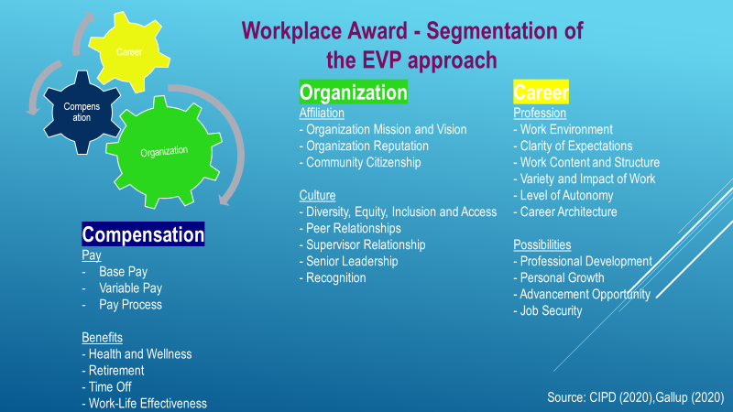
Employee engagement is closely related to remuneration management. Therefore, this relationship needs to be clearly defined and understood in each company.
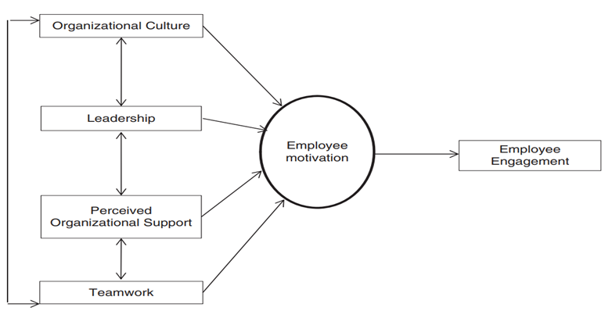
Source: Mehrzi and Singh, (2016)

Understanding the rules and roles for increasing employee engagement helps to create a good approach to attracting, developing and retaining talent. This achieves the best for both the company and the employees.
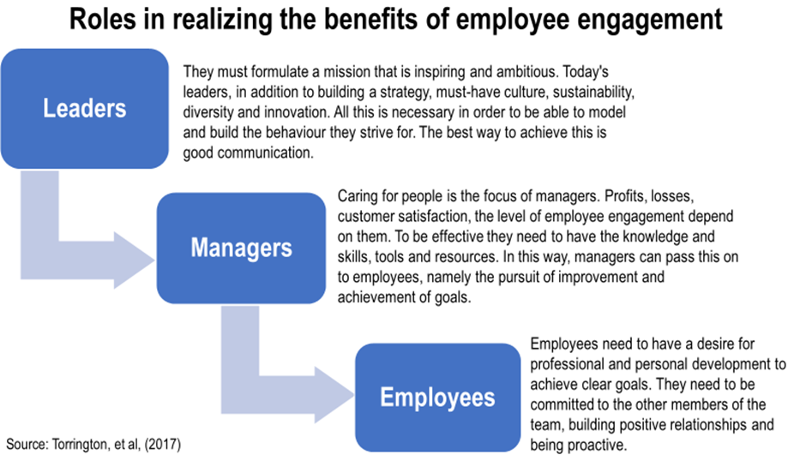

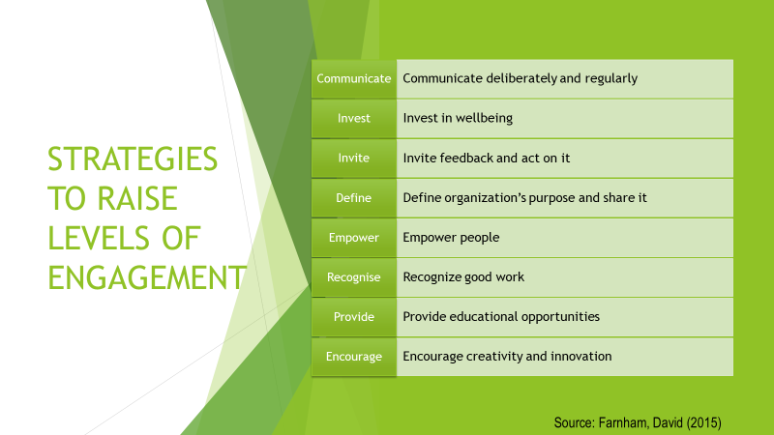
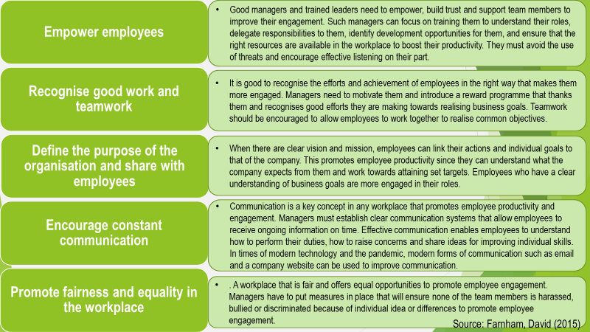
Modern engagement technologies offer opportunities for a visual way of learning, communication and creating friendships through interesting visual effects. Creating chat groups or pages will help gather like-minded people. Performance management software used in conjunction with workforce analysis can provide a clearer idea of identifying the need for more attention to the degree of commitment.

Conclusion
In conclusion, employee engagement is a concern for most employers because of the impact it has on the company's productivity. It is a constantly transforming characteristic that needs to be properly managed in order to achieve the company's goals. Managers need to define appropriate strategies in their respective workplaces to improve employee engagement. Authorized employees are more productive because they can achieve set goals without much supervision. The value proposition of employees is a basic concept that promotes the company's brand and allows it to attract and retain talented people. All this ensures the sustainable development of the organization, and employees feel proud and satisfied to be part of it.

References
- Anitha J., (2014), Determinants of employee engagement and their impact on employee performance, International Journal of Productivity and Performance Management.
Available at: https://scholar.google.co.uk/scholar?output=instlink&q=info:Rhb6O48AeTMJ:scholar.google.com/&hl=en&as_sdt=0,5&as_ylo=2014&as_yhi=2020&scillfp=14964283070811461903&oi=lle
(Accessed: 27.11.2020)
- Anthony‐McMann, et al, (2017), Exploring Different Operationalizations of Employee Engagement and Their Relationships With Workplace Stress and Burnout, HUMAN RESOURCE DEVELOPMENT QUARTERLY DOI: 10.1002/hrdq.
Available at: https://scholar.google.co.uk/scholar?output=instlink&q=info:e0zDlepaCHkJ:scholar.google.com/&hl=en&as_sdt=0,5&as_ylo=2015&as_yhi=2020&scillfp=11376924863494512961&oi=lle
(Accessed: 30.11.2020)
- Armstrong, Taylor, (2017), Armstrong’s Handbook of Human Resource Management Practice, Kogan Page, 14thed, p.218-222.
- Atherton, P., The New Rules for Employee Engagement, Actions Prove LLC.
Available at: https://actionsprove.com/the-new-rules-for-employee-engagement-part-1-know-your-role/
(Accessed: 27.11.2020)
- Barreiro, Treglown (2020), What makes an engaged employee? A facet-level approach to trait emotional intelligence as a predictor of employee engagement, Personality and Individual Differences, Volume 159, 1 June 2020, 109892.
Available at: https://scholar.google.co.uk/scholar?output=instlink&q=info:DGBAtK1AugAJ:scholar.google.com/&hl=en&as_sdt=0,5&as_ylo=2011&as_yhi=2020&scillfp=4975346666829377941&oi=lle
(Accessed: 29.11.2020)
- Bedarkar and Pandita, (2014)A study on the drivers of employee engagement impacting employee performance, Procedia - Social and Behavioral Sciences 133 ( 2014 ) 106 – 115.
Available at: https://scholar.google.co.uk/scholar?output=instlink&q=info:ZYQgeADJsFAJ:scholar.google.com/&hl=en&as_sdt=0,5&as_ylo=2014&as_yhi=2020&scillfp=16082256800322656014&oi=lle
(Accessed: 28.11.2020)
- Chanana and Sangeeta, (2020), Employee engagement practices during COVID‐19 lockdown, Journal of Public Affairs.
Available at: https://www.ncbi.nlm.nih.gov/pmc/articles/PMC7536939/
(Accessed: 30.11.2020)
- CIPG, (2020), Strategic reward and total reward, Moodle, UWTSD.
Available at: https://moodle.uwtsd.ac.uk/pluginfile.php/344736/mod_resource/content/1/Strategic%20%20Total%20Reward%20_%20Factsheets%20_%20CIPD.pdf
(Accessed: 06.12.2020)
- Farnham, David (2015), Human Resource Management in Context Insight, Strategy and Solutions, CIPD, 4thed, p.170-198.
- Gallup, (2020), The Relationship Between, Engagement at Work and Organizational Outcomes, Gallup.[ downloaded PDF]
Available at: https://www.gallup.com/workplace/321725/gallup-q12-meta-analysis-report.aspx
(Accessed: 30.11.2020)
- Gallup, (2020), Gallup's COVID-19 Pulse Survey.
Available at: https://advise.gallup.com/covid-19-pulse-questions
(Accessed: 30.11.2020)
- Gallup, (2020), Gallup’s Perspective on Building a High-Development Culture Through Your Employee Engagement Strategy, Gallup.[ downloaded PDF] file:///C:/Users/anast/Downloads/Building%20a%20High-Development%20Culture%20Through%20Your%20Employee%20Engagement%20Strategy.pdf
(Accessed: 06.12.2020)
- Gruman, et al, (2015), Employee engagement, human resource management practices and competitive advantage, Journal of organizational effectiveness, vol. 2, no. 1, pp. 7‐35.
Available at: https://scholar.google.co.uk/scholar?output=instlink&q=info:SftCGbBm0nwJ:scholar.google.com/&hl=en&as_sdt=0,5&as_ylo=2015&as_yhi=2020&scillfp=2678512966298419236&oi=lle
(Accessed: 01.12.2020)
- Gupta, N., Sharma, V., (2016), Exploring Employee Engagement—A Way to Better Business Performance, Global Business Review.
Available at: https://scholar.google.co.uk/scholar?output=instlink&q=info:DwcalWdjORUJ:scholar.google.com/&hl=en&as_sdt=0,5&as_ylo=2015&as_yhi=2020&scillfp=14609891817167539221&oi=lle
(Accessed: 28.11.2020)
- Gupta, Patil, (2015), A study on employees perception towards employee engagement, Globsyn Management Journal VOL IX, ISSUE 1 & 2, JANUARY - DECEMBER 2015, p.45-51.
Available at: https://www.globsyn.edu.in/wp-content/uploads/2020/04/GMJ_XI_2015.pdf#page=53
(Accessed: 4.12.2020)
- IES, (2003), The Drivers of Employee Engagement.
Available at: https://www.employment-studies.co.uk/system/files/resources/files/408.pdf
(Accessed: 11.12.2020)
- IES, (2007), Measures of engagement, The Drivers of Employee Engagement.
Available at: https://moodle.uwtsd.ac.uk/mod/resource/view.php?id=38924
(Accessed: 27.11.2020)
- IES, (2009), The Engaging Manager
Available at: https://www.employment-studies.co.uk/system/files/resources/files/470.pdf
(Accessed: 28.11.2020)
- Knight, et.al., (2017), Building work engagement: A systematic review and meta-analysis investigating the effectiveness of work engagement interventions, Journal of Organizational Behavior, J. Organiz. Behav. 38, 792–812
Available at: https://onlinelibrary.wiley.com/doi/pdf/10.1002/job.2167
(Accessed: 27.11.2020)
- Kruse, K., (2015), What Is The Definition of Employee Engagement?, [omline]
Available at: https://www.youtube.com/watch?v=Uu7EG6EZeAM
(Accessed: 27.11.2020)
- MacLeod and Clarke, (2015), Engaging for Success: enhancing performance through employee engagement, A report to Government.
Available at: https://engageforsuccess.org/wp-content/uploads/2015/08/file52215.pdf
(Accessed: 01.12.2020)
- Mehrzi and Singh, (2016), Competing through employee engagement: a proposed framework, International Journal of Productivity and Performance Management, Vol. 65 Iss6 pp. 831 - 843.
Available at: https://www.academia.edu/download/50097404/Competing_through_Employee_Engagement.pdf
(Accessed: 06.12.2020)
- Nimon, et al, (2015), Construct Overlap Between Employee Engagement and Job Satisfaction: A Function of Semantic Equivalence?, Journal of Happiness Studies, DOI 10.1007/s10902-015-9636-6.
Available at: https://scholar.google.co.uk/scholar?output=instlink&q=info:PnMlEsi6otgJ:scholar.google.com/&hl=en&as_sdt=0,5&as_ylo=2015&as_yhi=2020&scillfp=16288316034900749196&oi=lle
(Accessed: 05.12.2020)
- Pawar and Charak, (2016), Study on Intangible Framework of Talent Management for Retention using Employee Value Proposition in Indian IT Industry, World Academy of Informatics and Management Sciences, Volume 5 Issue 1, December-January 2016, ISSN (online):2278-131.
Available at: https://www.researchgate.net/profile/Avinash_Pawar2/publication/339956130_Study_on_Intangible_Framework_of_Talent_Management_for_Retention_using_Employee_Value_Proposition_in_Indian_IT_Industry/links/5e8de7dc4585150839c7b663/Study-on-Intangible-Framework-of-Talent-Management-for-Retention-using-Employee-Value-Proposition-in-Indian-IT-Industry.pdf
(Accessed: 05.12.2020)
- Sack, Susannah, (2019), How to Define Your Employee Value Proposition: The DIY Approach, Rally Recruitment Marketing.
Available at:
https://rallyrecruitmentmarketing.com/2019/01/define-your-employee-value-proposition/
(Accessed: 05.12.2020)
- Torrington, et al, (2017), Human Resource Management, Pearson, p.486-496.
- Torrington, et al, (2017), Human Resource Management, Pearson, p.307-321
- Welch, M., (2011), The evolution of the employee engagement concept: communication implications, Corporate Communications: An International Journal.
Available at: https://scholar.google.co.uk/scholar?output=instlink&q=info:S-uz4rLhkMMJ:scholar.google.com/&hl=en&as_sdt=0,5&as_ylo=2011&as_yhi=2020&scillfp=11229664883463761692&oi=lle
(Accessed: 30.11.2020)
- Wilkinson, et al, (2014), Employee voice: Charting new terrain.
Available at: http://www.academia.edu/download/53607374/_9780857939265_-_Handbook_of_Research_on_Employee_Voice__Employee_voice-_charting_new_terrain.pdf
(Accessed: 30.11.2020)
- Zecca, et al, (2015), Validation of the French Utrecht Work Engagement Scale and its relationship with personality traits and impulsivity, European Review of Applied Psychology, Vol. 65, Issue 1, 2015, p. 19-28, p.2.
Available at: https://doc.rero.ch/record/305065/files/Zecca_G.-Validation_of_the_French-20170830.pdf
(Accessed: 30.11.2020)

